Required Coding Activity 13.5: Performing CDC and Initializing a Cassandra Database Container

- Provide a screenshot of the Activity13.5 folder in VS Code.
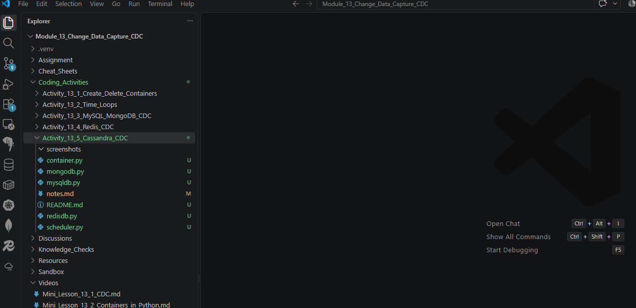

- Provide a screenshot to show that you successfully added the code to create a Cassandra database container.
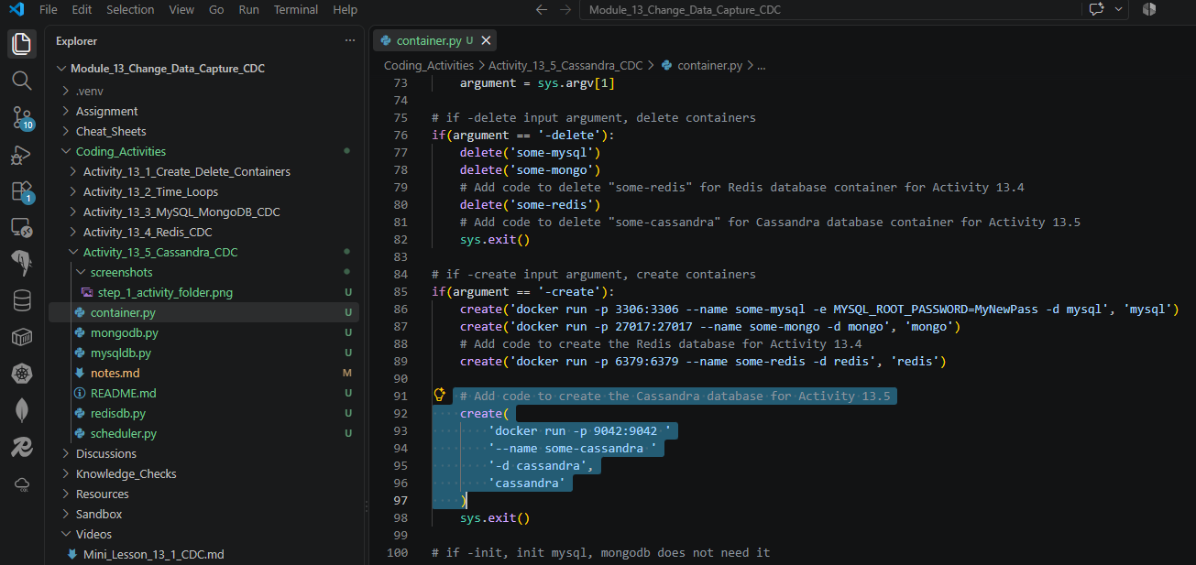

- Provide a screenshot to show that you added code to delete a Cassandra container.
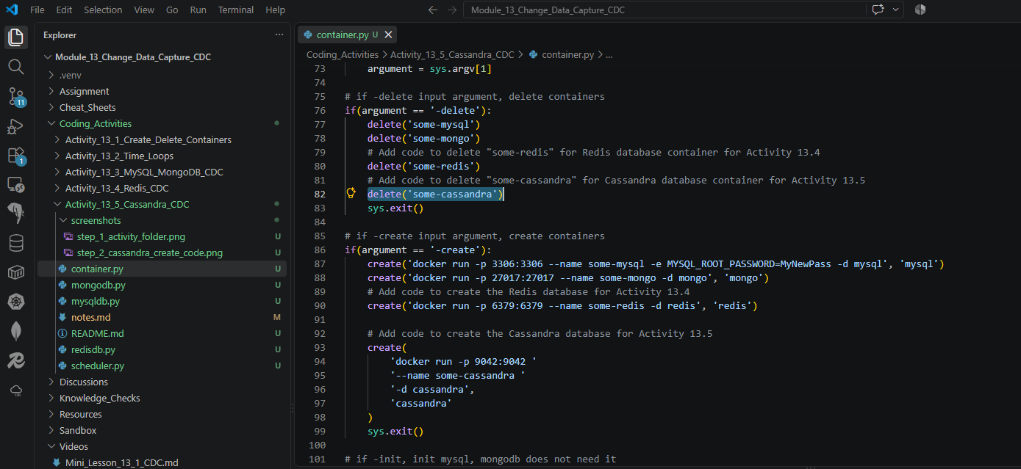

- Provide a screenshot to show that you added a new file called cassandradb.py to the solution.
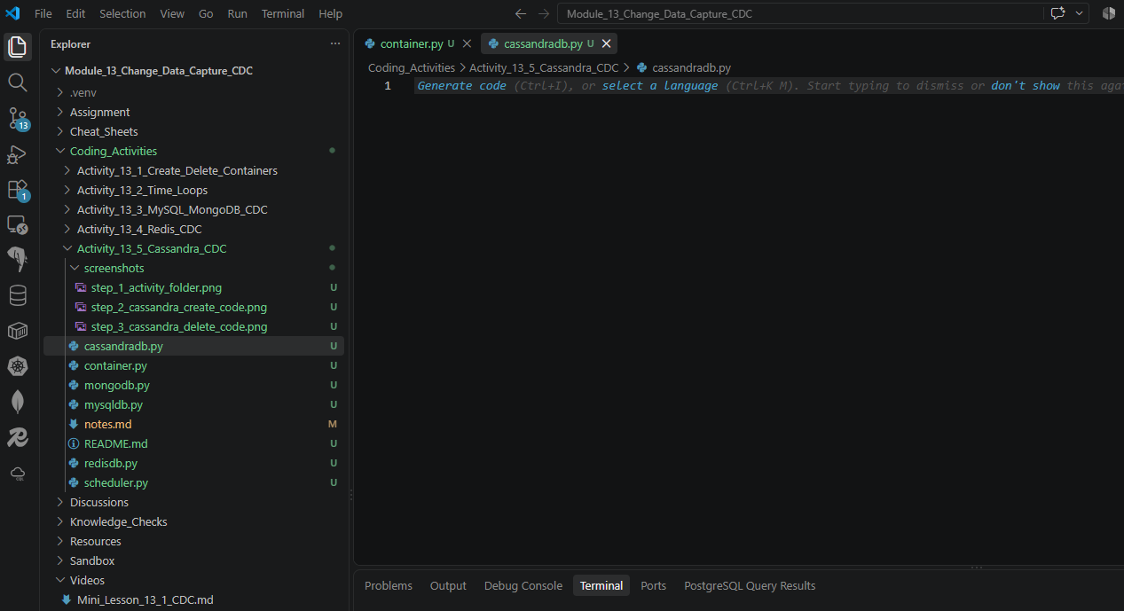

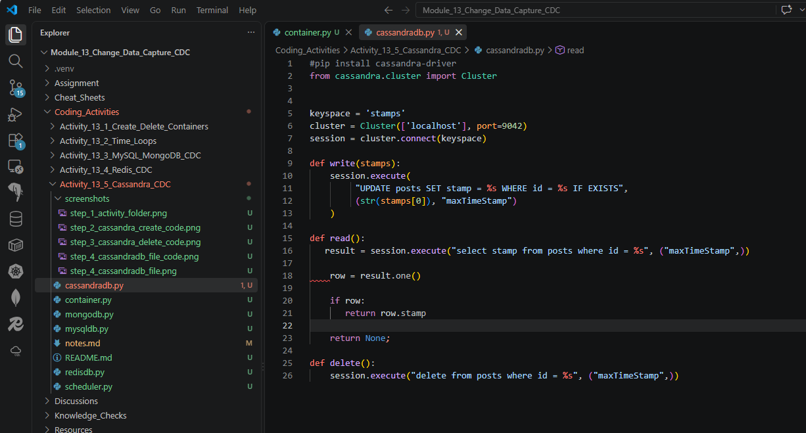

- Provide the following three screenshots to show that you modified the container.py program:
  - Provide a screenshot to show that you removed the comment to import Cluster.
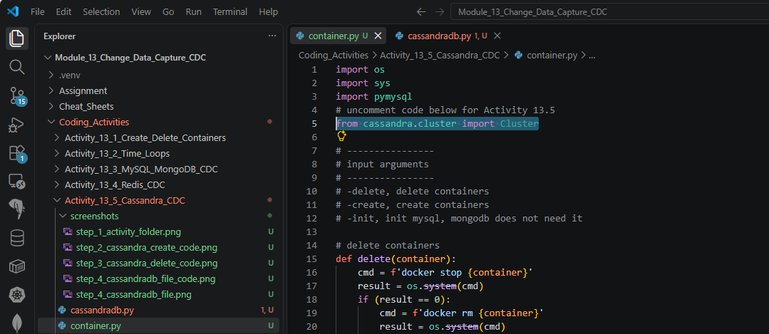

  - Provide a screenshot to show that you copied the init_cassandra() function.
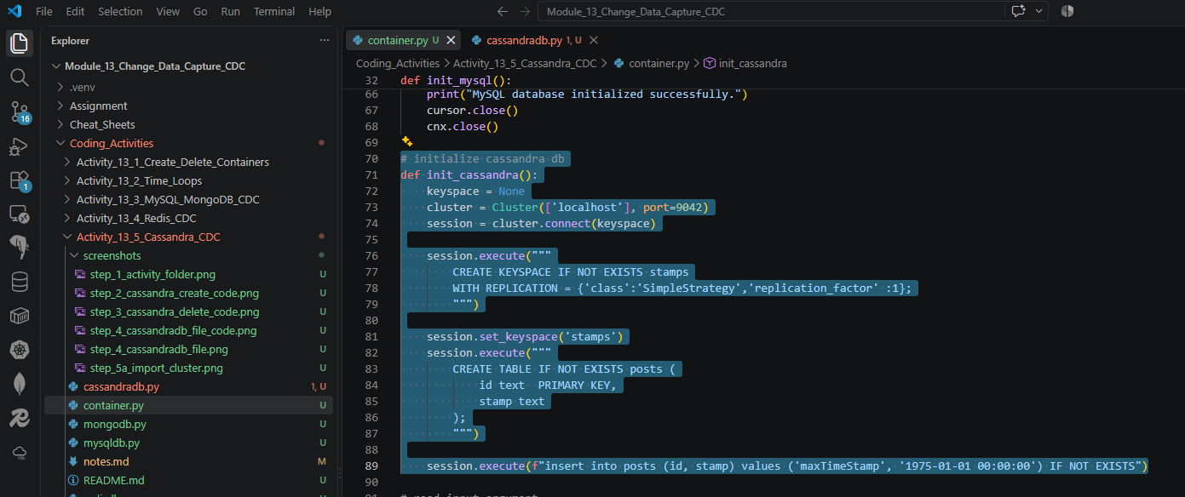

  - Provide a screenshot to show that you added a call to init_cassandra() when -init is passed as a parameter.
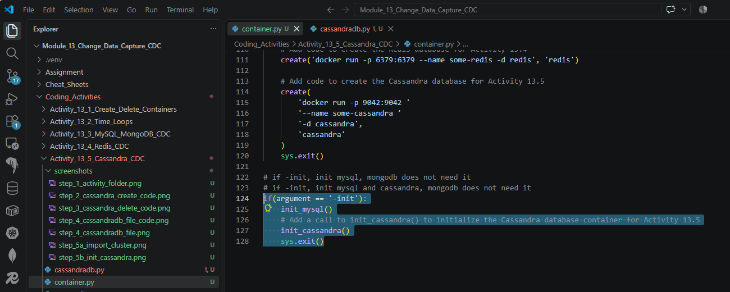

- Provide the following five screenshots to show that you modified the scheduler.py program:
  - Provide a screenshot to show that you uncommented the import statement to import cassandradb.
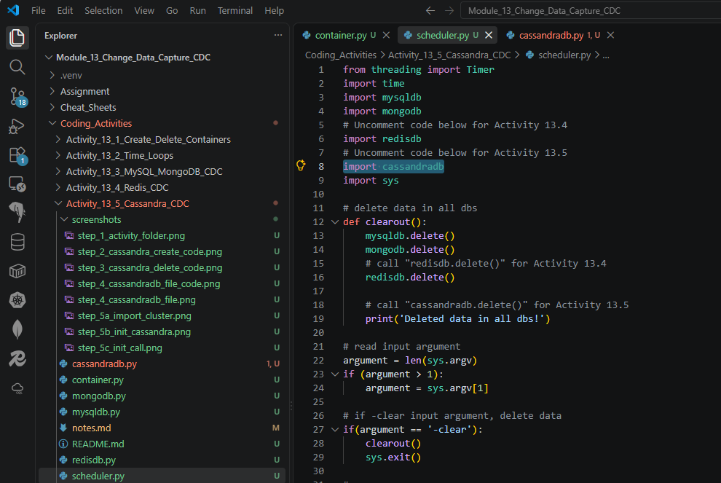

  - Provide a screenshot to show that you made a call to cassandradb.delete() in the clearout() function.
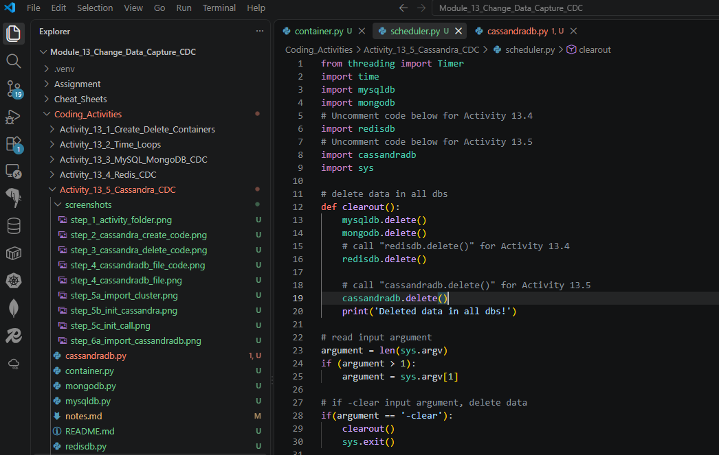

  - Provide a screenshot to show that you added the cassandra() function.
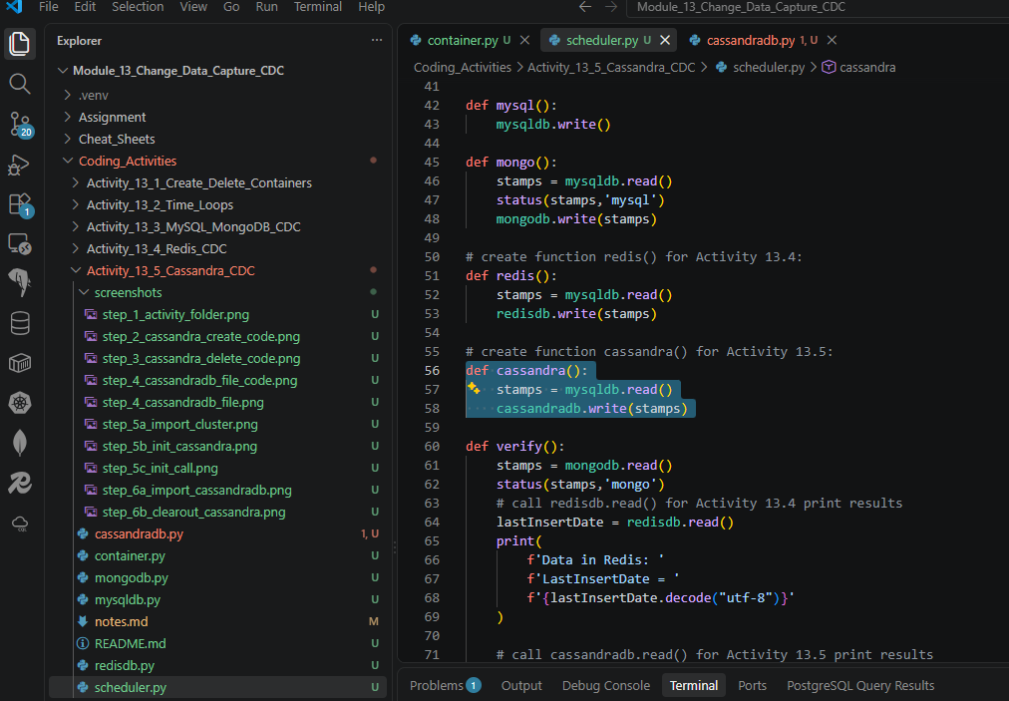

  - Modify the verify()function to read data from Cassandra.
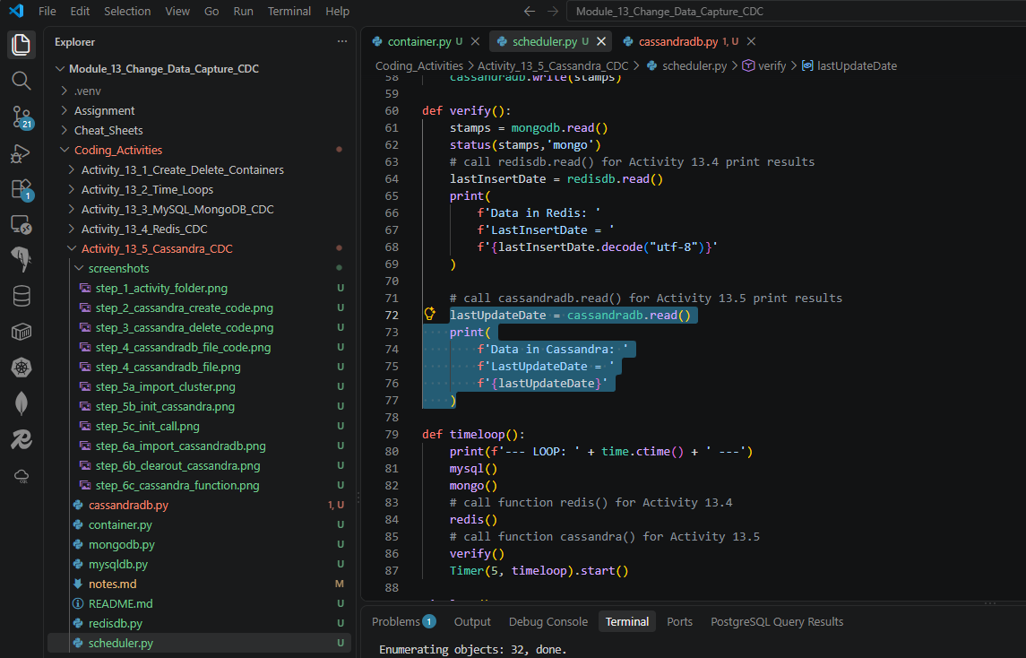

  - Modify the timeloop() function. Add a call to the cassandra() function. Provide a screenshot.
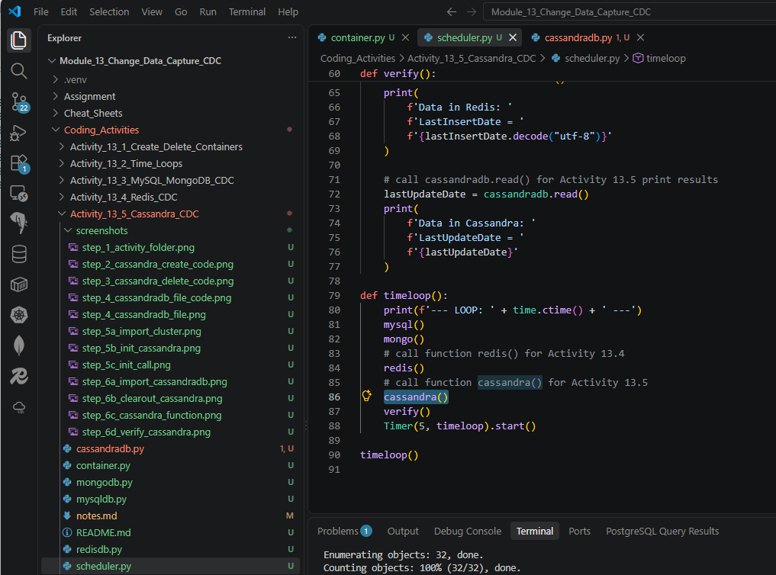

- Provide a screenshot of your command prompt to show that you ran the container.py program passing -create as a parameter.
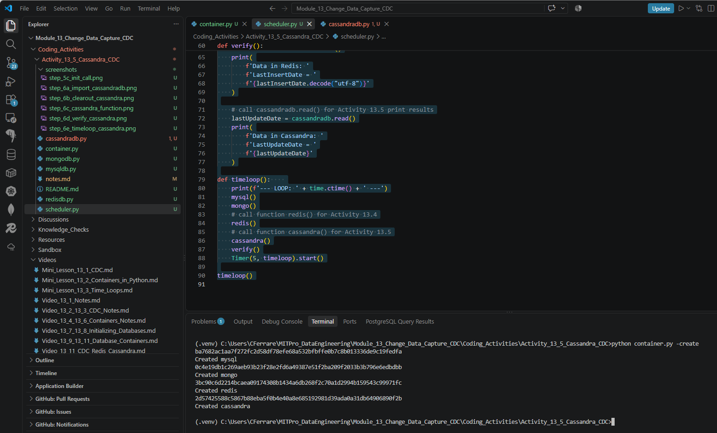

- Provide a screenshot of your Docker desktop that shows all four database containers running.
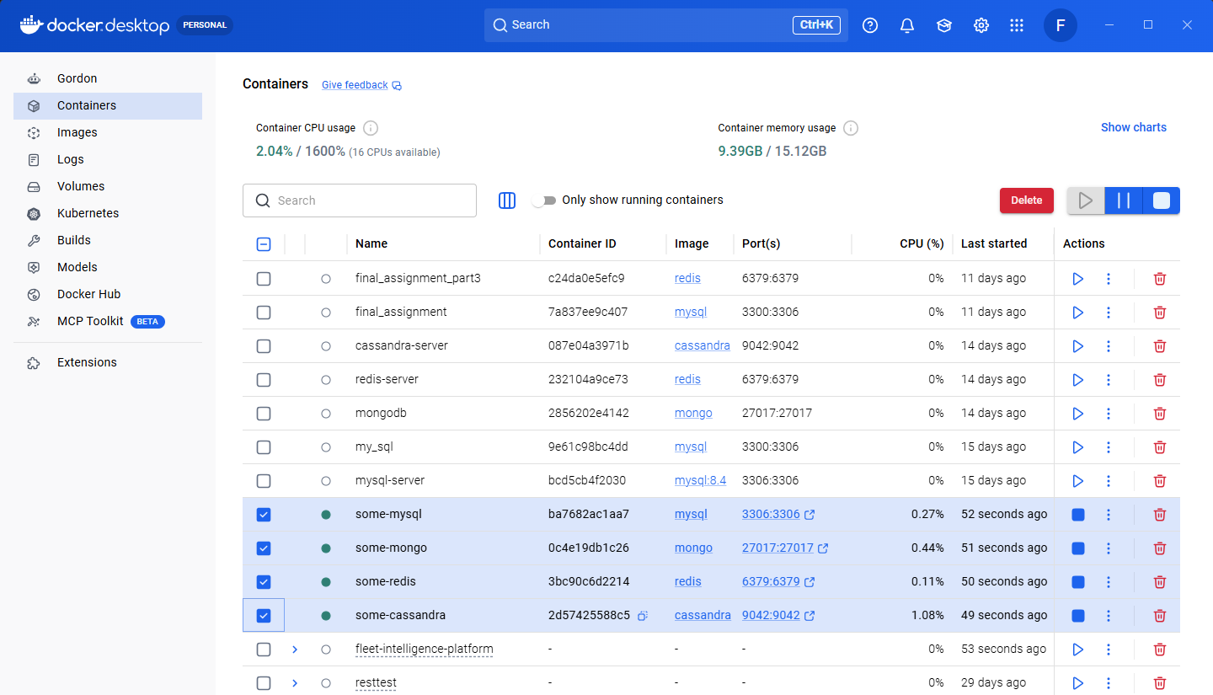

- Provide a screenshot of your command prompt to show that you ran the container.py program passing -init as a parameter.
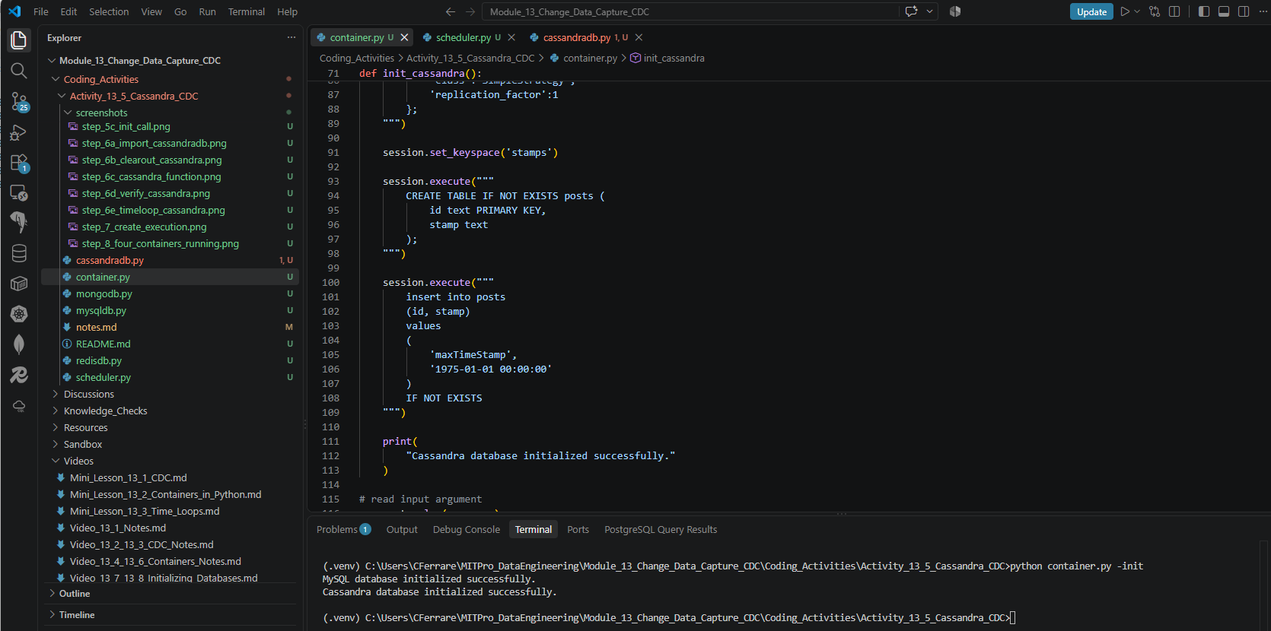

- Provide a screenshot of your command prompt to show that you ran the scheduler.py program.
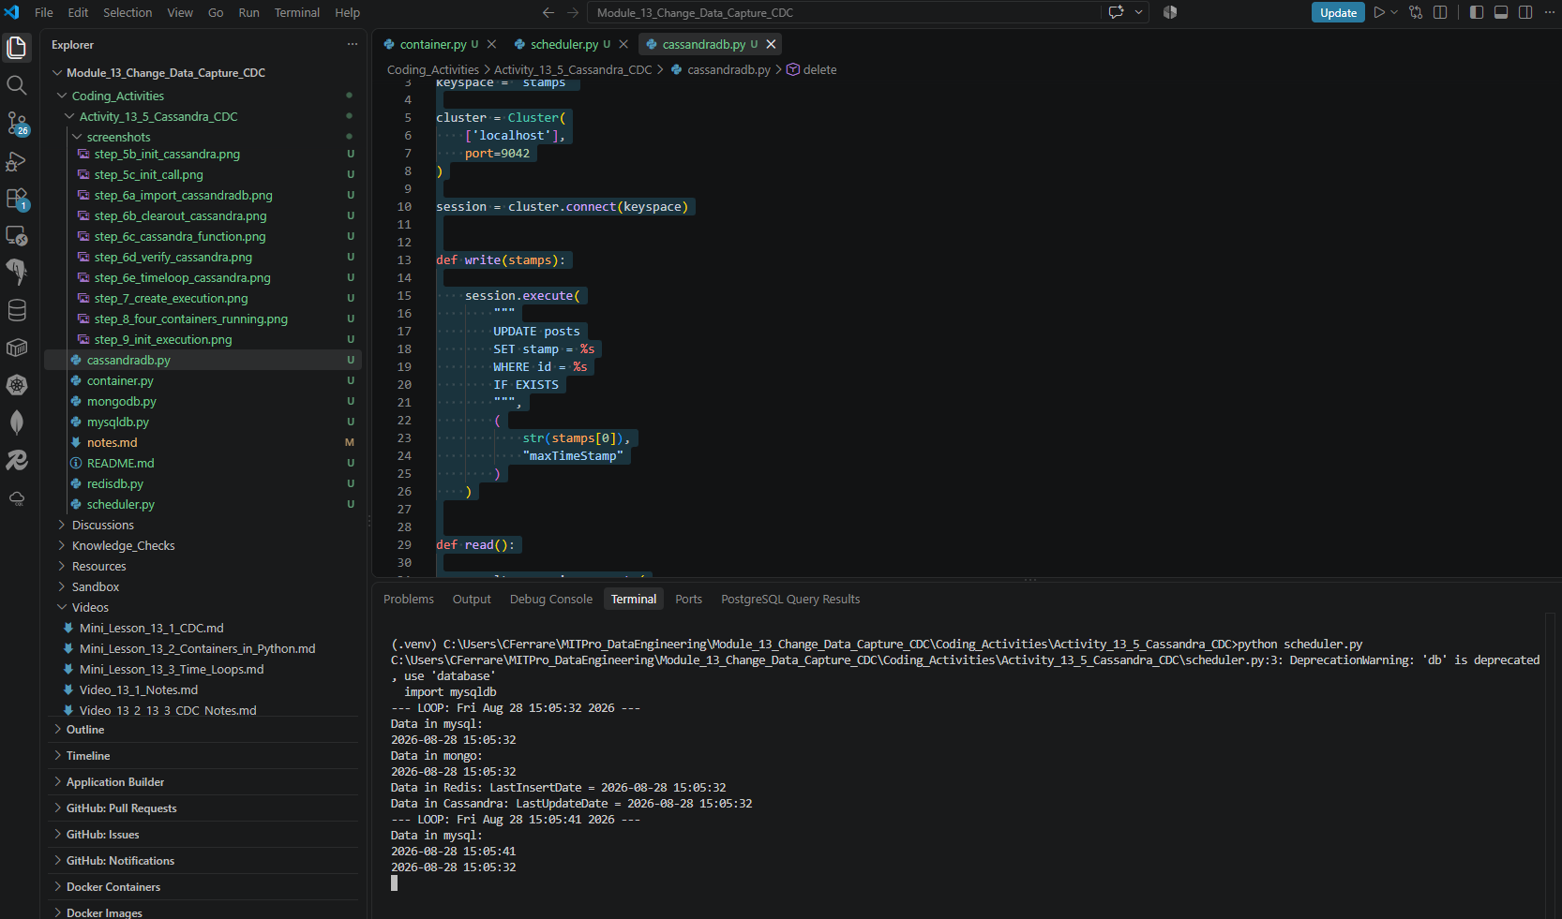

- Provide a screenshot of your command prompt to show that you closed the window running the scheduler.py Python program and ran the container.py program passing -delete as a parameter.
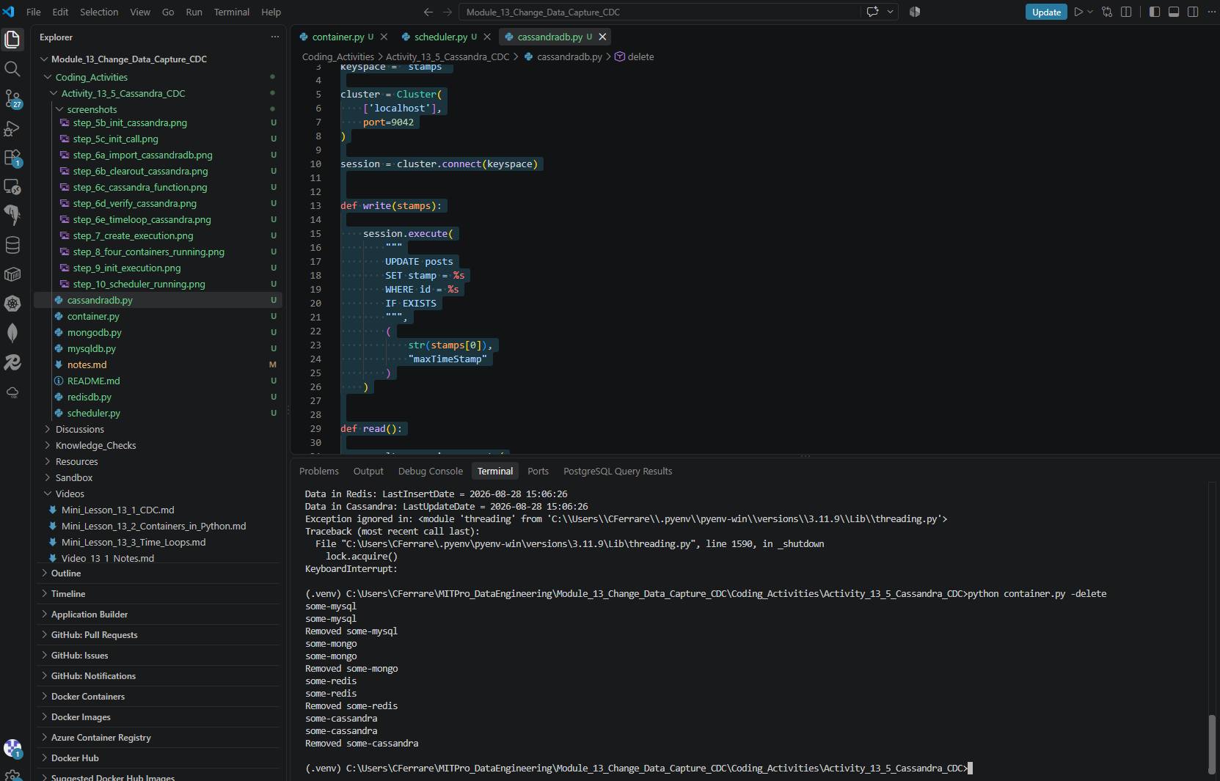

- Provide a screenshot of your Docker desktop to show that all four database containers have been deleted.
