Required Coding Activity 13.3: Performing CDC and Initializing MySQL and MongoDB Containers

- Provide a screenshot of the “Activity13.3” folder with a container.py file in VS Code.
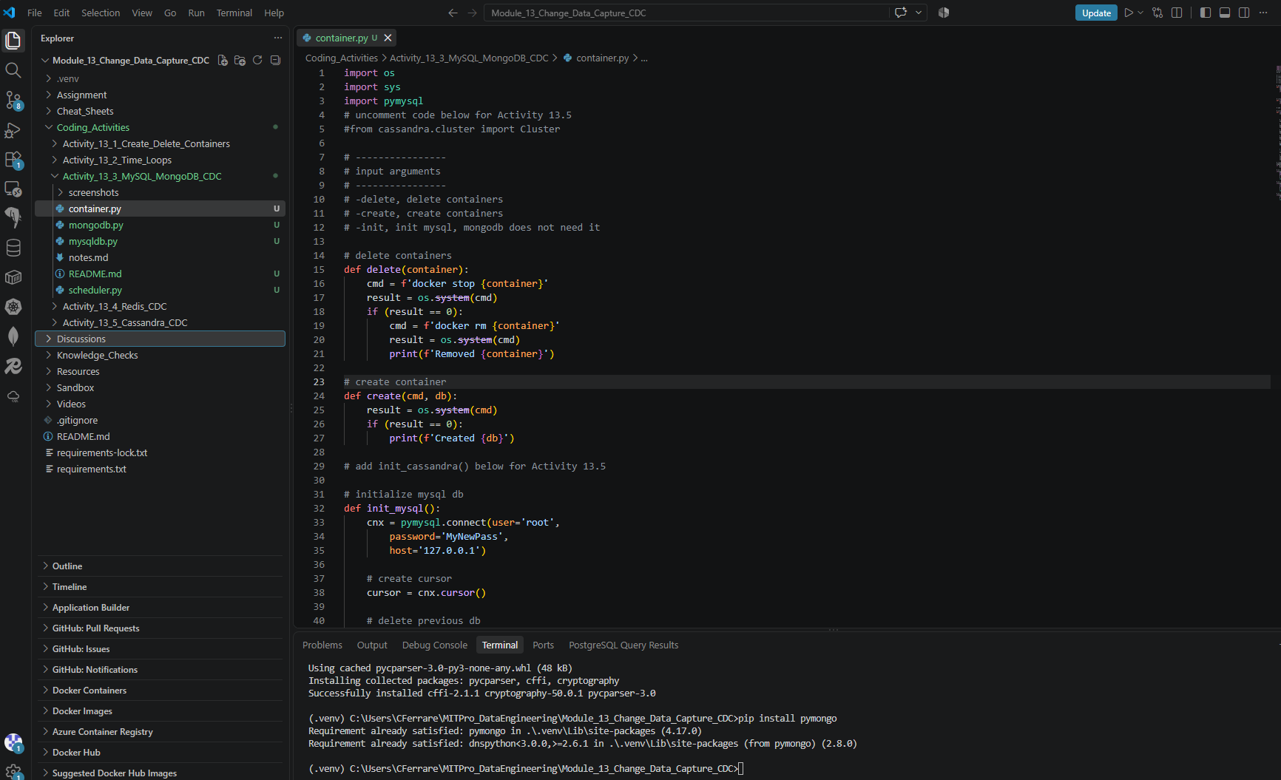

- Provide a screenshot of the command prompt showing that you successfully executed the container.py Python program and passed -create as a parameter.
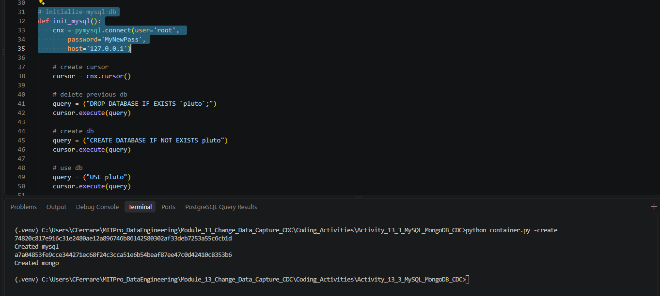

- Provide a screenshot of your Docker desktop showing the two containers, MySQL and MongoDB, running.
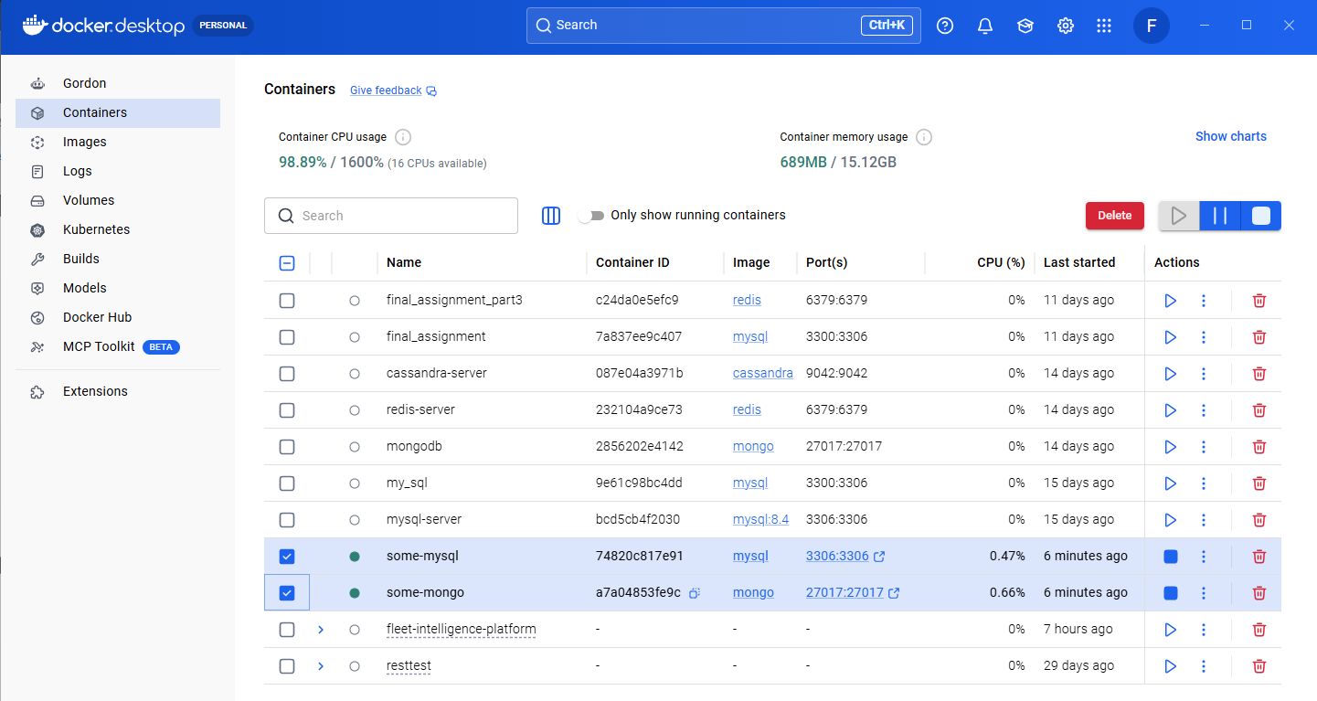

- Provide a screenshot to show that you successfully created the mysqldb.py file.
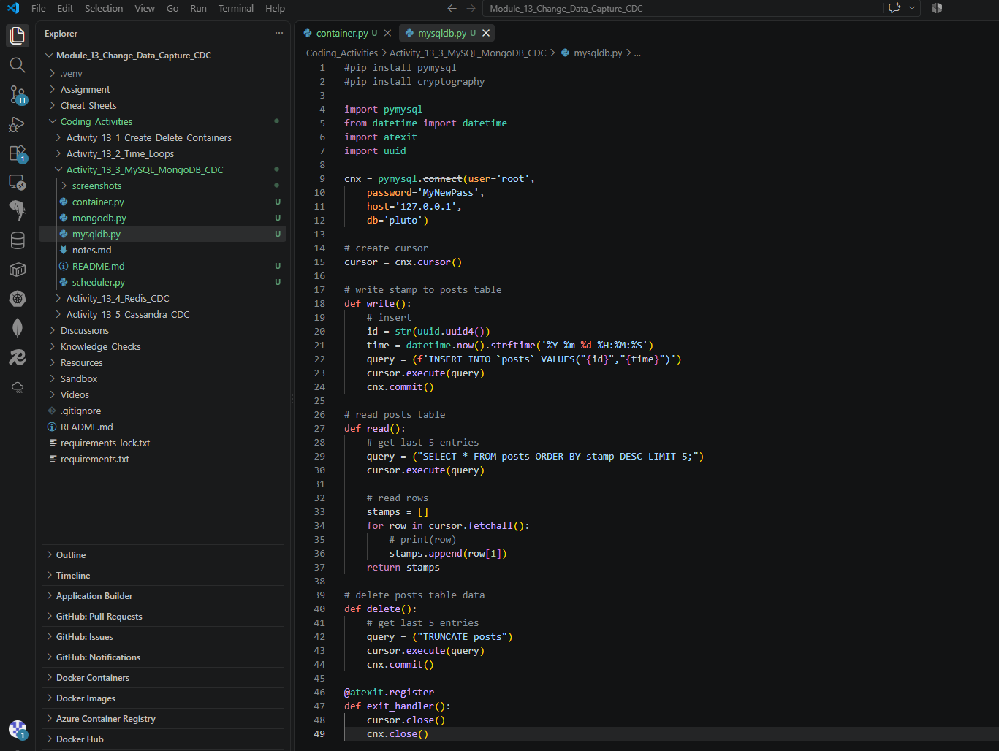

- Provide a screenshot to show that you successfully created the mongodb.py file.
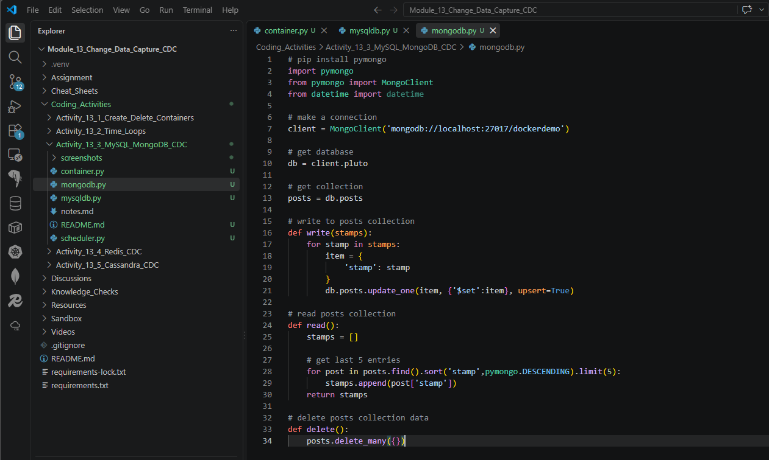
- Provide a screenshot to show that you successfully created the scheduler.py file.
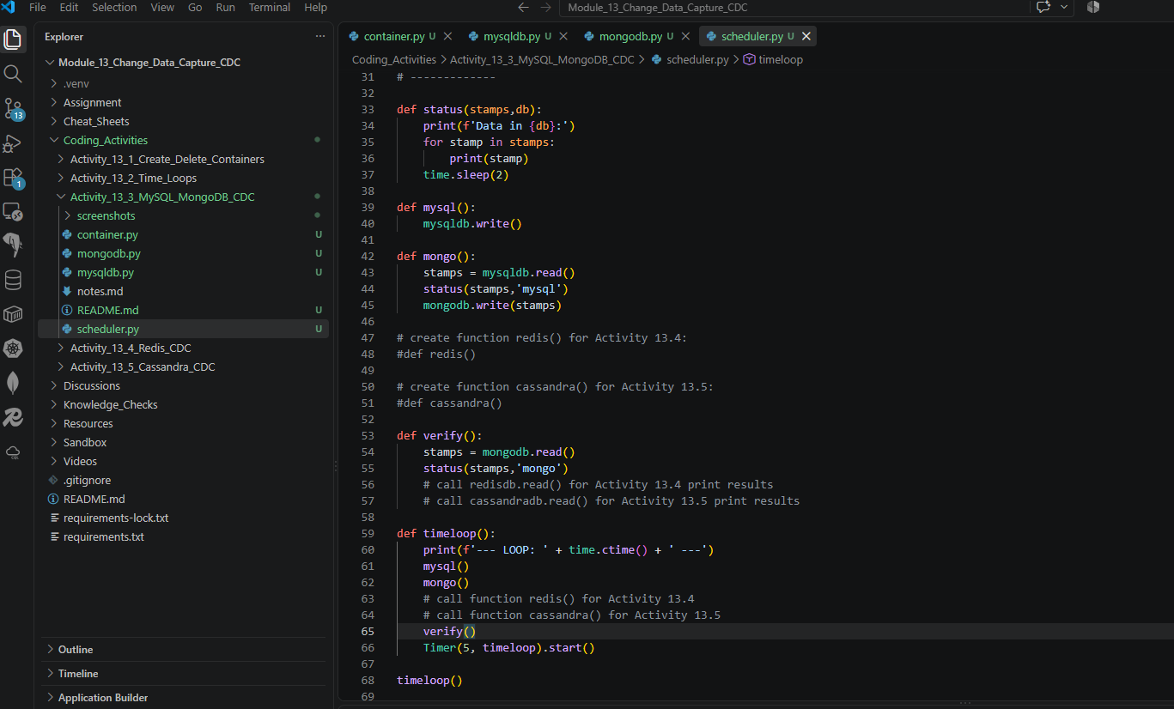

- Provide a screenshot of the command prompt showing that you successfully executed the container.py Python program and passed -init as a parameter to initialize your databases.
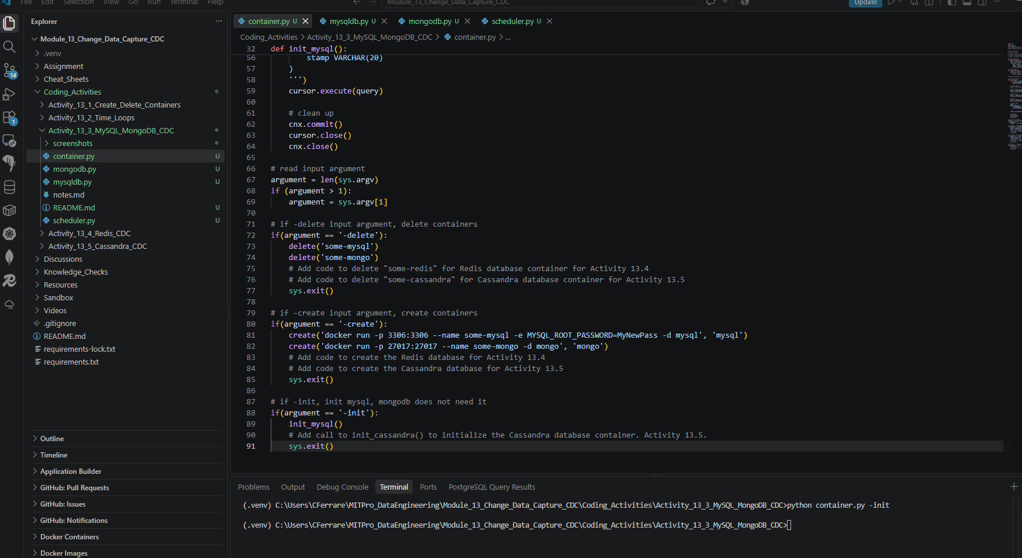

Pluto database created:
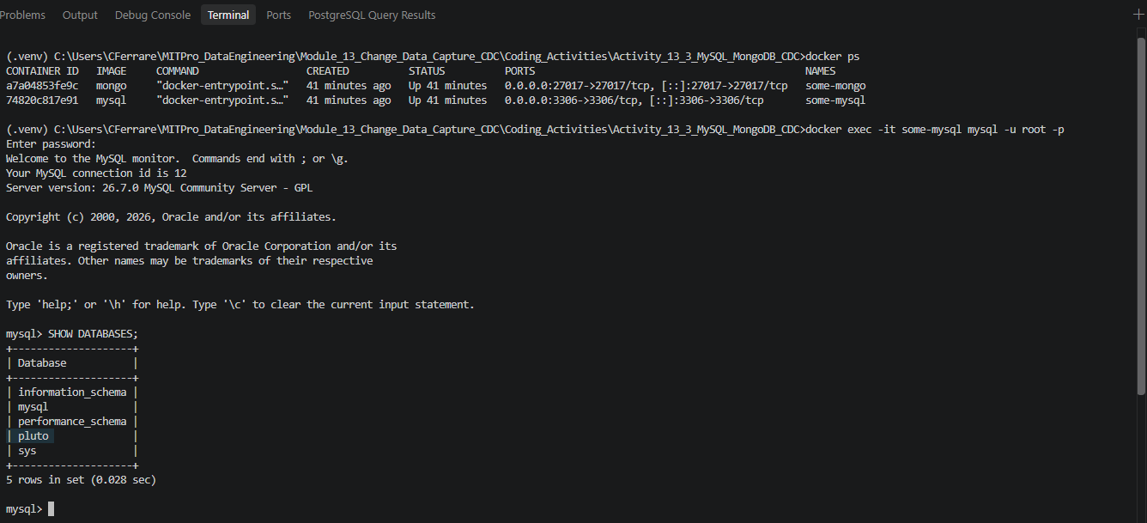

Posts table created:
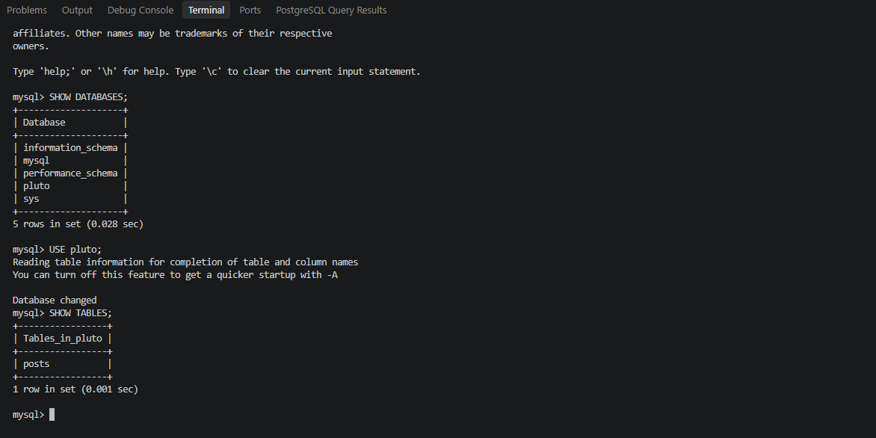

Verify table structure:
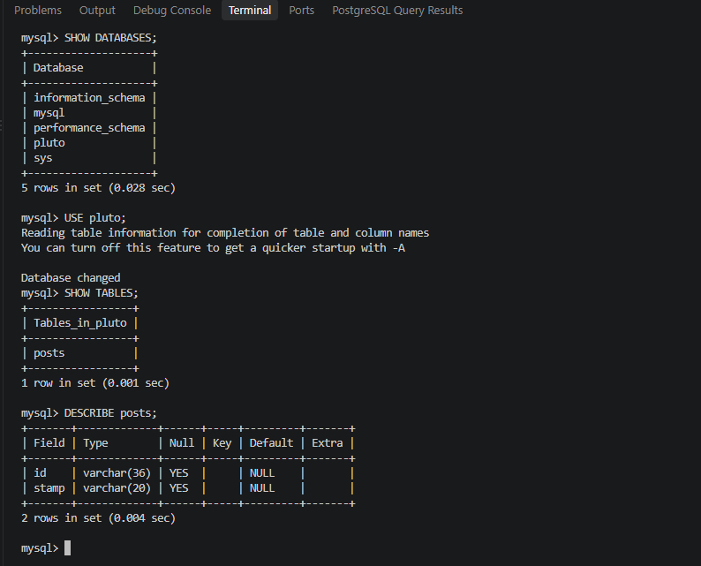

- Provide a screenshot of your Terminal window showing the scheduler.py program running.
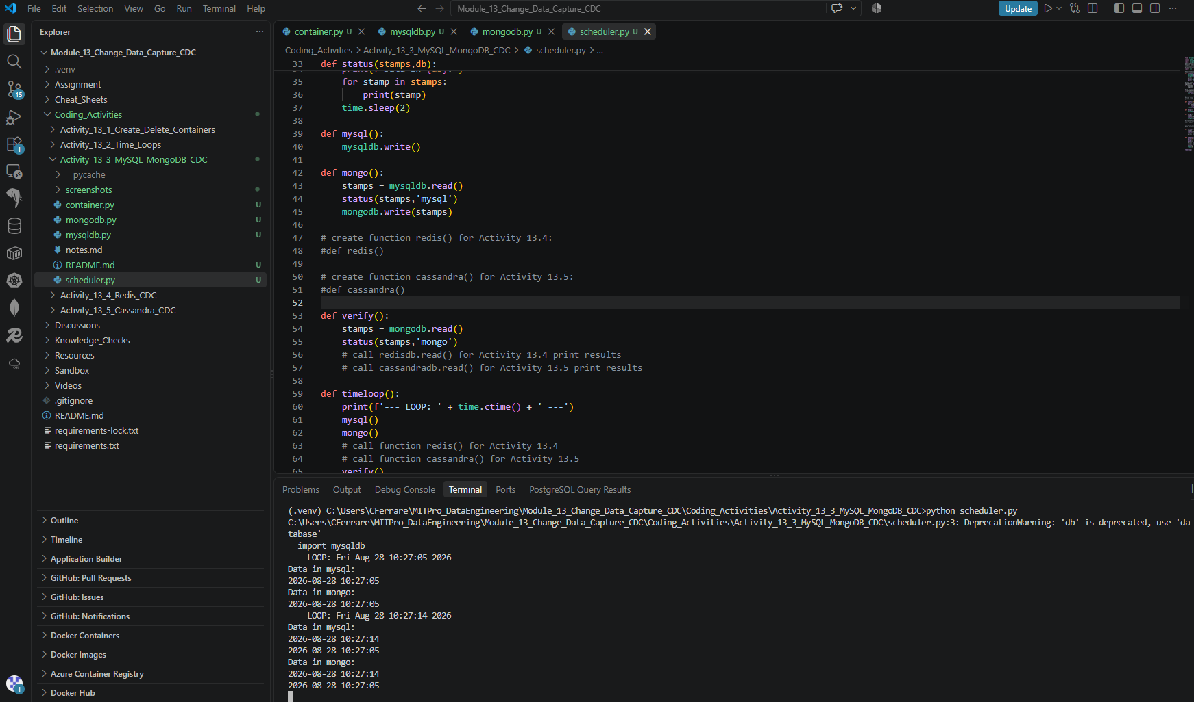

- Provide a screenshot to show that you successfully stopped the scheduler.py program by closing the command prompt window and ran the container.py command from the command prompt passing -delete as a parameter.
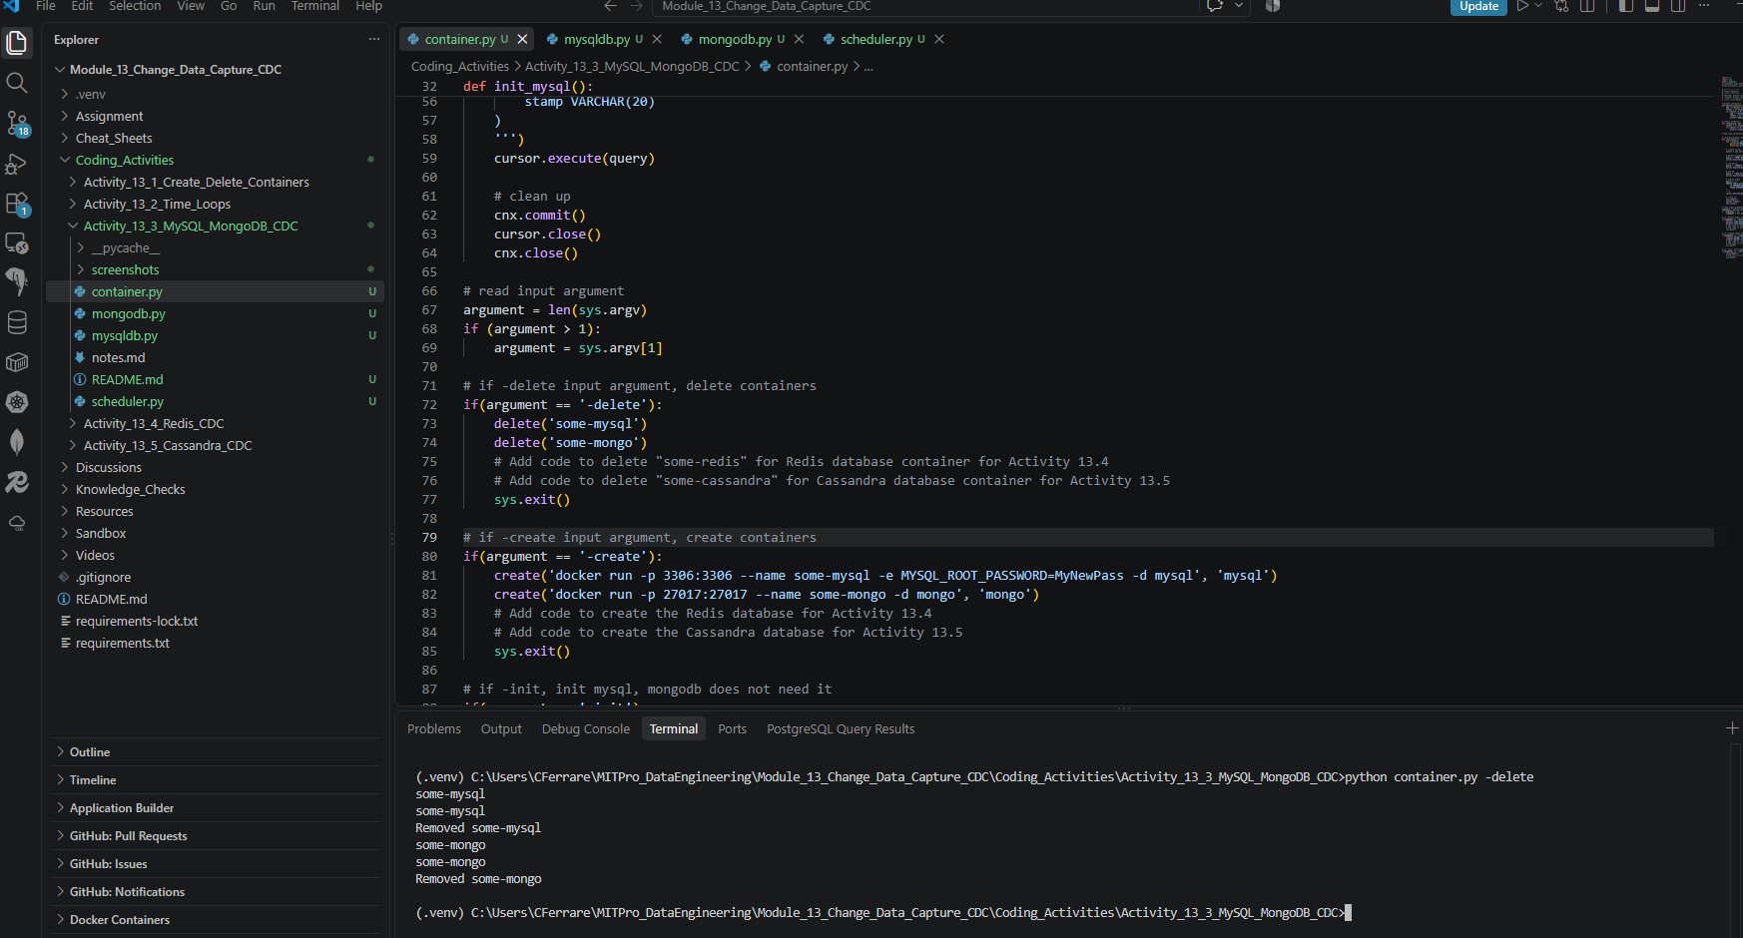

- Provide a screenshot of the Docker desktop showing that both database containers have been removed.
