Required Coding Activity 13.4: Performing CDC and Initializing a Redis Database Container

- Provide a screenshot of the Activity13.4 folder in VS Code.
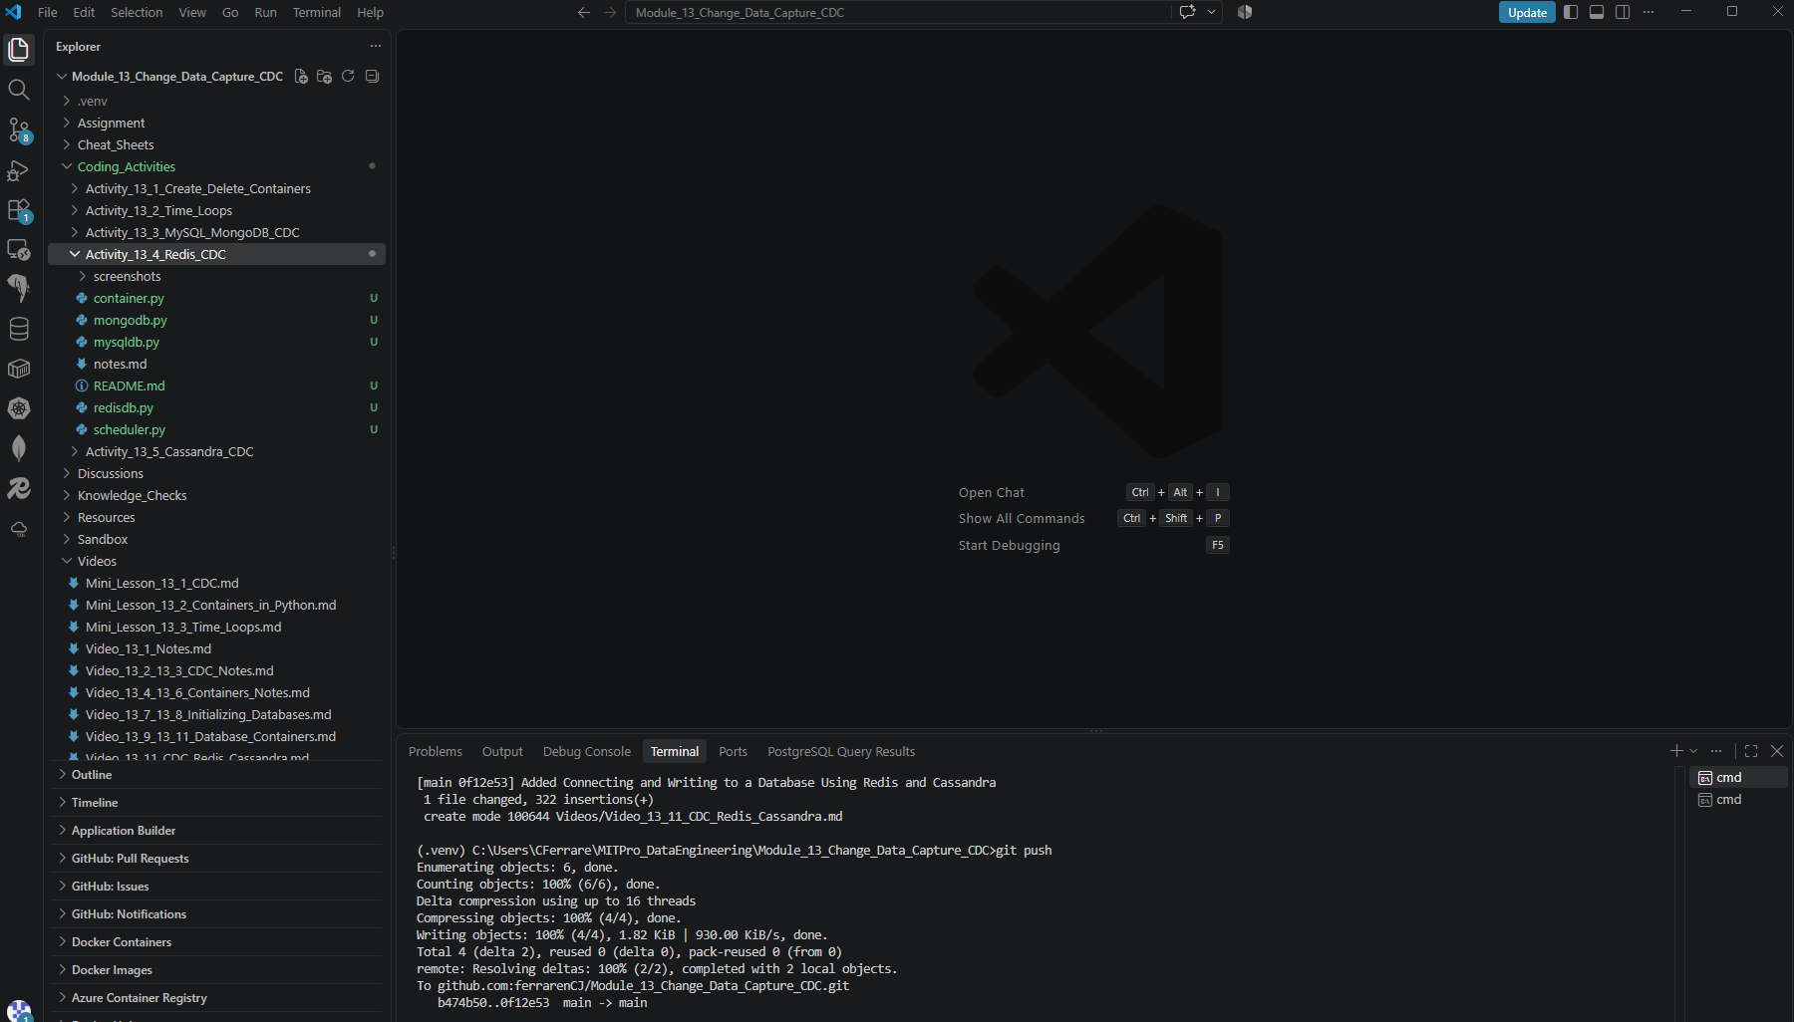
- Provide a screenshot to show that you successfully added the code to create a Redis database container.
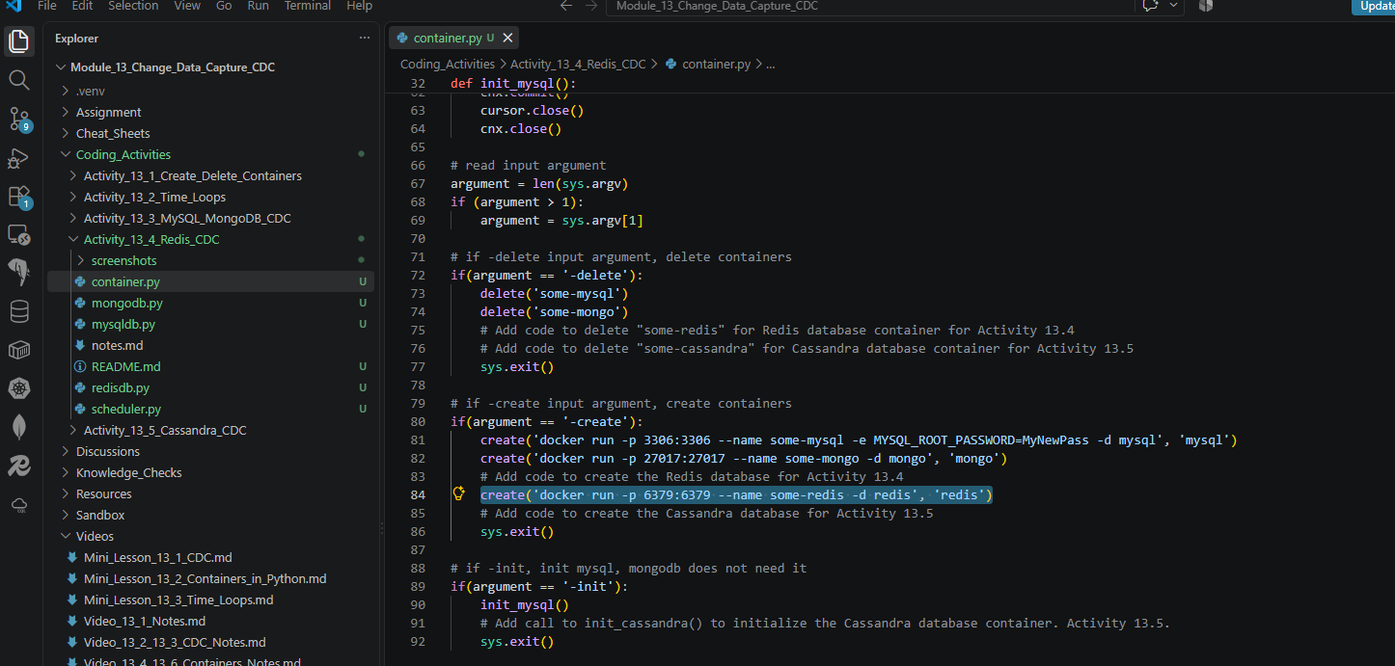
- Provide a screenshot of the command prompt to show that you successfully executed the container.py Python program and passed -create as a parameter.
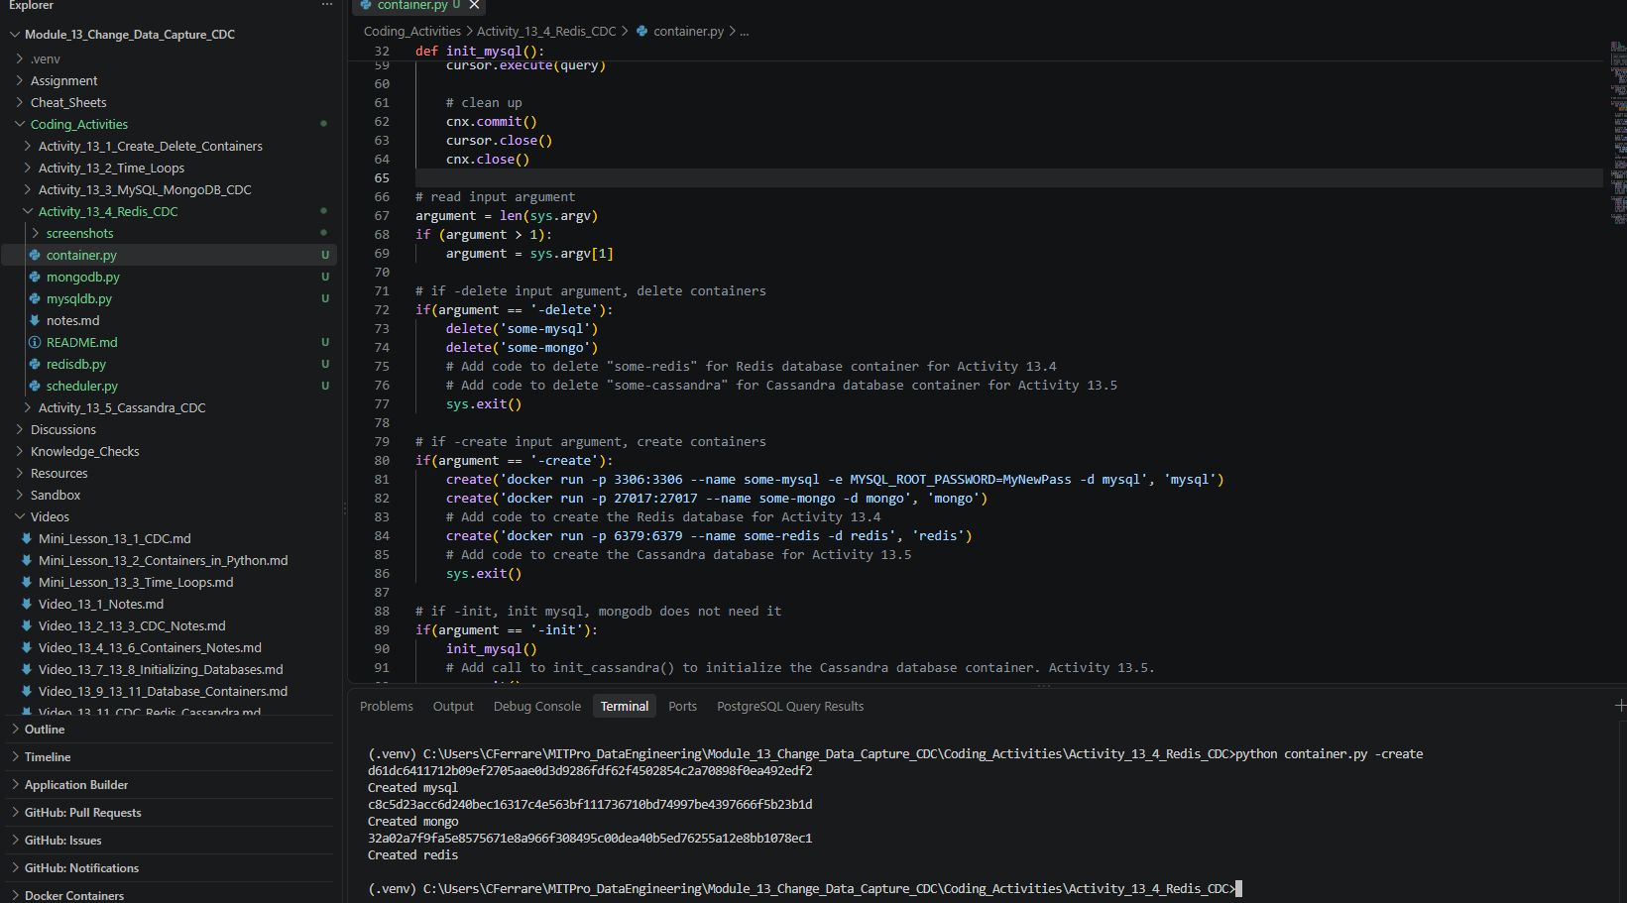
- Provide a screenshot of your Docker desktop to show that the three containers (MySQL, MongoDB, and Redis) are running.
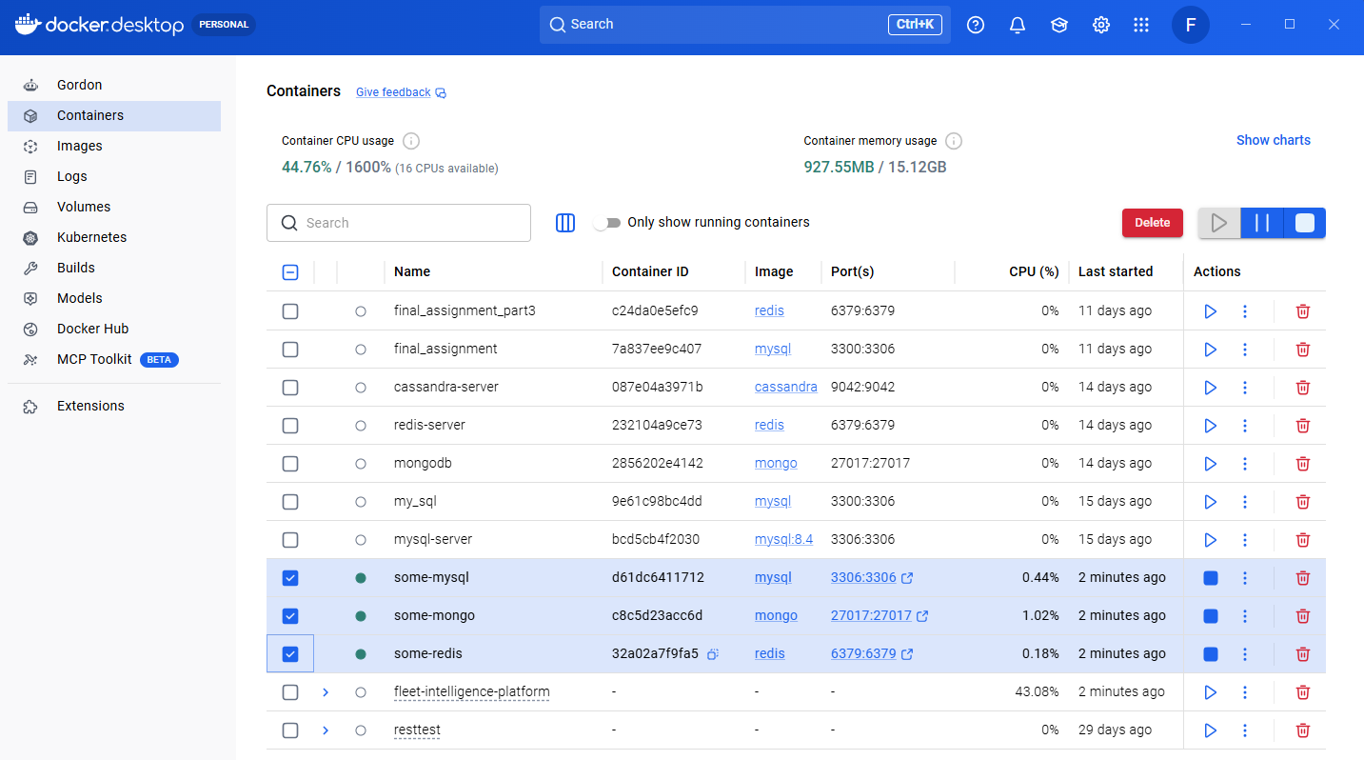

- Provide a screenshot of the command prompt to show that you successfully executed the container.py Python program and passed -init as a parameter to initialize your databases.
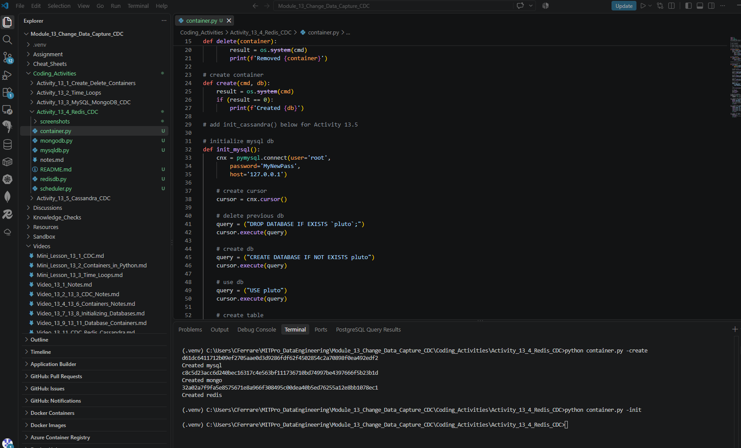

- Provide a screenshot to show that you added the code to delete the Redis database container.
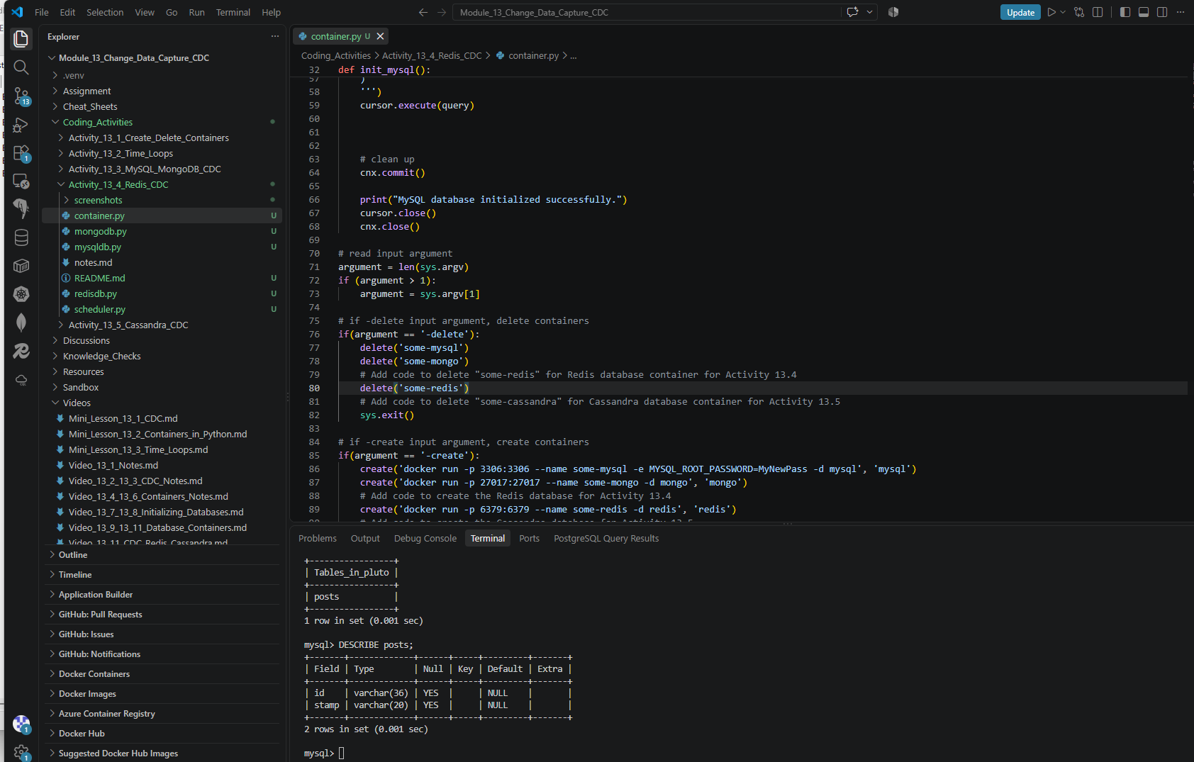

- Provide a screenshot to show that you created a new file called redisdb.py.
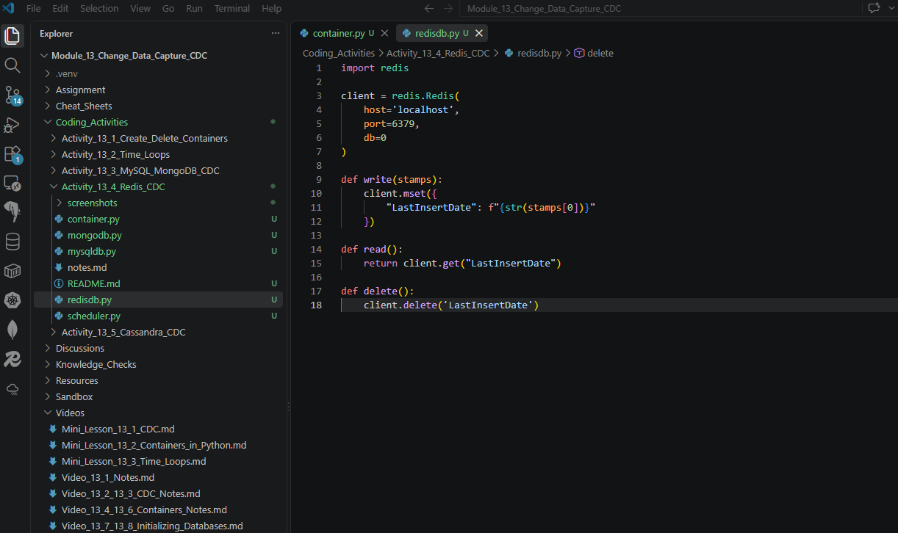

- Provide the following five screenshots to show that you modified the scheduler.py program:
  - Provide a screenshot to show that you uncommented the line to import redisdb to add the redisdb.py Python program to the scheduler.
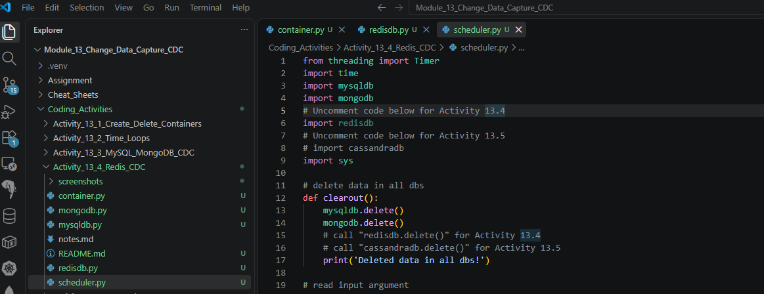

  - Provide a screenshot to show that you added a call to redisdb.delete() for the clearout()function.
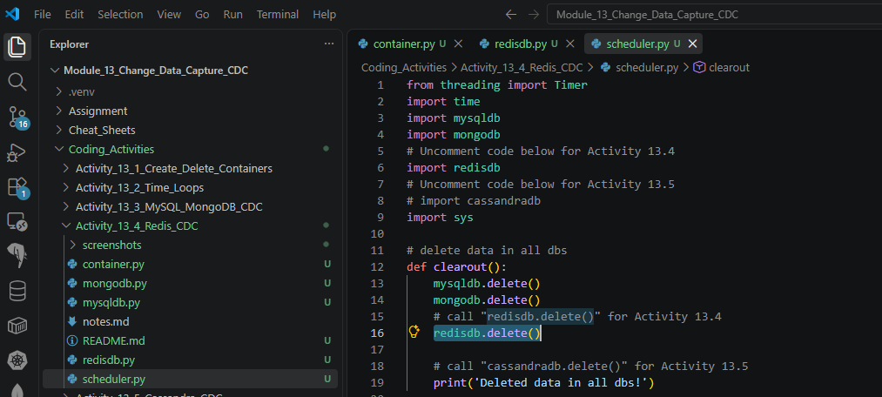

  - Provide a screenshot to show that you created a function called redis().
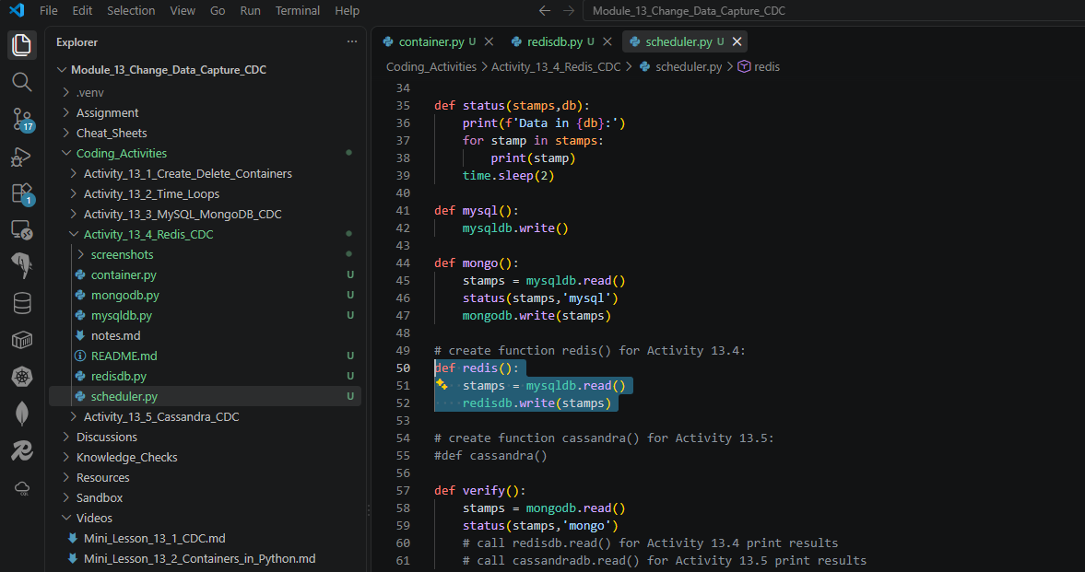

  - Provide a screenshot to show that you modified the verify() function, added a call to read data from Redis to get the Last Insert Date from the Redis database container, and printed it to the console.
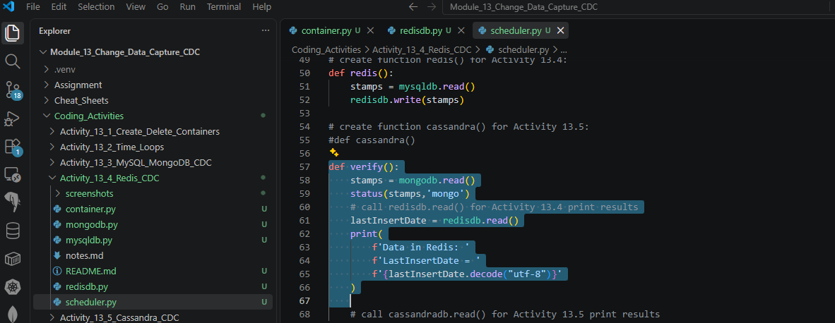

  - Provide a screenshot to show that you modified the timeloop() function and added a call to redis().
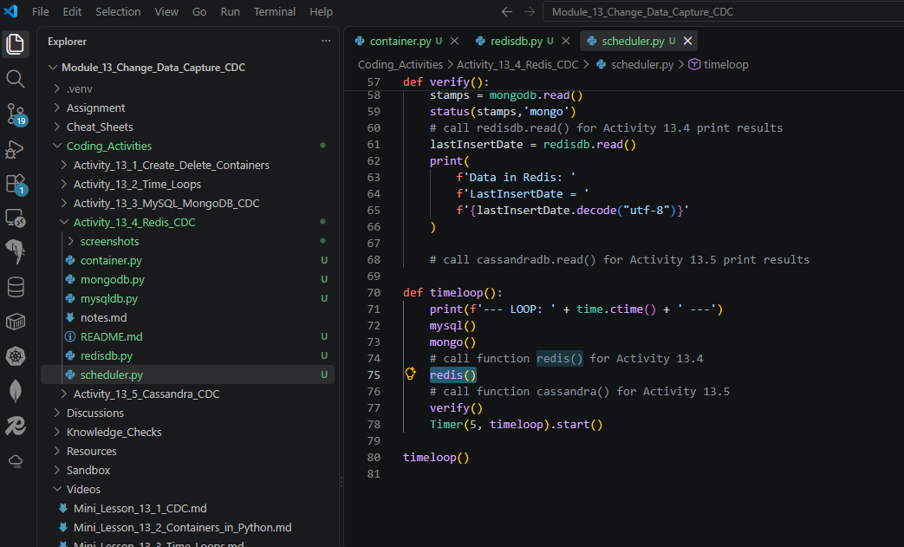

- Provide a screenshot of the command prompt showing the output of the scheduler.py program.
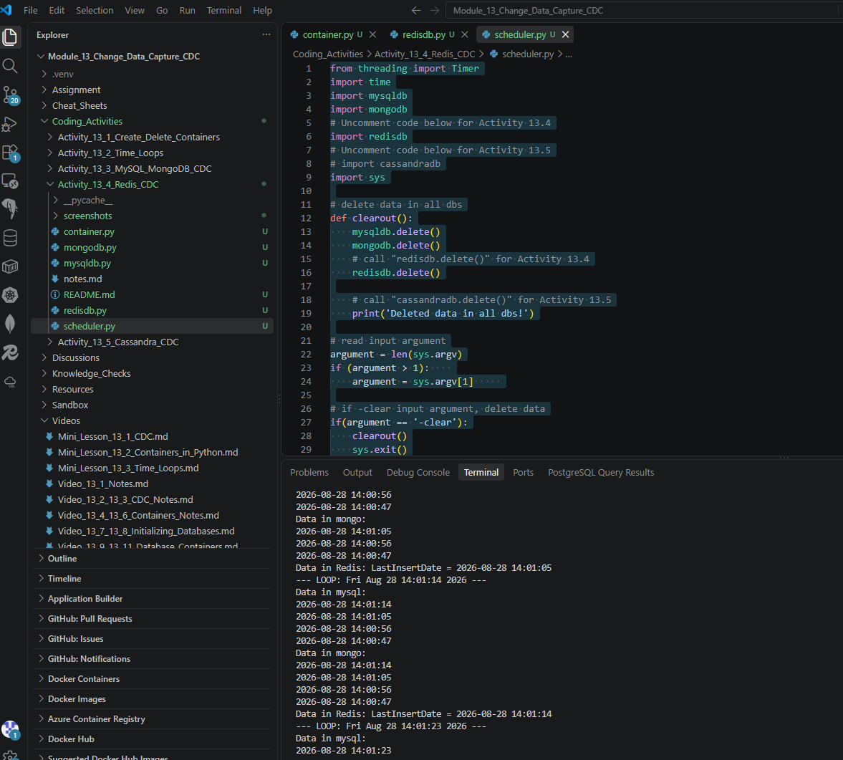

- Provide a screenshot of the command prompt showing that you successfully ran the container.py command passing the -delete parameter.
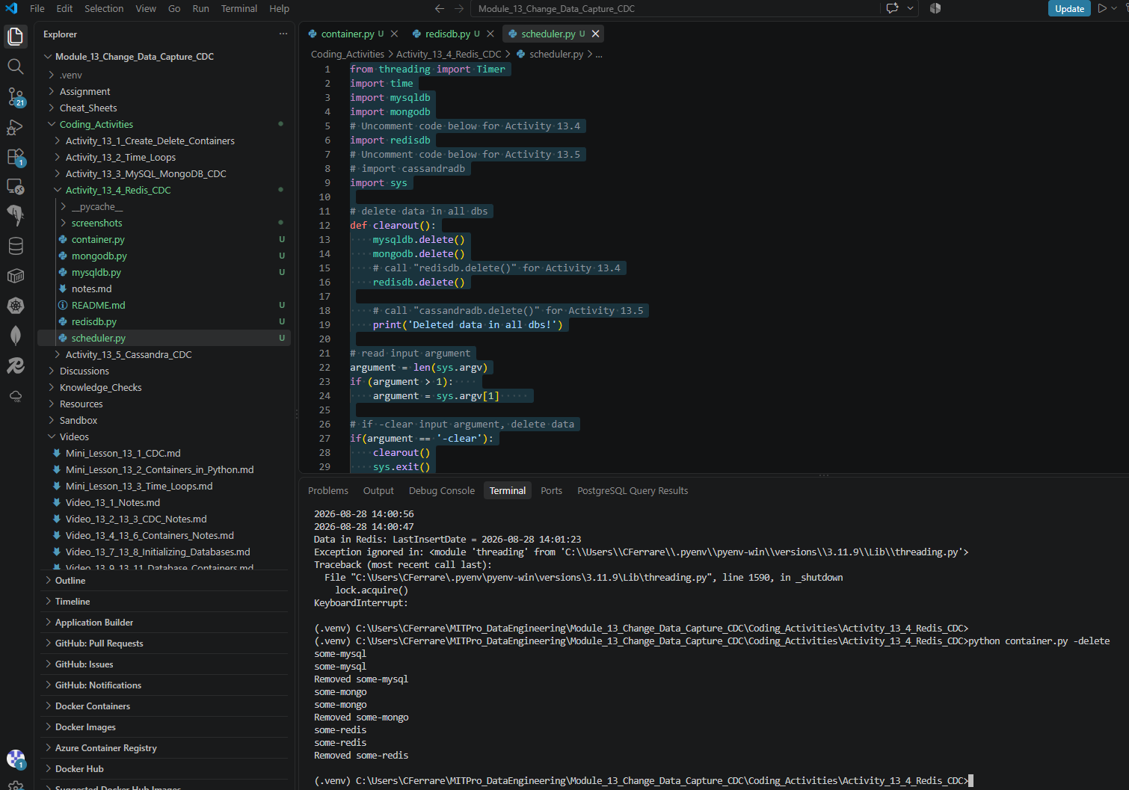

- Provide a screenshot of your Docker desktop showing that all three database containers have been removed.
