Required Coding Activity 13.1: Creating and Deleting Containers Using Python
- Provide a screenshot of the container.py file in VS Code.
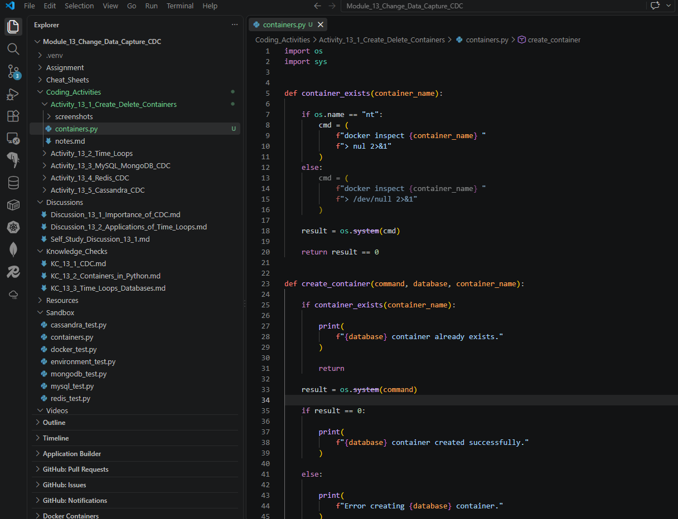

- Provide a screenshot that shows you have run the container.py file from the Terminal window and passed the -create argument as a parameter.
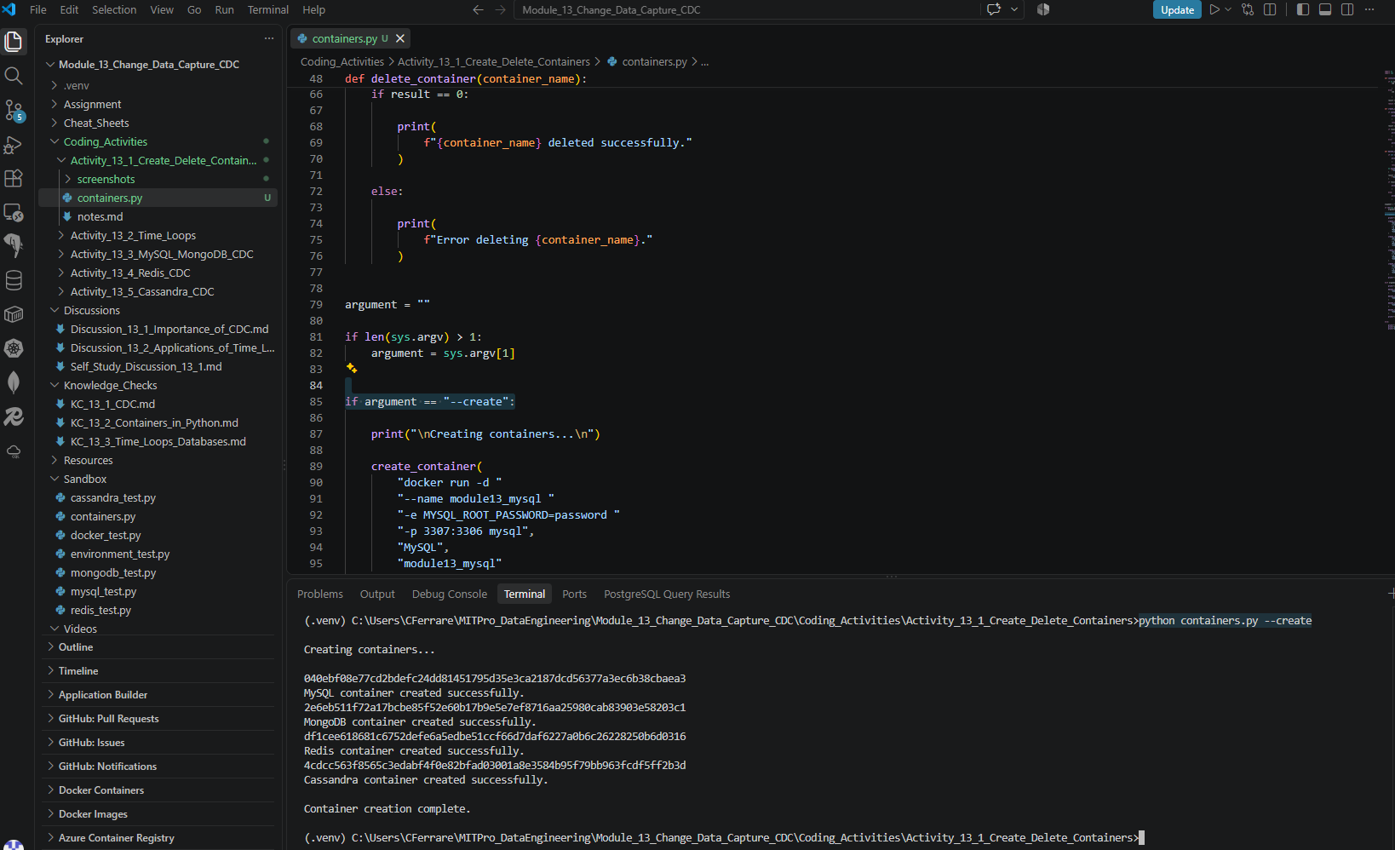

- Provide a screenshot of your Docker desktop that shows MySQL running.
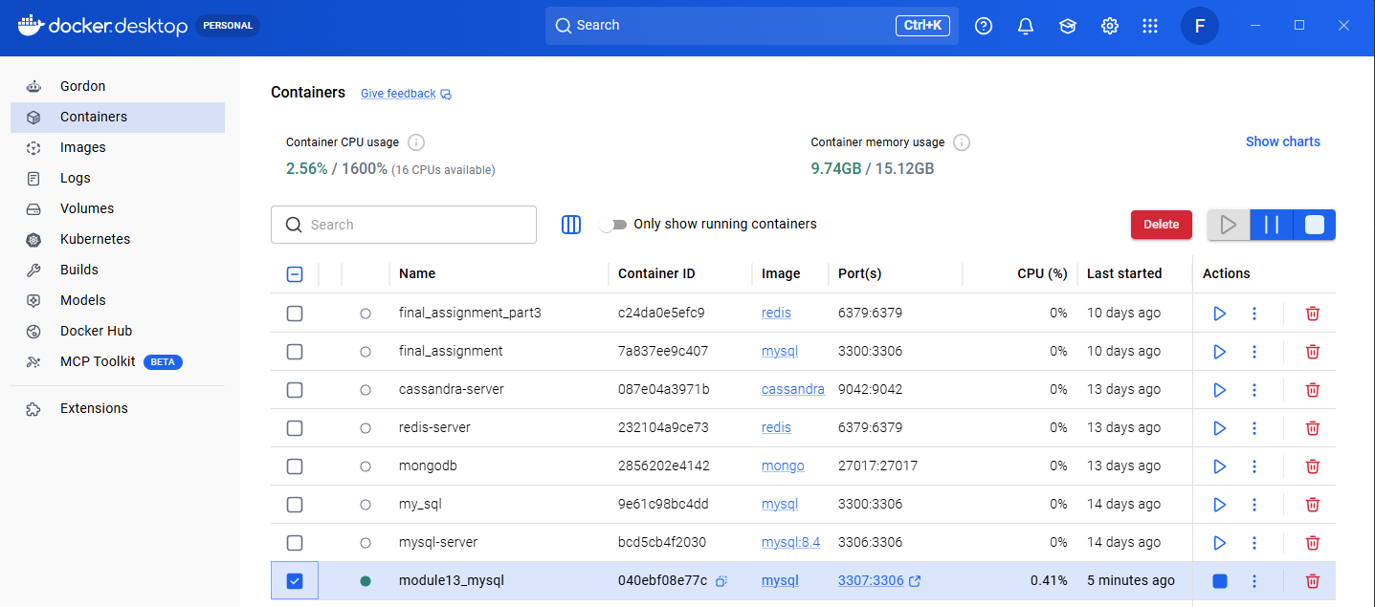

- Provide a screenshot of the command prompt output when you run the code to delete the MySQL container and run the containers.py Python program from the Terminal window by passing -delete as a parameter.

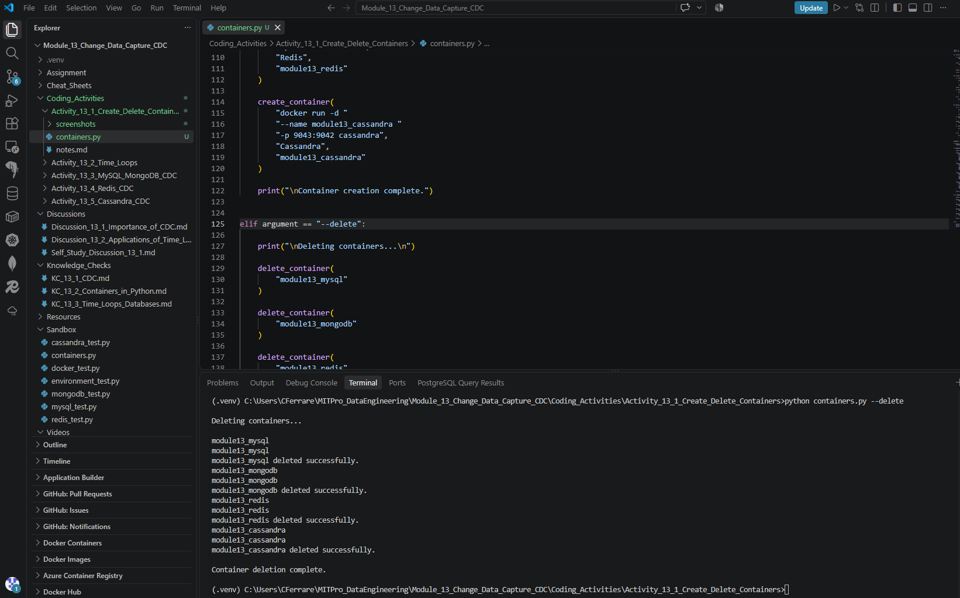

- Provide a screenshot of your Docker desktop to show that the MySQL container has been deleted.
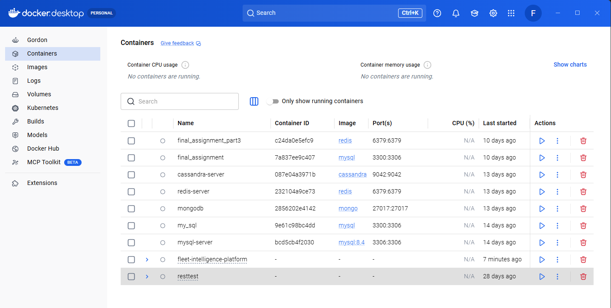

- Provide a screenshot to show that you have included the code to create the other database containers in MongoDB, Redis, and Cassandra.
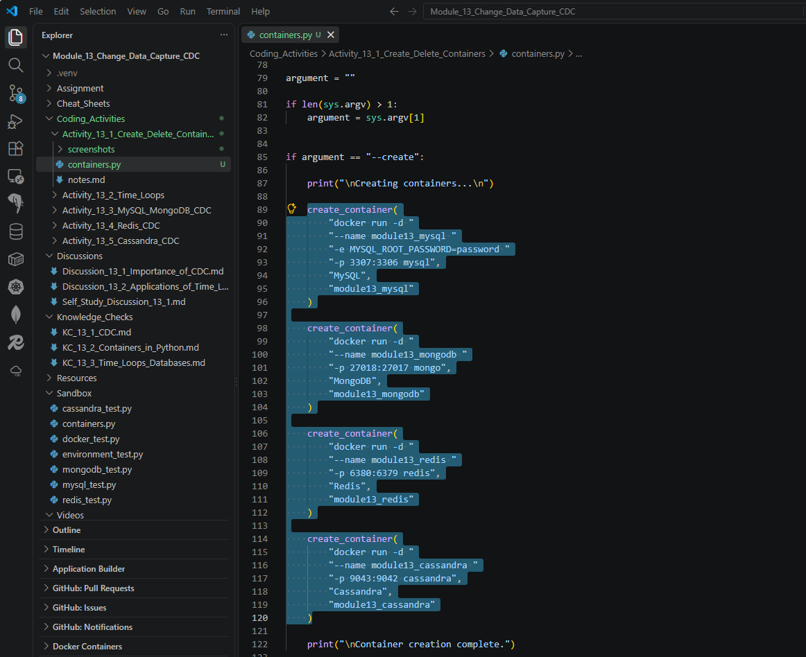

- Provide a screenshot of the command prompt output to show that you have run the containers.py Python program from the Terminal window passing -create as a parameter.
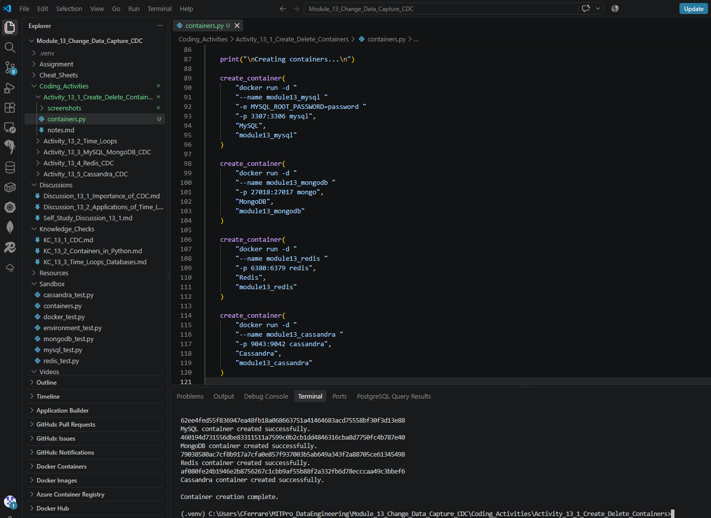

- Provide a screenshot of your Docker desktop showing that the four database containers are running.
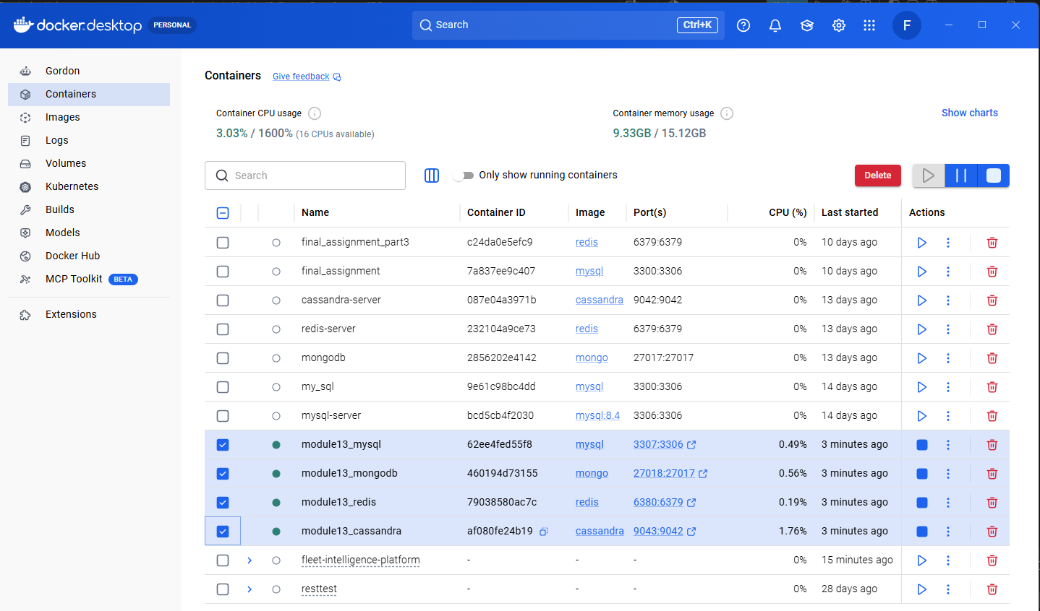

- Provide a screenshot of VS Code after including the code to delete the three database containers for MongoDB, Redis, and Cassandra to show that you added the calls to delete these three databases.
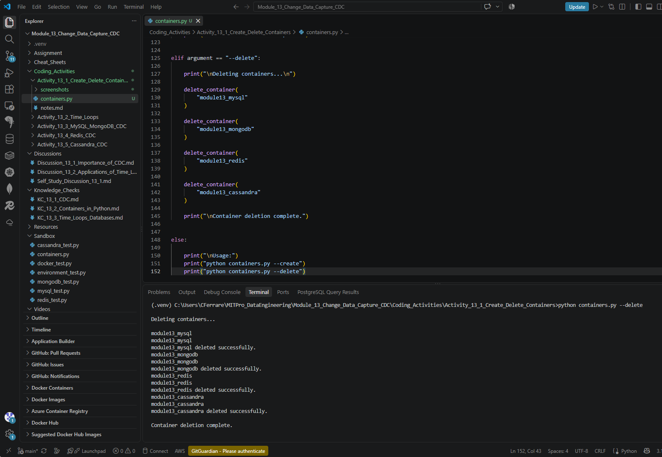

- Provide a screenshot of the command prompt output to show that you have successfully run the containers.py Python program from the Terminal window passing -delete as a parameter.
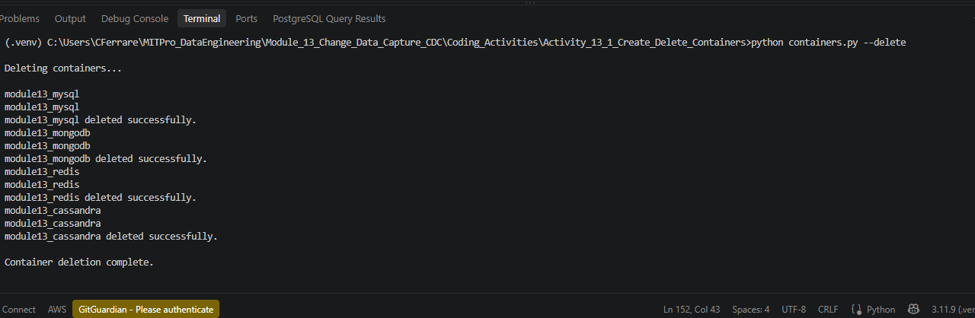

- Provide a screenshot of your Docker desktop showing that all the database containers have been deleted.
