Required Coding Activity 13.2: Implementing Time Loops

- Provide a screenshot from VS Code to show that you created a time_loop.py file within the “Activity 13.2” folder.
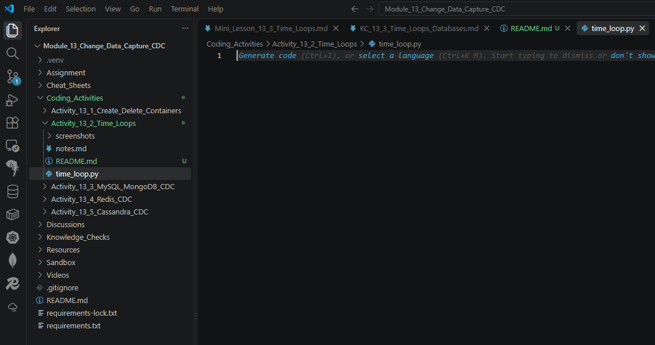

- Provide a screenshot to show that you successfully imported the necessary libraries to run a time loop inside the time_loop.py file.
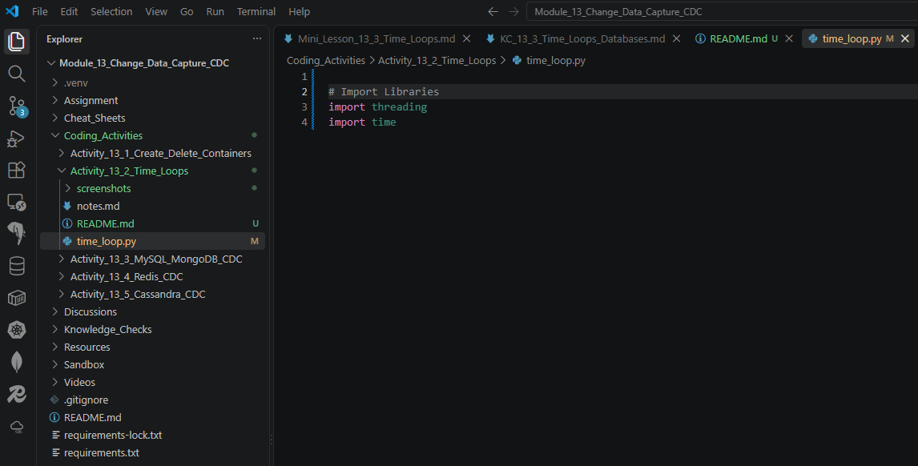

- Provide a screenshot to show that you successfully created the five lists with the correct elements in each list.
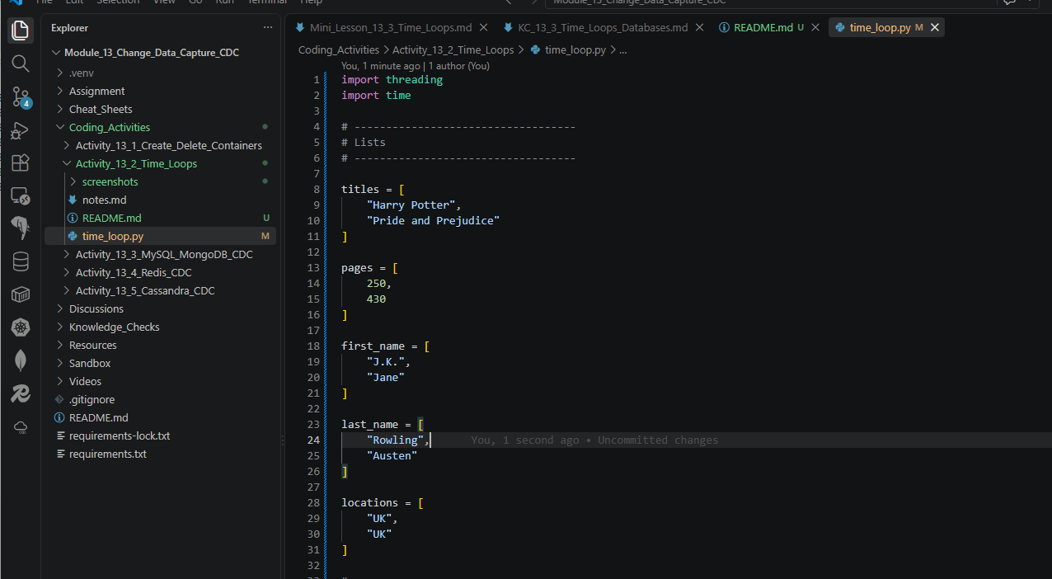

- Provide a screenshot (or screenshots, if needed) to show that you successfully completed the following:
  - Defined the build_book_dict() function with the five lists in the correct order.
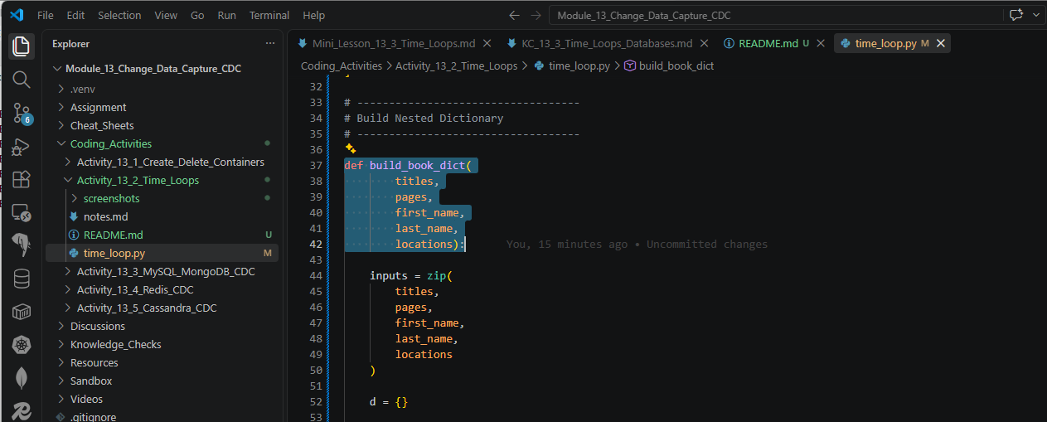

  - Used the Python zip() function to create a variable called inputs.
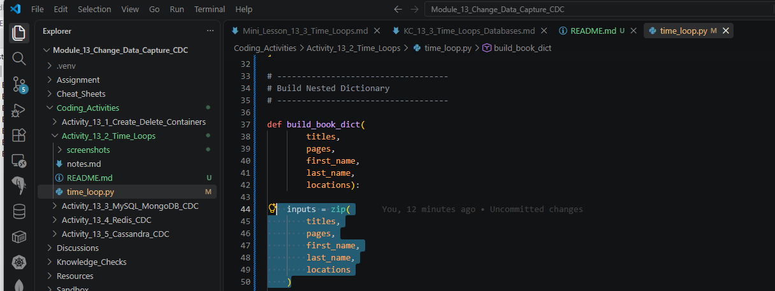

  - Created an empty dictionary, d, inside the build_book_dict() function.
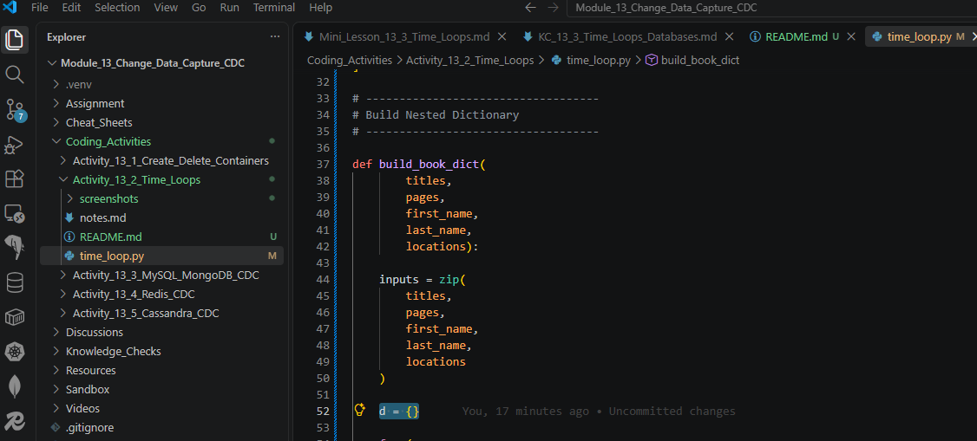

  - Used a for loop to iterate over all the entries in inputs and update the entries of the dictionary, d, so that d becomes a nested dictionary with the structure defined in Step 4.
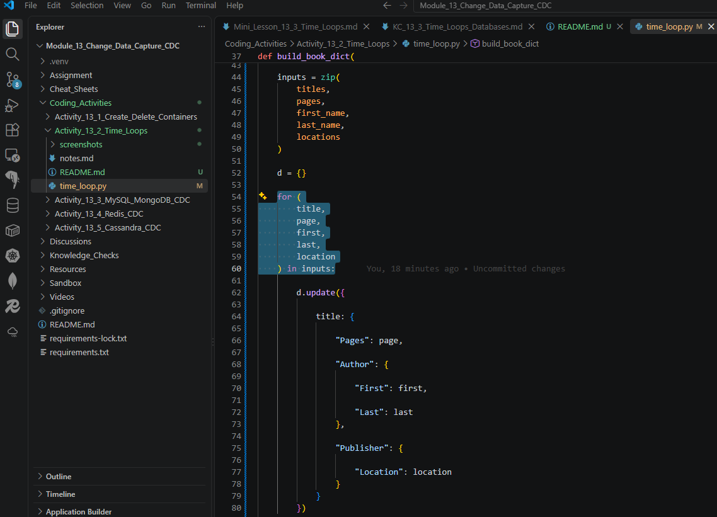

  - Added a line of code to delay the execution of your function by three seconds.
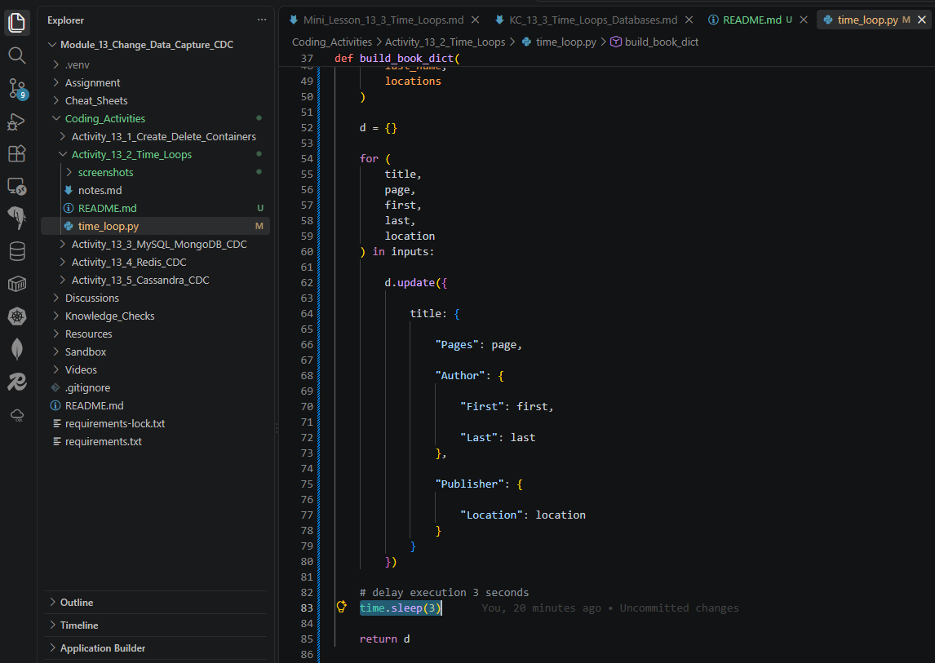

- Provide a screenshot of your Terminal window to show that you ran a print statement to call your function to ensure that your code works as expected.
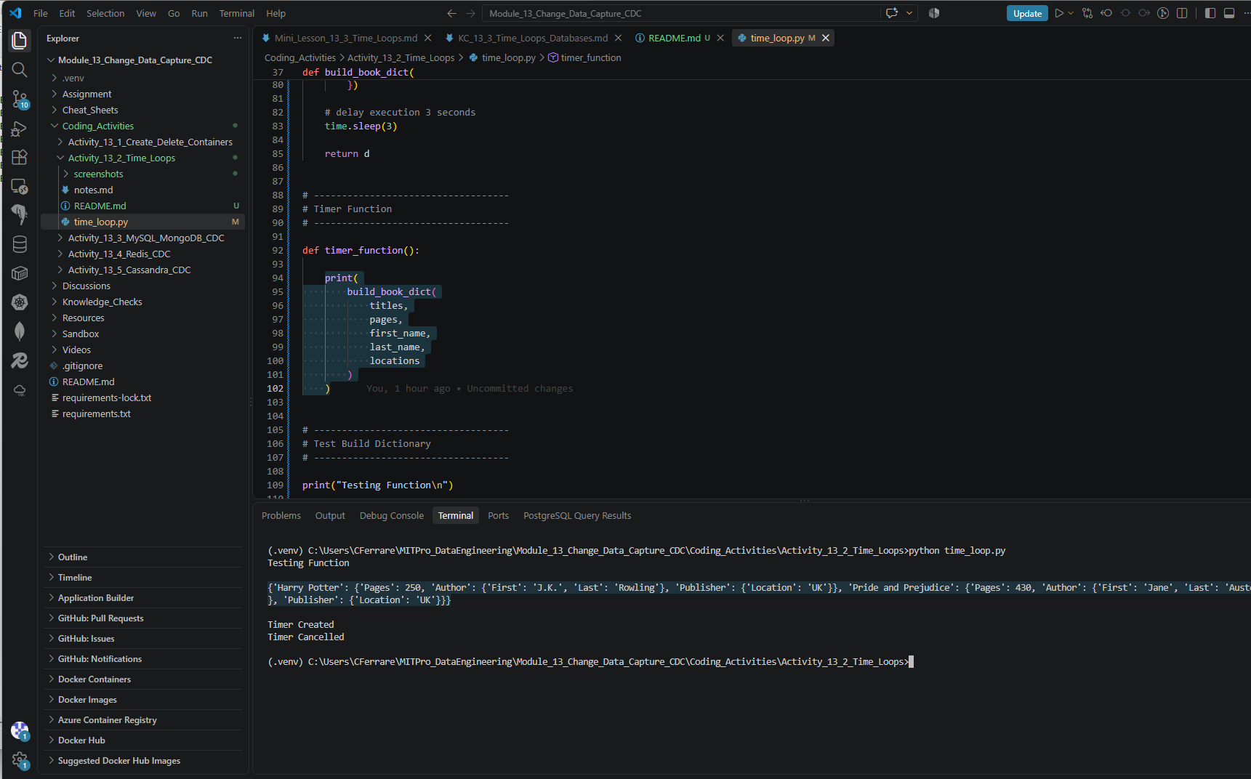

- Provide a screenshot to show that you successfully added a timer in your code that delays the execution of your code by five seconds.
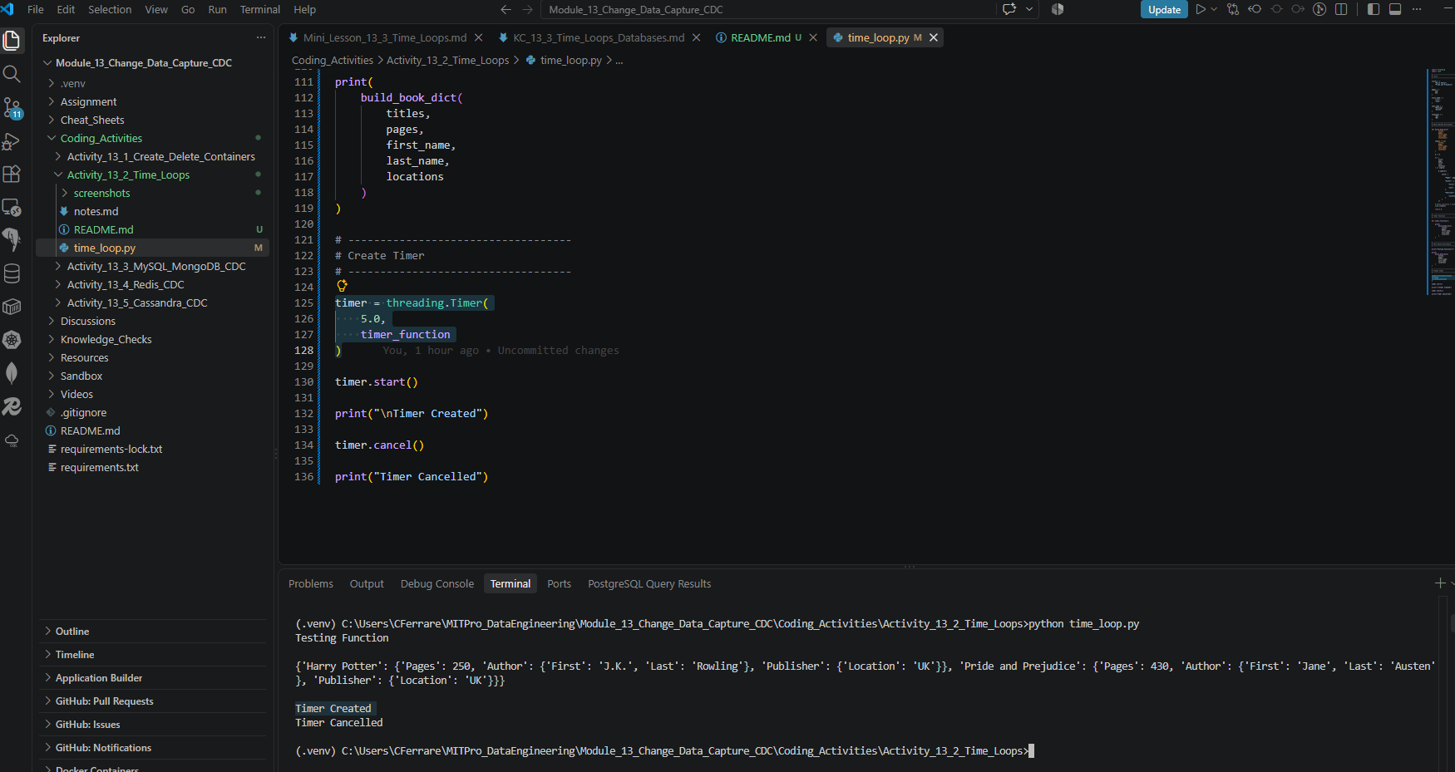

- Provide a screenshot of your Terminal window to show that you used the correct function to stop the timer, that you used a print statement to print the string “Timer Cancelled”, and that your code ran successfully.
