Required Coding Activity 14.3: Setting Up a Docker Network for MySQL

Step 1: Create Docker Network
- myCDCNetwork visible
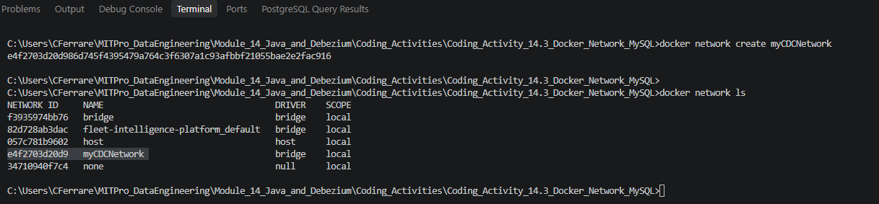

Step 2: Create Activity Folder
- Coding Activity 14.3 folder
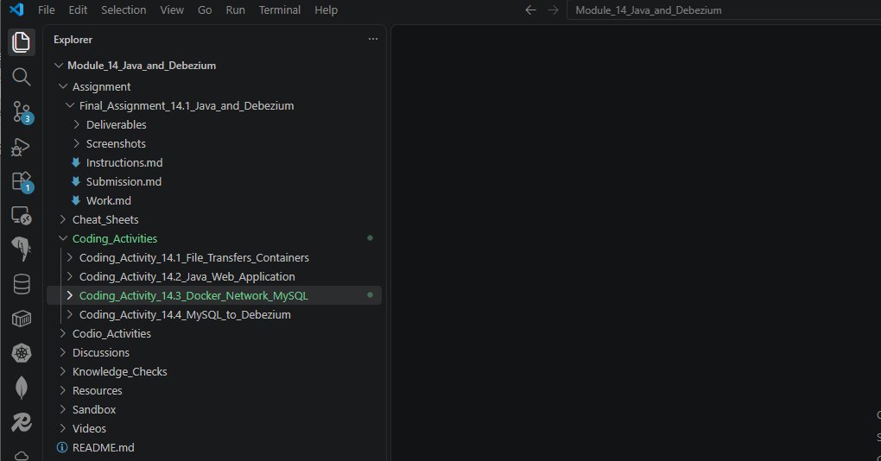
Step 3: Create customer.sql
- customer.sql file
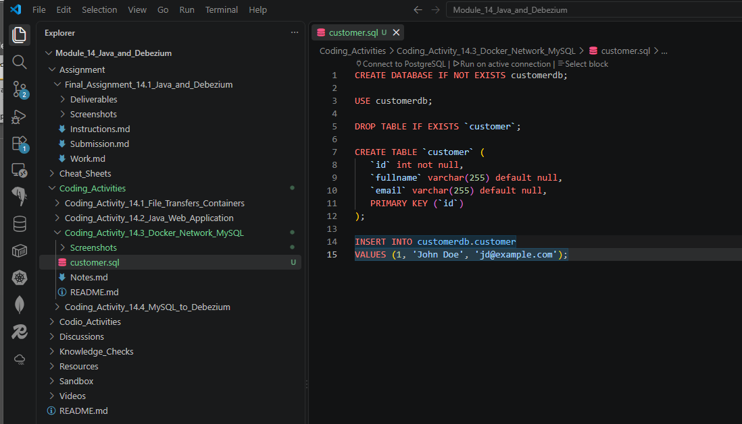

Step 4: Create Dockerfile
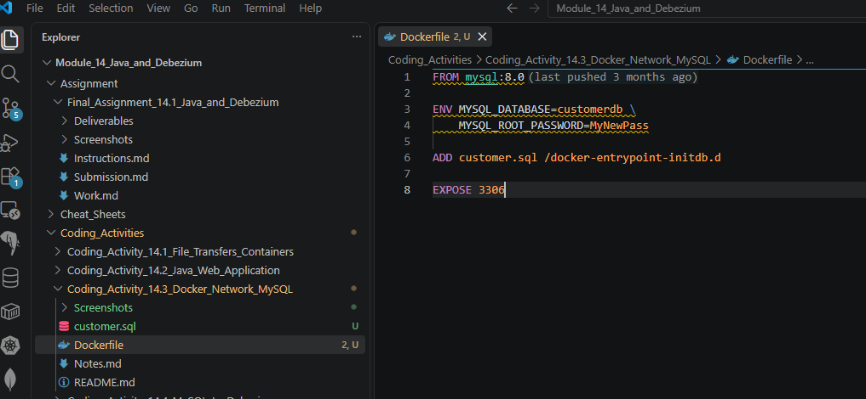

Step 5: Stop Running Containers
- docker stop <container_name>
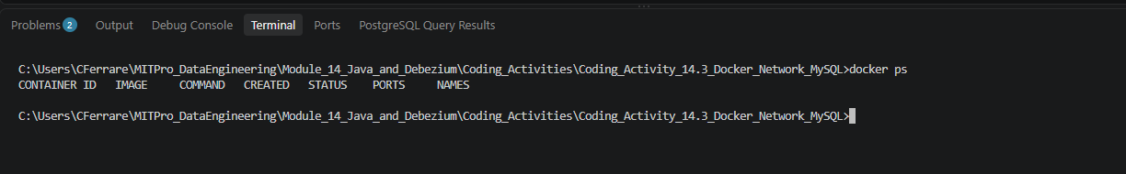

Step 6: Build MySQL Image
- docker build -t mysqlactivity14_3 .
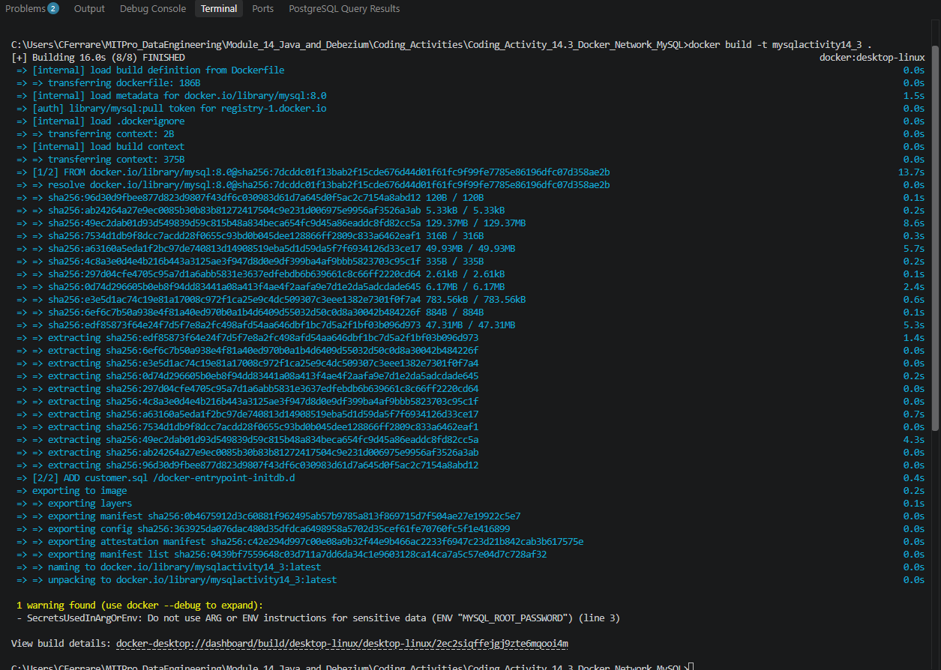

Step 7: Create MySQL Container and Connect to Network
- mysqlserver
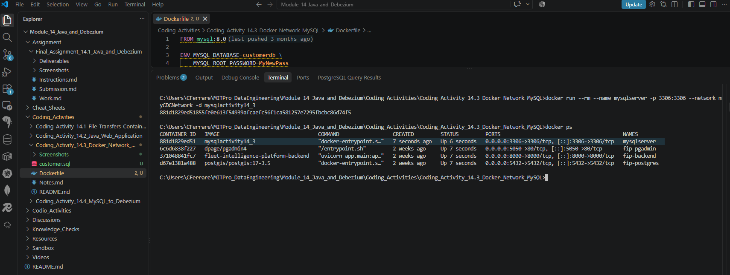

Step 8: Verify in Docker Desktop
- Docker Desktop: mysqlserver
