Required Final Assignment 14.1: Java and Debezium

Step 1: Verify No Running Containers
- The docker ps command was executed and confirmed that no Docker containers were running prior to starting the final assignment.
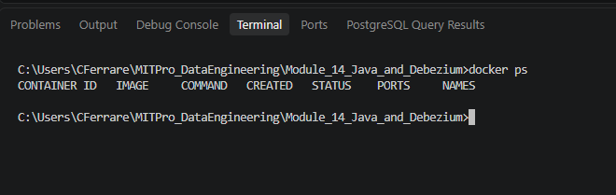

Step 2: Create Docker Network
- Executed docker network create CDCFinalAssignment and verified the network was created successfully using docker network ls.
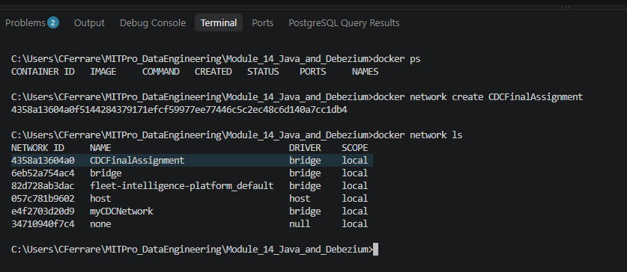
Step 3: Create Project Folder and Files
- Created the assignment folder and added the required Dockerfile and employee.sql files in Visual Studio Code.
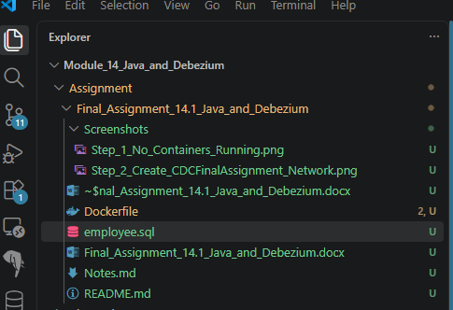

Step 4: Build MySQL Image
- Provide a screenshot to show that you successfully ran the Docker command to create the MySQL Docker image mysqlmasterimg.
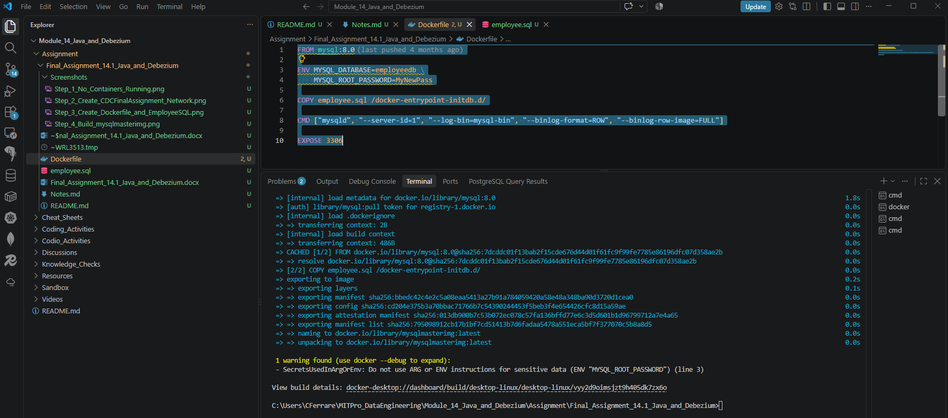

Step 5: Create mysqlmasterdb Container
- Created the MySQL Docker container mysqlmasterdb from the mysqlmasterimg image and attached it to the CDCFinalAssignment Docker network.
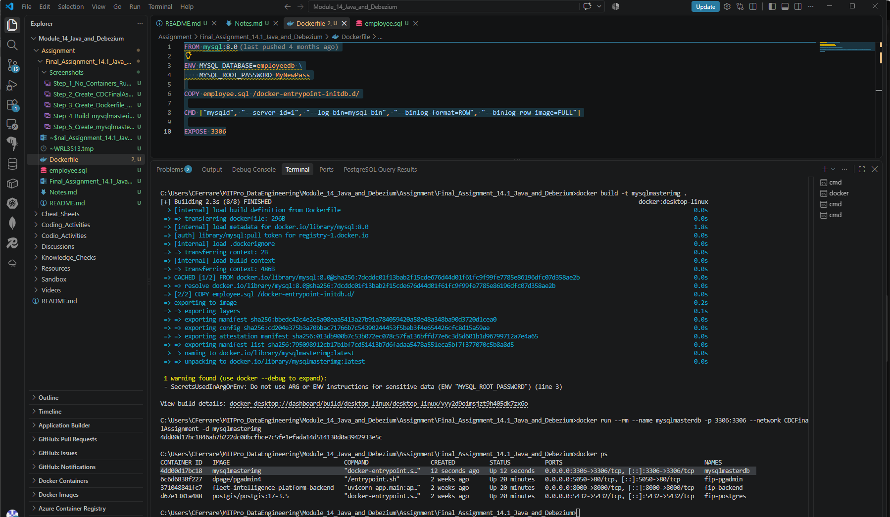

Step 6: Verify mysqlmasterdb Running
- Docker Desktop showing the mysqlmasterdb container running successfully and exposing port 3306.
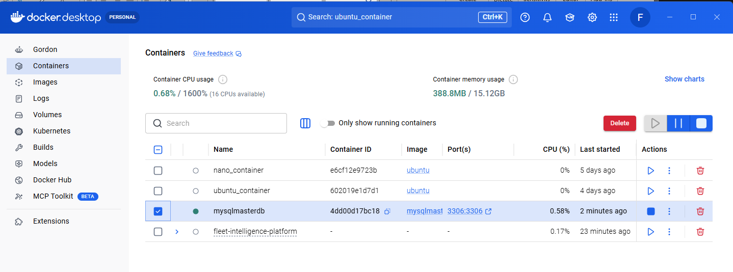
Step 7: Download and Extract Debezium Project
- Successfully extracted the Debezium project and verified the contents, including the Dockerfile, app folder, README, and LICENSE files.
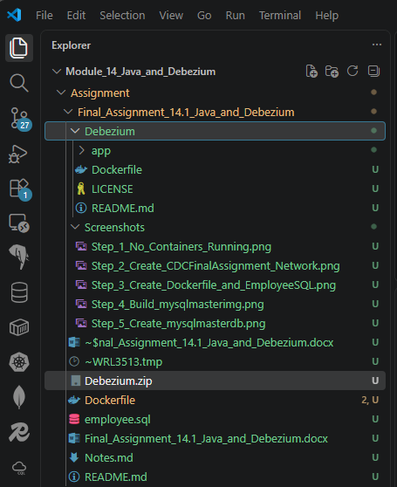
Step 8: Update Debezium Dockerfile and Build Image
- Updated the Debezium Dockerfile to use maven:3.9-eclipse-temurin-11 and successfully built the Docker image debeziumimg.
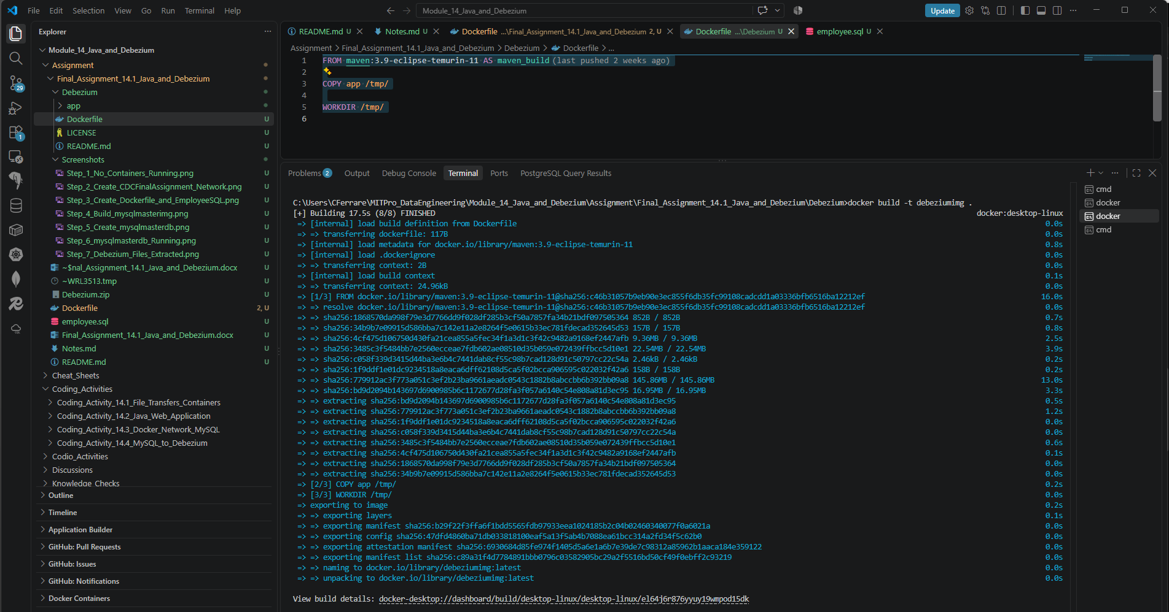

Step 9: Create Debezium Container
- Created the debeziumserver container from the debeziumimg image and attached it to the CDCFinalAssignment Docker network.
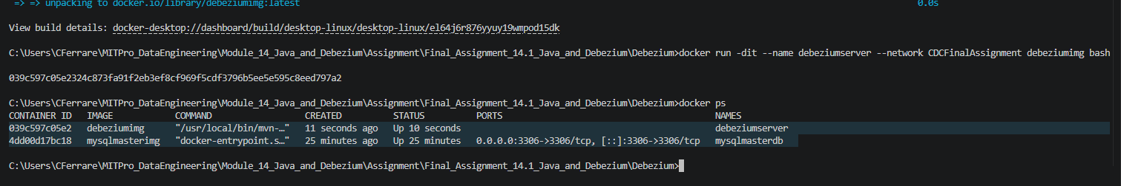

Step 10: Install Nano
- Successfully executed apt-get update and apt-get install -y nano within the debeziumserver container.
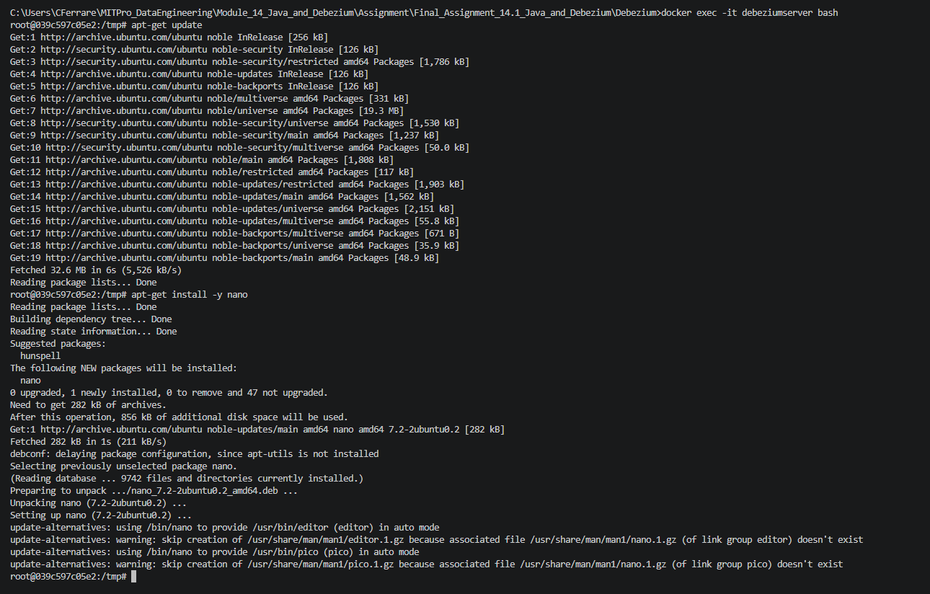

Step 11: Modify Debezium Configuration
- Modified DebeziumConnectorConfig.java by replacing all occurrences of customerdb with employeedb and mysqlserver with mysqlmasterdb.
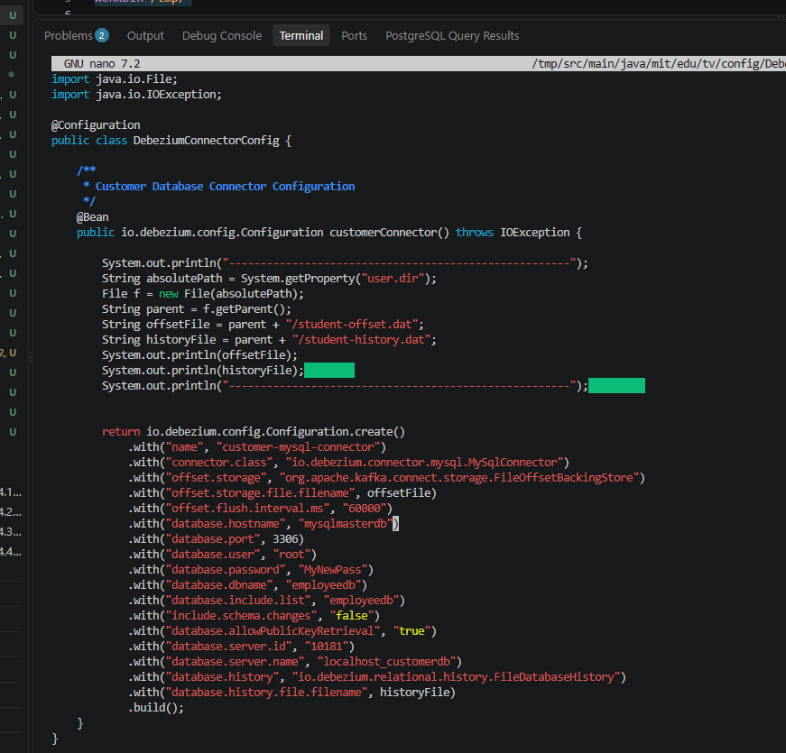

Step 12: Start Debezium
- This confirms Debezium successfully captured the initial employee record containing FirstName=John.
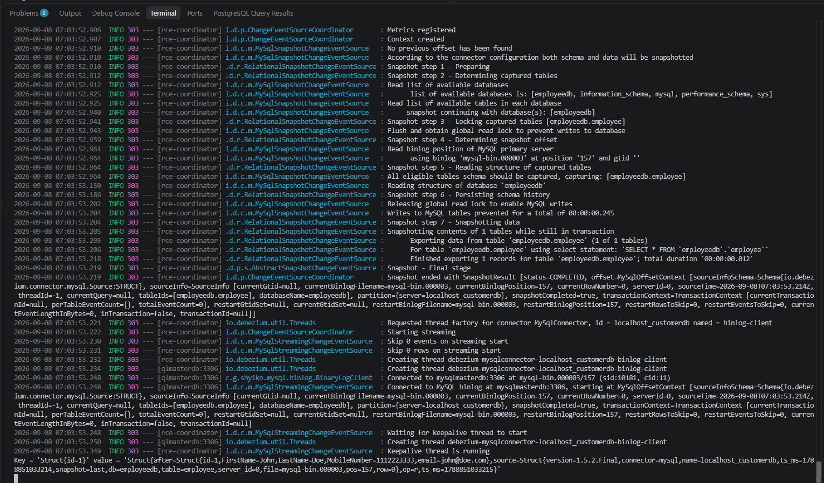
Step 13: Connect to MySQL
- Successfully connected to the employeedb database inside the mysqlmasterdb container using the MySQL command-line client.
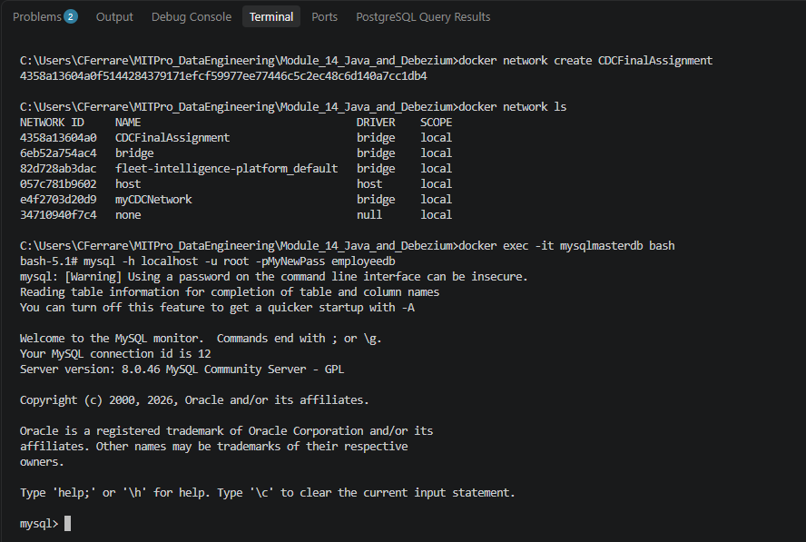

Step 14: Insert Mary Record
- Successfully inserted the employee record for Mary Doe into the employeedb.employee table.
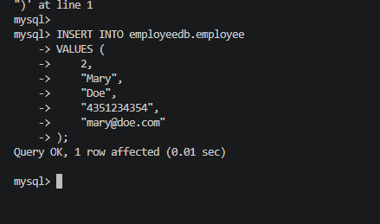

Step 15: Verify CDC Worked
- Debezium successfully detected the newly inserted employee record for Mary Doe and generated a CDC event from the MySQL binary log.
