Required Coding Activity 14.1: Uploading and Downloading Files to and from Containers

Objective
The objective of this activity is to learn how to transfer files and folders between a Docker container and a local machine using the docker cp command. This activity demonstrates how containers maintain separate file systems and how data can be moved between a host computer and a containerized environment.

Purpose
The purpose of these steps is to help students understand how Docker containers store and manage files independently from the host operating system. By creating files inside a container, copying them to a local machine, and verifying the results, students gain hands-on experience with container file management, a critical skill used in software development, cloud computing, and data engineering workflows.
As a data engineer, you will frequently need to:
- Move datasets into processing containers.
- Retrieve logs and output files from containers.
- Transfer configuration files between environments.
- Manage data pipelines running in Docker containers.
- Work with containerized applications in cloud platforms such as AWS, Azure, and Kubernetes.

This activity builds foundational Docker skills that are directly applicable to modern data engineering and DevOps environments.

- Create a Container
  - Establishes an isolated environment where applications and files can be stored.

On terminal:
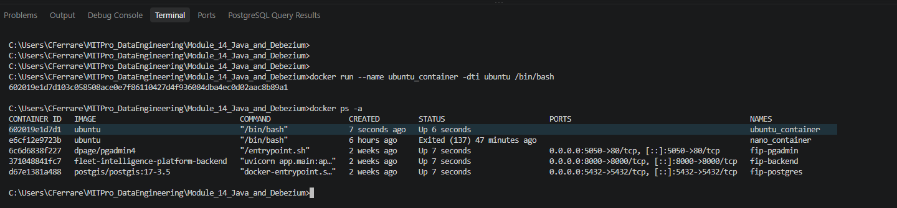

On Docker Desktop: 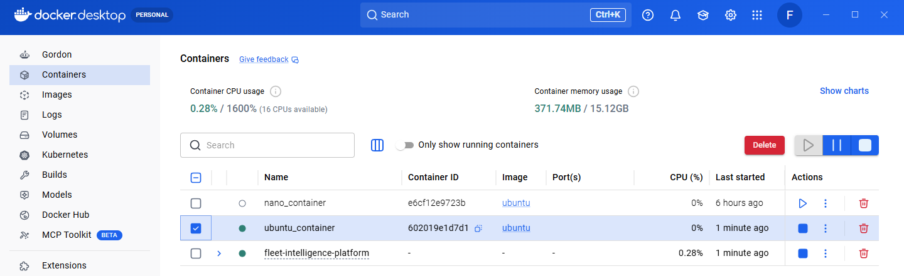

- Create Files Inside the Container.
  - Demonstrates that containers have their own file systems separate from the host machine.

On Destkop:
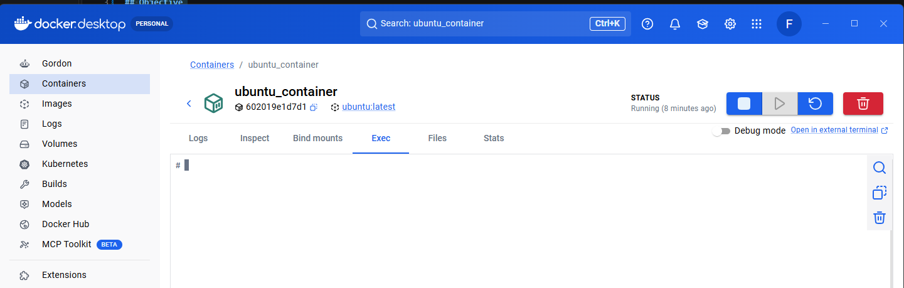

- Add Content to Files
  - Simulates creating application data, configuration files, or datasets within a container.

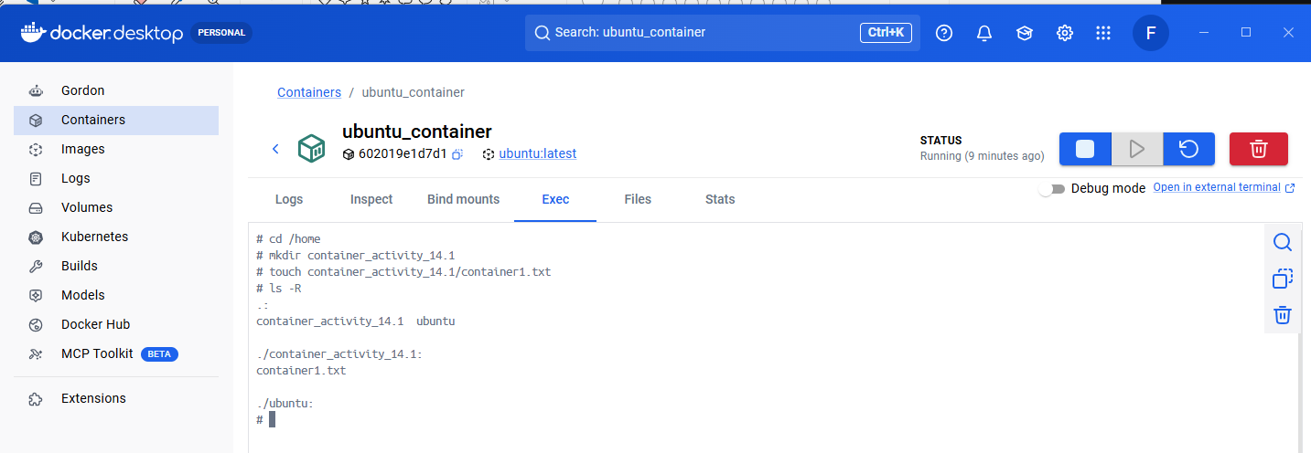

- Create a Local Directory
- Provides a destination for files copied from the container.

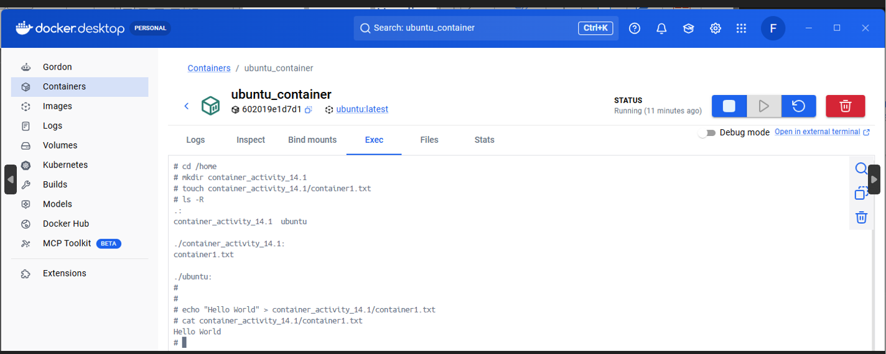

- Create a Local Directory
- Provides a destination for files copied from the container.

5a:
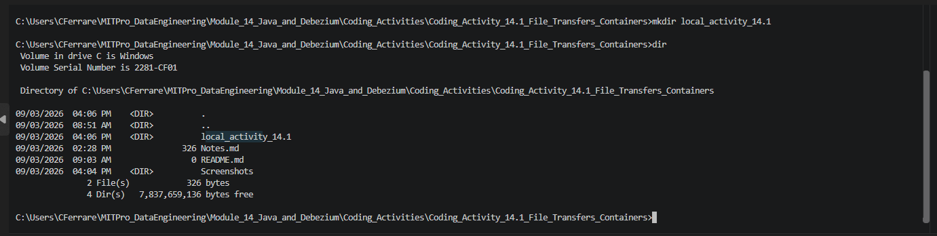

5b:
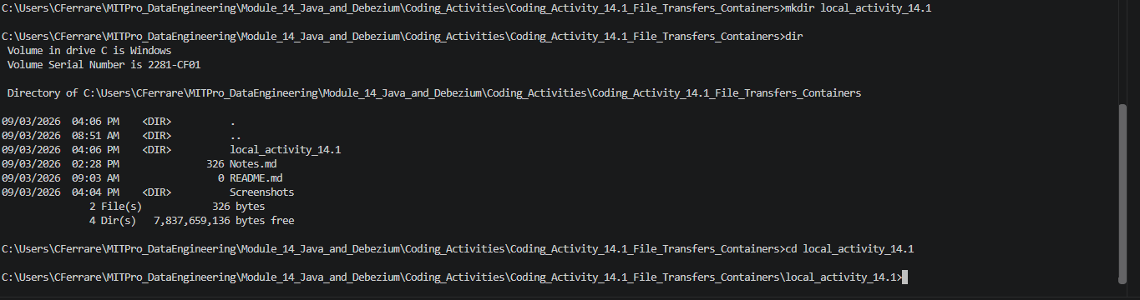

- Create a Local Directory
- Provides a destination for files copied from the container.

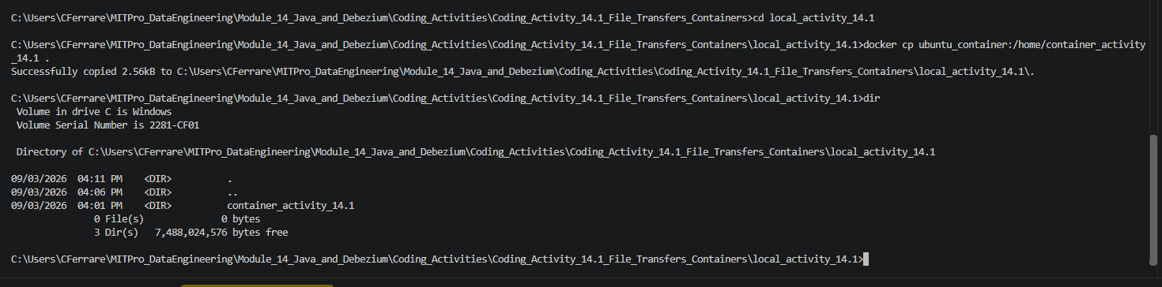

- Provide a screenshot of the folder to show that you successfully copied the container_activity_14.1 and its files folder to the local_activity_14.1 work folder.

