Required Coding Activity 14.4: Connecting MySQL to Debezium

Step 1: Verify MySQL Container Is Running
- mysqlserver
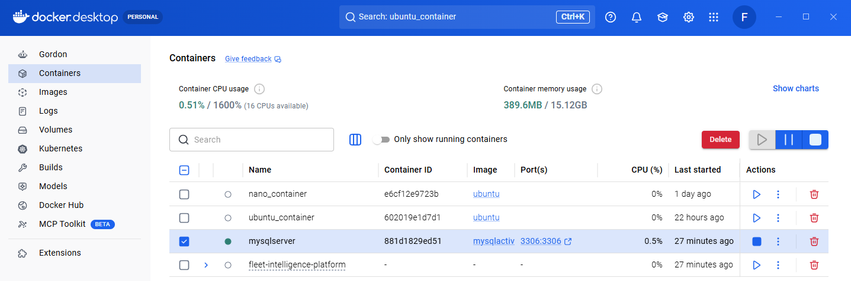
Step 2: Verify Docker Network
- myCDCNetwork
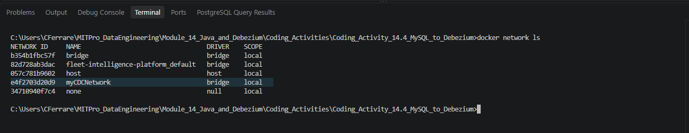

Step 3: Extract Debezium Project
- debeziumActivity14_4
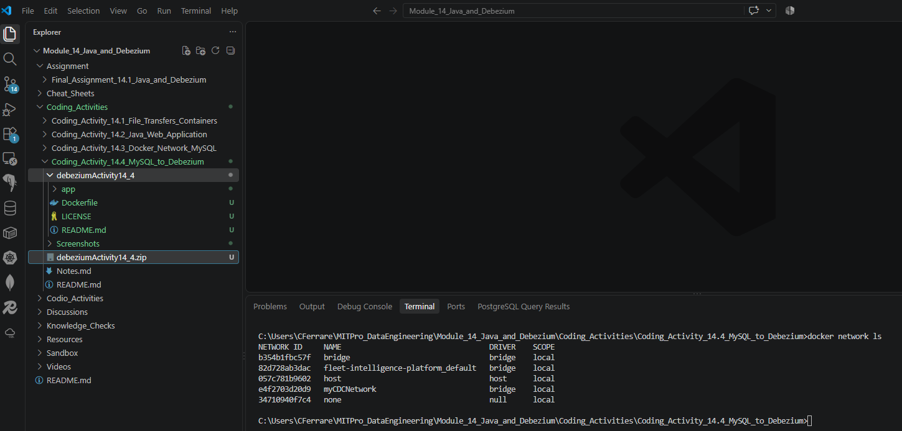
Step 4: Build Debezium Docker Image
- docker build -t debeziumactivity14_4 .
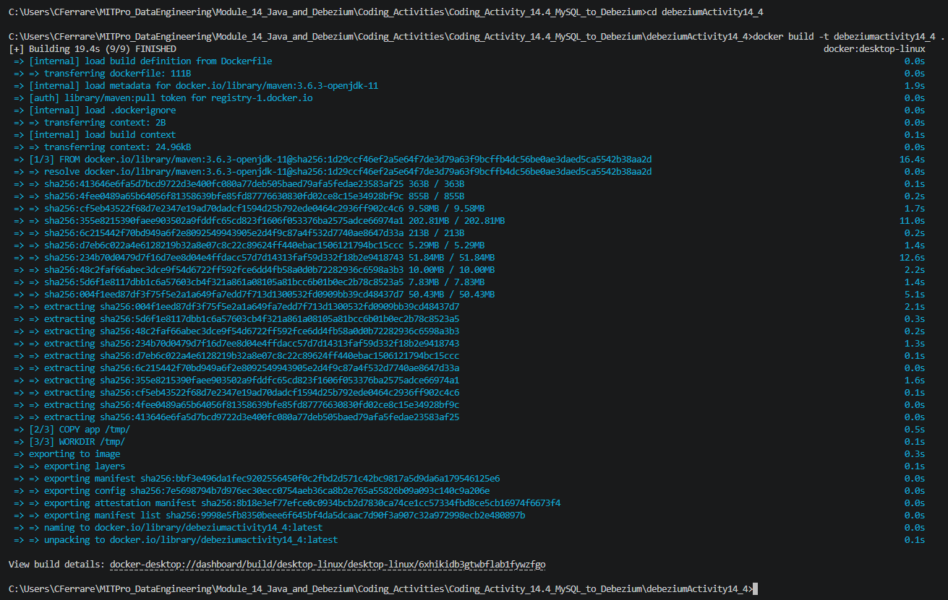
Step 5: Create Debezium Container
- docker run -it --rm --name debeziumserver --network myCDCNetwork debeziumactivity14_4 bash
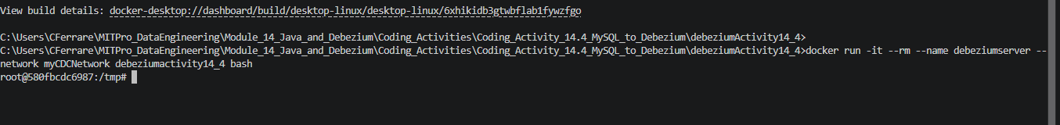

Step 6: Verify Both Containers
- Mysqlserver & debeziumserver
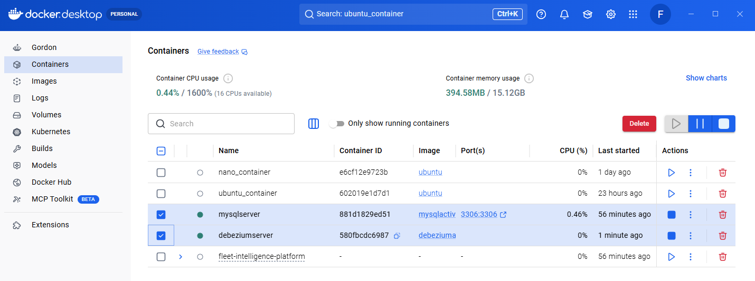

Step 7: Start Debezium Spring Boot Application
- DemoApplication
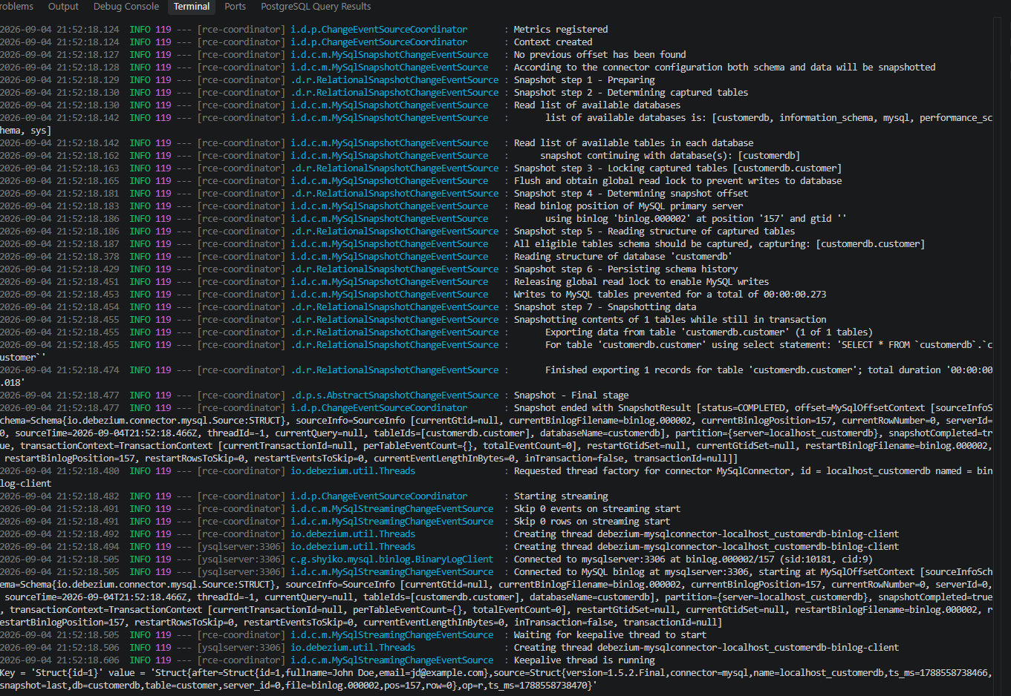

Step 8: Insert Record Through MySQL Workbench
- Lightning Bolt (Execute)
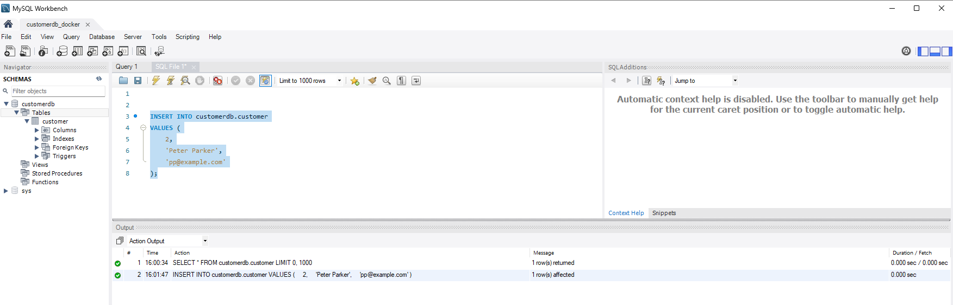

Step 9: Verify Debezium Captured Change
- mvn spring-boot:run
