Required Final Assignment 17.1: Performing ETL Using NiFi

Part 1: Writing Data to an Excel File
- Provide a screenshot to show that you successfully created the two folders: input and output.

- Step 1 - Created the input and output directories inside the NiFi container under /opt/nifi/nifi-current.
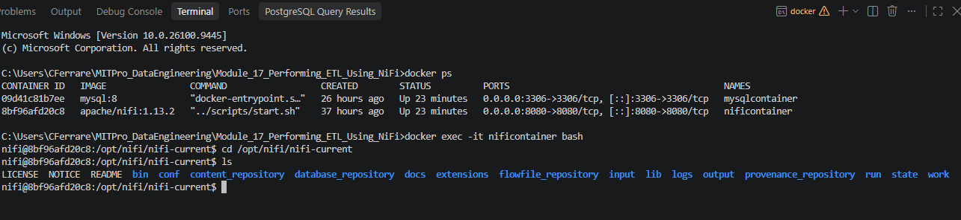

- Provide a screenshot to show that you successfully copied the movies.xlsx file in the input folder.

- Step 2 - Successfully copied the movies.xlsx file into the NiFi input directory and verified its presence.
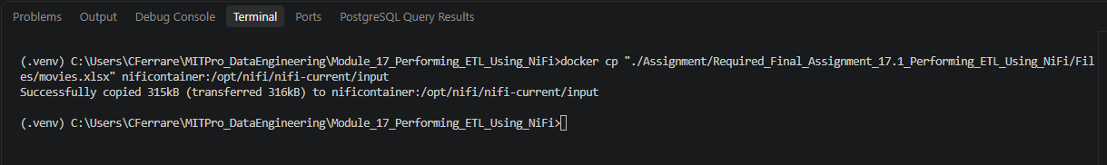

- Saved to NiFi input directory.
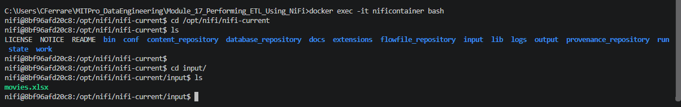

- Provide a screenshot to show that you successfully created the Assignment17 process group.

- Step 3 - Created the Assignment17 process group within the NiFi canvas to contain the ETL pipelines developed for Assignment 17.1.
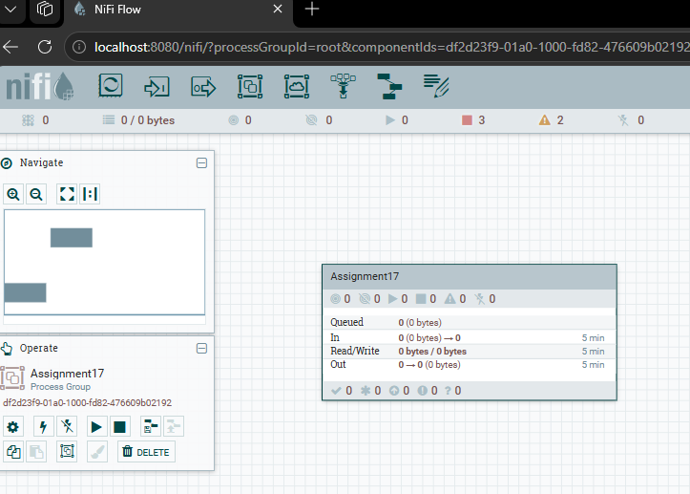

- Provide a screenshot to show that you correctly configured the properties for the GetFile processor.

- Step 4 - Configured the GetFile processor with the input directory /opt/nifi/nifi-current/input and file filter movies.xlsx to retrieve the Excel file for processing.
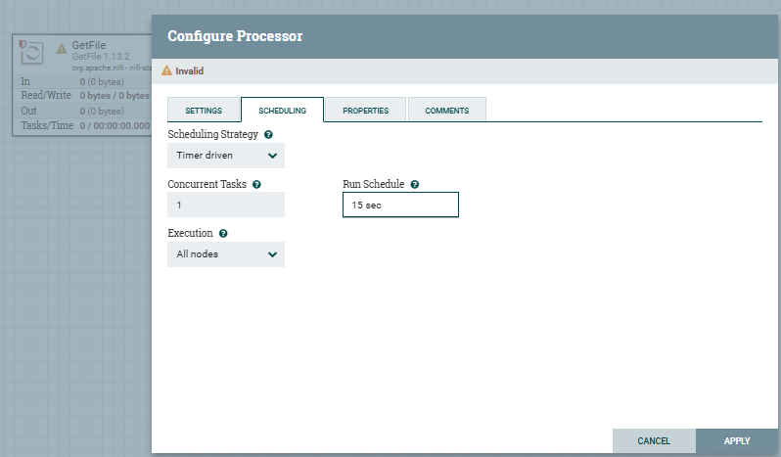
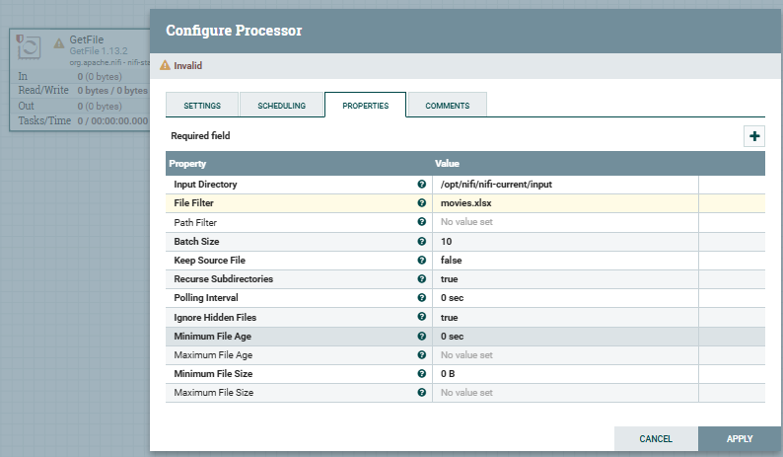

- Provide a screenshot to show that you correctly configured the properties for the ConvertExcelToCSVProcessor processor.

- Step 5 - Configured the ConvertExcelToCSVProcessor with a 15-second run schedule and specified the movies worksheet for conversion from Excel format to CSV format.
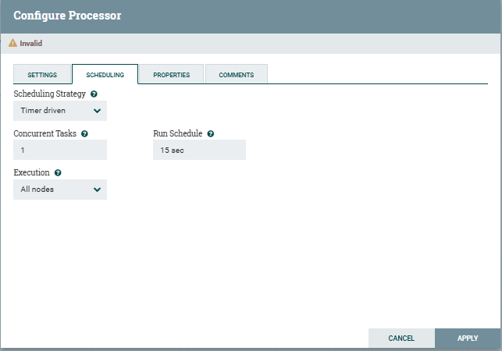
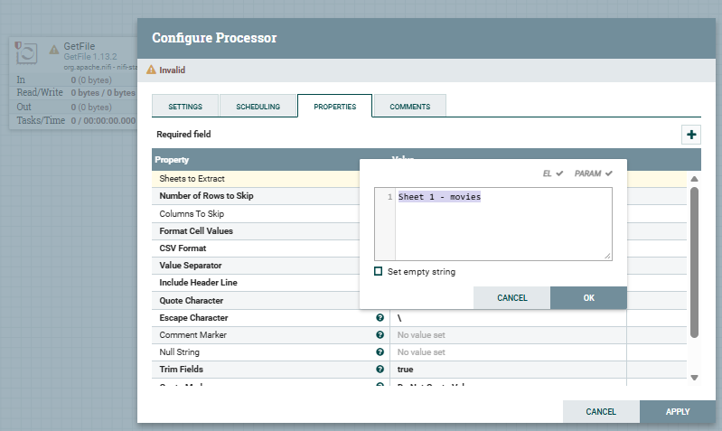

- Provide a screenshot to show that you correctly configured the properties for the PutFile processor.

- Step 6 - Configured the PutFile processor with a 15-second run schedule and output directory /opt/nifi/nifi-current/output to store the generated CSV file.
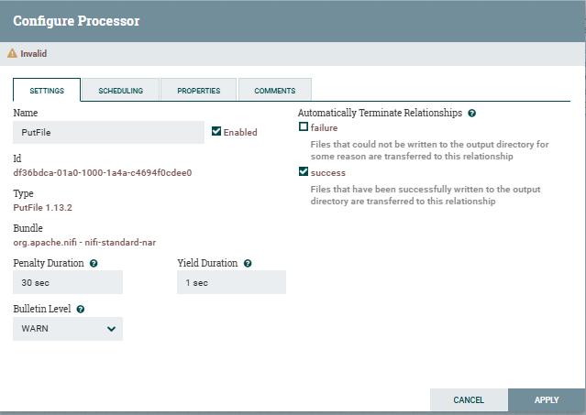
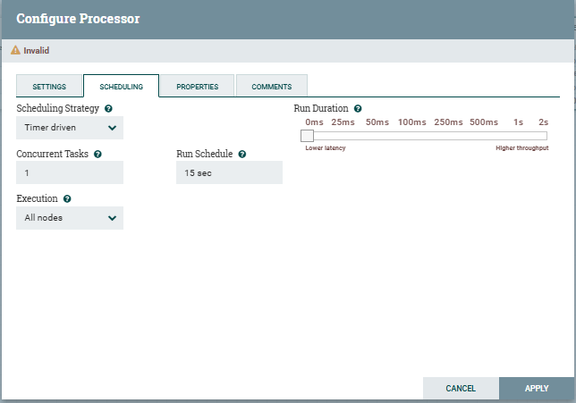
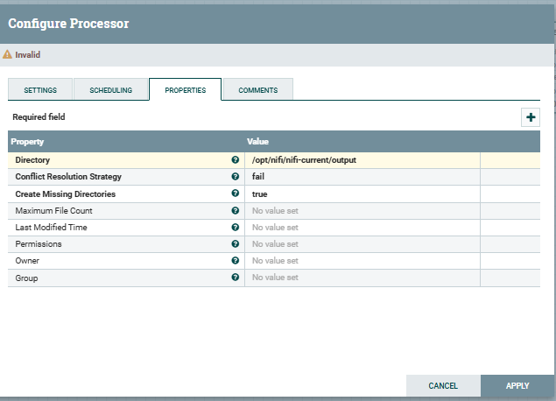

- Provide a screenshot to show that you successfully connected all the processors with the correct relationships.

- Step 7 - Connected the GetFile, ConvertExcelToCSVProcessor, and PutFile processors using the required relationships to create the Excel-to-CSV ETL pipeline.
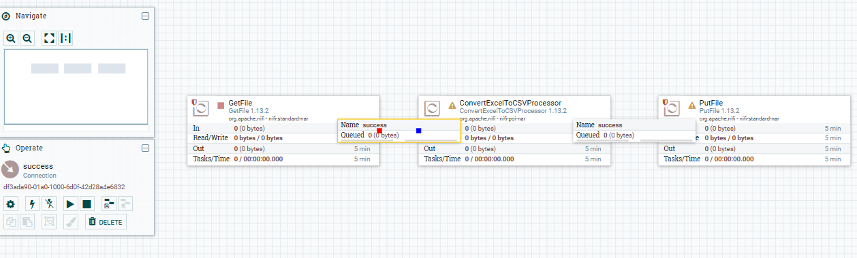

- Provide a screenshot to show that all the processors are running (as indicated by a green arrow).

- Step 8 - Started the GetFile, ConvertExcelToCSVProcessor, and PutFile processors and verified that the Excel-to-CSV ETL pipeline was running successfully.
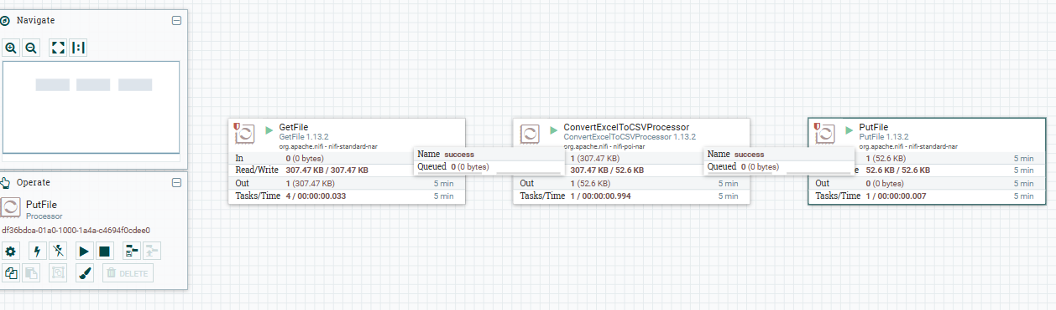

- Provide a screenshot to show that the movies_Assignment.csv file has been created.

- Step 9 - Verified that the Excel-to-CSV ETL pipeline successfully generated the output file movies_Sheet 1 - movies.csv in the /opt/nifi/nifi-current/output directory.
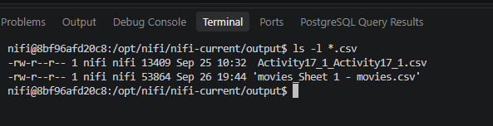

Part 2: Writing Data to an SQL Database
- Provide a screenshot of your MySQL Workbench to show that you have successfully initialized an empty movies table in the movielens database.

- Step 10 - Created the movielens database and initialized the movies table with columns idx, title, and genres. Executed SELECT * FROM movies; to verify that the table was initially empty.
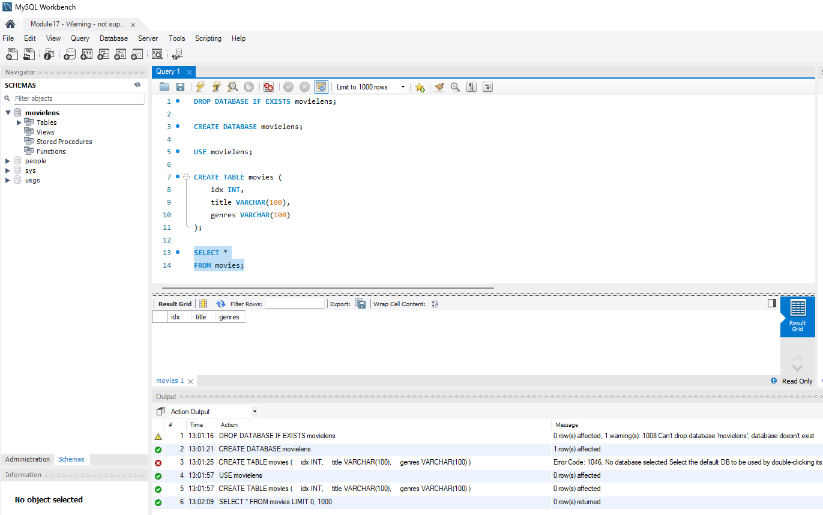

- Provide a screenshot to show that the movies.csv file is now on the NiFi server.

- Copy from local machine to NiFi container /opt/nifi/nifi-current/data directory.
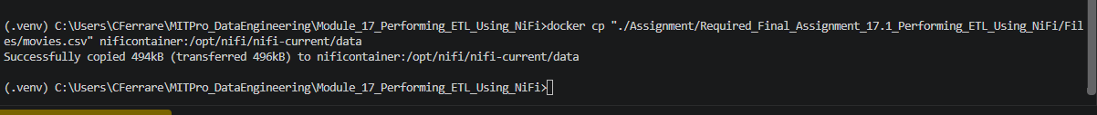

- Step 11 - Copied the movies.csv file into the /opt/nifi/nifi-current/data directory inside the NiFi container and verified that the file was successfully uploaded for processing.

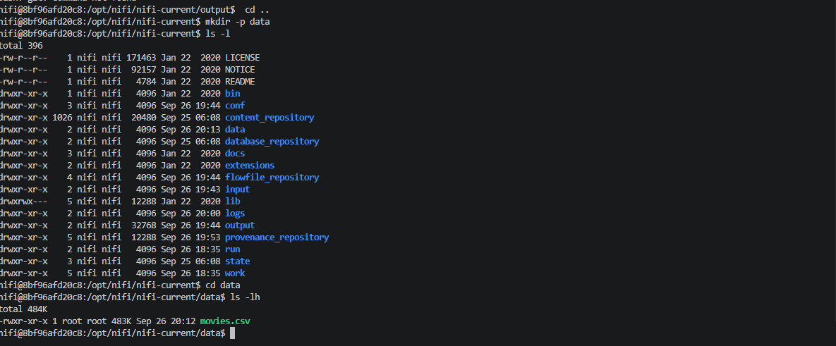

- Provide a screenshot to show that you successfully opened the NiFi UI.

- Step 12 - Opened the Apache NiFi user interface and accessed the Assignment17 process group to begin configuring the CSV-to-MySQL ETL pipeline.
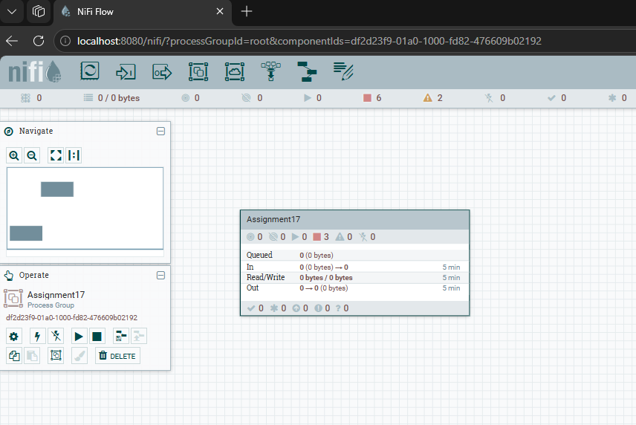

- Provide a screenshot to show that you successfully created and enabled the MySQL controller service.

- Step 13 - Created and enabled the MySQL DBCPConnectionPool controller service using the mysqlcontainer Docker container to connect Apache NiFi to the movielens database.
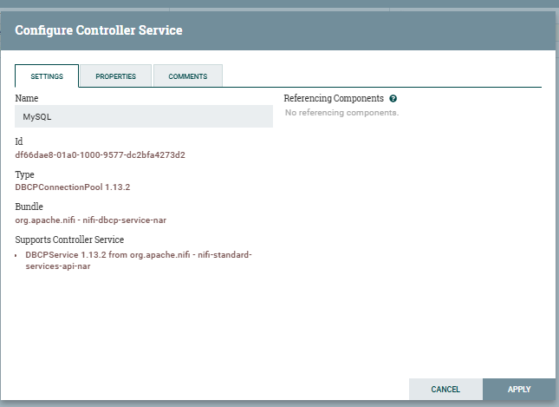

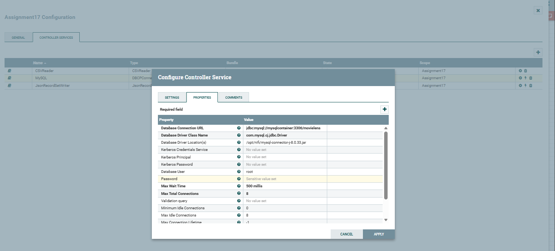

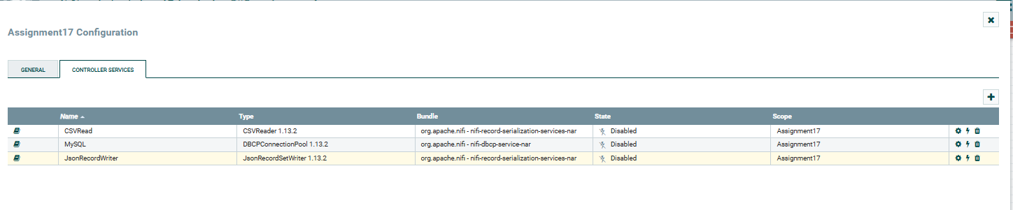
- Provide a screenshot of the controller screen to show that the three controller services (reader, writer, and MySQL) are enabled.

- Step 14 - Created and enabled the CSVRead, JsonRecordWriter, and MySQL controller services required to support the CSV-to-MySQL ETL pipeline.
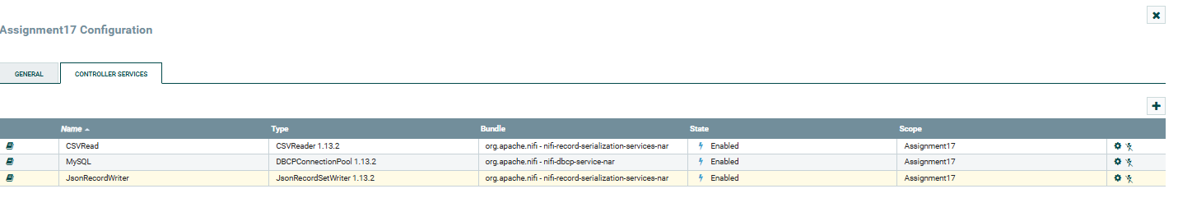
- Provide a screenshot of your complete data pipeline, including all five processors: GetFile, SplitText, ConvertRecord, ConvertJSONToSQL, and PutSQL.

- Part 2 Step 6 - Added the five required processors (GetFile, SplitText, ConvertRecord, ConvertJSONToSQL, and PutSQL) that will be used to load movie data from a CSV file into the movielens MySQL database.
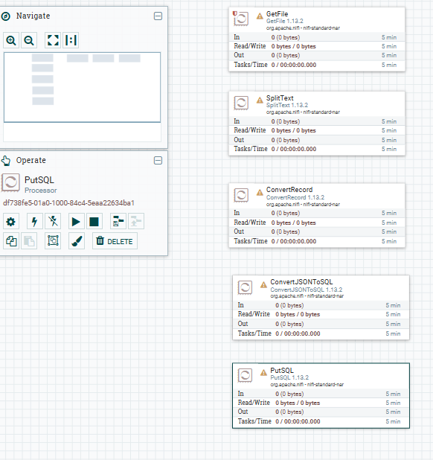
- Provide a screenshot of all five processors to show that the correct connectors have been added between the processors.

- get movies file, the Settings tab should be:
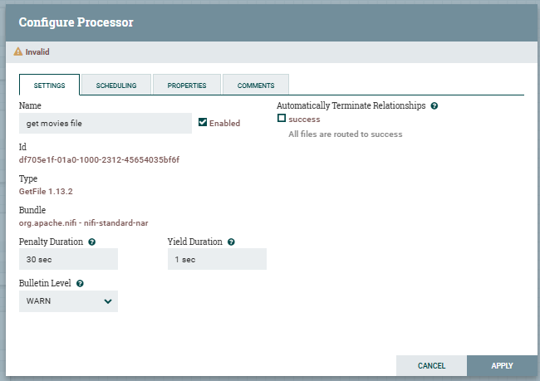
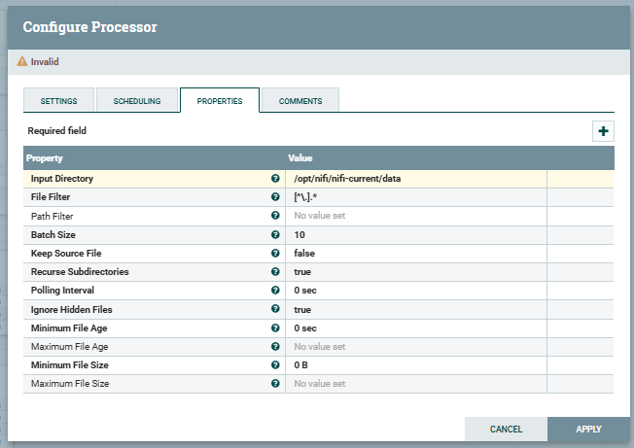

- SplitText, the Settings tab should be:
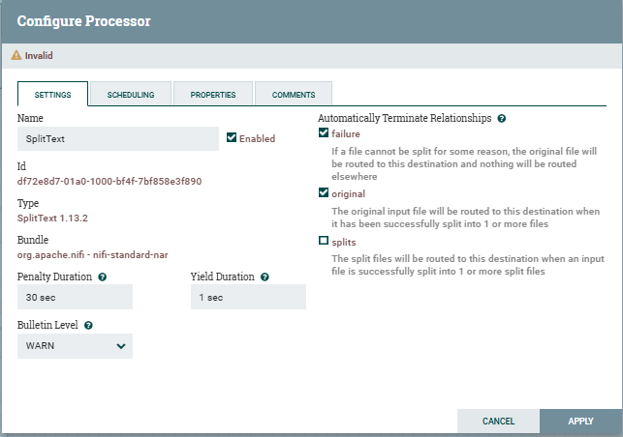
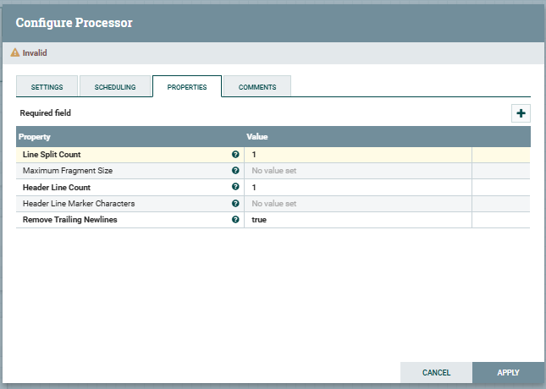

- For ConvertRecord, the Settings tab should be:
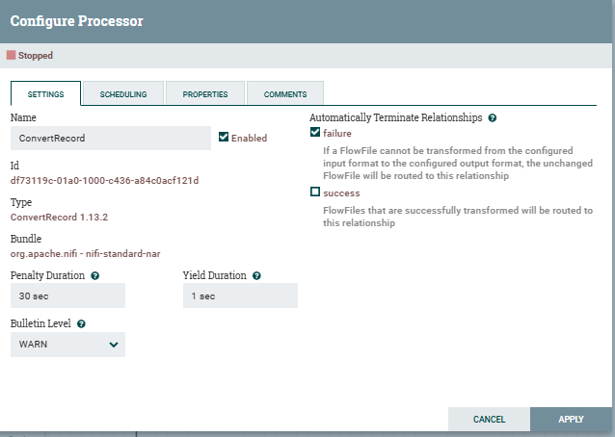
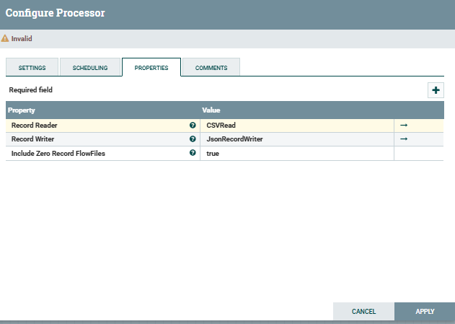

- ConvertJSONToSQL, the setting should be:
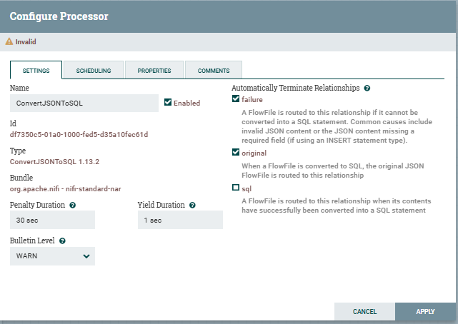
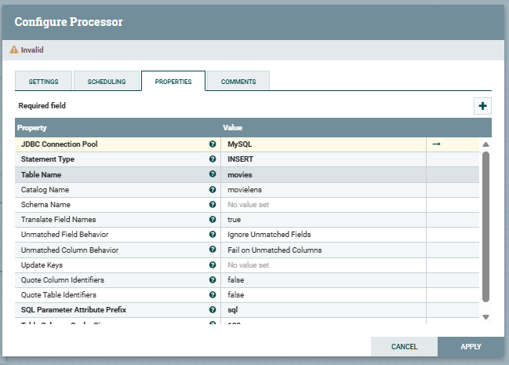

- PutSQL, setting should be:
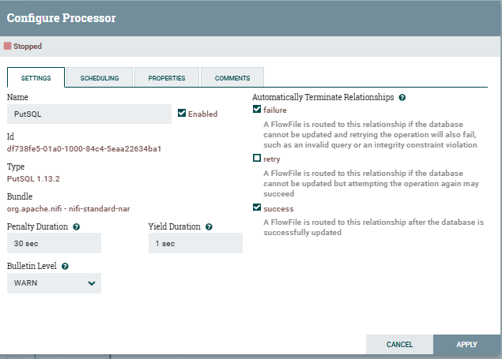
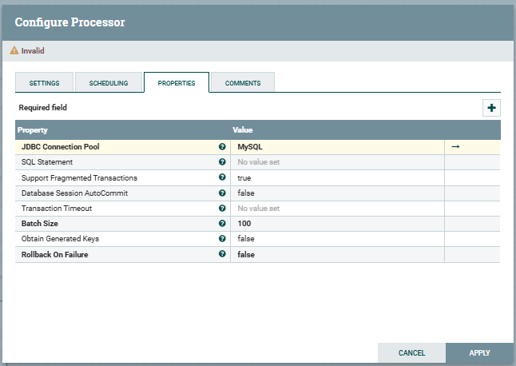

- Part 2 Step 7 - Configured and connected all processors using the required relationships to create the complete CSV-to-MySQL ETL workflow.
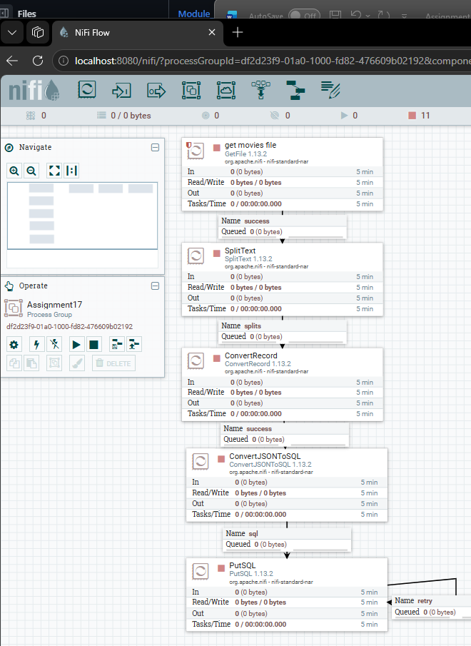
- Provide a screenshot of your NiFi browser screen to show all five processors connected and running.

- Part 2 Step 8 - Started the GetFile, SplitText, ConvertRecord, ConvertJSONToSQL, and PutSQL processors and verified that the CSV-to-MySQL ETL pipeline was running successfully.
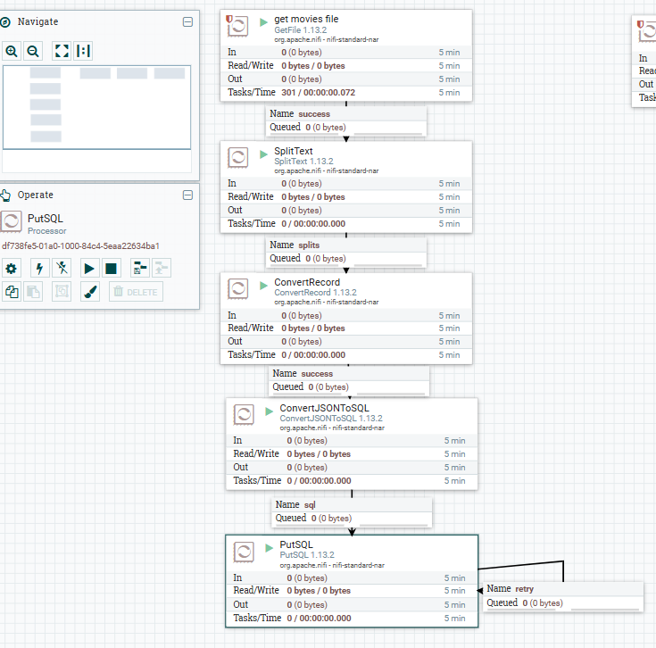

- Provide a screenshot of the result of this query to show that the movies table in the movieslens database is now saturated with data.

- GetFile already consumed the file. If movies.csv is no longer there, GetFile has consumed it.

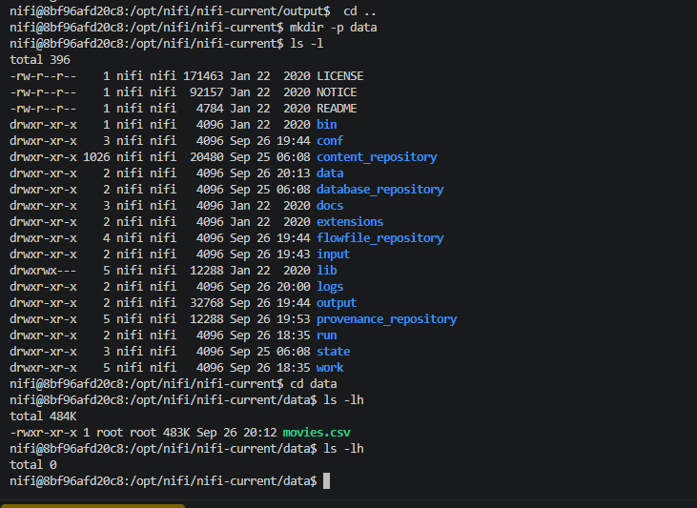

Part 2 Step 9 - Verified that movie records from movies.csv were successfully loaded into the movielens.movies table using the Apache NiFi ETL pipeline.
