Required Coding Activity 17.1: Using NiFi to Connect to an Excel File

- Created Input and Output Folders.
- Created the input and output directories inside the NiFi container under /opt/nifi/nifi-current.

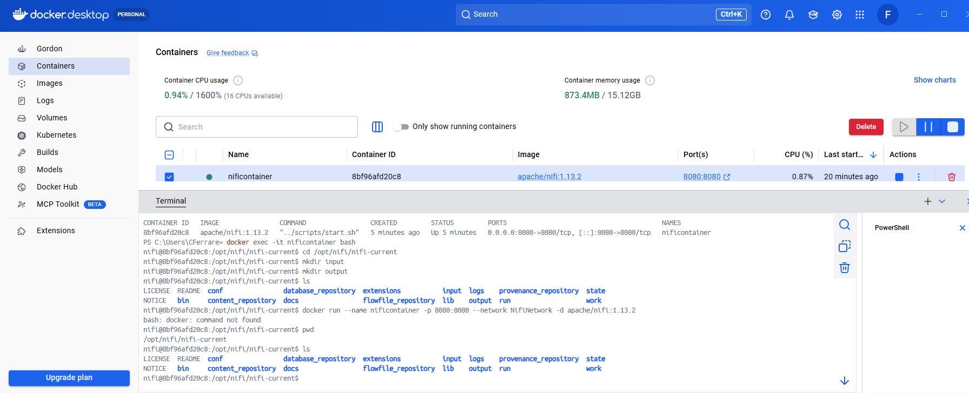

- Provide a screenshot to show that you successfully copied the Activity17_1.xlsx Excel file to the NiFi server.
- Docker copy cmd to docker input sub-directory we created in opt directory.
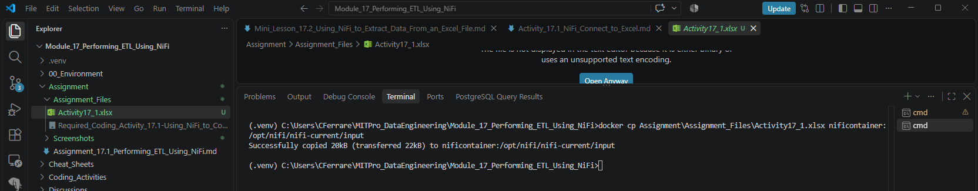

- Copied Activity17_1.xlsx to input folder
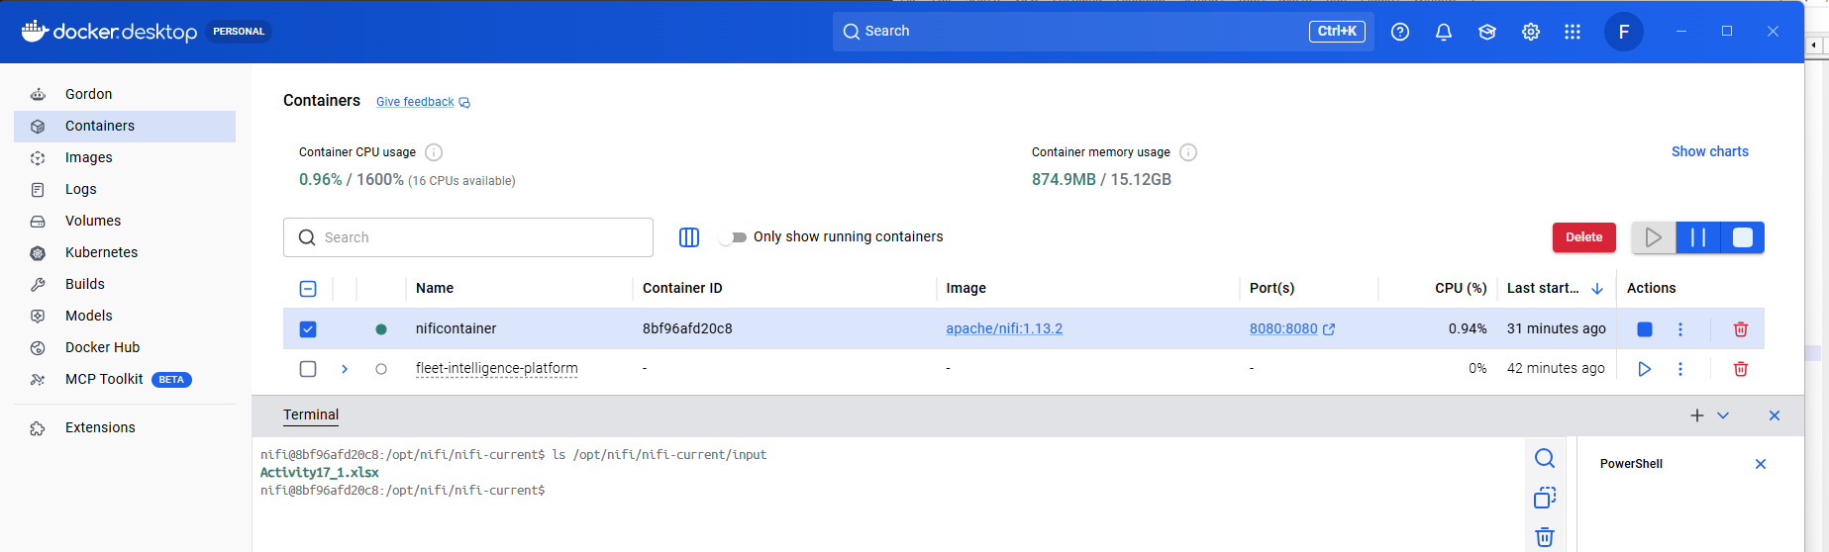

- Provide a screenshot to show that you can successfully open NiFi from the browser.

- Successfully opened Apache NiFi in the browser
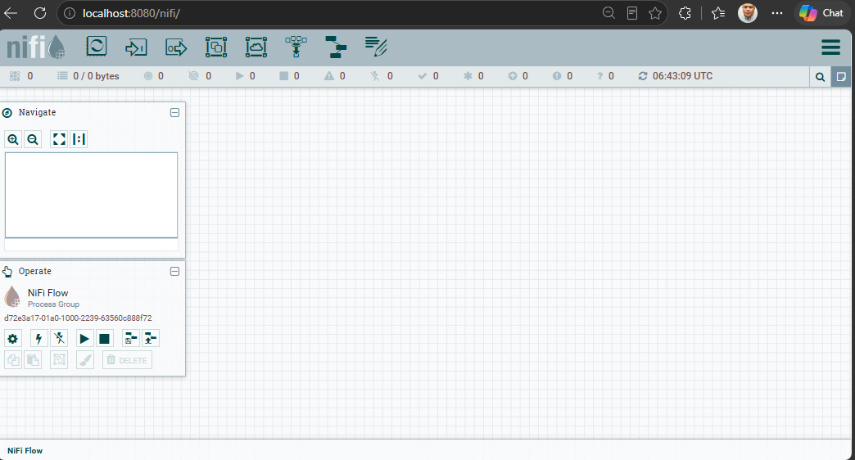

- Provide a screenshot to show that you successfully created the new Activity17.1 process group.

- Successfully created the Activity17.1 process group
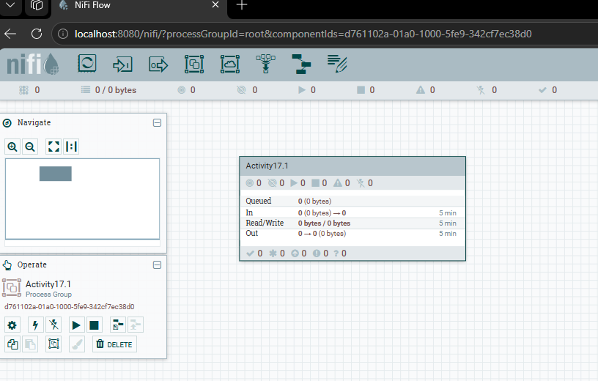

- Provide a screenshot to show that you successfully added the ConvertExcelToCSVProcessor processor to the NiFi canvas.

- Successfully added ConvertExcelToCSVProcessor to the NiFi canvas
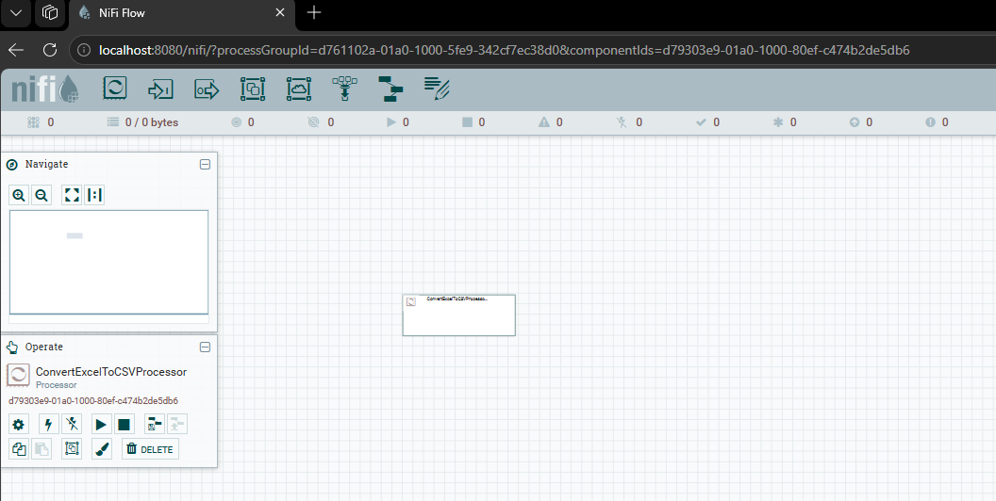

- Provide a screenshot to show that you configured the properties for the ConvertExcelToCSVProcessor processor correctly.
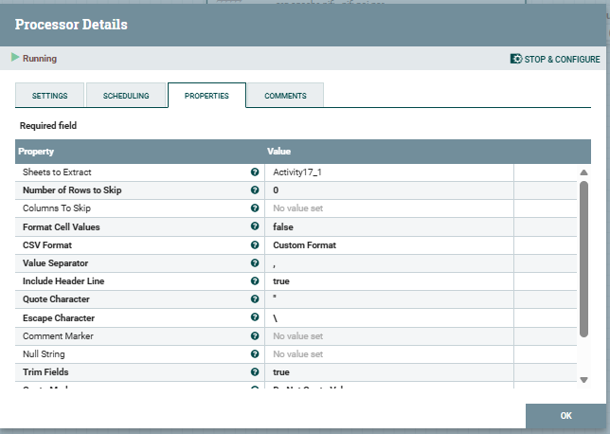
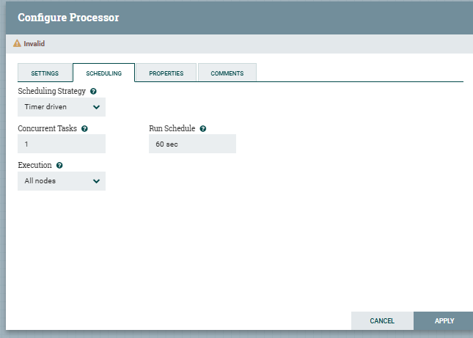

- Provide a screenshot to show that you successfully added the GetFile processor to the NiFi canvas.

- Add a GetFile processor. Provide a screenshot to show that you successfully added the GetFile processor to the NiFi canvas.
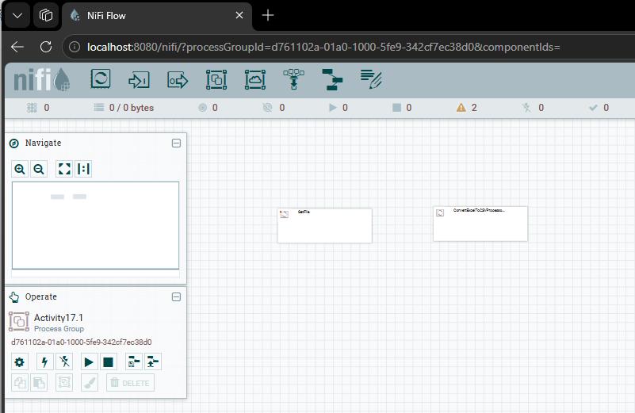
- Provide two screenshots. The first screenshot should show that you set the values in the PROPERTIES tab correctly. The second screenshot should show that you updated the scheduling time in the SCHEDULING tab correctly.

- Step08A_GetFile_Properties
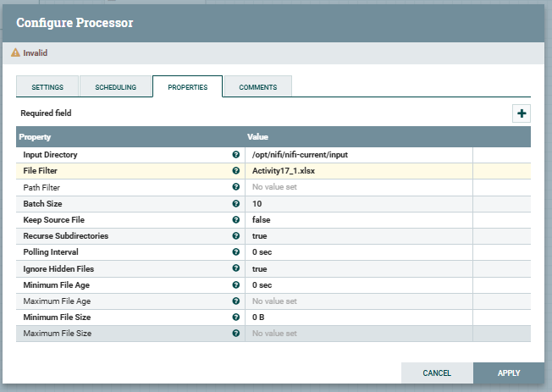

Step08B_GetFile_Scheduling
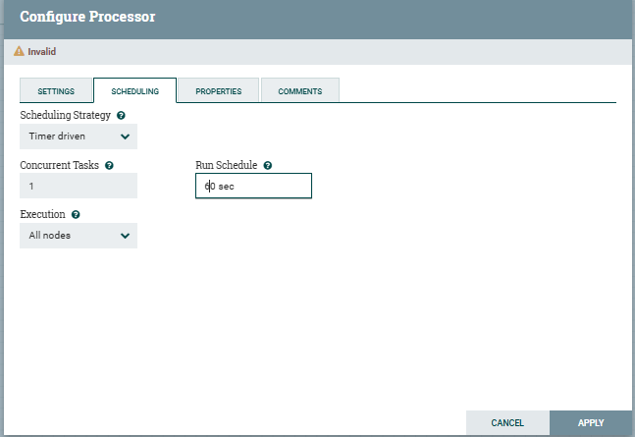
- Provide a screenshot to show that you successfully added the PutFile processor to the NiFi canvas.

- Added PutFile processor to the NiFi canvas
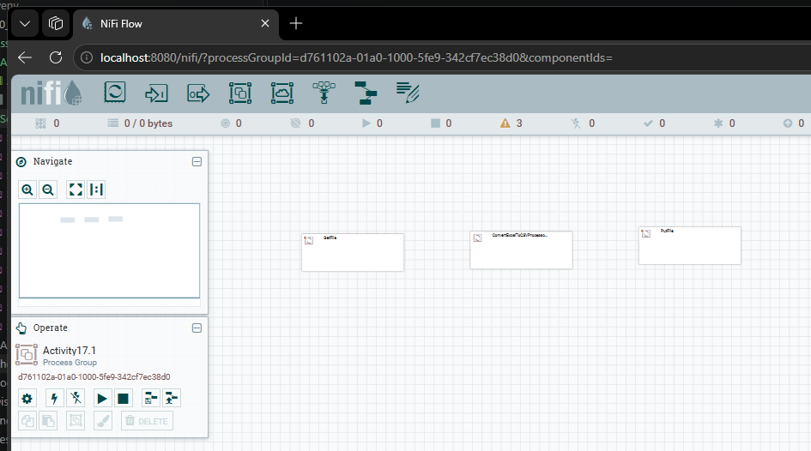

- Provide two screenshots. The first screenshot should show that you set the values in the PROPERTIES tab correctly. The second screenshot should show that you updated the scheduling time in the SETTINGS tab correctly.

- Step10A_PutFile_Properties
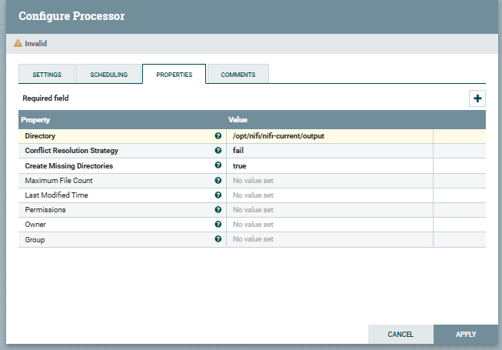
Step10B_PutFile_Settings
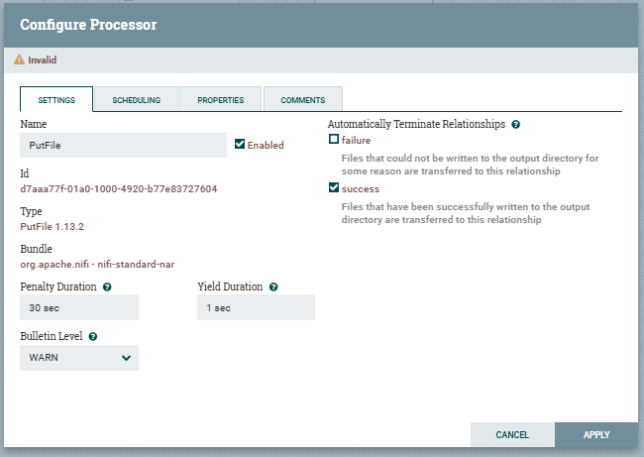

- Provide a screenshot to show that you successfully connected the GetFile and ConvertExcelToCSVProcessor processors.

- Successfully connected GetFile to ConvertExcelToCSVProcessor
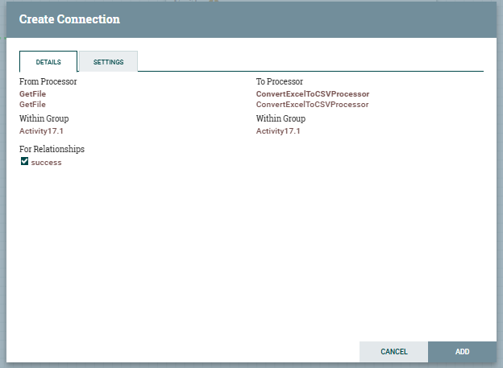

- Connected GetFile to ConvertExcelToCSVProcessor
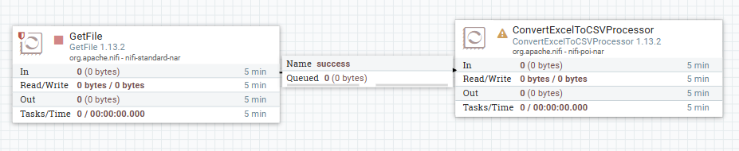

- Provide a screenshot to show that you successfully connected the ConvertExcelToCSVProcessor and PutFile processors.

- Connected ConvertExcelToCSVProcessor to PutFile using failure, original, and success relationships
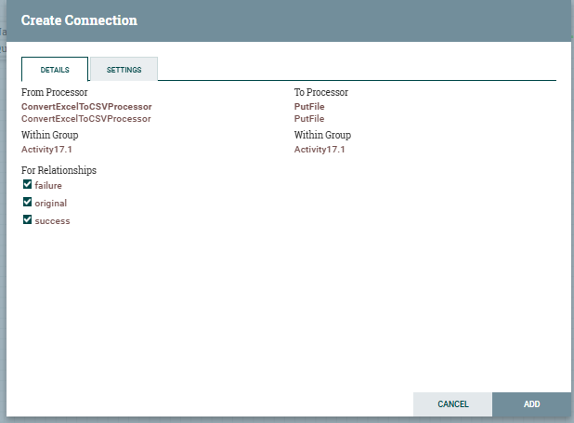

ConvertExcelToCSVProcessor → PutFile:
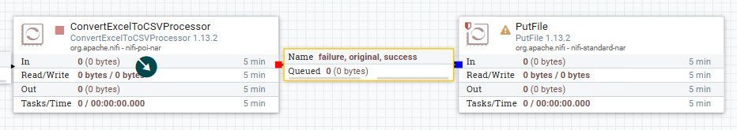

- Provide two screenshots. The first screenshot should show that the GetFile processor is running (as indicated by a green arrow). The second screenshot should show that the input folder is empty (i.e., that the GetFile processor has picked up the file from the input folder for processing).

- Step 13A - GetFile processor running and processing Activity17_1.xlsx
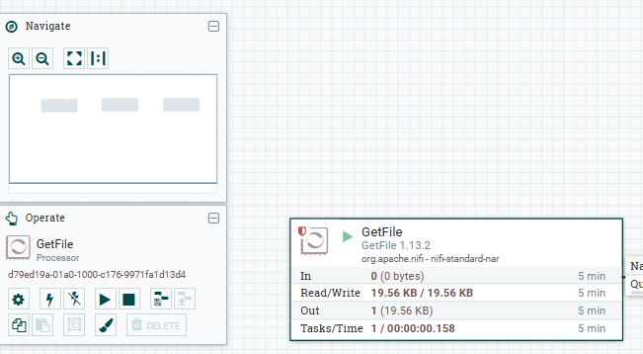

- Successfully picked up by the GetFile processor.
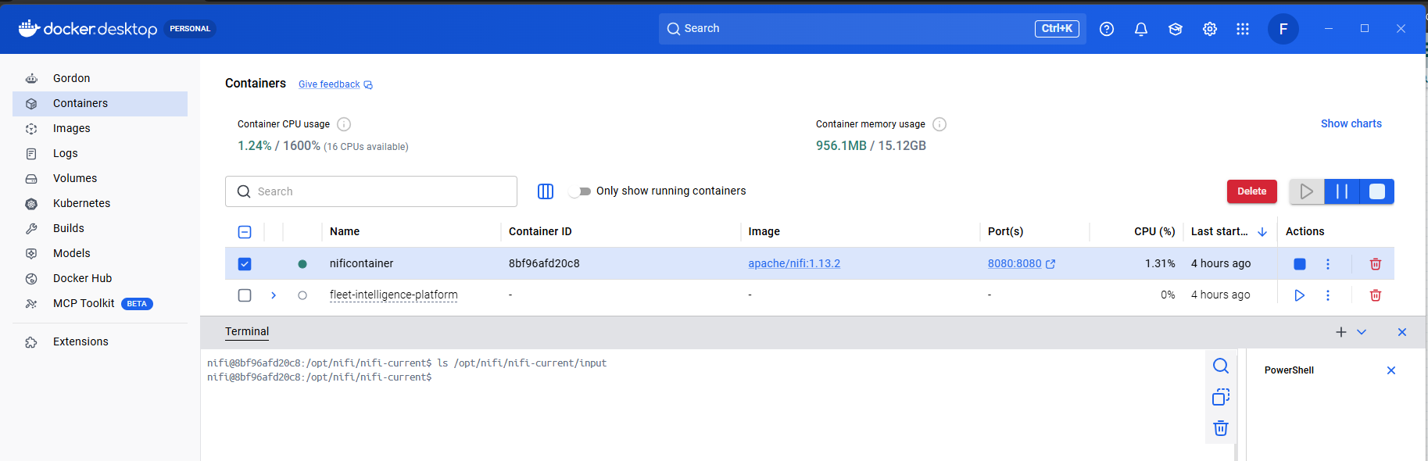

- Provide a screenshot to show that the ConvertExcelToCSVProcessor processor is running (as indicated by a green arrow).

- ConvertExcelToCSVProcessor running
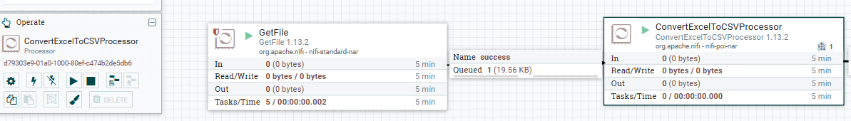

- Provide a screenshot to show that the PutFile processor is running (as indicated by a green arrow).

- PutFile processor running and processing the converted file
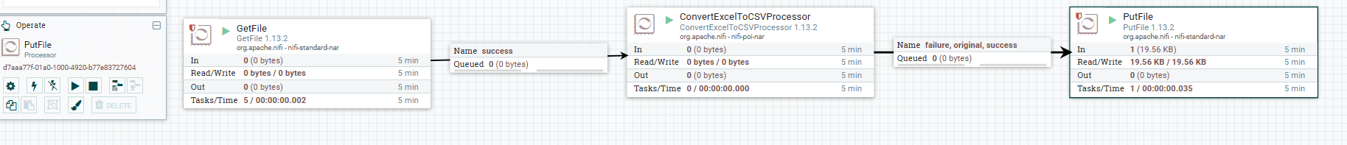

- Provide a screenshot to show that the CSV file has been created.

- Verified CSV file was created in the output directory
