Required Coding Activity 17.5: Using NiFi to Create a Pipeline in Cassandra

- Provide a screenshot of your Docker desktop to show that you successfully created the NiFi and Cassandra containers in the Docker network.
Step 1 - Successfully created the Cassandra and NiFi containers in the NifiNetwork Docker network.
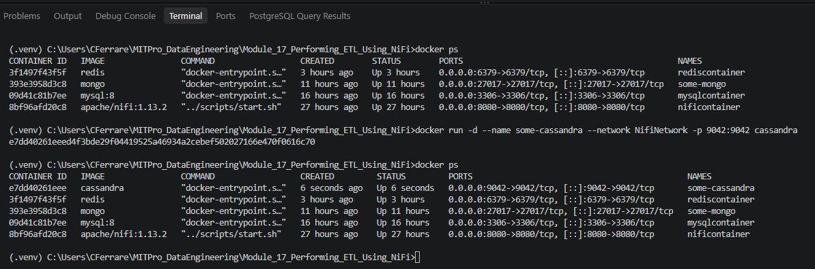

- Provide a screenshot of the bash window in the Cassandra server to show that you successfully ran the cqlsh command.
- Step 2 - Successfully connected to the Cassandra database using the cqlsh command.
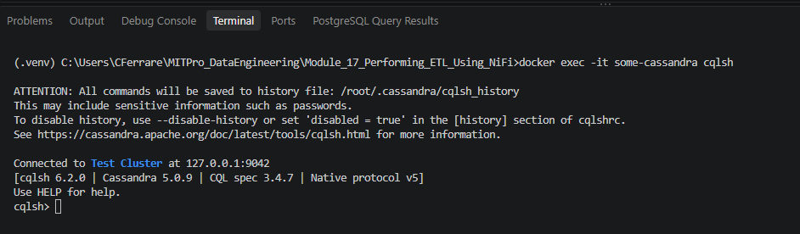

- Provide a screenshot of the Terminal window to show that “Peter Parker” was inserted correctly into the Cassandra data table.

- Step 3 - Successfully created the Cassandra person table and inserted Peter Parker into the database.
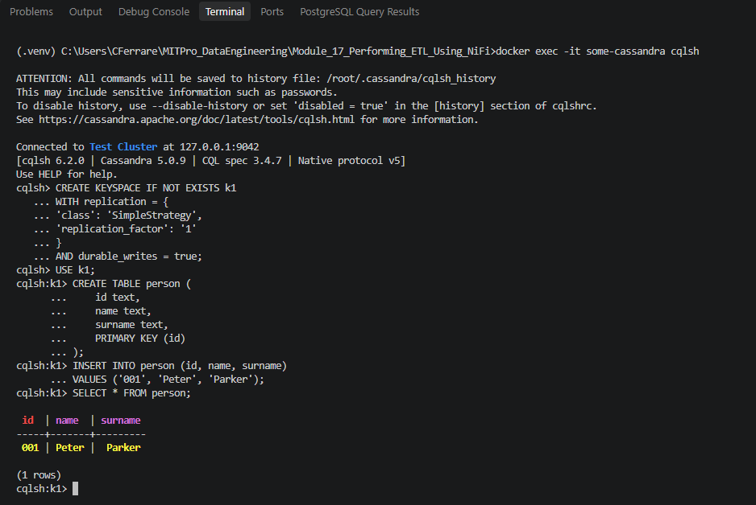

- Provide a screenshot to show that you successfully started the NiFi UI.
- Step 4 - Successfully started and accessed the Apache NiFi user interface.
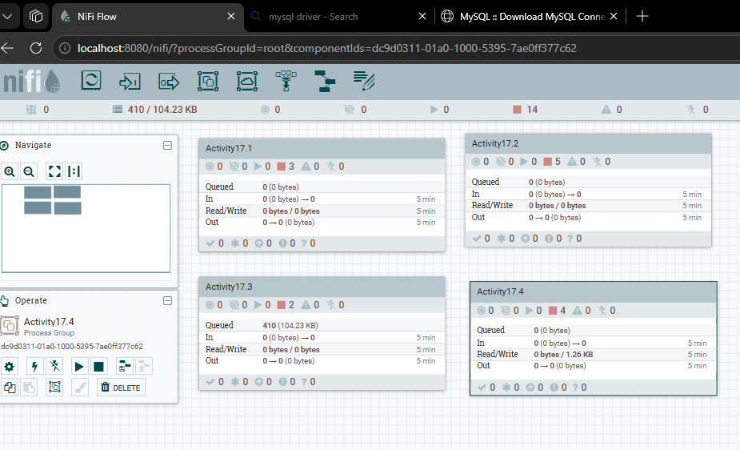
- Provide a screenshot to show that you successfully created the Cassandra-test process group.
- Step 5 - Successfully created the Cassandra-test process group.
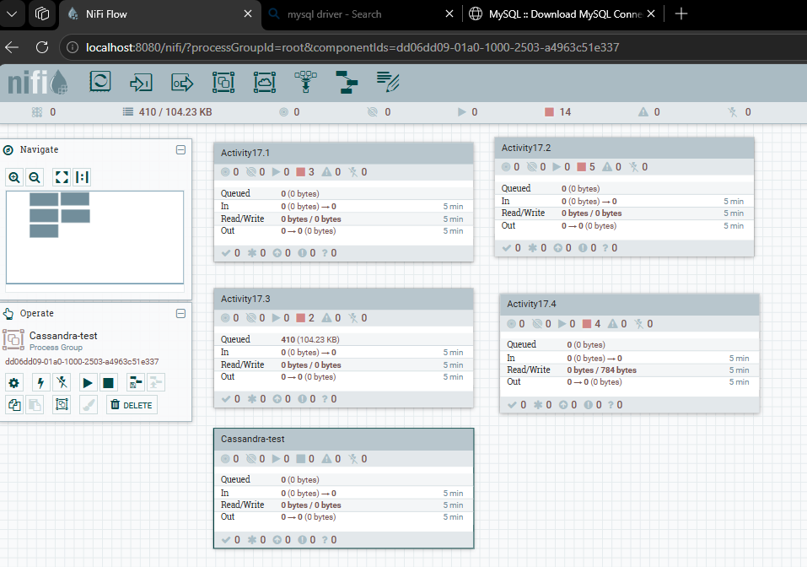

- Provide a screenshot to show that you correctly set the fields of the PROPERTIES tab.
- Step 6 - Configured the CassandraSessionProvider controller service with contact points, authentication, and keyspace settings.
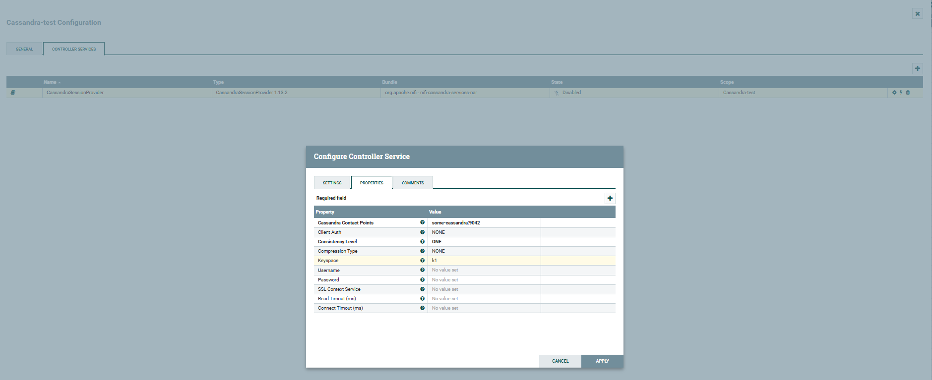

- Provide a screenshot to show that the CassandraSessionProvider controller service was successfully activated.

Step 7 - Successfully enabled the CassandraSessionProvider controller service.
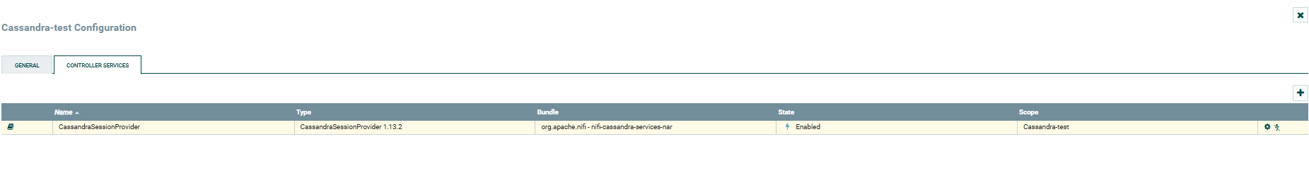

- Provide a screenshot to show that you correctly set the fields of the PROPERTIES tab.
- Step 8 - Configured QueryCassandra with the CassandraSessionProvider connection, keyspace k1, client authentication, and JSON output format.
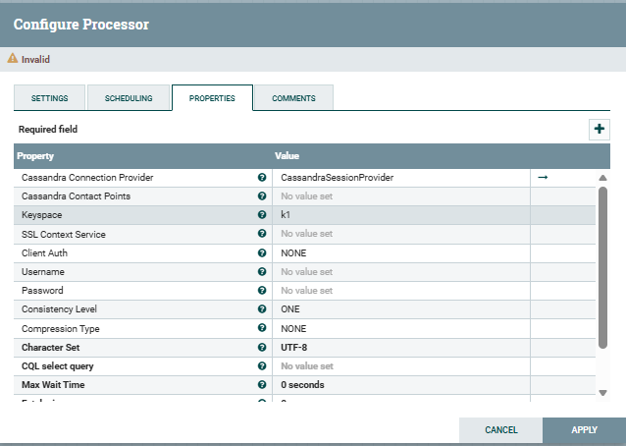

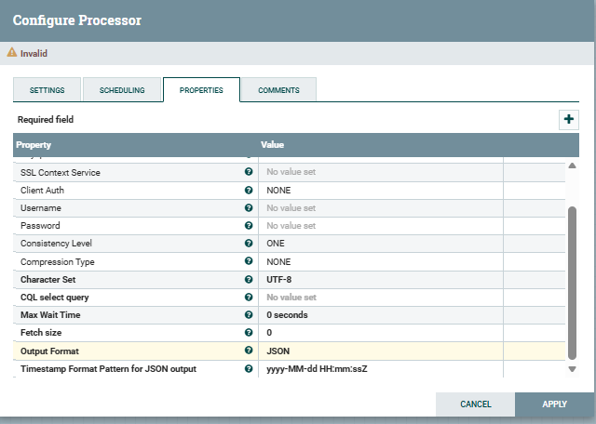
- Provide a screenshot to show that the person table is empty within MySQL Workbench.
Step 9 - Verified that the person table in the people database is empty prior to running the Cassandra-to-MySQL ETL pipeline.

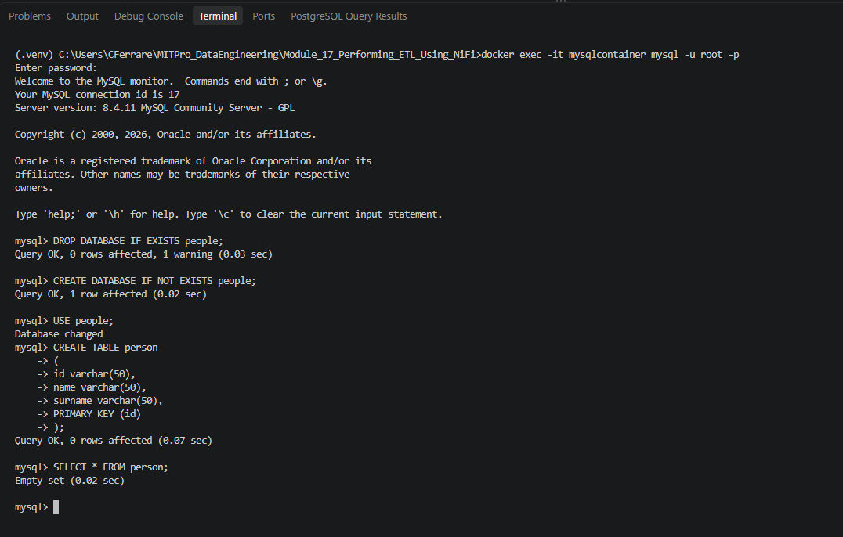

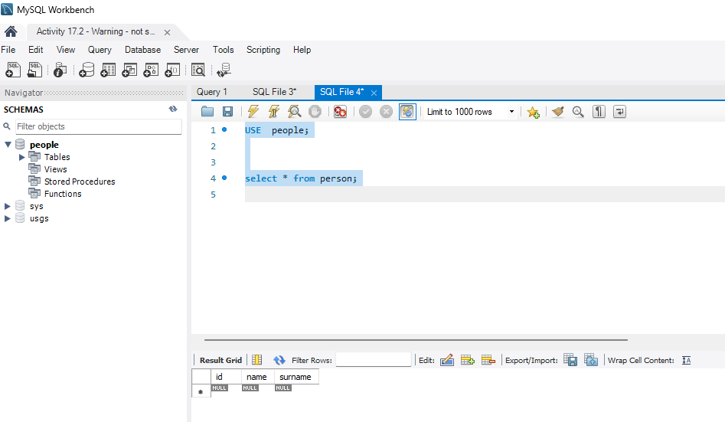
- Provide a screenshot of the DBCPConnectionPool connector service activated within the NiFi UI.
- Step 10 - Configured and enabled the DBCPConnectionPool controller service for the MySQL people database.

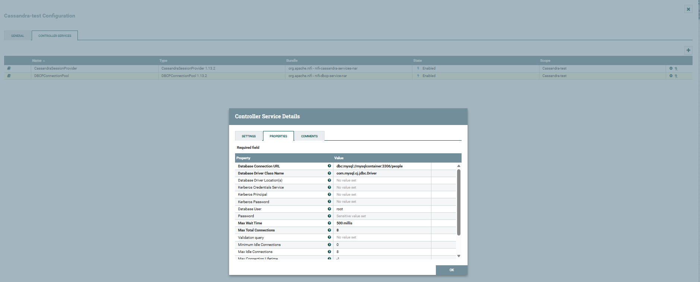
- Provide two screenshots. The first screenshot should show that you set the values in the SETTINGS tab correctly. The second screenshot should show that you updated the scheduling time in the PROPERTIES tab correctly.
Step 11A - Configured SplitJSON automatic relationship termination settings for failure and original relationships.

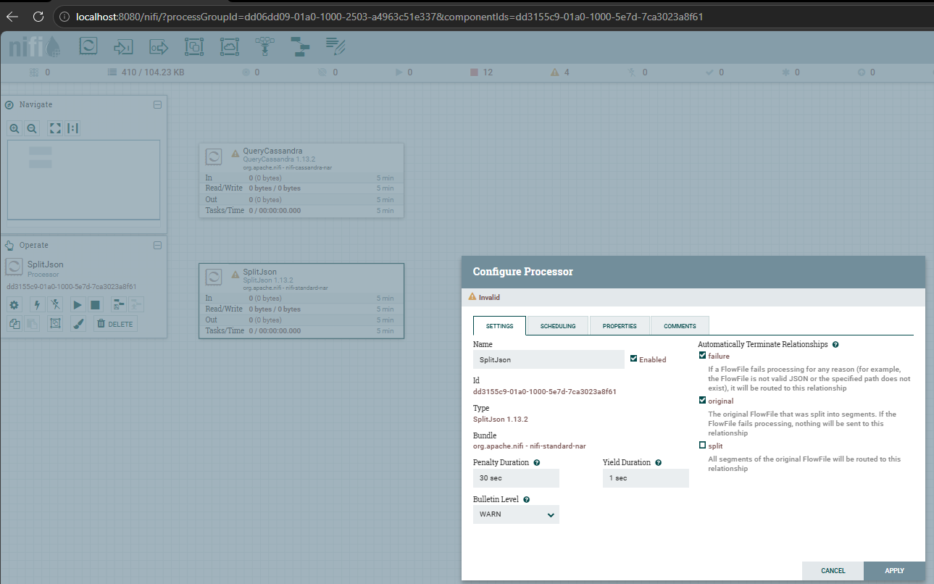

- Step 11B - Configured SplitJSON using the JsonPath expression $.*.
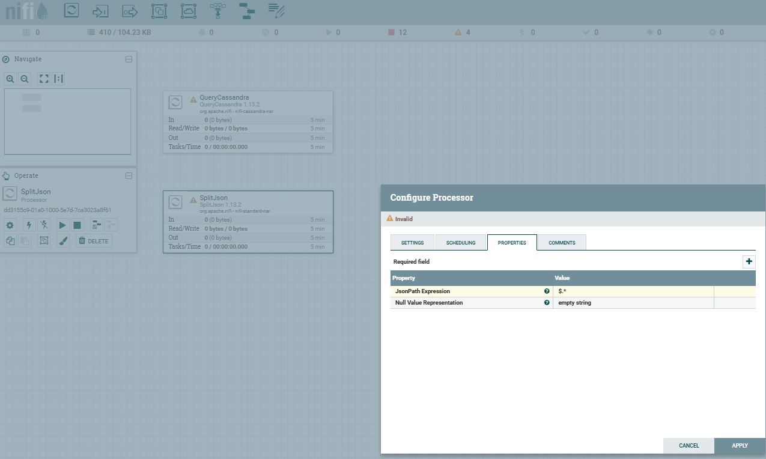

- Provide a screenshot to show that you configured the PROPERTIES tab for the ConvertJSONToSQL processor correctly.
- Step 12 - Configured ConvertJSONToSQL to generate INSERT statements for the people.person table.

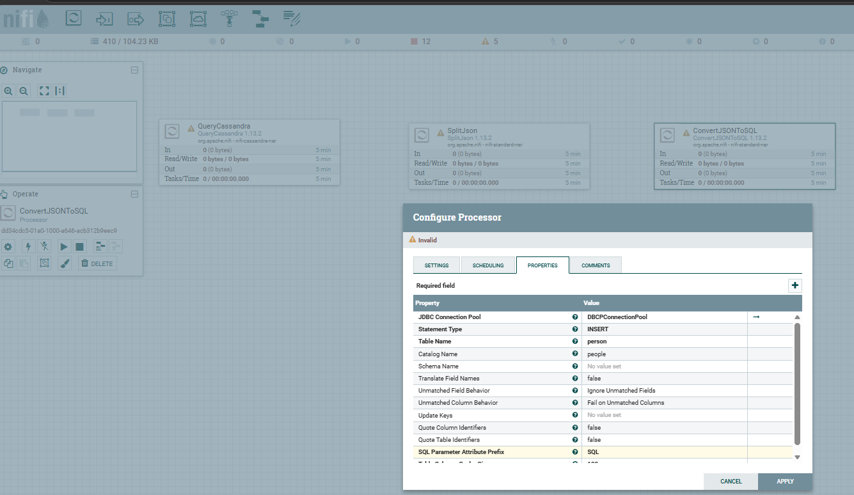
- Provide a screenshot of the connected QueryCassandra, SplitJSON, and ConvertJSONToSQL processors.
- Step 13 - Connected QueryCassandra, SplitJSON, and ConvertJSONToSQL using success and split relationships.

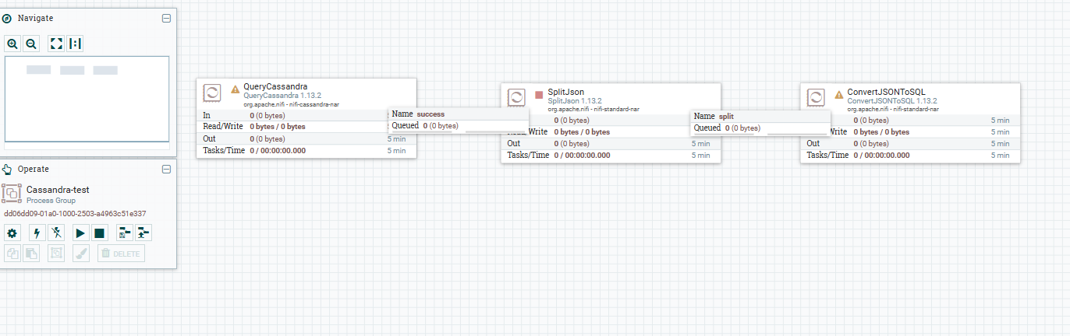
- Provide a screenshot to show that all four processors (QueryCassandra, SplitJSON, ConvertJSONToSQL, and PutSQL) are connected.
- QueryCassandra
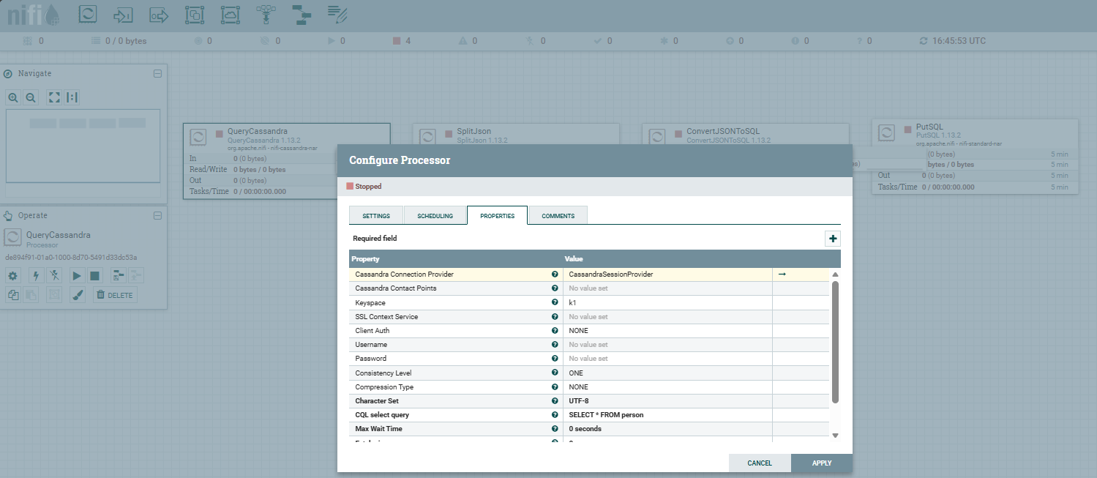

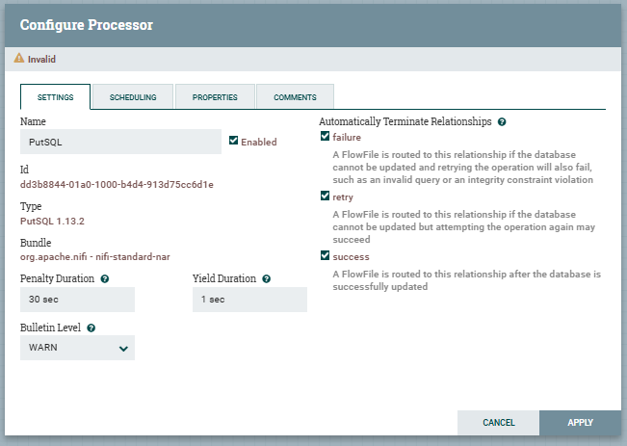
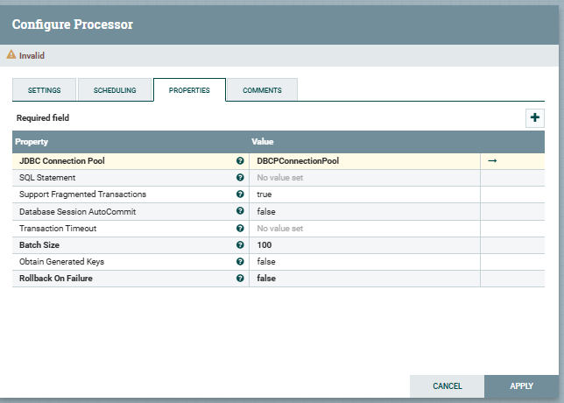
Step 14 - Connected QueryCassandra, SplitJSON, ConvertJSONToSQL, and PutSQL to complete the Cassandra-to-MySQL ETL pipeline.
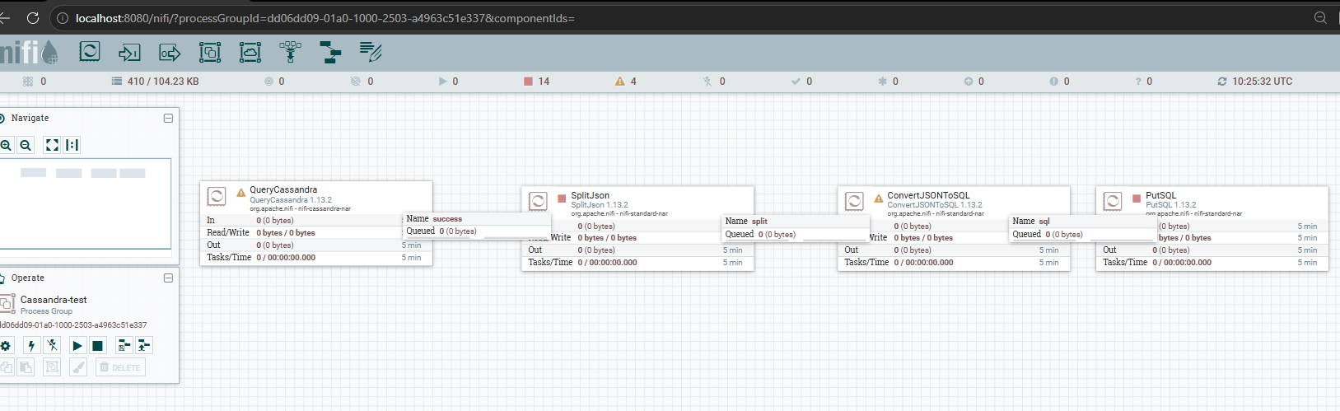
- Provide a screenshot to show the data was added to your MySQL database correctly.
- Run all the processors for the Cassandra-test flow.
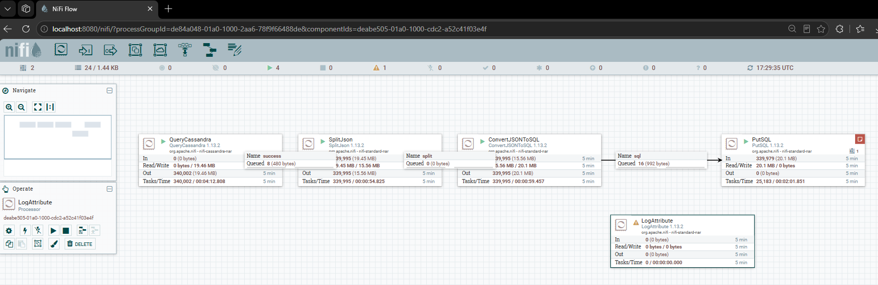
Step 15 - Verified that the Peter Parker record was successfully transferred from Cassandra into the MySQL person table using the NiFi ETL pipeline.

