Required Coding Activity 17.4: Using NiFi to Create a Pipeline in Redis

- Provide a screenshot of your Terminal window to show that you successfully started Redis.

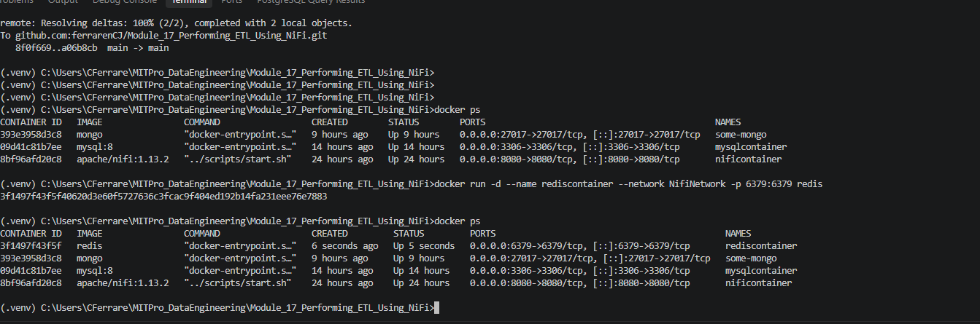

- Provide a screenshot of your Terminal window to show that you successfully started NiFi.
Step 2 - Successfully started Apache NiFi and verified the container is running.
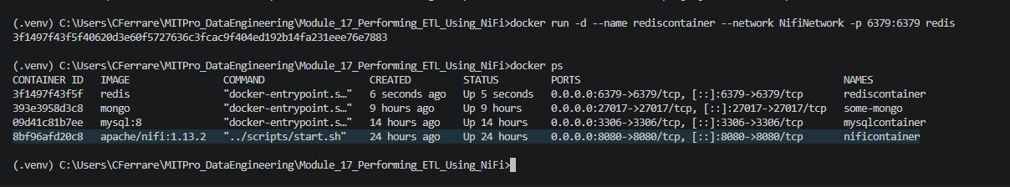

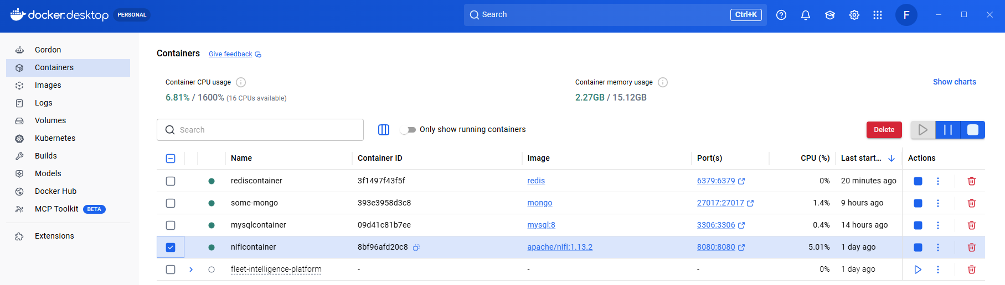

- Provide a screenshot to show that you successfully opened the NiFi UI.
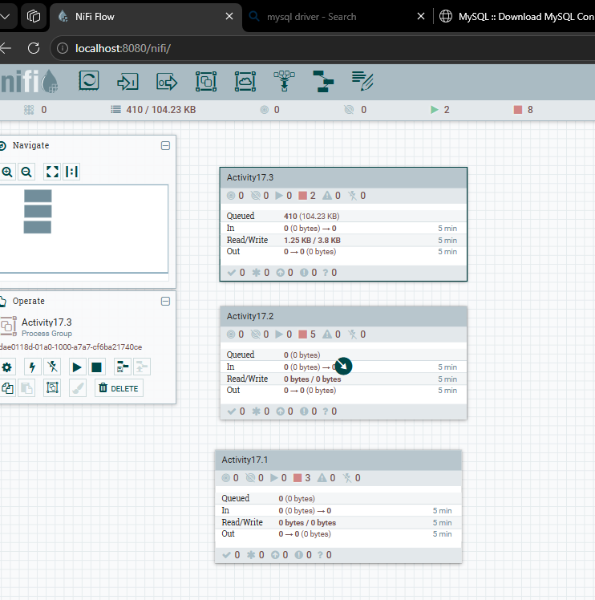

- Provide a screenshot to show that you set the RedisConnectionPoolService controller settings correctly.
- Step 4 - Configured the RedisConnectionPoolService controller using localhost:6379.
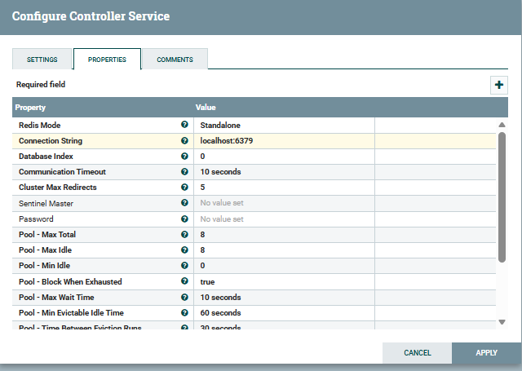
- Provide a screenshot to show that you set the RedisDistributedMapCacheClientService controller settings correctly.

- Step 5 - Configured the RedisDistributedMapCacheClientService controller to use RedisConnectionPoolService.
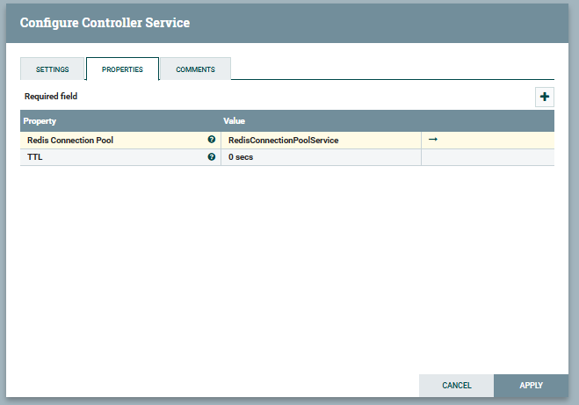

- Provide a screenshot to show that you enabled both the RedisConnectionPoolService and RedisDistributedMapCacheClientService controllers.

- Step 6 - Enabled the RedisConnectionPoolService and RedisDistributedMapCacheClientService controllers.
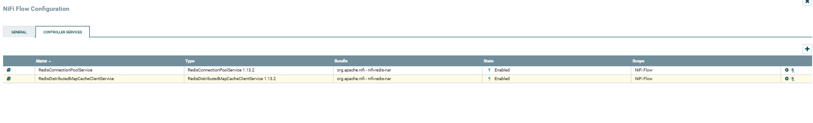
- Provide two screenshots. The first screenshot should show that you set the values in the PROPERTIES tab correctly. The second screenshot should show that you updated the scheduling time in the SCHEDULING tab correctly.

- Step 7A - Configured GenerateFlowFile to generate the current date and time using ${now()}.
- 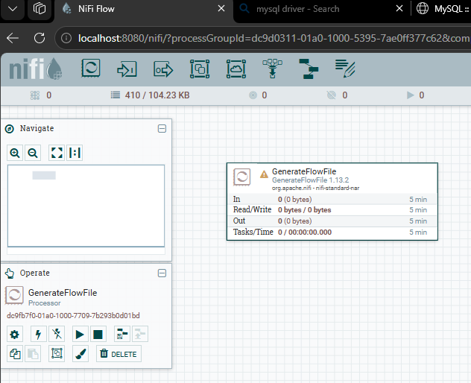

Step 7B - Configured GenerateFlowFile to run every 5 seconds.
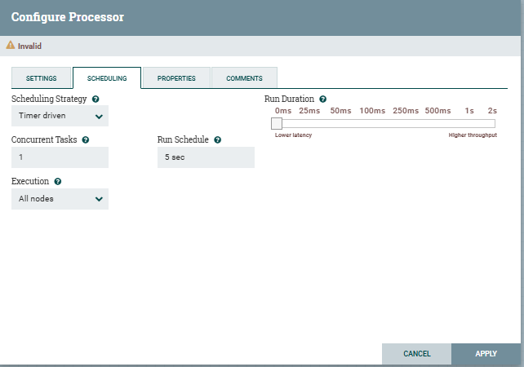
- Provide a screenshot to show that you set the PutDistributedMapCache controller settings correctly.

- Step 8 - Configured PutDistributedMapCache to store the current date and time in Redis using the key "date".
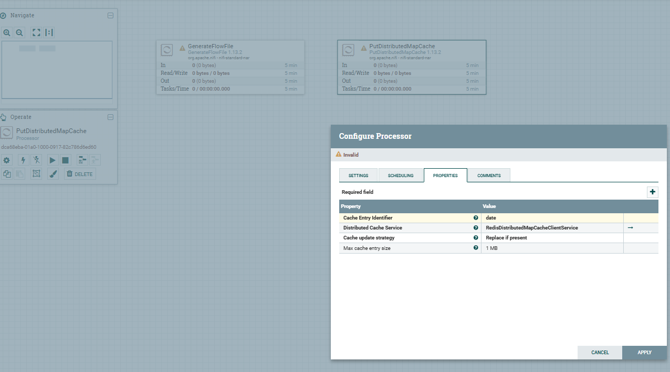

- Provide a screenshot to show that you set the FetchDistributedMapCache controller settings correctly.
- Step 9 - Configured FetchDistributedMapCache to retrieve the Redis value using the key date and store it in the date.retrieved attribute.
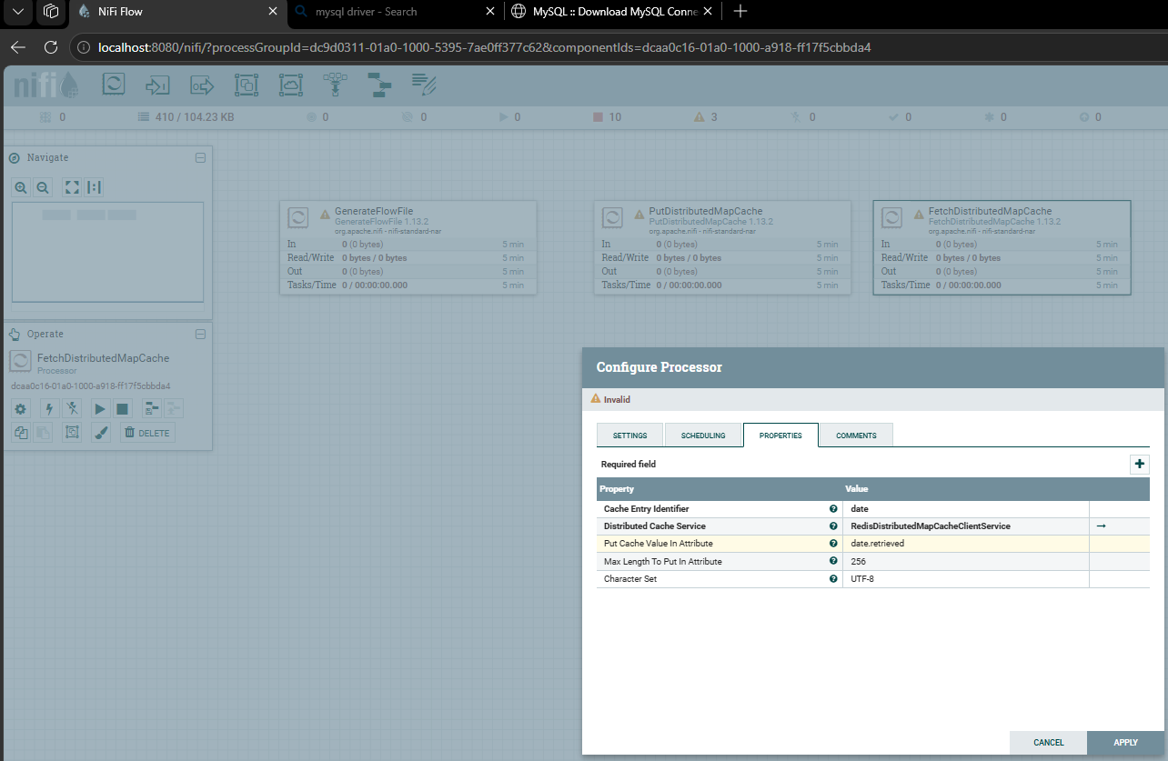
- Provide a screenshot to show that you have all the processors, GenerateFlowFile, PutDistributedMapCache, FetchDistributedMapCache, and LogAttribute, ready in NiFi.

- Step 10 - Added GenerateFlowFile, PutDistributedMapCache, FetchDistributedMapCache, and LogAttribute processors to the Activity17.4 process group.
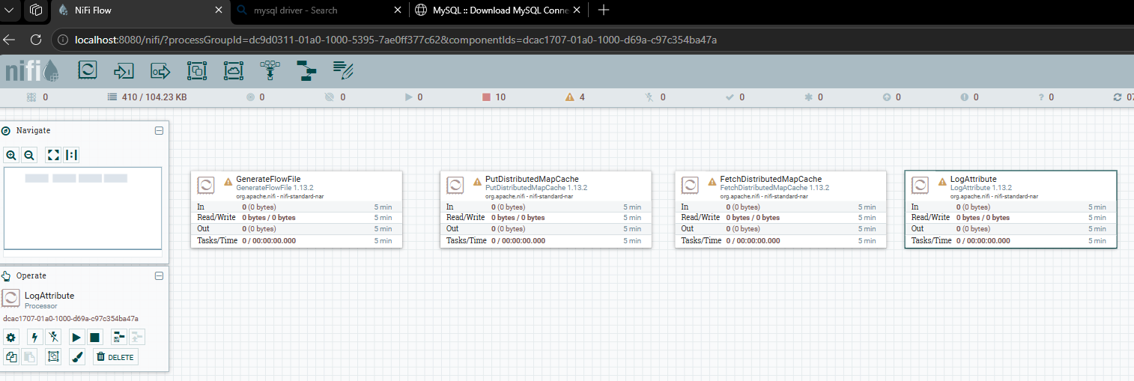

- Provide a screenshot to show that your flow is running with the correct relationships.
- Set Automatically Terminate Relationships equal to failure
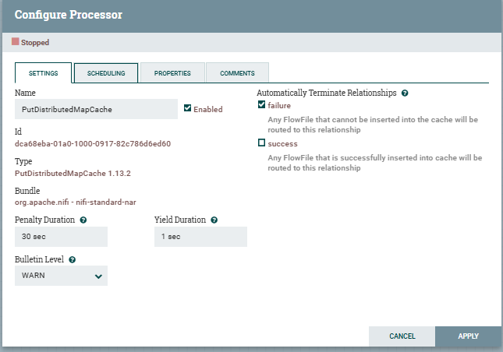

- Set Automatically Terminate Relationships equal to failure and not-found.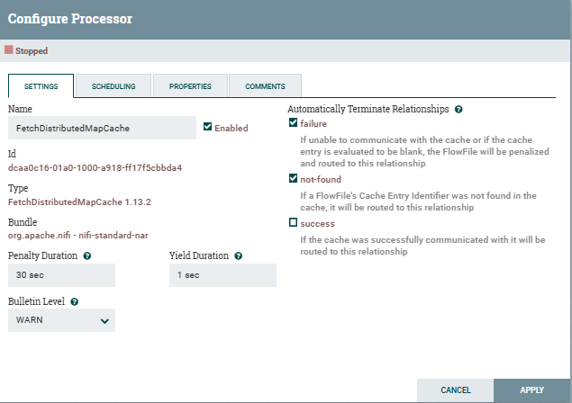

- Set Automatically Terminate Relationships equal to success.
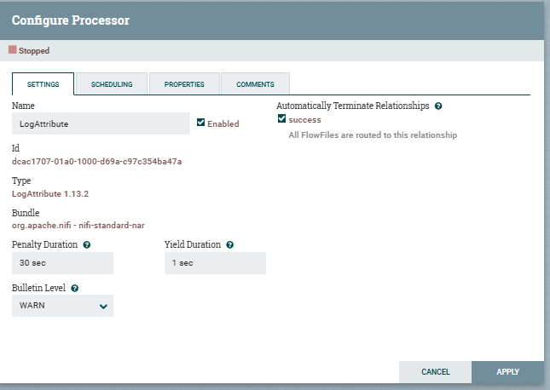

Step 11 - Successfully executed the Redis ETL pipeline with GenerateFlowFile, PutDistributedMapCache, FetchDistributedMapCache, and LogAttribute connected using success relationships.
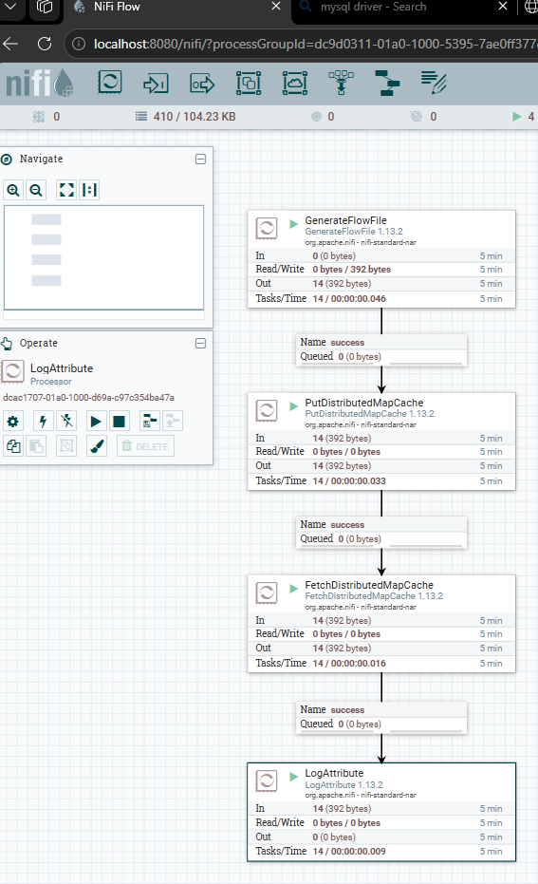

- Provide a screenshot to show that the nifi-app.log is being populated with the current date and time.
- Step 12 - Verified that nifi-app.log is being populated with the current date and time retrieved from Redis.
