Required Coding Activity 17.3: Using NiFi to Create a Pipeline in MongoDB

- Provide a screenshot of your Docker desktop to show the MongoDB and NiFi Docker containers running.

- Created mongo containers since we have NiFi already from previous activity.
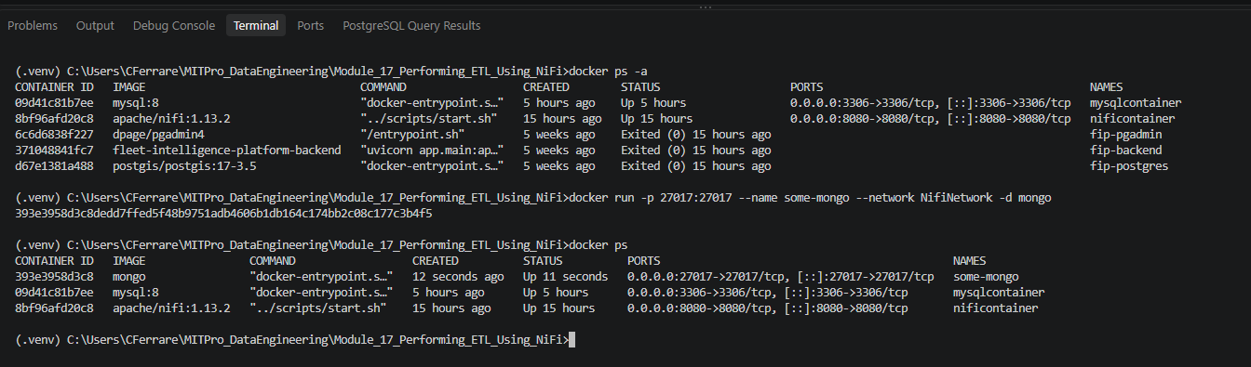

- Provide a screenshot to show that the output directory exists in the NiFi container.

- Step 2 - Verified the output directory exists in the NiFi container.

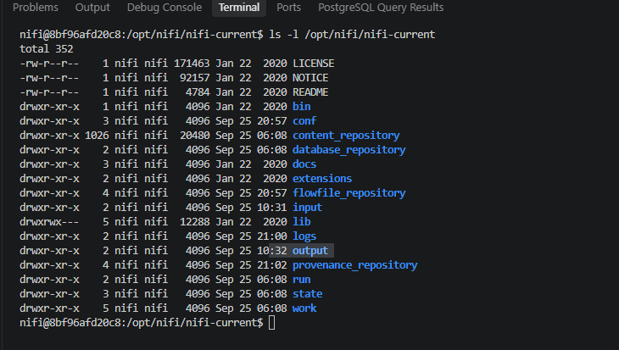

- Provide a screenshot to show that you successfully populated the MongoDB database.
- Step 3 - Successfully populated the sample_mflix.movies collection in MongoDB and verified the inserted documents.
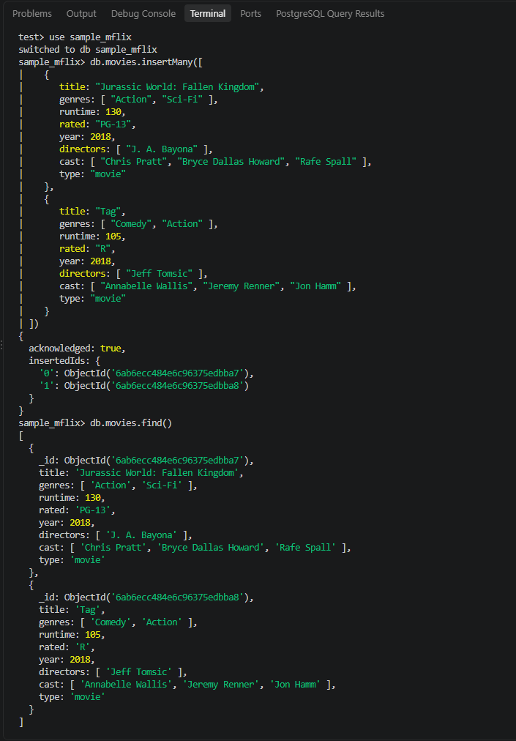
- Provide a screenshot to show that you successfully created the new Activity17.3 process group.

- Step 4 - Successfully created the Activity17.3 process group.
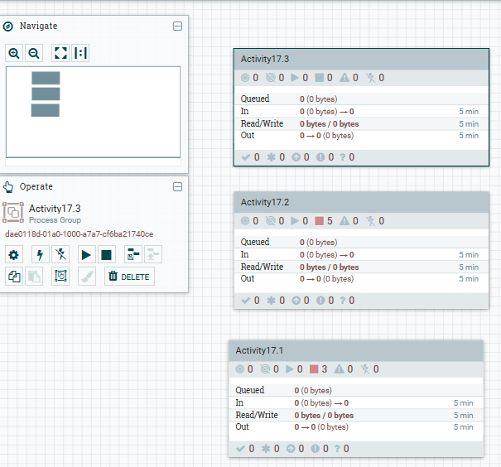

- Provide a screenshot to show that you successfully added the GetMongo process group.

- Step 5 - Successfully added the GetMongo processor to the Activity17.3 process group.
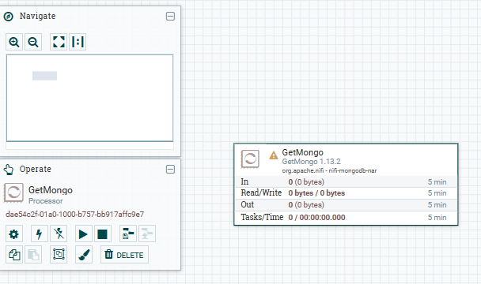

- Provide a screenshot to show that you successfully configured the GetMongo processor to connect to the MongoDB database.

- Step 6 - Configured the GetMongo processor to connect to the sample_mflix.movies collection in MongoDB.
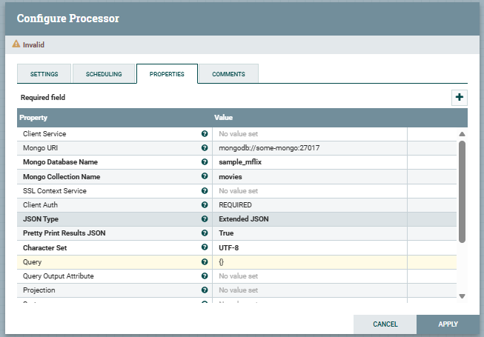

- Provide a screenshot to show that you successfully added the PutFile processor.
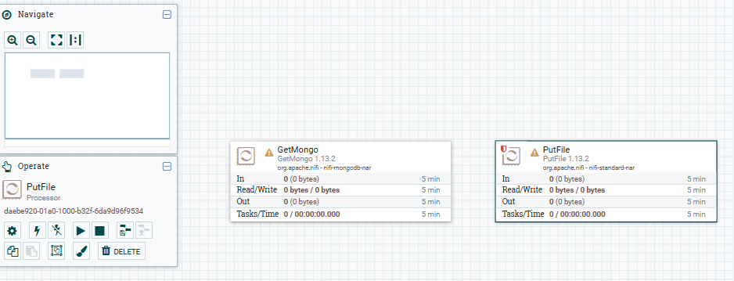

- Provide two screenshots. The first screenshot should show that you set the values in the SETTINGS tab correctly. The second screenshot should show that you updated the scheduling time in the PROPERTIES tab correctly.

Step 8A - Configured the PutFile Settings tab with failure and success relationships automatically terminated.
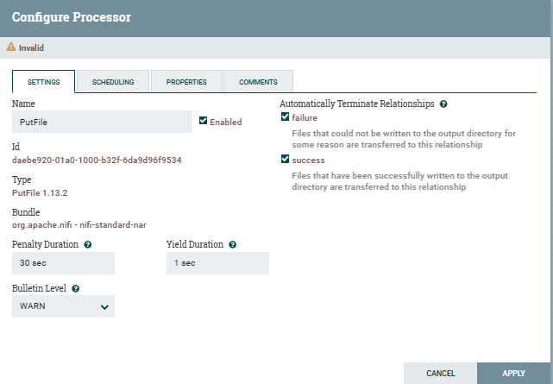

Step 8B - Configured the PutFile output directory and scheduling settings.
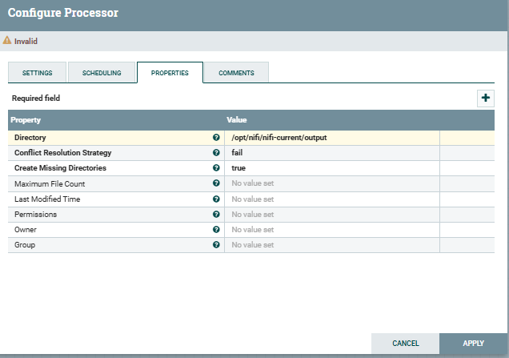
- Provide a screenshot to show that you successfully created and configured the connector between the GetMongo and PutFile processors.

Step 9 - Successfully created and configured the connector between GetMongo and PutFile.
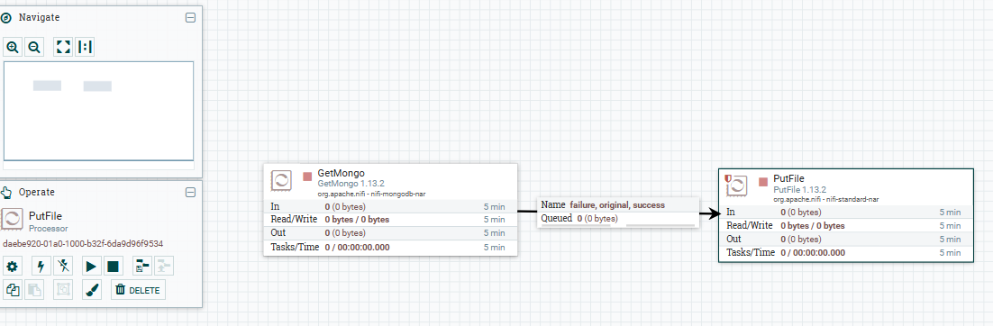

- Provide a screenshot of the NiFi canvas to show the GetMongo and PutFile processors running.

Step 10 - Successfully started the GetMongo and PutFile processors and verified data flow.
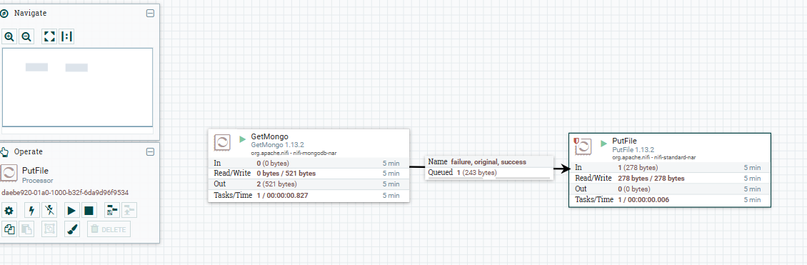

- Provide a screenshot to show that the /opt/nifi/nifi-current/output directory has files being populated.

Step 11 - Verified that the NiFi pipeline created files in the output directory.
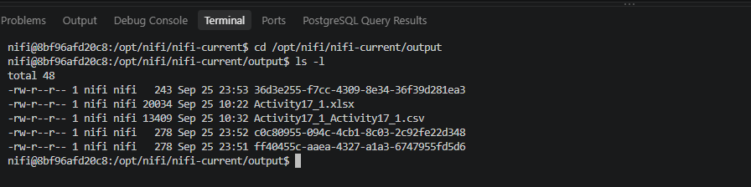

- Provide a screenshot to show that you successfully issued the cat command to display the contents of one file.
Step 12 - Displayed the JSON contents of a file generated by the MongoDB and NiFi ETL pipeline.
