Required Coding Activity 17.2: Using NiFi to Load Data to MySQL

- Provide a screenshot of your MySQL Workbench to show that you have successfully initialized an empty earthquakes table in the usgs database.

Step 1 - Successfully initialized the earthquakes table in the usgs database.
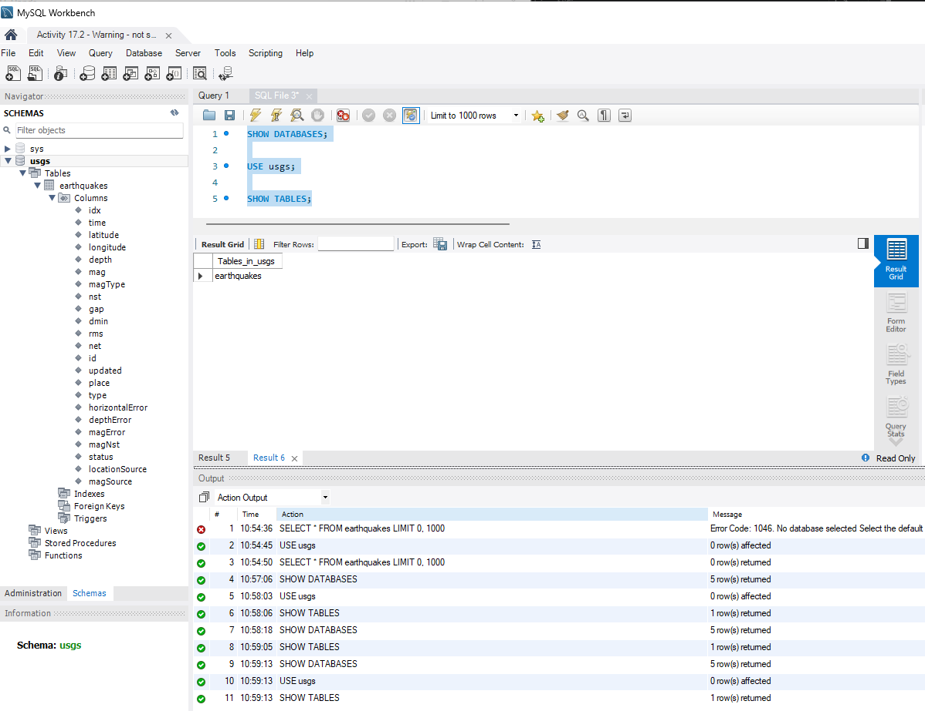

- Provide a screenshot to show that the Activity17-2.csv CSV file is now on the NiFi server.

- Successfully copied to nificontainer:/opt/nifi/current-nifi/data
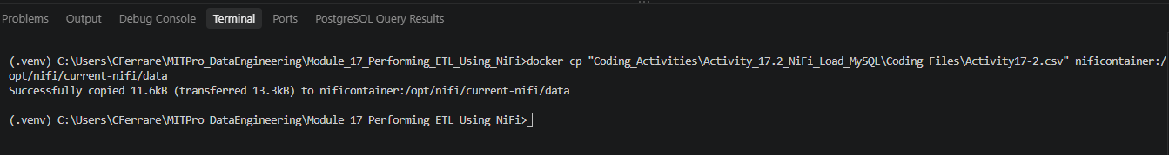

- Verified Activity17-2.csv was copied to the NiFi server.
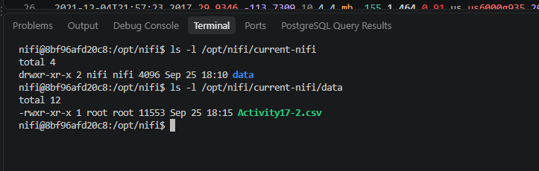

- Provide a screenshot of the controller screen to show that the three controller services (reader, writer, and MySQL) are enabled.

- Step 3 - Enabled MySQL, CSVReader, and JsonRecordSetWriter controller services.
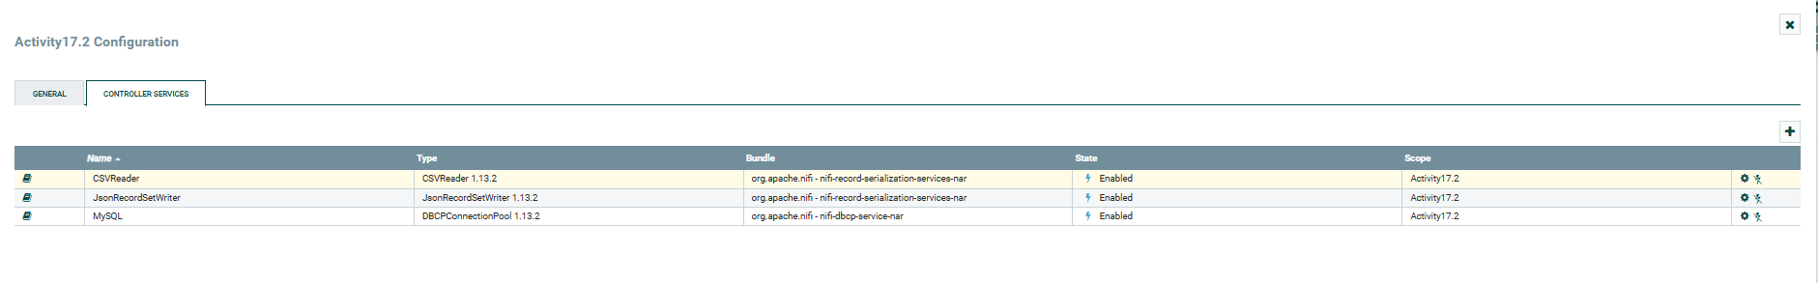

- Provide a screenshot of your complete data pipeline, including all five processors: GetFile, SplitText, ConvertRecord, ConvertJSONToSQL, and PutSQL.

- Step 4 - Created the five-processor data pipeline using GetFile, SplitText, ConvertRecord, ConvertJSONToSQL, and PutSQL.
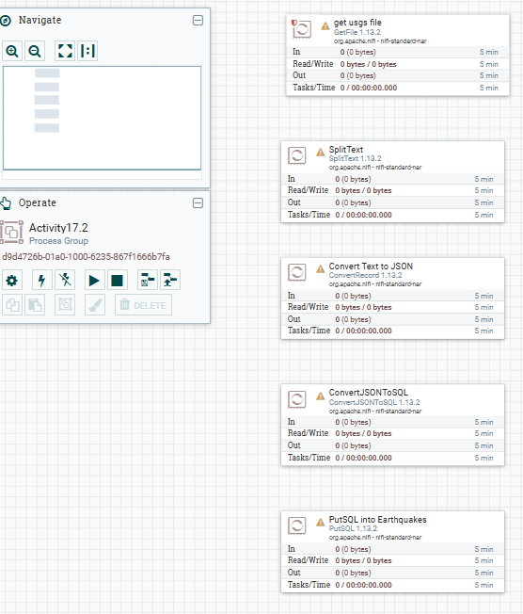

- Provide a screenshot of all five processors to show that the correct connections have been made.

Step 5 - Created all required processor connections including the PutSQL retry loop. 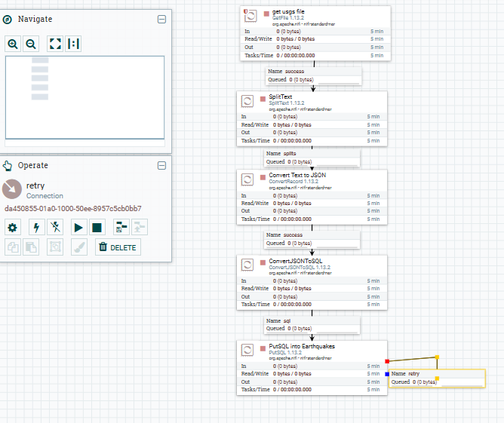

- Provide a screenshot of your NiFi browser screen to show all five processors connected and running.

- Step 6 - All five processors connected and running while loading earthquake data into MySQL.
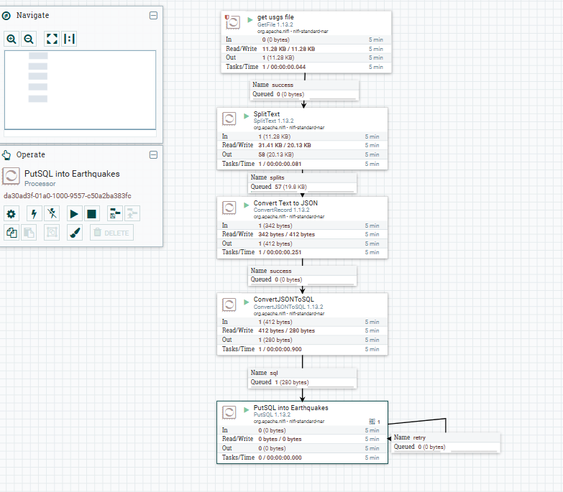

- Provide a screenshot of the result of this query to show that the earthquakes table in the usgs database is now saturated with data.

- Step 7 - Verified that earthquake data was successfully loaded into the earthquakes table in the usgs database. The table contains 58 records loaded through the NiFi ETL pipeline.

