# B.A. Solutions

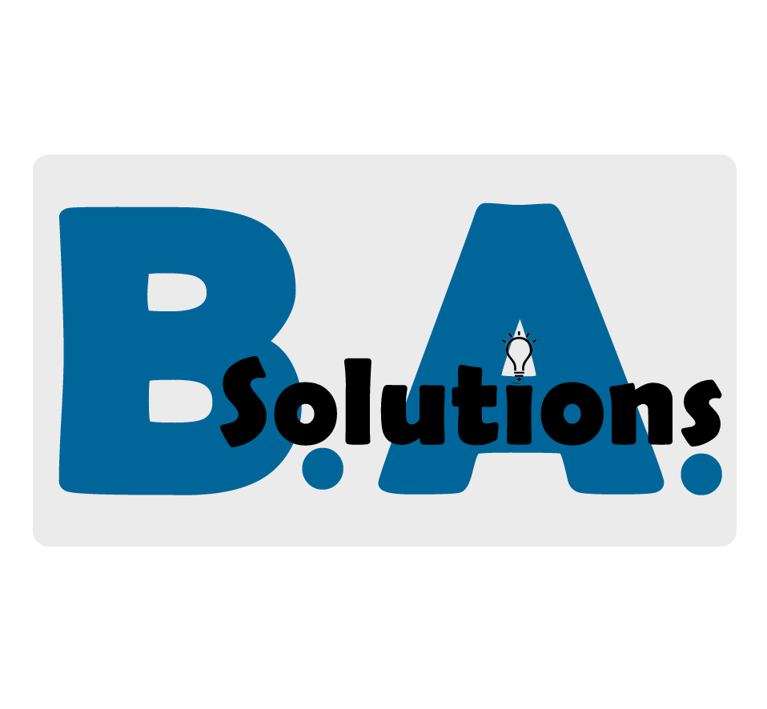

Statement of Work

M&P Records 21st Century Upgrade

Version 1.1.2

Thursday, February 16, 2017

Presented by: Trent Foor

Time and materials

|  |  |
| --- | --- |
| Client name | M&P Records |
| Client’s administrator | Mom Murdock |
| Project name | M&P Records 21st Century Upgrade |
| Engagement duration | One-hundred and eighty-five days (185) |
| Begin date | Feburary 29, 2017 |
| End date | August 6, 2017 |

Schedule of rates

[Include fixed-rate costs for items such as equipment and hourly rates for employee time and service.]

|  |  |  |
| --- | --- | --- |
| Item description | Delivery schedule (Business days) | Cost (estimate) |
| Equipment (Computers, network, and installation) | 15 | $35,000.00 |
| Software (purchased for equipment, i.e., Operating Systems) | 5 | $5,000.00 |
| Software (in-house development) | 50 | $80,000.00 |
| Integration | 10 | $4,842.00 |

Payment terms

|  |  |  |
| --- | --- | --- |
| Phase | Completion date | Payments due |
| Milestone One | February 16, 2017 | $45,000.00 |
| Milestone Two | March 16, 2017 | $35,000.00 |
| Milestone Three | April 16, 2017 | $40,000.00 |
| Project completion | May 13, 2017 | $80,000.00 |

Statement of work

Assumptions

[List any general assumptions regarding the project. Provide details about who will provide what materials, services, and information.]

All work is to meet local and National electrical codes as required by the NEC [1]

All hardware (network, server/client and support) is installed to ‘best practice’ per manufacturer and/or accepted industry standards.

Project is “Inclusive”, meaning B.A. Solutions is responsible for all costs included in this agreement. This assumption does not include modifications, additions, or deletions to this agreement.

Change management process

[Describe how to handle any changes to the project scope listed in the SOW. Detail how the changes will be addressed and implemented and how the associated costs will be handled.]

All changes are submitted in writing to both parties. Agreement is between M&P Records and B.A. Solutions. Both parties to state person responsible for initiating, reviewing and accepting changes.

Engagement related expenses

[Detail how all expenses that incur as a cost of doing business for the project will be handled. Explain who will be responsible for what expenses.]

All hardware procurement costs and installation expences handled by B.A. Solutions.

Marketing tools, documents, procures and all related items provided by B.A. Solutions

Changes are handled by this Statement of Work.

Professional services agreement

[Detail the general terms and conditions for services provided to your client. Include who owns the product once the project is complete and how maintenance or upgrades will be handled and billed in the future.]

All hardware and software is the wholly owned property of M&P Records. B.A. Solutions to provide any and all warranty information to M&P Records.

B.A. Solutions will provide all procurement, installation and software design/implemention to M&P Records. M&P Records should not be concerned with any aspect of this project before B.A. Solutions completes this project.

Acceptance and authorization

[Use the following area to create a signature page that confirms agreement of the products and services to be delivered, when, how, and for what price. Be sure to include any legal language as required by our company's legal representative. Get signatures of the client administrator, the Statement of Work author, and any other parties who are responsible for the SOW.]

The terms and conditions of the **Professional Services Agreement** apply in full to the services and products provided under this Statement of Work.

The sum of Two-hundred thousand dollars (USD) [$200,000.00] covers all costs incurred within the scope of this aggreement.

Changes or additions ot this agreement will be by mutual., written, agreement before commensing work.

**IN WITNESS WHEREOF**, the parties hereto each acting with proper authority have executed this Statement of Work, under seal.

|  |  |  |
| --- | --- | --- |
| Mom Murdock |  | Trent Foor |
| Full name |  | Full name |
| Owner, M&P Records |  | C.E.O., B.A. Solutions, Inc. |
| Title |  | Title |
|  |  |  |
| Signature |  | Signature |
| February 18, 2017 |  | February 18, 2017 |
| Date |  | Date |

NOTES

[1] The **National Electrical Code** (**NEC**), or NFPA 70, is a regionally adoptable standard for the safe installation of **electrical** wiring and equipment in the United States. It is part of the **National** Fire Codes series published by the **National** Fire Protection Association (NFPA), a private trade association.