, ,

By Author Name

Please see *Getting Started* on page 2

Please see *Great Articles* on page 3

By Author Name

# Writing Great Newsletter Articles

“You can transform your life and business in just seven minutes a day.” If that statement makes you want to read on, consider yourself hooked.

A newsletter is competing against a lot of distractions for the reader’s attention, so it’s important that the first one or two sentences of an article hook the reader. And since that hook creates an expectation, the article needs to justify the use of the hook, or the reader will feel manipulated.

Along with the hook, the article’s headline needs to be brief, active, and clear in its purpose. Beyond these essential characteristics, a headline attracts attention if it’s highly relevant, inspires curiosity, or has some other irresistible quality.

Newsletter articles are short on space and their readers are short on time, so the articles must be well-focused, aiming to make one major point. The making of this point can be achieved through two to five (or so) sub-points. These points must have, as their primary aim, the benefit of the reader, who should be able to point out this benefit. It can be new knowledge or insight, an idea about how to improve business, or better, how your business can improve them. The article should clarify, inspire, encourage, enthuse, provoke thought, satisfy—it should elicit a positive response. And the best response of all, of course, is that the reader decides that your products or services provide the solutions they need.

To sum it up, grab the reader’s attention through an effective headline and hook, and then reward the reader for following through by giving them something they didn’t have before. In addition, keep the article brief and well-focused, and if appropriate, demonstrate how your products and services address the issues raised in the article. By doing so, you stand a good chance of keeping the readers you have, and of gaining new readers with every issue.

When designed correctly, a newsletter provides specialized information to a targeted audience. To help you achieve this goal, this template offers suggestions that you can also find in the article in the Template task pane titled “Creating a Newsletter.” You may also be interested in reading “Printing a Newsletter,” which describes different printing options, such as using large paper to print your newsletter as a folded booklet. In addition to these template Help articles, the task pane also contains links to Help topics related to the Microsoft Office Word features used in this template, such as text boxes. As an added help, before you begin replacing this content with your own, you may want to print this template to so you can keep these instructions.

To find a particular article within this newsletter, refer to Inside This Issue, on page 1.

In creating a newsletter, first determine the audience. This could be anyone who might benefit from it, such as people interested in purchasing a product or service.

You can compile a mailing list from business reply cards, customer information sheets, business cards collected at trade shows, or membership lists. You might consider purchasing a mailing list from a company that serves your target customer.

Next, establish how much time and money you can spend on your newsletter. These factors will help determine the length of your newsletter and how frequently you publish it.

# Getting Started

Inside This Issue

1 Getting Started

1 Writing Great Newsletter Articles

2 Fitting an Article into a Tight Space

3 Inserting Your Own Art

4 The Elements of a Newsletter

“To catch the reader’s attention, place an interesting sentence or quote from the story here.”

Newsletter Date

Volume 1 Issue 1

Newsletter  
Title

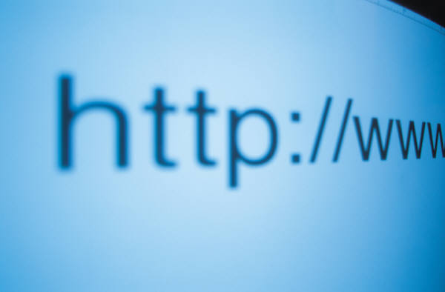

“To catch the reader’s attention, place an interesting sentence or quote from the story here.”

Caption describing picture or graphic.

Please see *Tight Space* on page 4

So you have space for one more article in your newsletter and one of your experts out in the field is writing the article. How can you determine how long the article should be?

As in newspapers, the length of a newsletter article can be thought of in terms of how many “column inches” are available for the article. A column inch is a measure of space, namely an area on a page one column wide and one inch deep, used to measure the amount of type that would fill that space. This will vary from newsletter to newsletter depending on the font you’re using, its size, the column width, and the amount of space between lines and between paragraphs. By knowing how many words on average fit into a column inch in your newsletter, and then by measuring how many column inches are available for the article, you can tell the writer how many words their article can have. Let’s take this scenario one step at a time.

1. Fill up at least ten inches of column with actual article text.
2. Print out the page and use a ruler to measure how many inches of column your text takes up.
3. Count the number of words in the text.
4. Divide the number of words in the article by the number of inches the text takes up. For example, let’s say you have 456 words in 12 inches of column: 456 ÷ 12 = 38. That’s your magic number for how many words fit in an inch of column in your newsletter. But you’re not finished yet.
5. Measure how many column inches you have available for the article. For example, we’ll say it’s seven inches.
6. Multiply your magic number by the number of column inches available for the article, which in this case would be: 38 x 7 = 266. This is the maximum length that the article can be.
7. To give yourself some room to fudge, tell the writer to write an article between 250 and 260 words. Once you get the article back and edit it, you can add or remove words here and there to get the article to the right length.

Using this approach, you soon will be a pro at writing perfect-length articles and adapting existing articles to the space you have.

*Getting Started* from page 1

By Author Name

# Fitting an Article into a Tight Space

You can replace the pictures in this template with your company’s art.

To do so, click where you want to insert the picture. On the **Insert** menu, point to **Picture**, and then click **From File**. Locate the picture you want to insert, and then click it. Next, click the arrow to the right of the **Insert** button, and then click either **Insert** to place a copy of the picture into the newsletter, **Link to File** to display the picture without actually inserting a copy, or **Insert and Link**.

Since the **Insert** command embeds a copy, the picture is always visible, but it may greatly increase the size (in bytes) of your newsletter, depending on how large the picture is.

In contrast, **Link to File** does not increase the size of your newsletter file, and if you make changes to the original picture, they automatically show up in the newsletter. But the picture won’t display if viewed from a computer that can’t link to the original (for instance, if the original picture is stored on another computer on a network).

**Insert and Link** inserts a copy so that the image is always available, and also automatically updates changes to the original.

By Author Name

# Inserting Your Own Art

*Great Articles* from page 1

Caption describing picture or graphic.



“To catch the reader’s attention, place an interesting sentence or quote from the story here.”



By Author Name

# The Elements of a Newsletter

In the course of adapting this template to suit your needs, you will see a number of different newsletter elements. The following is a list of many of the elements, accompanied by a brief definition.

**Body text.**  The text of your articles.

**Byline.**  A line of text listing the name of the author of the article.

**Caption text.**  Text that describes a graphic. A caption should be a short but descriptive full sentence.

**“Continued from” line.** A line of text indicating the page from which an article is continuing.

**“Continued on” line.**  A line of text indicating the page on which an article will be continued.

**Date.**  Either the date of publication or the date you expect the newsletter to be at the height of its circulation.

**Graphic.**  A photograph, piece of art, chart, diagram, or other visual element.

**Header.**  Text at the top of each page indicating the name of the newsletter and the page number.

**Headline.**  The title of an article. A headline needs to be clear in its purpose, brief, and active, and should attract attention by being relevant, inspiring curiosity, or for having some other irresistible quality.

**Newsletter title.**  The title of the newsletter.

**Pull quote.**  A phrase or sentence taken from an article that appears in large letters on the page, often within a box to set it apart from the article.

**Volume and issue.**  Volume refers to the number of years a newsletter has been in circulation. Issue refers to the number of newsletters published so far in the year. The ninth newsletter in its fifth year of circulation would be Volume 5, Issue 9.

*Tight Space* from page 2

**Phone:**

**Fax:**

**E-mail:**