https://github.com/openai/whisper

https://chatgpt.com/c/67d735f6-13f4-8009-a771-d4b4a9c1869c

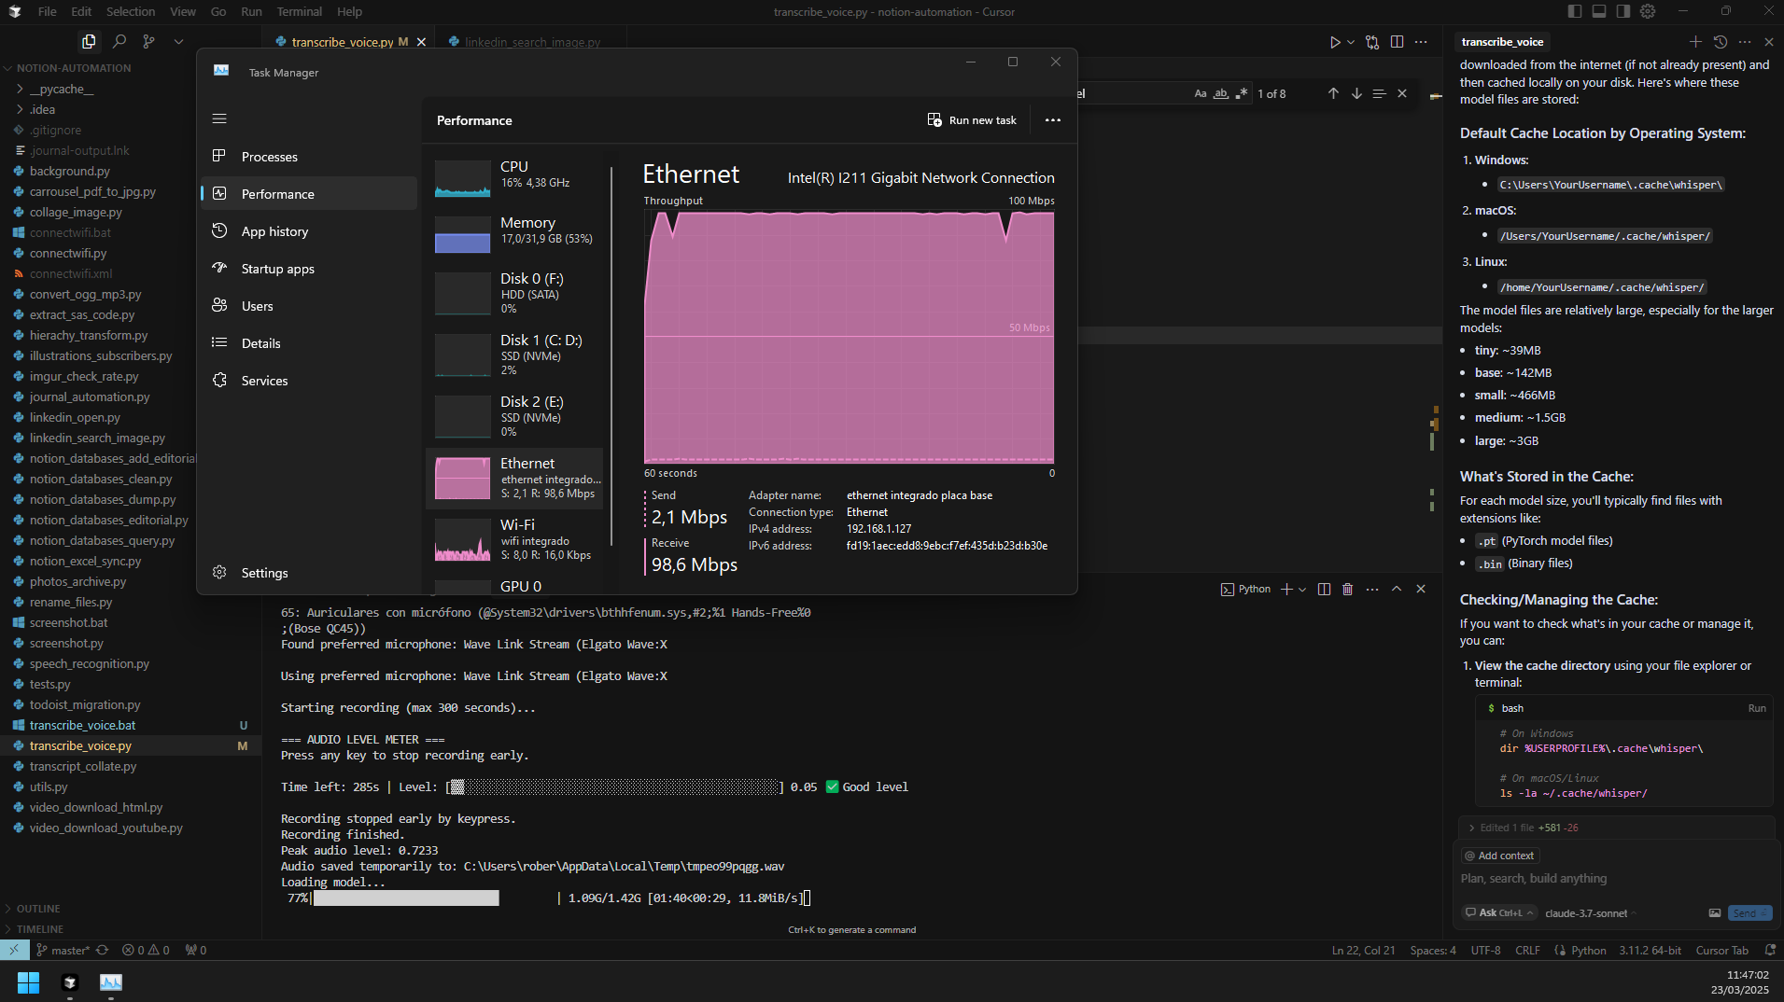

Load the medium model from internet

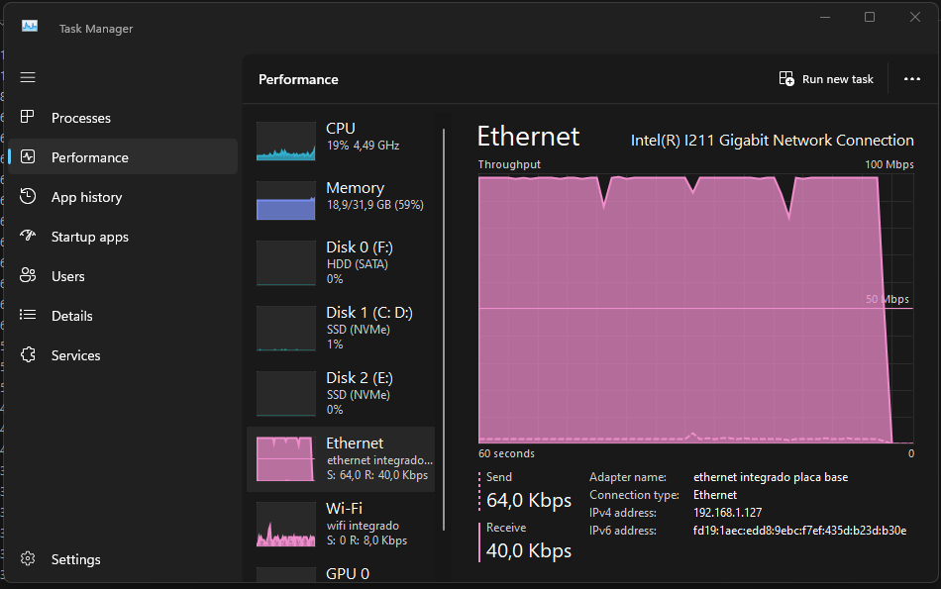

Frees memory after that

