**Increase Creativity Report**

**Add & Subtract**

Explain what you decided to add and subtract from your daily routine this week.

* Add:
  + Run in the park with no headphones;
  + Meditate;
  + Daily sketches
* Subtract:
  + Don’t use my smartphone before going to bed;
  + Drive without radio;
  + No listen to music when taking shower;

**Progress**

How many days have you already completed your additions and subtractions from your daily routine? Explain your experience so far.

I started this activity Monday. I’m driving without turning the radio and it’s helping me a lot to think more about new ideas. Another thing that is helping me a lot is to no listening music during taking shower. It’s interesting how we start to think more without the perception of time and space.

**Four Activities**

You will need to choose and complete four creativity increasing activities from the list provided. You should spend at least 20 minutes on each of these activities. You will describe your experience with each and you will need to find a way to record and showcase some results of each activity.

**Activity #1**

**Free Drawing**

I got a white paper and start drawing. It’s interesting that I started it trying not to think about patterns but instinctively we do that. But, after a while I really empty my mind did it with no thoughts which help me to get prepared to thing about other ideas.

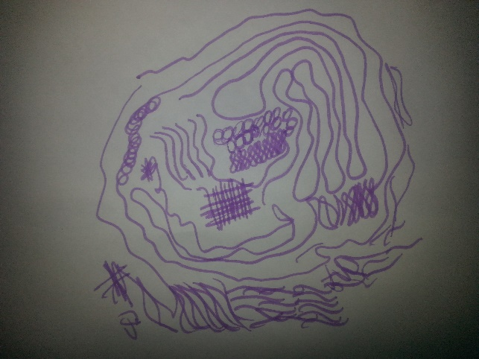

**Activity #2**

**Timed Sketches**

I have the idea to use this activity to start an idea about an icon that I’ll need to create to a website for other class. It helps me because I came up with ideas that I didn’t have before. The perspective and the question “what if” helped me to see this icon from different points of view.

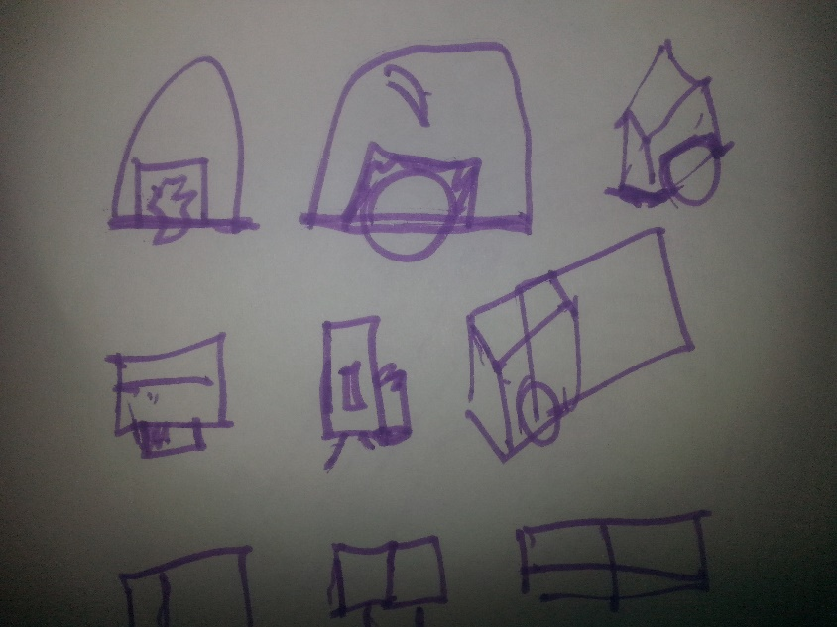

**Activity #3**

**Play a Role**

That was an interesting activity. It’s amazing how we can create a story from nothing if we put ourselves in the character shoes. This can be used, for example, to think about a target public or to think about client’s need.

|  |
| --- |
| **Character: John, 16 years old, live in Barrington NY, like adventures, have a group of friends, live in a small neighborhood. Have one bicycle and always use it to find new adventures.** |
| “Hello, I’m John, but my friends call me JN. I’m always getting in trouble because I love to explore. Yesterday I was cycling with my group of friends and we found this amazing abandoned old barn in the middle of the forest. We tried to open the door but it was closed. Looking by the window we could see a lot of things in there. I smelled a new adventure coming, so I decided to explore more. At the back of the barn there was a hole sufficient big for me to get through. It was dark. Suddenly I heard a strange noise coming from a room in the up floor…” |

**Activity #4**

**Free Association**

I did this activity with my little brother, it was funny. Sometimes the answers came fast, other take a time to get the next work. After the game I tried to write the nous that we used and created the list below. After a time playing we start to get the next word quicker.

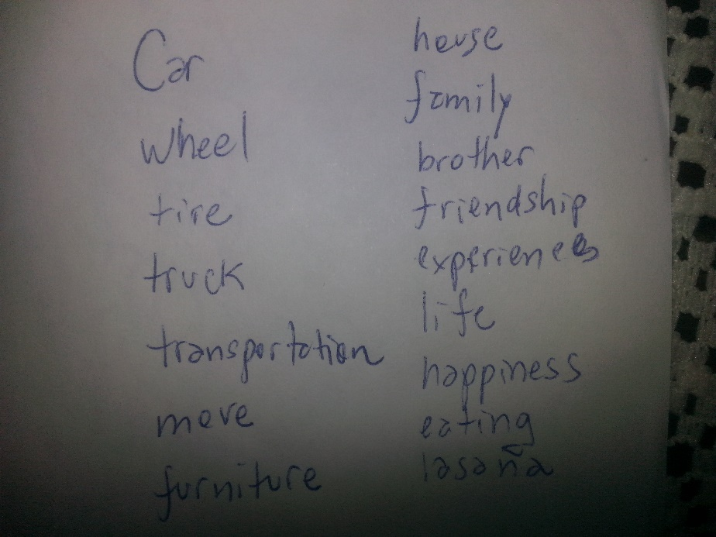

**Submission**

Save this completed document as a PDF (File -> Save As - > File Format: PDF)

Submit the PDF in I-Learn