ID: 2020091

Name: Jackson Ferreira Dos Santos

Heroku: <https://ancient-tundra-70389.herokuapp.com/>

Github: <https://github.com/ferreirajackson/CBWA-API-CA1>

Follow the instructions:

______________________________________________________________

To start the program, inform the following api-key

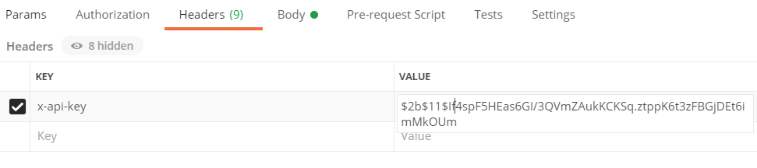

Key: x-api-key

Value: $2b$11$If4spF5HEas6GI/3QVmZAukKCKSq.ztppK6t3zFBGjDEt6imMkOUm

Get all projects

[https://ancient-tundra-70389.herokuapp.com/projects](http://0.0.0.0:3000/projects)

Get individual projects

https://ancient-tundra-70389.herokuapp.com/projects/BUG

https://ancient-tundra-70389.herokuapp.com/projects/BOOK

Add new Projects individually

[https://ancient-tundra-70389.herokuapp.com/projects](http://0.0.0.0:3000/projects)

json:

{

    "slug": "NEW",

    "name": "Brand new project",

    "description": "this is a new project"

}

Get all users

[https://ancient-tundra-70389.herokuapp.com/users](http://0.0.0.0:3000/users)

Get individual users

https://ancient-tundra-70389.herokuapp.com/users/me@cbwa.com

[https://ancient-tundra-70389.herokuapp.com/users/dave](https://still-journey-06848.herokuapp.com/users/dave)@cbwa.com

Add new users individually

[https://ancient-tundra-70389.herokuapp.com/users](http://0.0.0.0:3000/users)

json:

{

    "name": "McGregor",

    "email": "mcgregor@cbwa.com",

    "usertype": "user",

"key": "new password"

}

Get all issues (bring comments with it)

[https://ancient-tundra-70389.herokuapp.com/issues](http://0.0.0.0:3000/issues)

Get individual issues

https://ancient-tundra-70389.herokuapp.com/issues/BOOK-1

Get all issues for a project

[https://ancient-tundra-70389.herokuapp.com/projects/BOOK/issues](http://0.0.0.0:3000/projects/BOOK/issues)

______________________________________________________________

BONUS: Updated the status of an issue – PUT METHOD

[https://ancient-tundra-70389.herokuapp.com/projects/BOOK/issues/2/closed](http://0.0.0.0:3000/projects/BOOK/issues/2/closed)

As number 2 being the position (1 – first comment | 2 – second comment …)

______________________________________________________________

Add new issues to a project individually

[https://ancient-tundra-70389.herokuapp.com/projects/](https://still-journey-06848.herokuapp.com/projects/)BOOK/issues

json:

{

    "title": "Fix",

    "description": "That’s the third issue"

}

Informing the slug in the issue number, the program gets this project code and generate the proper issue number (BOOK-3 in this case).

Get all comments (optional)

[https://ancient-tundra-70389.herokuapp.com/comments](http://0.0.0.0:3000/comments)

Get all comments for an author (optional)

[https://ancient-tundra-70389.herokuapp.com/comments/me@cbwa.com](https://still-journey-06848.herokuapp.com/comments/me@cbwa.com)

[https://ancient-tundra-70389.herokuapp.com/comments](http://0.0.0.0:3000/comments)/dave@cbwa.com

Get all comments for an issue

https://ancient-tundra-70389.herokuapp.com/issues/BOOK-1/comments

Get individual comments for an issue

[https://ancient-tundra-70389.herokuapp.com/issues/BOOK-1/comments/1](https://still-journey-06848.herokuapp.com/issues/BOOK-1/comments/1)

As number 1 being the position (1 – first comment | 2 – second comment …)

_____________________________________________________________

Add new comments to an issue

[https://ancient-tundra-70389.herokuapp.com/issues/BUG-1/comments/](https://still-journey-06848.herokuapp.com/issues/BUG-1/comments/)

json:

{

    "text": "programming leads you nowhere, start punching random people",

    "author": "mcgregor@cbwa.com"

}

_____________________________________________________________