Examining Childcare Costs Across U.S. States
Ferrill, Teresa
Bellevue University, DSC640 – Data Presentation and Visualization
Term Project, Milestone 5
May 31, 2026

Summary of Analysis

The project used data from the National Database of Childcare Prices to look at childcare costs in different parts of the United States. The dataset was organized and reviewed in Python so the information could be compared by state, region, age group, and childcare setting. After comparing the data, the results showed noticeable differences in childcare prices across the country (Child Care Aware of America, 2022).

Findings
When the childcare data was compared across states, the costs were not evenly distributed across the country. States in the Northeast and parts of the West often appeared near the higher end of the cost comparisons, while many Southern and Midwestern states showed lower reported prices. The charts also showed that infant care was usually more expensive than toddler or preschool care - especially in center-based programs.
Some childcare costs were considerably higher in certain states than in others. These differences became more apparent when the visual comparisons were reviewed together across the different charts. A few states stayed near the high end across most of the comparisons, while other states were much lower in the dataset.
Assumptions
This analysis is based on the assumption that the childcare prices reported in the dataset are generally representative of costs within each state. The analysis focused mainly on childcare prices and differences across states, age groups, and care settings. The study focused mainly on childcare cost as an indicator of affordability, but other factors such as childcare availability, subsidies, and the number of children in a household can also affect the overall childcare costs for families (Blau & Currie, 2006).

Items That Still Need Clarification
Some parts of the dataset were difficult to evaluate because certain details were not included in the source information. The childcare prices were provided in the dataset, but it was not always clear how those values were calculated across states. Information related to childcare assistance programs, provider availability, and differences in childcare quality was also missing from the data used in the project. Because of that, the charts mainly reflect childcare price differences rather than the full childcare situation within each state.
Direction of Story, Message
The overall focus of the analysis was to compare childcare prices across states, regions, age groups, and childcare settings. The project was designed to highlight where childcare costs were higher or lower and present those differences through clear visual comparisons.
Target Audience
The project was written for audiences such as policymakers, workforce planners, and other groups interested in childcare cost trends. Since many of those readers may not regularly work with childcare datasets, the charts and explanations were kept more direct and easier to follow. The focus stayed on showing the cost differences clearly rather than spending time on technical details related to the data analysis process.
Mediums Included & Why
For this project, the information was presented in several different formats for different audiences.
- The first medium prepared was a dashboard, which was designed mainly for policymakers, workforce analysts, and research-oriented stakeholders who may want to compare childcare costs across states and explore the data in more detail by age group or childcare type. The dashboard format supports exploratory analysis by allowing viewers to quickly identify regional cost differences and affordability patterns.
- The second medium prepared was a presentation, which focused on workforce stakeholders and leadership audiences by walking through the main findings and explaining the main childcare cost differences across states and care types. These executive and workforce-related stakeholders need a concise, visually organized explanation of the major findings. The slide-based storytelling approach highlights key childcare affordability trends while supporting discussion around workforce participation and economic impact.
- The third medium prepared was an infographic, which was created for broader public audiences, including parents, families, and community stakeholders by providing a shorter and easier-to-read summary of the results. The infographic is focused on concise messaging and simplified visuals that communicate the major childcare affordability findings quickly and clearly.
Each format communicated the same findings while presenting the information in a way that best suits the intended audience. Copies of each finalized medium are included in Appendix A through Appendix C.
Design Decisions
The visuals were designed to keep the information straightforward and easy to follow. Similar colors were used throughout the dashboard, presentation, and infographic so the charts would feel consistent from one medium to another. Darker colors were used to show higher childcare costs because those differences were easier to notice at a glance. Most of the visuals relied on bar charts and line charts since they made state and cost comparisons easier to read. More complex chart styles were omitted to avoid making the results harder to interpret.
The information was also arranged from broader trends to more detailed findings. Larger charts and spacing were used in places where the most important results needed more attention so viewers could quickly recognize the main points of the analysis.
Ethical Considerations
The childcare data used in the project was already publicly available before the analysis began. The information focused on state-level childcare costs and did not contain personal details about individual families. Most of the preparation work involved getting the dataset into a format that could be used for charts, comparisons, and other visuals.
The analysis also avoided making claims that could not be supported by the data. While the results showed differences in childcare costs across states, the findings were not intended to explain why childcare prices differ across states. Care was also taken to present the charts and summaries in a way that accurately reflected the data and reduced the chance of misleading interpretation (Cairo, 2016).
Data Changes
The childcare data did not start in a format that worked well for the charts and comparisons. Some steps were taken to support data cleanup and analysis.
- A small number of rows had incomplete information. Those entries were reviewed during the data cleaning process.
- After the incomplete rows were addressed, the information was sorted by state so the results could be compared more easily across different parts of the country.
- Finally, regional groupings and average childcare cost fields were added later to support the visual analysis.
Legal and Regulatory Considerations
The childcare dataset used in the project was obtained from the U.S. Department of Labor Women’s Bureau National Database of Childcare Prices. Since the dataset only included statewide childcare cost information, there were no personal records or private family details involved in the analysis.
Risks from Transformations and Visualizations
Statewide childcare numbers do not always reflect what families may pay in smaller communities or individual cities. In some areas, local childcare costs may be much higher or lower than the state average shown in the charts. The visualizations also use darker colors to represent higher costs, which naturally draws more attention to those states when viewing the dashboard and presentation.
Another consideration is that viewers could incorrectly assume the analysis explains why childcare costs differ across states, even though the project was limited to comparing the reported cost data. For that reason, the charts and written explanations were kept as direct as possible and avoided making broader claims that were not supported by the dataset.
Data Sourcing and Credibility
The childcare information used in the project came from the National Database of Childcare Prices published by the U.S. Department of Labor. The results from the analysis were similar to findings discussed in other childcare affordability reports, including research from Child Care Aware of America.
The dataset is publicly available and was collected from a source intended to support research and policy-related work.
Lessons Learned
Working through the project showed how much the presentation style can affect how people understand data. In many cases, the simpler charts were easier to follow and made the main findings clearer than more detailed visuals. The project also showed that childcare prices alone do not fully explain affordability because additional factors were not included in the dataset.
Looking back, the analysis could be expanded further by including childcare assistance programs, regional cost patterns, or changes in childcare prices over time. One of the most valuable aspects of the project was taking a large dataset and turning it into information that connects to how childcare costs vary across states and care settings.

Conclusion
Not every state showed the same childcare cost trends in the dataset. In many of the comparisons, infant care costs were higher than the other age groups, especially in center-based childcare settings. The results showed that childcare prices differed considerably from one state to another (U.S. Department of Labor Women’s Bureau, 2023).
The project used several ways to present the information. The dashboard allowed the data to be explored in more detail, especially when comparing states and childcare categories. The presentation was organized more like a walkthrough of the major findings, while the infographic was intended to give a shorter overview that could be reviewed quickly.
The project only examined the childcare price information that was available in the dataset. Other factors that may affect affordability, such as childcare assistance programs, provider availability, or differences in care quality, were not included in the analysis. Because of that, the results provide only part of the overall picture. Even so, the comparisons still showed that childcare costs are not consistent across the country and may affect families differently depending on where they live.
The findings reinforce the importance of continued attention to childcare affordability because rising childcare costs may affect workforce participation, financial stability, and access to care for families across different regions of the United States.

References
Blau, D. & Currie, J. (2006). Pre-school, day care, and after-school care: Who's minding the kids? Handbook of the economics of education, Vol. 2, pp. 1163-1278. Elsevier.
Child Care Aware of America. (2022). The U.S. and the high cost of childcare: A review of prices and proposed solutions for a broken system. Retrieved from Child Care Aware of America: https://www.childcareaware.org
U.S. Department of Labor Women’s Bureau. (2023). National database of childcare prices. https://www.dol.gov/agencies/wb/topics/childcare

Appendix A: Dashboard Overview
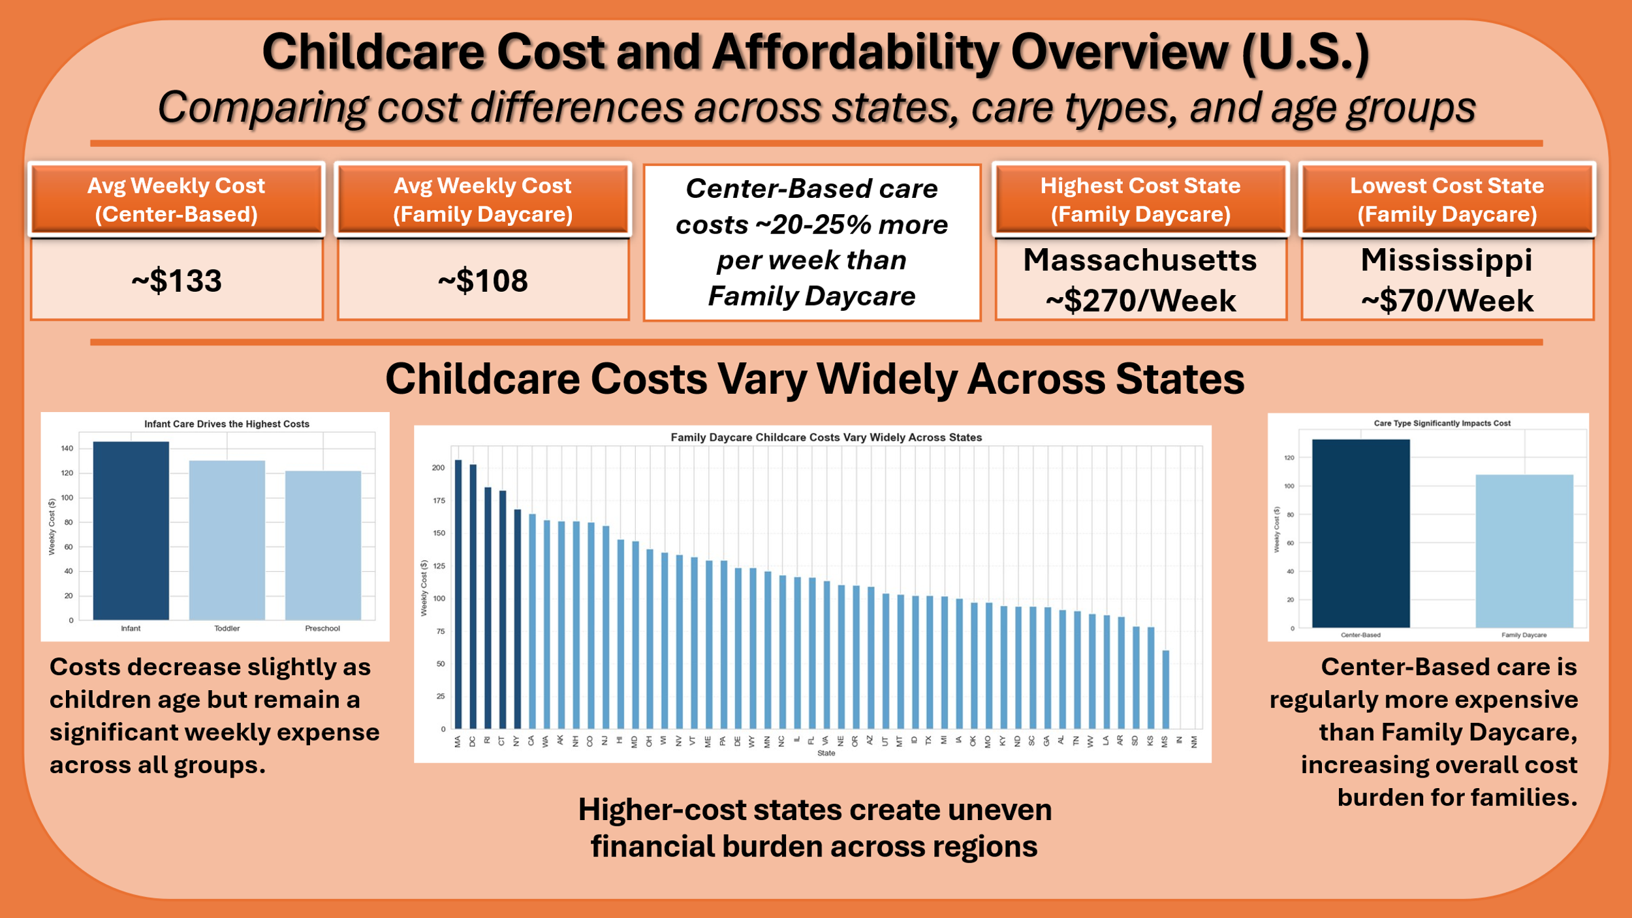

Appendix B: Presentation Slides
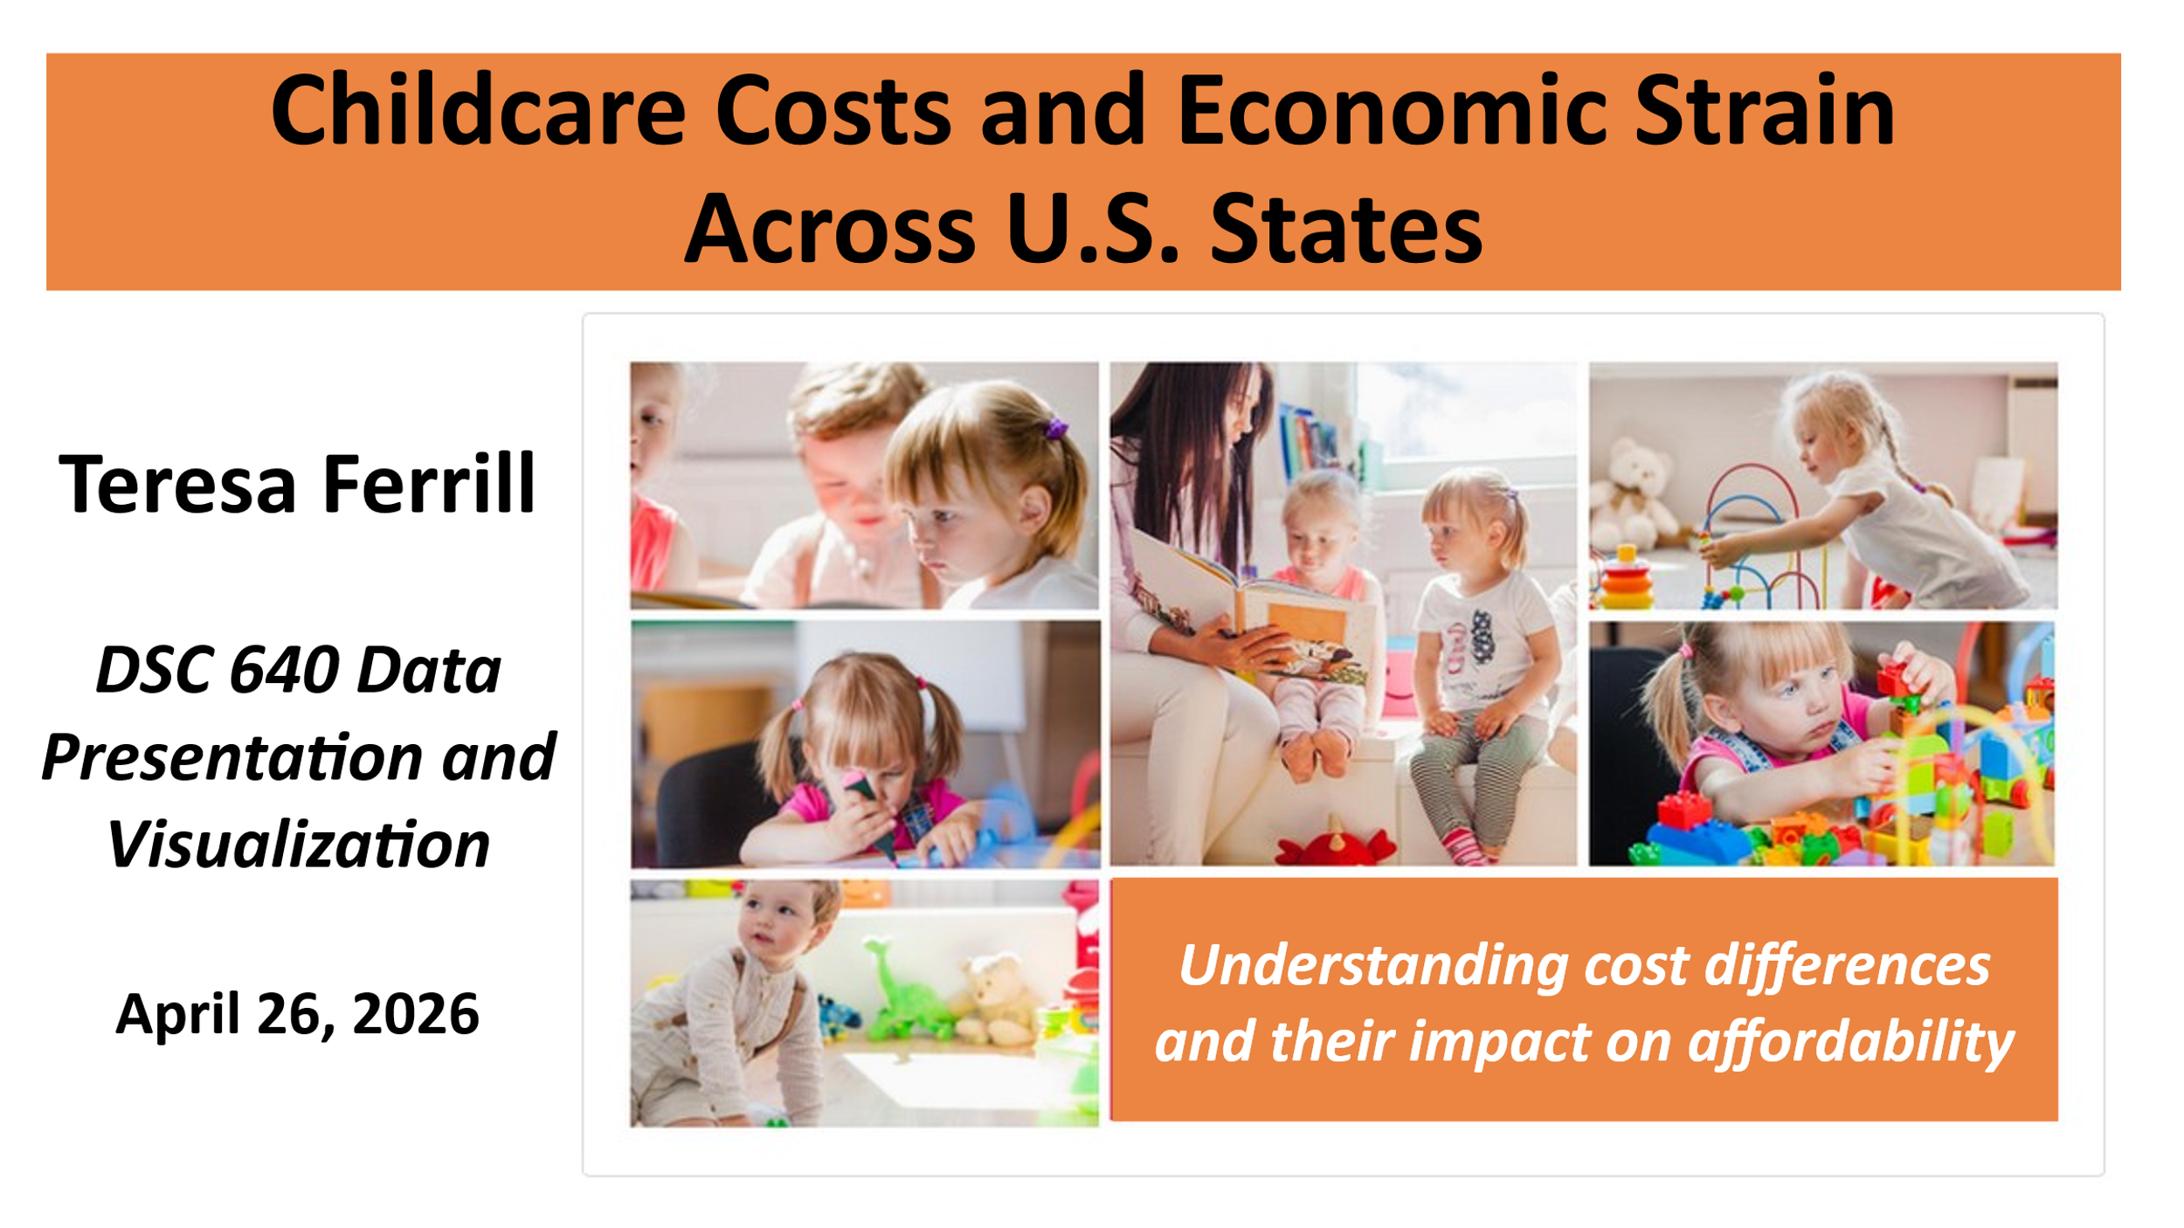
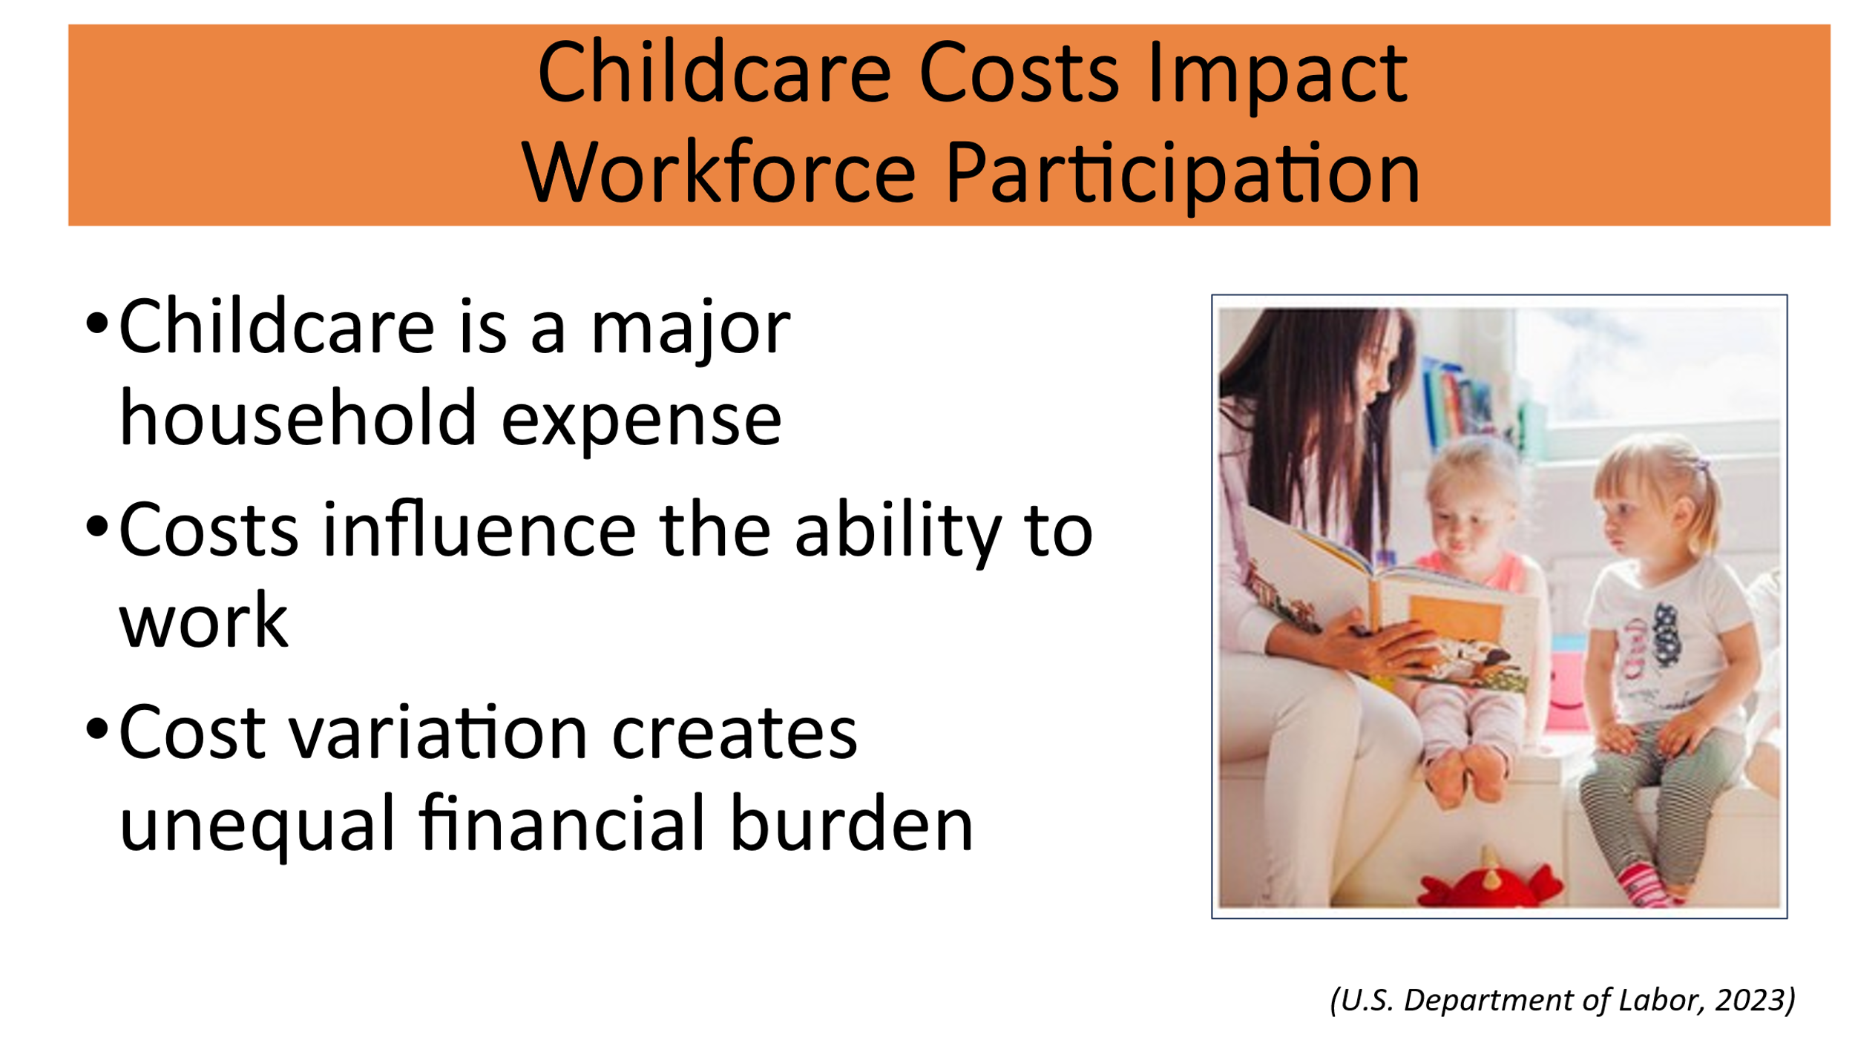
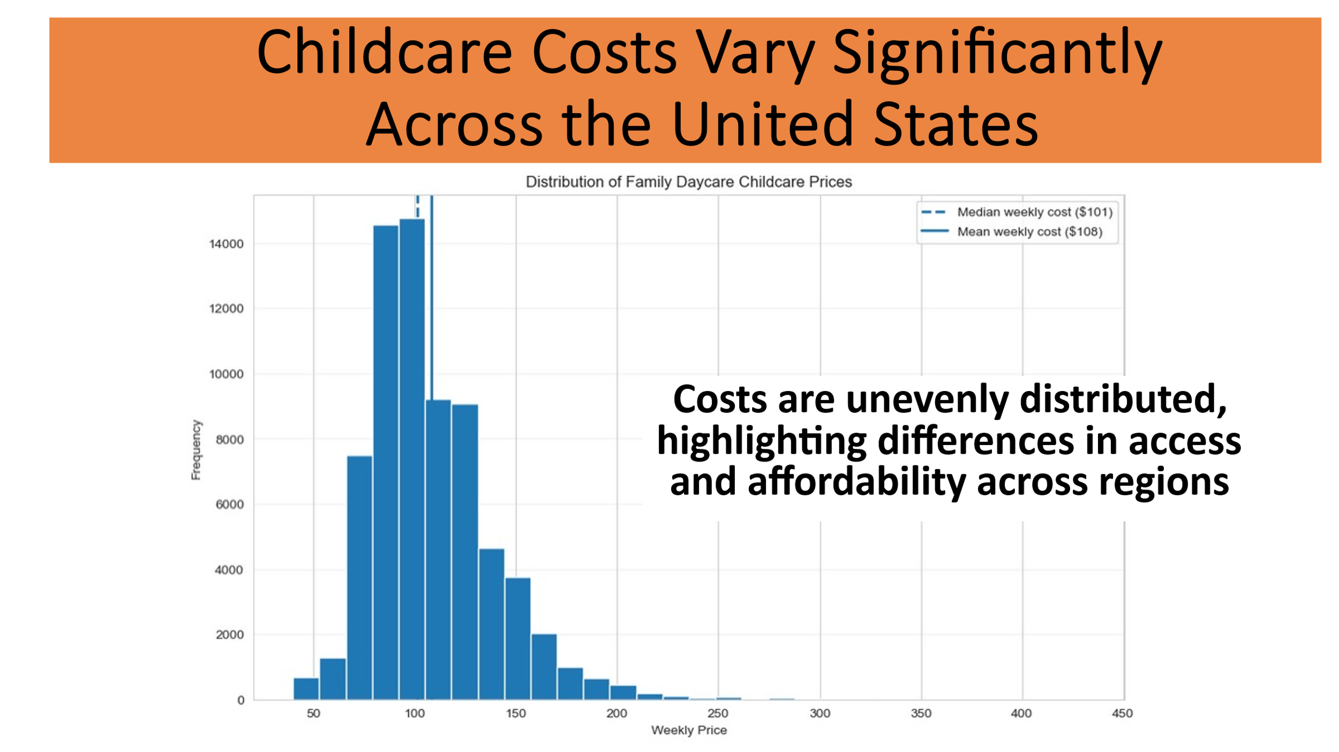
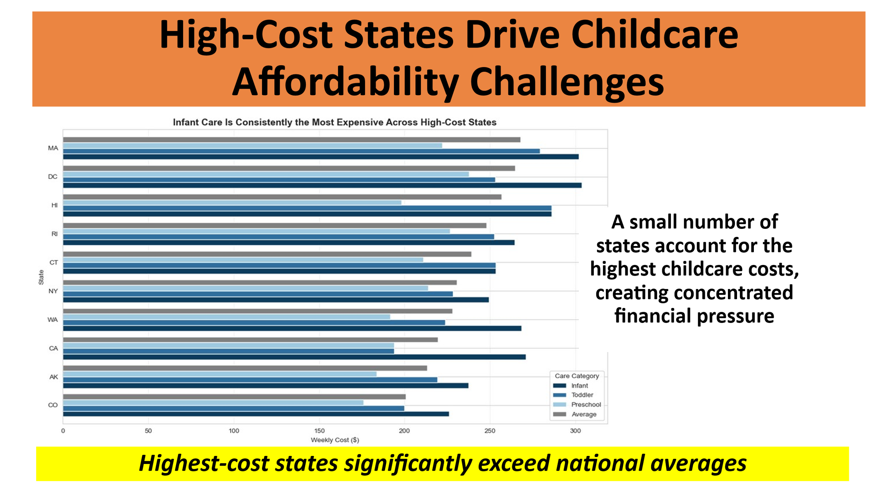
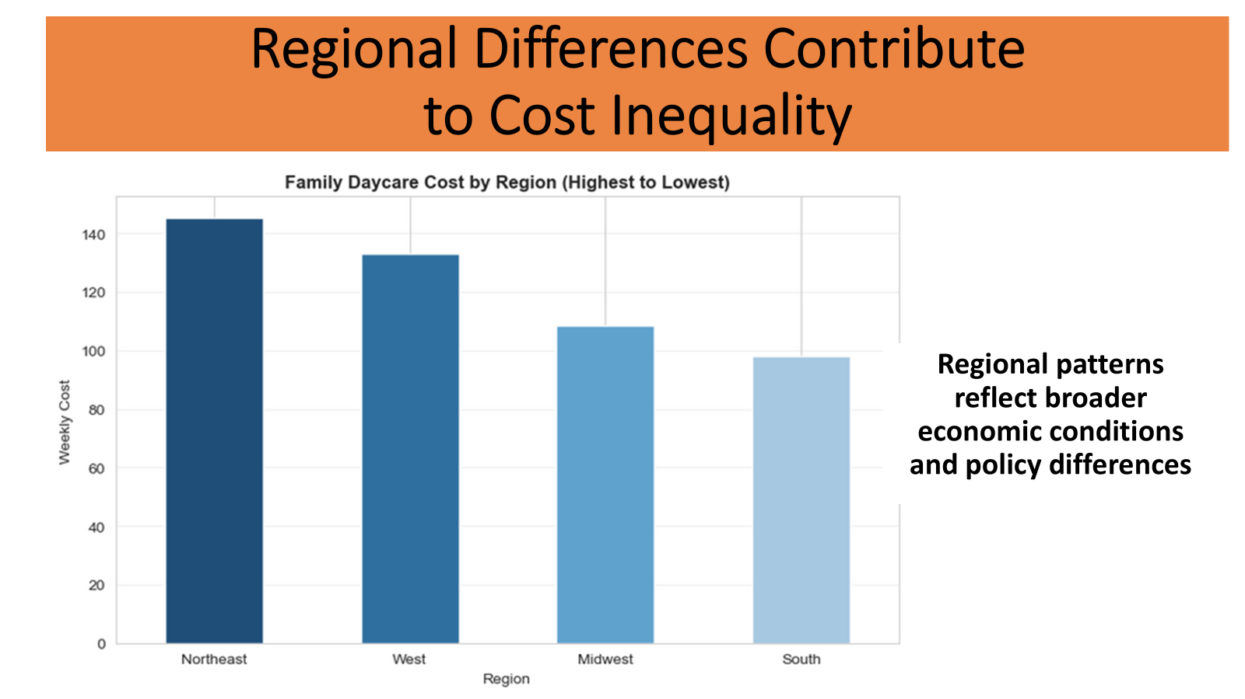
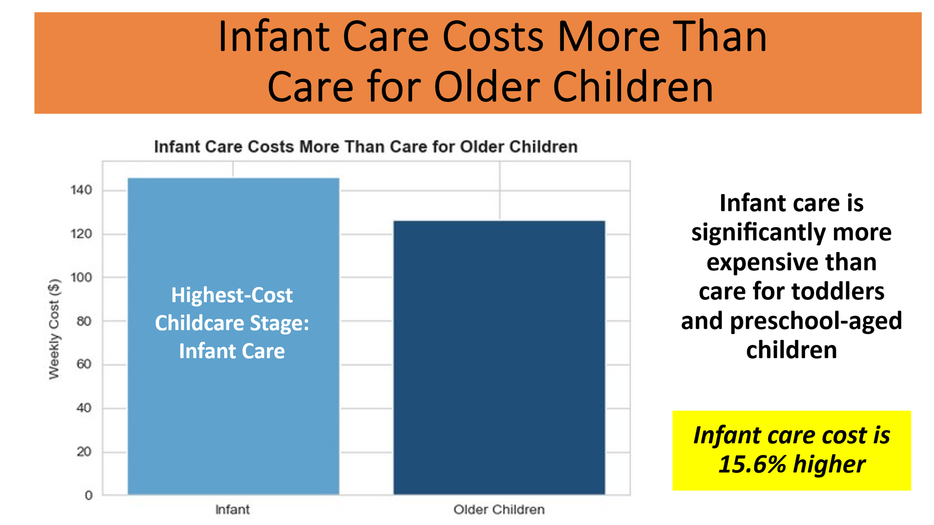
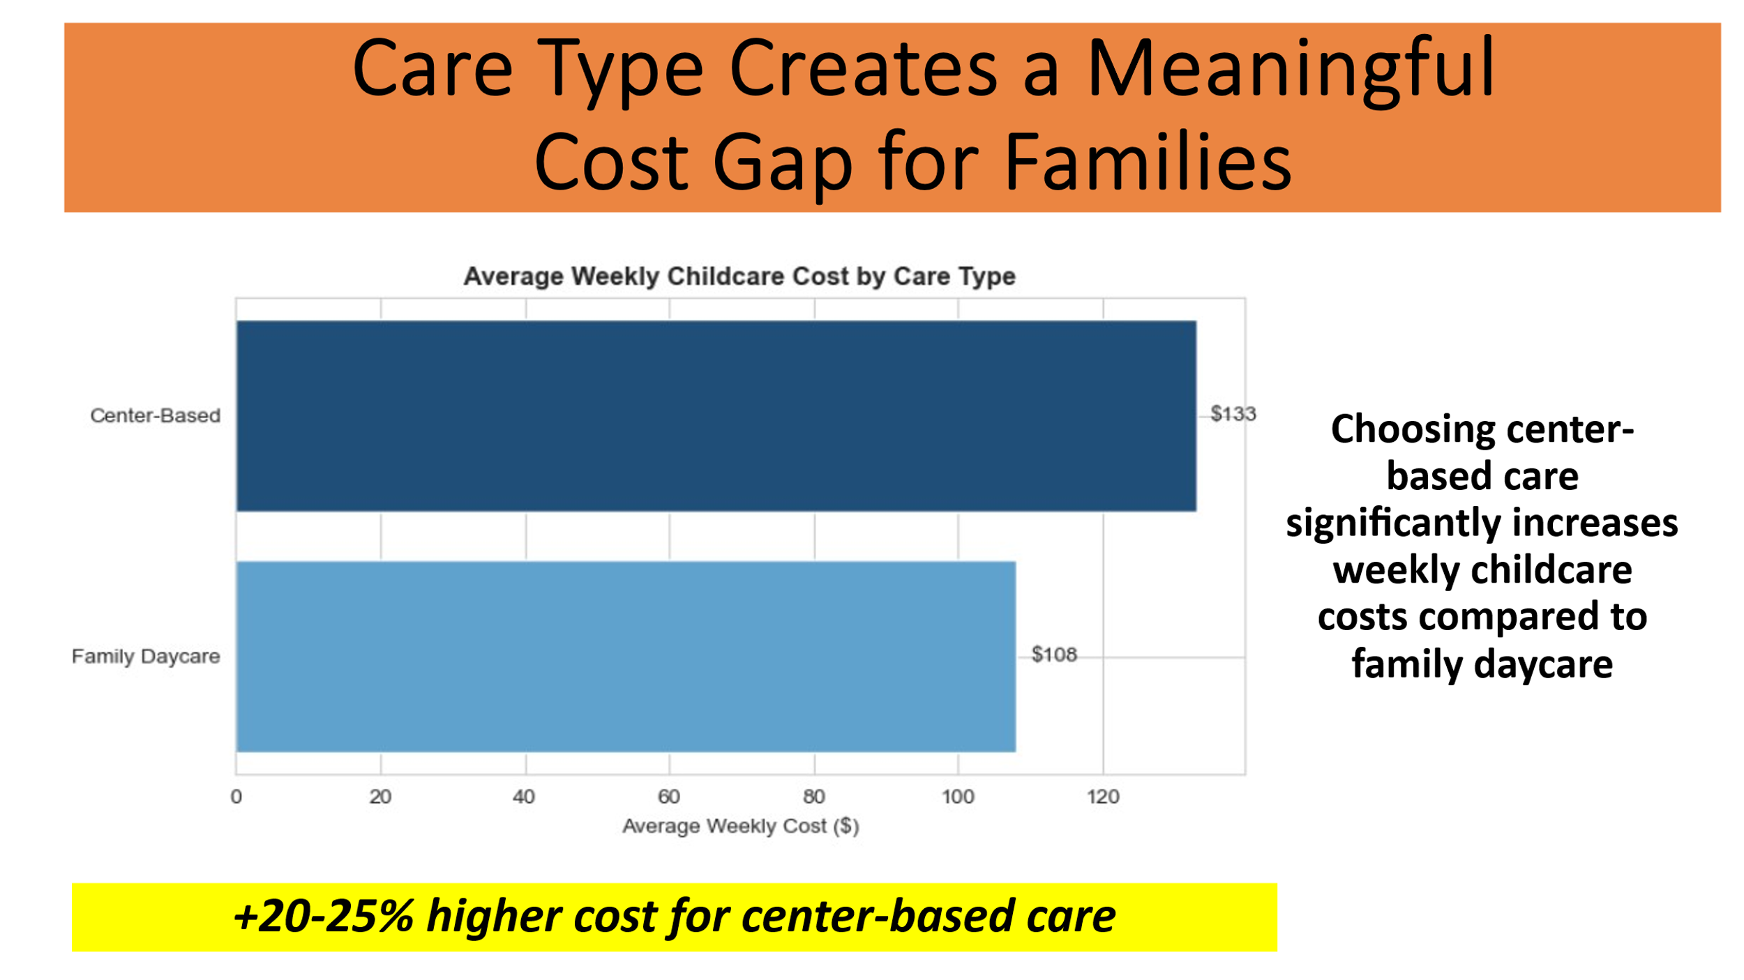
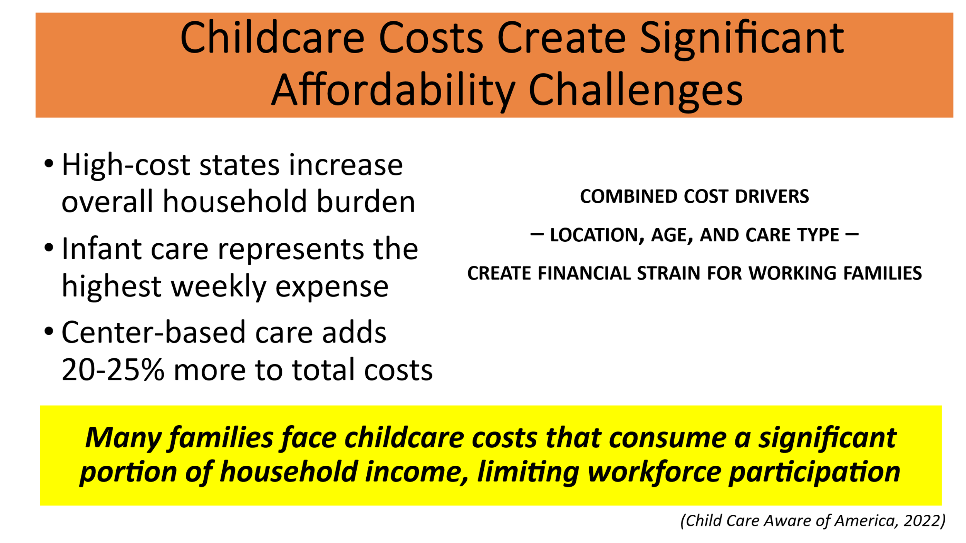
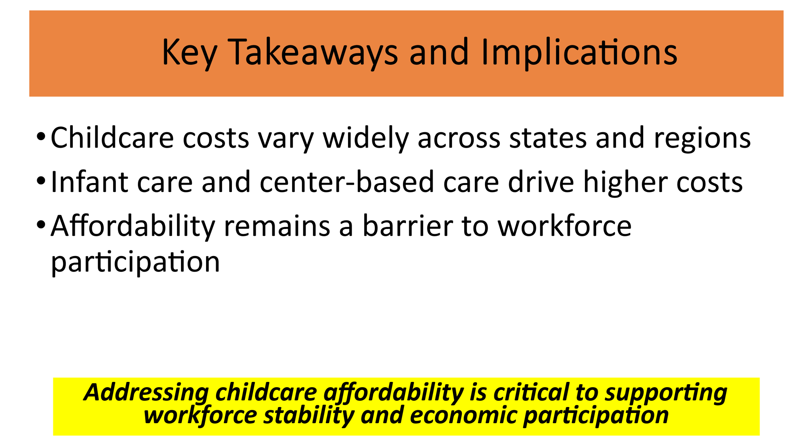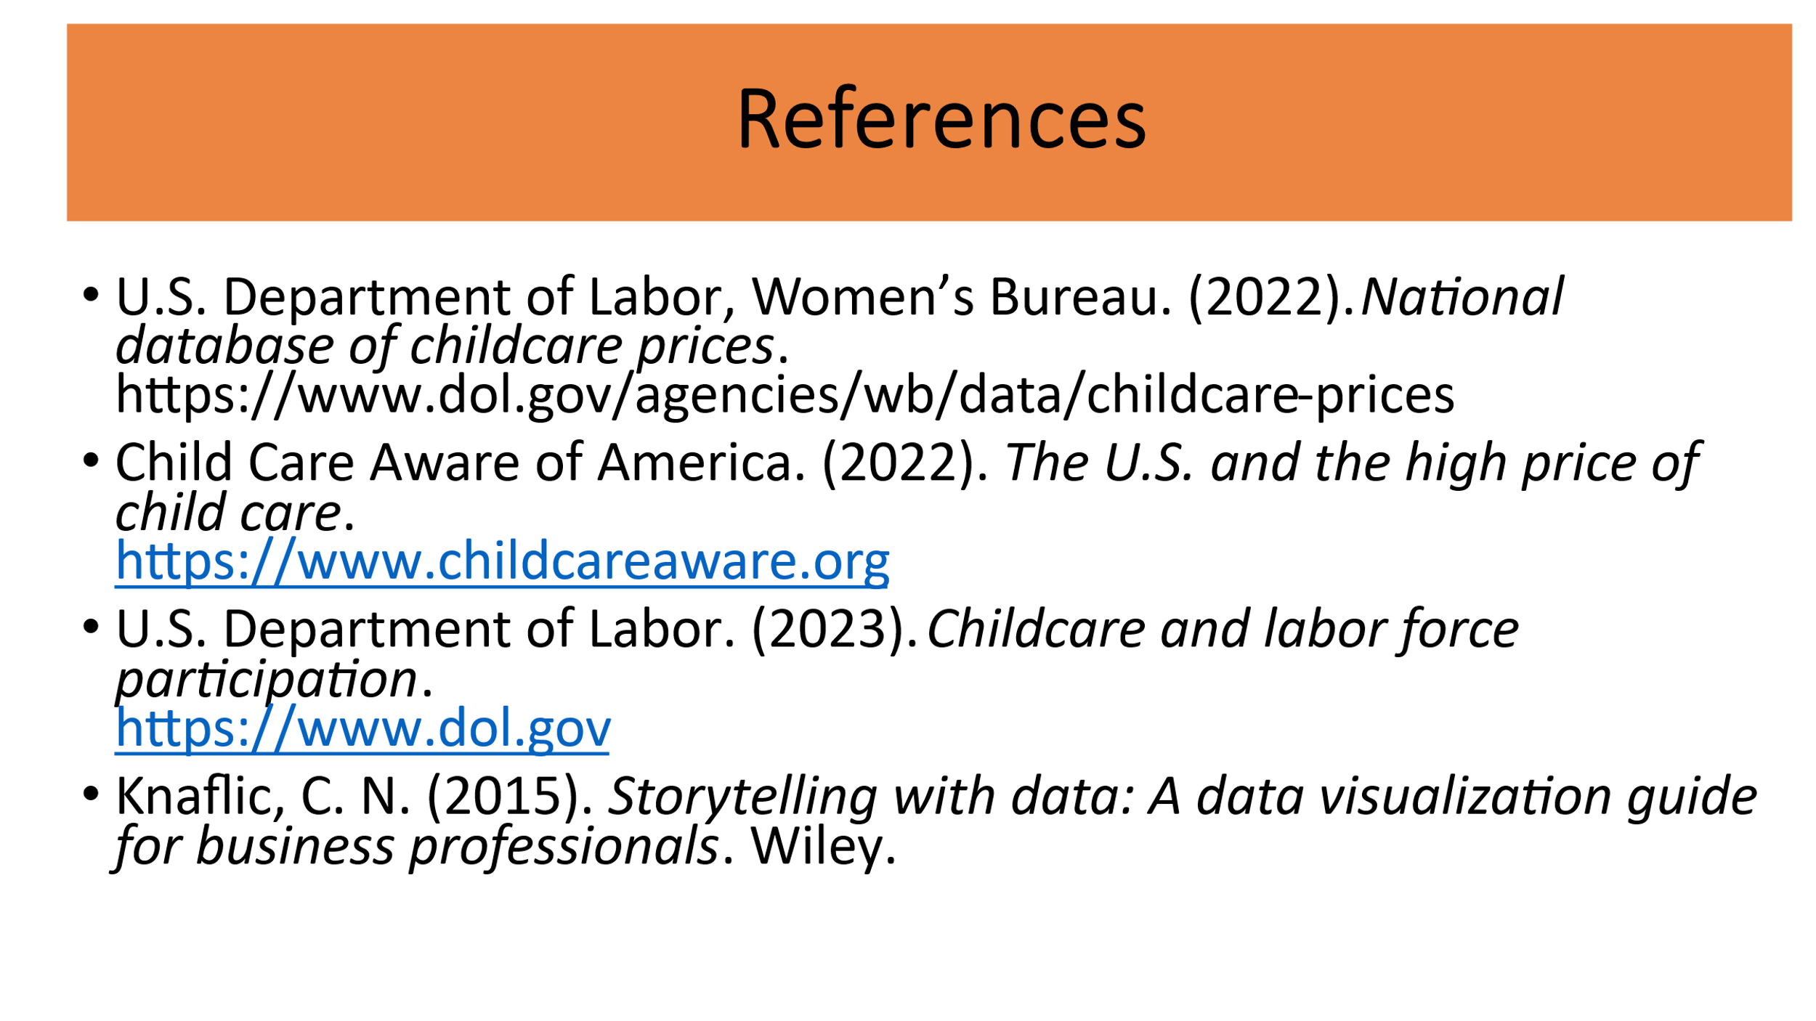

Appendix C: Infographic Summary
