**Exponential Impact Patterns in Rural Healthcare Workforce Development: Evidence from the ReConnect Gap Year Fellowship**

Christopher J. Guastaferro, MAODC | Aug 2025 Full paper (GitHub)

**Executive Summary**

Rural workforce shortages persist despite decades of well-intended interventions. This mixed-methods study of the ReConnect Gap Year Fellowship (Area Health Education Center of Southwest Oregon with Aviva Health) examines whether small, purposeful touchpoints in three domains- community integration, mentorship, and clinical experience- produce exponential rather than linear gains in rural practice commitment. Polynomial models explained more variance than linear models (R² 0.318 vs. 0.245, p = 0.028), with an inflection around 6.2 touchpoints. Community integration emerged as the strongest leverage point, and high-quality touchpoints amplified effects. Interpreting this cautiously, these preliminary findings (n = 20, single-site) suggest that programs may achieve outsized gains by sequencing and elevating specific high-quality touchpoints, especially early community integration, rather than simply adding hours.

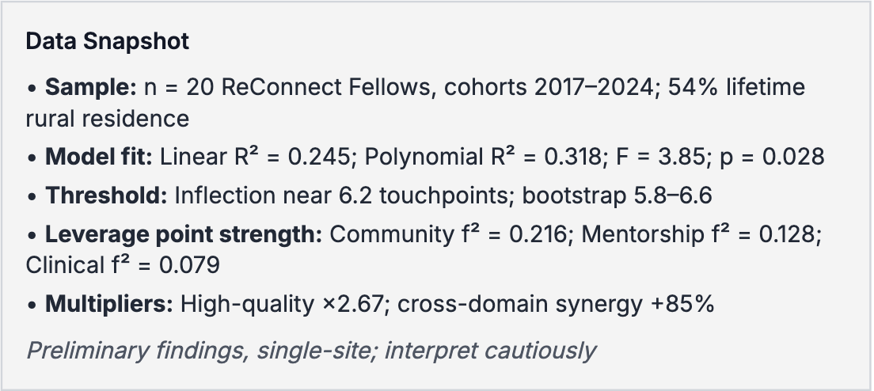**Context and Purpose**

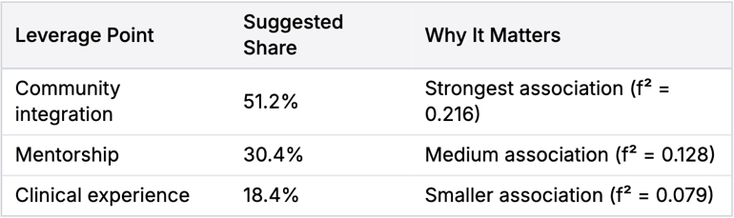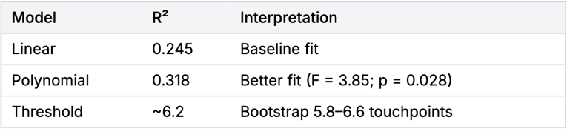The ReConnect Gap Year Fellowship provides pre-health students in rural southwest Oregon with medical scribing and Medical Assistant opportunities, structured mentorship, and community integration experiences in RUCA 4–10 settings (Roseburg and surrounding communities). The study investigates whether compounding touchpoint mechanisms within these leverage points generate exponential gains in rural practice commitment and how programs might optimize design and resource allocation to improve intern-to-employee conversion in rural healthcare.

**Methods at a Glance**

***Design:*** Mixed-methods analysis of existing survey data and program documentation, with IRB approval.

*****Sample:*** 20 ReConnect Fellows across 2017–2024; average lifetime rural residence 54%; participants included current fellows, medical students, residents, and practicing physicians in rural Oregon.

***Measures:*** Rural practice commitment composite (3–30; α = 0.87); touchpoint frequency within three leverage points (community integration, mentorship, clinical); touchpoint quality (1–10); transformative indicators (aha moments, pattern recognition, lasting change).

***Analysis:*** Linear vs. polynomial regression with R² change and F-tests; changepoint threshold detection; Cohen’s f²; moderated regression for quality-by-frequency; synergy tests; 1,000-iteration bootstrap with BCa intervals; thematic analysis of open-ended responses. Software: R 4.3.2 with base, changepoint, boot.

**Key Findings**

1. **Exponential Pattern and Threshold**

Polynomial models outperformed linear models (R² 0.318 vs. 0.245; F = 3.85; p = 0.028). A critical inflection occurred at approximately 6.2 touchpoints. Across bootstrap samples, thresholds clustered between 5.8 and 6.6, indicating pattern stability despite the small n. Interpreting this cautiously, programs may benefit when participants accumulate around six or more high-quality touchpoints per leverage point.

1. **Strongest Leverage Point**

Community integration showed the strongest association with increased commitment (f² = 0.216), exceeding mentorship (f² = 0.128) and clinical experience (f² = 0.079). This reverses common assumptions that clinical exposure is the primary driver and suggests that authentic community connection is a disproportionately powerful mechanism.

1. **Quality Multiplier and Synergy**

High-quality touchpoints (rating ≥ 7) amplified the effect of frequency with an estimated 2.67 times multiplier. When touchpoints spanned multiple leverage points, combined effects exceeded additive predictions by 85 percent, consistent with synergy. This implies that diversifying touchpoints across domains and elevating quality may unlock compounding gains.

1. **Framework and Preliminary Allocation Guidance**

The Touchpoint Taxonomy Framework proposes a three-level structure (leverage points, subcategories, and quality dimensions) and suggests a preliminary resource distribution emphasizing community integration (51.2 percent), mentorship (30.4 percent), and clinical experience (18.4 percent). This is a starting point for local testing rather than a prescriptive rule.

**Why It Matters For Practitioners and Funders**

***Design over Volume:*** The data favor intentionally designed, high‑quality interactions over adding more hours. Quality and cross‑domain variety appear to compound impact. Program leaders can pilot sequence and quality upgrades without major new spending.

***Early Community Connection:*** Front‑load community integration to lay identity and meaning foundations that amplify later mentorship and clinical learning.

***Funding and Accreditation:*** Consider recognizing community integration as a primary educational component and evolve metrics from hours logged to transformation indicators consistent with threshold, social learning, and choice architecture mechanisms.

**Practical Implementation Guide**

* Aim for approximately six or more high-quality touchpoints per leverage point, prioritizing community integration early. Track quality (≥ 7) as a design KPI, not just counts.
* Use the Touchpoint Taxonomy quality dimensions: intentionality, depth, authenticity, personalization, and frequency. Strengthen existing touchpoints before adding new ones.
* Pilot a preliminary resource split near 51 percent community, 30 percent mentorship, 18 percent clinical, then adjust to local context using rapid feedback cycles.

**Limitations and Cautions**

Findings are preliminary given the small sample (n = 20) and the single-site rural Oregon context. Although polynomial models outperformed linear ones and thresholds were stable in bootstrap tests, R² values remain modest, and self-selection plus retrospective reporting may bias estimates. Treat the threshold and allocation figures as hypotheses to test in larger, multi-site samples before using them as benchmarks.

**About the Study and Authors**

Christopher J. Guastaferro, MAODC (Hawai‘i Pacific University), Christin M. Rutledge, MPH, MCHES (AHEC Southwest and Aviva Health), and Lacey L. Ferguson, M.Ed. (ReConnect Gap Year Fellowship, AHEC Southwest, and Aviva Health). Theoretical integration draws on Threshold Concept Theory, Social Learning Theory, and Nudge Theory to explain compounding mechanisms behind touchpoint effects.