**Query C/1: The average, the minimum, the maximum, and the standard deviation of the number of fix-up tasks per user.**

**Query C/2: The average, the minimum, the maximum, and the standard deviation of the number of applications per fix-up task.**

**Query C/3: The average, the minimum, the maximum, and the standard deviation of the maximum price of the fix-up tasks.**

select avg(f.maxPrice),min(f.maxPrice),max(f.maxPrice),sqrt(sum(f.maxPrice *f.maxPrice)/count(f. maxPrice)-avg(f.maxPrice)*avg(f.maxPrice)) from FixUpTask f;

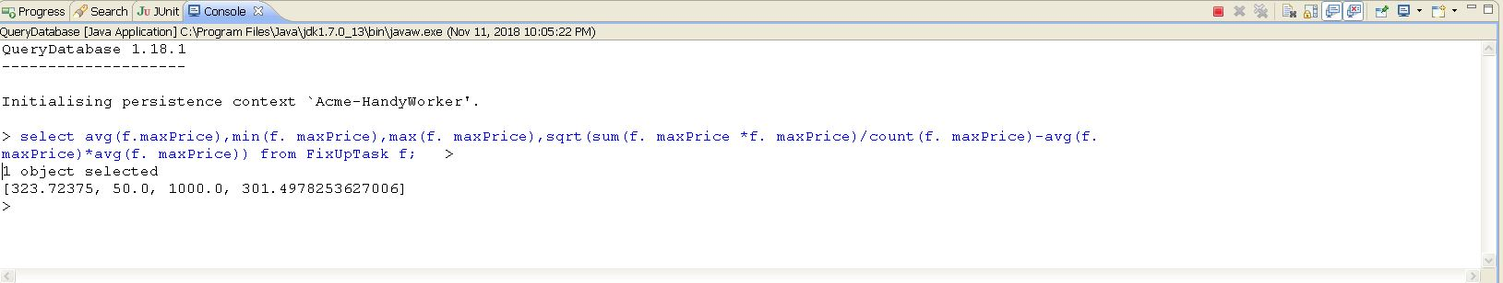

**Query C/4: The average, the minimum, the maximum, and the standard deviation of the price offered in the applications.**

select avg(a.offeredPrice),min(a.offeredPrice),max(a.offeredPrice),sqrt(sum(a.offeredPrice * a.offeredPrice)/count(a.offeredPrice)-avg(a.offeredPrice)*avg(a.offeredPrice)) from Application a;

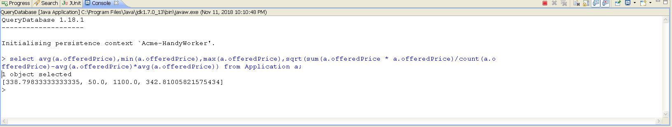

**Query C/5: The ratio of pending applications.**

select (sum(case when a.status='PENDING' then 1.0 else 0 end)/count(*)) from Application a;

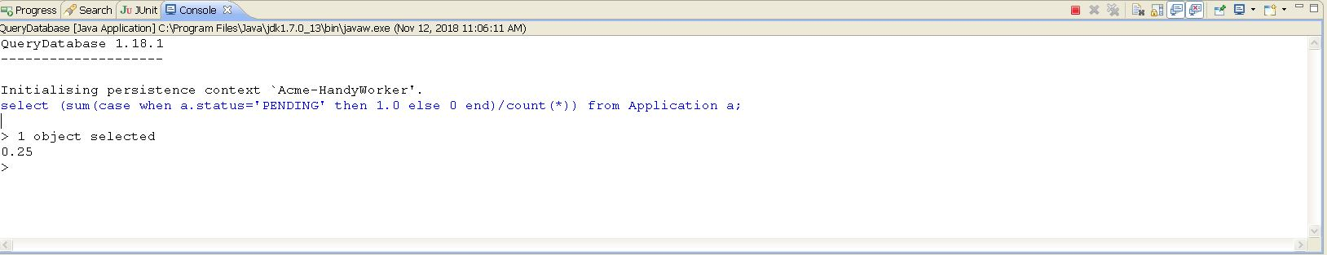

**Query C/6: The ratio of accepted applications.**

select (sum(case when a.status='ACCEPTED' then 1.0 else 0 end)/count(*)) from Application a;

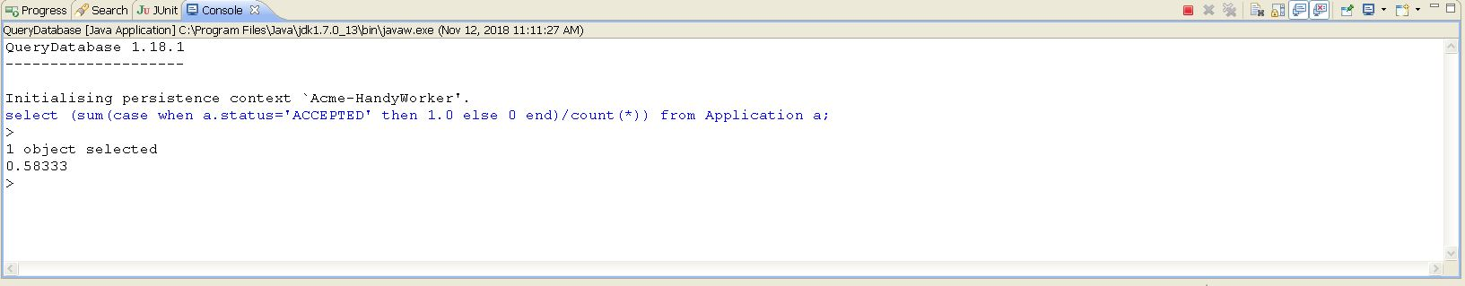

**Query C/7: The ratio of rejected applications.**

select (sum(case when a.status='REJECTED' then 1.0 else 0 end)/count(*)) from Application a;

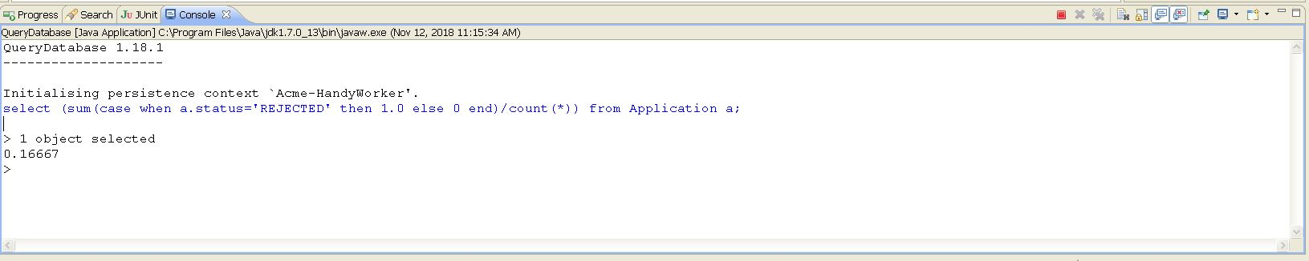

**Query C/8: The ratio of pending applications that cannot change its status because their time period’s elapsed.**

Select a from Application a where a.status='PENDING' and a .registerMoment <CURRENT_TIMESTAMP;

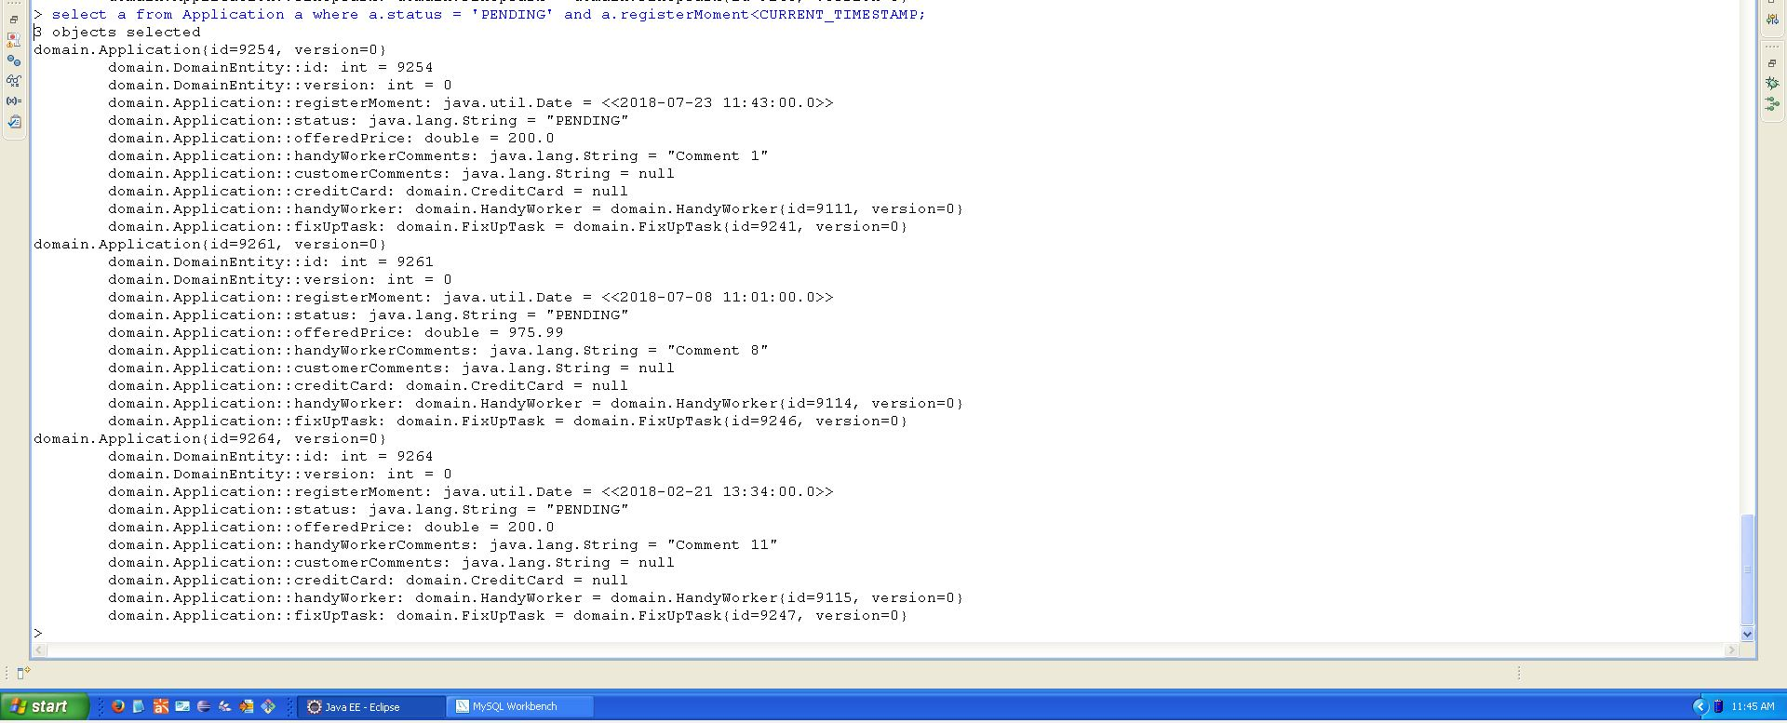

**Query C/9: The listing of customers who have published at least 10% more fix-up tasks than the average, ordered by number of applications.**

**Select c from customer c**

**Query C/10: The listing of handy workers who have got accepted at least 10% more ap-plications than the average, ordered by number of applications.**

**select a.handyWorker from Application a where (((sum (case when a.status = 'ACCEPTED' then 1.0 else 0 end))) >0);**

**select t from Trip t where t.applicationsFor.size > 1.1*(select avg(t.applicationsFor.size) from Trip t) order by t.applicationsFor.siz**