
COCA-COLA İÇECEK
CCI SAMARKAND
PLANT BOOK
Production lines, equipment and utilities overview

Plant | CCI Samarkand, Jomboy District, Samarkand Region, Uzbekistan
Production lines | PET | HOT line (HF) | CAN | RGB
Document | Plant Book (equipment register)
Edition | Rev. 1.0 – October 2026 (working draft)
Language | English
Classification | Confidential – internal use only

LINE 1  PET |  | LINE 2  HOT LINE (HF) |  | LINE 3  CAN |  | LINE 4  RGB

Contents
1 Plant General Information 4
2 Package Types 5
3 Production Lines Overview 6
4 Line-1 PET 7
4.1 Line data and equipment register 7
4.2 Contiform 324 Pro – Stretch blow moulder 10
4.3 Preform feed unit – Contifeed RS 12
4.4 Filler Modulfill VFS and closure handling 14
4.5 Inspection units – Checkmat and PET-View 16
4.6 Contiflow 90/2 – Beverage processing 17
4.7 Contiroll 1.200-30 – Labeler 19
4.8 Variopac Pro FS-8 – Packer 20
4.9 Pack conveyor, palletizing and stretch wrapping 22
4.10 Linadry dryer, SynCo conveyor, coding and lubrication 25
4.11 SFM subsystems and electronic installations 27
5 Line-2 HOT Fill (HF) PET 28
5.1 Line data and equipment register 28
5.2 Preform tipper and preform feed unit – Contifeed RS 31
5.3 Contiform 314 Pro – Stretch blow moulder 33
5.4 Contiflow 30/2 – Beverage treatment (mixer) 35
5.5 VarioFlash H – Flash pasteurizers (slurry and juice) 36
5.6 FlexiFruit – Pre-dosing filler 38
5.7 Hot filler Modulfill NWJ and cap sorting 39
5.8 Inspection units and neck sterilizer 42
5.9 Linacool – Bottle cooler 43
5.10 Linadry dryer, SynCo conveyor, coding and lubrication 45
5.11 Contiroll 720-18 – Labeler 47
5.12 Variopac Pro FS-8 – Shrink packer 48
5.13 Pack conveyor, palletizing and stretch wrapping 50
5.14 NH3 refrigeration and SFM packages 52
6 Line-3 CAN 53
6.1 Line data and equipment register 53
6.2 Depalletiser Pressant and pallet conveyor 1 55
6.3 Contiflow 30/2 – Beverage treatment (mixer) 57
6.4 Can filler, seamer and can end feed 58
6.5 Inspection units – Checkmat 731 FM-X and Checkmat 707 60
6.6 Linaflex – Tunnel pasteuriser 62
6.7 Linadry dryers and SynCo container conveyor 64
6.8 Variopac Pro PFS-6 – Shrink packer 66
6.9 Pack conveyor, palletising and stretch wrapping 68
6.10 Line power distribution and SFM packages 71
6.11 Coding, conveyor lubrication and UPS 72
7 Line-4 RGB 73
7.1 Line data and equipment register 73
7.2 Depalletiser and palletiser – KUKA robot cells 75
7.3 Uncaser and caser – QF.X-8L / QF.Z-8L 77
7.4 Case washer – XIX30 78
7.5 Bottle washer – SXP54-00 79
7.6 Bottle inspection – HEUFT ASEBI and FBI 81
7.7 Mixer DBF250T and CO2 purifier 82
7.8 Filler with crowner – YG14424A 84
7.9 Coding and labelling – Videojet, Novexx and UBS 85
7.10 Conveyors, lubrication and FMS 87
7.11 Line power – 3-phase automatic voltage regulator 89
8 Utilities and Facilities 90
8.1 Steam boiler room 90
8.2 Diesel generator equipment 90
8.3 Air compressors 93
8.4 CO2 production equipment 97
8.5 Liquid nitrogen equipment 98
8.6 Rooftop units 100
8.7 Power supply equipment 101
8.8 Refrigeration and cooling equipment 103
9 Water Treatment 105
9.1 System data and equipment register 105
9.2 Raw water supply – booster set and pump room panel 107
9.3 Pre-treatment and ultrafiltration 109
9.4 Activated carbon filters 111
9.5 Water softeners 112
9.6 Cartridge filtration and reverse osmosis 114
9.7 UV disinfection – OPRP2 115
9.8 Treated water distribution and soft water network 116
9.9 Chemical dosing and membrane cleaning 117
9.10 Control system 119
10 Syrup Room 120
10.1 Syrup room data and equipment register 120
10.2 Sugar receiving and sugar dissolver 122
10.3 Syrup filtration and plate heat exchanger 124
10.4 Simple syrup and final syrup tanks 126
10.5 Aroma dosing and syrup distribution 127
10.6 Syrup Juice – slurry tanks and drum dumping 129
10.7 CIP system 131
10.8 Control system 132
10.9 Line 4 RGB syrup equipment (Omnia) 133
11 Waste Water Treatment 134
11.1 System data and equipment register 134
11.2 Collection, screening and equalisation 135
11.3 Neutralisation, treatment and discharge 135
12 Quality Control Laboratory 136
12.1 Laboratory data and asset overview 136
12.2 Chemical and physical analysis 136
12.3 Microbiology 137
12.4 Packaging and closure testing 137
12.5 Weighing and general laboratory equipment 138
Appendix A Open items and data to verify 139

1 Plant General Information
Plant | CCI Samarkand | Address | Jomboy District, Samarkand Region, Uzbekistan
Plant area | 185,000 m² | Covered area | 31,486 m²
Annual average production | 60,000,000 PHC | Number of employees | 149 (permanent)
Working schedule | Full year, 2 shifts, 12 hours, 24/7 | Non-returnable product ratio | 83 %
PET bottle types | 0.5 L CNT, 1 L CNT, 1.5 L CNT, 2.5 L CNT | Returnable glass bottle types | RB 250 ml CNT

Product range
Coca-Cola, Coca-Cola Zero, Fanta products, Sprite, Sprite Mojito, Cappy juice products, Fuse Tea iced tea products.

Wastewater system
Process and domestic wastewater is discharged into the industrial-zone drainage system; rainwater is discharged into the stream bed.
Note: general information values are carried over from the plant-book template and should be confirmed for Samarkand.

2 Package Types
LINE | BOTTLE | FORMATS | PACK | PRODUCTS
Line 1 – PET CSD | Contour PET bottle | 0.5 / 1.0 / 1.5 / 2.5 L | Shrink pack: 0.5 L 12 (4×3), 1.5 L 6 (2×3) | Coca-Cola, Fanta, Sprite
Line 2 – PET Hot-fill | Heat-set PET bottle | 0.5 / 1.0 / 1.5 L | Shrink pack 6 (2×3) | Fuse Tea, Cappy Pulpy
Line 3 – CAN | Aluminium can | 0.25 L | Shrink pack | Sprite
Line 4 – RGB | Returnable glass bottle | 0.25 L | Plastic crate | Coca-Cola, Fanta

Source: format lists on the Krones conveyor and palletizer HMIs and packs seen on site (October 2026). Line 2 hot-fill runs 0.5, 1.0 and 1.5 L. CAN pack size and RGB bottles per crate still to be confirmed.

3 Production Lines Overview
LINE | TYPE | EQUIPMENT SUPPLIER | CAPACITY | PACKAGES | PLANT-BOOK STATUS
Line 1 | PET (BF-Bloc, CSD) | Krones AG, Germany | 54,000 bph | 0.5 / 1 / 1.5 / 2.5 L PET | Register, nameplates and photos (Section 4)
Line 2 | HOT fill (HF) PET | Krones AG, Germany | 22,400 bph @ 1 L | 0.5 / 1 / 1.5 L PET | Register, nameplates and photos (Section 5)
Line 3 | CAN | Krones AG, Germany | 48,000 cph @ 0.25 L | Cans | Register, nameplates and photos (Section 6)
Line 4 | RGB | Hefei Zhongchen, China | 48,000 bph (washer plate) | 0.25 L returnable glass | Register, nameplates and photos (Section 7)

Each production line is documented in the same format: a line data sheet, an equipment register, and one page per machine with machine table, electrical data and photographs. Utilities and facilities that serve all lines are covered in Section 8. Water treatment, the syrup room, waste water treatment and the quality control laboratory are covered in Sections 9 to 12.

4 Line-1 PET

4.1 Line data and equipment register
Manufacturer | Krones AG – Germany | Line | BF-Bloc Line CSD
Capacity | 54,000 bph | Krones system no. | C372673
Customer | Coca Cola Ichimligi Uzbekistan Ltd (92039221) | Year of manufacture (YOM) | 2024
Installed power | – kW | Package types | 0.5 / 1 / 1.5 / 2.5 L PET
Functional location | PRD00183 – SMR Line-01 / Pet / Krones | Cost centre | 7102066018

Line process flow
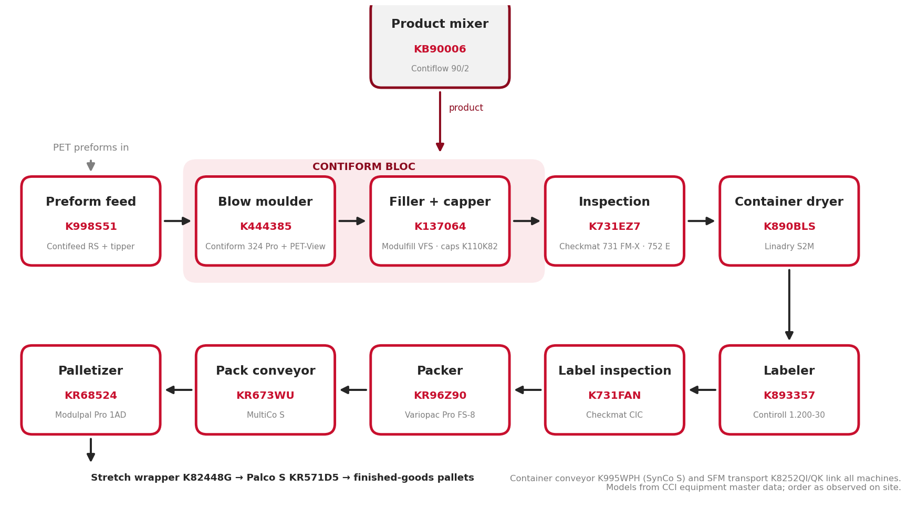
Figure 4.1 – Line-1 PET process flow, from preform feed to palletizing (machine order as observed on site)

Krones equipment register
No. | KRONES NO. | DESCRIPTION | ASSET NO. | DETAILS
1 | K110K82 | Feed system for caps – sorting system | 223000000097 | Section 4.4
2 | K137064 | Bottle filler Modulfill VFS 5.760-160-113 | 223000000095 | Section 4.4
3 | K440A09 | Set of moulds | see 4.2 | Section 4.2
4 | K444385 | Stretch-blow moulder Contiform 324 Pro | 223000000092 | Section 4.2
5 | K731EZ7 | Inspection unit Checkmat 731 FM-X | 223000000096 | Section 4.5
6 | K731FAN | Inspection unit Checkmat CIC (label) | 223000000100 | Section 4.5
7 | K752U45 | Inspection unit Checkmat 752 E | 223000000098 | Section 4.5
8 | K776F20 | PET inspector PET-View 776 D (inside Contiform) | 223000000093 | Section 4.2 / 4.5
9 | K8206CR | SFM labeling technology | – | Section 4.11
10 | K8206CS | SFM labeling technology | – | Section 4.11
11 | K8212IR | SFM filling / process technology | – | Section 4.11
12 | K82448G | Stretch wrapper Robopac Genesis Thunder (Aetna Group) | 223000000107 | Section 4.9
13 | K8252QI | SFM transport technology | – | Section 4.11
14 | K8252QK | SFM transport technology | – | Section 4.11
15 | K82724N | Preform tipper / preform bunker (M. Tanner AG) | 223000000110 | Section 4.3
16 | K890BLS | Container dryer Linadry S2M | 223000000099 | Section 4.10
17 | K893357 | Container labeler Contiroll 1.200-30 | 223000000054 | Section 4.7
18 | K919IXL | Electronic installation | – | Section 4.11
19 | K919IXM | Electronic installation | – | Section 4.11
20 | K995WPH | Container conveyor SynCo S | 223000000104 | Section 4.10
21 | K998S51 | Preform feed unit Contifeed RS | 223000000094 | Section 4.3
22 | KB90006 | Beverage processing Contiflow 90/2 | 223000000001 | Section 4.6
23 | KR571D5 | Pallet conveyor Palco S | 223000000108 | Section 4.9
24 | KR673WU | Pack conveyor MultiCo S | 223000000105 | Section 4.9
25 | KR68524 | Palletizer Modulpal Pro 1AD | 223000000106 | Section 4.9
26 | KR96Z90 | Packer Variopac Pro FS-8 | 223000000103 | Section 4.8

Sources: Krones equipment tree (system C372673); asset numbers from the SAP fixed-asset register (plant 1802) and equipment master data, cost centre 7102066018. In all tables “–” means not available / not applicable.

Other Line-1 assets (not in the Krones list)
No. | EQUIPMENT | MANUFACTURER / MODEL | SERIAL NO. | ASSET NO.
1 | Container code / dating unit 1 (laser) | Videojet VJ 3640 | 4918364 / P 230920 | 223000000101
2 | Container code / dating unit 2 (laser) | Videojet VJ 3640 | 4918364 / P 230920 | 223000000102
3 | Conveyor lubrication (dry lube Dry Tech 4 VL83) | Diversey | – | 223000000109
4 | Electrical power distributor – UPS | SK 3304540 | – | 223000000111
5 | Set of blow moulds 1 L (with replaceable parts) | – | – | 223000000010 / 223000000011
6 | Blow moulds 2.5 L | – | – | 223000000025
7 | Blow moulds 2.5 L Coca-Cola and Fanta | – | – | 223000000051
8 | T&T coding machine (QR codes) | OOO “JETINK” | – | 223000000055 / 056 / 060 / 061
9 | Marking machine | Matrix System | – | 223000000057
10 | Pallet label applicator | UBS | – | 223000000050
11 | Labeling machine | APL8300PRO (003425) | – | 223000000012
12 | Multifunction industrial PC | TREX DCAS | – | 223000000048
13 | Industrial panel PC (panel included) | – | – | 223000000024
14 | Laser fume extractor (coding station) | Videojet Xtract Pro | – | –

4.2 Contiform 324 Pro – Stretch blow moulder

Machine data
MACHINE | KRONES NO. | TYPE | MFG. DATE | SERIAL NO. | INST. POWER kW | SAP NO. | ASSET NO.
Stretch blow moulder | K444385 | Contiform 324 Pro | 2024 | K444385 | – | 1000002325 | 223000000092
Set of moulds | K440A09 | 1 L and 2.5 L | 2024 | K440A09 | – | 1000002800 | 223000000010 / 011 / 025 / 051

Electrical data – main supply (nameplate K444385)
PARAMETER | MAIN SUPPLY
Rated voltage | 400 / 230 V
Type of current / system | AC 3/N/PE
System frequency | 50 Hz
Full-load current (Ib max) | 626 A
Short-circuit rating | 26 kA (Icc)
Min. short-circuit current (Ik min) | 0.95 kA
Back-up fuse | 630 A
Connection diagram no. | K444385-001

Manufacturer and standards
Manufacturer: Krones AG, Werk Neutraubling (Germany). Year of manufacture: 2024. Serial number = Krones commission number. Standards: IEC 60204-1 / IEC 61439-1. The Contiform 324 Pro forms a block with the filler (“Contiform Bloc”). PET-View 776 D empty-bottle inspection (K776F20, asset 223000000093) is built into the Contiform outlet: cameras check every blown bottle before filling and reject faulty ones. Being inside the machine guarding, it is listed in the table only, without separate photos.

Photos
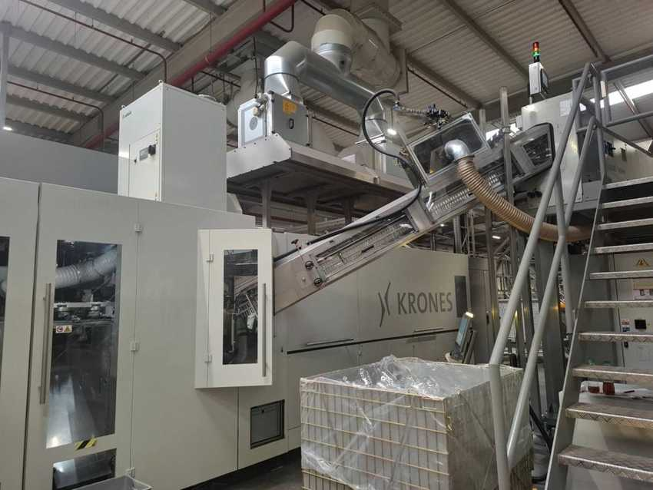 |  | 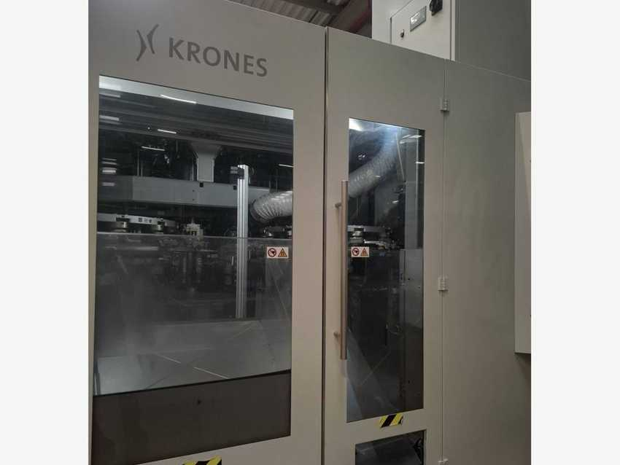
Contiform 324 Pro with Contifeed preform elevator |  | Contiform 324 Pro – front view
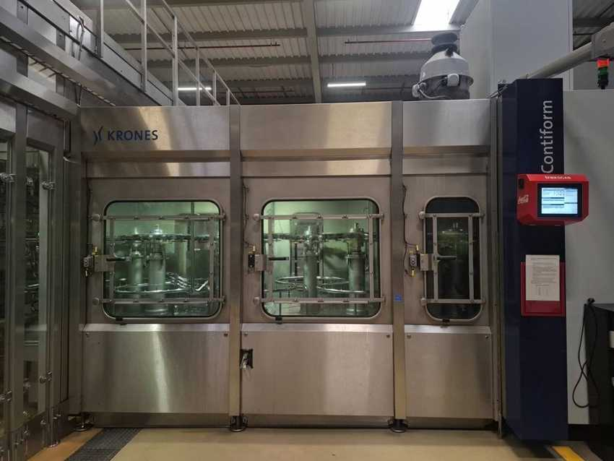 |  | 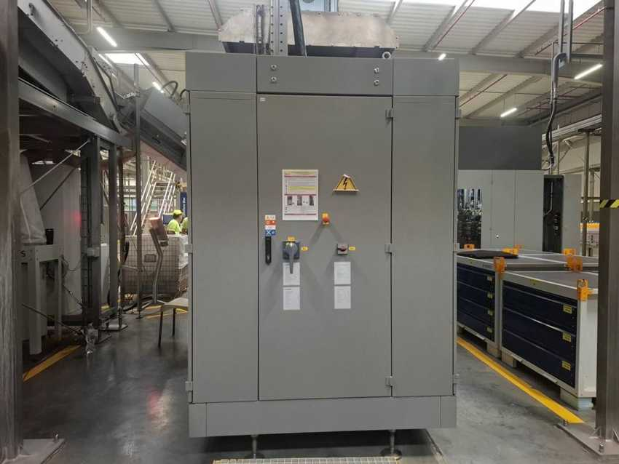
Contiform 324 Pro – blow wheel / transfer area |  | Contiform 324 Pro – electrical control cabinet

4.3 Preform feed unit – Contifeed RS

Machine data
MACHINE | KRONES NO. | TYPE | MFG. DATE | SERIAL NO. | INST. POWER kW | SAP NO. | ASSET NO.
Preform feed unit 1 | K998S51 | Contifeed RS | 2024 | K998S51 | – | 1000002924 | 223000000094
Roller sorter | K998S51 | GEN3 C21-50 / 1 | 2024 | K998S51 | – | – | –
Preform tipper (bunker) | K82724N | M. Tanner AG 1099955 | 2024 | K 827-24N | – | – | 223000000110

Electrical data (nameplates K998S51)
PARAMETER | MAIN SUPPLY | AUXILIARY SUPPLY
Rated voltage | 400 / 230 V | 400 / 230 V
Type of current / system | AC 3/N/PE | AC 3/N/PE
System frequency | 50 Hz | 50 Hz
Full-load current (Ib max) | 35 A | 4 A
Short-circuit rating | 1.26 kA / 1 s (Icw) | 0.29 kA / 1 s (Icw)
Min. short-circuit current (Ik min) | 0.76 kA | 0.38 kA
Back-up fuse | 50 A | 8 A
Connection diagram no. | K998S51 | K998S51

Manufacturer and standards
Manufacturer: Krones AG, Werk Neutraubling (Germany). Year of manufacture: 2024. Serial number = Krones commission number. Standards: IEC 60204-1 / IEC 61439-1.

Cabinet cooling unit – Seifert SLIMLINE KG 4274
Part no. | 42749626 | Krones part no. | 0906480679
Serial no. | M9626014970 | Production date | 12/24
Supply | 230 V, 50/60 Hz | Power / current | 1.4 kW / 3.6 A @ 50 Hz
Cooling capacity | 1.50 kW | Refrigerant / IP | R134a 620 g / IP 55

Photos
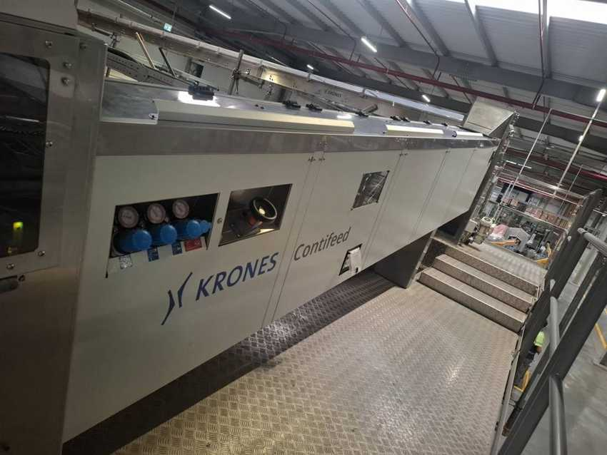 |  | 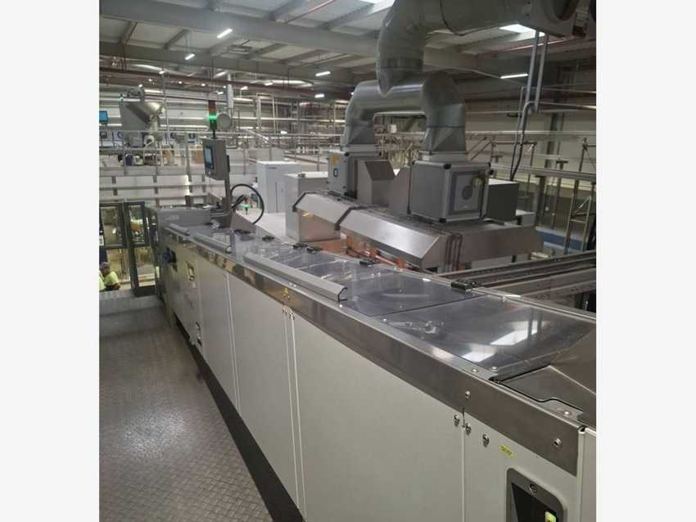
Contifeed – side view |  | Contifeed – roller sorter, top view
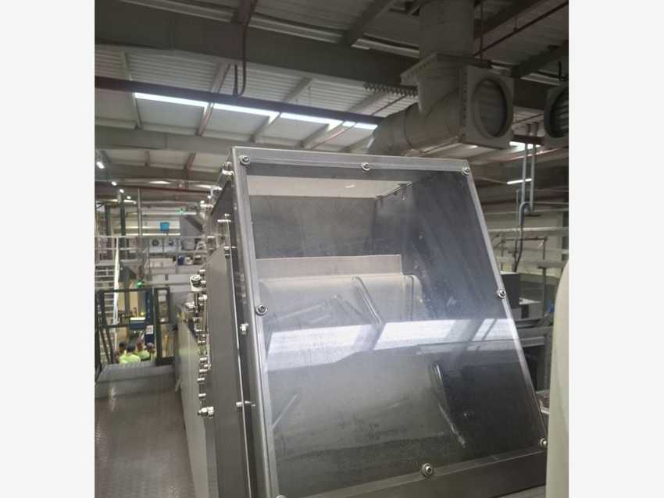 |  | 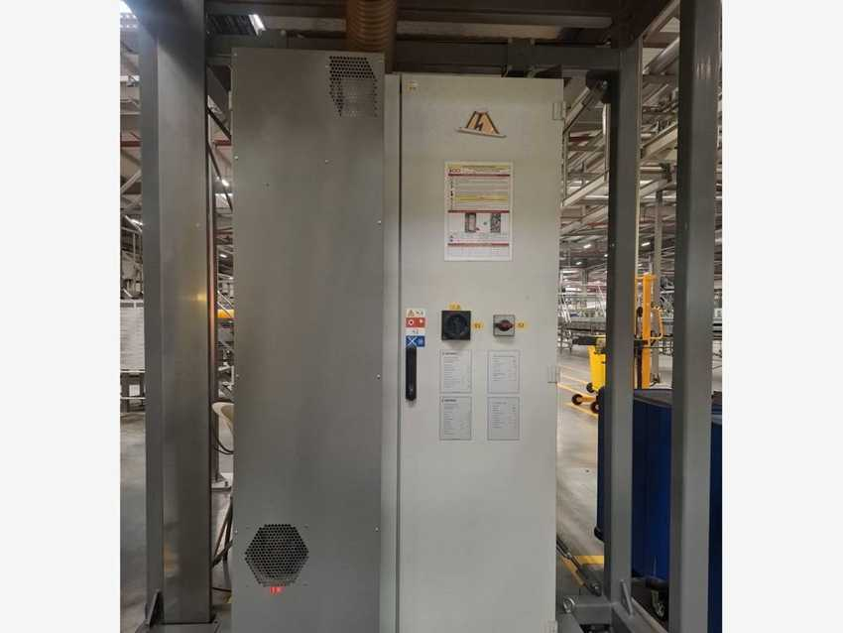
Contifeed – preform hopper |  | Contifeed – control cabinet
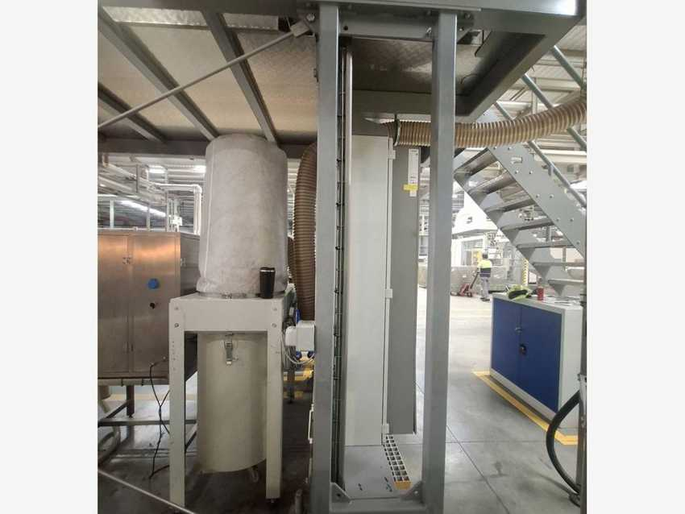 |  | 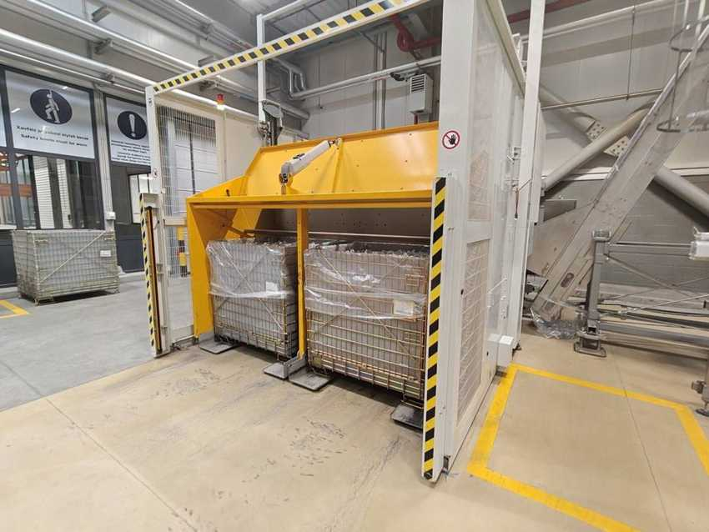
Control cabinet with Seifert cooling unit |  | Preform tipper K82724N (M. Tanner AG) – tips preform containers into the bunker / elevator

4.4 Filler Modulfill VFS and closure handling

Machine data
MACHINE | KRONES NO. | TYPE | MFG. DATE | SERIAL NO. | INST. POWER kW | SAP NO. | ASSET NO.
Bottle filler | K137064 | Modulfill VFS 5.760-160-113 | 2024 | K137064 | – | 1000002324 | 223000000095
Cap sorting system | K110K82 | Krones / Gassner cap feed | 2024 | K110K82 | – | 1000002798 | 223000000097

Electrical data (nameplates K137064)
PARAMETER | MAIN SUPPLY | AUXILIARY SUPPLY
Rated voltage | 400 / 230 V | 400 / 230 V
Type of current / system | AC 3/N/PE | AC 3/N/PE
System frequency | 50 Hz | 50 Hz
Full-load current (Ib max) | 63 A | 5 A
Short-circuit rating | 54 kA / 1 s (Icw) | 0.29 kA / 1 s (Icw)
Min. short-circuit current (Ik min) | 0.64 kA | 0.32 kA
Back-up fuse | 80 A | 16 A
Connection diagram no. | K137064 | K137064

Manufacturer and standards
Manufacturer: Krones AG, Werk Neutraubling (Germany). Year of manufacture: 2024. Serial number = Krones commission number. Standards: IEC 60204-1 / IEC 61439-1. The filler is part of the Contiform Bloc (blow moulder + filler). Caps are lifted by a Gassner cap elevator into the Krones cap sorting system (stainless control cabinet with its own HMI on the filler platform) and fed by chute to the capper.

Cap sorting cabinet cooling unit – Seifert SLIMLINE KG 4269
Part no. / Krones part no. | 42699634 / 0906543057 | Serial no. | M9634010662
Production date | 07/23 | Supply | 230 V, 50/60 Hz
Input power | 560 W max (480 W @ 50 Hz) | Current | 2.4 A rated, 2.8 A max, 5.8 A starting
Fuse / SCCR | 6 A (T) / 5 kA | Cooling capacity / refrigerant | 500 W @ 50 Hz / R134a 142 g, IP 55

Photos
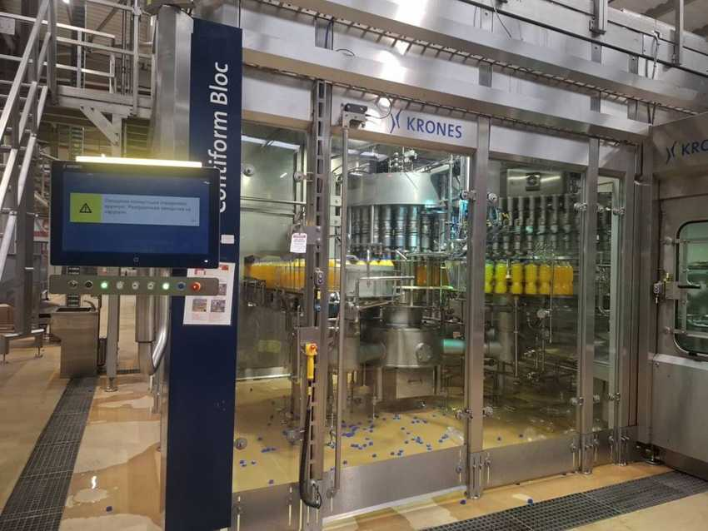 |  | 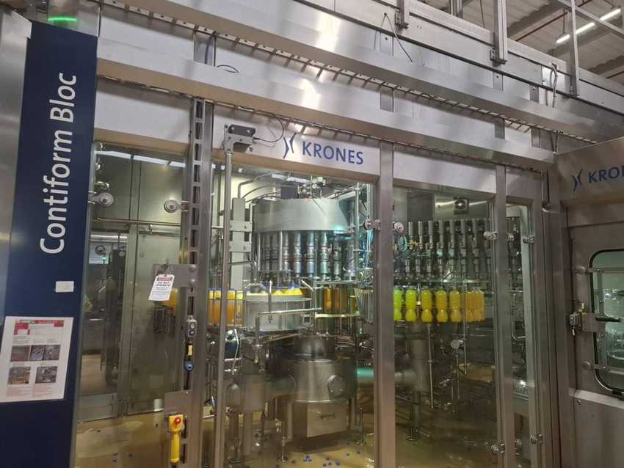
Modulfill VFS filler – Contiform Bloc filler cell |  | Modulfill VFS filler – filler cell with HMI
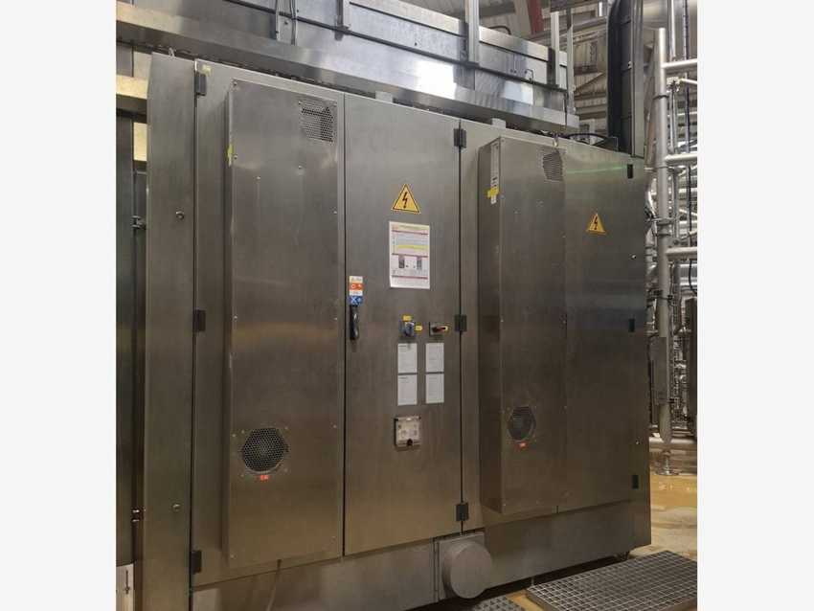 |  | 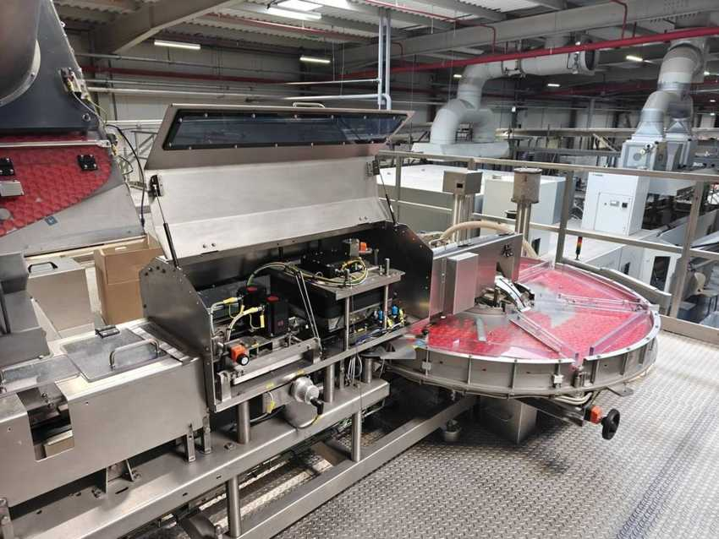
Filler – electrical control cabinet |  | Cap sorting system K110K82 – sorter disc
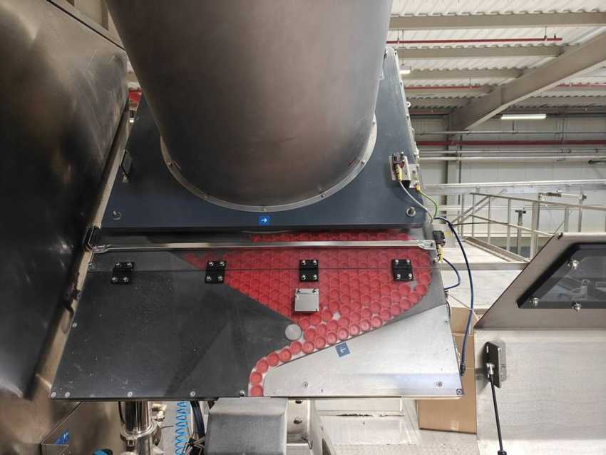 |  | 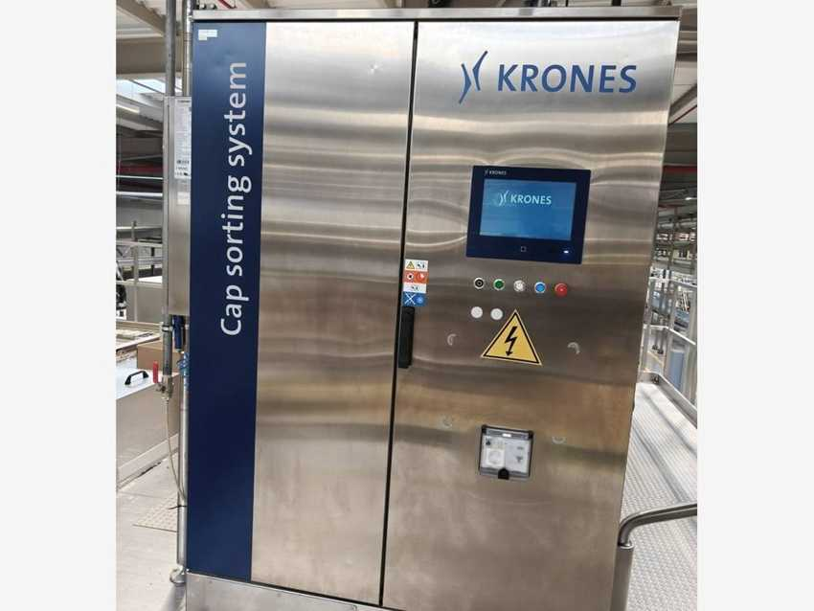
Cap hopper outlet and cap chute |  | Cap sorting system control cabinet (Gassner elevator above)

4.5 Inspection units – Checkmat and PET-View

Machine data
MACHINE | KRONES NO. | TYPE | MFG. DATE | SERIAL NO. | INST. POWER kW | SAP NO. | ASSET NO.
Inspection unit | K731EZ7 | Checkmat 731 FM-X | 2024 | K731EZ7 | – | 1000002863 | 223000000096
Label inspection (=LN01.CK2) | K731FAN | Checkmat CIC | 2024 | K731FAN | – | – | 223000000100
Inspection unit (capping) | K752U45 | Checkmat 752 E | 2024 | K752U45 | – | – | 223000000098
PET inspector (inside Contiform) | K776F20 | PET-View 776 D | 2024 | K776F20 | – | – | 223000000093

Electrical data (nameplates)
PARAMETER | K731EZ7 | K731FAN
Rated voltage | 230 V | 230 V
Type of current / system | AC 1/N/PE | AC 1/N/PE
System frequency | 50 Hz | 50 Hz
Full-load current (Ib max) | 4 A | 4 A
Short-circuit rating | 1 kA / 1 s (Icc) | 1 kA / 1 s (Icc)
Min. short-circuit current (Ik min) | 0.16 kA | 0.16 kA
Back-up fuse | 16 A | 10 A
Connection diagram no. | K731EZ7 | K731FAN

Manufacturer and standards
Manufacturer: Krones AG, Werk Neutraubling (Germany). Year of manufacture: 2024. Serial number = Krones commission number. Standards: IEC 60204-1 / IEC 61439-1.

Photos
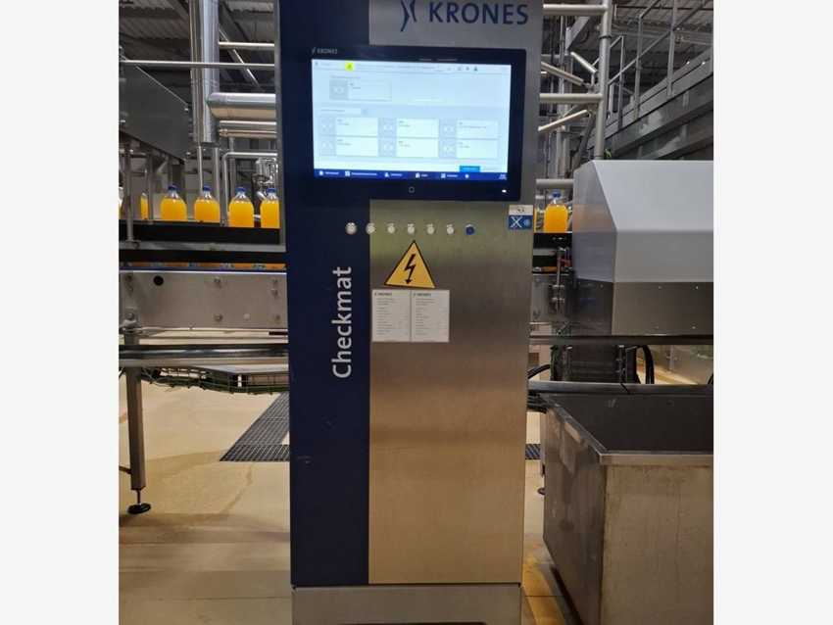 |  | 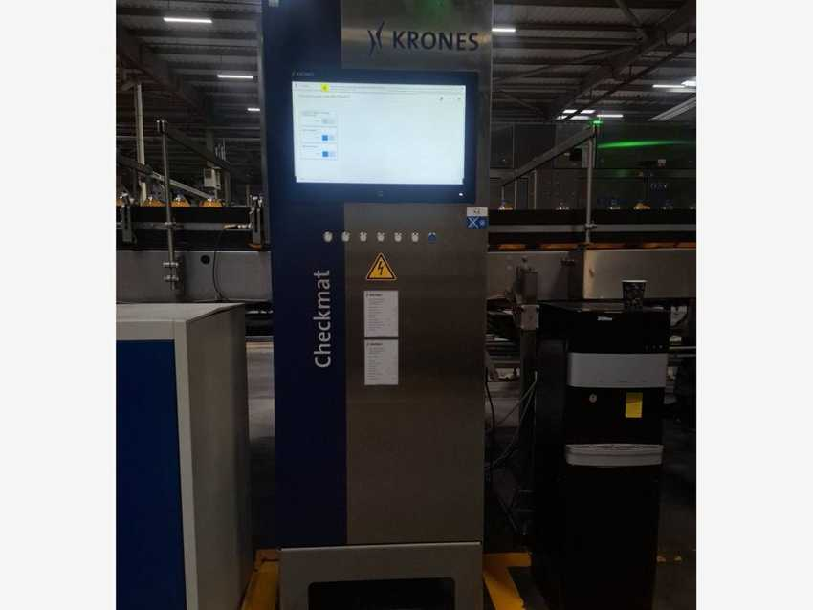
Checkmat K731EZ7 |  | Checkmat K731FAN (=LN01.CK2)

4.6 Contiflow 90/2 – Beverage processing

Machine data
MACHINE | KRONES NO. | TYPE | MFG. DATE | SERIAL NO. | INST. POWER kW | SAP NO. | ASSET NO.
Mixer (beverage processing) | KB90006 | Contiflow 90/2 | 2024 | KB90006 | – | 1000002329 | 223000000001

Electrical data (nameplates KB90006)
PARAMETER | MAIN SUPPLY | AUXILIARY SUPPLY
Rated voltage | 400 / 230 V | 400 / 230 V
Type of current / system | AC 3/N/PE | AC 3/N/PE
System frequency | 50 Hz | 50 Hz
Full-load current (Ib max) | 156 A | 4 A
Short-circuit rating | 55 kA / 1 s (Icc) | 0.42 kA / 1 s (Icw)
Min. short-circuit current (Ik min) | 2.4 kA | 0.29 kA
Back-up fuse | 200 A | 16 A
Connection diagram no. | KB90006 | KB90006

Manufacturer and standards
Manufacturer: Krones AG, Werk Neutraubling (Germany). Year of manufacture: 2024. Serial number = Krones commission number. Standards: IEC 60204-1 / IEC 61439-1.

Photos
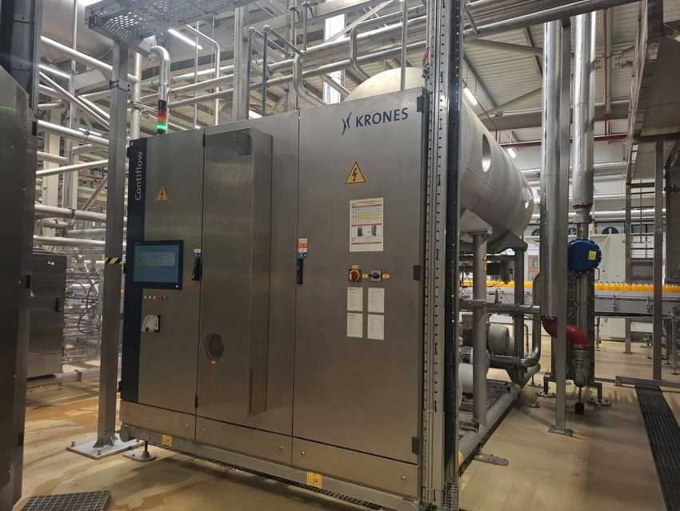 |  | 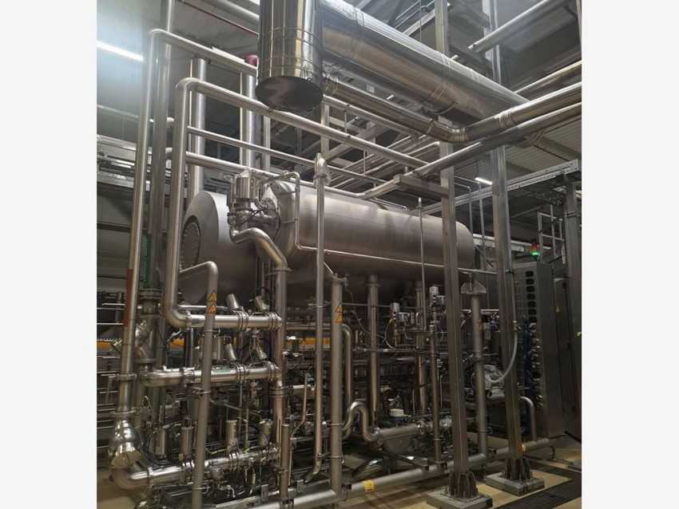
Contiflow – control cabinet and tank |  | Contiflow – tank and valve block
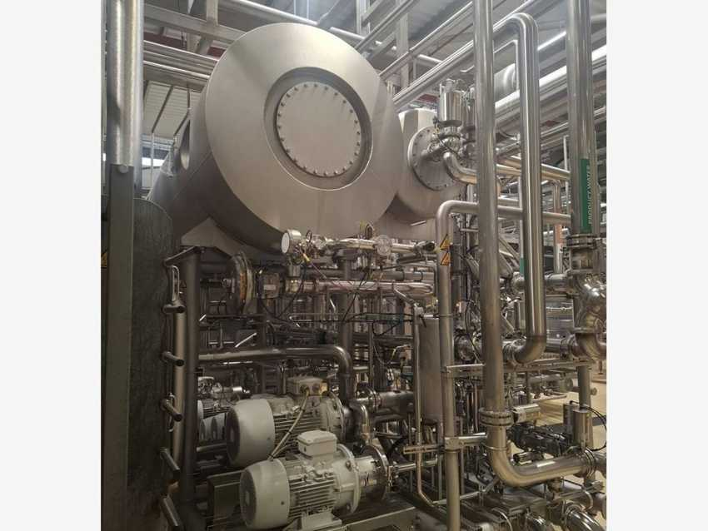 |  | 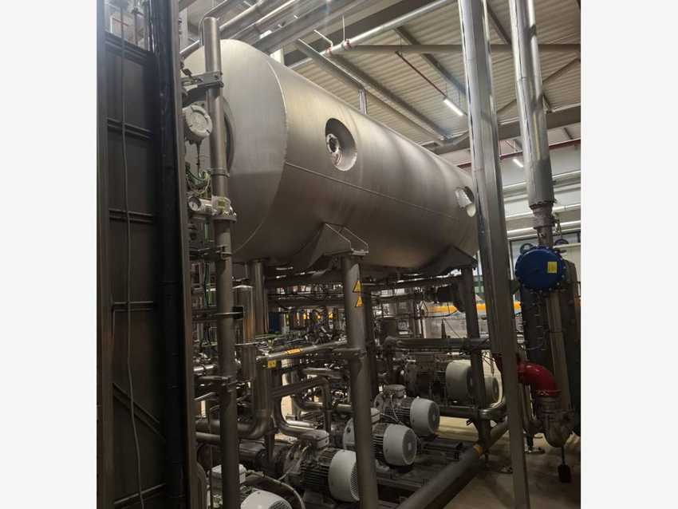
Contiflow – tank front and pumps |  | Contiflow – tank and pump row

4.7 Contiroll 1.200-30 – Labeler

Machine data
MACHINE | KRONES NO. | TYPE | MFG. DATE | SERIAL NO. | INST. POWER kW | SAP NO. | ASSET NO.
Labeler (=LN01.LA1) | K893357 | Contiroll 1.200-30 | 2024 | K893357 | – | 1000002326 | 223000000054

Electrical data (nameplates K893357)
PARAMETER | MAIN SUPPLY | AUXILIARY SUPPLY
Rated voltage | 400 / 230 V | 400 / 230 V
Type of current / system | AC 3/N/PE | AC 3/N/PE
System frequency | 50 Hz | 50 Hz
Full-load current (Ib max) | 34 A | 19 A
Short-circuit rating | 1.26 kA / 1 s (Icw) | 0.43 kA / 1 s (Icw)
Min. short-circuit current (Ik min) | 0.4 kA | 0.32 kA
Back-up fuse | 50 A | 25 A
Connection diagram no. | K893357 LA1 | K893357 LA1

Manufacturer and standards
Manufacturer: Krones AG, Werk Neutraubling (Germany). Year of manufacture: 2024. Serial number = Krones commission number. Standards: IEC 60204-1 / IEC 61439-1. Plant location tag: =LN01.LA1.

Photos
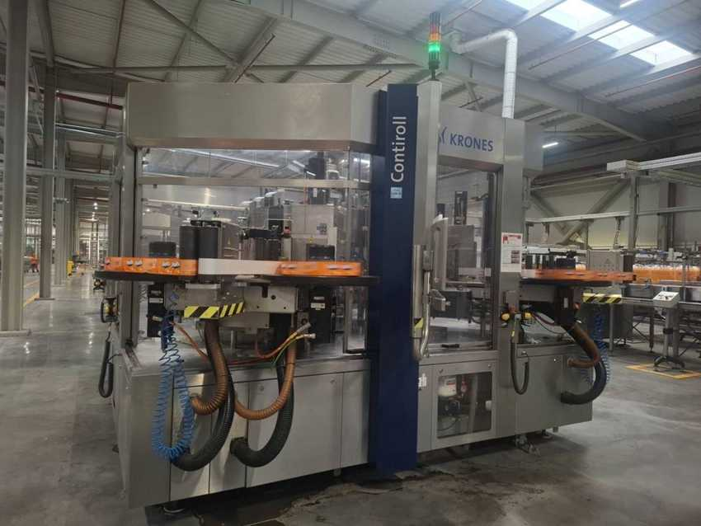 |  | 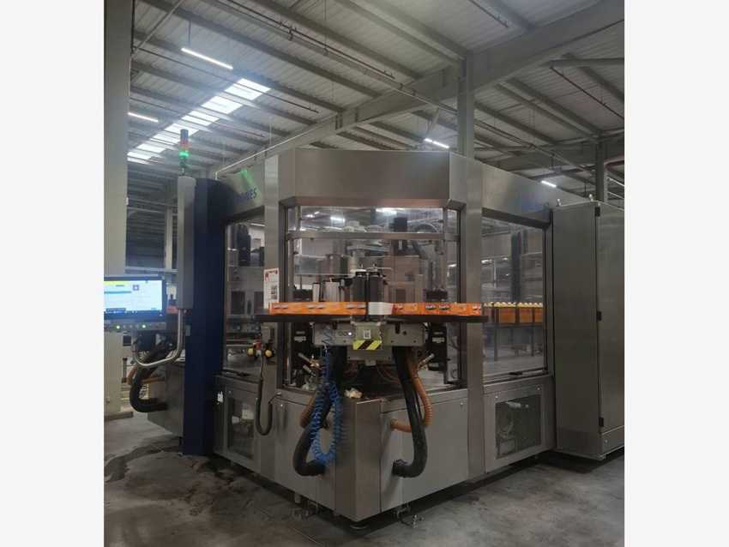
Contiroll labeler – front view |  | Contiroll labeler – side view with HMI

4.8 Variopac Pro FS-8 – Packer

Machine data
MACHINE | KRONES NO. | TYPE | MFG. DATE | SERIAL NO. | INST. POWER kW | SAP NO. | ASSET NO.
Shrink packer (non-returnables) | KR96Z90 | Variopac Pro FS-8 | 2024 | KR96Z90 / SE202301 | – | 1000002327 | 223000000103

Electrical data (nameplates KR96Z90, switches E3 / E4)
PARAMETER | MAIN SUPPLY | AUXILIARY SUPPLY
Rated voltage | 400 / 230 V | 400 / 230 V
Type of current / system | AC 3/N/PE | AC 3/N/PE
System frequency | 50 Hz | 50 Hz
Full-load current (Ib max) | 294 A | 6 A
Short-circuit rating | 55 kA (Icc) | 0.29 kA / 1 s (Icw)
Min. short-circuit current (Ik min) | 1.2 kA | 0.4 kA
Back-up fuse | 400 A | 10 A
Connection diagram no. | KR96Z90-001 | KR96Z90-001

Manufacturer and standards
Manufacturer: Krones AG, Werk Neutraubling (Germany). Year of manufacture: 2024. Serial number = Krones commission number. Standards: IEC 60204-1 / IEC 61439-1. Groups bottles into packs (e.g. 0.5 L 4×3 and 1.5 L 2×3), wraps them in shrink film and shrinks the film in the heated tunnel.

Cooling unit – Seifert SLIMLINE KG 4274 (on packer grouping section)
Part no. / Krones part no. | 42749626 / 0906480679 | Serial no. | M9626012949
Production date | 02/24 | Supply | 230 V, 50/60 Hz
Power / current | 1.4 kW max, 3.6 A @ 50 Hz, 5.6 A max | Fuse / SCCR | 16 A (T) / 5 kA
Cooling capacity | 1.50 kW | Refrigerant / IP | R134a 620 g / IP 55

Photos
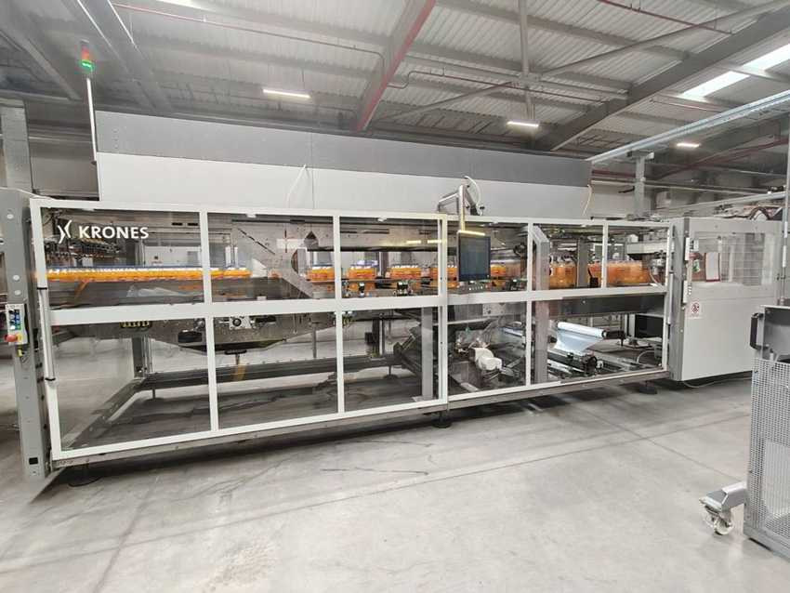 |  | 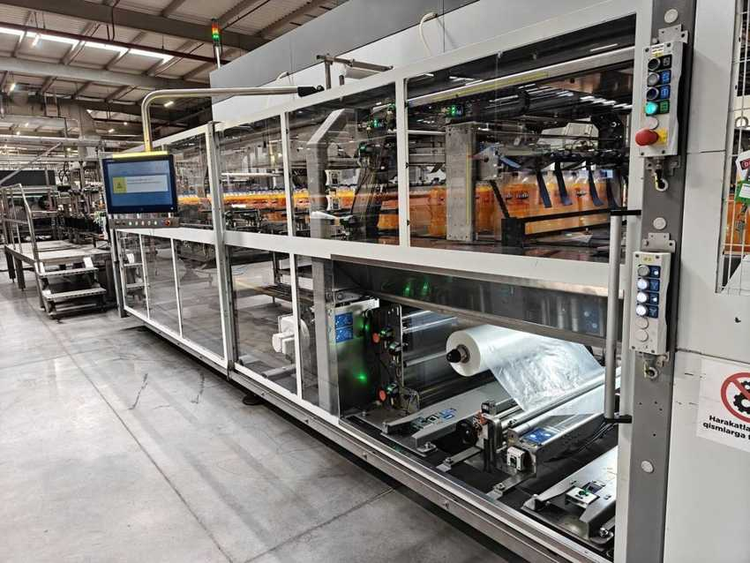
Variopac Pro FS-8 – packer with Fanta packs |  | Variopac Pro FS-8 – HMI and shrink-film unit
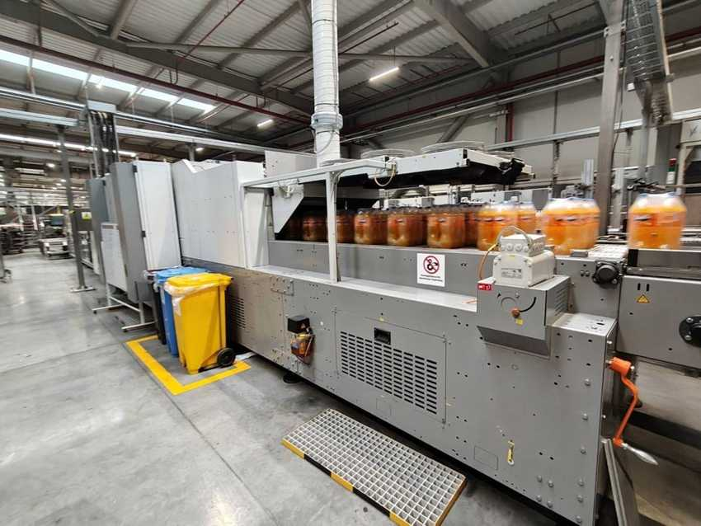 |  | 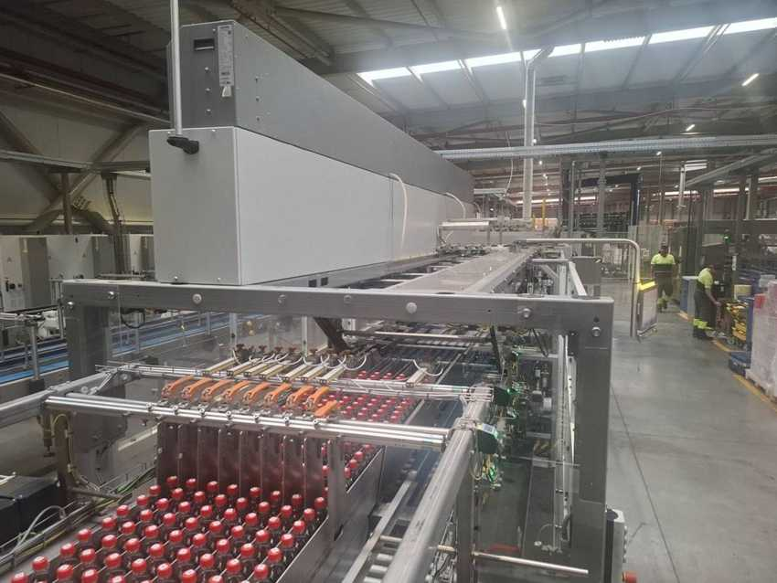
Shrink tunnel – Fanta 1.5 L packs leaving the tunnel |  | Packer infeed – bottle grouping section

4.9 Pack conveyor, palletizing and stretch wrapping

Machine data
MACHINE | KRONES NO. | TYPE | MFG. DATE | SERIAL NO. | INST. POWER kW | SAP NO. | ASSET NO.
Pack conveyor | KR673WU | MultiCo S | 2024 | KR673WU | – | – | 223000000105
Layer forming robot | KR68524 | Robobox T-GS | 2024 | KR68524 | – | – | see palletizer
Palletizer | KR68524 | Modulpal Pro 1AD | 2024 | KR68524 | – | 1000002328 | 223000000106
Stretch wrapper | K82448G | Robopac Genesis Thunder | 2024 | T223060238 | 28.5 | 1000002799 | 223000000107
Pallet conveyor | KR571D5 | Palco S | 2024 | KR571D5 | – | – | 223000000108

Electrical data – Modulpal Pro palletizer (nameplates KR68524, switches E1 / E2)
PARAMETER | MAIN SUPPLY | AUXILIARY SUPPLY
Rated voltage | 400 / 230 V | 400 / 230 V
Type of current / system | AC 3/N/PE | AC 3/N/PE
System frequency | 50 Hz | 50 Hz
Full-load current (Ib max) | 75 A | 6 A
Short-circuit rating | 55 kA (Icc) | 0.17 kA / 1 s (Icw)
Min. short-circuit current (Ik min) | 1 kA | 0.38 kA
Back-up fuse | 80 A | 10 A
Connection diagram no. | KR68524-001 | KR68524-001

Palletizer values read from a photo of the cabinet door – please confirm on site.

Electrical data – stretch wrapper (nameplate K82448G)
PARAMETER | ROBOPAC GENESIS THUNDER
Rated voltage | 400 V AC
Frequency / phases | 50 Hz / 3PH / PE
Current (absorption) | 52.8 A
Total power | 28.5 kW
Short-circuit current | 10 kA
Electrical drawing no. | T2230238

Stretch wrapper: Robopac Genesis Thunder, manufacturer Aetna Group S.p.A., Villa Verucchio (Italy); Aetna serial no. T223060238, Krones no. K82448G. Palletizer running format seen on HMI: 0.5 L shrinkpack 4×3. Layers are formed by the Krones Robobox T-GS before the Modulpal Pro.
MultiCo S pack conveyor: process plate “Pack conveyor 1, MultiCo, KR673WU, 2024”, Krones Hungary Kft., Debrecen; location tag =LN01.MCO1; drives SEW-Eurodrive MGFAS2-DSM-C (400 V, IE5). Set-up plate KR67-3WU covers 0.5 L, 1.5 L and 1 L PET packs.
Palco S pallet conveyor: galvanised chain and roller conveyors that bring empty pallets and tier sheets to the Modulpal Pro, carry full pallets through the Robopac stretch wrapper and out to the forklift pick-up point.

Photos
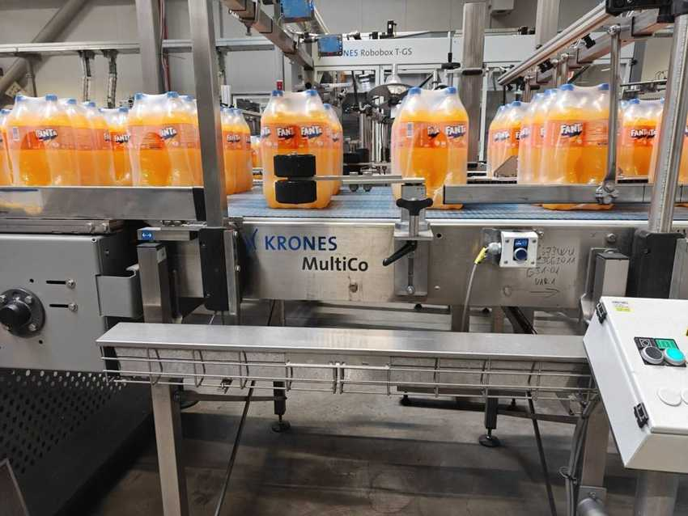 |  | 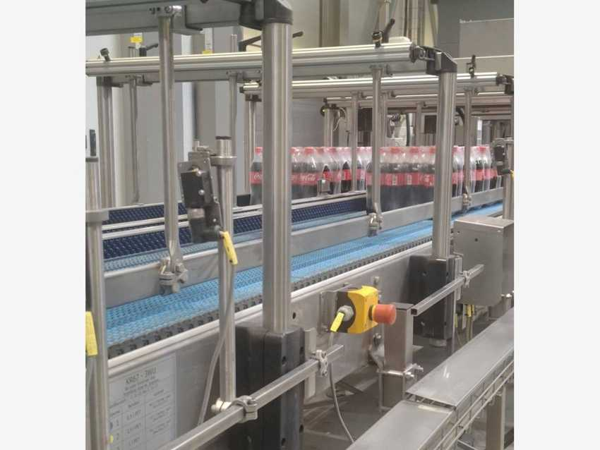
MultiCo S pack conveyor (KR673WU) with Fanta packs |  | MultiCo S – Coca-Cola 0.5 L packs to palletizer
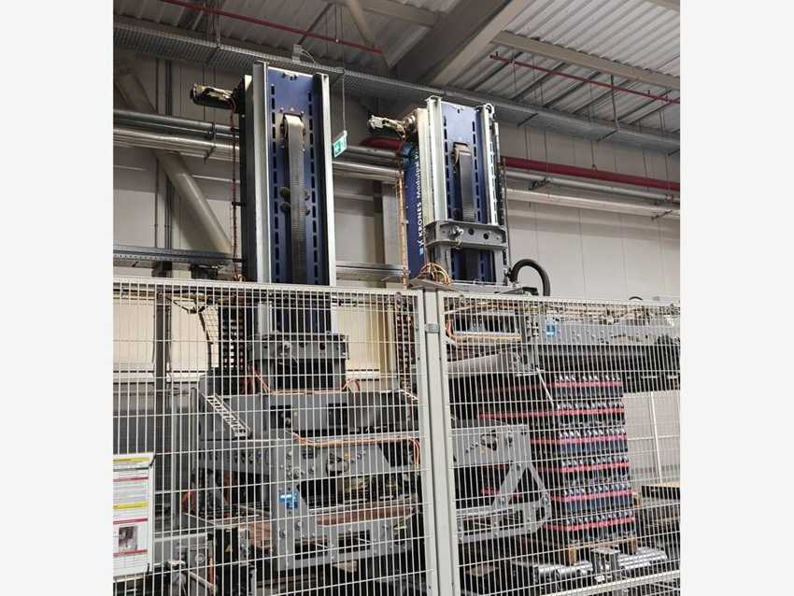 |  | 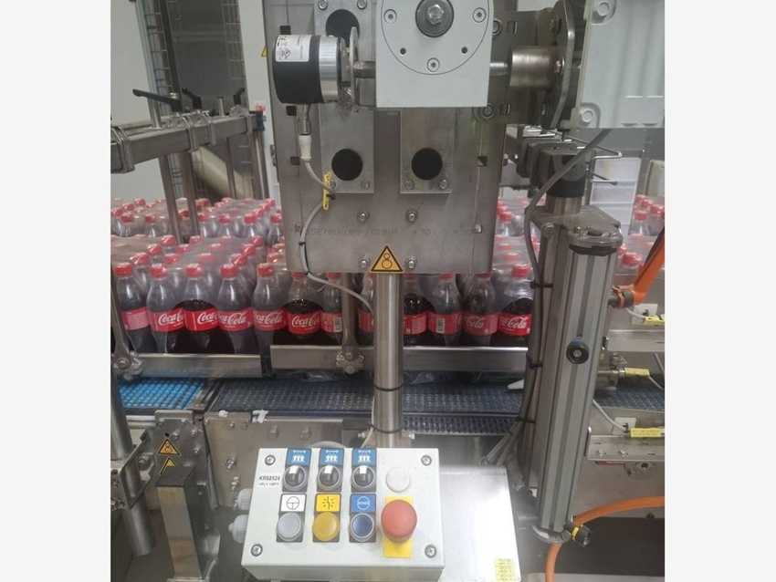
Modulpal Pro 1AD palletizer – columns and full pallet |  | Palletizer infeed – pack grouping section (=PL1 +BP3)
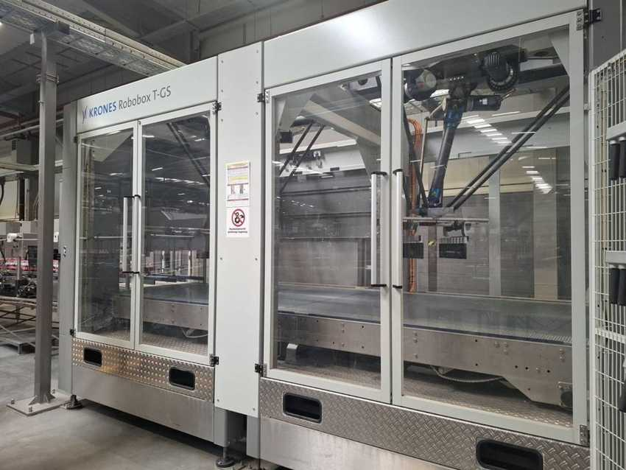 |  | 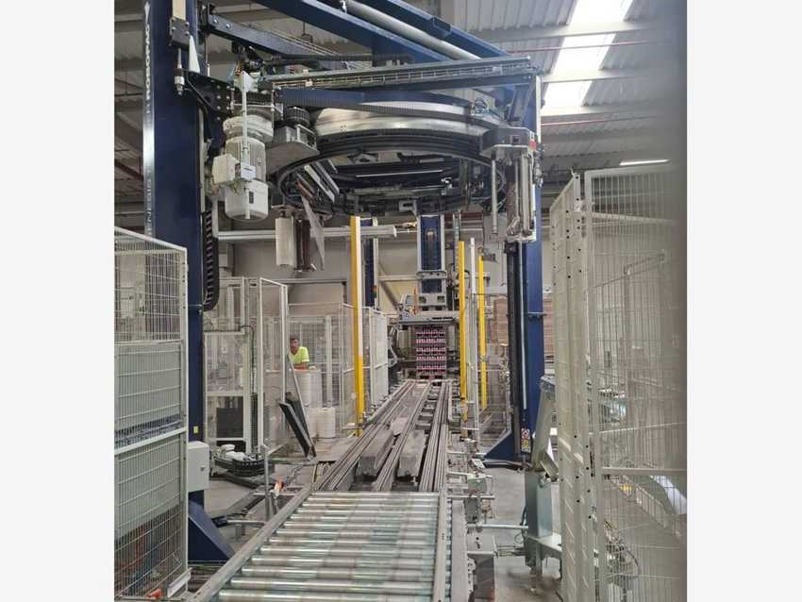
Robobox T-GS layer forming robot |  | Robopac Genesis Thunder stretch wrapper – wrapping ring
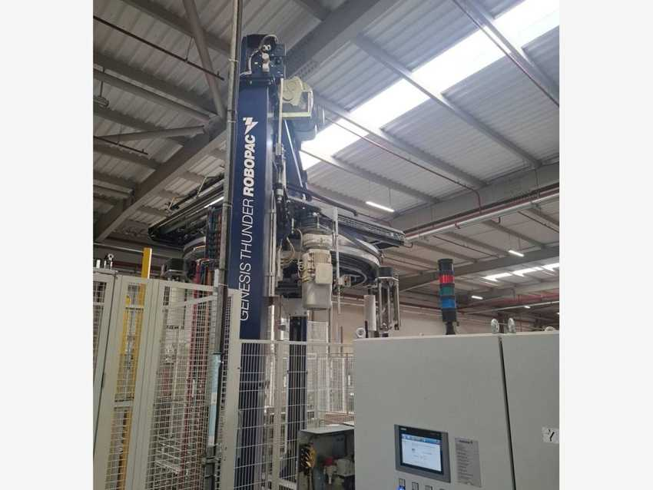 |  | 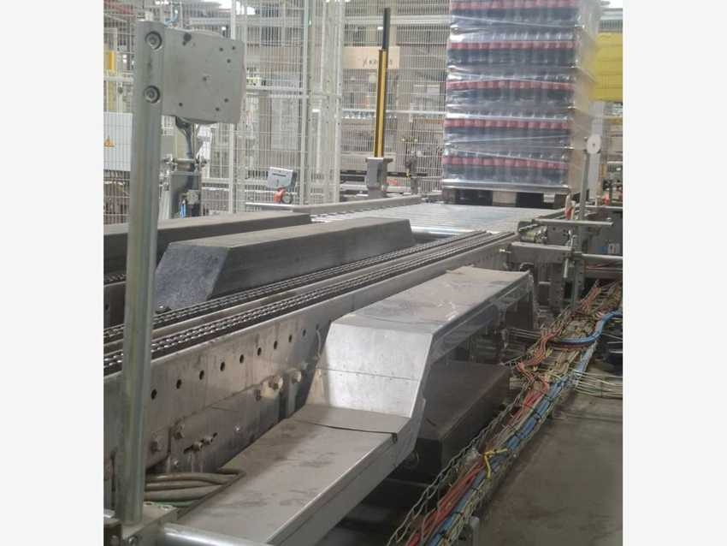
Stretch wrapper – control cabinet with HMI |  | Palco S (KR571D5) – roller conveyor with wrapped pallet
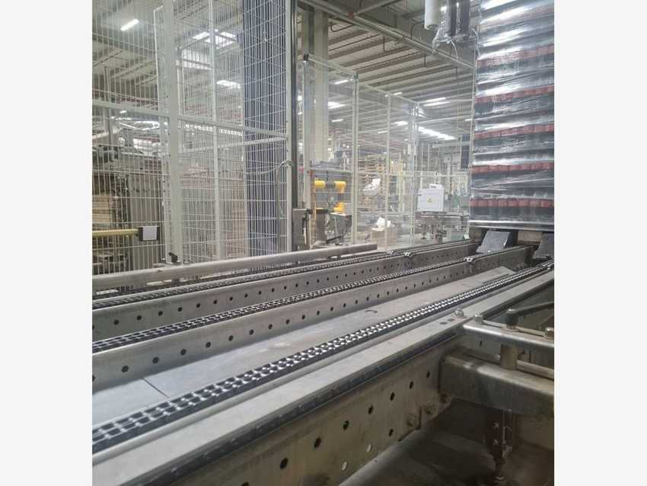 |  | 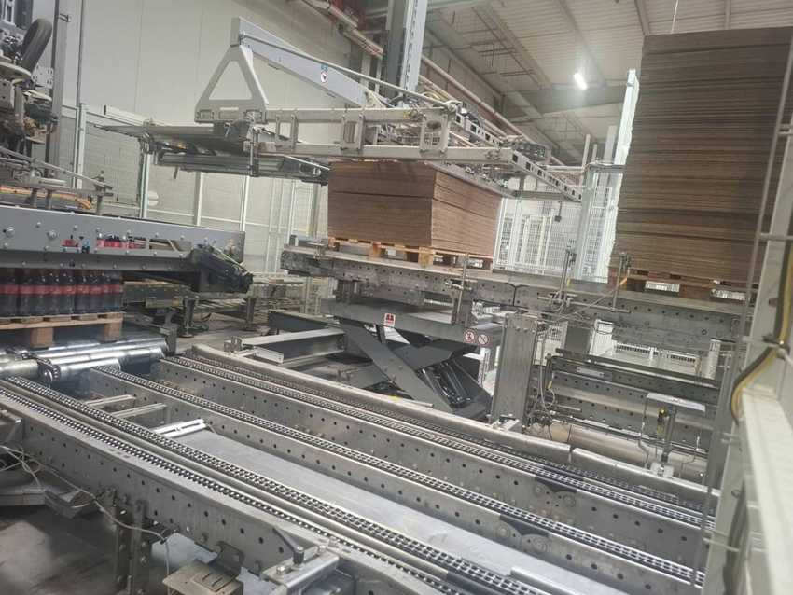
Palco S – chain conveyors at the stretch wrapper |  | Palco S – empty pallet / tier-sheet station with scissor lift

4.10 Linadry dryer, SynCo conveyor, coding and lubrication

Machine data
MACHINE | KRONES NO. | TYPE | MFG. DATE | SERIAL NO. | INST. POWER kW | SAP NO. | ASSET NO.
Container dryer | K890BLS | Linadry S2M | 2024 | K890BLS | – | – | 223000000099
Container conveyor 1 | K995WPH | SynCo S | 2024 | K995WPH | – | 1000002923 | 223000000104
Flow module (part of K995WPH) | K995WPH | Flowliner | 2024 | – | – | – | –
Laser coder 1 | — | Videojet 3640 | 2024 | – | – | 1000002781 | 223000000101
Laser coder 2 | — | Videojet 3640 | 2024 | – | – | – | 223000000102
Conveyor lubrication | — | Diversey (Dry Tech 4 VL83) | 2024 | – | – | – | 223000000109
Fume extractor | — | Videojet Xtract Pro | – | – | – | – | –

Container conveyor: type SynCo, manufactured 2024 by Krones Hungary Kft., Debrecen; operator panel tag K995WPH =TBB1 +GL1. The two Videojet 3640 laser coders are mounted on the SynCo conveyor and print the date / batch code (e.g. “YM 300327S1 / 300926 15:15”). A Krones Flowliner module on the SynCo conveyor arranges the bottle flow before the coders.. The Diversey unit doses the dry lubricant Dry Tech 4 VL83 onto the conveyor chains.

Photos
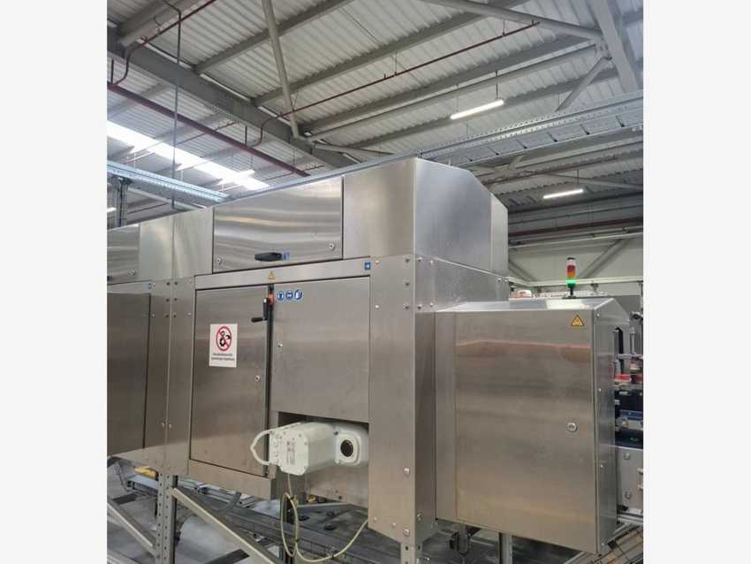 |  | 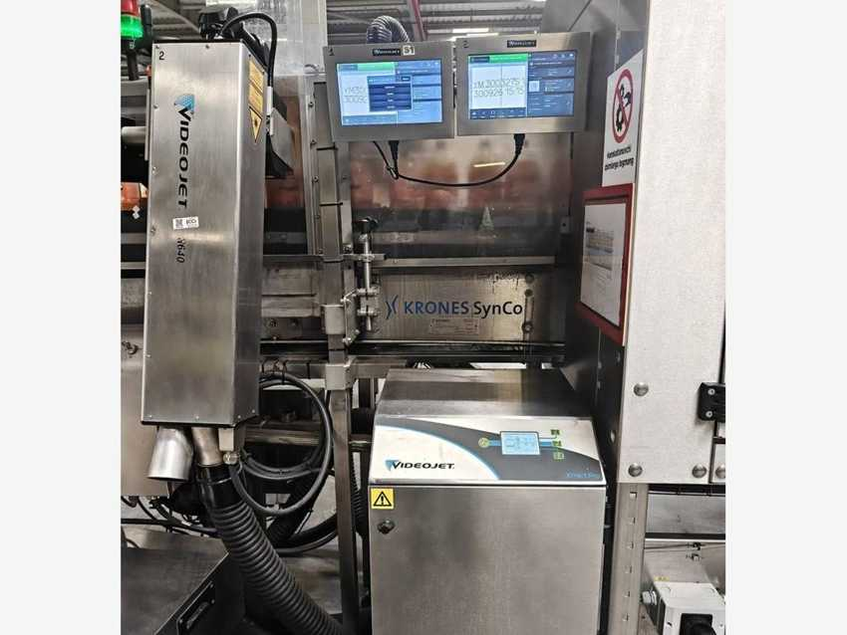
Linadry S2M container dryer (K890BLS) |  | SynCo S container conveyor 1 (K995WPH) with plate
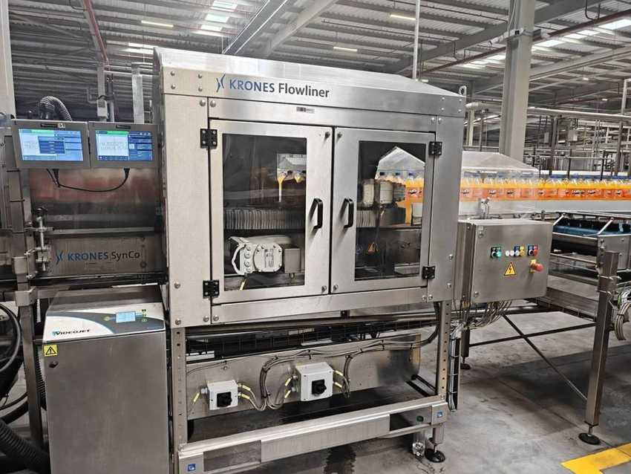 |  | 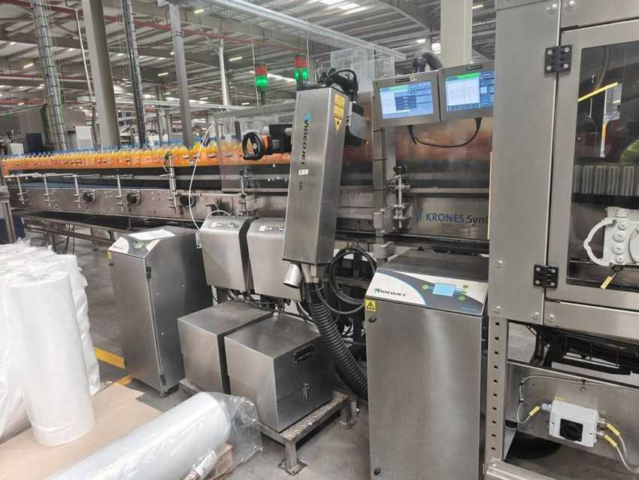
Krones Flowliner on the SynCo conveyor |  | Coding station – Videojet 3640 laser, HMIs and Xtract Pro
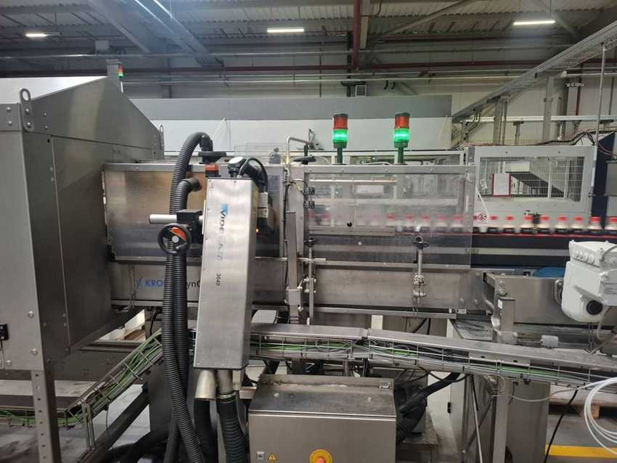 |  | 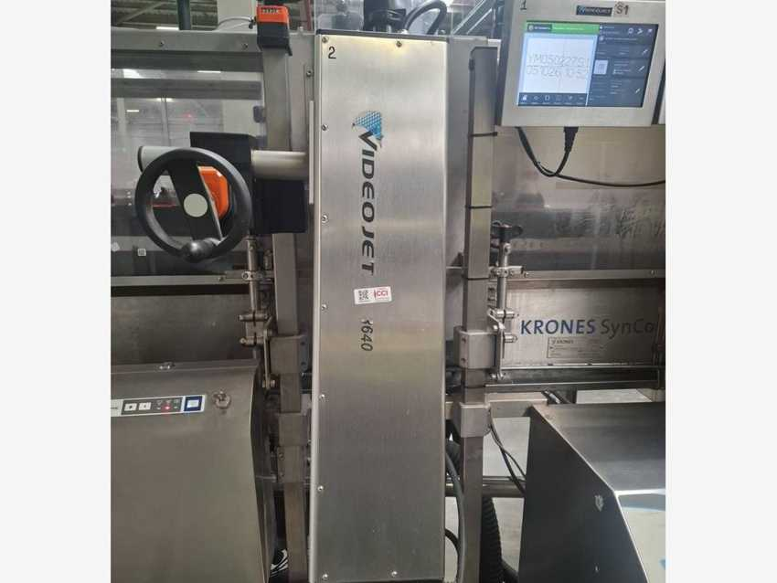
Videojet 3640 laser coder 1 |  | Videojet 3640 laser coder 2
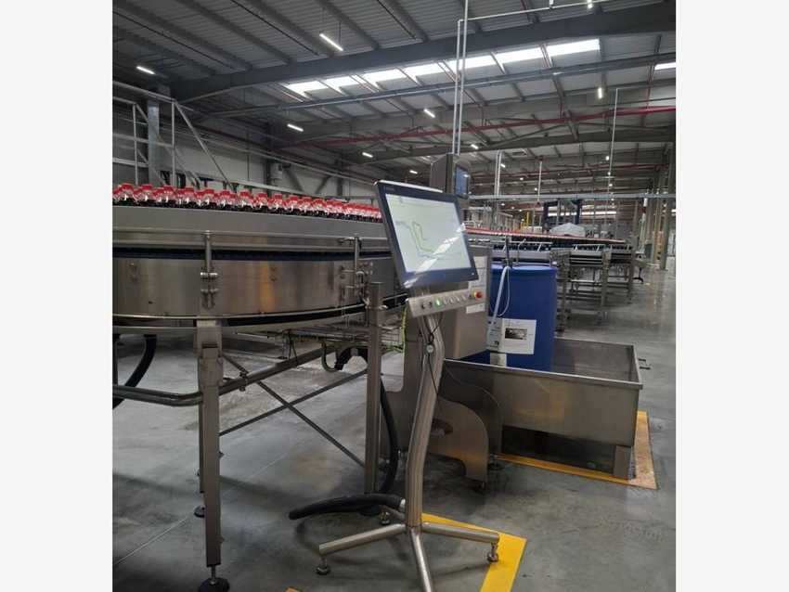 |  | 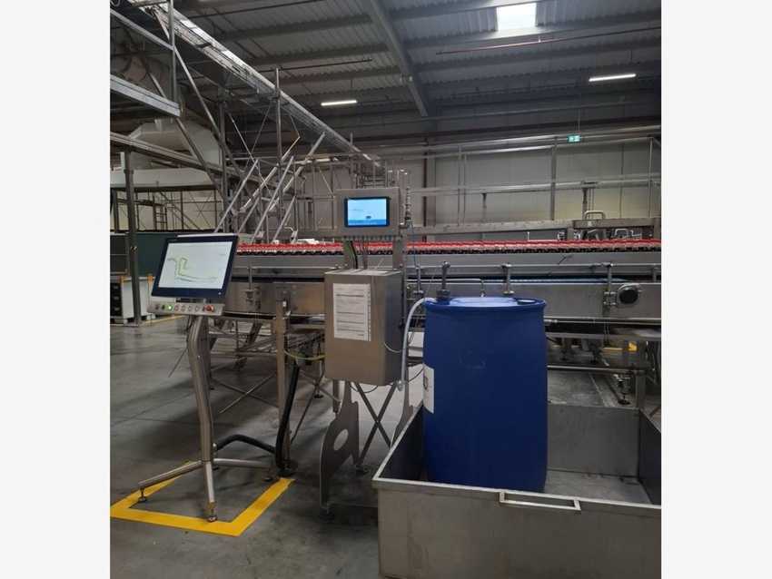
Diversey conveyor lubrication unit |  | Diversey lubrication controller

4.11 SFM subsystems and electronic installations
KRONES NO. | DESCRIPTION | MFG. DATE | SERIAL NO. | INST. POWER kW | SAP NO. | ASSET NO.
K8206CR | SFM labeling technology | – | – | – | – | –
K8206CS | SFM labeling technology | – | – | – | – | –
K8212IR | SFM filling / process technology | – | – | – | – | –
K8252QI | SFM transport technology | – | – | – | – | –
K8252QK | SFM transport technology | – | – | – | – | –
K919IXL | Electronic installation | – | – | – | – | –
K919IXM | Electronic installation | – | – | – | – | –

5 Line-2 HOT Fill (HF) PET

5.1 Line data and equipment register
Manufacturer | Krones AG – Germany | Line | SAMARKAND Nitro Hotfill line (HF PET)
Capacity | 22,400 bph @ 1 L | Krones system no. | C372674
Customer | Coca Cola Ichimligi Uzbekistan Ltd | Year of manufacture (YOM) | 2024
Installed power | – kW | Package types | 0.5 / 1 / 1.5 L PET (Fuse Tea, Cappy Pulpy; 6-pack 2×3)
Functional location | PRD00184 – SMR Line-02 / HF Pet / Krones | Cost centre | 7108036018

Line process flow
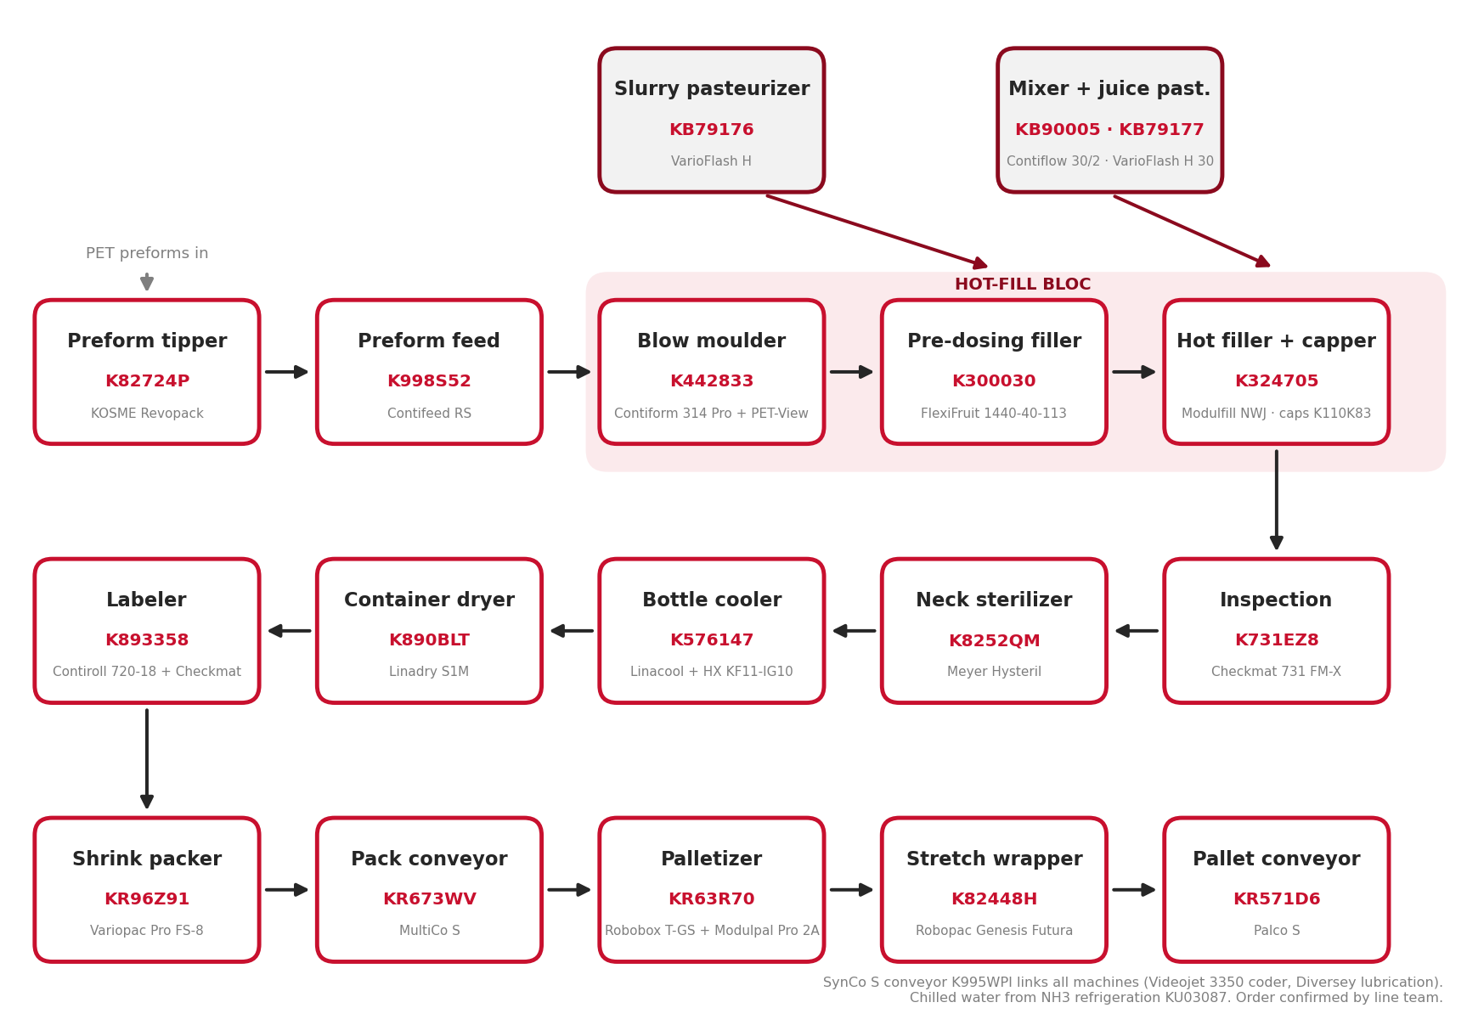
Figure 5.1 – Line-2 Hot Fill process flow, from preform feed to palletizing (order confirmed by line team)

Krones equipment register
No. | KRONES NO. | DESCRIPTION | ASSET NO. | DETAILS
1 | K82724P | Preform tilting device – KOSME Revopack | 223000000135 | Section 5.2
2 | K998S52 | Preform feed unit – Contifeed RS | 223000000112 | Section 5.2
3 | K442833 | Stretch-blow moulder – Contiform 314 Pro | verify | Section 5.3
4 | K440A10 | Set of moulds / change parts | – | Section 5.3
5 | K776F21 | PET-View 776 D (inside Contiform) | 223000000121 | Section 5.3
6 | KB90005 | Beverage treatment – Contiflow 30/2 | 223000000131 | Section 5.4
7 | KB79176 | Flash pasteurizer slurry – VarioFlash H | 223000000128 | Section 5.5
8 | KB79177 | Flash pasteurizer juice – VarioFlash H 30 | 223000000130 | Section 5.5
9 | K300030 | Pre-dosing filler – FlexiFruit 1440-40-113 | verify | Section 5.6
10 | K324705 | Hot filler – Modulfill NWJ 2.520-70-113 | 223000000113 | Section 5.7
11 | K110K83 | Cap sorting system (Gassner cap feed) | 223000000115 | Section 5.7
12 | K8252QM | Neck sterilizer – Meyer Hysteril | 223000000129 | Section 5.8
13 | K731EZ8 | Checkmat 731 FM-X | 223000000116 | Section 5.8
14 | K752U47 | Checkmat (CIC / 752 E) | verify | Section 5.8
15 | K752U48 | Checkmat 752 E | verify | Section 5.8
16 | K576147 | Bottle cooler – Linacool | 223000000117 | Section 5.9
17 | K890BLT | Container dryer – Linadry S1M | 223000000119 | Section 5.10
18 | K995WPI | Container conveyor – SynCo S | 223000000124 | Section 5.10
19 | K893358 | Labeler – Contiroll 720-18 | 223000000118 | Section 5.11
20 | KR96Z91 | Shrink packer – Variopac Pro FS-8 | 223000000122 | Section 5.12
21 | KR673WV | Pack conveyor – MultiCo S | verify | Section 5.13
22 | KR63R70 | Palletizer – Modulpal Pro 2A (+ Robobox T-GS) | 223000000123 | Section 5.13
23 | K82448H | Stretch wrapper – Robopac Genesis Futura | 223000000125 | Section 5.13
24 | KR571D6 | Pallet conveyor – Palco S | verify | Section 5.13
25 | KU03087 | NH3 refrigeration (Kälte, NH3) | – | Section 5.14
26 | K8206CT | SFM labelling technology | – | Section 5.14
27 | K8212IS | SFM filling / process technology | – | Section 5.14
28 | K8252QL | SFM transport technology | – | Section 5.14
29 | K8252QN | SFM transport technology | – | Section 5.14

Sources: Krones equipment list (system C372674), nameplates, SAP fixed-asset register (plant 1802) and equipment master data, cost centre 7108036018. “verify” = master data asset is duplicated or does not match SAP (see Appendix A). In all tables “–” means not available / not applicable.

Other Line-2 assets (not in the Krones list)
No. | EQUIPMENT | MANUFACTURER / MODEL | SERIAL NO. | ASSET NO.
1 | Container code / dating unit (laser) – SAP 1000002782 | Videojet 3350 (+ Xtract Pro extractor) | 39831034003 | 223000000126
2 | Conveyor lubrication | Diversey (Dicolube D54) | 0095-001-0001374 | 223000000127
3 | Drum dumping station – slurry | MCC20 | MCC20 | 223000000133
4 | Electrical power distributor – UPS | SK 3304540 | – | 223000000134
5 | Syrup room equipment | – | – | 223000000136
6 | Cooling tower | Hansa | – | 223000000137
7 | Plate heat exchanger skid (cooler water) | Krones / Sondex KF11-IG10 | 4955595 | –
8 | Marking machine | Matrix System | – | 223000000058
9 | Labeling machine | APL8300PRO (003424) | – | 223000000013
10 | Industrial panel PC (panel included) | – | – | 223000000023
11 | Liquid nitrogen doser – SAP 1000002788 | VBS G3 & G3 Pro | – | –
12 | QR coding unit – SAP 1000002998 | Jeting | – | –
13 | Date coder – SAP 1000002840 | Videojet 3640 | – | –

5.2 Preform tipper and preform feed unit – Contifeed RS

Machine data
MACHINE | KRONES NO. | TYPE | MFG. DATE | SERIAL NO. | INST. POWER kW | SAP NO. | ASSET NO.
Preform tilting device | K82724P | KOSME Revopack | 2024 | P06947 | – | 1000002792 | 223000000135
Preform feed unit | K998S52 | Contifeed RS | 2024 | K998S52 | – | – | 223000000112

Electrical data
PARAMETER | K998S52 MAIN | K998S52 AUX | K82724P TIPPER
Rated voltage | 400 / 230 V | 400 / 230 V | 400 V
Type of current / system | AC 3/N/PE | AC 3/N/PE | 3 PH / TN-S
System frequency | 50 Hz | 50 Hz | 50 Hz
Full-load current (Ib max) | 33 A | 4 A | 7.8 A
Short-circuit rating | 1.26 kA / 1 s (Icw) | 0.29 kA / 1 s (Icw) | 10 kA
Min. short-circuit current (Ik min) | 0.76 kA | 0.38 kA | –
Back-up fuse | 50 A | 8 A | 10 A
Connection diagram no. | K998S52 | K998S52 | P06947

Preform tipper: Kosme S.r.l., Roverbella (Italy), model Revopack, IP54, 1,400 kg, 10 cycles/h, load limit 500 kg. Tips preform containers into the bunker feeding the Contifeed elevator and roller sorter.

Photos
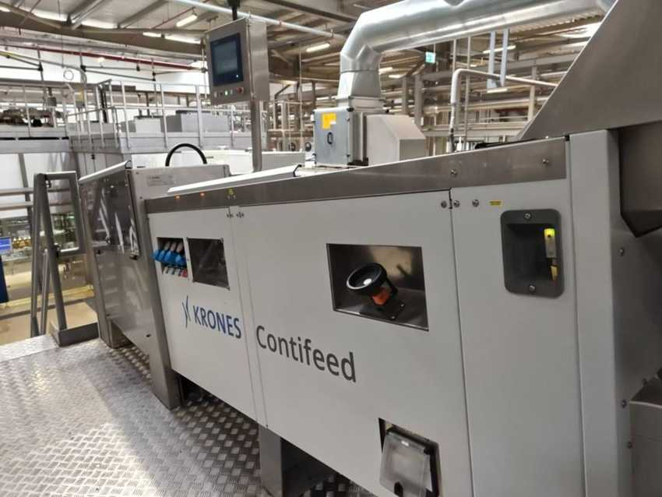 |  | 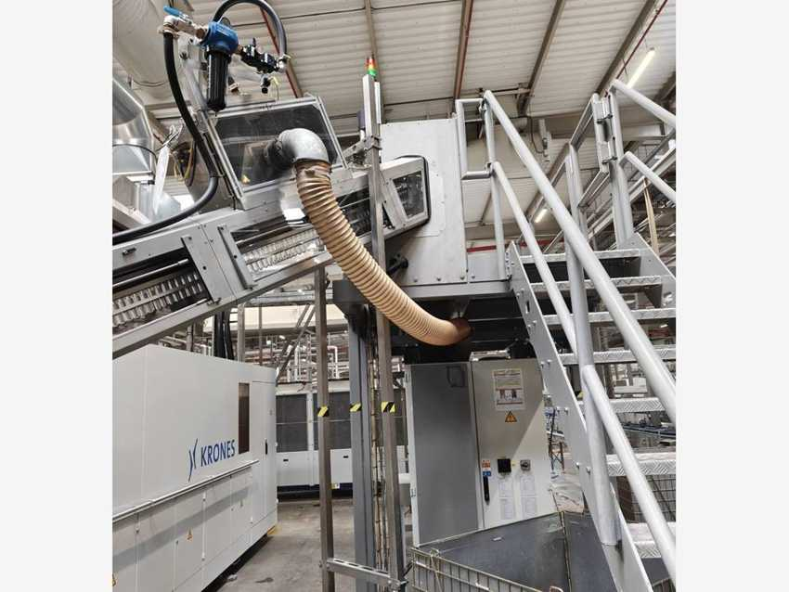
Contifeed RS (K998S52) with HMI |  | Contifeed preform elevator to the roller sorter
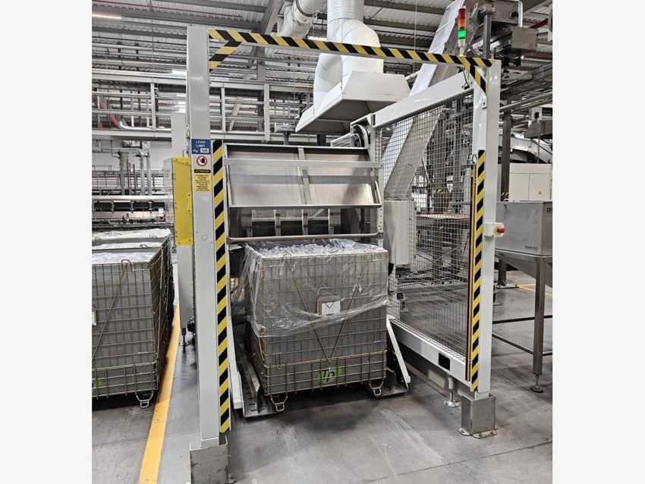
KOSME Revopack preform tipper (K82724P)

5.3 Contiform 314 Pro – Stretch blow moulder

Machine data
MACHINE | KRONES NO. | TYPE | MFG. DATE | SERIAL NO. | INST. POWER kW | SAP NO. | ASSET NO.
Stretch blow moulder | K442833 | Contiform 314 Pro | 2024 | K442833 | – | 1000002342 | verify
Set of moulds / change parts | K440A10 | Krones change-part trolleys | 2024 | K440A10 | – | – | –
PET inspector (inside Contiform) | K776F21 | PET-View 776 D | 2024 | K776F21 | – | – | 223000000121

Electrical data (nameplates K442833)
PARAMETER | MAIN SUPPLY | AUXILIARY SUPPLY
Rated voltage | 400 / 230 V | 400 / 230 V
Type of current / system | AC 3/N/PE | AC 3/N/PE
System frequency | 50 Hz | 50 Hz
Full-load current (Ib max) | 711 A | 10 A
Short-circuit rating | 28 kA (Icc) | 0.43 kA / 1 s (Icw)
Min. short-circuit current (Ik min) | 1 kA | 0.02 kA
Back-up fuse | 800 A | 16 A
Connection diagram no. | K442833-001 | K442833-001

Manufacturer and standards
Manufacturer: Krones AG, Werk Neutraubling (Germany). Year of manufacture: 2024. Serial number = Krones commission number. Standards: IEC 60204-1 / IEC 61439-1. Largest consumer on Line 2 (711 A). Change parts (stretching / blowing units) are stored in Krones drawer trolleys (4 drawers × 120 kg, max 1,000 kg) next to the machine. PET-View 776 D empty-bottle inspection is built into the outlet – listed in the table only.

Photos
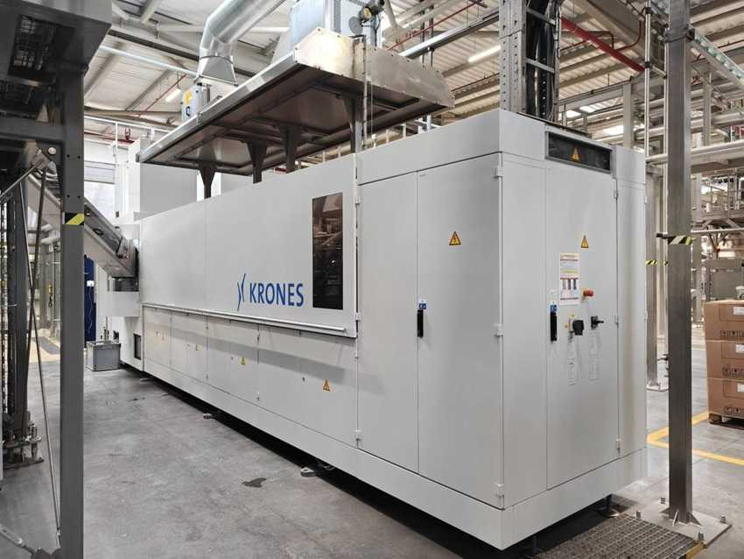 |  | 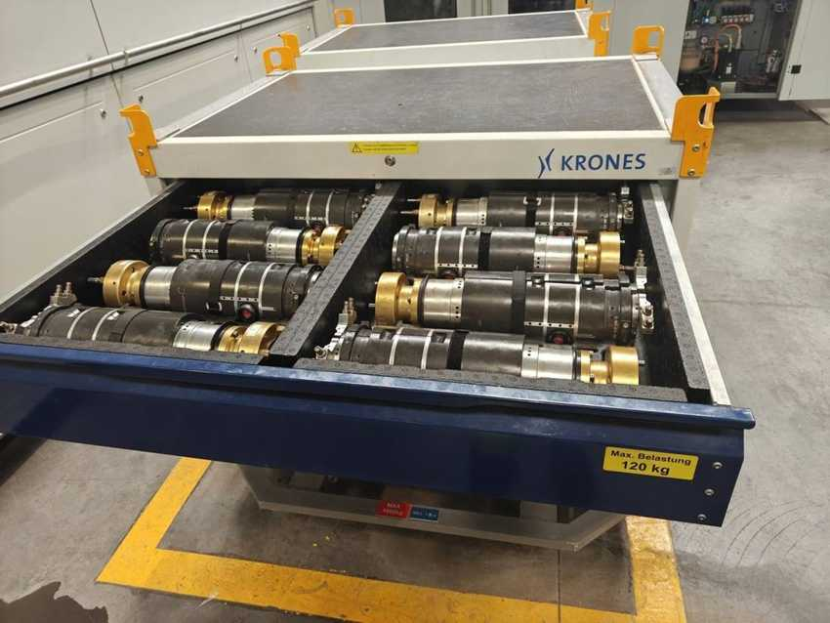
Contiform 314 Pro (K442833) |  | Change parts K440A10 – stretching / blowing units in drawer
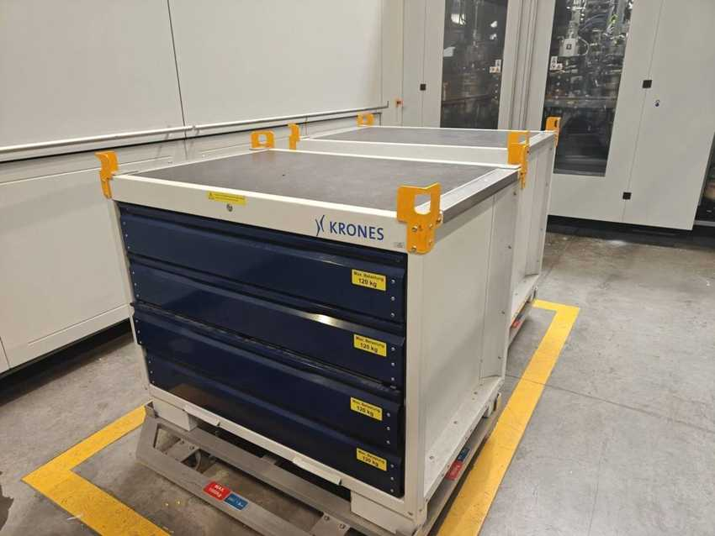
Krones change-part trolleys

5.4 Contiflow 30/2 – Beverage treatment (mixer)

Machine data
MACHINE | KRONES NO. | TYPE | MFG. DATE | SERIAL NO. | INST. POWER kW | SAP NO. | ASSET NO.
Mixer (beverage treatment) | KB90005 | Contiflow 30/2 | 2024 | KB90005 | – | 1000002343 | 223000000131

Electrical data (nameplates KB90005)
PARAMETER | MAIN SUPPLY | AUXILIARY SUPPLY
Rated voltage | 400 / 230 V | 400 / 230 V
Type of current / system | AC 3/N/PE | AC 3/N/PE
System frequency | 50 Hz | 50 Hz
Full-load current (Ib max) | 45 A | 4 A
Short-circuit rating | 55 kA / 1 s (Icc) | 0.42 kA / 1 s (Icw)
Min. short-circuit current (Ik min) | 0.39 kA | 0.29 kA
Back-up fuse | 50 A | 16 A
Connection diagram no. | KB90005 | KB90005

Manufacturer and standards
Manufacturer: Krones AG, Werk Neutraubling (Germany). Year of manufacture: 2024. Serial number = Krones commission number. Standards: IEC 60204-1 / IEC 61439-1. Mixes syrup and treated water into finished product for the hot-fill line.

Photos
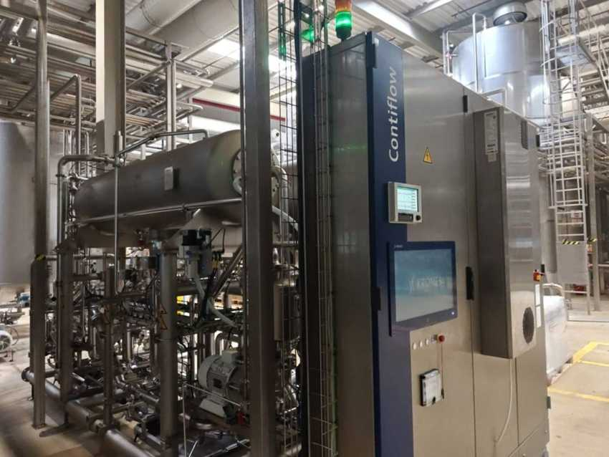 |  | 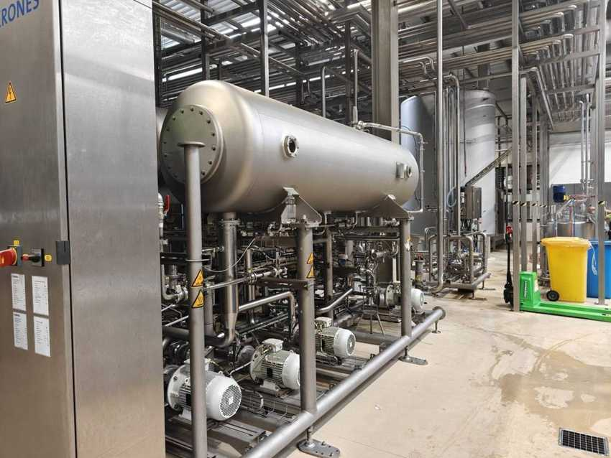
Contiflow 30/2 – control cabinet and tank |  | Contiflow 30/2 – tank and pump row

5.5 VarioFlash H – Flash pasteurizers (slurry and juice)

Machine data
MACHINE | KRONES NO. | TYPE | MFG. DATE | SERIAL NO. | INST. POWER kW | SAP NO. | ASSET NO.
Flash pasteurizer – slurry | KB79176 | VarioFlash H | 2024 | KB79176 | – | 1000002332 | 223000000128
Flash pasteurizer – juice | KB79177 | VarioFlash H 30 | 2024 | KB79177 | – | – | 223000000130

Electrical data (nameplates)
PARAMETER | KB79176 MAIN | KB79176 AUX | KB79177 MAIN | KB79177 AUX
Rated voltage | 400 / 230 V | 400 / 230 V | 400 / 230 V | 400 / 230 V
Type of current / system | AC 3/N/PE | AC 3/N/PE | AC 3/N/PE | AC 3/N/PE
System frequency | 50 Hz | 50 Hz | 50 Hz | 50 Hz
Full-load current (Ib max) | 120 A | 4 A | 24 A | 4 A
Short-circuit rating | 0.55 kA / 1 s (Icw) | 0.29 kA / 1 s (Icw) | 55 kA / 1 s (Icw) | 0.29 kA / 1 s (Icw)
Min. short-circuit current (Ik min) | 0.96 kA | 0.33 kA | 0.4 kA | 0.33 kA
Back-up fuse | 160 A | 16 A | 35 A | 16 A
Connection diagram no. | KB79176-001 | KB79176-001 | KB79177-001 | KB79177-001

Manufacturer and standards
Manufacturer: Krones AG, Werk Neutraubling (Germany). Year of manufacture: 2024. Serial number = Krones commission number. Standards: IEC 60204-1 / IEC 61439-1. Both units heat the product in heat exchangers to pasteurization temperature, hold it and send it to the fillers: KB79176 treats the slurry / pulp, KB79177 the juice. The slurry pasteurizer is marked as a food-safety critical control point (CCP 2).

Photos
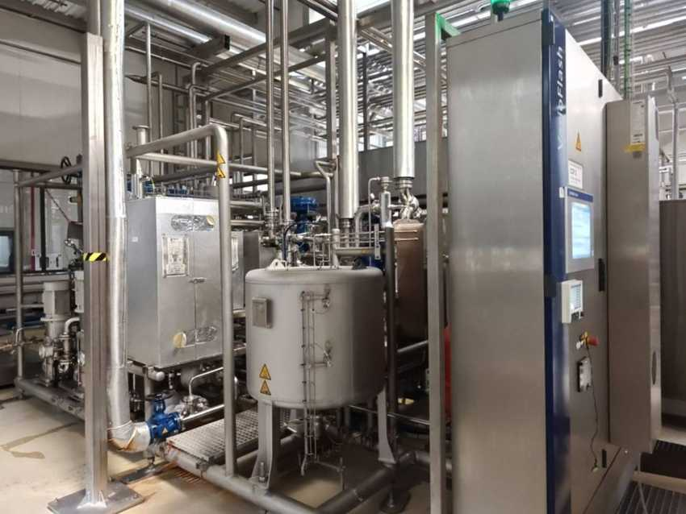 |  | 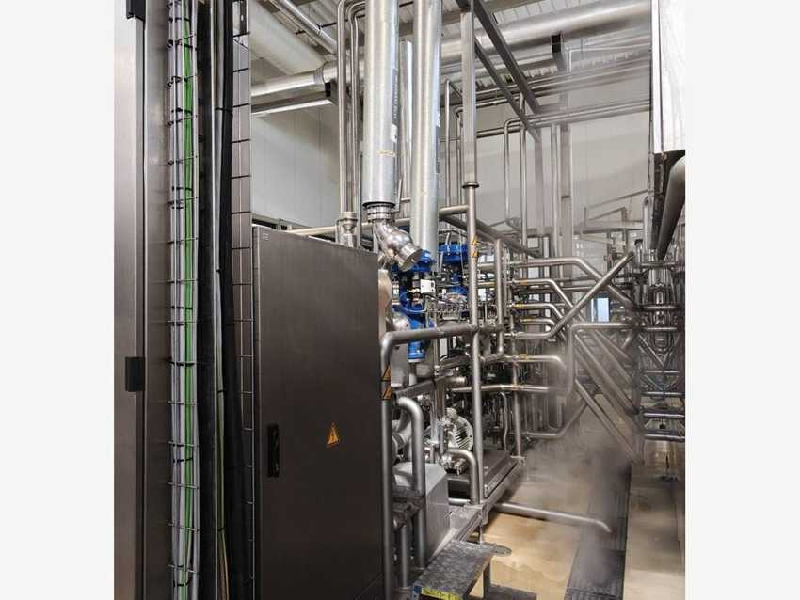
VarioFlash H slurry (KB79176) – skid, buffer tank and cabinet |  | VarioFlash H slurry – valve and pipe side
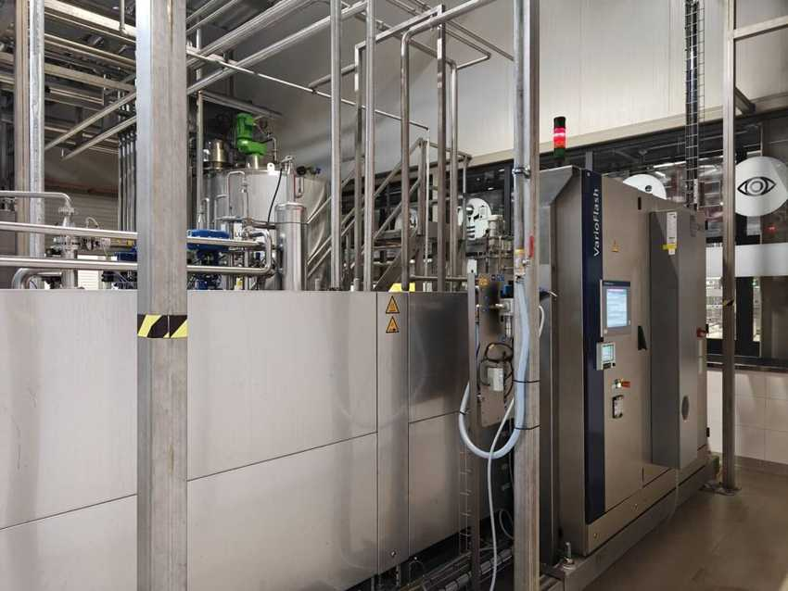 |  | 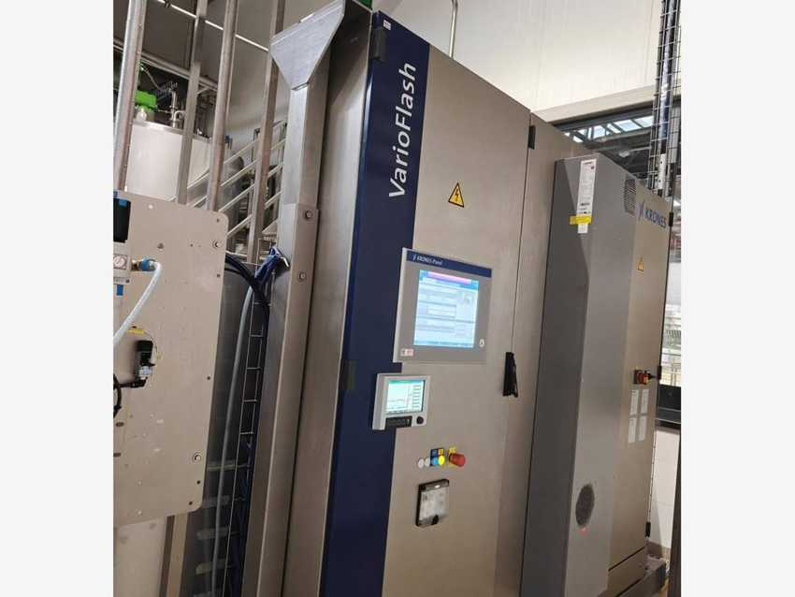
VarioFlash H 30 juice (KB79177) – skid |  | VarioFlash H 30 – control cabinet with iPanel and recorder

5.6 FlexiFruit – Pre-dosing filler

Machine data
MACHINE | KRONES NO. | TYPE | MFG. DATE | SERIAL NO. | INST. POWER kW | SAP NO. | ASSET NO.
Pre-dosing filler | K300030 | FlexiFruit 1440-40-113 | 2024 | K300030 | – | 1000002789 | verify

Electrical data (nameplates K300030)
PARAMETER | MAIN SUPPLY | AUXILIARY SUPPLY
Rated voltage | 400 / 230 V | 400 / 230 V
Type of current / system | AC 3/N/PE | AC 3/N/PE
System frequency | 50 Hz | 50 Hz
Full-load current (Ib max) | 26 A | 2 A
Short-circuit rating | 1.15 kA / 1 s (Icw) | 0.29 kA / 1 s (Icw)
Min. short-circuit current (Ik min) | 0.4 kA | 0.32 kA
Back-up fuse | 35 A | 16 A
Connection diagram no. | K300030-001 | K300030-001

Manufacturer and standards
Manufacturer: Krones AG, Werk Neutraubling (Germany). Year of manufacture: 2024. Serial number = Krones commission number. Standards: IEC 60204-1 / IEC 61439-1. Doses pulp / fruit pieces into the bottles before the main hot filler.

Photos
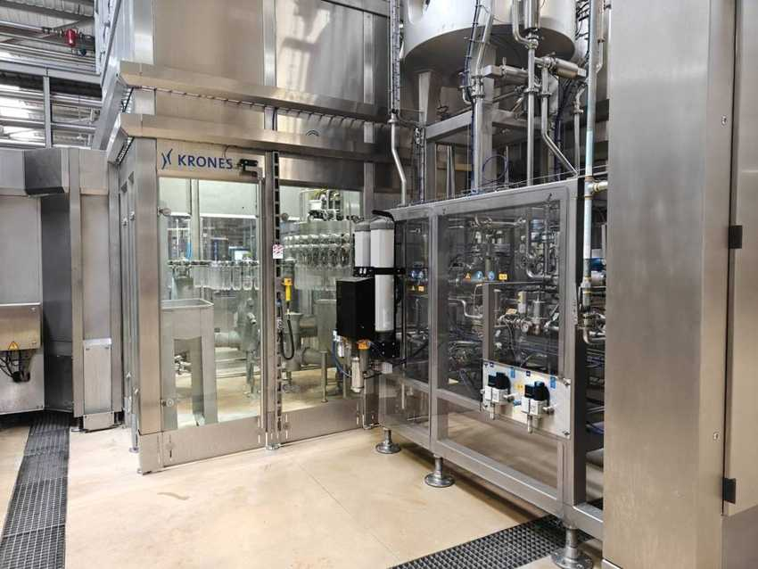 |  | 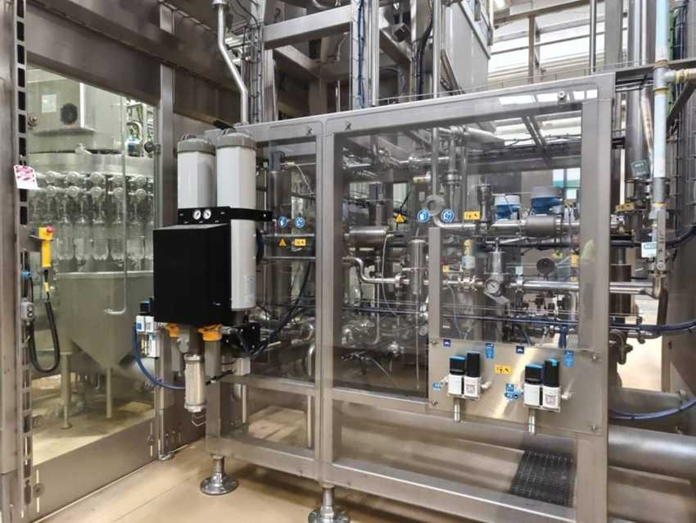
FlexiFruit pre-dosing filler (K300030) |  | FlexiFruit – process valve panel

5.7 Hot filler Modulfill NWJ and cap sorting

Machine data
MACHINE | KRONES NO. | TYPE | MFG. DATE | SERIAL NO. | INST. POWER kW | SAP NO. | ASSET NO.
Hot filler (vacuum filler) | K324705 | Modulfill NWJ 2.520-70-113 | 2024 | K324705 | – | 1000002341 | 223000000113
Cap sorting system | K110K83 | Krones / Gassner cap feed | 2024 | K110K83 | – | 1000002787 | 223000000115

Electrical data (nameplates K324705)
PARAMETER | MAIN SUPPLY | AUXILIARY SUPPLY
Rated voltage | 400 / 230 V | 400 / 230 V
Type of current / system | AC 3/N/PE | AC 3/N/PE
System frequency | 50 Hz | 50 Hz
Full-load current (Ib max) | 75 A | 6 A
Short-circuit rating | 41 kA (Icc) | 0.29 kA / 1 s (Icw)
Min. short-circuit current (Ik min) | 0.8 kA | 0.32 kA
Back-up fuse | 100 A | 16 A
Connection diagram no. | K324705-001 | K324705-001

Manufacturer and standards
Manufacturer: Krones AG, Werk Neutraubling (Germany). Year of manufacture: 2024. Serial number = Krones commission number. Standards: IEC 60204-1 / IEC 61439-1. Hot (vacuum) filler with capper (“Vacuumf. TK 2520” in the Krones list). Caps are fed by the Gassner elevator into the Krones cap sorting system on the filler platform.

Cap sorting cabinet cooling unit – Seifert SLIMLINE KG 4269
Part no. / Krones part no. | 42699634 / 0906543057 | Serial no. | M9634010719
Production date | 08/23 | Supply | 230 V, 50/60 Hz
Input power | 560 W max (480 W @ 50 Hz) | Current | 2.4 A rated, 2.8 A max, 5.8 A starting
Fuse / SCCR | 6 A (T) / 5 kA | Cooling capacity / refrigerant | 500 W @ 50 Hz / R134a 142 g, IP 55

Photos
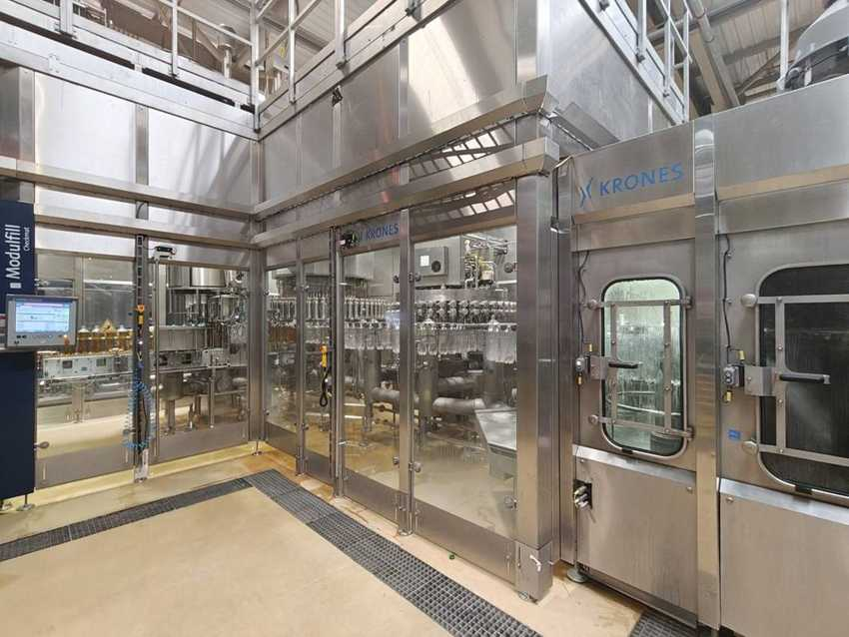 |  | 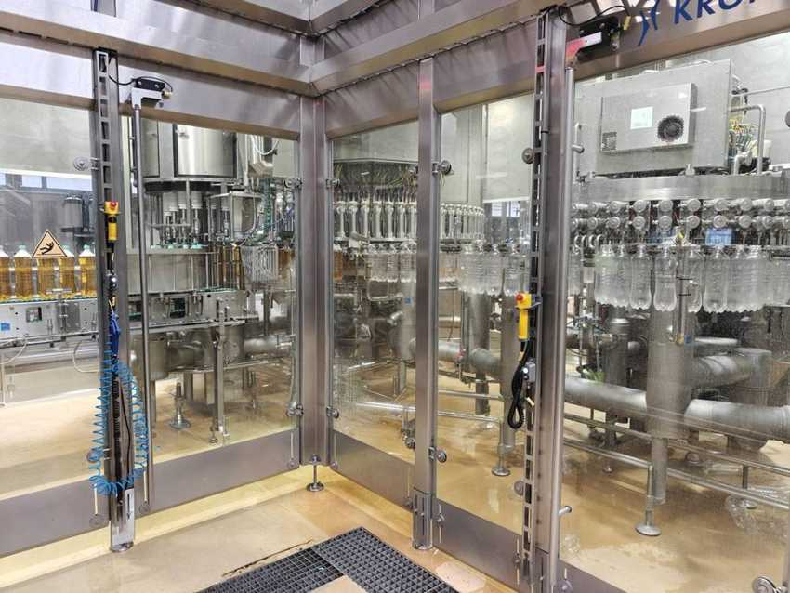
Modulfill NWJ hot filler block |  | Filler carousel and capper
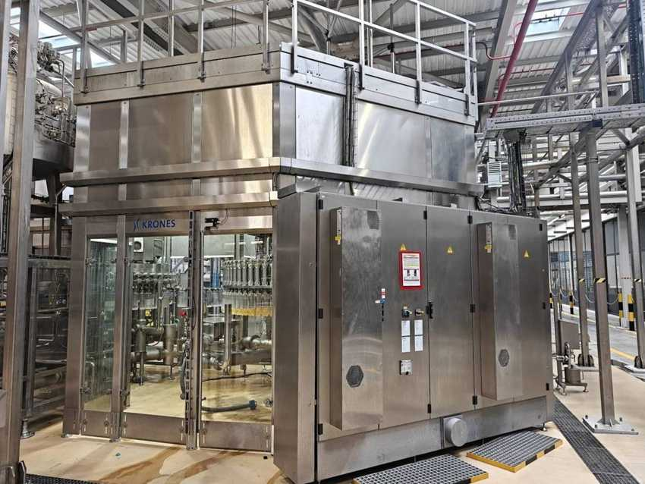 |  | 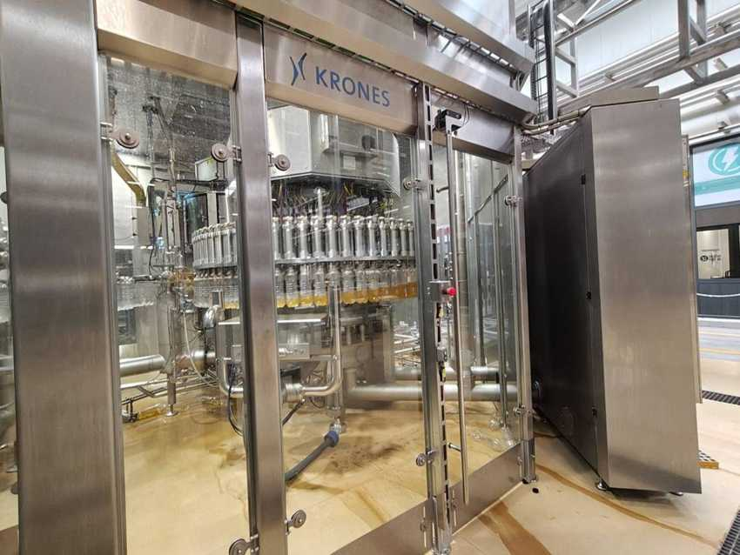
Filler enclosure with electrical cabinet |  | Filler carousel – filled bottles
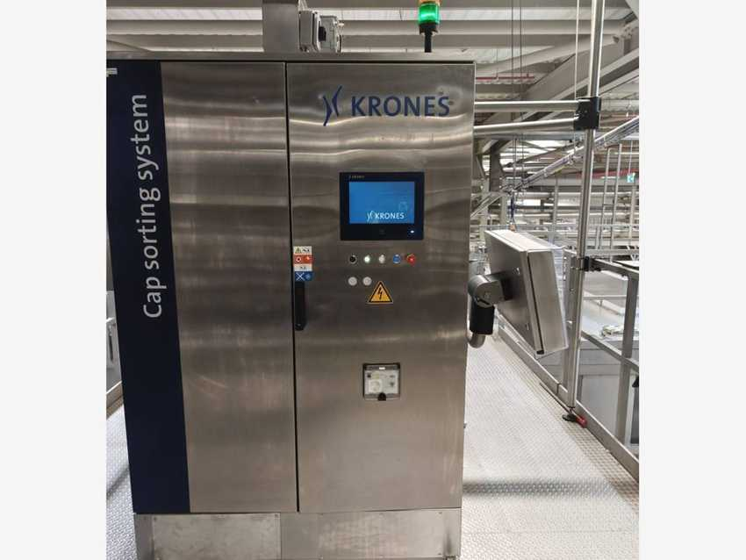 |  | 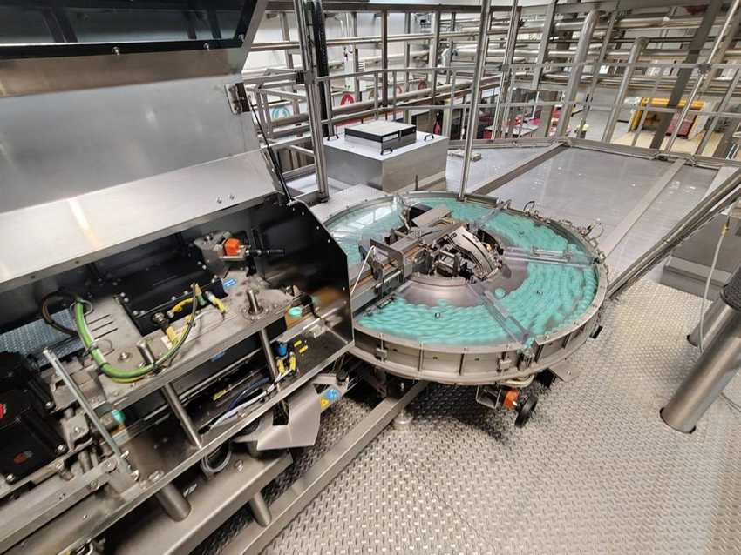
Cap sorting system K110K83 – control cabinet |  | Cap sorter disc
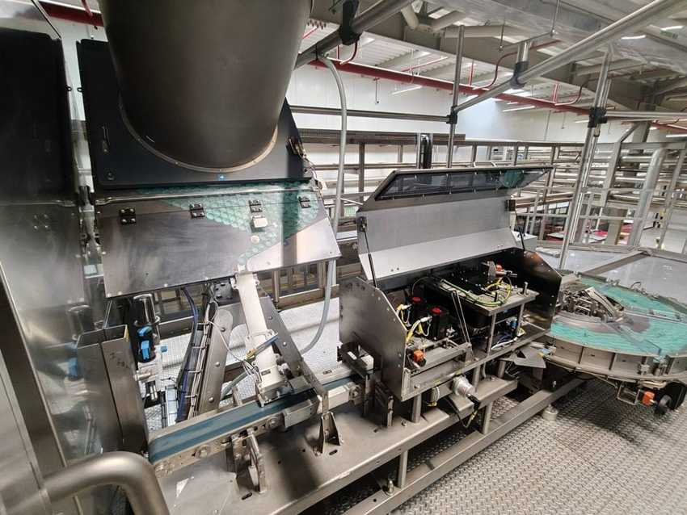
Cap hopper outlet and drive unit

5.8 Inspection units and neck sterilizer

Machine data
MACHINE | KRONES NO. | TYPE | MFG. DATE | SERIAL NO. | INST. POWER kW | SAP NO. | ASSET NO.
Inspection (fill level / cap) | K731EZ8 | Checkmat 731 FM-X | 2024 | K731EZ8 | – | 1000002791 | 223000000116
Neck sterilizer | K8252QM | Meyer Hysteril | 2024 | 651260 | – | 1000002790 | 223000000129
Inspection unit | K752U47 | Checkmat CIC / 752 E | 2024 | K752U47 | – | – | verify
Inspection unit | K752U48 | Checkmat 752 E | 2024 | K752U48 | – | – | verify

Neck sterilizer: H. I. Meyer Maschinenbau, Neustadt (Germany), type Hysteril, serial 651260, supplied in the Krones transport package (K8252QM). After hot filling, capping and inspection by the Checkmat 731 FM-X, the bottles are tilted / laid down so the hot product sterilizes the inside of the neck and cap. Checkmat 731 FM-X (process plate “Inspection mach. (Checkmat) 1”, 2024) checks fill level and cap after the filler. K752U47 appears to be controlled from the cap sorting cabinet; a Checkmat is also built into the Contiroll labeler.

Photos
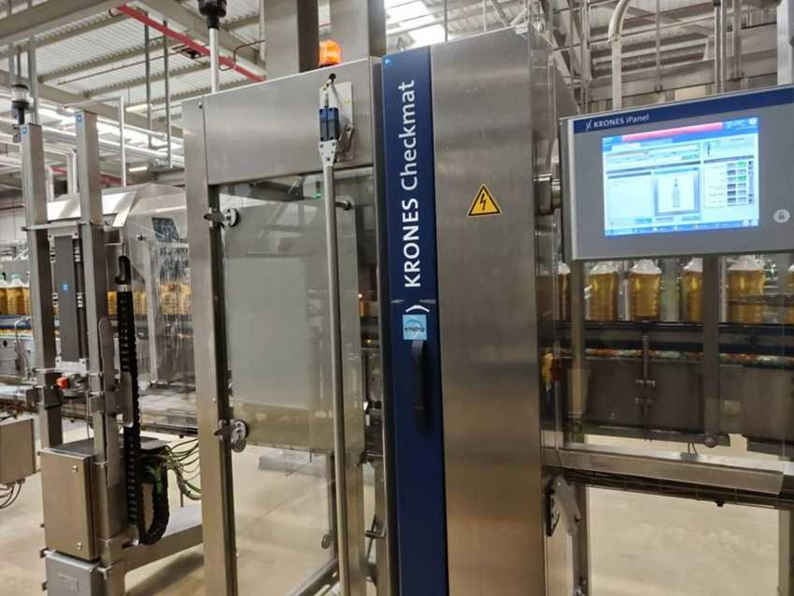 |  | 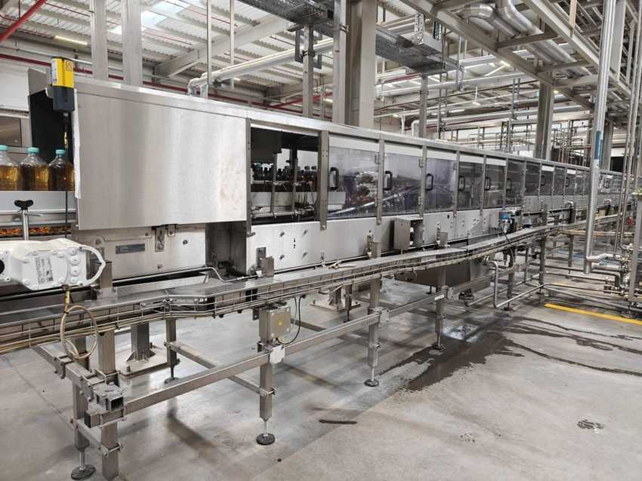
Checkmat 731 FM-X (K731EZ8) |  | Meyer Hysteril neck sterilizer (K8252QM)

5.9 Linacool – Bottle cooler

Machine data
MACHINE | KRONES NO. | TYPE | MFG. DATE | SERIAL NO. | INST. POWER kW | SAP NO. | ASSET NO.
Bottle cooler | K576147 | Linacool (Cooler 1) | 2024 | K576147 | – | 1000002344 | 223000000117
Plate heat exchanger skid | – | Krones / Sondex KF11-IG10 | 2024 | 4955595 | 989.99 (thermal) | – | –

Electrical data (nameplates K576147)
PARAMETER | MAIN SUPPLY | AUXILIARY SUPPLY
Rated voltage | 400 / 230 V | 400 / 230 V
Type of current / system | AC 3/N/PE | AC 3/N/PE
System frequency | 50 Hz | 50 Hz
Full-load current (Ib max) | 71 A | 2 A
Short-circuit rating | 17 kA (Icc) | 0.43 kA / 1 s (Icw)
Min. short-circuit current (Ik min) | 0.8 kA | 0.32 kA
Back-up fuse | 80 A | 5 A
Connection diagram no. | K576147 | K576147

Manufacturer: Krones AG, Werk Flensburg (Germany), 2024. The hot-filled bottles pass through a long tunnel where water sprays cool them in stages to near room temperature before labelling. Spray water is cooled by chilled water in the plate heat exchanger skid KF11-IG10 (Sondex for Krones, 989.99 kW, 32.64 m², max 10 bar / test 12.5 bar, −10 to 110 °C, 2 exchangers).

Photos
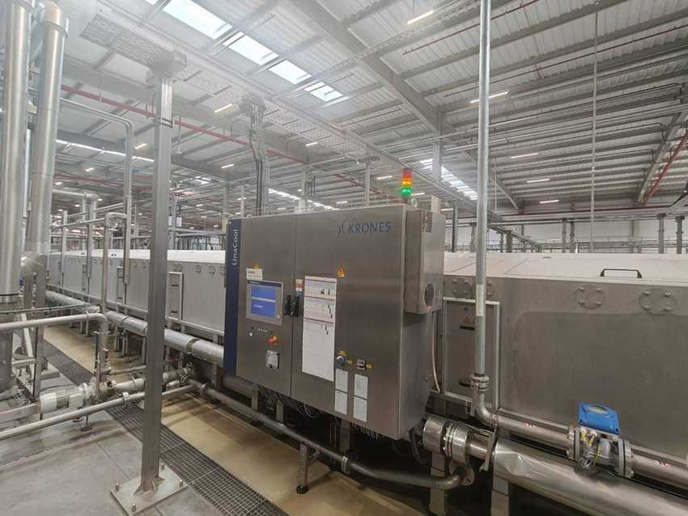 |  | 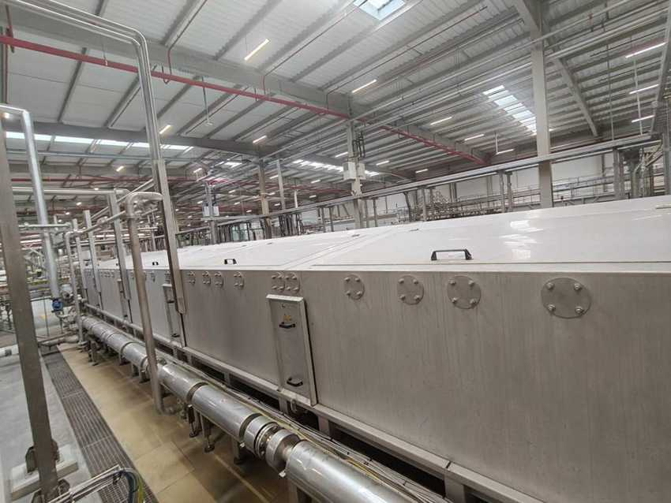
Linacool control cabinet with tunnel |  | Linacool cooling tunnel
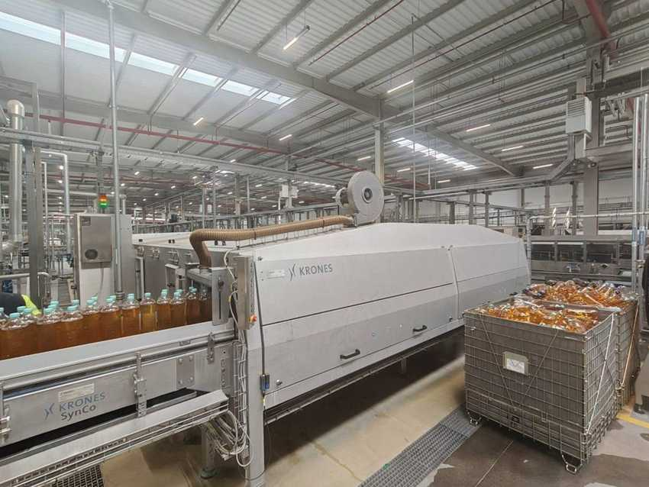 |  | 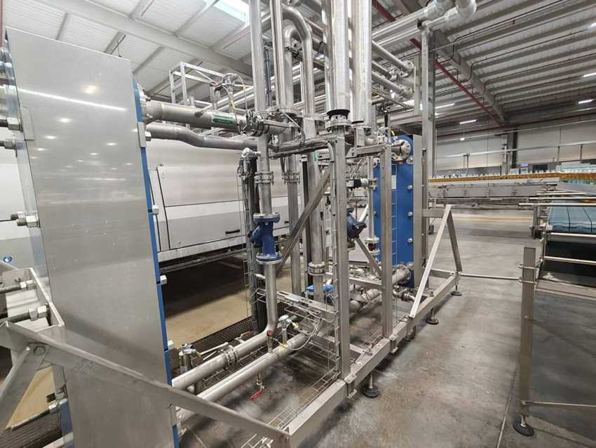
Linacool outlet with blower unit |  | Heat exchanger skid KF11-IG10 (process / chilled water)

5.10 Linadry dryer, SynCo conveyor, coding and lubrication

Machine data
MACHINE | KRONES NO. | TYPE | MFG. DATE | SERIAL NO. | INST. POWER kW | SAP NO. | ASSET NO.
Container dryer | K890BLT | Linadry S1M | 2024 | K890BLT | – | 1000002348 | 223000000119
Container conveyor | K995WPI | SynCo S | 2024 | K995WPI | – | 1000002347 | 223000000124
Laser coder | — | Videojet 3350 | 2024 | 39831034003 | – | 1000002782 | 223000000126
Conveyor lubrication | — | Diversey (Dicolube D54) | 2024 | 0095-001-0001374 | – | – | 223000000127

Electrical data – Linadry S1M (nameplate K890BLT)
PARAMETER | MAIN SUPPLY
Rated voltage | 400 / 230 V
Type of current / system | AC 3/N/PE
System frequency | 50 Hz
Full-load current (Ib max) | 23 A
Short-circuit rating | 1.15 kA / 1 s (Icw)
Min. short-circuit current (Ik min) | 0.48 kA
Back-up fuse | 35 A
Connection diagram no. | K890BLT

Linadry S1M made by Krones Hungary Kft., Debrecen (2024). The Videojet 3350 laser (location =GH01, project P 231225, SAR 4916312) prints the date / batch code, e.g. “YM 090727S3 / 051026 14:23”, with an Xtract Pro fume extractor. The Diversey unit doses Dicolube D54 lubricant onto the conveyor chains.

Photos
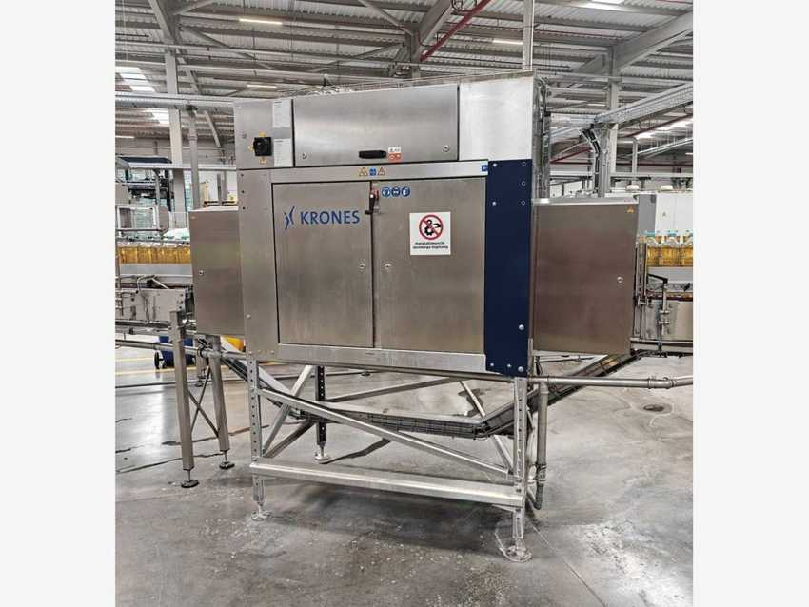 |  | 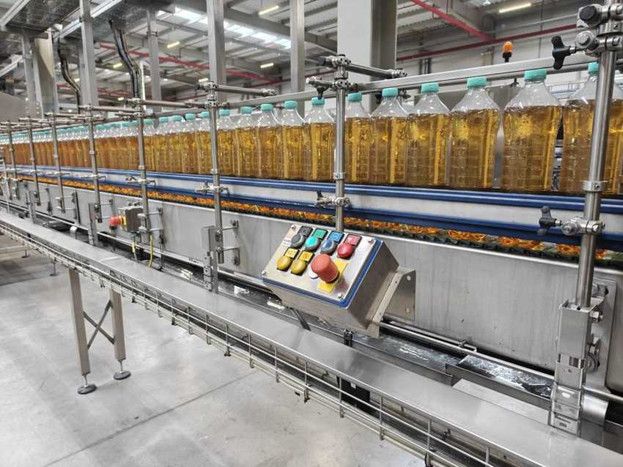
Linadry S1M container dryer (K890BLT) |  | SynCo S container conveyor (K995WPI)
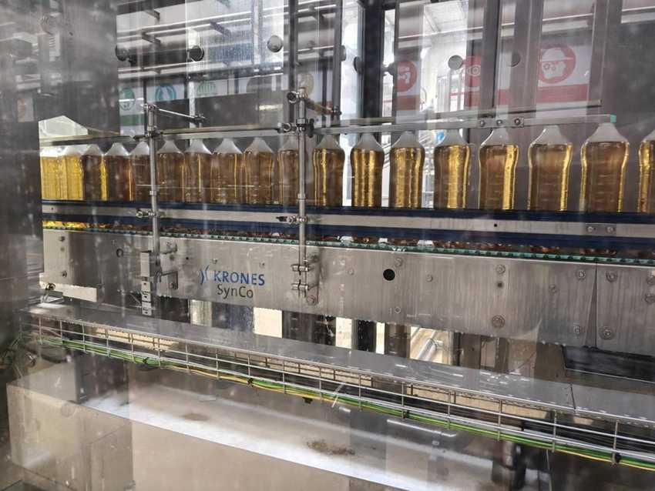 |  | 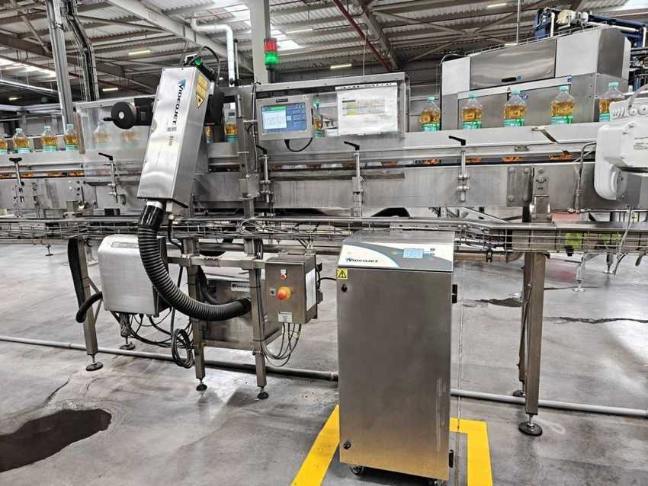
SynCo S with hot-filled bottles |  | Videojet 3350 laser coder with Xtract Pro
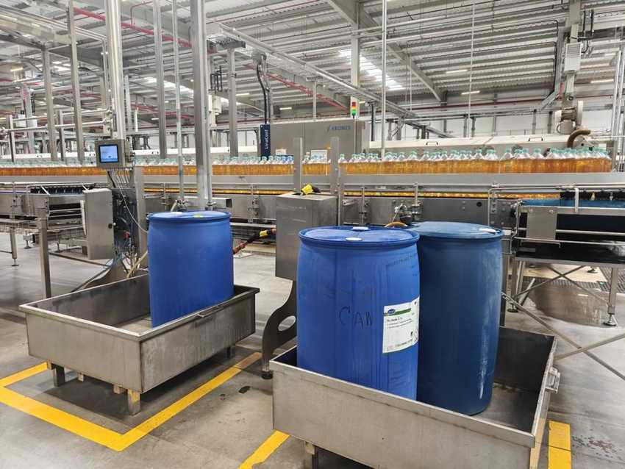 |  | 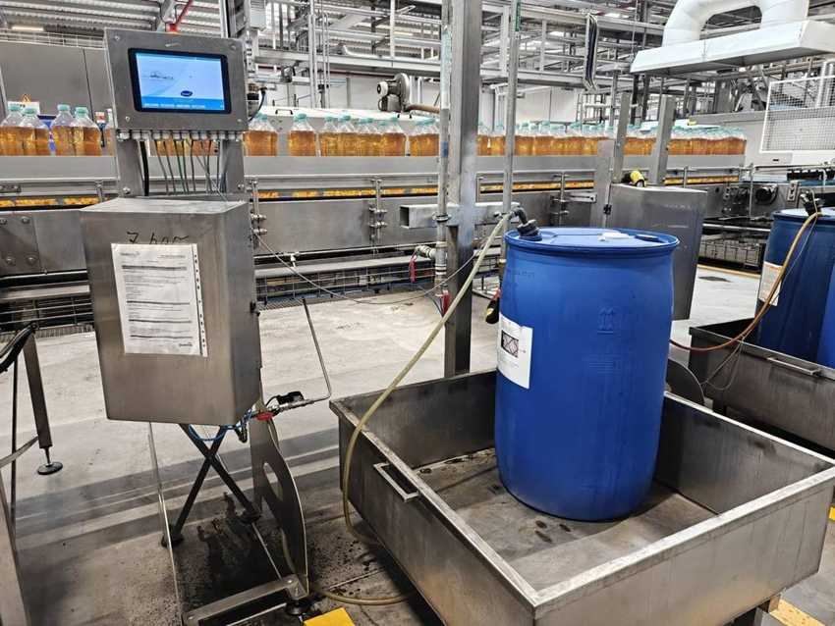
Diversey conveyor lubrication unit |  | Diversey lubrication controller

5.11 Contiroll 720-18 – Labeler

Machine data
MACHINE | KRONES NO. | TYPE | MFG. DATE | SERIAL NO. | INST. POWER kW | SAP NO. | ASSET NO.
Labeler (=ETB2.0901 +KK1) | K893358 | Contiroll 720-18 | 2024 | K893358 | – | 1000002346 | 223000000118

Electrical data (nameplates K893358)
PARAMETER | MAIN SUPPLY | AUXILIARY SUPPLY
Rated voltage | 400 / 230 V | 400 / 230 V
Type of current / system | AC 3/N/PE | AC 3/N/PE
System frequency | 50 Hz | 50 Hz
Full-load current (Ib max) | 22 A | 14 A
Short-circuit rating | 1.15 kA / 1 s (Icw) | 0.43 kA / 1 s (Icw)
Min. short-circuit current (Ik min) | 0.4 kA | 0.32 kA
Back-up fuse | 35 A | 20 A
Connection diagram no. | K893358-001 | K893358-001

Manufacturer and standards
Manufacturer: Krones AG, Werk Neutraubling (Germany). Year of manufacture: 2024. Serial number = Krones commission number. Standards: IEC 60204-1 / IEC 61439-1. Roll-fed wrap-around labeler with built-in Checkmat label inspection (column “Contiroll / Checkmat”).

Photos
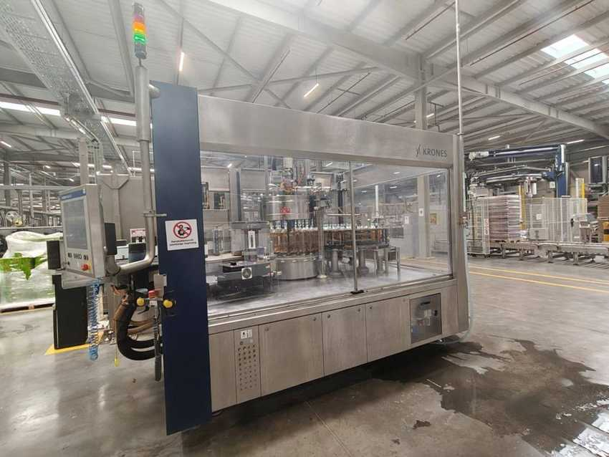 |  | 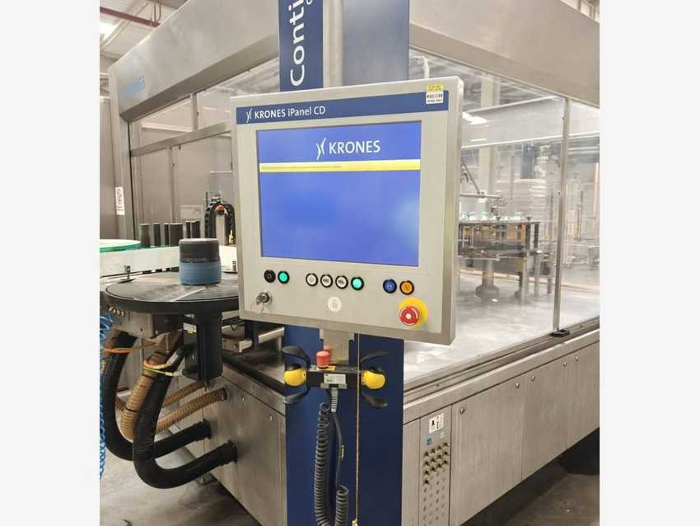
Contiroll 720-18 labeler (K893358) |  | Contiroll – iPanel and label roll station

5.12 Variopac Pro FS-8 – Shrink packer

Machine data
MACHINE | KRONES NO. | TYPE | MFG. DATE | SERIAL NO. | INST. POWER kW | SAP NO. | ASSET NO.
Shrink packer | KR96Z91 | Variopac Pro FS-8 | 2024 | KR96Z91 | – | 1000002333 | 223000000122

Electrical data (nameplates KR96Z91)
PARAMETER | MAIN SUPPLY | AUXILIARY SUPPLY
Rated voltage | 400 / 230 V | 400 / 230 V
Type of current / system | AC 3/N/PE | AC 3/N/PE
System frequency | 50 Hz | 50 Hz
Full-load current (Ib max) | 294 A | 6 A
Short-circuit rating | 55 kA (Icc) | 0.29 kA / 1 s (Icw)
Min. short-circuit current (Ik min) | 1.2 kA | 0.4 kA
Back-up fuse | 400 A | 10 A
Connection diagram no. | KR96Z91-001 | KR96Z91-001

Manufacturer and standards
Manufacturer: Krones AG, Werk Neutraubling (Germany). Year of manufacture: 2024. Serial number = Krones commission number. Standards: IEC 60204-1 / IEC 61439-1. Groups bottles into packs (Fuse Tea 1.5 L, 6-pack 2×3), wraps them in shrink film and shrinks the film in the heated tunnel.

Photos
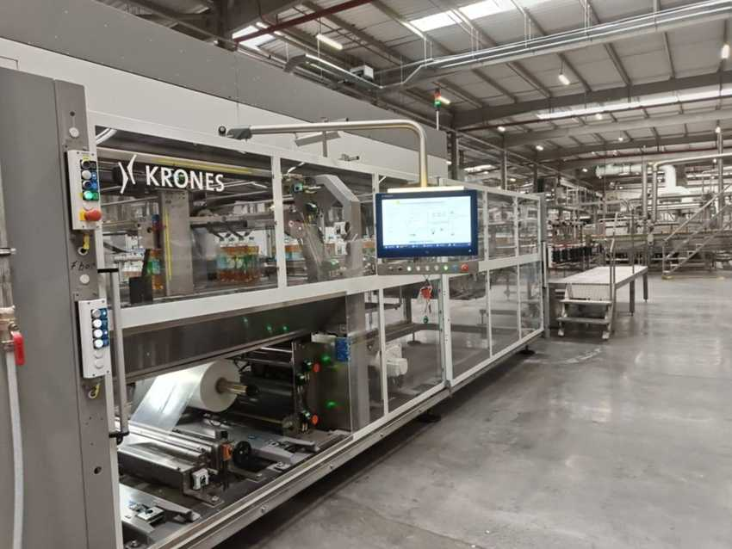 |  | 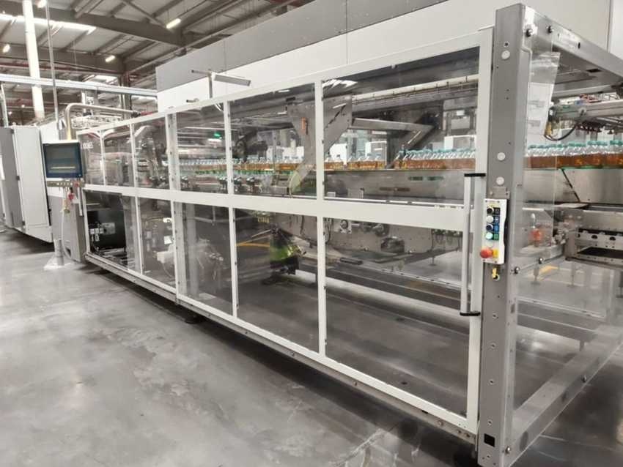
Variopac Pro FS-8 – HMI and film unit |  | Variopac Pro – infeed and grouping section
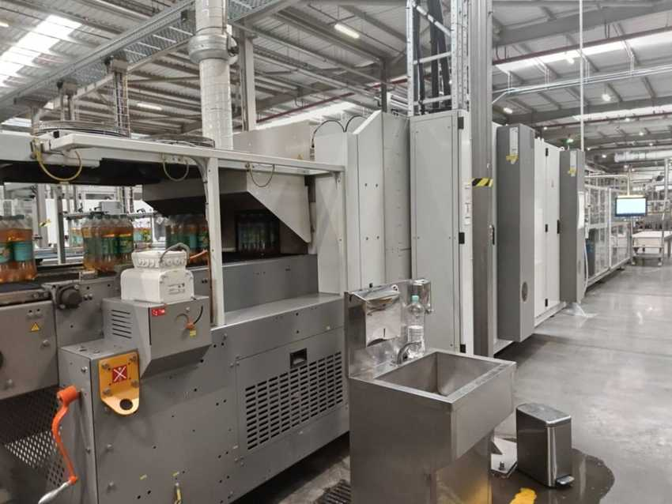
Shrink tunnel outlet

5.13 Pack conveyor, palletizing and stretch wrapping

Machine data
MACHINE | KRONES NO. | TYPE | MFG. DATE | SERIAL NO. | INST. POWER kW | SAP NO. | ASSET NO.
Pack conveyor | KR673WV | MultiCo S | 2024 | KR673WV | – | 1000002349 | verify
Layer forming robots | KR63R70 | Robobox T-GS | 2024 | KR63R70 | – | – | see palletizer
Palletizer | KR63R70 | Modulpal Pro 2A | 2024 | KR63R70 | – | 1000002334 | 223000000123
Stretch wrapper | K82448H | Robopac Genesis Futura | 2024 | 5223060267 | 18 | – | 223000000125
Pallet conveyor | KR571D6 | Palco S | 2024 | KR571D6 | – | 1000002345 | verify

Electrical data – stretch wrapper (nameplate K82448H)
PARAMETER | ROBOPAC GENESIS FUTURA
Rated voltage | 400 V
Frequency / phases | 50 Hz / 3PH / N / PE
Current (absorption) | 34 A
Total power | 18 kW
Short-circuit current | 10 kA
Electrical drawing no. | 5223267

MultiCo: process plate “Pack conveyor 1, MultiCo, KR673WV, 2024”, Krones Hungary Kft., Debrecen. Palletizer lubricants (line lubrication schedule): Krones Celerol FL 7203 (chains) and Celerol L 7009 (reservoir and guides). Palco S groups: infeed / empty pallet magazine, bottom pad inserter, wrapper, labeller / discharge. Stretch wrapper: Aetna Group S.p.A. (Robopac), Villa Verucchio (Italy).

Photos
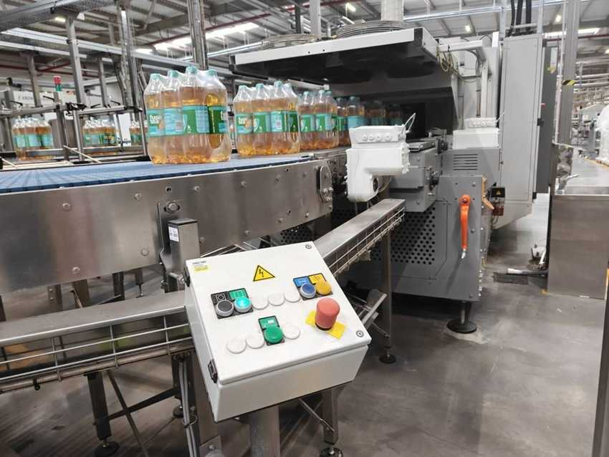 |  | 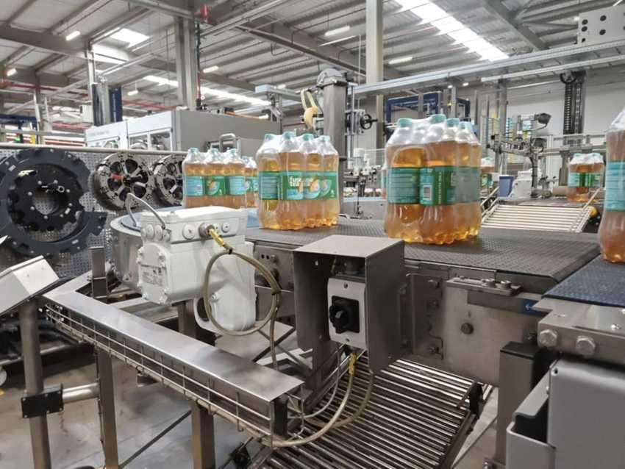
MultiCo S (KR673WV) – Fuse Tea packs leaving the shrink tunnel |  | MultiCo S – packs to the palletizer
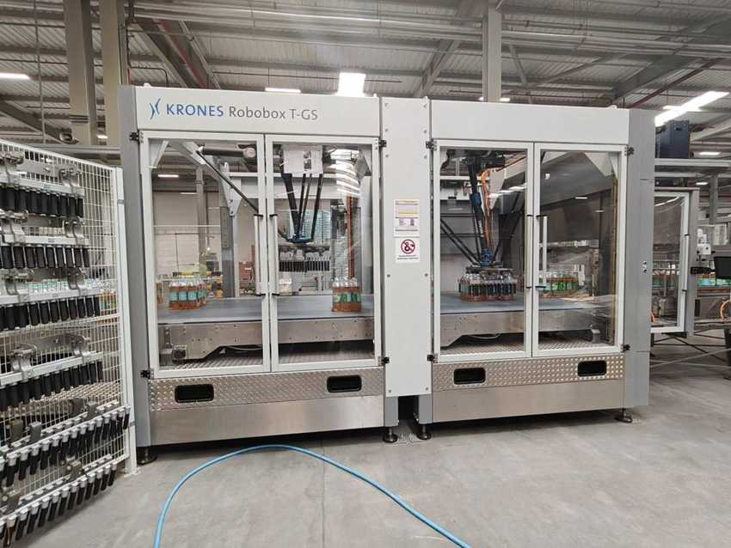 |  | 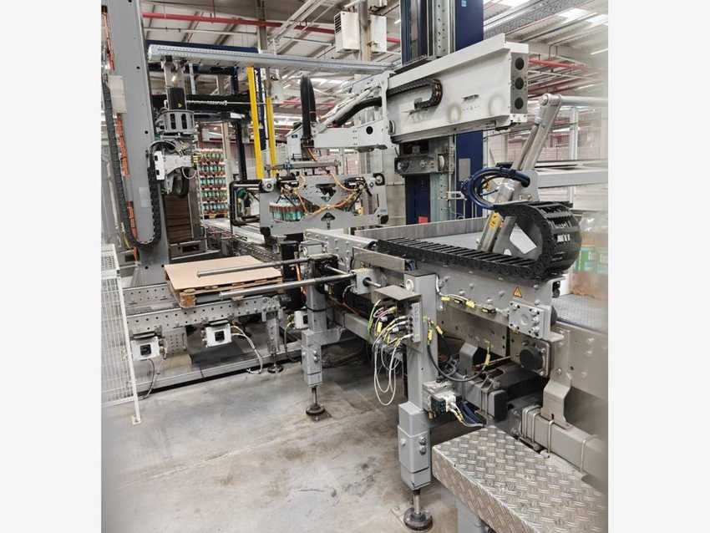
Robobox T-GS layer forming robots |  | Modulpal Pro 2A palletizing cell
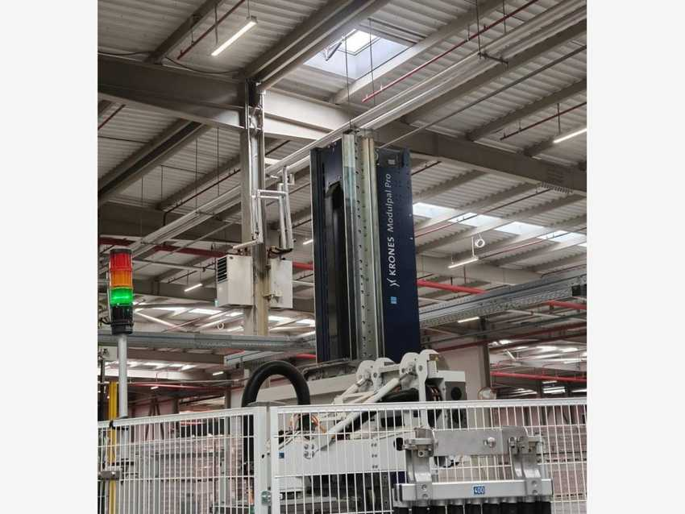 |  | 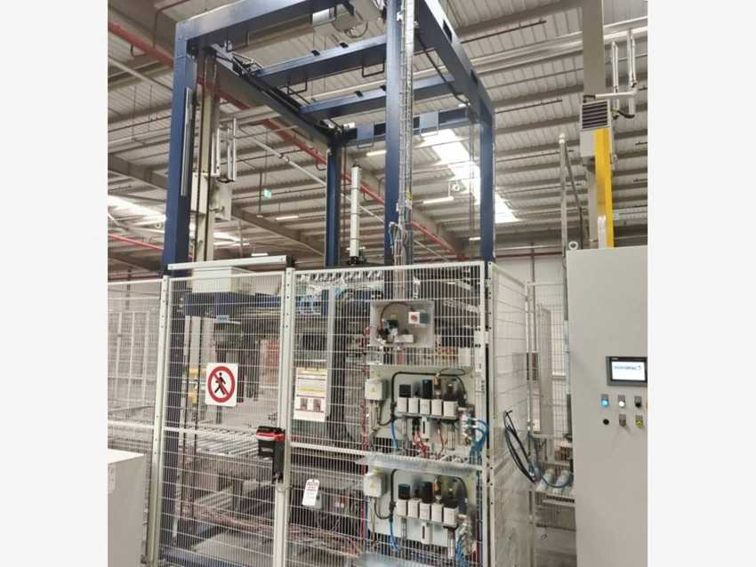
Modulpal Pro column and layer gripper |  | Robopac Genesis Futura stretch wrapper (K82448H)
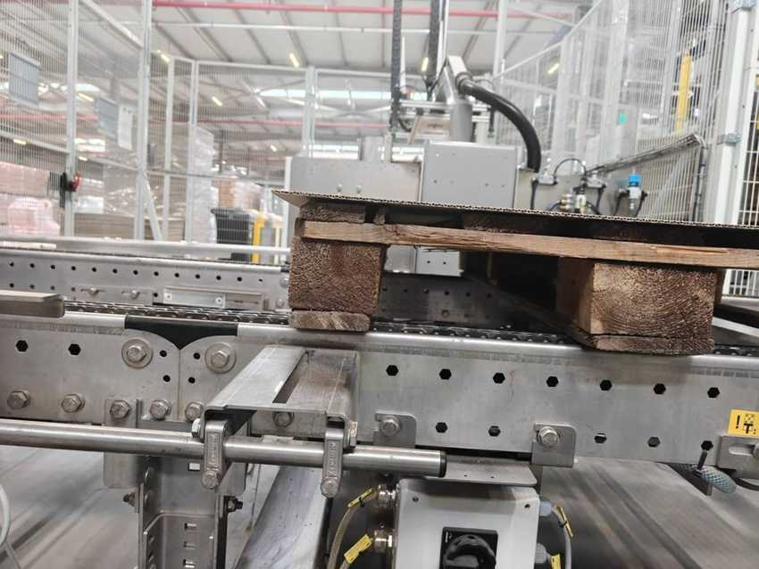 |  | 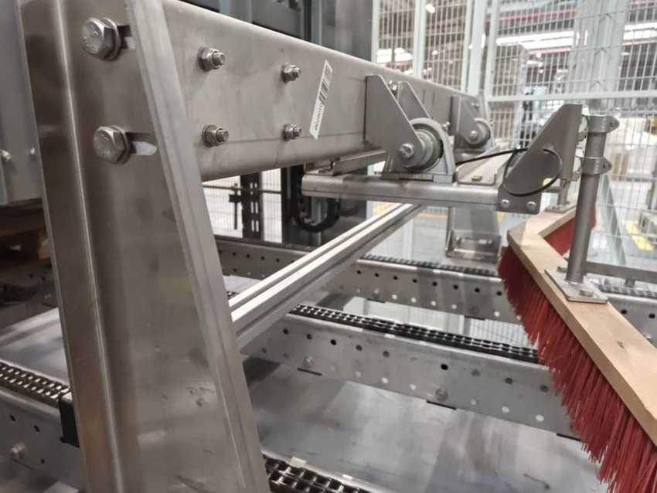
Palco S (KR571D6) – empty pallet with tier sheet |  | Palco S – pallet conveyor chains

5.14 NH3 refrigeration and SFM packages
KRONES NO. | DESCRIPTION | MFG. DATE | SERIAL NO. | INST. POWER kW | SAP NO. | ASSET NO.
KU03087 | NH3 refrigeration (Kälte, NH3) – chilled water for the line | – | – | – | – | –
K8206CT | SFM labelling technology | – | – | – | – | –
K8212IS | SFM filling / process technology | – | – | – | – | –
K8252QL | SFM transport technology | – | – | – | – | –
K8252QN | SFM transport technology | – | – | – | – | –

These items are engineering / cabinet packages or plant-room equipment and are listed in the register only. K8252QM (also SFM transport) is the neck sterilizer – see 5.8.

6 Line-3 CAN

6.1 Line data and equipment register
Manufacturer | Krones AG – Germany | Line | SAMARKAND can line (Dosenlinie)
Capacity | 48,000 cph @ 0.25 L | Krones system no. | C372677
Customer | Coca Cola Ichimligi Uzbekistan Ltd | Year of manufacture (YOM) | 2024
Installed power | – kW | Package types | Cans (Sprite seen on line)
Functional location | PRD00185 – SMR Line-03 / Can / Krones | Cost centre | 7101026018

Line process flow
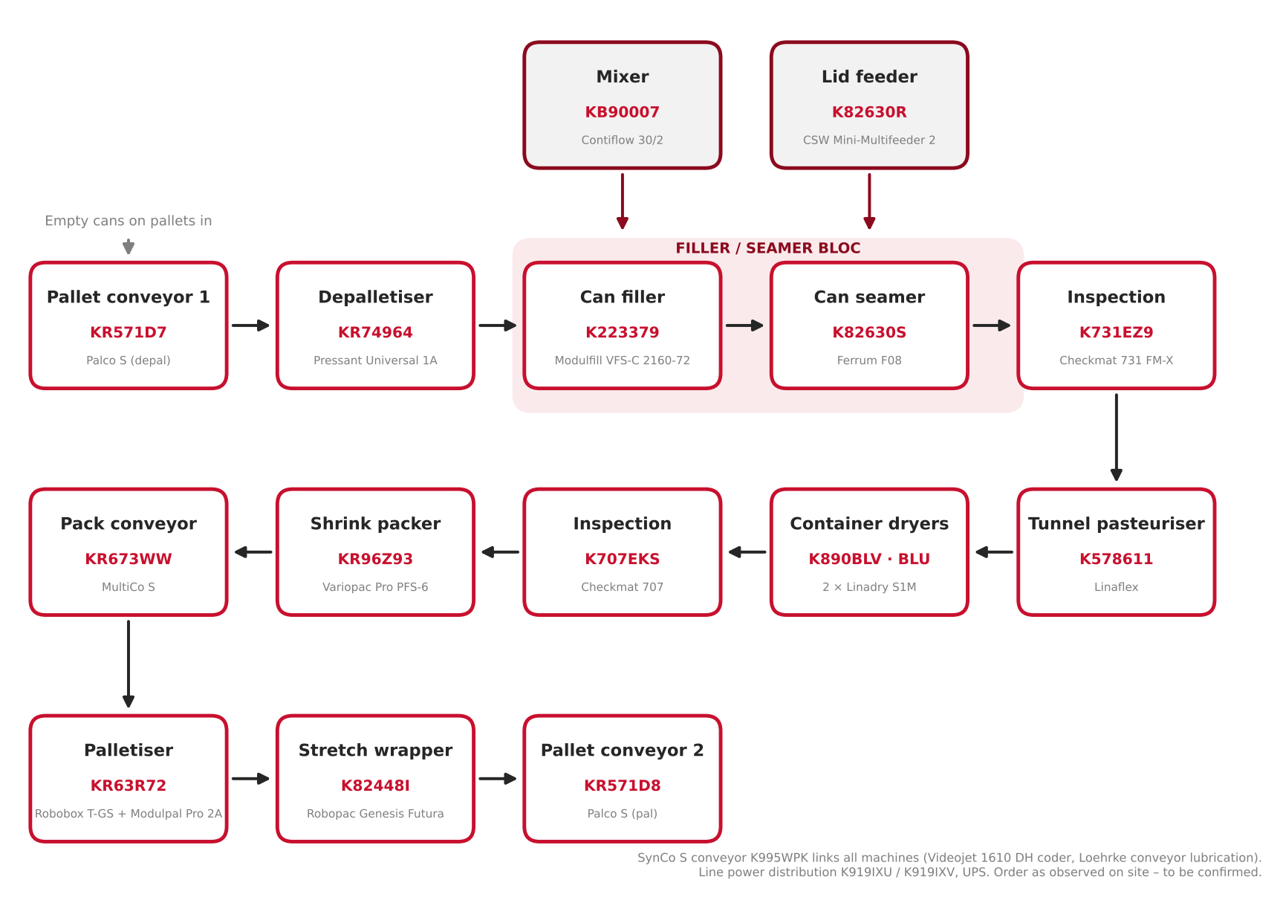
Figure 6.1 – Line-3 CAN process flow, from depalletising to pallet exit (order as observed on site – to be confirmed)

Krones equipment register
No. | KRONES NO. | DESCRIPTION | ASSET NO. | DETAILS
1 | KR571D7 | Pallet conveyor 1 (depal) – Palco S | 223000000086 | Section 6.2
2 | KR74964 | Semi-auto block depalletiser – Pressant Universal 1A | 223000000085 | Section 6.2
3 | KB90007 | Beverage treatment – Contiflow 30/2 | 223000000000 | Section 6.3
4 | K223379 | Can filler – Modulfill VFS-C 2160-72 (TK 2160) | 223000000073 | Section 6.4
5 | K82630S | Can seamer – Ferrum F08 | 223000000074 | Section 6.4
6 | K82630R | Can end feed – CSW Mini-Multifeeder 2 | 223000000076 | Section 6.4
7 | K731EZ9 | Checkmat 731 FM-X | 223000000075 | Section 6.5
8 | K578611 | Tunnel pasteuriser – Linaflex | 223000000077 | Section 6.6
9 | K890BLV | Container dryer 1 – Linadry S1M | 223000000078 | Section 6.7
10 | K890BLU | Container dryer 2 – Linadry S1M | 223000000079 | Section 6.7
11 | K707EKS | Checkmat 707 | 223000000081 | Section 6.5
12 | K995WPK | Container conveyor – SynCo S | 223000000090 | Section 6.7
13 | KR96Z93 | Shrink packer – Variopac Pro PFS-6 | 223000000080 | Section 6.8
14 | KR673WW | Pack conveyor – MultiCo S | 223000000084 | Section 6.9
15 | KR63R72 | Palletiser – Modulpal Pro 2A (+ Robobox T-GS) | 223000000087 | Section 6.9
16 | K82448I | Stretch wrapper – Robopac Genesis Futura 40 | 223000000089 | Section 6.9
17 | KR571D8 | Pallet conveyor 2 (pal) – Palco S | 223000000088 | Section 6.9
18 | K919IXU | Electronic installation – line power distribution | – | Section 6.10
19 | K919IXV | Electronic installation – line power distribution | – | Section 6.10
20 | K8206CV | SFM labelling technology | – | Section 6.10
21 | K8212IU | SFM filling / process technology | – | Section 6.10
22 | K8252QQ | SFM transport technology | – | Section 6.10

Sources: Krones equipment list (system C372677), nameplates, SAP fixed-asset register (plant 1802) and equipment master data, cost centre 7101026018. Checkmat 731 FM-X asset per SAP register (master data shows 223000000116). In all tables “–” means not available / not applicable.

Other Line-3 assets (not in the Krones list)
No. | EQUIPMENT | MANUFACTURER / MODEL | SERIAL NO. | ASSET NO.
1 | Container code / dating unit (see 6.11) | Videojet 1610 DH | 23338005C18ZH | 223000000082
2 | Conveyor lubrication (see 6.11) | Loehrke Loewados BSA I (SAP: Diversey) | 0095-001-0001342 | 223000000083
3 | Uninterruptible power supply (see 6.11) | SK 3304540 | 2023K000023166 | 223000000091
4 | Marking machine | Matrix System | – | 223000000059
5 | Labeling machine | APL8300PRO (003422) | – | 223000000014
6 | Industrial panel PC (panel included) | – | – | 223000000022

6.2 Depalletiser Pressant and pallet conveyor 1

Machine data
MACHINE | KRONES NO. | TYPE | MFG. DATE | SERIAL NO. | INST. POWER kW | SAP NO. | ASSET NO.
Pallet conveyor 1 (depal) | KR571D7 | Palco S | 2024 | KR571D7 | – | – | 223000000086
Depalletiser | KR74964 | Pressant Universal 1A | 2024 | KR74964 | – | 1000002336 | 223000000085

Electrical data (nameplates KR74964)
PARAMETER | MAIN SUPPLY | AUXILIARY SUPPLY
Rated voltage | 400 / 230 V | 400 / 230 V
Type of current / system | AC 3/N/PE | AC 3/N/PE
System frequency | 50 Hz | 50 Hz
Full-load current (Ib max) | 51 A | 4 A
Short-circuit rating | 1.26 kA / 1 s (Icw) | 0.17 kA / 1 s (Icw)
Min. short-circuit current (Ik min) | 0.6 kA | 0.38 kA
Back-up fuse | 63 A | 10 A
Connection diagram no. | KR74964-001 | KR74964-001

Full pallets of empty cans arrive on the Palco S roller conveyor (process plate “Pallet conveyor 1, Palco, KR571D7, 2024”, Krones Hungary Kft., Debrecen). The Pressant takes the can layers off the pallet and pushes them onto the can conveyor; empty pallets go to the pallet magazine. Cabinet cooler: Seifert SLIMLINE KG 4274, serial M9626012550 (10/23).

Photos
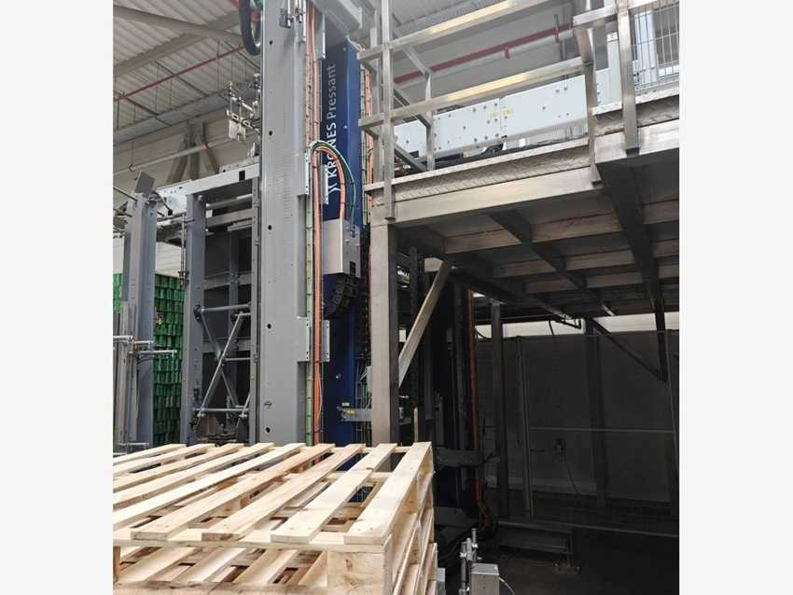 |  | 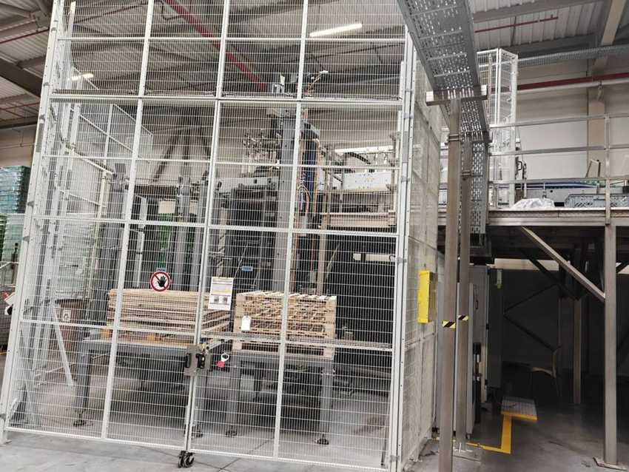
Krones Pressant depalletiser (KR74964) |  | Depalletiser cell with empty pallet magazine
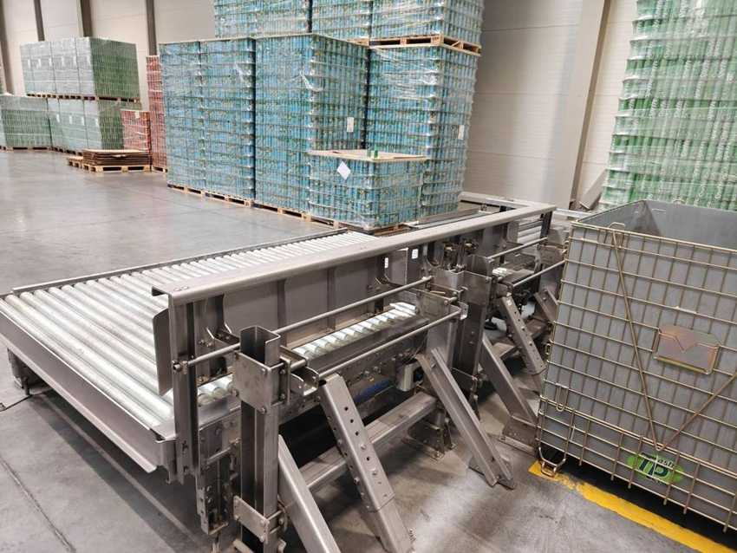
Palco S pallet conveyor 1 (KR571D7)

6.3 Contiflow 30/2 – Beverage treatment (mixer)

Machine data
MACHINE | KRONES NO. | TYPE | MFG. DATE | SERIAL NO. | INST. POWER kW | SAP NO. | ASSET NO.
Mixer (beverage treatment) | KB90007 | Contiflow 30/2 | 2024 | KB90007 | – | 1000002330 | 223000000000

Electrical data (nameplates KB90007)
PARAMETER | MAIN SUPPLY | AUXILIARY SUPPLY
Rated voltage | 400 / 230 V | 400 / 230 V
Type of current / system | AC 3/N/PE | AC 3/N/PE
System frequency | 50 Hz | 50 Hz
Full-load current (Ib max) | 66 A | 4 A
Short-circuit rating | 0.99 kA / 1 s (Icw) | 0.4 kA / 1 s (Icw)
Min. short-circuit current (Ik min) | 0.55 kA | 0.29 kA
Back-up fuse | 80 A | 16 A
Connection diagram no. | KB90007 | KB90007

Manufacturer and standards
Manufacturer: Krones AG, Werk Neutraubling (Germany). Year of manufacture: 2024. Serial number = Krones commission number. Standards: IEC 60204-1 / IEC 61439-1. Mixes syrup, treated water and CO2 into finished product for the can filler. Nameplate confirms KB90007 (master data shows K890007).

Photos
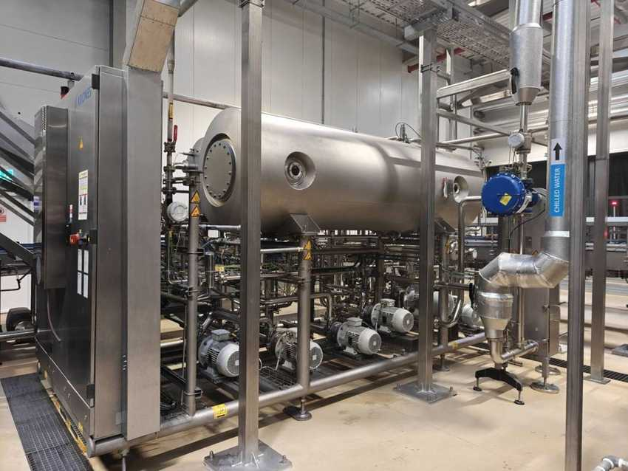 |  | 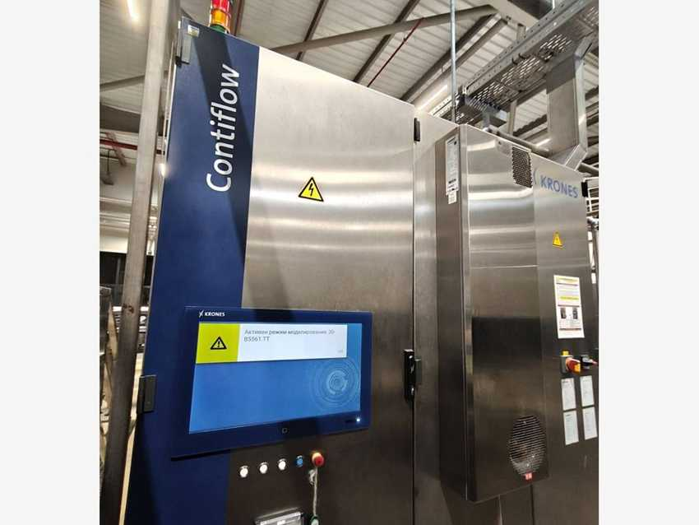
Contiflow 30/2 skid – tank, pumps and cabinet |  | Contiflow control cabinet with HMI

6.4 Can filler, seamer and can end feed

Machine data
MACHINE | KRONES NO. | TYPE | MFG. DATE | SERIAL NO. | INST. POWER kW | SAP NO. | ASSET NO.
Can filler | K223379 | Modulfill VFS-C 2160-72 | 2024 | K223379 | – | 1000002335 | 223000000073
Can seamer | K82630S | Ferrum F08 | 2023 | C10-932700 | – | 1000002354 | 223000000074
Can end (lid) feed | K82630R | CSW Mini-Multifeeder 2 (MMF-2) | 2024 | 203902 | 2 | – | 223000000076

Electrical data
PARAMETER | K223379 MAIN | K223379 AUX | K82630R LID FEED
Rated voltage | 400 / 230 V | 400 / 230 V | 400 / 230 V
Type of current / system | AC 3/N/PE | AC 3/N/PE | AC 3/N/PE
System frequency | 50 Hz | 50 Hz | 50 Hz
Full-load current (Ib max) | 53 A | 4 A | 6 A
Short-circuit rating | 1.26 kA / 1 s (Icw) | 0.29 kA / 1 s (Icw) | 6 kA (Icc)
Min. short-circuit current (Ik min) | 0.5 kA | 0.32 kA | –
Back-up fuse | 63 A | 16 A | 16 A
Connection diagram no. | K223379 | K223379 | E203902

Can filler “TK 2160” by Krones AG, Neutraubling (2024). Seamer by Ferrum Packaging Ltd., Schafisheim (Switzerland), type F08, 2023, serial C10-932700 (plate shows customer ref. K8263OS). Lid feeder by CSW Machinery BV, Deventer (Netherlands), serial 203902, 2 kW, air 2.4 Nm³/h at 6 bar, IP54, 1,350 kg.

Photos
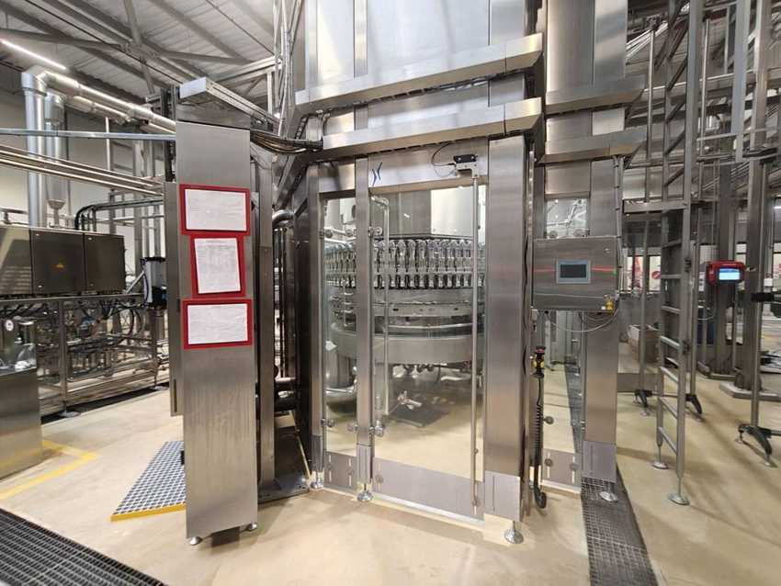 |  | 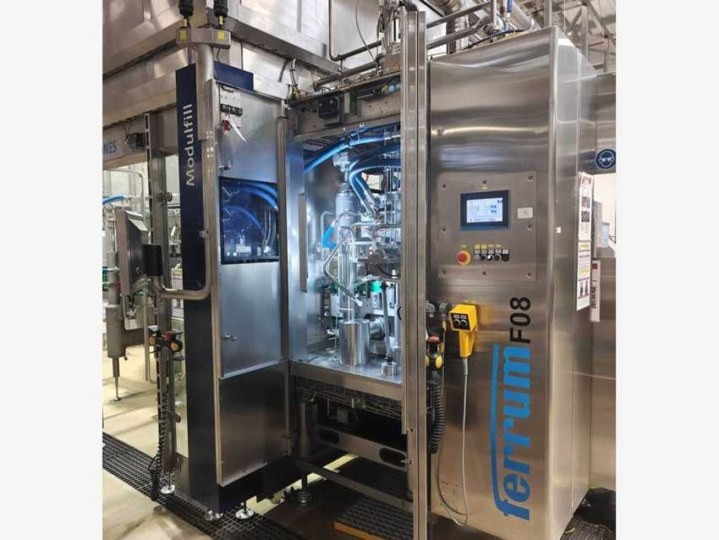
Modulfill VFS-C can filler (K223379) |  | Ferrum F08 seamer next to the can filler
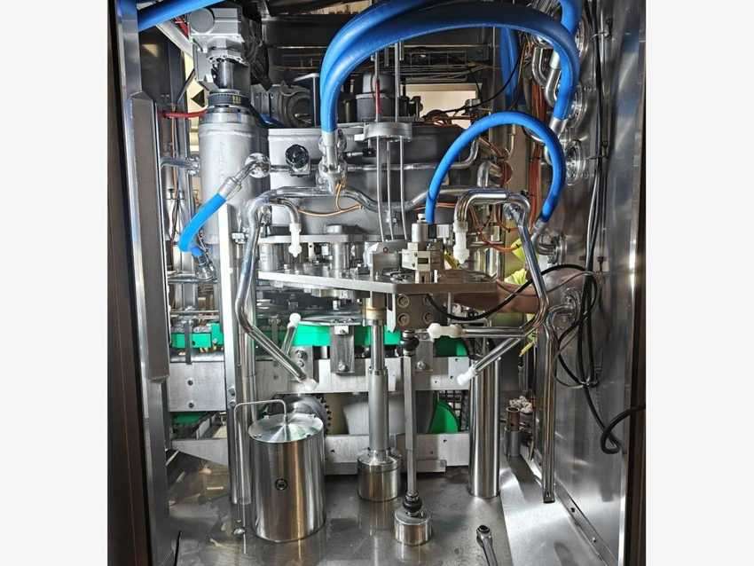 |  | 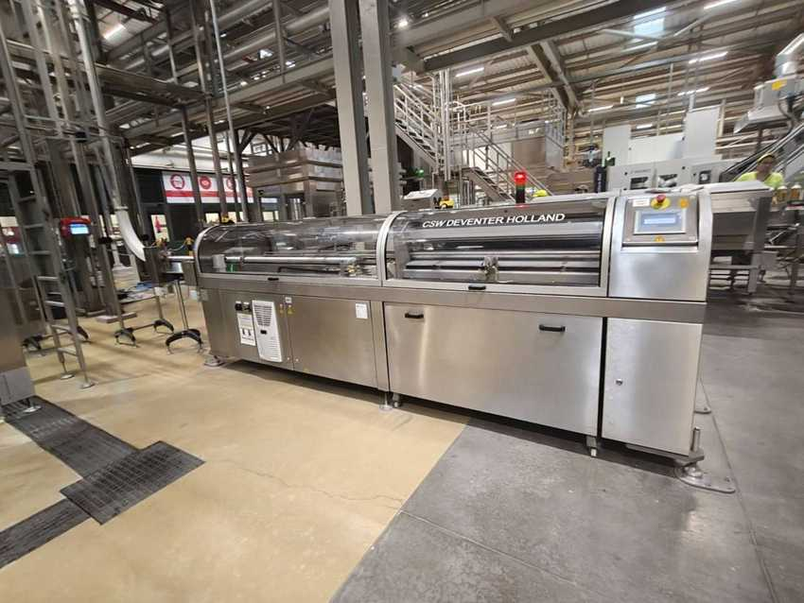
Seamer – seaming head and turret |  | CSW Mini-Multifeeder 2 lid feeder (K82630R)

6.5 Inspection units – Checkmat 731 FM-X and Checkmat 707

Machine data
MACHINE | KRONES NO. | TYPE | MFG. DATE | SERIAL NO. | INST. POWER kW | SAP NO. | ASSET NO.
Inspection after seamer | K731EZ9 | Checkmat 731 FM-X | 2024 | K731EZ9 | – | – | 223000000075
Inspection before packer | K707EKS | Checkmat 707 | 2024 | K707EKS | – | – | 223000000081

Electrical data (nameplates)
PARAMETER | K731EZ9 | K707EKS
Rated voltage | 230 V | 230 V
Type of current / system | AC 1/N/PE | AC 1/N/PE
System frequency | 50 Hz | 50 Hz
Full-load current (Ib max) | 4 A | 4 A
Short-circuit rating | 0.29 kA / 1 s (Icw) | 0.29 kA / 1 s (Icw)
Min. short-circuit current (Ik min) | 0.16 kA | 0.16 kA
Back-up fuse | 10 A | 10 A
Connection diagram no. | K731EZ9-001 | K707EKS-001

Manufacturer and standards
Manufacturer: Krones AG, Werk Neutraubling (Germany). Year of manufacture: 2024. Serial number = Krones commission number. Standards: IEC 60204-1 / IEC 61439-1. Checkmat 731 FM-X checks fill level and lid after the seamer; Checkmat 707 inspects cans before packing and rejects faulty cans into a bin.

Photos
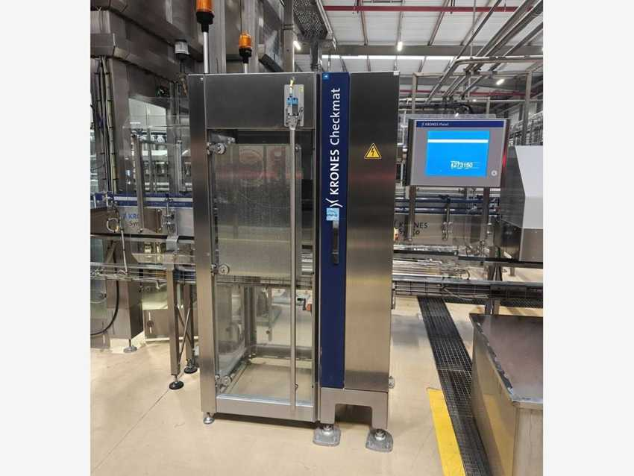 |  | 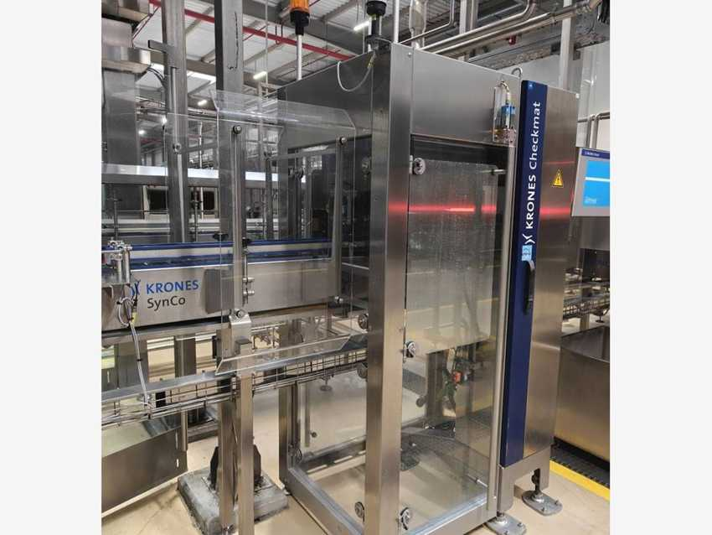
Checkmat 731 FM-X (K731EZ9) |  | Checkmat 731 FM-X over the can conveyor
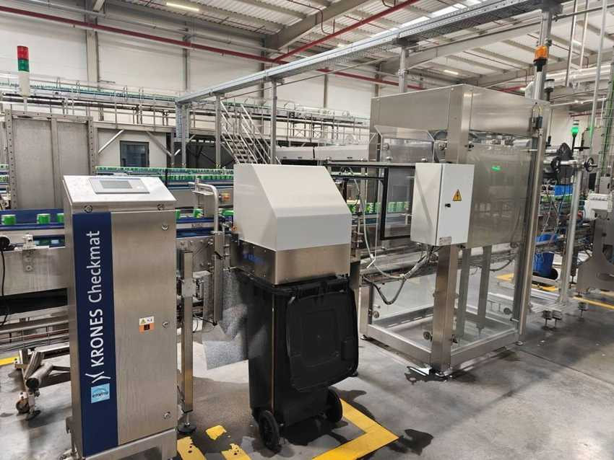
Checkmat 707 (K707EKS) with reject unit

6.6 Linaflex – Tunnel pasteuriser

Machine data
MACHINE | KRONES NO. | TYPE | MFG. DATE | SERIAL NO. | INST. POWER kW | SAP NO. | ASSET NO.
Tunnel pasteuriser | K578611 | Linaflex (Pasteuriser 1) | 2024 | K578611 | – | 1000002340 | 223000000077

Electrical data (nameplates K578611)
PARAMETER | MAIN SUPPLY | AUXILIARY SUPPLY
Rated voltage | 400 / 230 V | 400 / 230 V
Type of current / system | AC 3/N/PE | AC 3/N/PE
System frequency | 50 Hz | 50 Hz
Full-load current (Ib max) | 99 A | 2 A
Short-circuit rating | 17 kA (Icc) | 0.43 kA / 1 s (Icw)
Min. short-circuit current (Ik min) | 1.25 kA | 0.32 kA
Back-up fuse | 125 A | 5 A
Connection diagram no. | K578611 | K578611

Manufacturer: Krones AG, Werk Flensburg (Germany), 2024. Filled and closed cans pass through the tunnel where water sprays heat them to pasteurisation temperature and cool them down again. The pasteuriser is marked as food-safety critical control point CCP 1.

Cabinet cooling unit – Seifert SLIMLINE KG 4274 (stainless)
Part no. / Krones part no. | 42749627 / 0906480710 | Serial no. | M9627011213
Production date | 08/23 | Supply | 230 V, 50/60 Hz
Power / current | 1.4 kW max (791 W @ 50 Hz), 3.7 A @ 50 Hz | Fuse / SCCR | 16 A (T) / 5 kA
Cooling capacity | 1.50 kW | Refrigerant / IP | R134a 620 g / IP 55

Photos
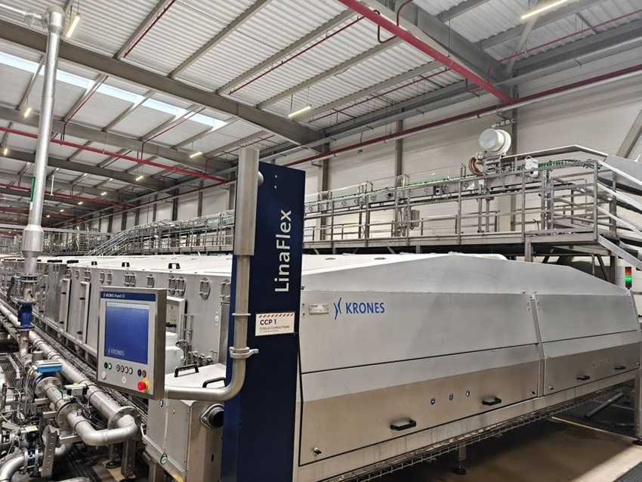
Linaflex tunnel pasteuriser (K578611)

6.7 Linadry dryers and SynCo container conveyor

Machine data
MACHINE | KRONES NO. | TYPE | MFG. DATE | SERIAL NO. | INST. POWER kW | SAP NO. | ASSET NO.
Container dryer 1 | K890BLV | Linadry S1M | 2024 | K890BLV | – | – | 223000000078
Container dryer 2 | K890BLU | Linadry S1M | 2024 | K890BLU | – | – | 223000000079
Container conveyor | K995WPK | SynCo S | 2024 | K995WPK | – | – | 223000000090

Electrical data (nameplates)
PARAMETER | K890BLV / BLU | K995WPK MAIN | K995WPK AUX
Rated voltage | 400 / 230 V | 400 / 230 V | 400 / 230 V
Type of current / system | AC 3/N/PE | AC 3/N/PE | AC 3/N/PE
System frequency | 50 Hz | 50 Hz | 50 Hz
Full-load current (Ib max) | 23 A (each) | 53 A | 7 A
Short-circuit rating | 1.15 kA / 1 s (Icw) | 0.46 kA / 1 s (Icw) | 0.43 kA / 1 s (Icw)
Min. short-circuit current (Ik min) | 0.48 kA | 0.32 kA | 0.32 kA
Back-up fuse | 35 A | 63 A | 10 A
Connection diagram no. | K890BLV / K890BLU | K995WPK-001 | K995WPK-001

Linadry dryers by Krones Hungary Kft., Debrecen (2024): blow water off the cans after the pasteuriser. SynCo S conveyor cabinet by Krones AG, Neutraubling – links all machines of the line.

Photos
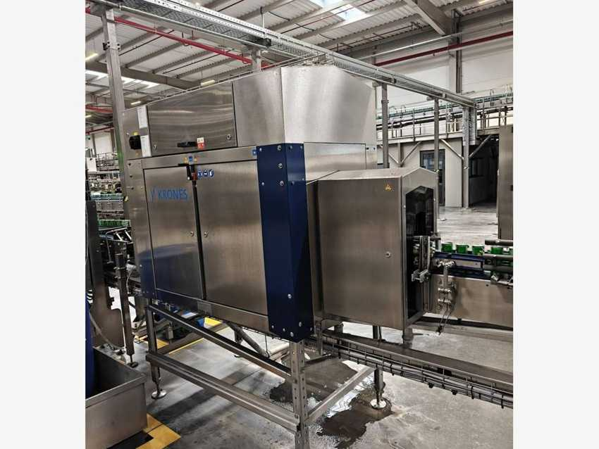 |  | 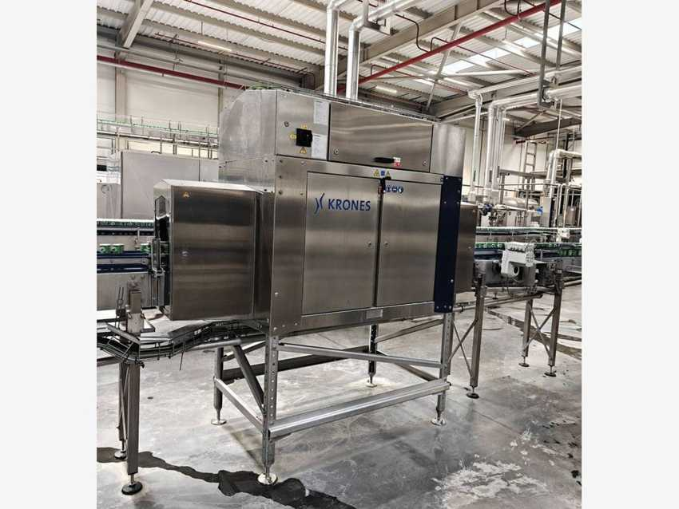
Linadry S1M container dryer 1 (K890BLV) |  | Linadry S1M container dryer 2 (K890BLU)
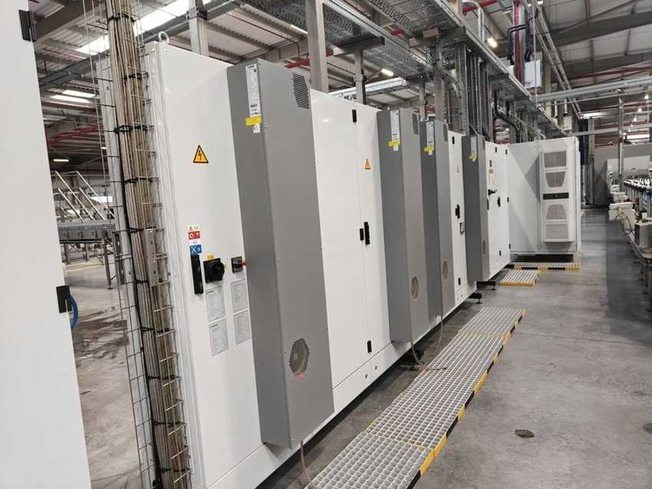
SynCo S conveyor control cabinet and line cabinet row

6.8 Variopac Pro PFS-6 – Shrink packer

Machine data
MACHINE | KRONES NO. | TYPE | MFG. DATE | SERIAL NO. | INST. POWER kW | SAP NO. | ASSET NO.
Shrink packer | KR96Z93 | Variopac Pro PFS-6 | 2024 | KR96Z93 | – | 1000002337 | 223000000080

Electrical data (nameplates KR96Z93)
PARAMETER | MAIN SUPPLY | AUXILIARY SUPPLY
Rated voltage | 400 / 230 V | 400 / 230 V
Type of current / system | AC 3/N/PE | AC 3/N/PE
System frequency | 50 Hz | 50 Hz
Full-load current (Ib max) | 150 A | 6 A
Short-circuit rating | 55 kA (Icc) | 0.29 kA / 1 s (Icw)
Min. short-circuit current (Ik min) | 1.2 kA | 0.4 kA
Back-up fuse | 160 A | 10 A
Connection diagram no. | KR96Z93-001 | KR96Z93-001

Manufacturer and standards
Manufacturer: Krones AG, Werk Neutraubling (Germany). Year of manufacture: 2024. Serial number = Krones commission number. Standards: IEC 60204-1 / IEC 61439-1. Groups cans into packs, wraps them in shrink film and shrinks the film in the heated tunnel.

Photos
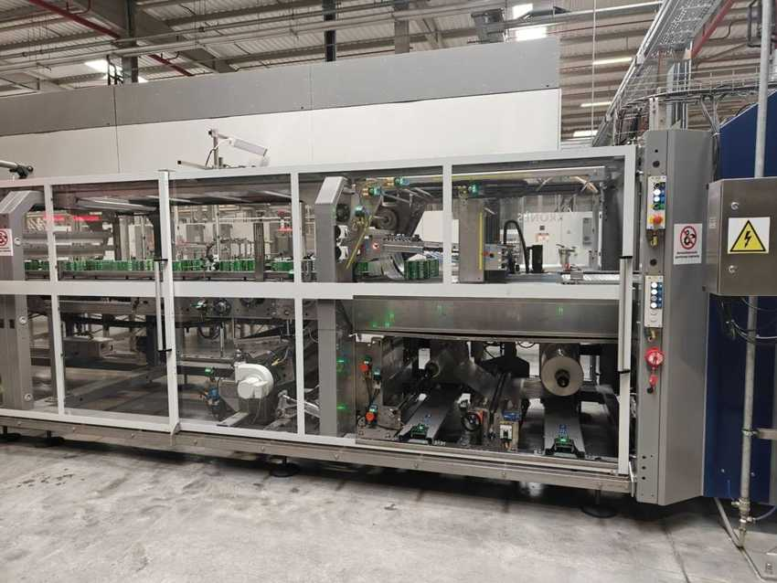 |  | 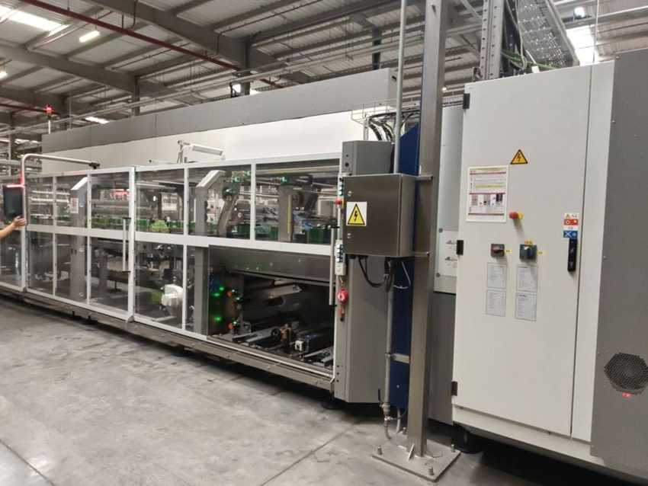
Variopac Pro PFS-6 – grouping section with cans |  | Variopac Pro PFS-6 – full length with shrink tunnel
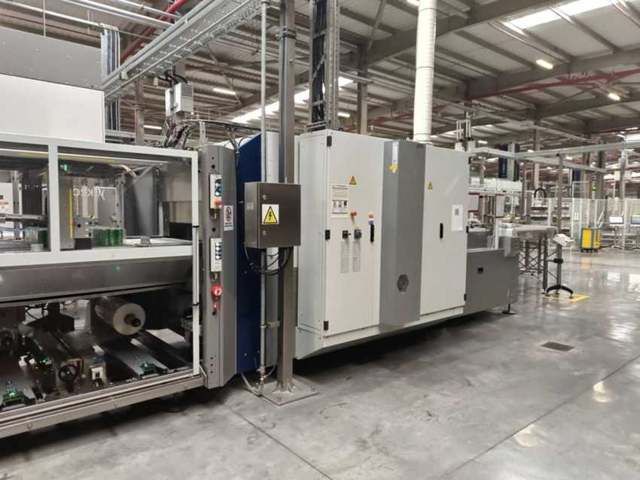
Variopac Pro – control cabinets and outlet

6.9 Pack conveyor, palletising and stretch wrapping

Machine data
MACHINE | KRONES NO. | TYPE | MFG. DATE | SERIAL NO. | INST. POWER kW | SAP NO. | ASSET NO.
Pack conveyor (=LN03.MCO1) | KR673WW | MultiCo S | 2024 | KR673WW | – | – | 223000000084
Layer forming robot | KR63R72 | Robobox T-GS | 2024 | KR63R72 | – | – | see palletiser
Palletiser | KR63R72 | Modulpal Pro 2A | 2024 | KR63R72 | – | 1000002339 | 223000000087
Stretch wrapper | K82448I | Robopac Genesis Futura 40 | 2024 | 5323050209 | 18.5 | – | 223000000089
Pallet conveyor 2 (pal) | KR571D8 | Palco S | 2024 | KR571D8 | – | – | 223000000088

Electrical data (nameplates)
PARAMETER | KR63R72 MAIN | KR63R72 AUX | KR673WW MAIN | KR571D8 MAIN
Rated voltage | 400 / 230 V | 400 / 230 V | 400 / 230 V | 400 / 230 V
Type of current / system | AC 3/N/PE | AC 3/N/PE | AC 3/N/PE | AC 3/N/PE
System frequency | 50 Hz | 50 Hz | 50 Hz | 50 Hz
Full-load current (Ib max) | 75 A | 5 A | 16 A | 19 A
Short-circuit rating | 55 kA (Icc) | 0.17 kA / 1 s (Icw) | 0.46 kA / 1 s (Icw) | 0.64 kA / 1 s (Icw)
Min. short-circuit current (Ik min) | 0.96 kA | 0.4 kA | 0.38 kA | 0.38 kA
Back-up fuse | 80 A | 10 A | 20 A | 25 A
Connection diagram no. | KR63R72-001 | KR63R72-001 | KR673WW | KR571D8-001

Auxiliary supplies: MultiCo 3 A / 0.29 kA / 0.1 kA / 10 A; Palco KR571D8 3 A / 0.64 kA / 0.38 kA / 10 A.

Electrical data – stretch wrapper (nameplate K82448I)
PARAMETER | ROBOPAC GENESIS FUTURA
Rated voltage | 400 V
Frequency / phases | 50 Hz / 3PH / N / PE
Current (absorption) | 35 A
Total power | 18.5 kW
Short-circuit current | 10 kA
Electrical drawing no. | 5323209

Palletiser made by Krones AG, Werk Rosenheim (Germany); cabinet cooler Seifert KG 4274, serial M9626012555. Stretch wrapper by Aetna Group S.p.A. (Robopac), Villa Verucchio (Italy), Aetna serial 5323050209. Palco S KR571D8 (“Pallet conveyor 2”, Krones Hungary) holds the empty-pallet magazine and carries full pallets to the exit.

Photos
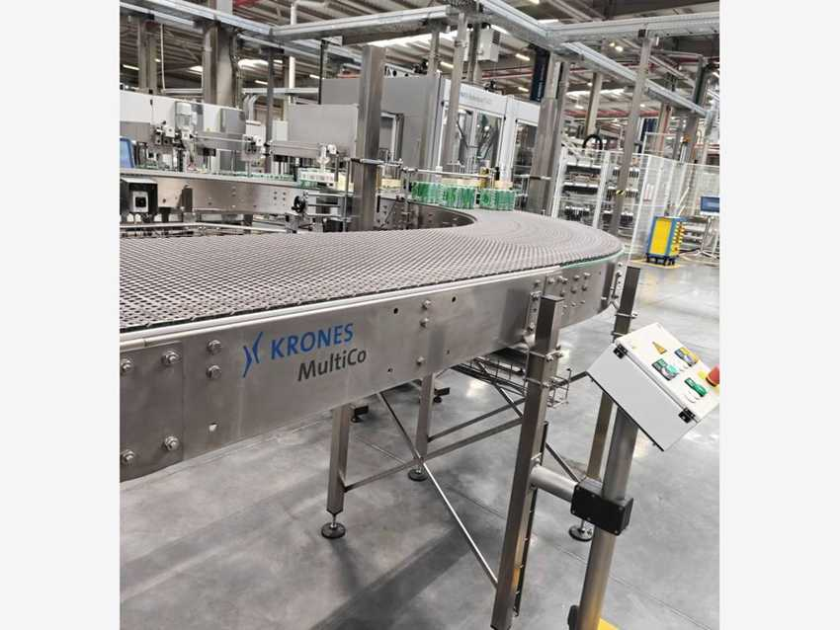 |  | 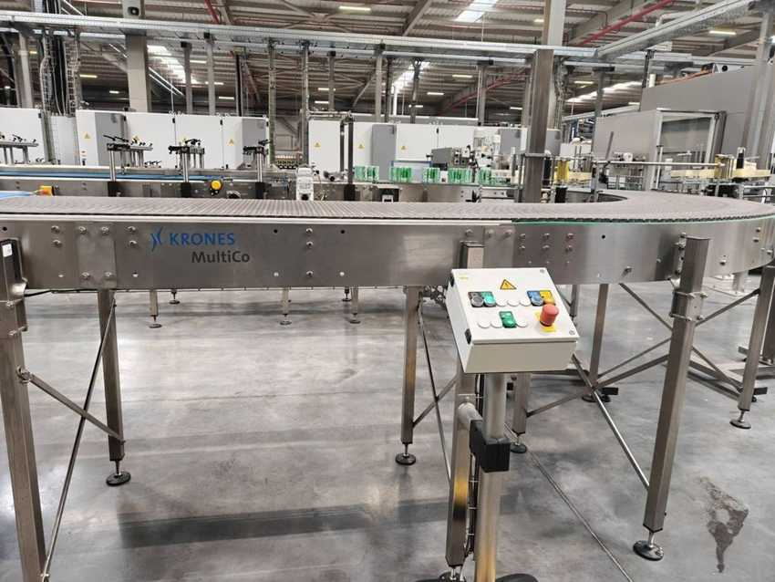
MultiCo S (KR673WW) with Sprite packs, Robobox T-GS behind |  | MultiCo S with local operator panel
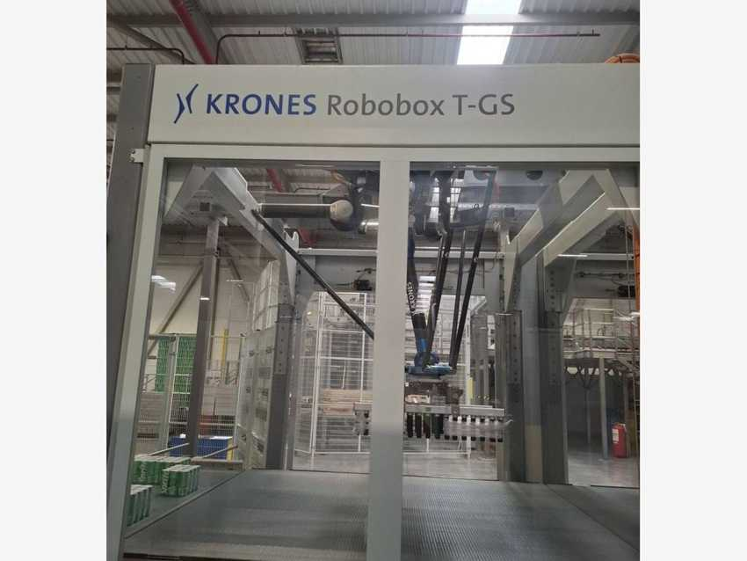 |  | 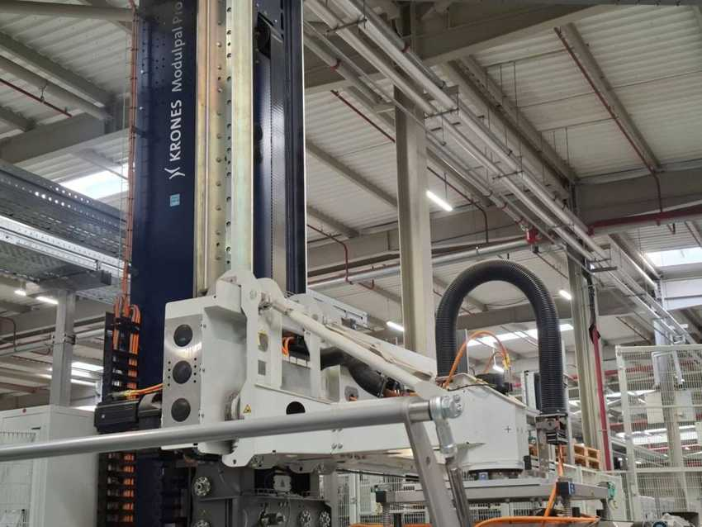
Robobox T-GS layer forming robot |  | Modulpal Pro 2A palletiser (KR63R72)
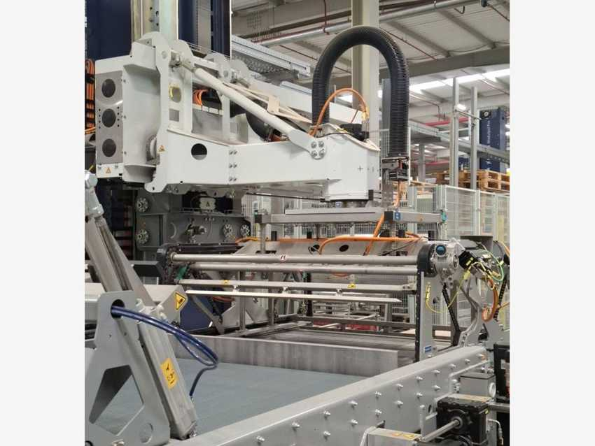 |  | 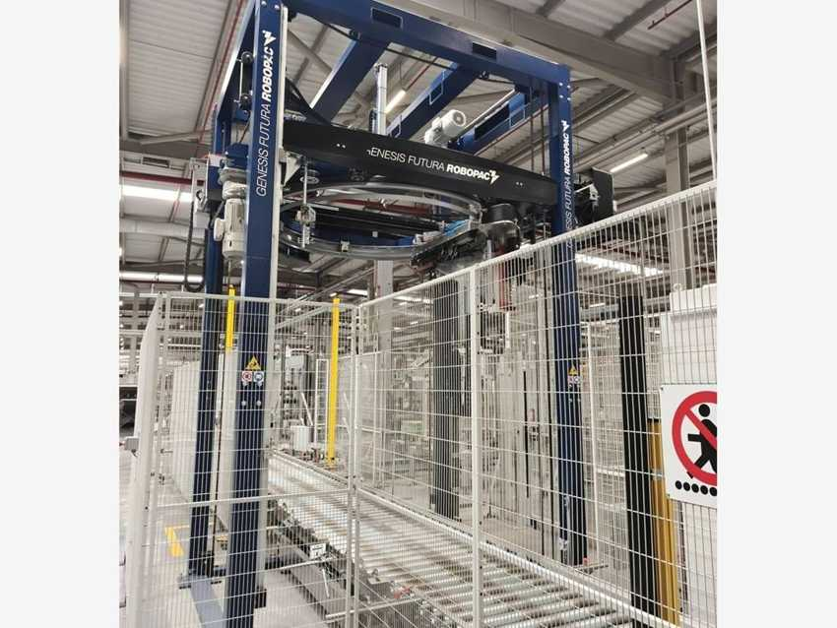
Modulpal Pro – layer gripper over forming table |  | Robopac Genesis Futura stretch wrapper (K82448I)
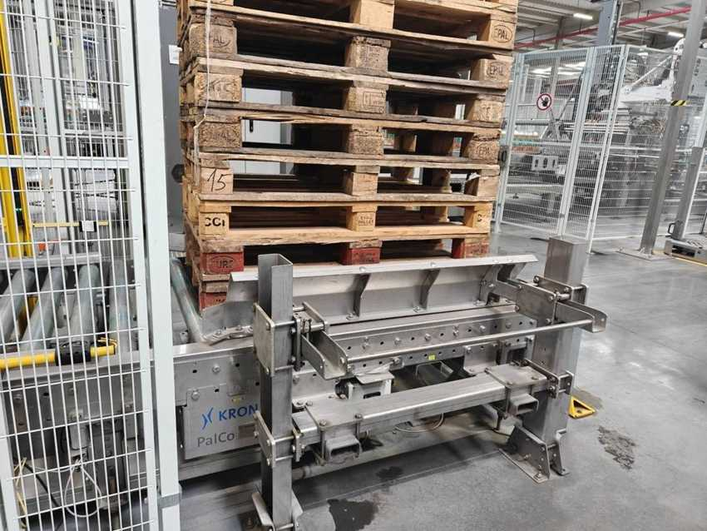
Palco S pallet conveyor 2 – empty pallet magazine (KR571D8)

6.10 Line power distribution and SFM packages

Line power distribution cabinets K919IXU / K919IXV
Manufacturer | Krones AG, Neutraubling (cabinet KlöMö) | Order no. / system no. | 7035397 / C372677
Nominal voltage / frequency | 400 V / 50 Hz, TN-S | Nominal busbar current | 630 A
Rated peak withstand current Ipk | 70 kA | Short-time current Icw | 33 kA
Arc-flash label (IEEE 1584-2018) | 66 kA; 4.293 cal/cm² @ 609.6 mm; boundary 1,354 mm | PPE category | 2 (both cabinets)

Nameplate data photographed on K919IXV; K919IXU carries the same arc-flash label values.
KRONES NO. | DESCRIPTION | MFG. DATE | SERIAL NO. | INST. POWER kW | SAP NO. | ASSET NO.
K8206CV | SFM labelling technology | – | – | – | – | –
K8212IU | SFM filling / process technology | – | – | – | – | –
K8252QQ | SFM transport technology | – | – | – | – | –

Photos
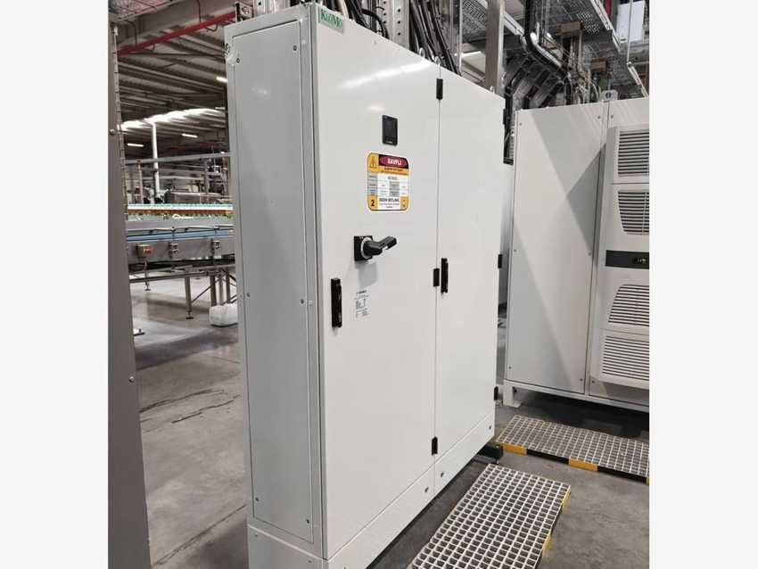
Line power distribution cabinet K919IXV

6.11 Coding, conveyor lubrication and UPS

Machine data
MACHINE | KRONES NO. | TYPE | MFG. DATE | SERIAL NO. | INST. POWER kW | SAP NO. | ASSET NO.
Container code / dating unit | — | Videojet 1610 DH | 2024 | 23338005C18ZH | – | 1000002338 | 223000000082
Conveyor lubrication (dosing unit) | — | Loehrke Loewados BSA I | – | – | – | – | 223000000083
Uninterruptible power supply | — | UPS cabinet (Rittal cooling unit) | 2024 | 2023K000023166 | – | – | 223000000091

The Videojet 1610 DH inkjet coder prints the date / batch code on the cans. The Loehrke Loewados BSA I unit doses the conveyor lubricant from a drum next to the Modulfill can filler. The line UPS sits in a separate cabinet with a Rittal cooling unit (the master data lists the cooler part no. SK 3304540 as UPS model).
SAP master data lists the conveyor lubrication as Diversey; the unit on site is a Loehrke Loewados BSA I – to verify.

Photos
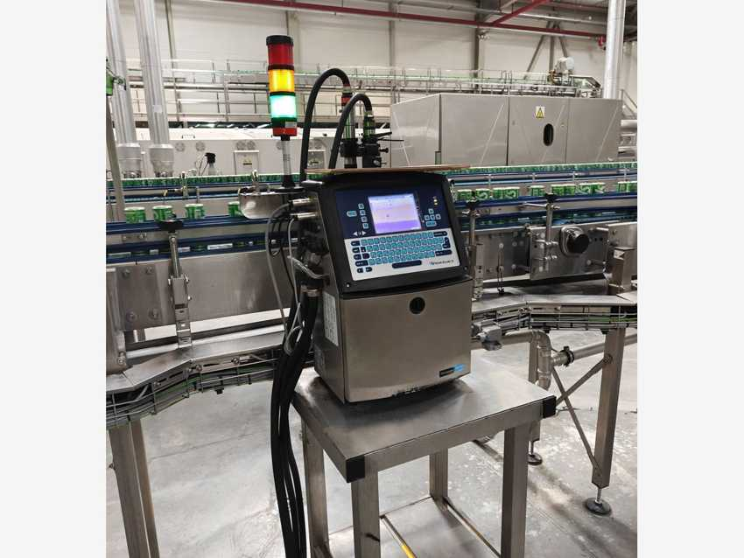 |  | 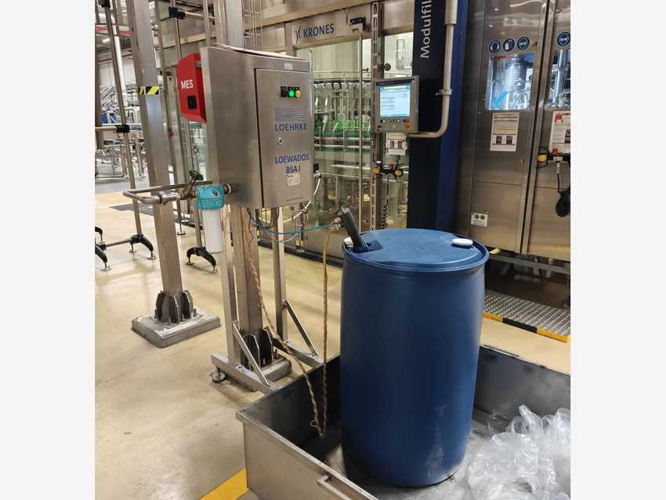
Videojet 1610 DH inkjet coder on the can conveyor |  | Loehrke Loewados BSA I – conveyor lubrication dosing unit
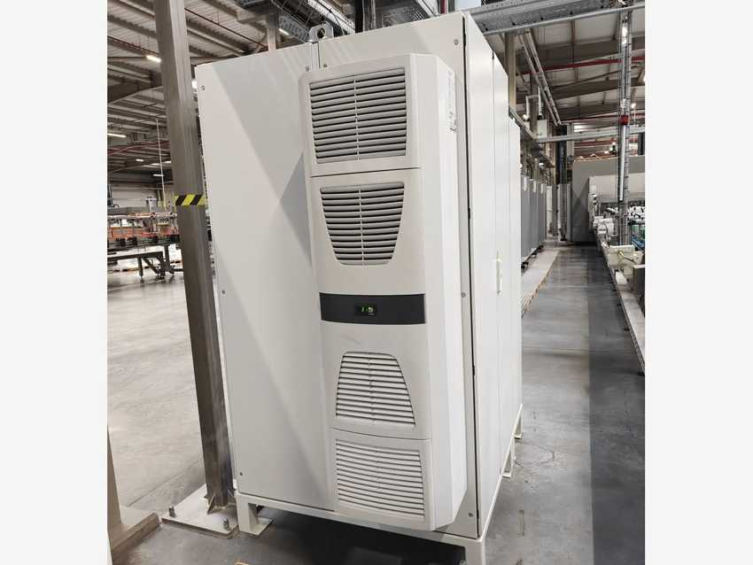
UPS cabinet with Rittal cooling unit

7 Line-4 RGB

7.1 Line data and equipment register
Manufacturer | Hefei Zhongchen – China (main supplier) | Line | Returnable glass bottle (RGB) line
Functional location | SMR Line-04 / RGB | Cost centre | 7105086018
Customer | Coca Cola Ichimligi Uzbekistan Ltd | Year of manufacture (YOM) | 2024 – 2025 (start-up 2026)
Other suppliers | HEUFT, KUKA, Omnia, Novexx, UBS, Videojet | Package types | RGB 250 ml (Coca-Cola, Fanta)
Rated capacity | 48,000 bph (bottle washer and conveyor plates) | Container | Returnable glass bottle in plastic crates

Line process flow
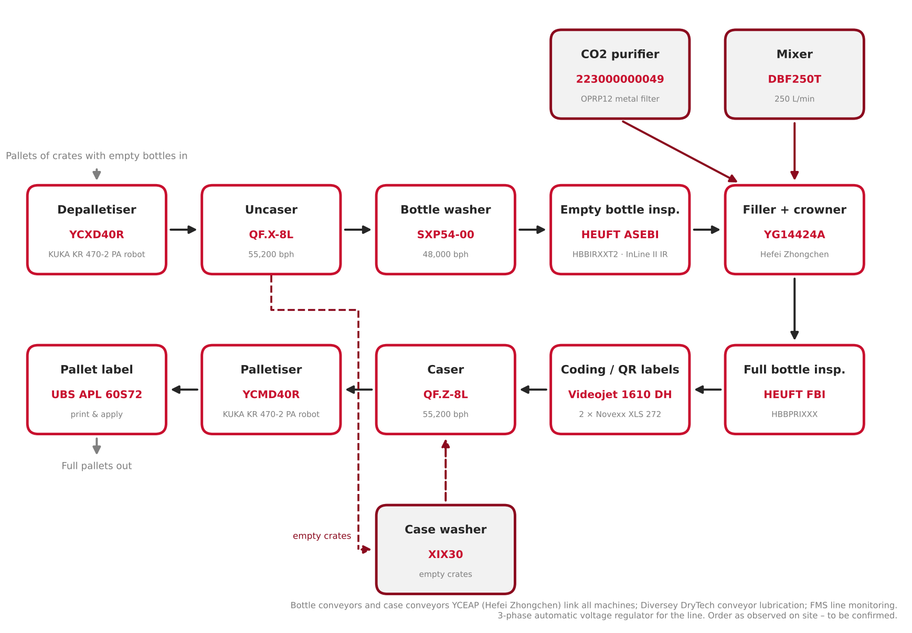
Figure 7.1 – Line-4 RGB process flow, from depalletising to pallet exit (order as observed on site – to be confirmed)

Equipment register
No. | MACHINE / DESCRIPTION | MAKER | MODEL | SERIAL NO. | YOM | ASSET NO.
1 | Filler with crowner – 7.8 | Hefei Zhongchen | YG14424A | 01.01.01.144002 | 2025.03 | 223000000139
2 | Mixer – 7.7 | Hefei Zhongchen | DBF250T | 01.01.03.250014 | 2024.08 | 223000000140
3 | Bottle washer – 7.5 | Hefei Zhongchen | SXP54-00 | 01.01.02.005401 | 2025.02 | 223000000141
4 | Case washer – 7.4 | Hefei Zhongchen | XIX30 | 01.01.08.030002 | 2024.08 | 223000000142
5 | Caser – 7.3 | Hefei Zhongchen | QF.Z-8L | 00423 | 2025.03 | 223000000143
6 | Uncaser – 7.3 | Hefei Zhongchen | QF.X-8L | 00422 | 2025.03 | 223000000144
7 | Palletizer – 7.2 | Hefei Zhongchen | YCMD40R | 202404577 | 2025.05 | –
8 | Depalletizer – 7.2 | Hefei Zhongchen | YCXD40R | 202404577 | 2025.05 | –
9 | ROBOT KUKA (Depalletizer) – 7.2 | KUKA | KR 470 2 PA / FLR | 8173457 | 2024-12 | 223000000145
10 | ROBOT KUKA (Palletizer) – 7.2 | KUKA | KR 470 2 PA / FLR | 8173458 | 2024-12 | 223000000146
11 | FBI (Full bottle inspector) – 7.6 | HEUFT | HBBPRIXXX | 24G103524 | 2024 | 223000000148
12 | FMS (Filling management system) – 7.10 | Hefei Zhongchen | – | – | – | –
13 | Case conveyors – 7.10 | Hefei Zhongchen | YCEAP | 251480 | 2025-05 | 223000000149
14 | Bottle conveyors – 7.10 | Hefei Zhongchen | – | – | – | 223000000150
15 | QR code applier (2 units) – 7.9 | Novexx Solutions GmbH | XLS 272 | 1174092 | 2024 | –
16 | Pallet label print & apply (UBS) – 7.9 | United Barcode Systems | APL 60S72, Zebra, RH | 003967 | 2025 | –
17 | Date coder – 7.9 | Videojet Technologies Inc. | 1610 DH | 25224006C18ZH | – | –
18 | ASEBI (empty bottle inspector) – 7.6 | HEUFT | HBBIRXXT2 | 24G103523 | 2024 | 223000000147
19 | Syrup room equipment (not photographed) | Omnia Technologies S.P.A. | – | – | – | –
20 | CO2 purifier (RGB line) – 7.7 | – | – | – | 2025.11 | 223000000049
21 | 3-phase automatic voltage regulator – 7.11 | – | – | – | 2026.08 | 223000000138
22 | Conveyor lubrication – 7.10 | Diversey | DryTech 4 (VL83) | – | – | –

Source: CCI Samarkand equipment master data and SAP fixed-asset register (plant 1802), corrected from nameplates (caser QF.Z-8L). Items 20–22 are not in the master data (SAP register or site only). For items 20–21 the year is the SAP capitalisation date. Palletizer and depalletizer have no asset number and share serial 202404577 – to verify.

7.2 Depalletiser and palletiser – KUKA robot cells

Machine data
MACHINE | MAKER | TYPE / MODEL | MFG. DATE | SERIAL NO. | INST. POWER kW | SAP NO. | ASSET NO.
Depalletiser | Hefei Zhongchen | YCXD40R | 2025.05 | 202404577 | – | – | –
Palletiser | Hefei Zhongchen | YCMD40R | 2025.05 | 202404577 | 45 | – | –
Robot (depalletiser) | KUKA | KR 470-2 PA / FLR | 2024-12 | 8173457 | – | – | 223000000145
Robot (palletiser) | KUKA | KR 470-2 PA / FLR | 2024-12 | 8173458 | – | – | 223000000146

Electrical data (nameplates)
PARAMETER | YCMD40R PALLETISER | KUKA KR C4 CONTROLLERS (2)
Rated voltage | AC 400 V | 3 × 400 V
Frequency | 50 Hz | 50/60 Hz
Installed power / full-load current | 45 kW | 22 A
Mains fuse / Icc | – | 25 A / 25 kA
Capacity | 0–40 cases/min | –
Weight | 17 t | 140 kg
Dimensions L × W × H | 15,500 × 14,500 × 4,500 mm | –
P/N / article no. | 202404577 | 11080735
Serial no. / date | 2025.05 | 3321743 and 3321173 / 2024-12

Pallets of crates with empty bottles are unloaded layer by layer by a KUKA KR 470-2 PA robot (depalletiser YCXD40R) and placed on the crate conveyor to the uncaser. At the end of the line a second KUKA robot builds the full pallets (palletiser YCMD40R). Each fenced robot cell has its own Hefei Zhongchen control cabinet with operator panel, a KUKA KR C4 robot controller and a Rittal SK 1194.364 cabinet cooling unit (S/N 2024SH000002565; 220 V, 2.7 A, 0.45 kW).
Only the palletiser (YCMD40R) plate was photographed; the depalletiser plate is still to be read. Which robot cell is shown in each photo is to be confirmed.

Photos
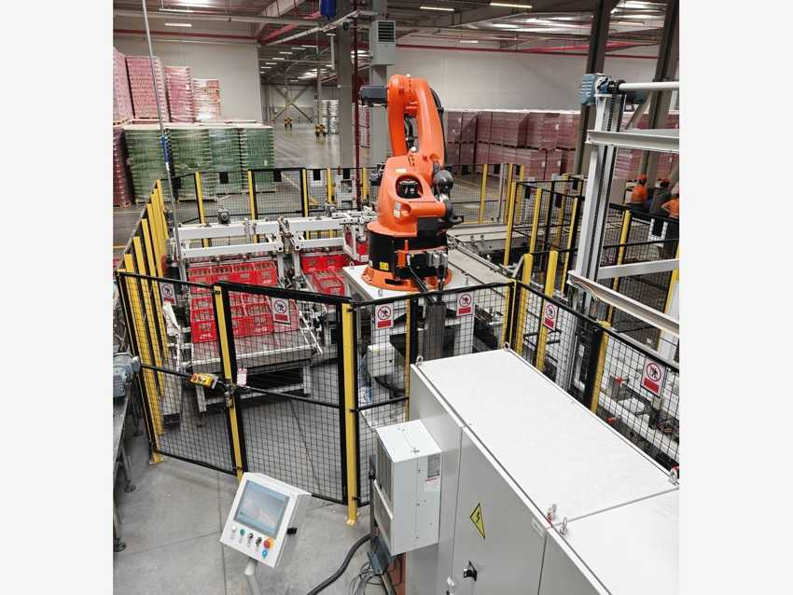 |  | 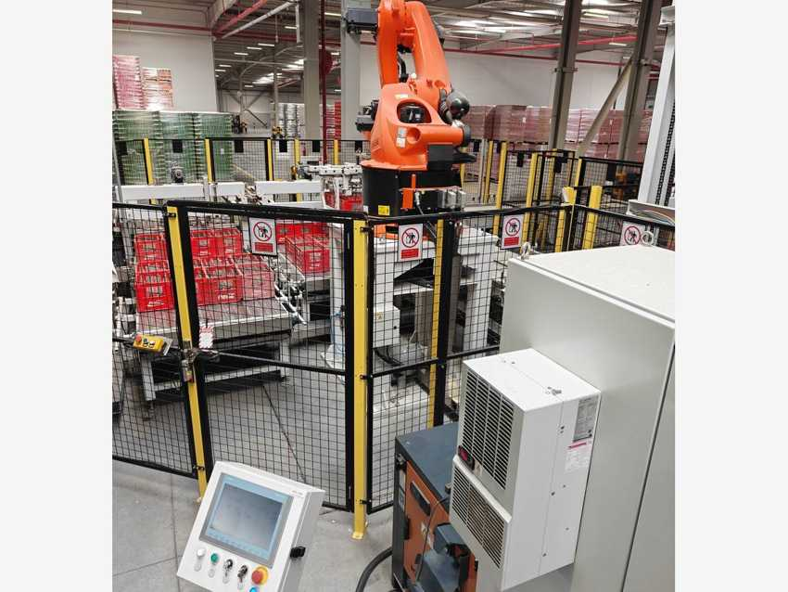
KUKA robot cell with crate pallet station |  | KUKA KR 470 robot and cell control cabinet
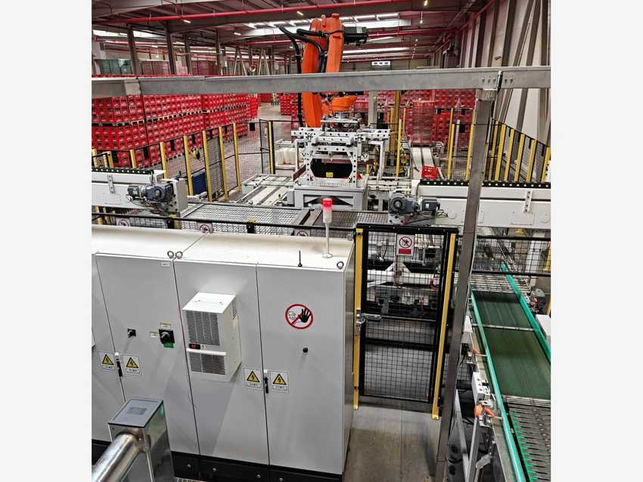 |  | 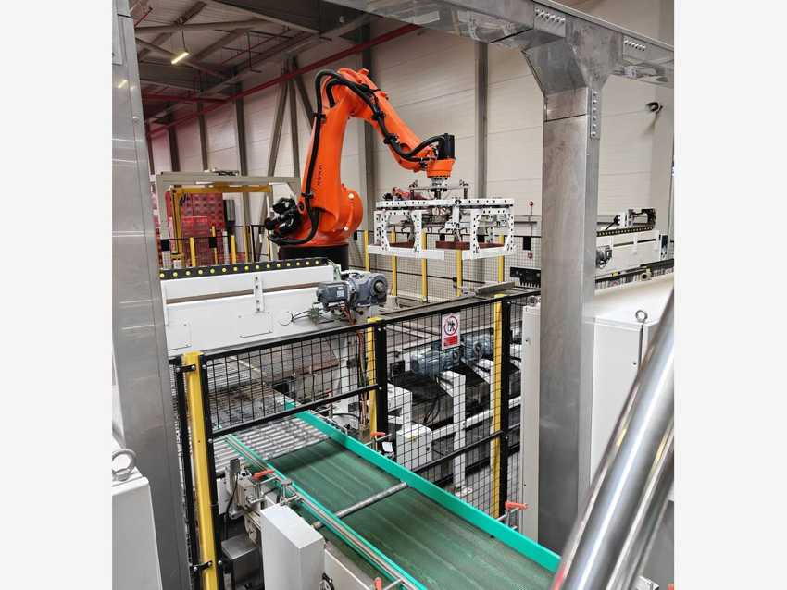
Robot cell control cabinet next to the crate conveyor |  | KUKA robot with crate gripper over the crate conveyor

7.3 Uncaser and caser – QF.X-8L / QF.Z-8L

Machine data
MACHINE | MAKER | TYPE / MODEL | MFG. DATE | SERIAL NO. | INST. POWER kW | SAP NO. | ASSET NO.
Uncaser | Hefei Zhongchen | QF.X-8L | 2025.03 | 00422 | 13 | – | 223000000144
Caser (“Crater”) | Hefei Zhongchen | QF.Z-8L | 2025.03 | 00423 | 13 | – | 223000000143

Electrical data (nameplates)
PARAMETER | QF.X-8L UNCASER | QF.Z-8L CASER
Rated voltage / frequency | 400 V, 50 Hz | 400 V, 50 Hz
Installed power | 13 kW | 13 kW
Capacity | 55,200 bph | 55,200 bph
Weight | 4.5 t | –
Dimensions L × W × H | 4,050 × 2,830 × 3,050 mm | … × 3,490 mm (partly unreadable)
Ex-works no. | EX NO. 000422 | EX NO. 000423

The uncaser lifts the empty bottles out of the crates with gripper heads and places them on the bottle conveyor to the bottle washer; the empty crates go to the case washer. After filling, the caser puts the full bottles back into the washed crates. Both machines have the same frame with glass guard doors, a light tower and an operator panel.
The master data writes the caser model as “QF 7-8L”; the nameplate reads QF.Z-8L.

Photos
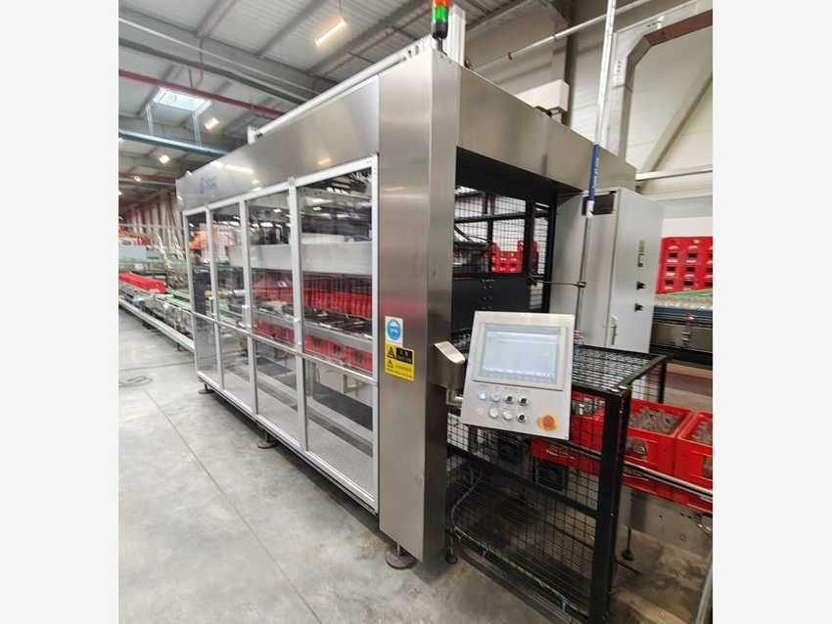 |  | 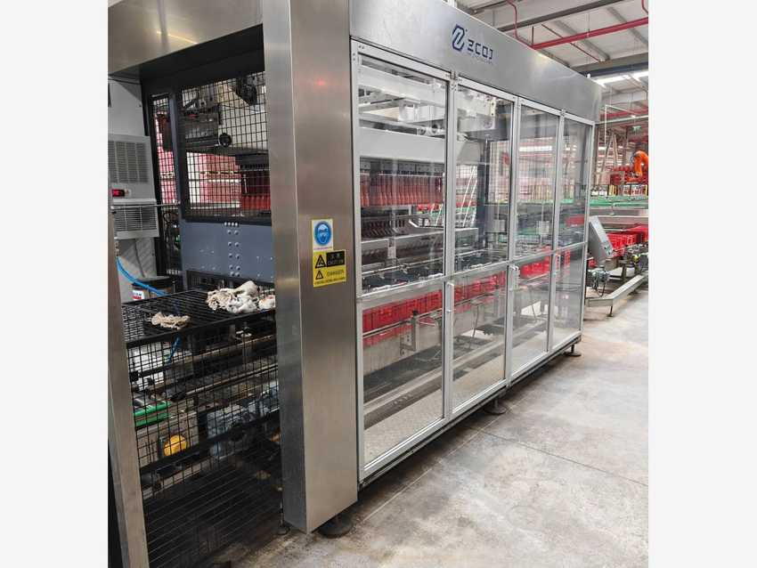
QF.X-8L uncaser with operator panel |  | QF.Z-8L caser – guarded frame

7.4 Case washer – XIX30

Machine data
MACHINE | MAKER | TYPE / MODEL | MFG. DATE | SERIAL NO. | INST. POWER kW | SAP NO. | ASSET NO.
Case (crate) washer | Hefei Zhongchen | XIX30 | 2024.08 | 01.01.08.030002 | – | – | 223000000142

Empty crates from the uncaser run on the incline conveyor into the washing tunnel, where spray headers fed with soft water and recovered water from the bottle washer clean them inside and out. The clean crates go on to the caser. Data from the master data; the nameplate was not photographed.

Photos
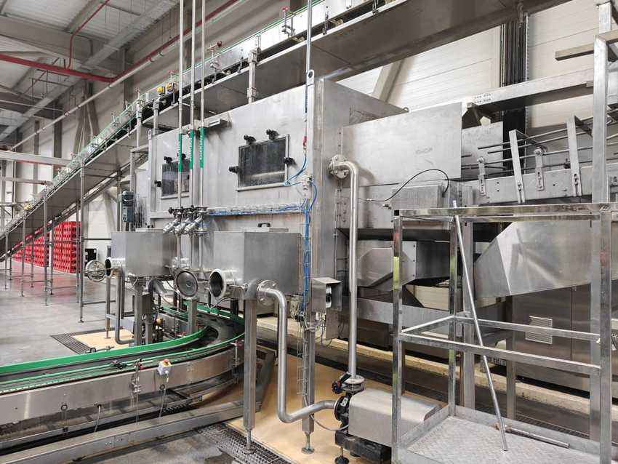 |  | 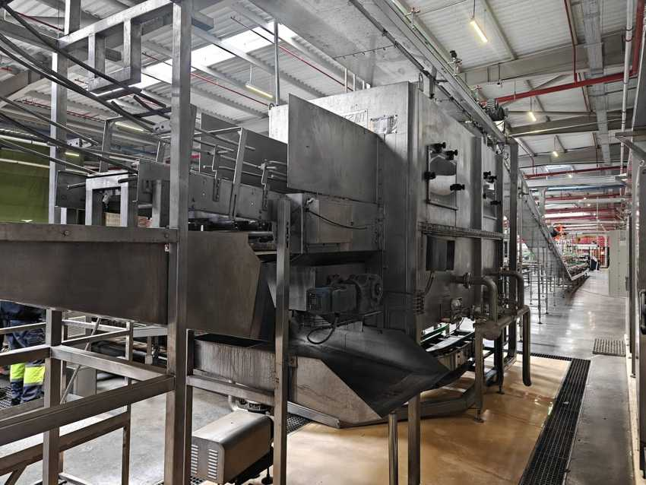
Case washer – side with soft-water spray headers |  | Case washer – crate infeed and drive

7.5 Bottle washer – SXP54-00

Machine data
MACHINE | MAKER | TYPE / MODEL | MFG. DATE | SERIAL NO. | INST. POWER kW | SAP NO. | ASSET NO.
Bottle washer | Hefei Zhongchen | SXP54-00 | 2025.02 | 01.01.02.005401 | – | – | 223000000141

Electrical data (nameplate)
PARAMETER | SXP54-00 BOTTLE WASHER
Rated voltage | AC 3 × 400 V
Frequency | 50 Hz
Installed power | 1_2 kW, without ultrasonic (middle digit not readable)
Capacity | 48,000 bottles/h
Weight | 155 t
Dimensions L × W × H | 19,700 × 10,200 × 6,340 mm
P/N | 01.01.02.005401

SXP series ultra-high-speed double-end bottle washer. Bottles go through a pre-soak, four caustic compartments (about 55–80 °C) with four label-removal stations, a hot-water compartment, the 1st, 2nd and 3rd circulation-water zones and a final soft-water rinse. Waste water is sent to the crate washer.

Photos
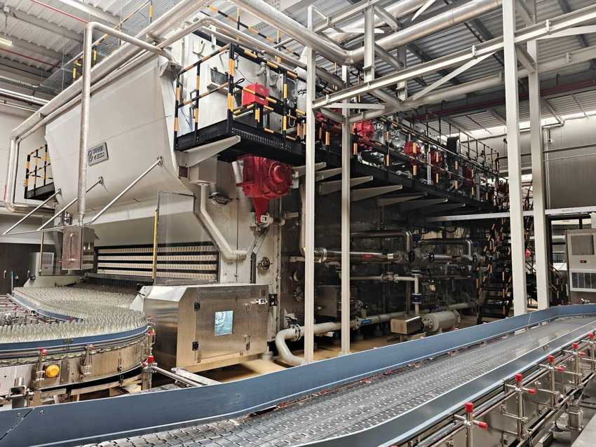 |  | 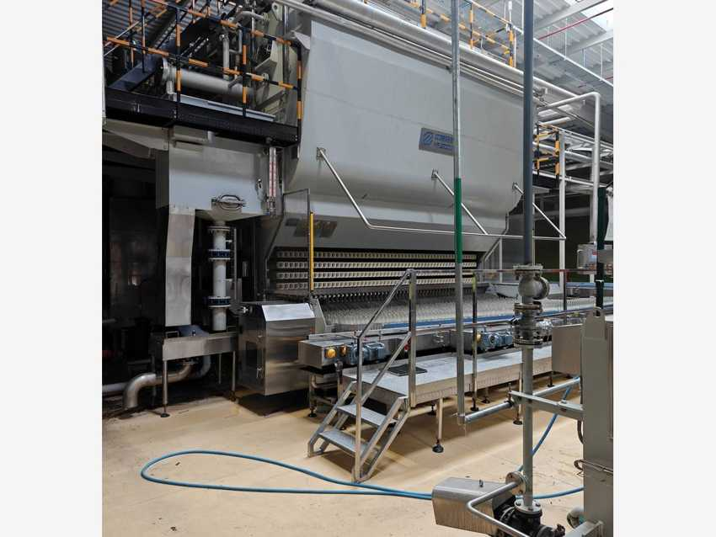
SXP54-00 bottle washer – bottle discharge and conveyors |  | Bottle washer – discharge side
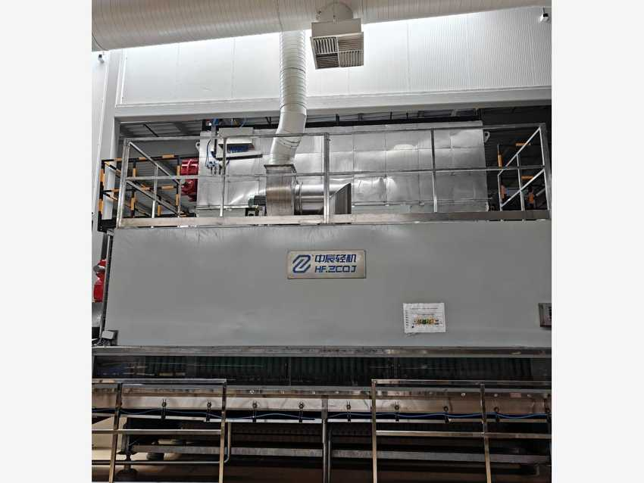
Bottle washer – front with Hefei Zhongchen logo

7.6 Bottle inspection – HEUFT ASEBI and FBI

Machine data
MACHINE | MAKER | TYPE / MODEL | MFG. DATE | SERIAL NO. | INST. POWER kW | SAP NO. | ASSET NO.
Empty bottle inspector (ASEBI) | HEUFT | HBBIRXXT2 (InLine II IR) | 2024 | 24G103523 | – | – | 223000000147
Full bottle inspector (FBI) | HEUFT | HBBPRIXXX | 2024 | 24G103524 | – | – | 223000000148

The HEUFT InLine II IR empty bottle inspector checks every washed bottle before the filler and rejects dirty or damaged bottles. After filling and crowning, the HEUFT full bottle inspector checks the bottles on the conveyor and rejects faulty ones. Both are made by HEUFT Systemtechnik GmbH (Germany).

Photos
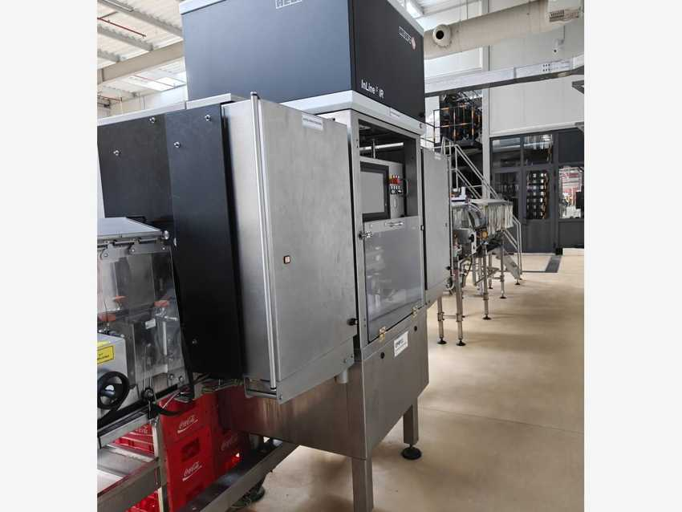 |  | 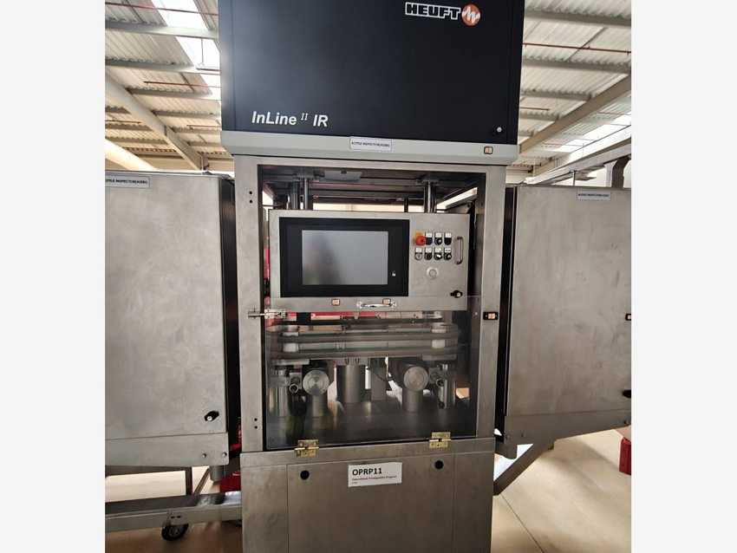
HEUFT InLine II IR empty bottle inspector |  | ASEBI – operator panel and inspection head
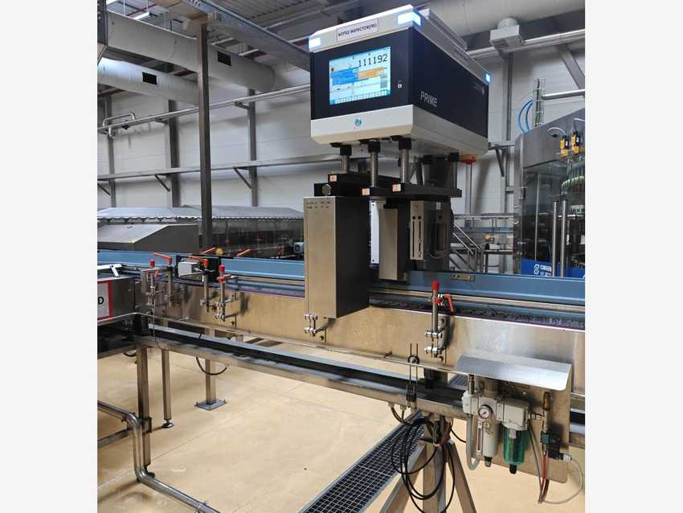
HEUFT full bottle inspector on the bottle conveyor

7.7 Mixer DBF250T and CO2 purifier

Machine data
MACHINE | MAKER | TYPE / MODEL | MFG. DATE | SERIAL NO. | INST. POWER kW | SAP NO. | ASSET NO.
Mixer | Hefei Zhongchen | DBF250T | 2024.08 | 01.01.03.250014 | 31.5 | – | 223000000140
CO2 purifier (RGB line) | – | – | 2025.11 | – | – | – | 223000000049

Electrical data (nameplate DBF250T)
PARAMETER | DBF250T MIXER
Rated voltage / frequency | AC 415 V / 50 Hz
Installed power | 31.5 kW
Capacity | 250 L/min
Weight | ≈ 3,500 kg
Dimensions L × W × H | 5,000 × 3,000 × 3,100 mm

The DBF250T mixer de-aerates the water, mixes it with syrup in the set ratio and carbonates the beverage before it goes to the filler. The CO2 skid next to it has two sanitary filter housings with pressure gauges, a pump, valves and an SMC refrigerated dryer (label IDFA11E-23-…, plate not readable), plus the OPRP12 control point “Metal filter (100 mesh)”.
CO2 purifier data from the SAP asset register only (not in the master data); year = capitalisation date. OPRP12 is usually the product filter – confirm the skid title on site.

Photos
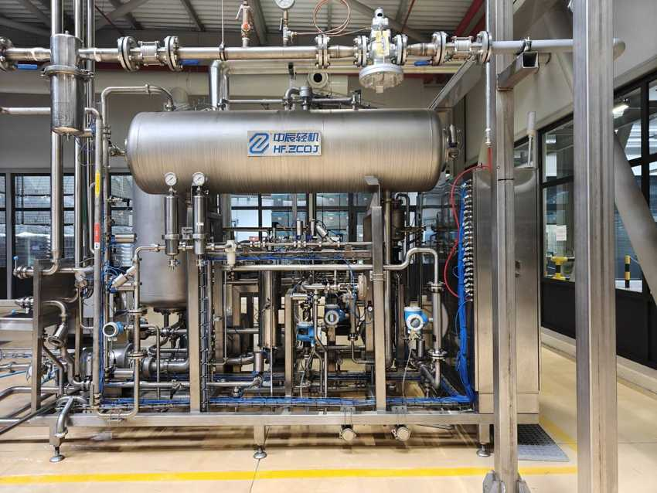 |  | 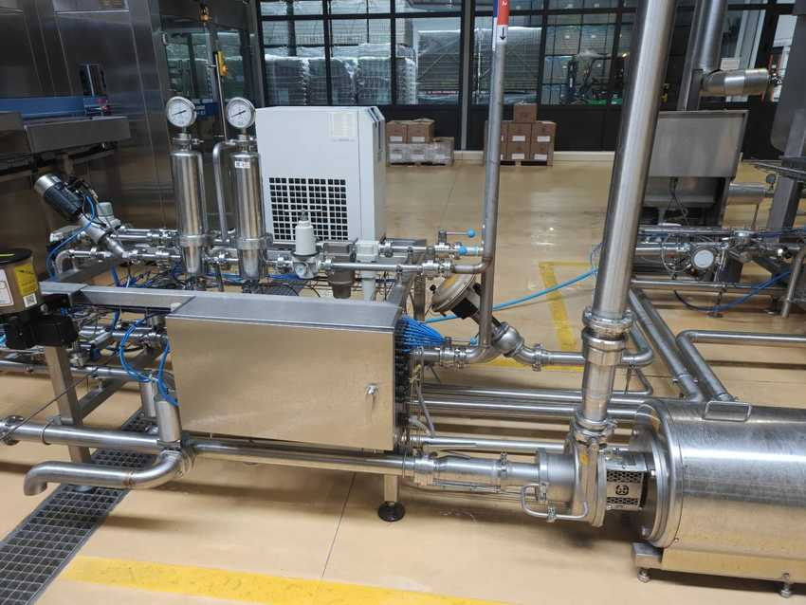
DBF250T mixer – carbonation tank and pipework |  | CO2 skid – filter housings and pump
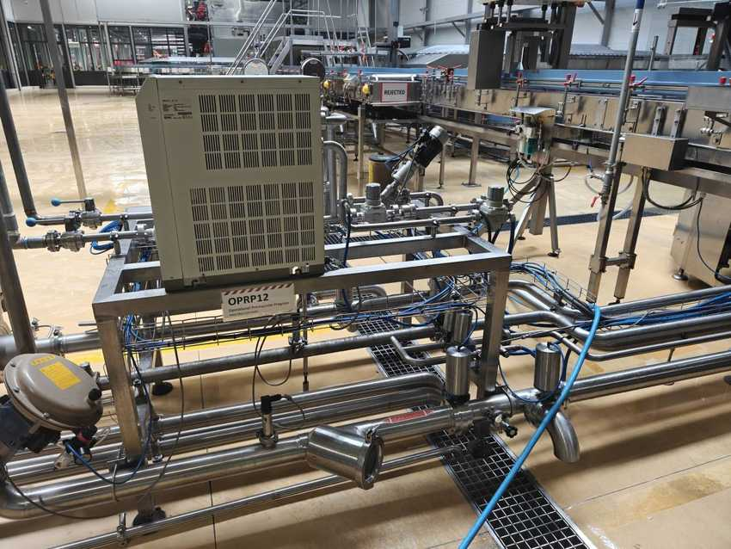
CO2 skid – SMC unit and OPRP12 metal filter

7.8 Filler with crowner – YG14424A

Machine data
MACHINE | MAKER | TYPE / MODEL | MFG. DATE | SERIAL NO. | INST. POWER kW | SAP NO. | ASSET NO.
Filler with crowner | Hefei Zhongchen | YG14424A | 2025.03 | 01.01.01.144002 | – | – | 223000000139

Rotary filler with integrated crowner. The washed and inspected bottles are filled with the carbonated beverage from the mixer and closed with crown corks in the same block. Guard doors, operator stations and the Hefei Zhongchen (HF.ZCQJ) logo bands are visible around the bloc.
Nameplate not photographed. Model labelled on site as EG14424A; the master data says YG14424A – confirm on the plate.

Photos
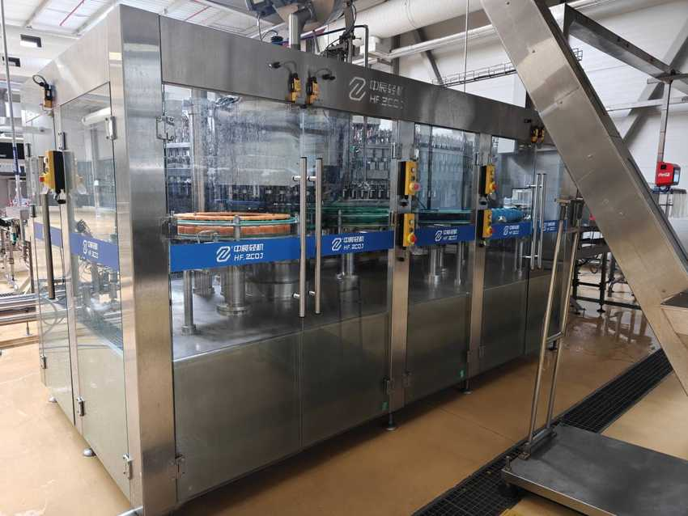 |  | 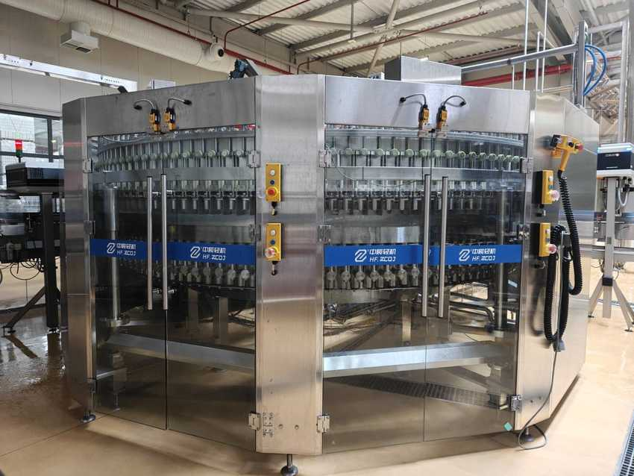
Filler and crowner bloc – guarded front |  | Filler carousel with filling valves

7.9 Coding and labelling – Videojet, Novexx and UBS

Machine data
MACHINE | MAKER | TYPE / MODEL | MFG. DATE | SERIAL NO. | INST. POWER kW | SAP NO. | ASSET NO.
Date coder | Videojet | 1610 DH | – | 25224006C18ZH | – | – | –
QR code applier (2 units) | Novexx Solutions | XLS 272 | 2024 | 1174092 (unit 1) | – | – | –
Pallet label print & apply | United Barcode Systems | APL 60S72, Zebra, RH | 2025 | 003967 | – | – | –

Electrical data (nameplate UBS APL 60S72)
PARAMETER | UBS APL 60S72
Power supply | 100 VAC / 5.6 A or 240 VAC / 2.3 A
Frequency | 50/60 Hz
Compressed air | 6 bar, 120 l/min
Serial no. / year | 003967 / 2025
Manufacturer | United Barcode Systems, Vilassar de Mar (Spain)

The Videojet 1610 DH inkjet coder prints the date / batch code on the bottles. Two Novexx XLS 272 label applicators on the bottle conveyor apply the QR-code labels. At the end of the line the UBS APL 60S72 print-and-apply unit (Zebra printer, right-hand) prints a pallet label and applies it to the side of every wrapped pallet.
No asset numbers for these units in the master data; the second Novexx unit is not listed at all.

Photos
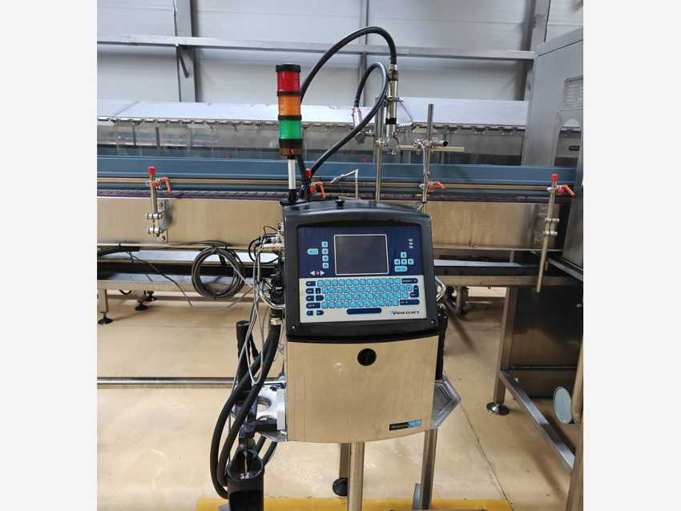 |  | 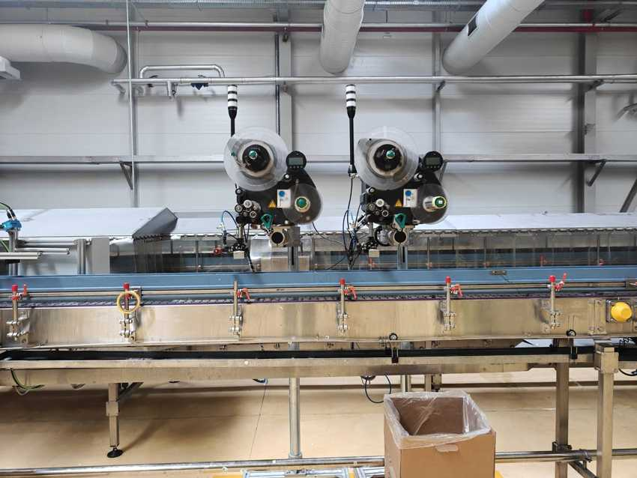
Videojet 1610 DH coder on the bottle conveyor |  | Two Novexx XLS 272 QR-code label applicators
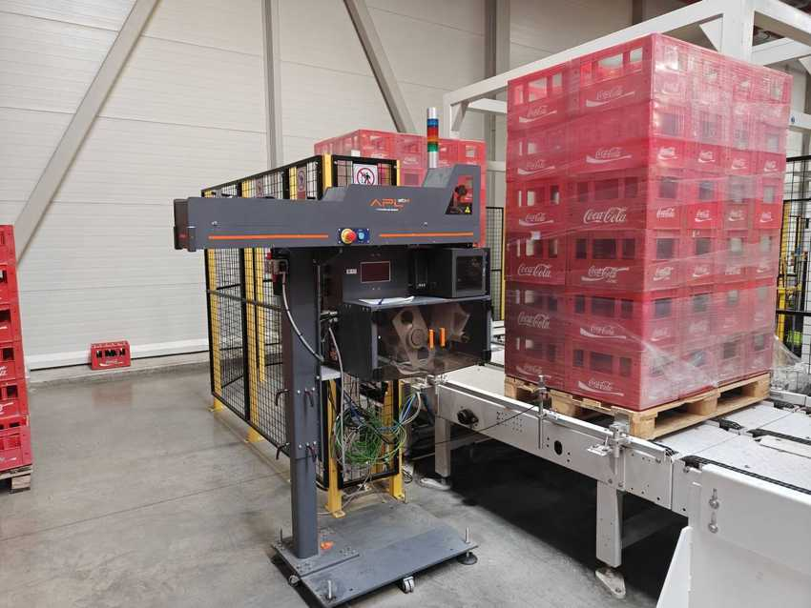
UBS APL 60S72 pallet label print & apply

7.10 Conveyors, lubrication and FMS

Machine data
MACHINE | MAKER | TYPE / MODEL | MFG. DATE | SERIAL NO. | INST. POWER kW | SAP NO. | ASSET NO.
Case conveyors | Hefei Zhongchen | YCEAP | 2025.05 | 251480 | 25 | – | 223000000149
Bottle conveyors | Hefei Zhongchen | – | – | – | – | – | 223000000150
Conveyor lubrication | Diversey | DryTech 4 (VL83) | – | – | – | – | –
FMS (filling management system) | Hefei Zhongchen | – | – | – | – | – | –

Electrical data (nameplate YCEAP conveyor line)
PARAMETER | YCEAP CONVEYOR LINE
Power source | 4.. V / 50 Hz (partly unreadable)
Type of current / system | AC 3/N/…
Power | 25 kW
Working speed | 48,000 (per hour)
Standard | GB/T 10595-2017
Serial no. / date | 251480 / 2025

Plastic-chain case conveyors with green guide rails carry the crates from the depalletiser through the uncaser, case washer and caser to the palletiser. Stainless slat-chain bottle conveyors with wide accumulation tables link the uncaser, bottle washer, inspectors, filler, coder, labellers and caser. Diversey DryTech 4 (VL83) dry lubricant is dosed from a 200 L drum through a stainless dosing cabinet. The FMS operator station (PC) collects production data for the line.
FMS: no model or serial in the master data; photo taken with the screen off.

Photos
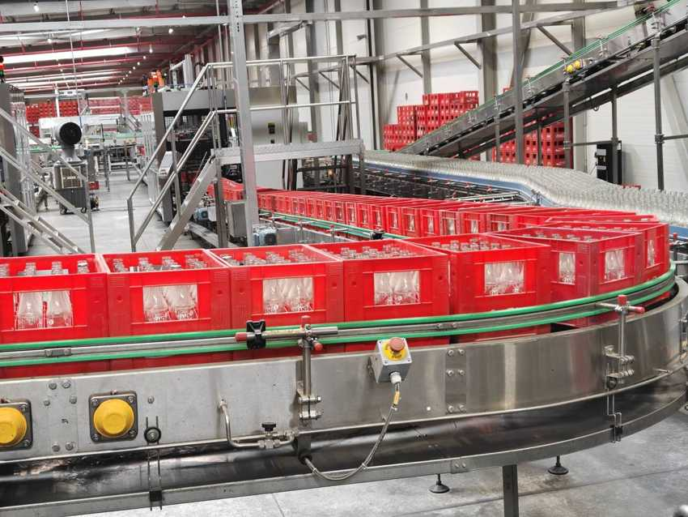 |  | 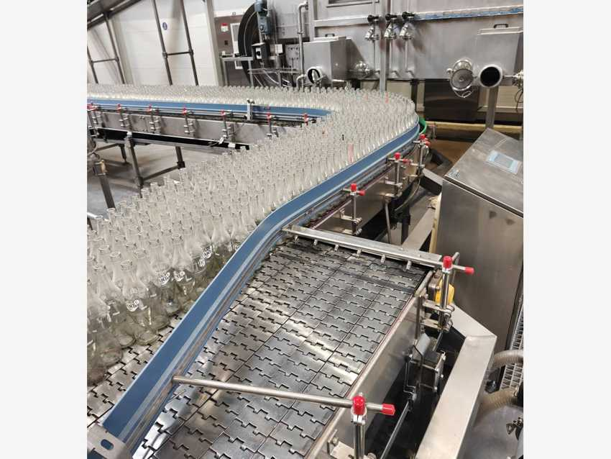
Case conveyor curve with Fanta crates |  | Bottle accumulation table with 250 ml Fanta bottles
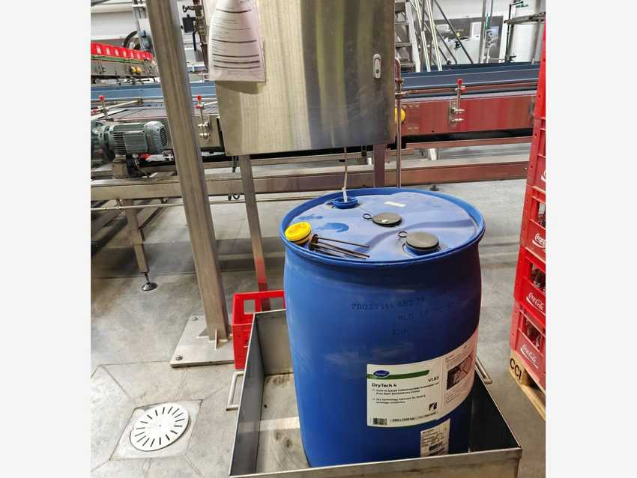 |  | 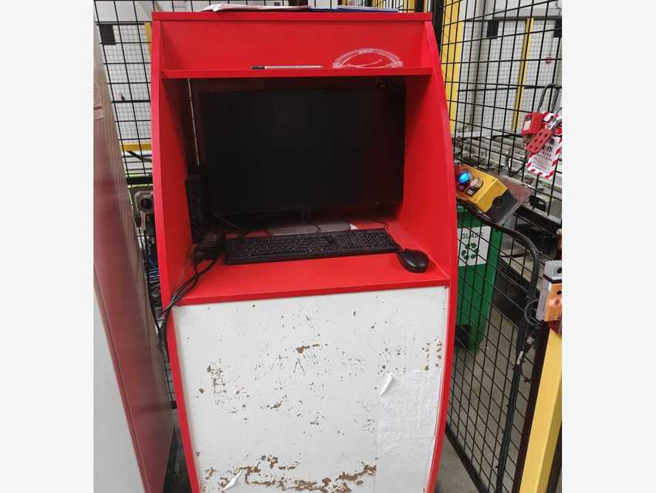
Diversey DryTech 4 dosing unit and drum |  | FMS operator station

7.11 Line power – 3-phase automatic voltage regulator

Machine data
MACHINE | MAKER | TYPE / MODEL | MFG. DATE | SERIAL NO. | INST. POWER kW | SAP NO. | ASSET NO.
3-phase automatic voltage regulator | – | – | 2026.08 | – | – | – | 223000000138

Cabinet cooling unit – Rittal SK 1194.420
PARAMETER | RITTAL SK 1194.420
Serial no. | 2024SH000008609
Rated voltage | 220 V / 50 Hz / 1~
Rated current / starting current | 4.0 A / 20.0 A
Rated power input | 0.65 kW (L35 L35)
Total cooling capacity | 1.20 kW (L35 L35)
Refrigerant | R134a, 325 g
Manufacturing date | 25.04.2024

The line has its own 3-phase automatic voltage regulator in a stainless three-door cabinet with a status beacon. The cabinet is cooled by a Rittal enclosure cooling unit (data below). The SAP register text links this asset to 223000000005 “Electric transformer 500 kW Sterostab” – the regulator’s own nameplate is still to be read (usually inside the middle door).
Year in the machine table is the SAP capitalisation date.

Photos
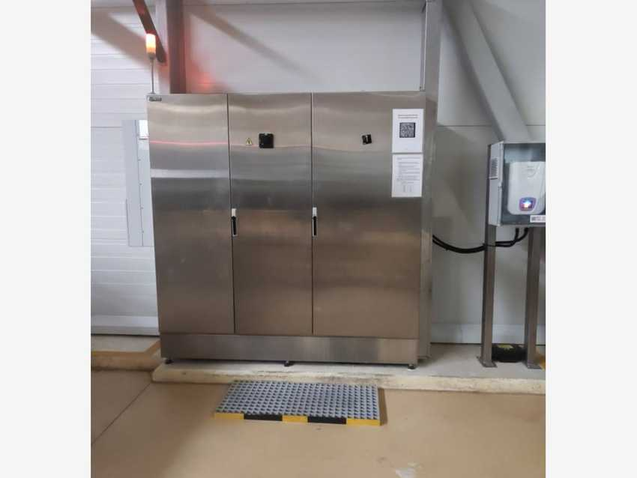
3-phase automatic voltage regulator cabinet

8 Utilities and Facilities

8.1 Steam boiler room
DESCRIPTION | OEM | MODEL / TYPE | SERIAL NO. | CAPACITY | POWER | YOM | EQUIP. NO. (PM) | ASSET NO.
Steam boiler | ERENSAN | ESB 850 | 90800916 | 8,500 kg/h | – | 2023 | 1000002420 | 223000000016

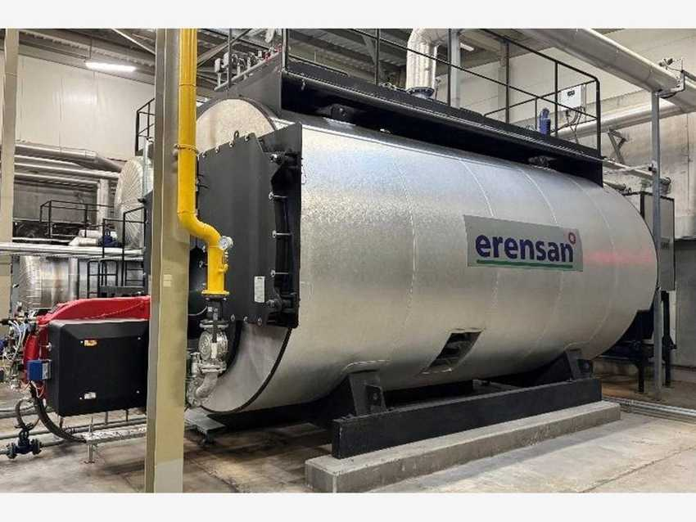 |  | 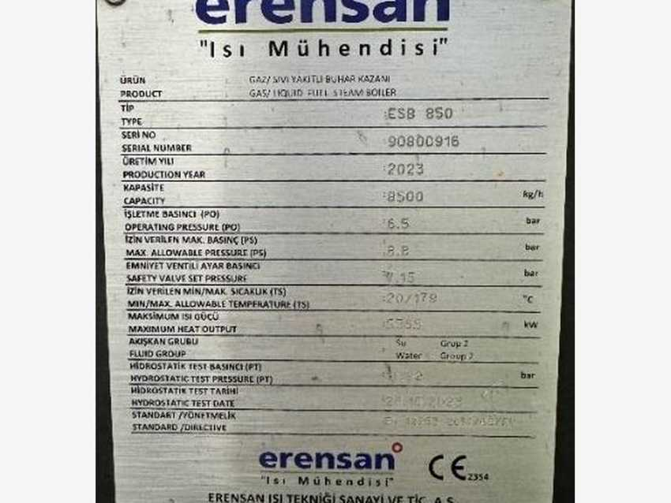
Steam boiler ERENSAN ESB 850 – photo 1 |  | Steam boiler ERENSAN ESB 850 – photo 2

8.2 Diesel generator equipment
DESCRIPTION | OEM | MODEL / TYPE | SERIAL NO. | CAPACITY | POWER | YOM | EQUIP. NO. (PM) | ASSET NO.
Oil reservoir 40 t (1) | Metal Installation | Diesel tank 40 m³ | – | 40 m³ | – | – | – | 223000000062
Oil reservoir 40 t (2) | Metal Installation | Diesel tank 40 m³ | – | 40 m³ | – | – | – | 223000000063
Oil reservoir 40 t (3) | Metal Installation | Diesel tank 40 m³ | – | 40 m³ | – | – | – | 223000000064
Diesel generator 1 | AKSA | APD 2250M ECO46-1L/4 | 27148 | 2,000 kW | – | 2023 | 1000002358 | 223000000008
Diesel generator 2 | AKSA | AC 825 ECO40-VL/4 | 25487692 | 750 (unit to confirm) | – | 2023 | 1000002414 | 223000000009

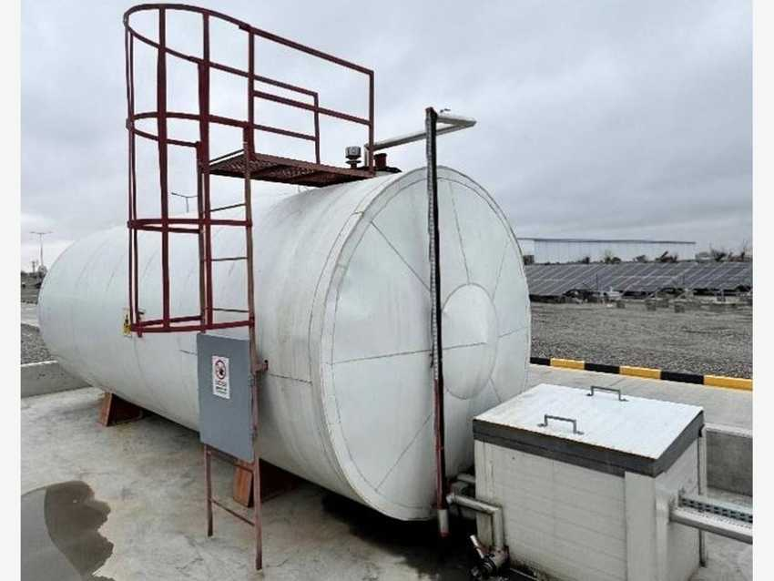 |  | 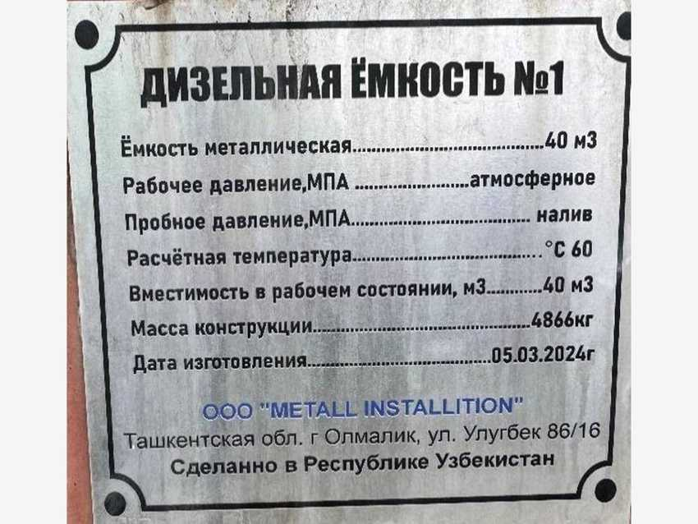
Diesel oil reservoir 40 t – photo 1 |  | Diesel oil reservoir 40 t – photo 2
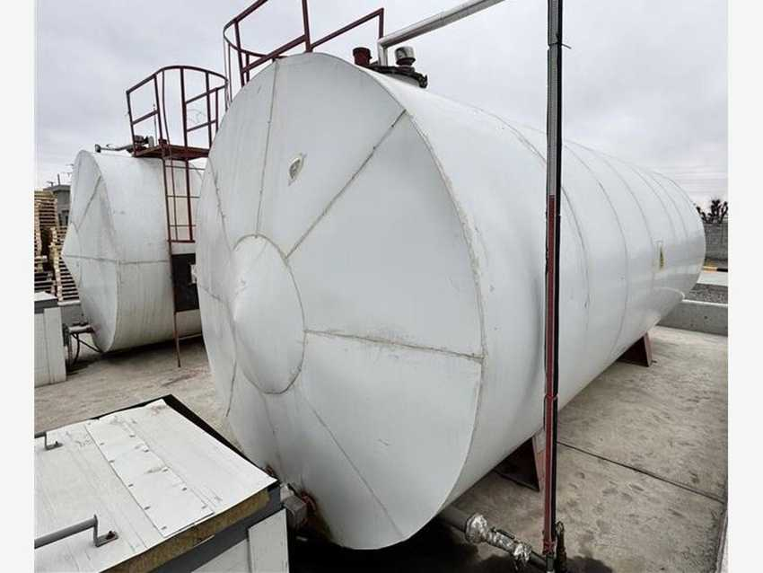 |  | 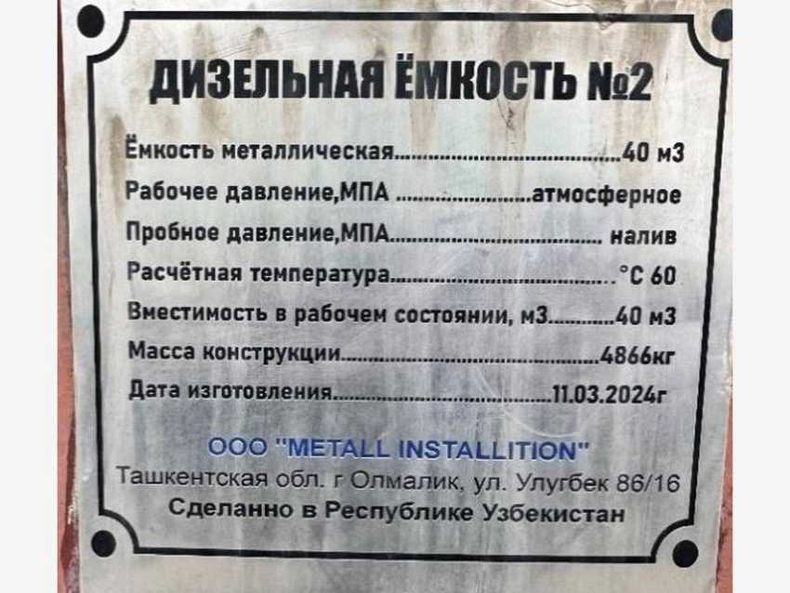
Diesel oil reservoir 40 t – photo 3 |  | Diesel oil reservoir 40 t – photo 4
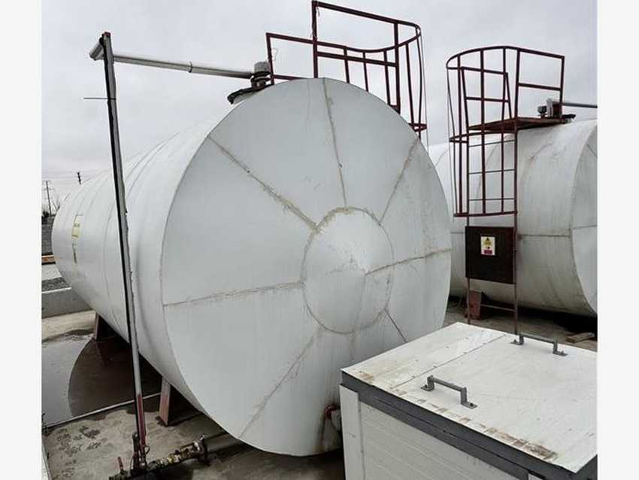 |  | 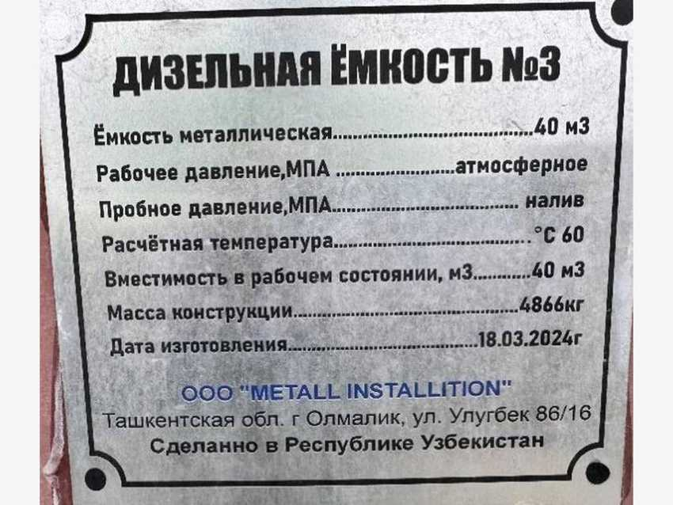
Diesel oil reservoir 40 t – photo 5 |  | Diesel oil reservoir 40 t – photo 6
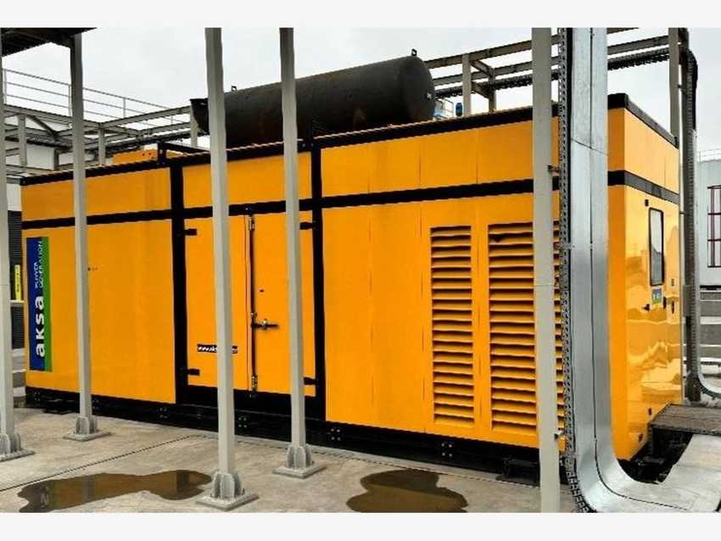 |  | 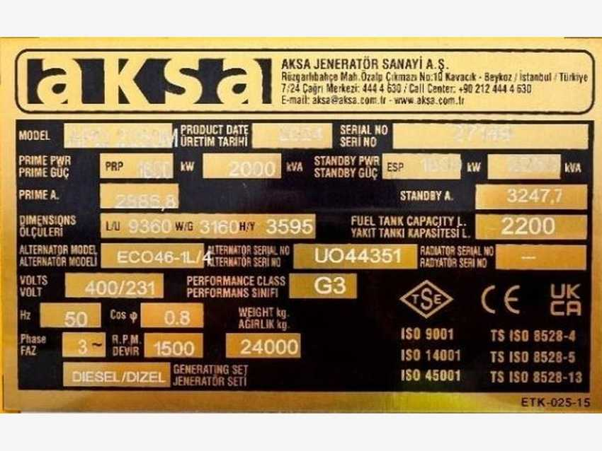
Diesel generator AKSA APD 2250M – photo 1 |  | Diesel generator AKSA APD 2250M – photo 2
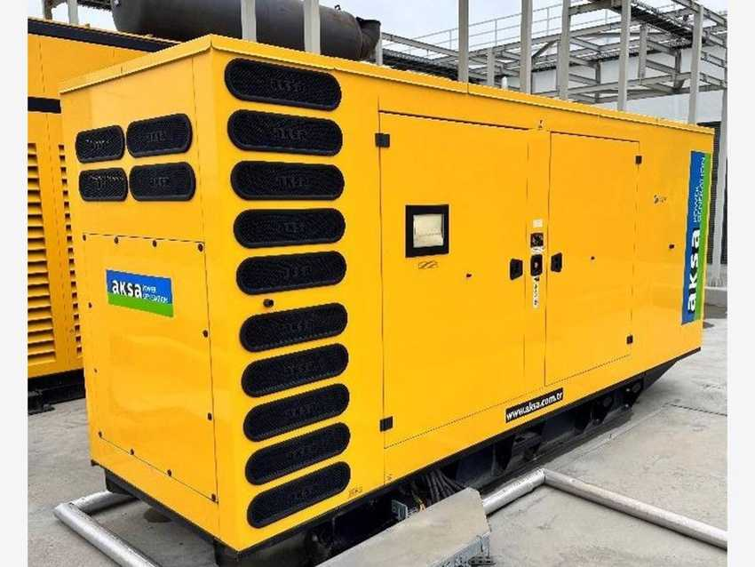 |  | 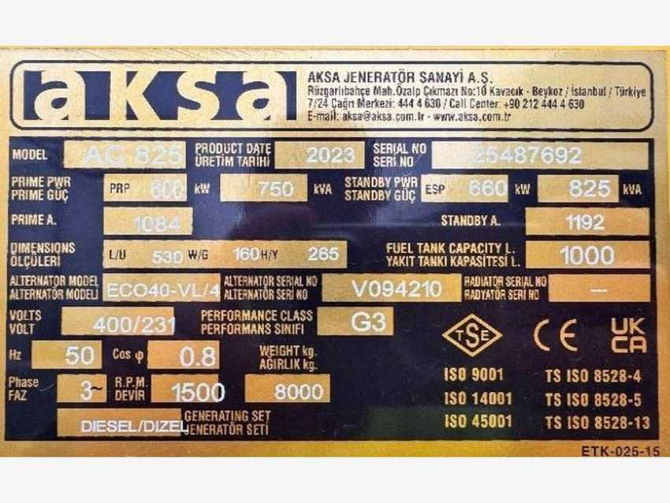
Diesel generator AKSA AC 825 – photo 1 |  | Diesel generator AKSA AC 825 – photo 2

8.3 Air compressors
DESCRIPTION | OEM | MODEL / TYPE | SERIAL NO. | CAPACITY | POWER | YOM | EQUIP. NO. (PM) | ASSET NO.
LP compressor 1 | Atlas Copco | ZT75STD | APF277337 | 8.6 bar | 75 kW | 2023 | 1000002415 | 223000000017
LP compressor 2 | Atlas Copco | ZT75STD | APF277338 | 8.6 bar | 75 kW | 2023 | 1000002416 | 223000000018
Air dryer | Atlas Copco | FD510 A | IJT755451 | – | 75 kW | 2023 | 8102191124 | 223000000018
Air receiver | Atlas Copco | 2000 L | 114938 | 2,000 L | – | 2023 | – | 223000000019
LP compressor 3 | SULLAIR | S7507 | 0125120021 | – | – | 2025 | – | –
Air dryer | SULLAIR | – | P115738281 | – | – | 2026 | – | –
HP compressor 1 | ABC (Arizaga Bastarrica y Cia) | HS2200 | 25844 | – | – | 2024 | 1000002421 | 223000000038
HP compressor 2 | ABC (Arizaga Bastarrica y Cia) | HS1000 | 25845 | – | – | – | 1000002422 | 223000000039
Air dryer | Airsec | FD-120BP-WHN | 34783 | – | – | 2023 | – | –
Air dryer | Airsec | FD-060BP-WHN | 34738 | – | – | 2023 | – | –

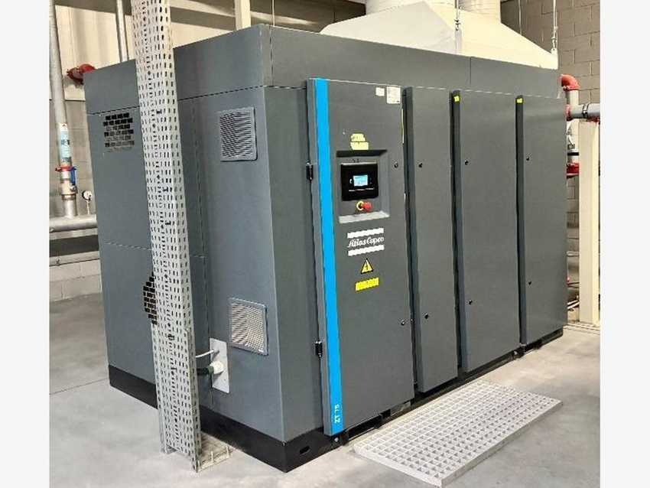 |  | 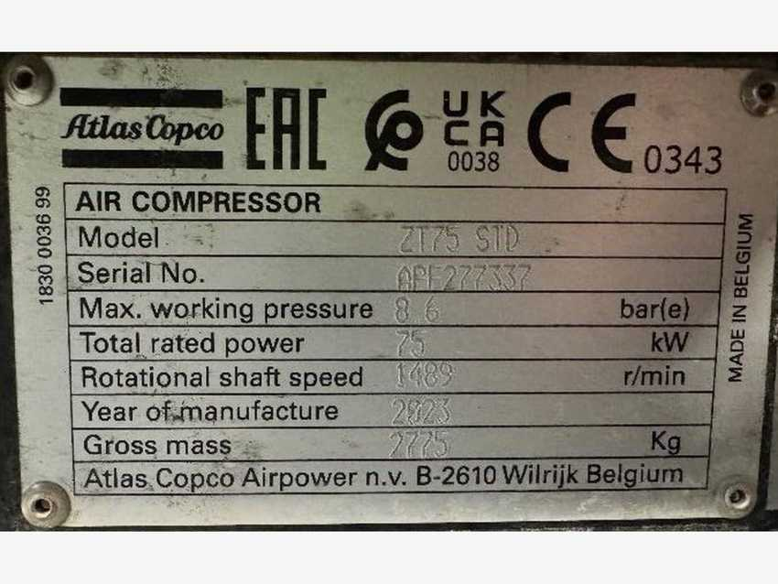
Atlas Copco compressor / dryer / receiver – photo 1 |  | Atlas Copco compressor / dryer / receiver – photo 2
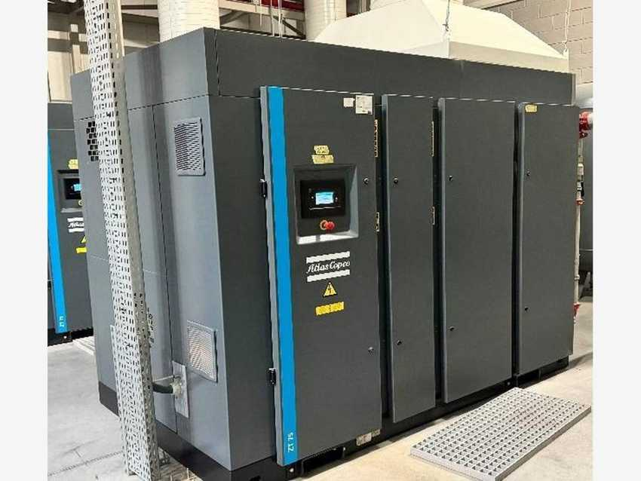 |  | 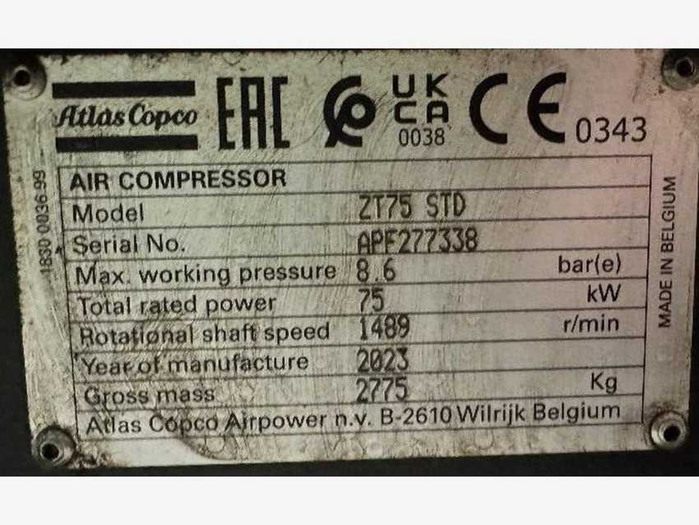
Atlas Copco compressor / dryer / receiver – photo 3 |  | Atlas Copco compressor / dryer / receiver – photo 4
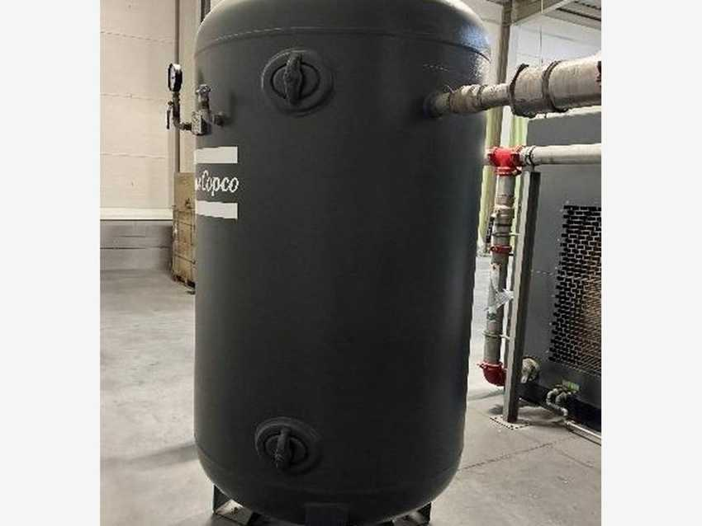 |  | 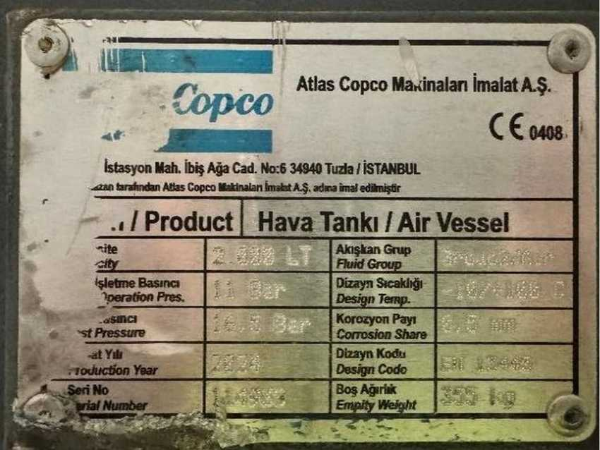
Atlas Copco compressor / dryer / receiver – photo 5 |  | Atlas Copco compressor / dryer / receiver – photo 6
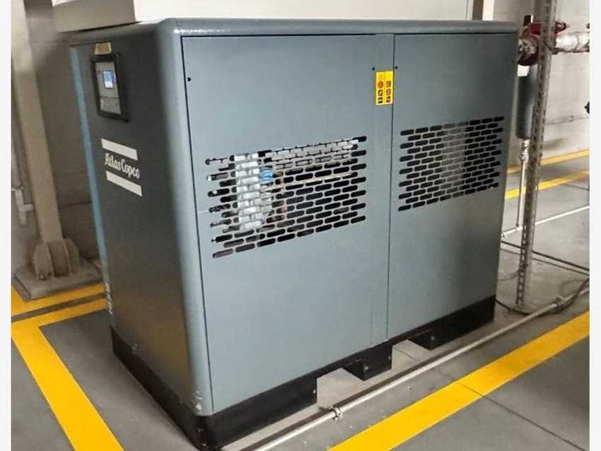 |  | 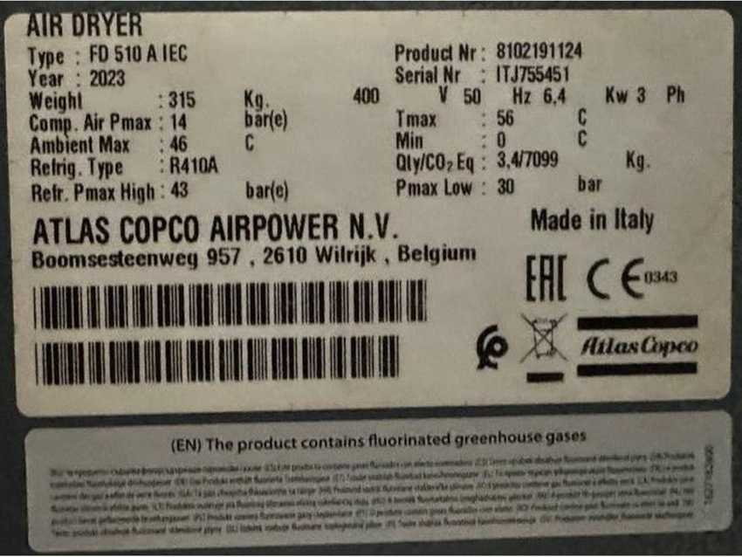
Atlas Copco compressor / dryer / receiver – photo 7 |  | Atlas Copco compressor / dryer / receiver – photo 8
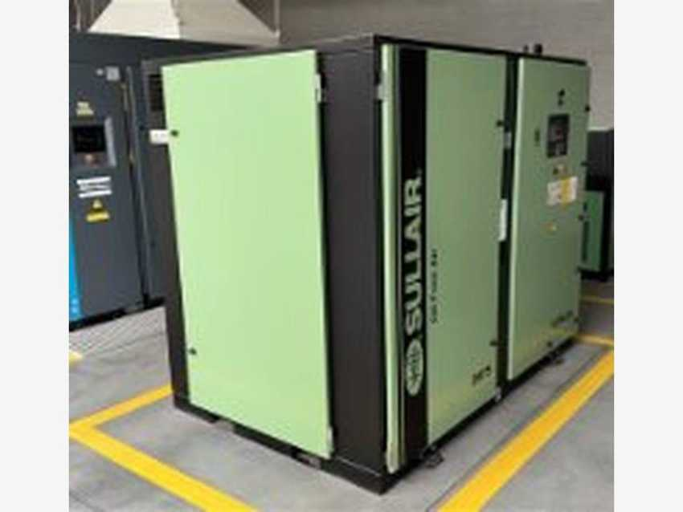 |  | 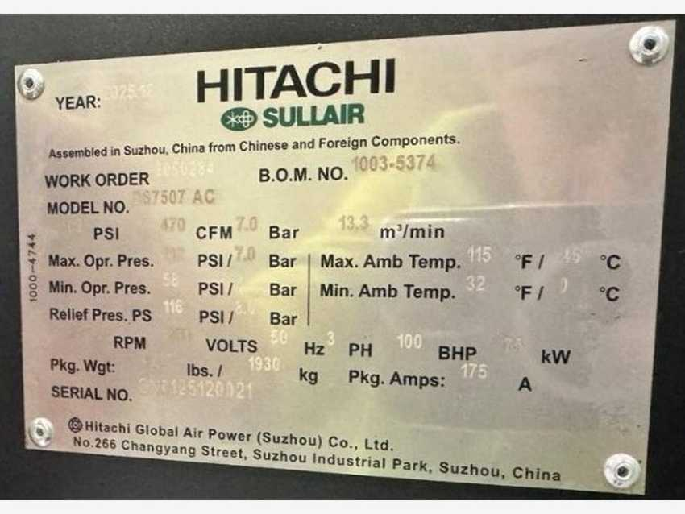
SULLAIR compressor and dryer – photo 1 |  | SULLAIR compressor and dryer – photo 2
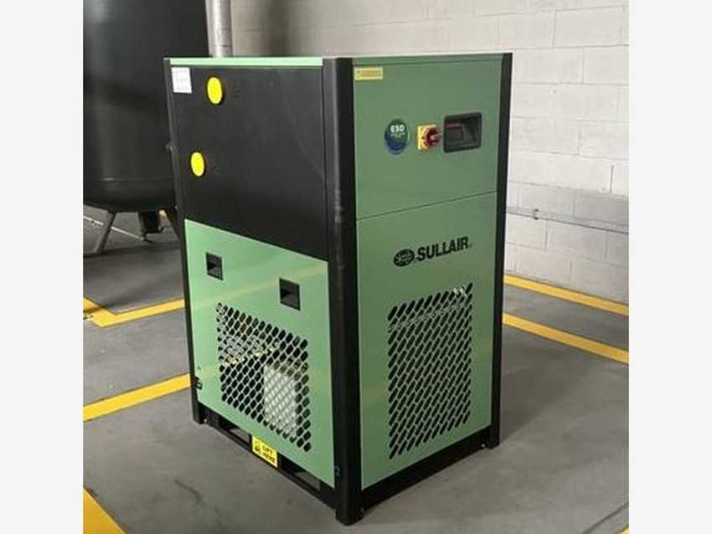 |  | 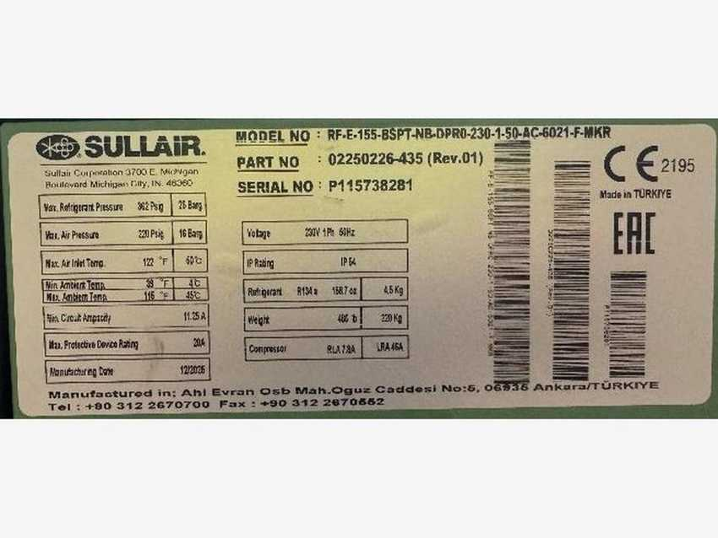
SULLAIR compressor and dryer – photo 3 |  | SULLAIR compressor and dryer – photo 4
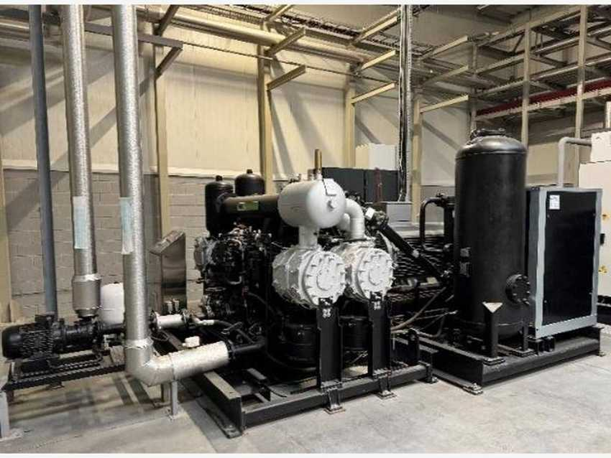 |  | 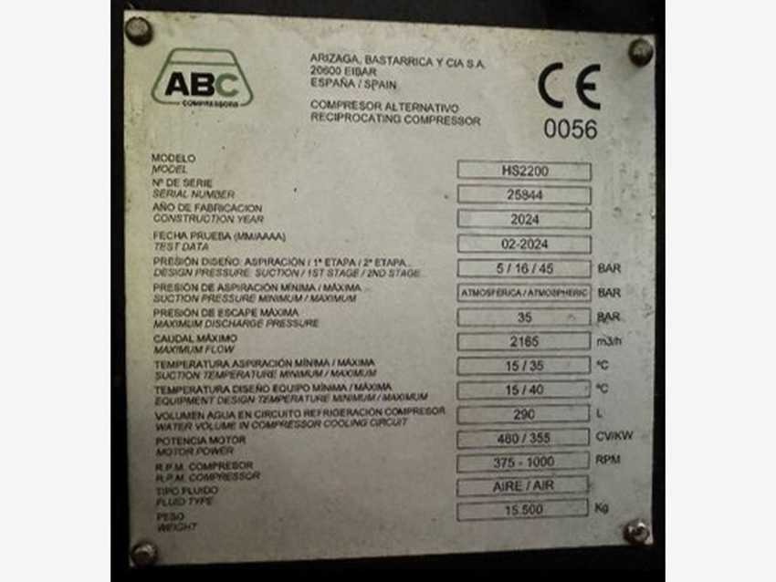
High-pressure compressors and dryers (ABC / Airsec) – photo 1 |  | High-pressure compressors and dryers (ABC / Airsec) – photo 2
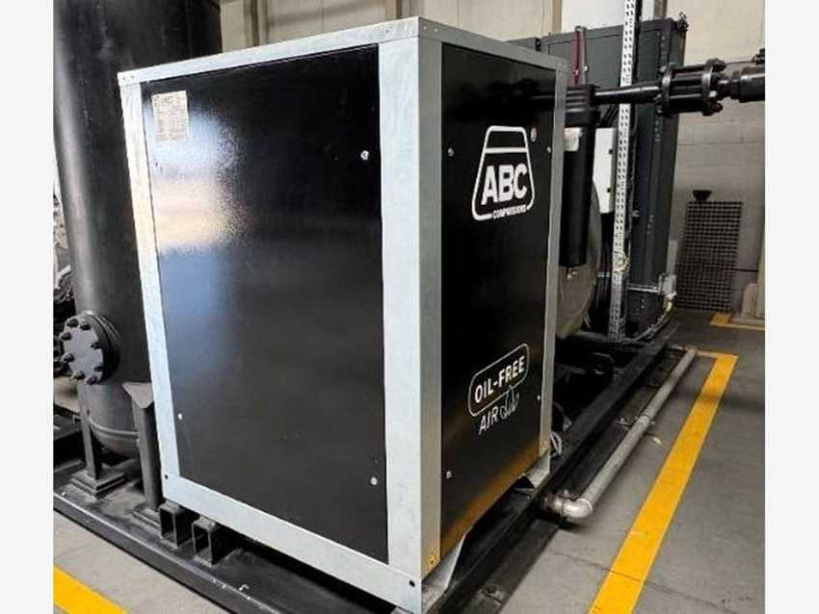 |  | 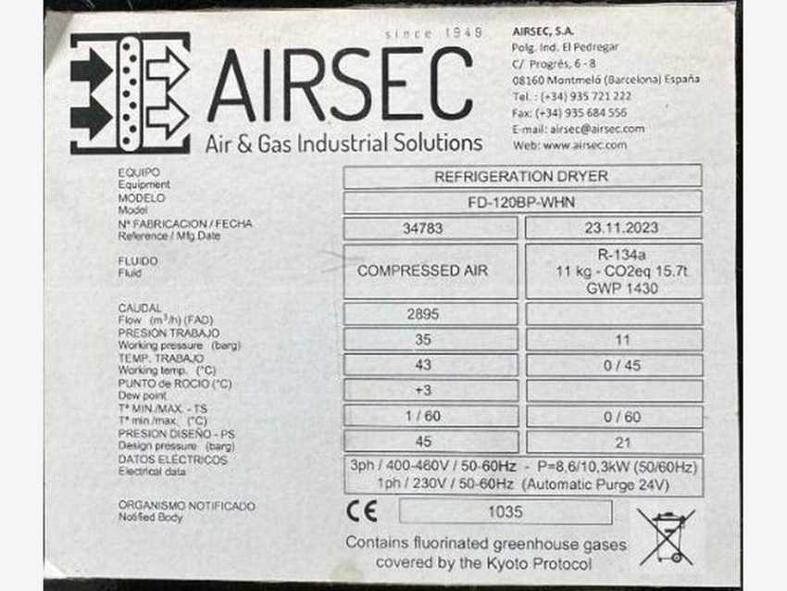
High-pressure compressors and dryers (ABC / Airsec) – photo 3 |  | High-pressure compressors and dryers (ABC / Airsec) – photo 4
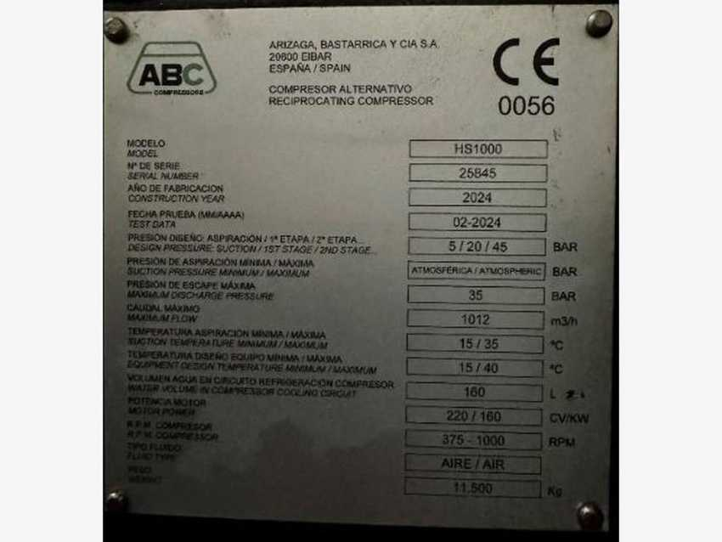 |  | 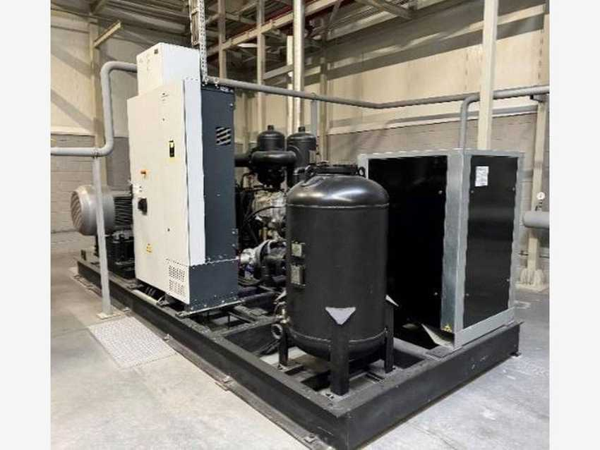
High-pressure compressors and dryers (ABC / Airsec) – photo 5 |  | High-pressure compressors and dryers (ABC / Airsec) – photo 6
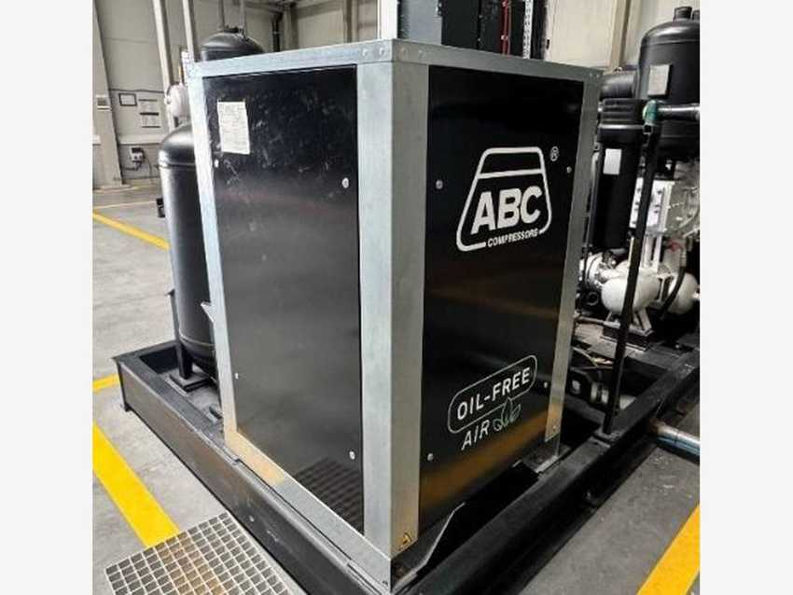 |  | 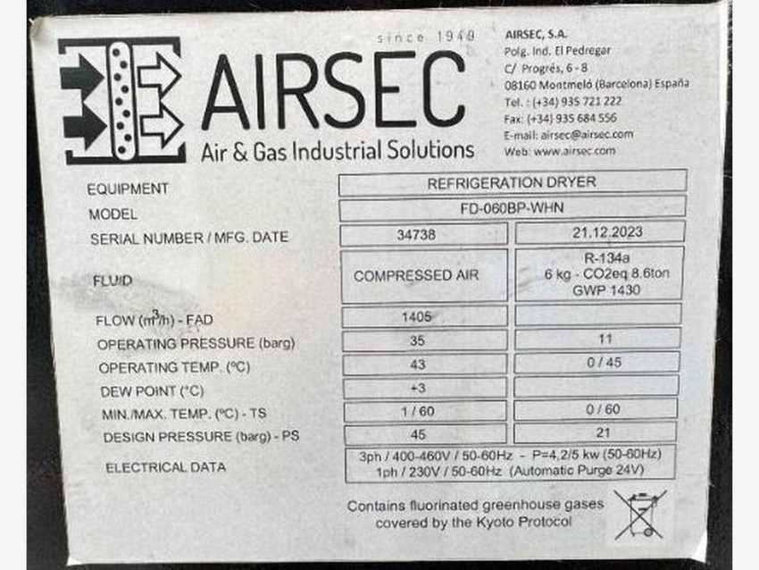
High-pressure compressors and dryers (ABC / Airsec) – photo 7 |  | High-pressure compressors and dryers (ABC / Airsec) – photo 8

Corrections applied from nameplate photos: HP compressor 2 shown as HS1000; dryers shown as Airsec FD-120BP-WHN (SN 34783, 23.11.2023) and FD-060BP-WHN (SN 34738, 21.12.2023).

8.4 CO2 production equipment
DESCRIPTION | OEM | MODEL / TYPE | SERIAL NO. | CAPACITY | POWER | YOM | EQUIP. NO. (PM) | ASSET NO.
CO2 plant | Union Engineering | TDL12 | 25844 | 1,000 kg/h | – | 2024 | 1000002635 | 223000000044
LCO2 analyzer | Airborne Labs | MAX-Bev Gen2 | 01135 | – | – | – | 1000002636 | 223000000043
CO2 filter | Parker Domnick Hunter | PCO2-3200 | 23PCO210680 | – | – | – | 1000002637 / 1000002638 | 223000000020 / 223000000021
LCO2 vessel 1 | ISISAN | 50,000 L | 22/0429 | 50,000 L | – | – | – | 223020000001
LCO2 vessel 2 | ISISAN | 50,000 L | 22/0430 | 50,000 L | – | – | – | 223020000002

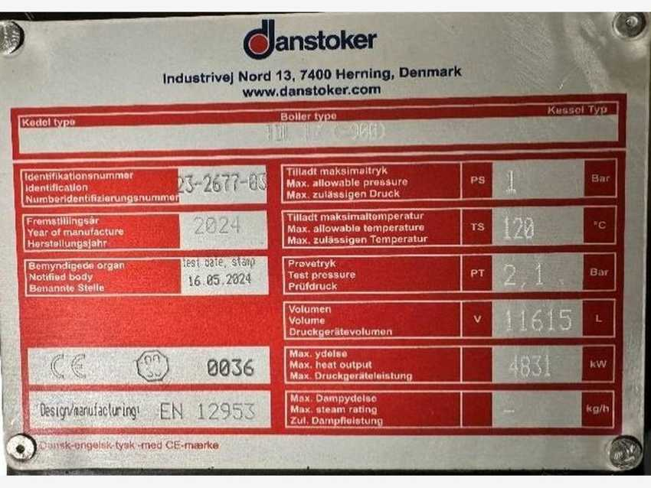 |  | 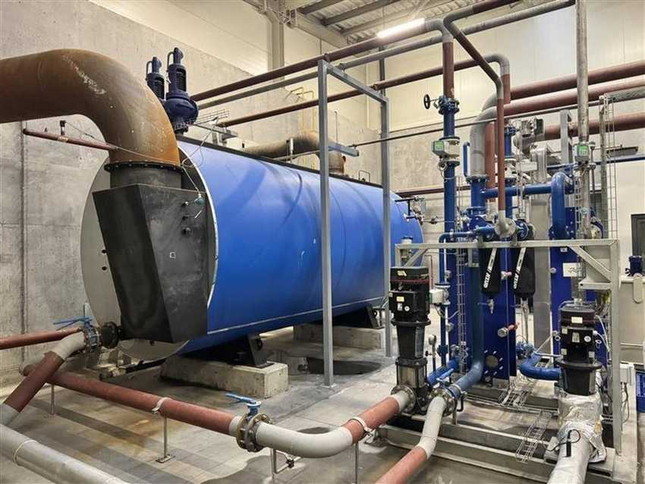
CO2 plant – Danstoker boiler nameplate (4,831 kW max output) |  | CO2 plant – boiler
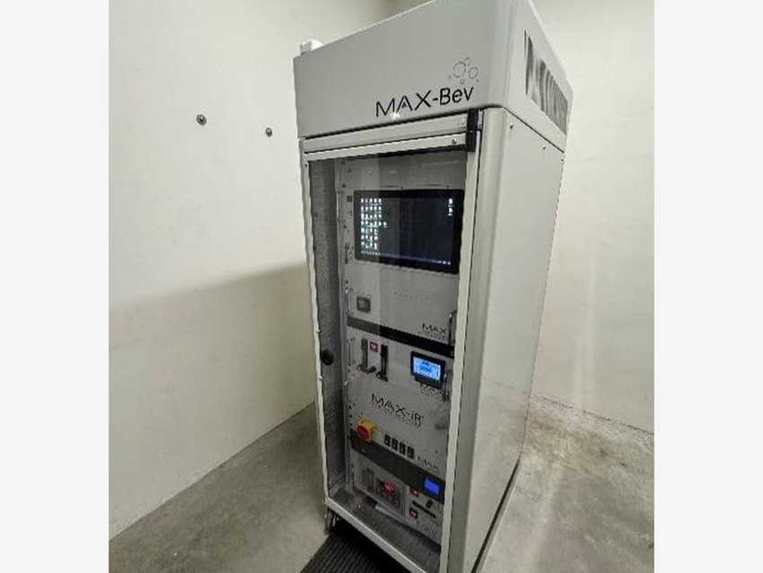 |  | 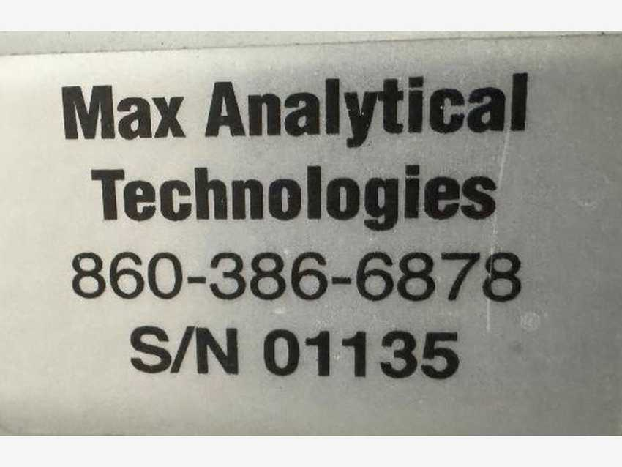
LCO2 analyzer Airborne Labs MAX-Bev Gen2 – photo 1 |  | LCO2 analyzer Airborne Labs MAX-Bev Gen2 – photo 2
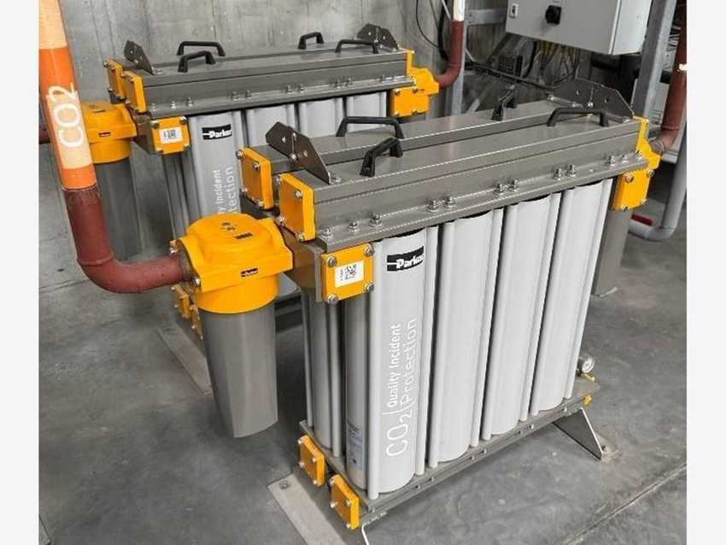 |  | 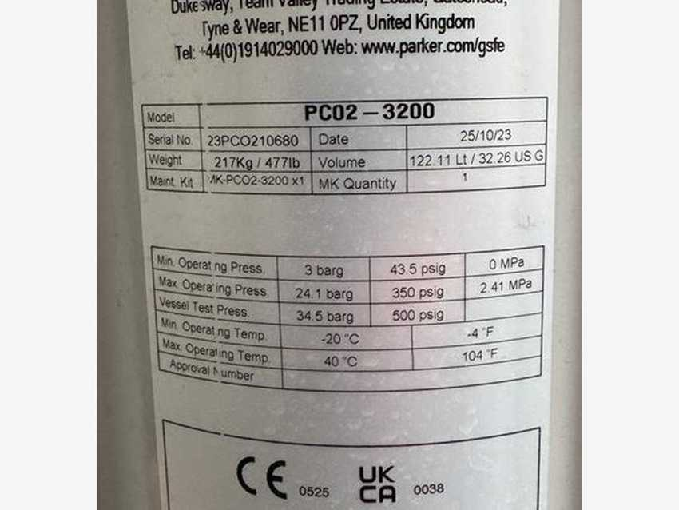
CO2 filter Parker Domnick Hunter PCO2-3200 – photo 1 |  | CO2 filter Parker Domnick Hunter PCO2-3200 – photo 2
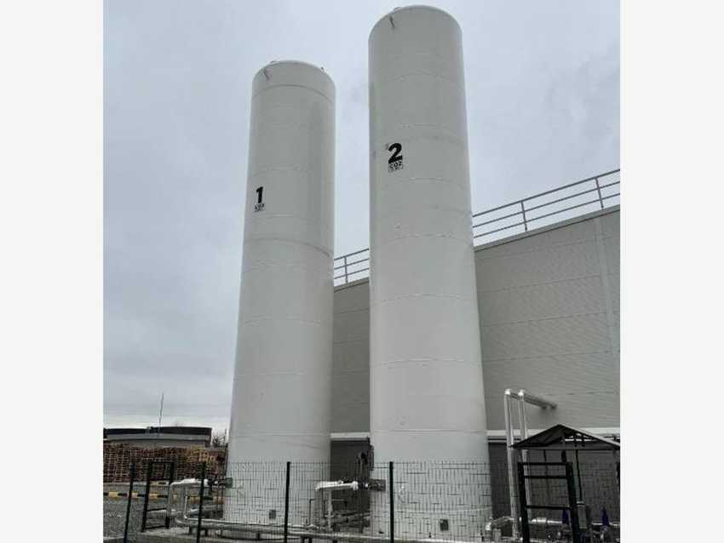 |  | 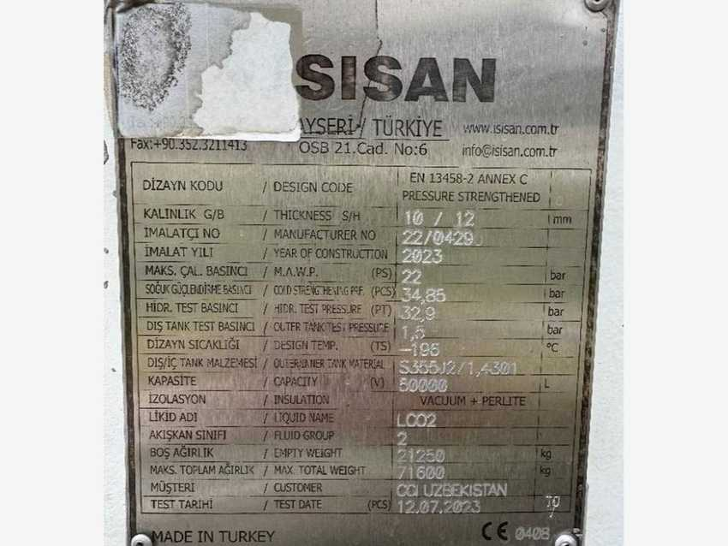
ISISAN LCO2 vessel – photo 1 |  | ISISAN LCO2 vessel – photo 2
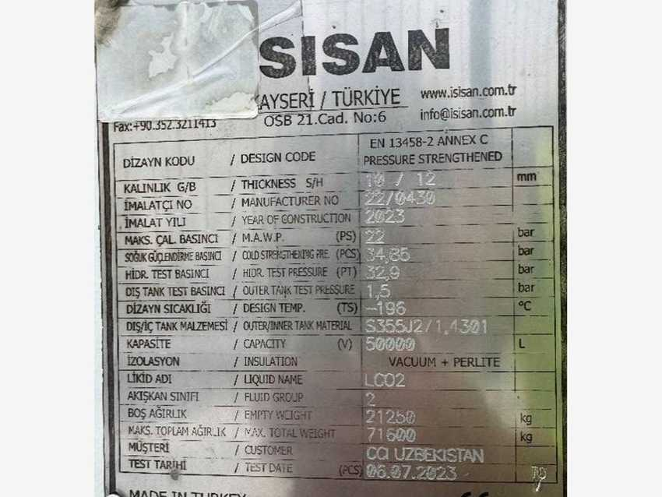
ISISAN LCO2 vessel – photo 3

8.5 Liquid nitrogen equipment
DESCRIPTION | OEM | MODEL / TYPE | SERIAL NO. | CAPACITY | POWER | YOM | EQUIP. NO. (PM) | ASSET NO.
LN2 vessel | ISISAN | 31,300 L | 22/0439 | 31,300 L | – | – | – | 223020000000

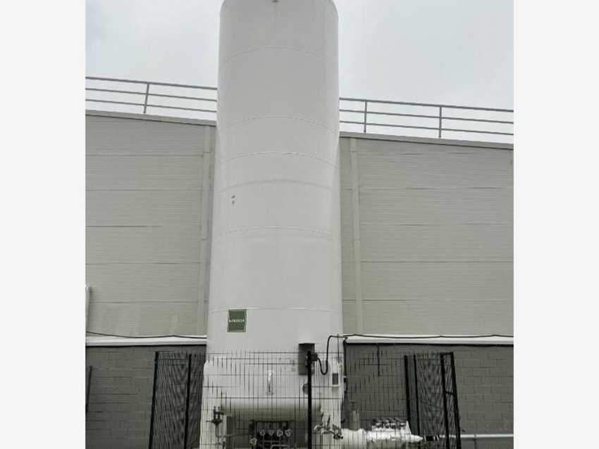 |  | 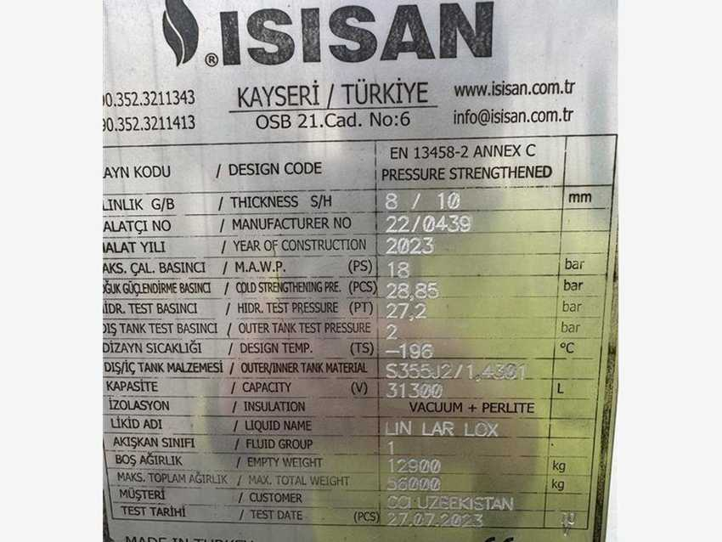
ISISAN LN2 vessel – photo 1 |  | ISISAN LN2 vessel – photo 2

8.6 Rooftop units
DESCRIPTION | OEM | MODEL / TYPE | SERIAL NO. | CAPACITY | POWER | YOM | EQUIP. NO. (PM) | ASSET NO.
Rooftop unit – RGB line 1 | Imbat | HSE 0272 | 2500021-01006-01 | – | – | 2025 | – | –
Rooftop unit – RGB line 2 | Imbat | HSE 0272 | 2500021-01006-02 | – | – | 2025 | – | –
Rooftop unit – syrup room 1 | Imbat | HSE 0272 | KL-RT.2310.16567 | – | – | 2025 | – | –
Rooftop unit – syrup room 2 | Imbat | HSE 0272 | KL-RT.2310.16566 | – | – | 2025 | – | –

To verify: the syrup-room nameplates show production year 2023, while the register lists 2025.
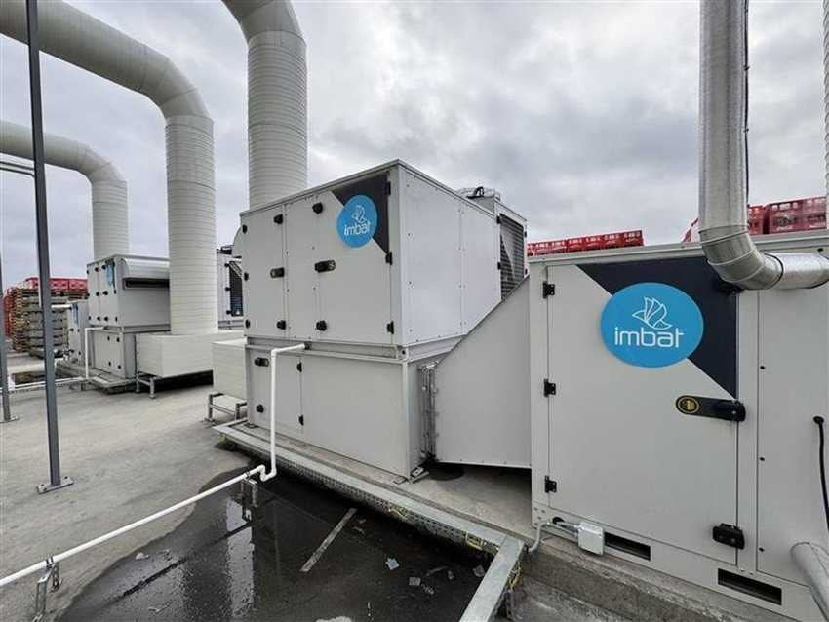 |  | 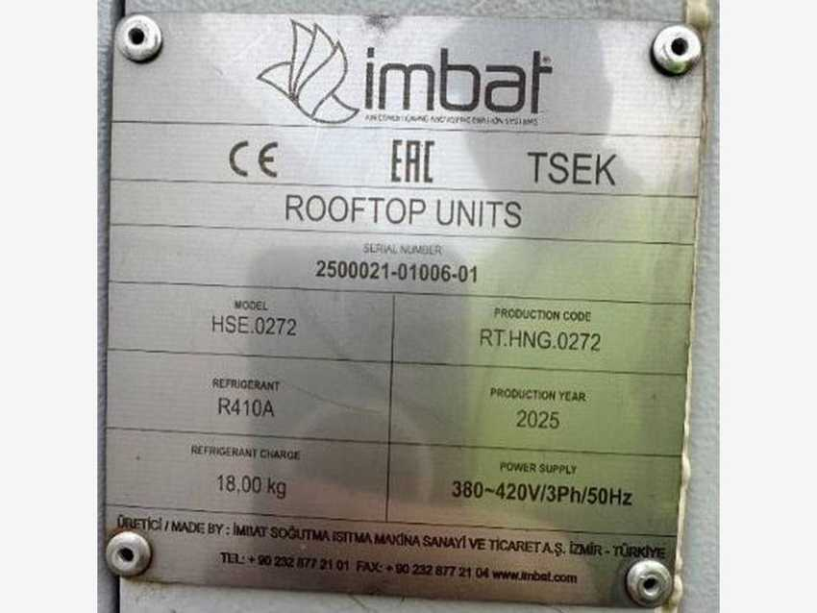
Rooftop unit – RGB line (1) |  | Nameplate – RGB line rooftop unit (1)
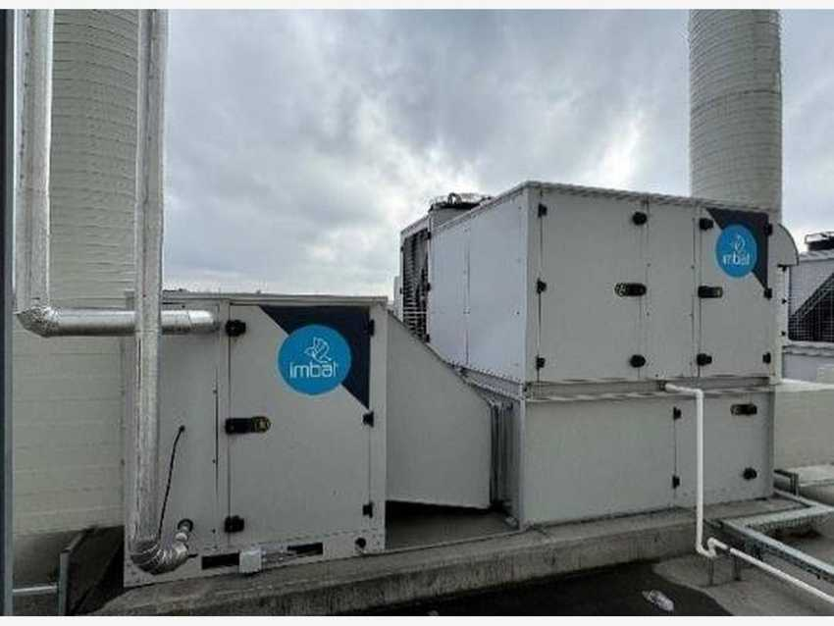 |  | 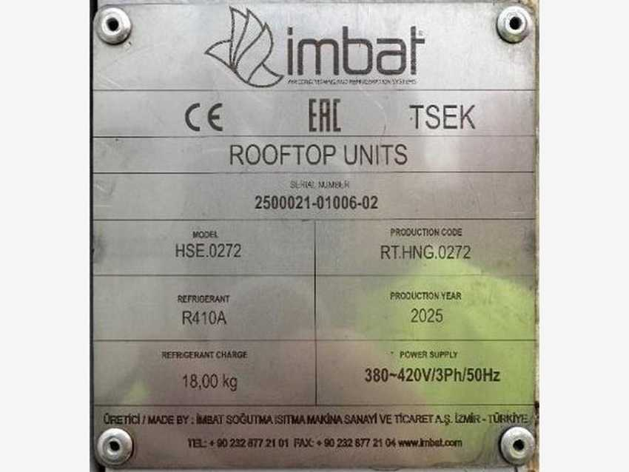
Rooftop unit – RGB line (2) |  | Nameplate – RGB line rooftop unit (2)
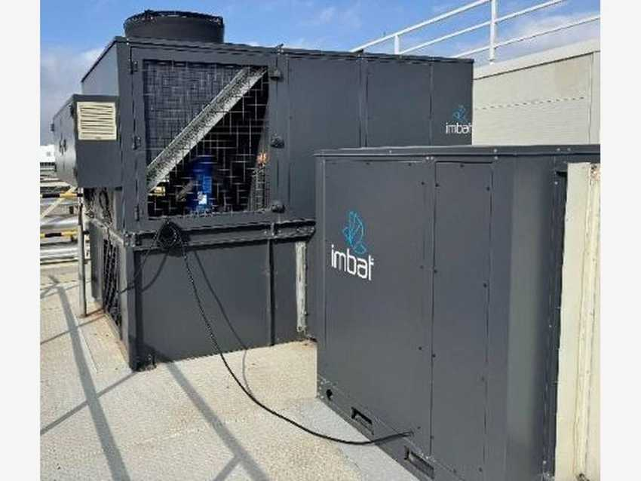 |  | 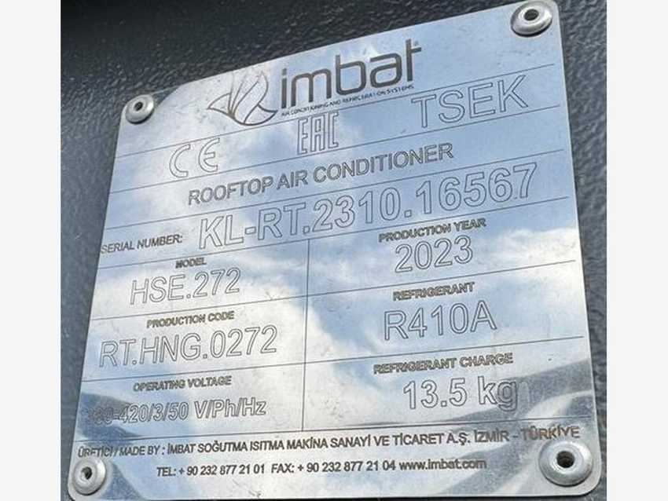
Rooftop unit – syrup room (1) |  | Nameplate – syrup room rooftop unit (1)
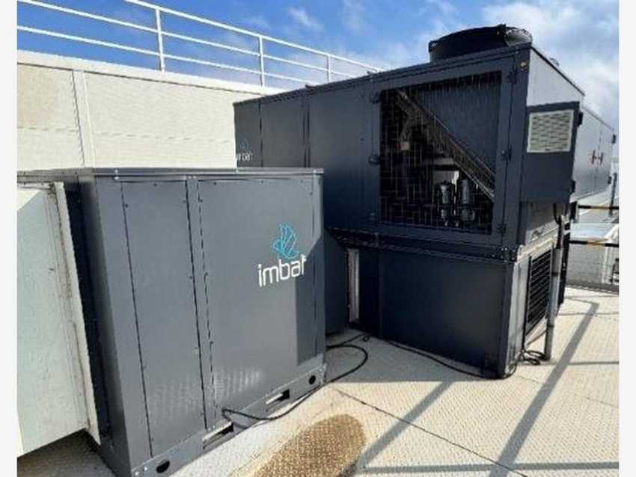 |  | 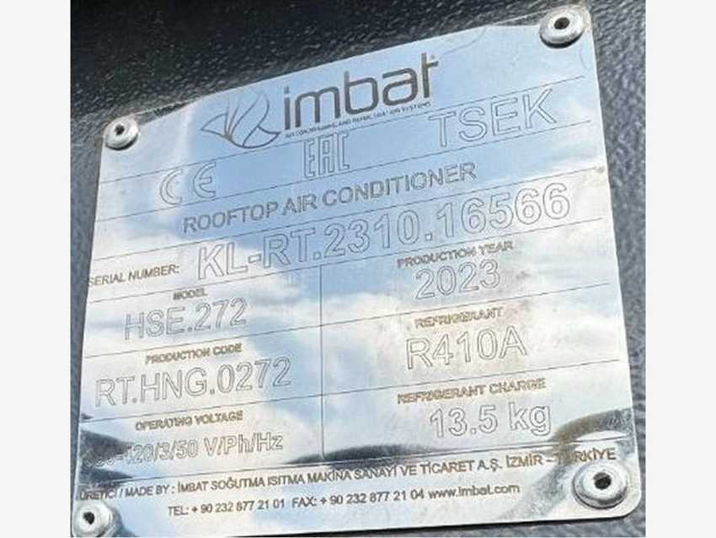
Rooftop unit – syrup room (2) |  | Nameplate – syrup room rooftop unit (2)

8.7 Power supply equipment
DESCRIPTION | OEM | MODEL / TYPE | SERIAL NO. | CAPACITY | POWER | YOM | EQUIP. NO. (PM) | ASSET NO.
Switchgear 1 | ASTOR | AS12 CBC | AS23-05056-1-1 | – | – | – | – | 223000000022
Switchgear 2 | ASTOR | AS12 CBC | AS23-05056-1-1 | – | – | – | – | 223000000023
Switchgear 3 | ASTOR | AS12 CBC | AS23-05056-1-1 | – | – | – | – | 223000000024
Transformer 1 | IREM | 500 kW STEROSTAB 143135 | 756564 | 500 kW | – | – | – | 223000000005
Transformer 2 | IREM | 500 kW STEROSTAB 143135 | 756564 | 500 kW | – | – | – | 223000000006
Transformer 3 | IREM | 500 kW STEROSTAB 143135 | 756564 | 500 kW | – | – | – | 223000000007

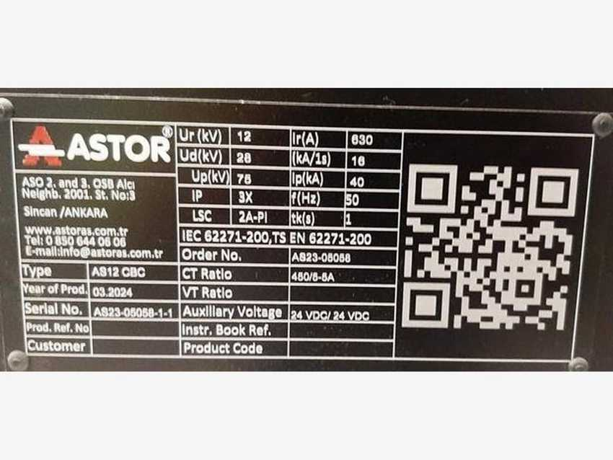 |  | 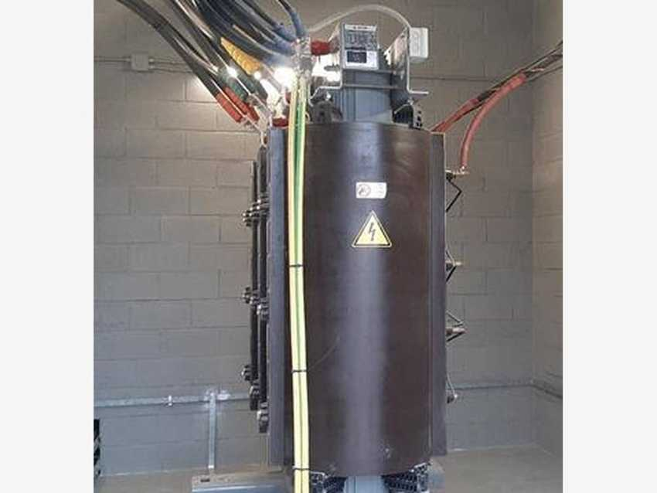
ASTOR AS12 CBC switchgear – photo 1 |  | ASTOR AS12 CBC switchgear – photo 2
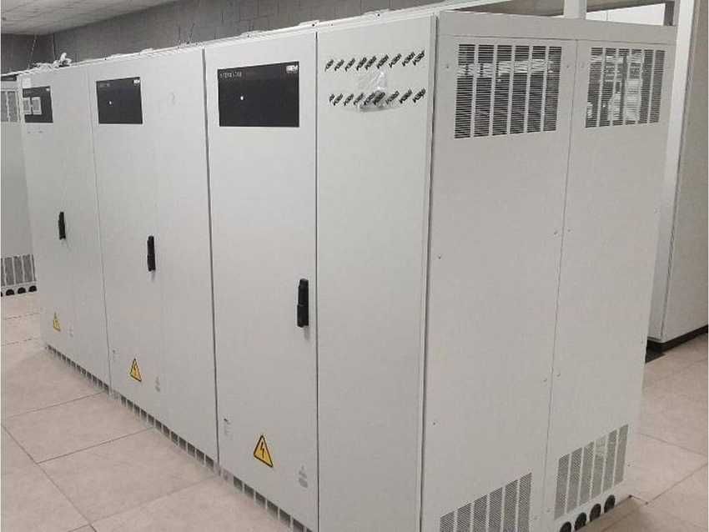 |  | 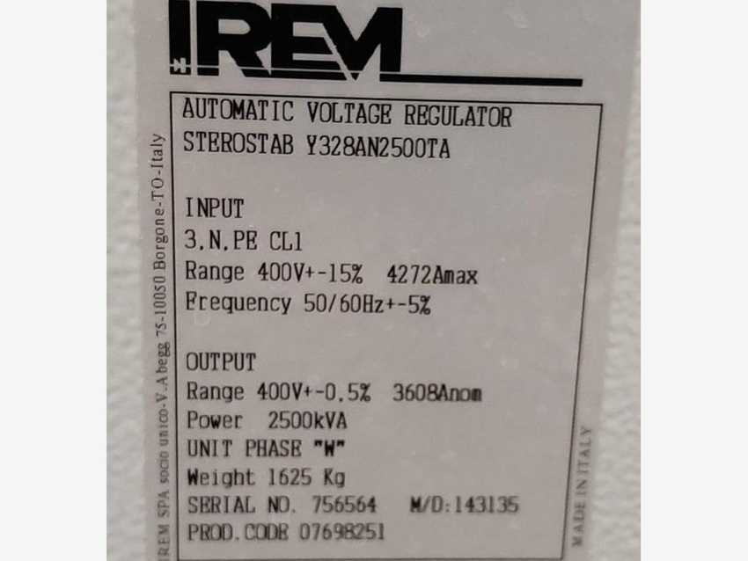
IREM transformer – photo 1 |  | IREM transformer – photo 2

8.8 Refrigeration and cooling equipment
DESCRIPTION | OEM | MODEL / TYPE | SERIAL NO. | CAPACITY | POWER | YOM | EQUIP. NO. (PM) | ASSET NO.
Refrigeration unit | Frigo Mekanik | CSH9573-240Y DX | – | – | – | – | 1000002632 | 223000000035
Chiller | Niba | HMP (5X5) | NBK416.23R2 | – | – | – | – | 223000000036
CO2 evaporator | Frigo Block | PSEC-630 | 23 11 05206 | – | – | – | – | 223000000037
External unit | Terkan | TSD-N12R | 23274 | – | 9 kW | – | – | 223000000027 – 223000000030
Inside refrigeration | Terkan | TSD-D12SUB | 23280 | – | 13 kW | – | – | 223000000031 – 223000000034

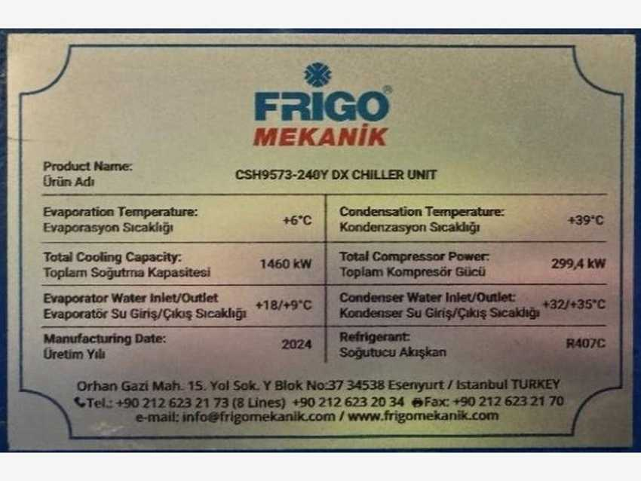 |  | 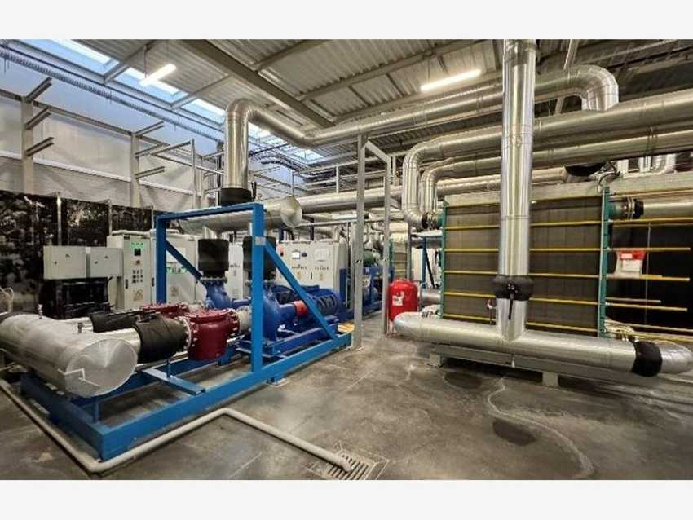
Frigo Mekanik CSH9573-240Y DX – photo 1 |  | Frigo Mekanik CSH9573-240Y DX – photo 2
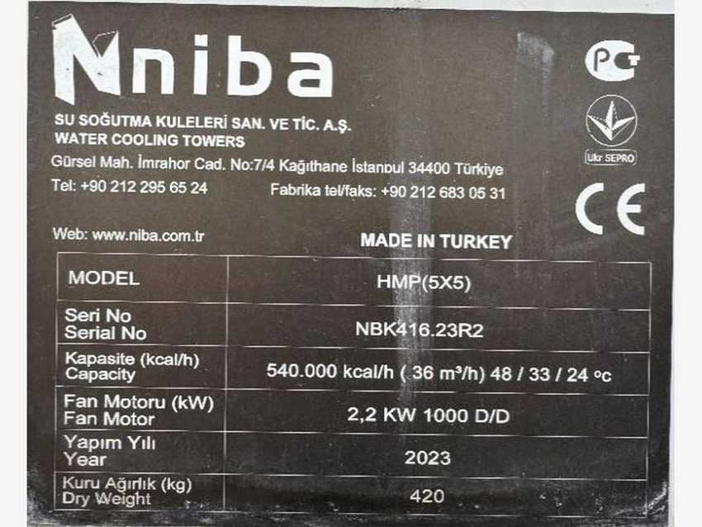 |  | 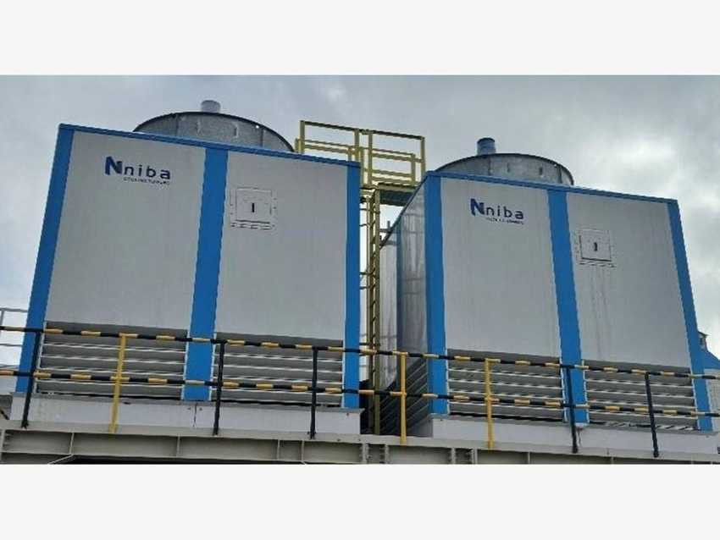
Niba HMP (5X5) – photo 1 |  | Niba HMP (5X5) – photo 2
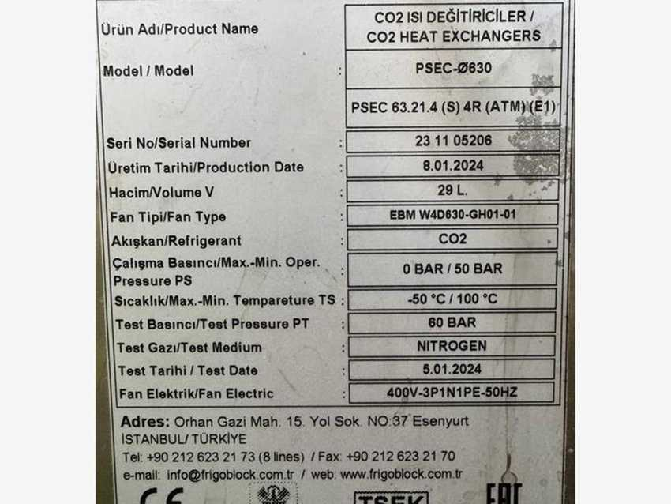 |  | 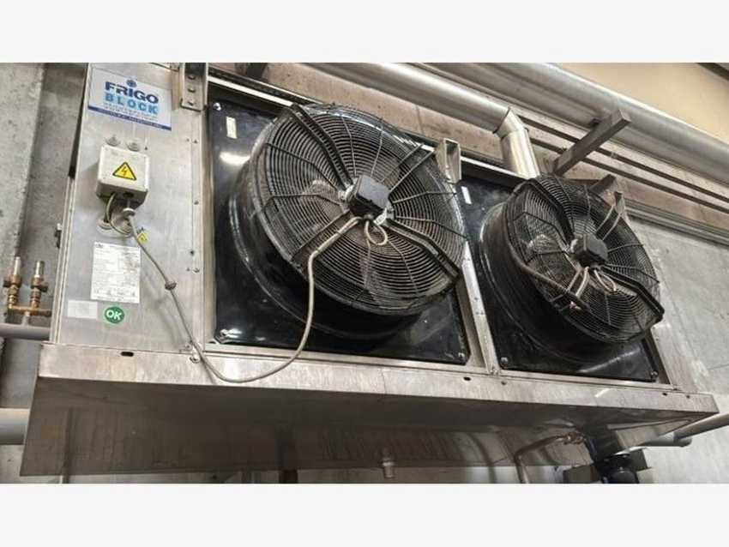
Frigo Block PSEC-630 – photo 1 |  | Frigo Block PSEC-630 – photo 2
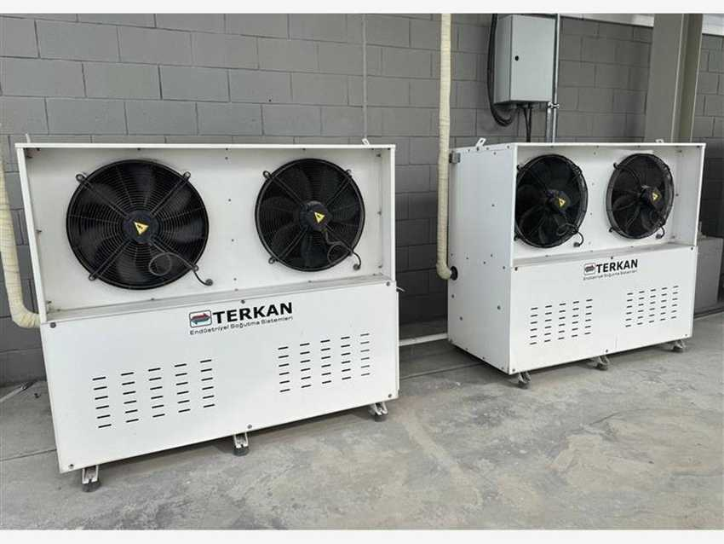 |  | 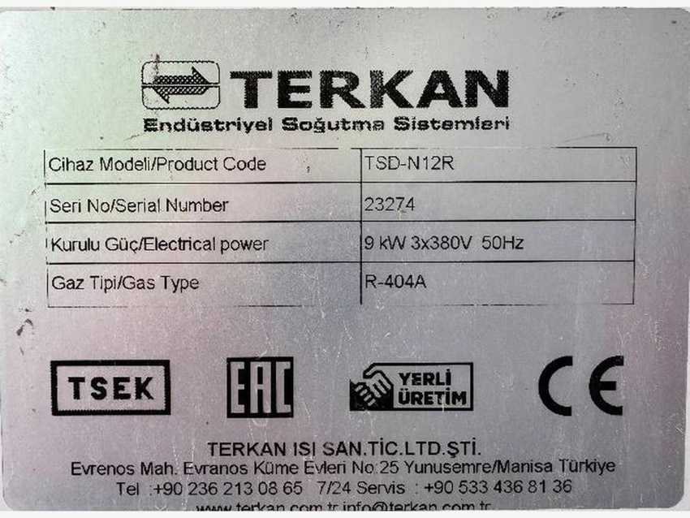
Terkan external unit – photo |  | Terkan TSD-N12R – nameplate
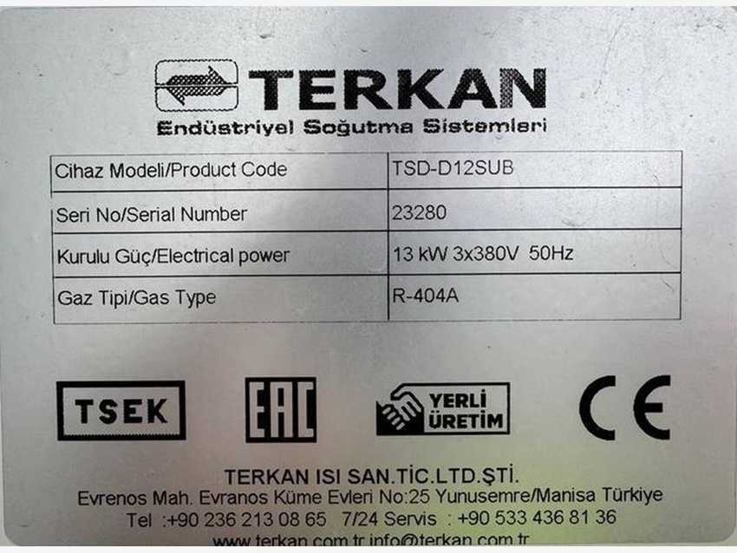 |  | 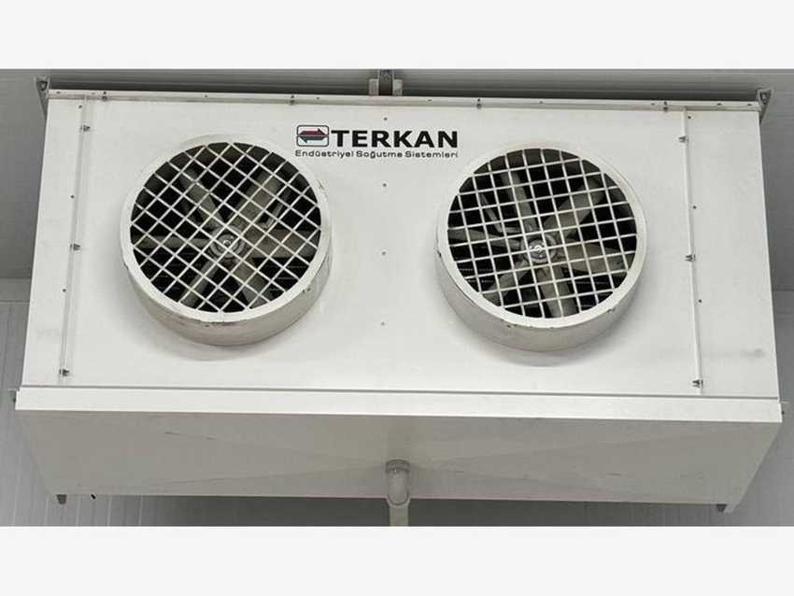
Terkan inside refrigeration – photo |  | Terkan TSD-D12SUB – nameplate

Corrections applied from nameplate photos: Terkan units shown as TSD-N12R (9 kW) and TSD-D12SUB (13 kW).

9 Water Treatment

9.1 System data and equipment register
Supplier | Aquamatch (Deniz Su), Aydın – Türkiye | Functional location | WTR00038 – SMR / Water Treatment
SAP asset | 223000000004 – Complete water treatment system | Cost centre | 7300006018 (QA general)
Year of manufacture | 2023 (plates); capitalised September 2024 | Project no. | Aquamatch P1346/23
Products | Treated (process) water for Lines 1–4 and the syrup room | Soft water | Bottle and case washers, CIP, utilities
Food safety | UV disinfection = OPRP2 | Waste stream | RO reject and backwash to waste water (Section 11)

The water treatment plant turns the incoming raw water into treated (process) water that meets the Coca-Cola KORE water quality requirements. The main line is pre-dosing, pre-filtration, ultrafiltration, activated carbon, cartridge filtration and reverse osmosis, followed by UV disinfection before the water is pumped to the four lines and the syrup room. A separate softener branch makes soft water for the washers, CIP and utilities. Chemicals for dosing and membrane cleaning are stored in a dedicated chemical room.

Process flow
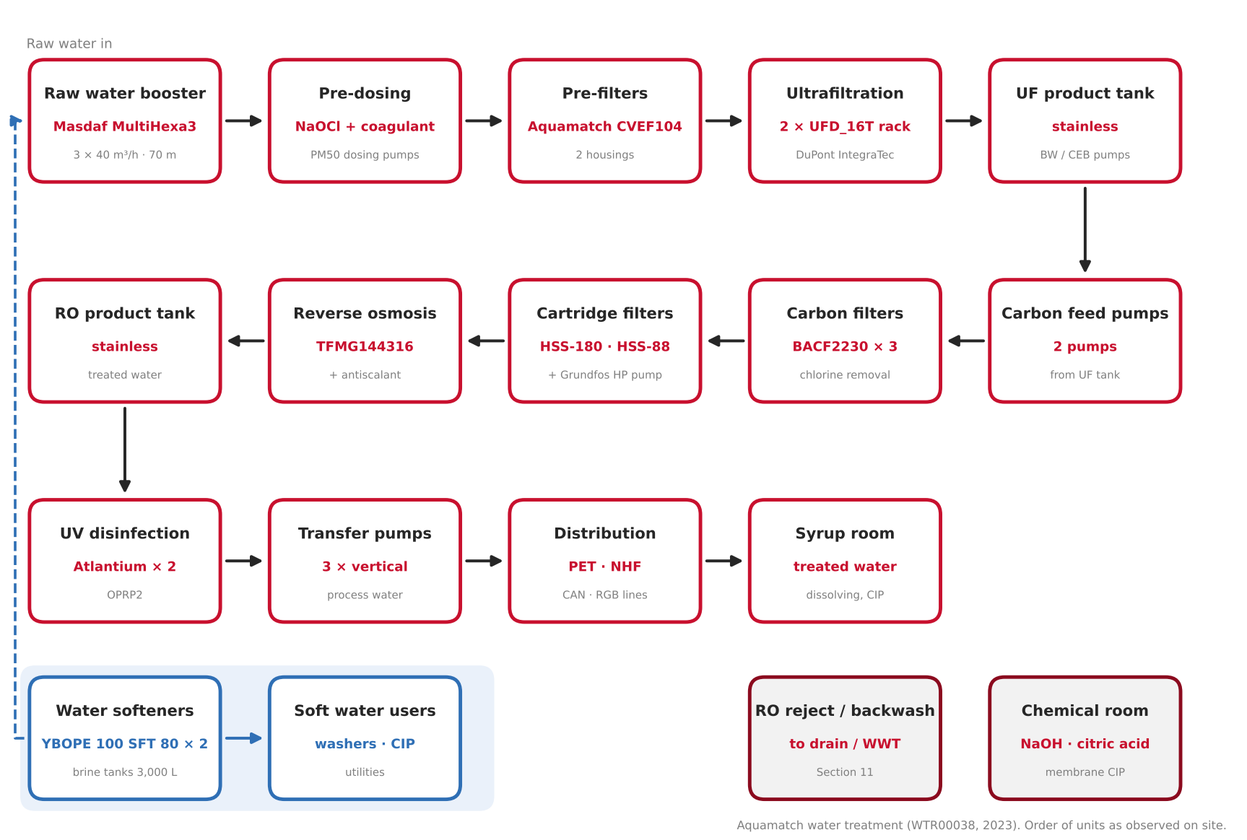
Figure 9.1 – Water treatment process flow, from raw water to the production lines (order as observed on site)

Equipment register
No. | EQUIPMENT / UNIT | MAKER | MODEL / TYPE | SERIAL NO. | SAP NO. | ASSET NO.
1 | Raw water booster set (3 pumps) | Masdaf | MultiHexa3 45-4 FxA | 24021676 | – | –
2 | Pump room motor control centre MCC-HYD | Paneltech | 400 V, 160 A | – | – | –
3 | Hypochlorite dosing pump | – | MS1C165C51C4000 | 21G04617D | 1000002479 | 223000000004
4 | Pre-filters (2 housings) | Aquamatch | CVEF104 | P1346/23 | 1000002475 | 223000000004
5 | Ultrafiltration system (2 racks) | Aquamatch / DuPont | UFD_16T_RACK, IntegraTec MB 80 TR | P1346/23 | 1000002474 | 223000000004
6 | UF feed pump (VFD) | Lowara | ESHE 65-200/185/P25VS | PLM160B34S3/3185 E3 | 1000002471 | 223000000004
7 | UF backwash / CEB pumps (2) | – | – | – | – | –
8 | UF product water tank | – | stainless | – | – | –
9 | Carbon filter feed pumps (2) | – | – | – | – | –
10 | Activated carbon filters (3) | Aquamatch | BACF2230 | P1346/23 | 1000002478 | 223000000004
11 | Water softeners (2) | Aquamatch | YBOPE 100 SFT 80 | P1346/23_1nolu / _2nolu | 1000002476 | 223000000004
12 | Brine (salt) tanks | – | PE, 3,000 L | – | – | –
13 | Cartridge filter | Aquamatch | HSS-180 | P1348/23 | 1000002472 | 223000000004
14 | Cartridge filter | Aquamatch | HSS-88 | ST0K003/23 | 1000002473 | 223000000004
15 | RO high-pressure pump | Grundfos | CR vertical multistage | – | – | –
16 | Reverse osmosis unit | Aquamatch | TFMG144316 | P1346/23 | 1000002477 | 223000000004
17 | RO product water tank | – | stainless | – | – | –
18 | UV unit 1 | Atlantium | RZ163-11 | F01N09231368 | 1000002469 | 223000000004
19 | UV unit 2 | Atlantium | RZ163-11HP | F02N09231371 | 1000002470 | 223000000004
20 | Product water transfer pumps (3) | – | vertical multistage | – | – | –
21 | Chemical dosing and membrane CIP | Aquamatch | PM50 dosing pumps, PE tanks | – | – | –
22 | Control panel and power board DB-PR | Siemens HMI | SIMATIC HMI | – | – | –

Sources: SAP PM equipment list (items with SAP no.), nameplates and the October 2026 photo walk. P1346/23 is the Aquamatch project number shared by several units. Items without SAP no. were found on site and are not yet registered as SAP equipment.

9.2 Raw water supply – booster set and pump room panel

Machine data
MACHINE | MAKER | TYPE / MODEL | MFG. DATE | SERIAL NO. | INST. POWER kW | SAP NO. | ASSET NO.
Raw water booster set | Masdaf | MultiHexa3 45-4 FxA | 2024 | 24021676 | 45 (3 × 15) | – | –
Diaphragm pressure vessel | DAF | – | – | – | – | – | –
Motor control centre MCC-HYD | Paneltech | 400 V, 160 A | 03.2024 | – | – | – | –

Nameplate data
PARAMETER | MASDAF BOOSTER SET | PANELTECH MCC-HYD
Type / panel code | MultiHexa3 45-4 FxA · FXA03/Y15-BMS | MCC-HYD, Form 2B
Flow / head | 3 × 40 m³/h at 70 m | –
Motor power / speed | 3 × 15 kW, 3000 rpm | –
Rated voltage | – | 400 V (Ui 690 V, Uimp 8 kV)
Rated current / Ipk | – | 160 A / 36 kA
Protection | – | IP41
Serial no. / date | 24021676 (panel 202401017) / 2024 | 03.2024

Raw water from the supply header is boosted by the Masdaf MultiHexa3 set: three vertical multistage pumps under frequency control (FxA panel), with a DAF diaphragm pressure vessel and a Y-strainer on the suction header. The raw water header feeds the treatment line, the softener branch and a separate fire-water branch. All pump drives in the pump room are supplied from the Paneltech motor control centre MCC-HYD.
The FAULT lamp on MCC-HYD was lit during the photo walk (October 2026) – to be checked by maintenance. Booster set and MCC are not in the SAP equipment list.

Photos
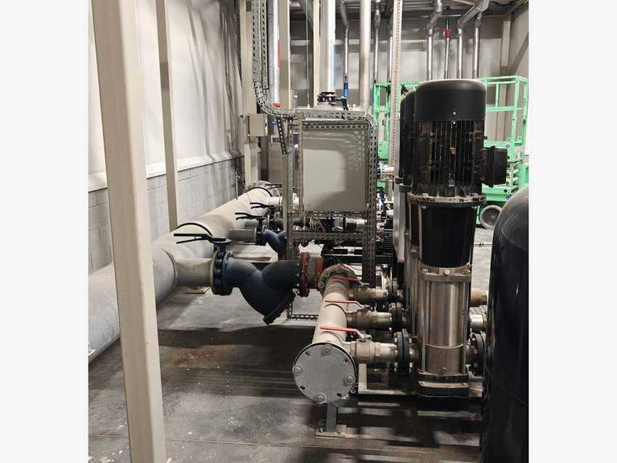 |  | 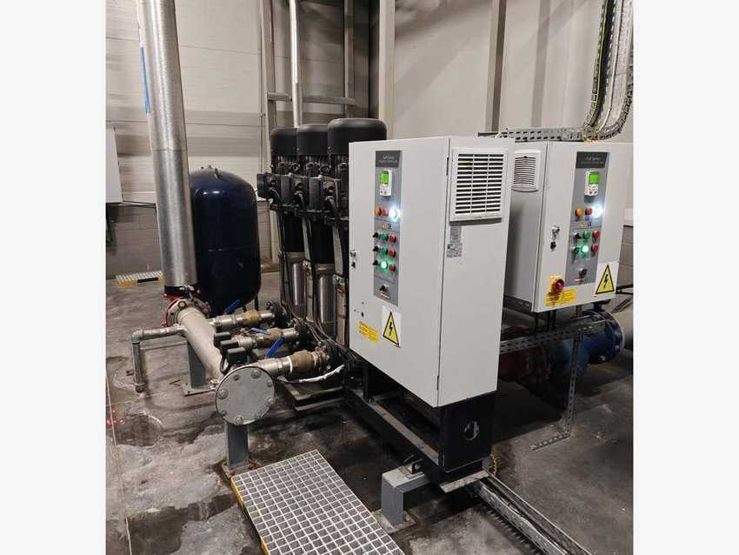
Masdaf booster set – vertical multistage pumps |  | Booster set with FxA frequency control panels
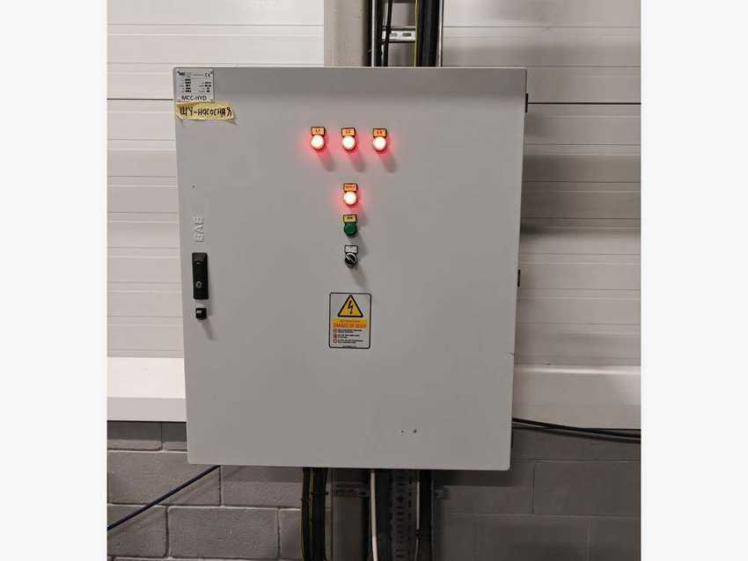
Pump room motor control centre MCC-HYD

9.3 Pre-treatment and ultrafiltration

Machine data
MACHINE | MAKER | TYPE / MODEL | MFG. DATE | SERIAL NO. | INST. POWER kW | SAP NO. | ASSET NO.
Hypochlorite dosing pump | – | MS1C165C51C4000 | 2023 | 21G04617D | – | 1000002479 | 223000000004
Pre-filters (2 housings) | Aquamatch | CVEF104 | 2023 | P1346/23 | – | 1000002475 | 223000000004
Ultrafiltration system (2 racks) | Aquamatch | UFD_16T_RACK | 2023 | P1346/23 | – | 1000002474 | 223000000004
UF feed pump | Lowara | ESHE 65-200/185 | 2023 | PLM160B34S3/3185 E3 | 18.5 | 1000002471 | 223000000004
UF backwash / CEB pumps (2) | – | – | – | – | – | – | –

Sodium hypochlorite and coagulant are dosed into the raw water. Two stainless pre-filter housings (Aquamatch CVEF104) remove coarse particles and protect the membranes. The two ultrafiltration racks, each with about 16 DuPont IntegraTec MB 80 TR hollow-fibre modules (PES, inside-out), remove fine particles, bacteria and turbidity. The filtrate is collected in the stainless UF product water tank. The membranes are cleaned automatically by backwash (BW) and chemically enhanced backwash (CEB) with the dedicated BW/CEB pumps.
UF feed pump power 18.5 kW taken from the Lowara model code (…/185). SAP lists one UF system; there are two racks on site.

Photos
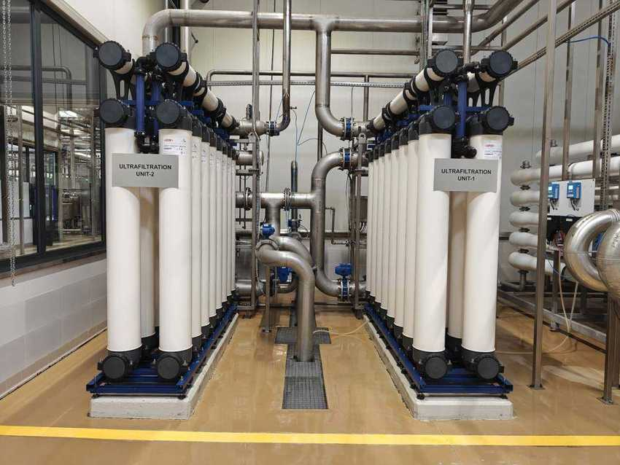 |  | 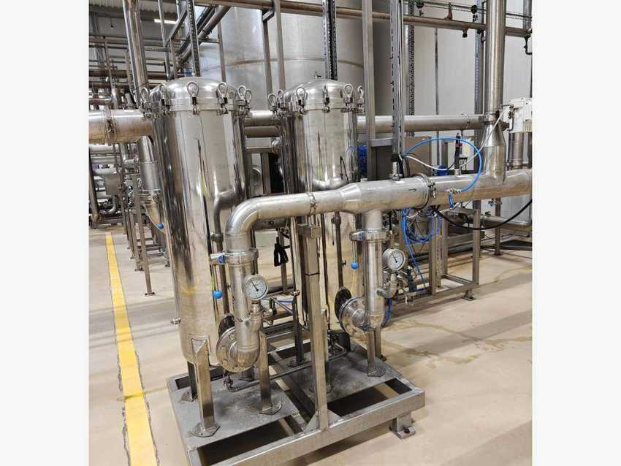
Ultrafiltration units 1 and 2 – DuPont IntegraTec modules |  | Pre-filter housings with pressure gauges
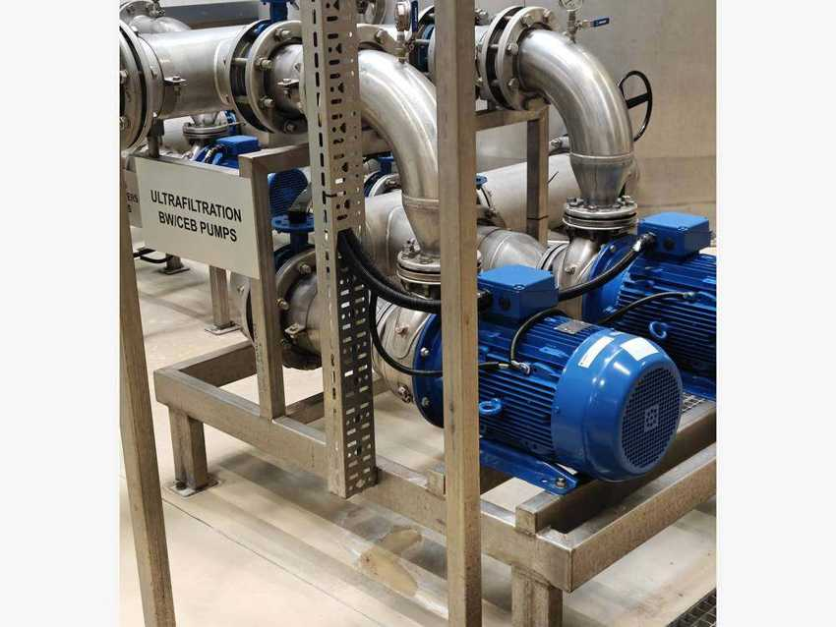 |  | 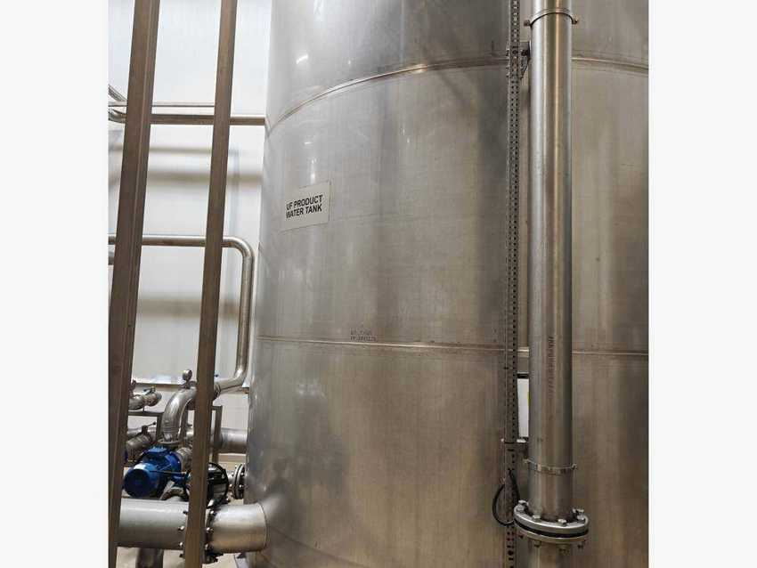
Ultrafiltration BW/CEB pumps |  | UF product water tank

9.4 Activated carbon filters

Machine data
MACHINE | MAKER | TYPE / MODEL | MFG. DATE | SERIAL NO. | INST. POWER kW | SAP NO. | ASSET NO.
Activated carbon filters 1–3 | Aquamatch | BACF2230 | 2023 | P1346/23 | – | 1000002478 | 223000000004
Carbon filter feed pumps (2) | – | – | – | – | – | – | –

Two feed pumps take the UF filtrate to three stainless activated carbon filters. The carbon removes the residual chlorine from the hypochlorite dosing, organic matter, taste and odour, and so protects the RO membranes. Each filter has a manway, sight glass and an automatic valve manifold for service and backwash. The vessels are marked as confined spaces – entry only with a valid work permit.

Photos
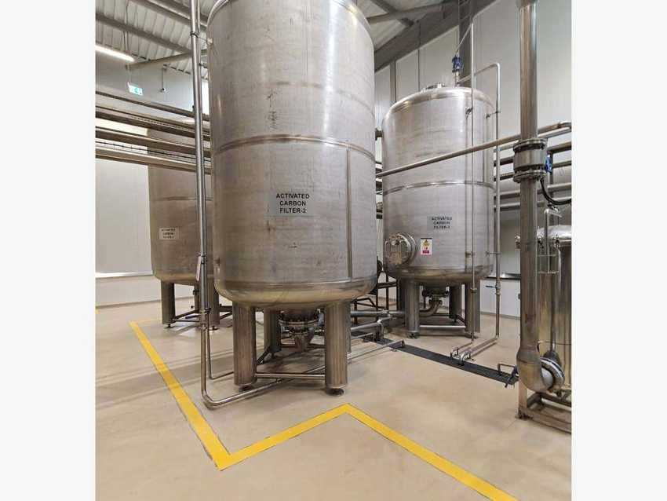 |  | 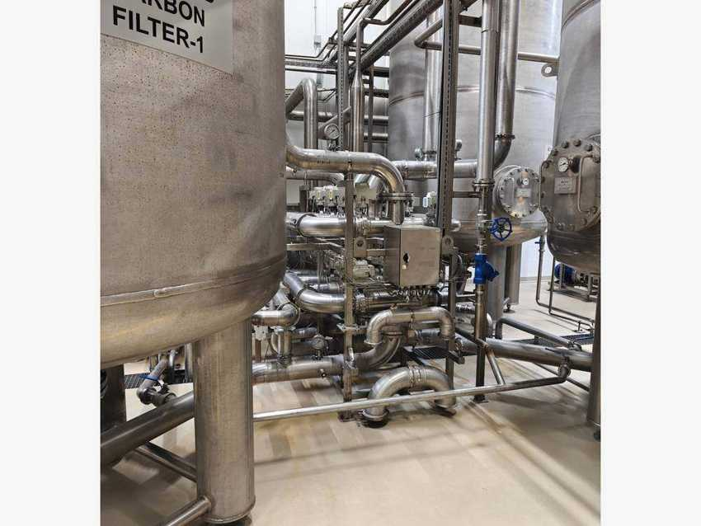
Activated carbon filters 2 and 3 |  | Carbon filter 1 with automatic valve manifold
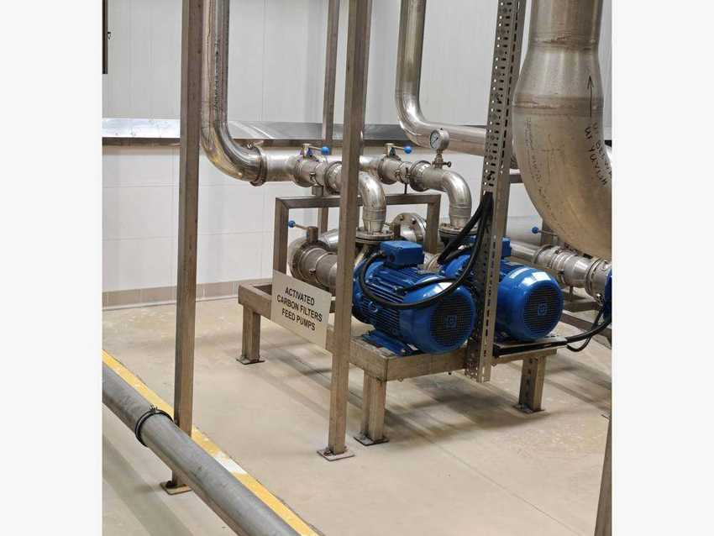
Activated carbon filter feed pumps

9.5 Water softeners

Machine data
MACHINE | MAKER | TYPE / MODEL | MFG. DATE | SERIAL NO. | INST. POWER kW | SAP NO. | ASSET NO.
Water softener 1 | Aquamatch | YBOPE 100 SFT 80 | 2023 | P1346/23_1nolu | – | 1000002476 | 223000000004
Water softener 2 | Aquamatch | YBOPE 100 SFT 80 | 2023 | P1346/23_2nolu | – | 1000002476 | 223000000004
Brine (salt) tanks | – | PE, 3,000 L | – | – | – | – | –

Regeneration sequence (Aquamatch operating sheet)
STEP | OPEN VALVES / ACTION
Service | BFV16.101 + 102 – raw water flows down through the resin and leaves as soft water
Backwash | BFV16.103 + 104 – water flows upwards through the bed to drain
Salting (brine) | BFV16.106 + 105 – brine drawn by the ejector through the resin to drain
Slow rinse | BFV16.106 + 105 – filtered water through the ejector pushes the brine out
Fast rinse | BFV16.101 + 105 – service water rinses the resin to drain
Brine tank filling | BFV16.101 – water fills the brine tank until the float closes

The two softeners treat a branch of raw water and supply the soft water network (bottle and case washers, CIP, utilities). Hardness is removed by ion exchange on a resin bed. The resin is regenerated with brine made from salt tablets (NaCl ≥ 99.5 %, 25 kg bags) in the 3,000 L brine tanks; the water level in each brine tank is held by a float valve. Each softener has seven automatic butterfly valves (BFV16.101–107) and a local Aquamatch control panel that shows service, backwash and regeneration status for both tanks.
The Russian operating sheet lists the backwash valves as BFV15.103 / 104; the Aquamatch diagram shows BFV16.103 / 104 – sheet to be corrected.

Photos
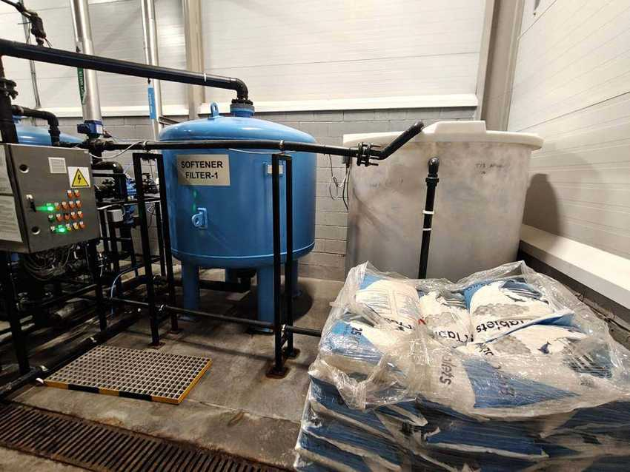 |  | 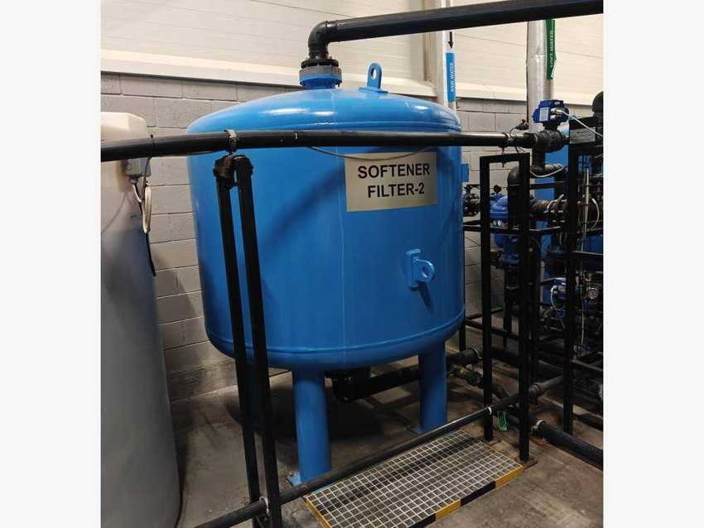
Softener filter 1, brine tank and salt store |  | Softener filter 2
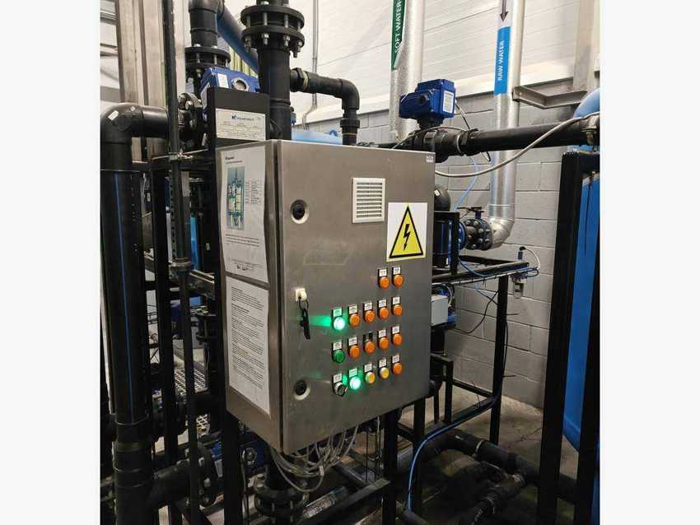 |  | 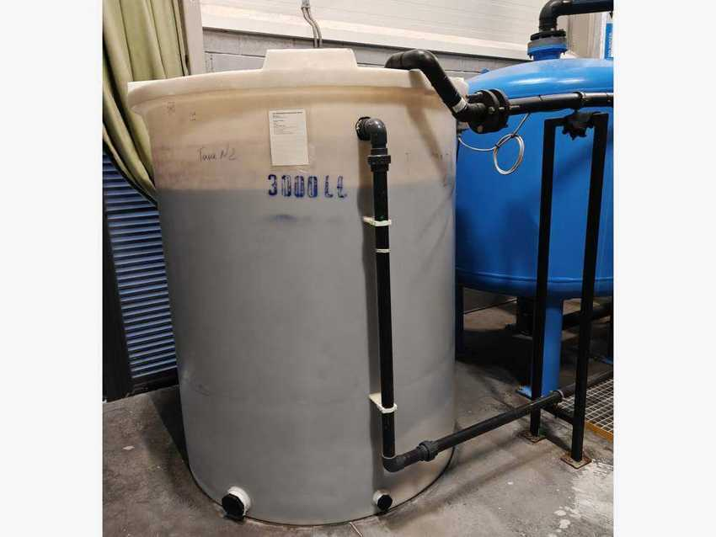
Softener control panel and valve rack |  | Brine (salt) tank, 3,000 L

9.6 Cartridge filtration and reverse osmosis

Machine data
MACHINE | MAKER | TYPE / MODEL | MFG. DATE | SERIAL NO. | INST. POWER kW | SAP NO. | ASSET NO.
Cartridge filter | Aquamatch | HSS-180 | 2023 | P1348/23 | – | 1000002472 | 223000000004
Cartridge filter | Aquamatch | HSS-88 | 2023 | ST0K003/23 | – | 1000002473 | 223000000004
RO high-pressure pump | Grundfos | CR vertical multistage | – | – | – | – | –
Reverse osmosis unit | Aquamatch | TFMG144316 | 2023 | P1346/23 | – | 1000002477 | 223000000004
Antiscalant dosing (2 pumps) | Aquamatch | PM50 · Vitec 1141 | – | – | – | – | –

Cartridge filters protect the membranes from particles. The Grundfos high-pressure pump feeds the Aquamatch RO skid, where the membranes in two rows of pressure vessels remove dissolved salts and give the treated water its low and stable alkalinity and TDS. Antiscalant (Vitec 1141) is dosed before the RO to prevent scaling. The permeate is stored in the stainless RO product water tank; the concentrate goes to drain / waste water treatment. Swing-bend flow plates allow the membranes to be cleaned in place.

Photos
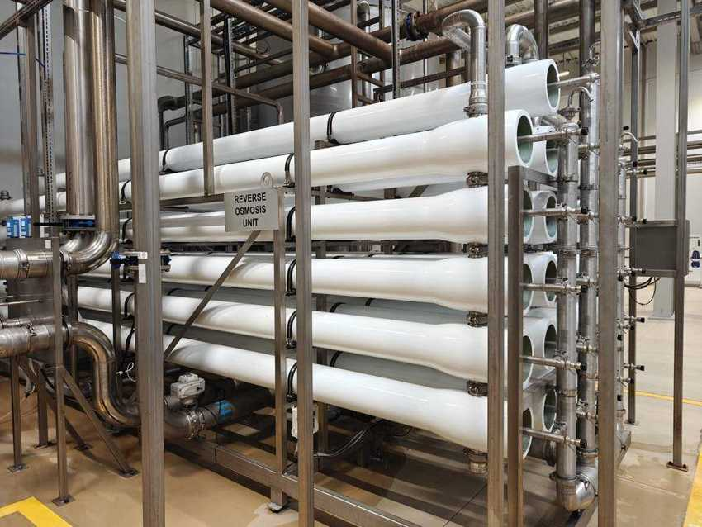 |  | 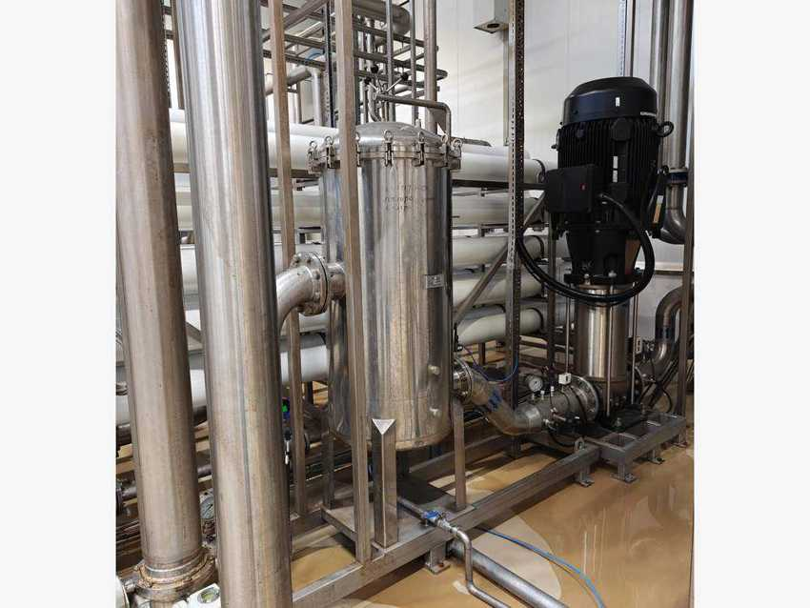
Reverse osmosis unit – membrane pressure vessels |  | Cartridge filter housing and Grundfos HP pump
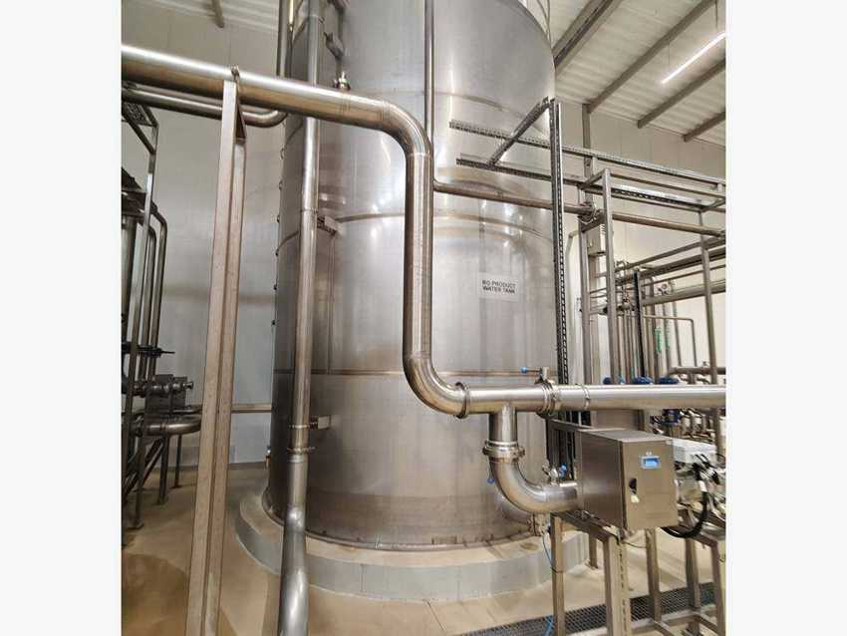
RO product water tank

9.7 UV disinfection – OPRP2

Machine data
MACHINE | MAKER | TYPE / MODEL | MFG. DATE | SERIAL NO. | INST. POWER kW | SAP NO. | ASSET NO.
UV unit 1 | Atlantium | RZ163-11 | 2023 | F01N09231368 | – | 1000002469 | 223000000004
UV unit 2 | Atlantium | RZ163-11HP | 2023 | F02N09231371 | – | 1000002470 | 223000000004

Two Atlantium Hydro-Optic UV reactors are the final microbiological barrier before the water goes to the lines. The UV unit on the treated-water line is tagged OPRP2 (Operational Prerequisite Program, UV2) in the food safety plan: its UV intensity and flow are shown on the touch-screen controller and must stay within the validated limits. A second UV reactor (UVL-1) is installed after the RO product water tank, with a bypass line.
Which serial (F01N… / F02N…) is installed at OPRP2 and at UVL-1 is to be confirmed on the reactor labels.

Photos
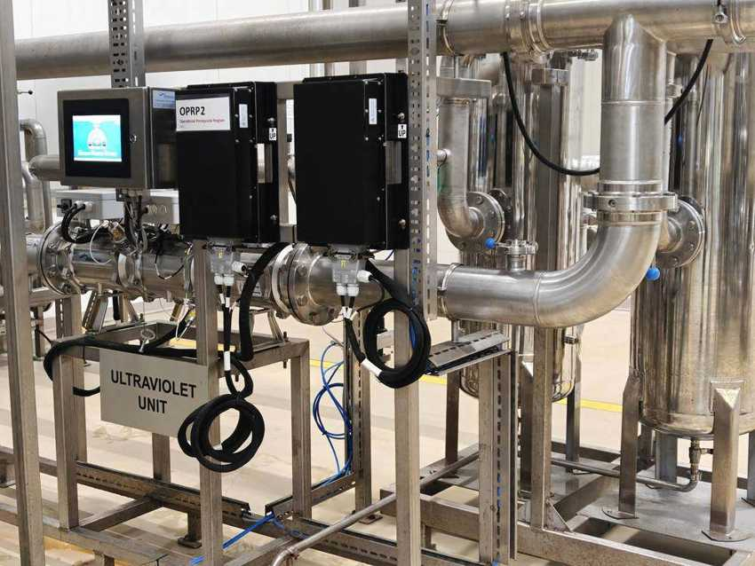 |  | 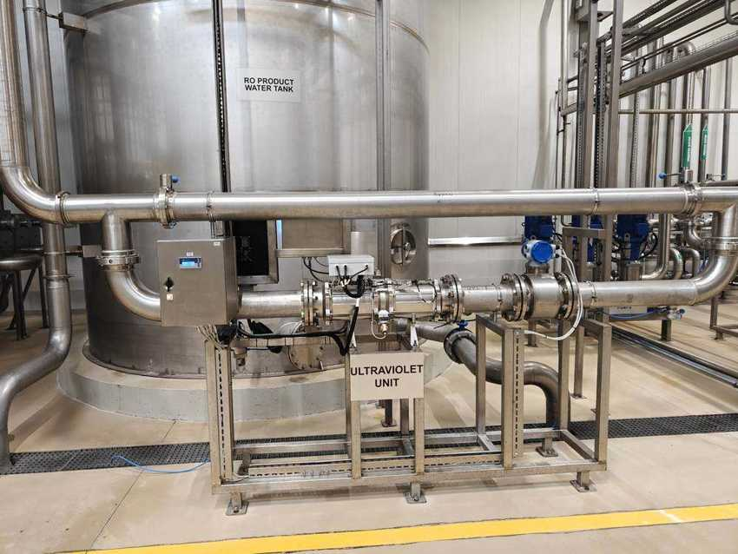
UV reactor with controller – OPRP2 |  | UV unit after the RO product water tank

9.8 Treated water distribution and soft water network

Machine data
MACHINE | MAKER | TYPE / MODEL | MFG. DATE | SERIAL NO. | INST. POWER kW | SAP NO. | ASSET NO.
Product water transfer pumps (3) | – | vertical multistage | – | – | – | – | –
Process water distribution plate | – | swing-bend | – | – | – | – | –
Polishing filter with analyser | Mettler-Toledo | analyser M300 | – | – | – | – | –
Raw / soft water headers | – | DN headers, flow meters | – | – | – | – | –

Three vertical multistage pumps deliver treated (process) water to the production lines through a stainless distribution plate with separate lines for PET (Line 1), NHF (Line 2 hot fill), CAN (Line 3) and RGB (Line 4), and to the syrup room. A filter housing with a Mettler-Toledo analyser monitors the water quality on line. Insulated raw water and soft water headers with flow meters and actuated valves distribute soft water to the washers, CIP and utilities.

Photos
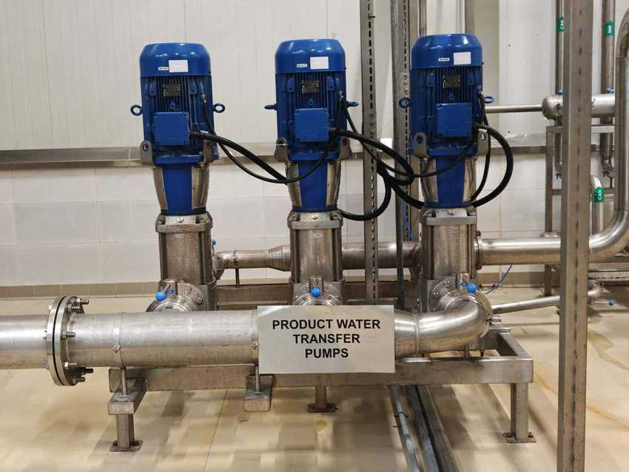 |  | 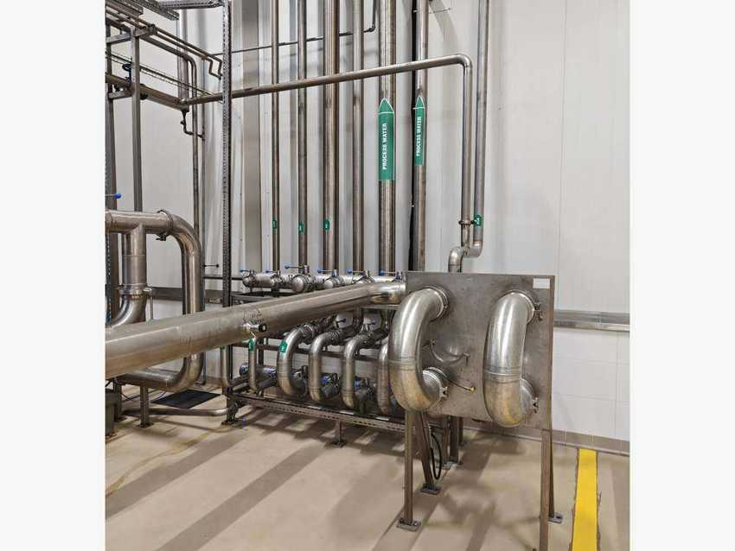
Product water transfer pumps |  | Process water distribution plate – PET, NHF, CAN, RGB
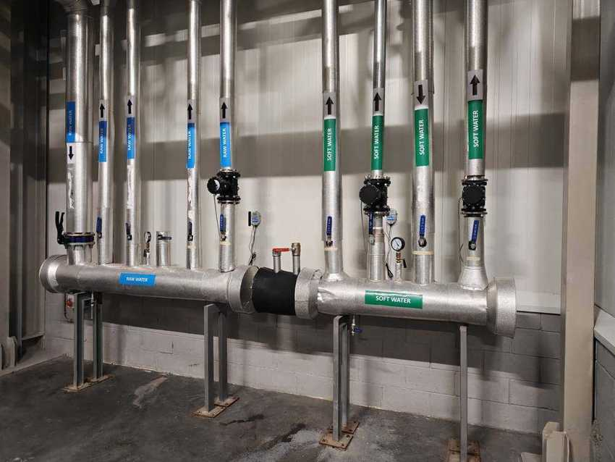 |  | 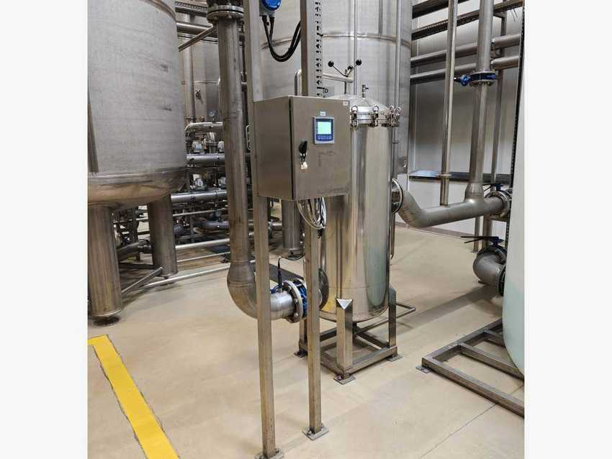
Raw water and soft water headers |  | Polishing filter with Mettler-Toledo analyser

9.9 Chemical dosing and membrane cleaning

Machine data
MACHINE | MAKER | TYPE / MODEL | MFG. DATE | SERIAL NO. | INST. POWER kW | SAP NO. | ASSET NO.
Dosing pumps | Aquamatch | PM50 series | – | – | – | – | –
Membrane CIP tank | – | PE | – | – | – | – | –
Chemical transfer pump | – | – | – | – | – | – | –

Chemicals in use
CHEMICAL | USE | STORAGE / DOSING
Sodium hypochlorite | Raw water disinfection, sanitation | PE tanks ≈ 300 L and ≈ 1,000 L, PM50 pumps
Coagulant | Before UF, binds fine particles | PE tank ≈ 300 L, dosing pump
Antiscalant Vitec 1141 | RO – prevents scaling | PE tank ≈ 1,000 L, 2 × PM50
Sodium hydroxide 30 % | Membrane CIP (alkaline) | PE tank, transfer pump
Citric acid | Membrane CIP (acid) | PE tank (Astro, order 20231670/23)
Tank labelled “Hypochlorite acid” | Probably HCl – to confirm | PE tank ≈ 1,000 L
Salt tablets NaCl ≥ 99.5 % | Softener regeneration | 25 kg bags, brine tanks

All water treatment chemicals are stored in a separate chemical room. Every tank stands in its own PP spill bund and is labelled; an eyewash station is at the entrance. Dosing pumps feed hypochlorite, coagulant and antiscalant to the process, while caustic and citric acid are used with the membrane CIP tank to clean the UF and RO membranes.
Safety: one tank is labelled “Hypochlorite acid”. Sodium hypochlorite and hydrochloric acid must never be mixed (chlorine gas) – HSE to confirm the content and correct the label.

Photos
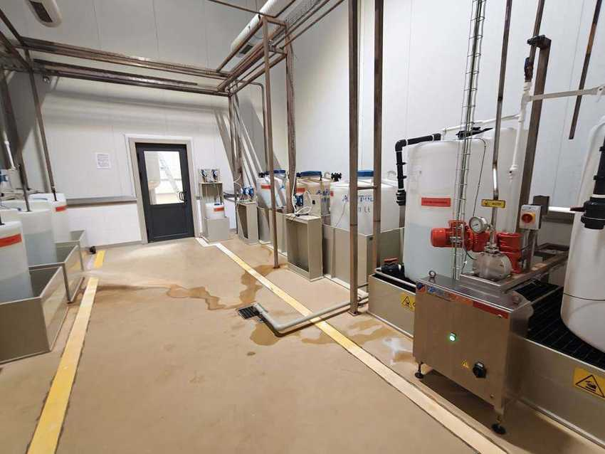 |  | 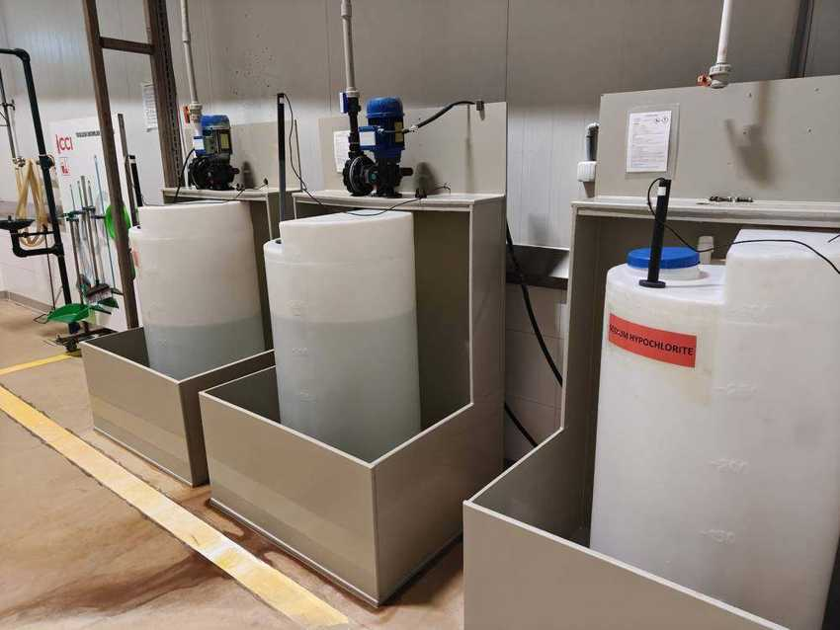
Chemical room – tanks in spill bunds |  | Dosing tanks with pumps
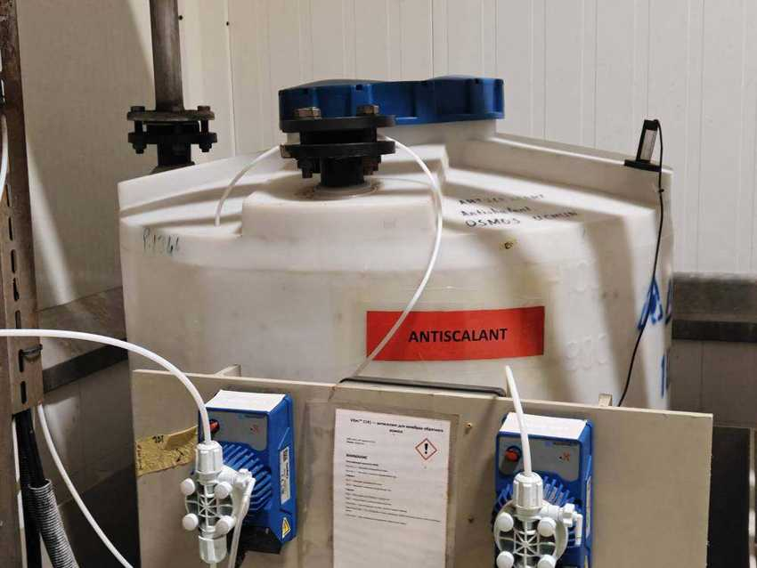 |  | 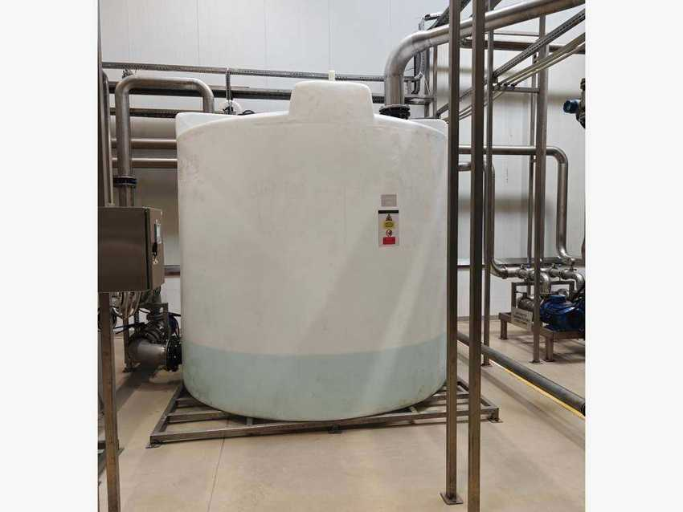
Antiscalant tank with two dosing pumps |  | Membrane cleaning (CIP) tank

9.10 Control system

Machine data
MACHINE | MAKER | TYPE / MODEL | MFG. DATE | SERIAL NO. | INST. POWER kW | SAP NO. | ASSET NO.
Water treatment control panel | Siemens / Aquamatch | SIMATIC HMI | – | – | – | – | –
Power distribution board DB-PR | – | – | – | – | – | – | –
Panel cooling unit | Uludağ Klima | SVK 1000 | 04.10.2023 | – | – | – | –

Panel cooling unit (nameplate)
PARAMETER | ULUDAĞ KLIMA SVK 1000
Cooling capacity (L35/L35) | 1,000 W
Power supply | 230 V, 50/60 Hz
Max. running / starting current | 2.4 A / 3.4 A
Refrigerant | R134a, 380 g
Protection / size | IP54 · 750 × 350 × 225 mm, 30 kg
Production date | 04.10.2023

The plant is controlled from the main stainless control panel with a Siemens SIMATIC HMI that shows the full plant mimic (tanks, pumps, filters, UF, RO). The panel has an emergency stop, alarm lamp and cabinet cooling units. Power for the treatment hall comes from distribution board DB-PR; a Mettler-Toledo analyser box is mounted next to it.

Photos
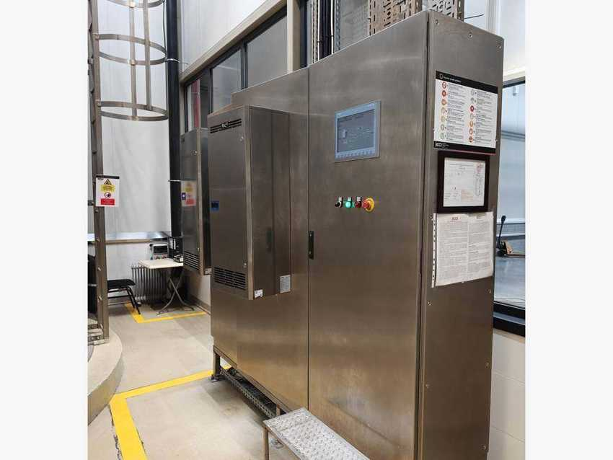 |  | 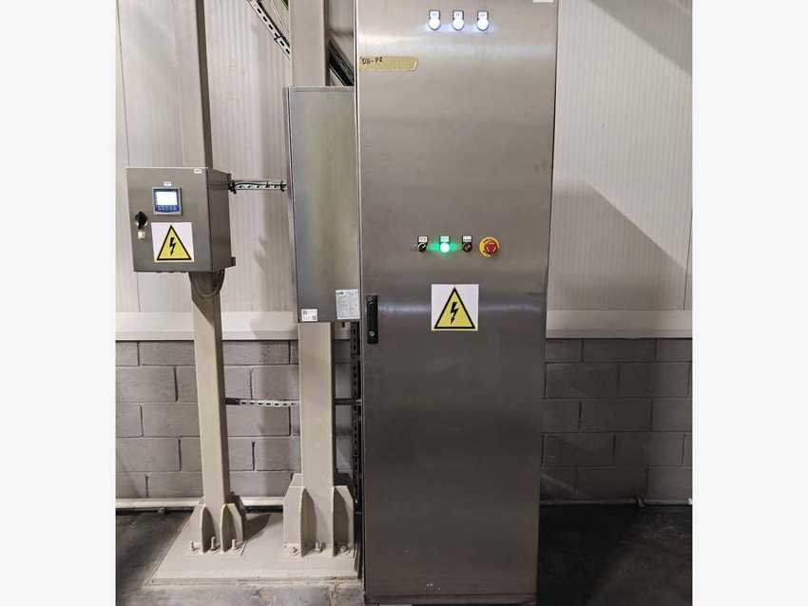
Main control panel with Siemens SIMATIC HMI |  | Power distribution board DB-PR

10 Syrup Room

10.1 Syrup room data and equipment register
Syrup Sparkling | TMCI Padovan (SAP-Blendtech), Italy – SYP00046 | Syrup Juice | SYP00047 – slurry / juice for Line 2
SAP asset (main) | 223000000015 – Syrup preparation equipment | Cost centre | 7300006018 (QA general)
SAP asset (Line 2) | 223000000136 – Syrup room equipment | Year of manufacture | 2023 (plates)
RGB line | Omnia Technologies (Italy); tanks 223020000004 / 005 | Room HVAC | Rooftop units – see Section 8.6
Users | Line mixers: PET, NHF, CAN, RGB | Control | Siemens HMI and SCADA workstation

The syrup room prepares the syrup for all beverages. Sugar is received in 50 kg bags, dissolved continuously in treated water, filtered, heated / cooled in a plate heat exchanger and stored as simple syrup. In the final syrup tanks the simple syrup is mixed with the beverage base and aromas to make finished syrup for each flavour, which is sent to the line mixers through swing-bend distribution panels. The juice side prepares the slurry for the Line 2 hot-fill products. A fully automatic CIP system cleans tanks, pipework and mixers.

Process flow
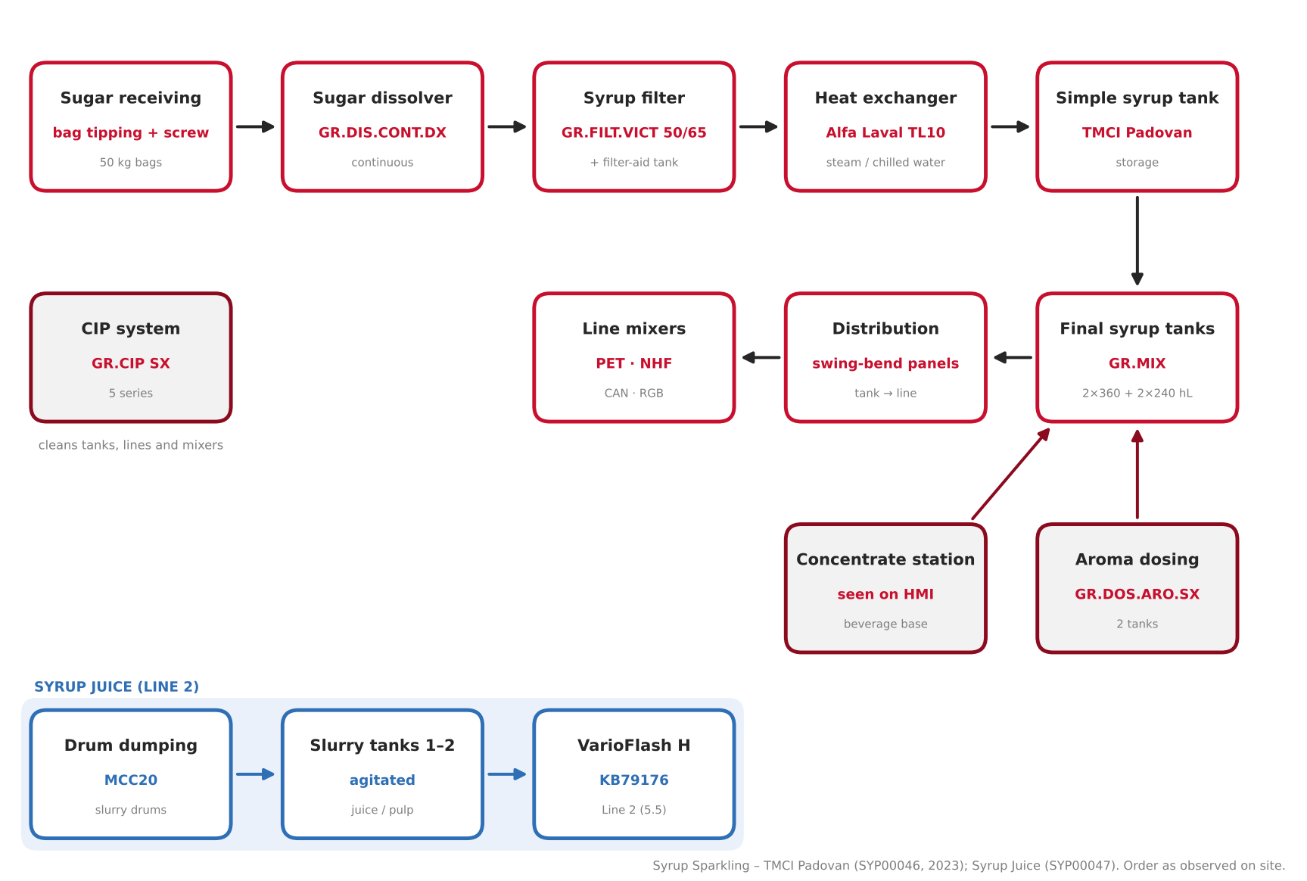
Figure 10.1 – Syrup room process flow, from sugar receiving to the line mixers (order as observed on site)

Equipment register
No. | EQUIPMENT / UNIT | MAKER | MODEL / TYPE | SERIAL NO. | SAP NO. | ASSET NO.
1 | Sugar receiving – bag tipping + screw conveyor | – | – | – | – | –
2 | Sugar dissolver (continuous) | TMCI Padovan | GR.DIS.CONT.DX | 90605203-0/001 | 1000002417 | 223000000015
3 | Simple syrup filter | TMCI Padovan | GR.FILT.VICT.50/65+E (DX) | 90605220-0/001 | – | 223000000015
4 | Filter-aid dosing tank (≈ 650 L) | TMCI Padovan | – | – | – | –
5 | Plate heat exchanger | Alfa Laval | TL10-PBASE | AAM1000082 | – | –
6 | Simple syrup tank | TMCI Padovan | – | – | – | 223000000015
7 | Final syrup (mix) tanks, 4 pcs | TMCI Padovan | GR.MIX 2×360 + 2×240 hL | 90605210-0/001 | 1000002419 | 223000000015
8 | Aroma dosing tanks + cabinet Q3 | TMCI Padovan | GR.DOS.ARO.SX | 90605209-0/001 | 1000002355 | 223000000015
9 | Concentrate station 1 (seen on HMI) | TMCI Padovan | – | – | – | –
10 | Pectin dissolving station (seen on HMI) | TMCI Padovan | – | – | – | –
11 | Syrup distribution panels | TMCI Padovan | swing-bend | – | – | 223000000015
12 | CIP system, 5 series | TMCI Padovan | GR.CIP SX | 90605213-0/001 | 1000002423 | 223000000015
13 | Control cabinets Q00 + SCADA workstation | TMCI Padovan / Siemens | SIMATIC HMI | – | – | 223000000015
14 | Slurry (juice) tanks 1–2 | – | agitated | – | – | 223000000136
15 | Drum dumping station – slurry | – | MCC20 | – | – | 223000000133
16 | RGB syrup room equipment | Omnia Technologies | – | – | – | –
17 | RGB syrup tanks (2) | – | – | – | – | 223020000004 / 005

Sources: SAP PM equipment list, SAP and QA asset registers, nameplates and the October 2026 photo walk. Items without SAP no. are not yet registered as SAP equipment. Zero-value RGB entries 223000000070 and 229800000134 may duplicate the RGB tanks – see Appendix A.

10.2 Sugar receiving and sugar dissolver

Machine data
MACHINE | MAKER | TYPE / MODEL | MFG. DATE | SERIAL NO. | INST. POWER kW | SAP NO. | ASSET NO.
Sugar receiving (bag tipping + screw) | – | – | – | – | – | – | –
Sugar dissolver (“Dissolving tank”) | TMCI Padovan | GR.DIS.CONT.DX | 2023 | 90605203-0/001 | – | 1000002417 | 223000000015

Cabinet cooling unit – Irinox (Stulz)
PARAMETER | KCVE2000261800I
Serial no. / date | 0001076654 / 30.05.2023
Supply | 400/460 V 3~, 50/60 Hz
Current (starting) | 1.7 / 1.8 A (40 A)
Cooling / input power | 2.0 / 2.1 kW · 0.9 / 1.1 kW
Refrigerant / protection | R134a 0.345 kg · IP54

Pallets of 50 kg sugar bags are raised on a hydraulic scissor-lift table next to the guarded tipping platform. The operator empties the bags into the hopper and an inclined screw conveyor lifts the sugar into the dissolver; a dust extraction duct runs above the station. The continuous dissolver dissolves the sugar in treated water to the target Brix. Its control cabinet is cooled by an Irinox air conditioner.
The dissolver tank plate (volume, design pressure) is still to be photographed.

Photos
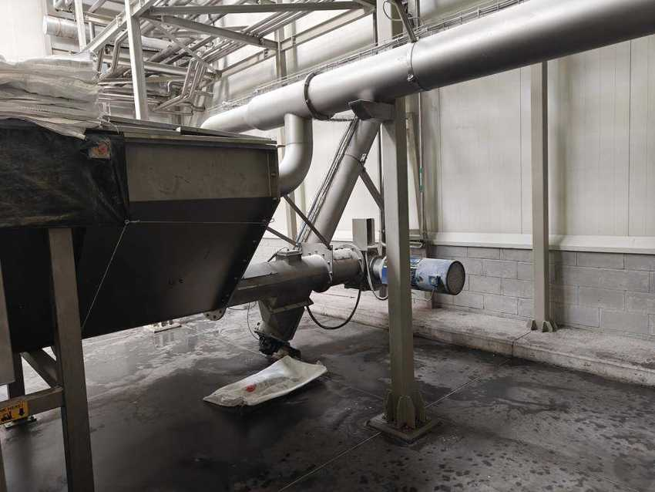 |  | 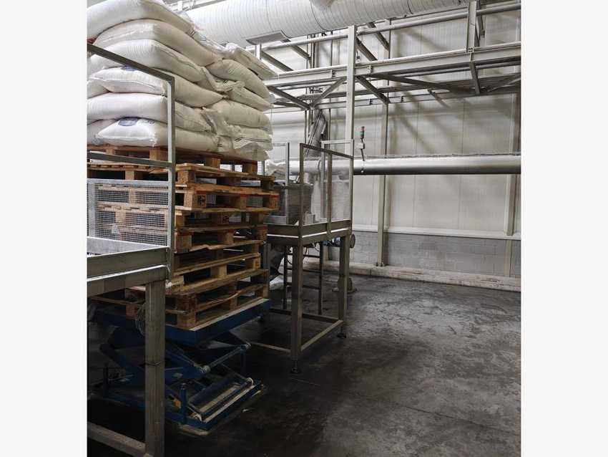
Bag-tipping hopper with inclined screw conveyor |  | Sugar pallets at the scissor-lift table
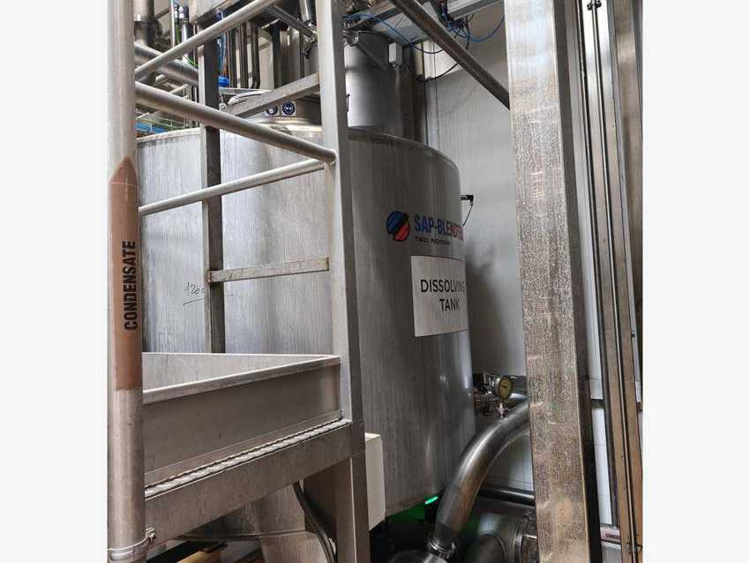 |  | 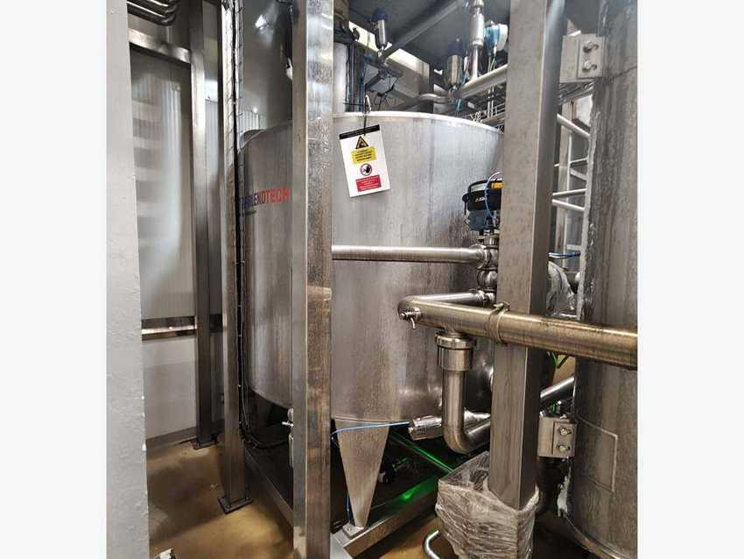
Continuous sugar dissolver (Dissolving tank) |  | Sugar dissolver – side view

10.3 Syrup filtration and plate heat exchanger

Machine data
MACHINE | MAKER | TYPE / MODEL | MFG. DATE | SERIAL NO. | INST. POWER kW | SAP NO. | ASSET NO.
Simple syrup filter (“Filtration tank”) | TMCI Padovan | GR.FILT.VICT.50/65+E (DX) | 2023 | 90605220-0/001 | – | – | 223000000015
Filter-aid dosing tank (≈ 650 L) | TMCI Padovan | agitated | – | – | – | – | –
Plate heat exchanger | Alfa Laval | TL10-PBASE | 2023 | AAM1000082 | – | – | –

Nameplate data
PARAMETER | SYRUP FILTER | PLATE HEAT EXCHANGER
Volume | 4,334 L | 226 L
Design / allowable pressure | 8.0 bar | 0 / 10 bar
Test pressure / date | 11.8 bar · 04.10.2023 | 14.3 bar · 11.08.2023
Temperature range | −10 / +85 °C | 0 / 120 °C
PED category / fluid group | Category IV | Fluid group 2
Fluid | Food liquids, CO2, air, N2 | Syrup, steam, chilled water
Vessel / serial no. | 11929 | AAM1000082 (faint – to confirm)

The simple syrup is filtered in a pressure filter; the small agitated tank next to it is most likely used to prepare the filter aid. The Alfa Laval plate heat exchanger then heats or cools the syrup – the pipe labels show steam condensate, chilled water and sugar syrup connections. A second, smaller PHE is mounted on the same skid.
Filter, filter-aid tank and PHE are not in the SAP equipment list. Use of the agitated tank as filter-aid tank to be confirmed.

Photos
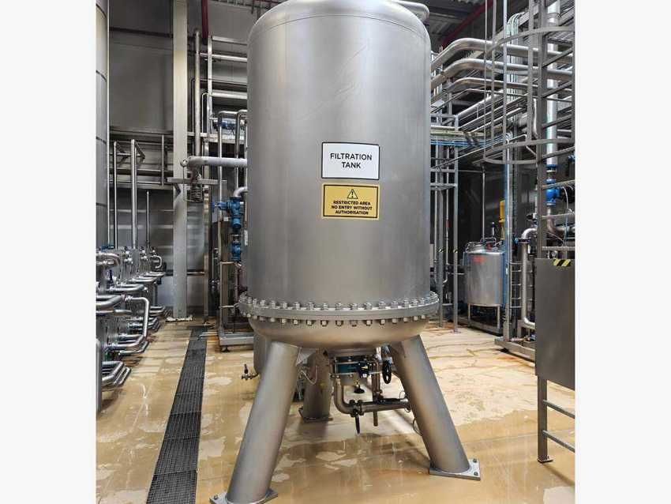 |  | 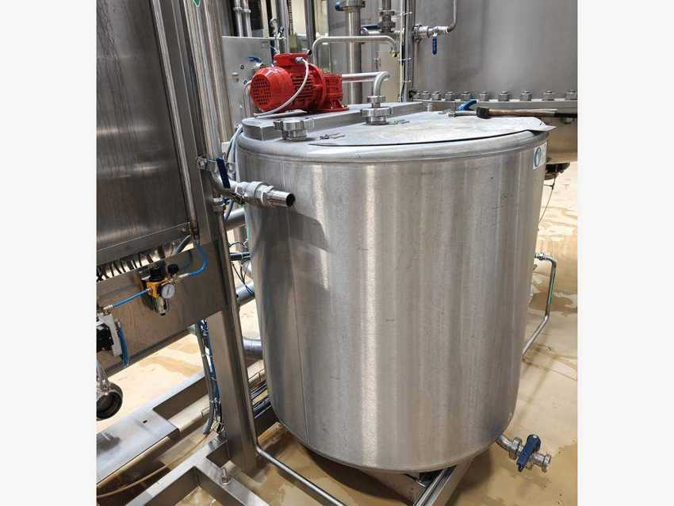
Simple syrup filter (Filtration tank) |  | Agitated filter-aid tank
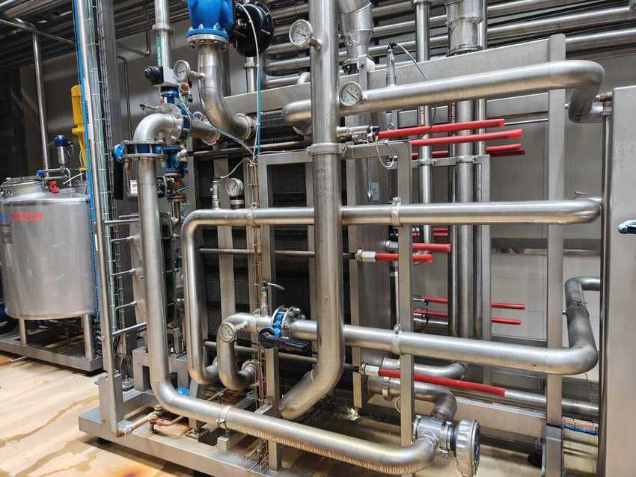
Alfa Laval plate heat exchanger skid

10.4 Simple syrup and final syrup tanks

Machine data
MACHINE | MAKER | TYPE / MODEL | MFG. DATE | SERIAL NO. | INST. POWER kW | SAP NO. | ASSET NO.
Simple syrup tank | TMCI Padovan | – | 2023 | – | – | – | 223000000015
Final syrup (mix) tanks, 4 pcs | TMCI Padovan | GR.MIX 2×360 + 2×240 hL | 2023 | 90605210-0/001 | – | 1000002419 | 223000000015

After filtration and cooling the simple syrup is stored in the simple syrup tank. In the four numbered final syrup (mix) tanks it is mixed with the beverage base and aromas according to the formula. After the quality release the finished syrup is sent to the line that runs the product. The tanks stand on cone legs under a stainless pipe bridge.
The “mix tanks” of SAP (2 × 360 hL + 2 × 240 hL) are taken to be the four final syrup tanks seen on site – to confirm. The simple syrup tank plate (volume) is still to be photographed.

Photos
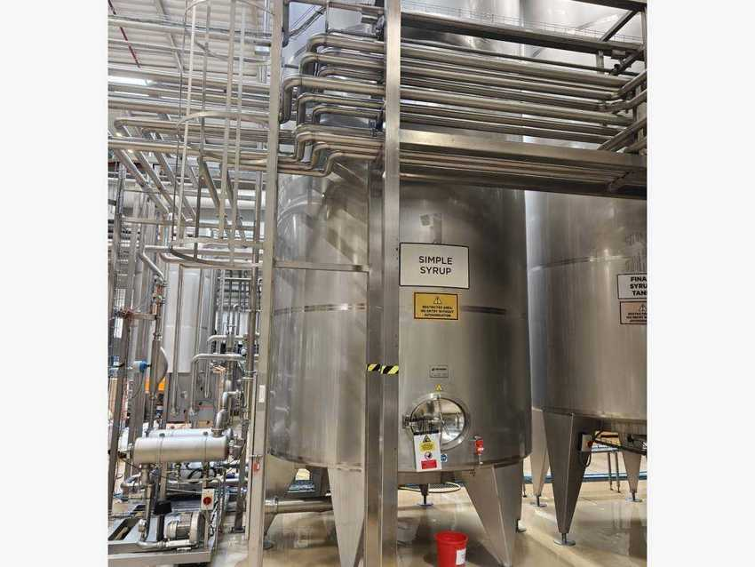 |  | 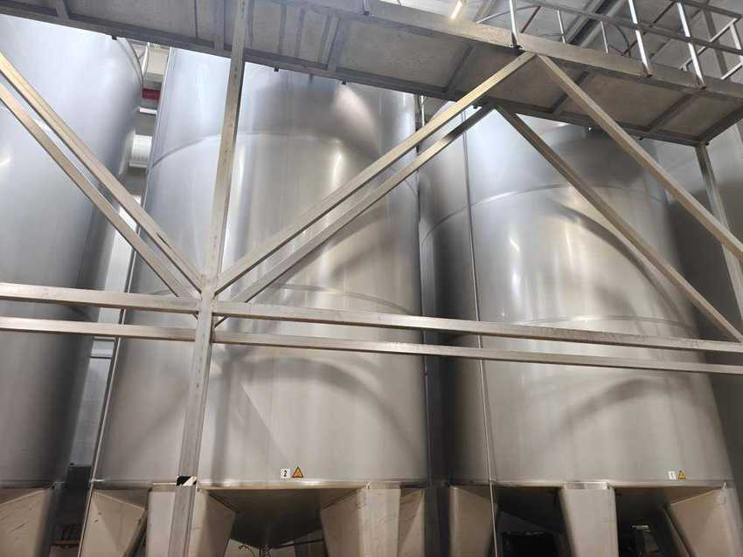
Simple syrup tank |  | Final syrup (mix) tanks 1 and 2
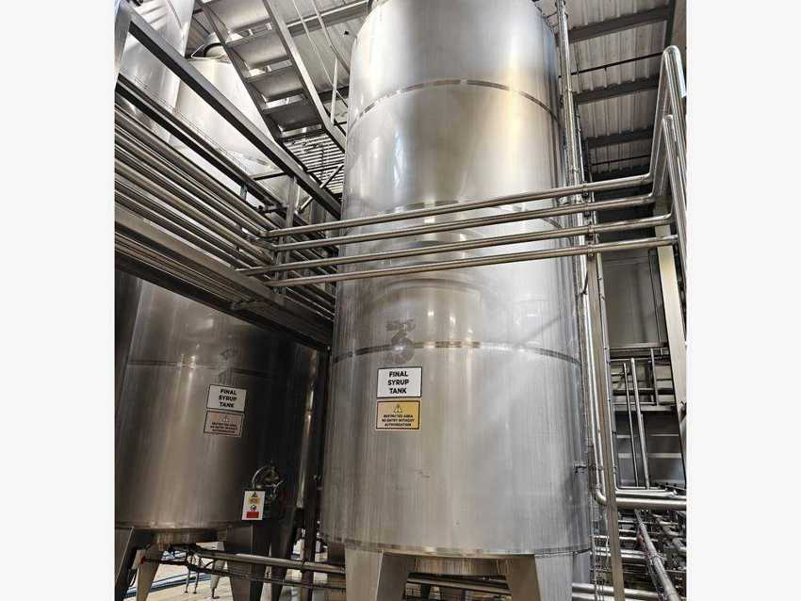
Final syrup tank 3

10.5 Aroma dosing and syrup distribution

Machine data
MACHINE | MAKER | TYPE / MODEL | MFG. DATE | SERIAL NO. | INST. POWER kW | SAP NO. | ASSET NO.
Aroma dosing tanks + cabinet Q3 | TMCI Padovan | GR.DOS.ARO.SX | 2023 | 90605209-0/001 | – | 1000002355 | 223000000015
Syrup distribution panels | TMCI Padovan | swing-bend | 2023 | – | – | – | 223000000015

Cabinet Q3 cooling unit – Irinox (Stulz)
PARAMETER | KCVE1500228800I
Serial no. / date | 0001090195 / 07.09.2023
Supply | 400/460 V 2~, 50/60 Hz
Current (starting) | 2.5 / 2.6 A (110 A)
Cooling / input power | 1.4 / 1.5 kW · 0.75 / 0.825 kW
Refrigerant / protection | R134a 0.28 kg · IP54

Two agitated aroma dosing tanks, controlled from cabinet Q3 with its own HMI, add the flavour components to the final syrup. Every syrup tank has its own swing-bend panel: the operator connects a tank to the PET, NHF, CAN or RGB line, or to CIP supply / return, by moving a bend between numbered ports – so a product cannot reach the wrong line by accident.
SAP writes the aroma dosing serial as 90605209-0-001; the plate reads 90605209-0/001.

Photos
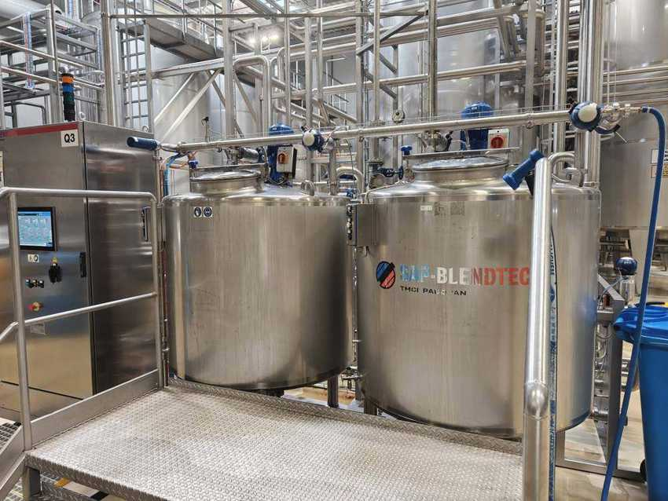 |  | 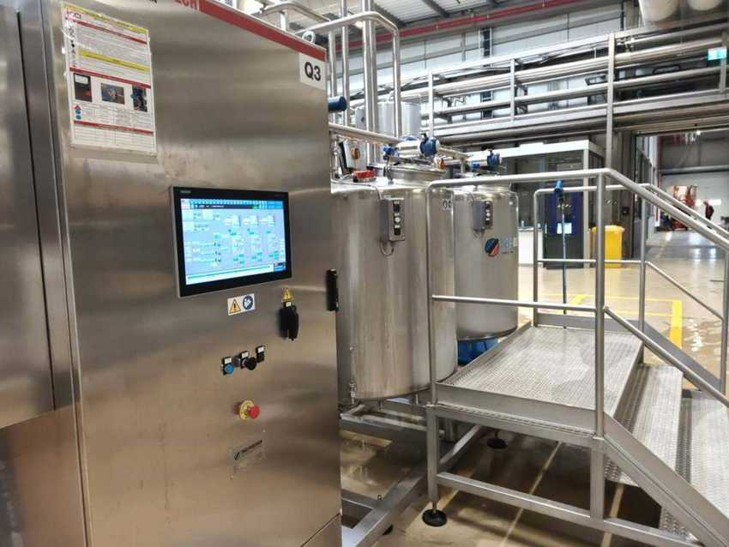
Aroma dosing tanks with SAP-Blendtech logo |  | Aroma dosing cabinet Q3 with HMI
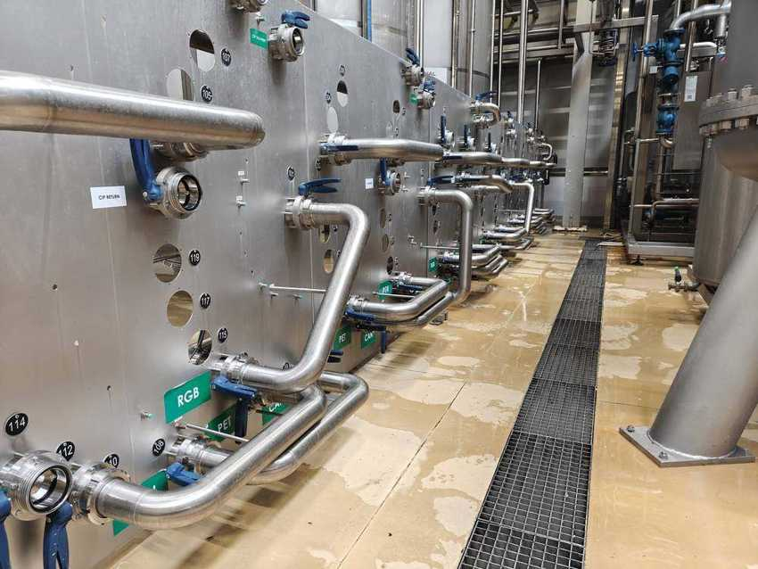 |  | 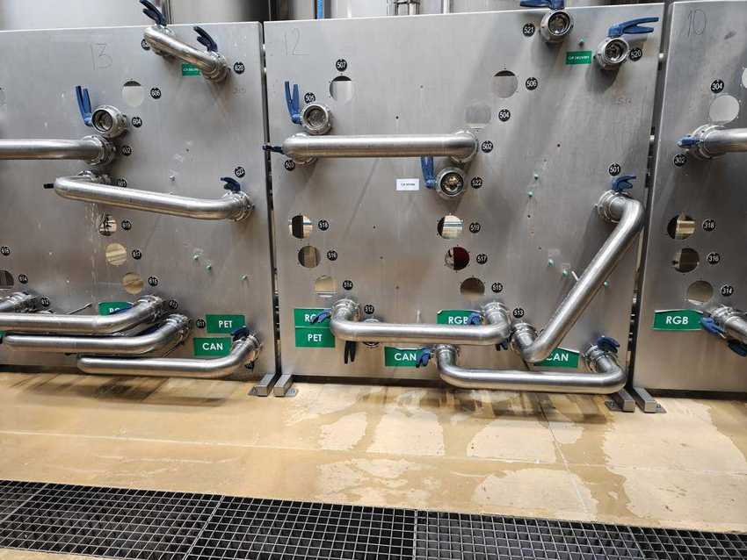
Syrup distribution panels – PET, CAN, RGB outlets |  | Swing-bend panels 12 and 13

10.6 Syrup Juice – slurry tanks and drum dumping

Machine data
MACHINE | MAKER | TYPE / MODEL | MFG. DATE | SERIAL NO. | INST. POWER kW | SAP NO. | ASSET NO.
Slurry (juice) tanks 1–2 | – | agitated | – | – | – | – | 223000000136
Drum dumping station – slurry | – | MCC20 | 2024 | – | – | – | 223000000133

Cabinet cooling unit – Rittal Blue e+
PARAMETER | SK 3185530
Serial no. / date | 2023K000132305 / 28.08.2023
Supply | 110–240 V 1~ / 380–480 V 3~, 50–60 Hz
Power input / cooling | 0.62 kW / 1.60 kW
Fuse | 15 A
Refrigerant / protection | R134a 300/450 g · IP55 / IP24

Slurry drums arrive on a roller conveyor into the guarded drum dumping cell, are tipped into the hopper and the slurry is pumped to the two agitated slurry (juice) tanks. Each tank has its own swing-bend panel (juice, CIP return, product water) and a deaerator on the outlet. From here the slurry goes to the Line 2 VarioFlash H pasteuriser (KB79176) and the FlexiFruit pre-dosing filler (Section 5).
The MCC20 machine plate (maker, serial, power) and a slurry tank plate (volume) are still to be photographed.

Photos
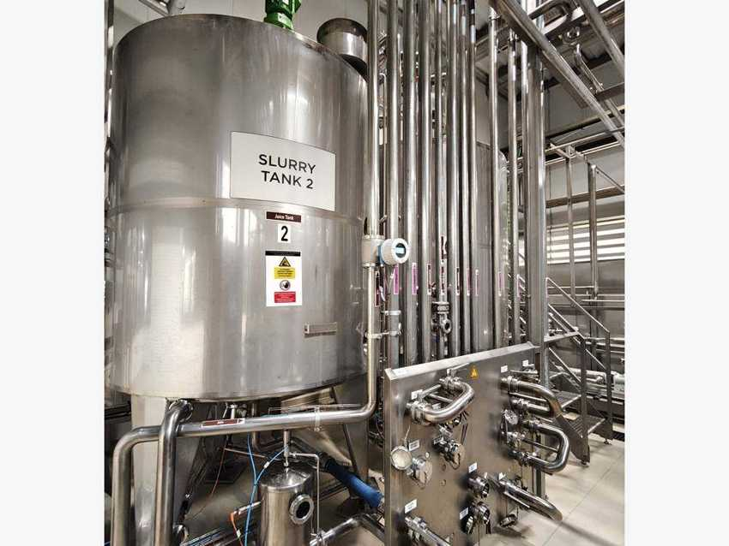 |  | 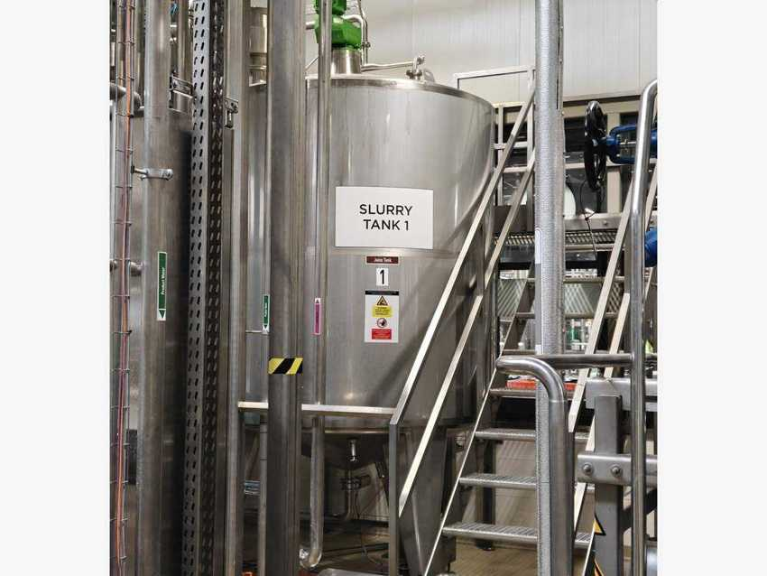
Slurry tank 2 with swing-bend panel |  | Slurry tank 1
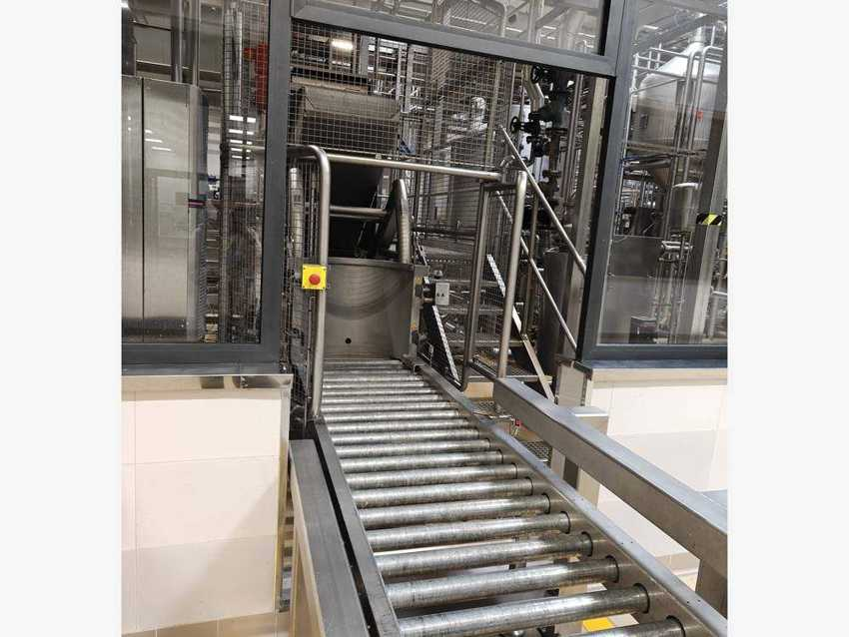 |  | 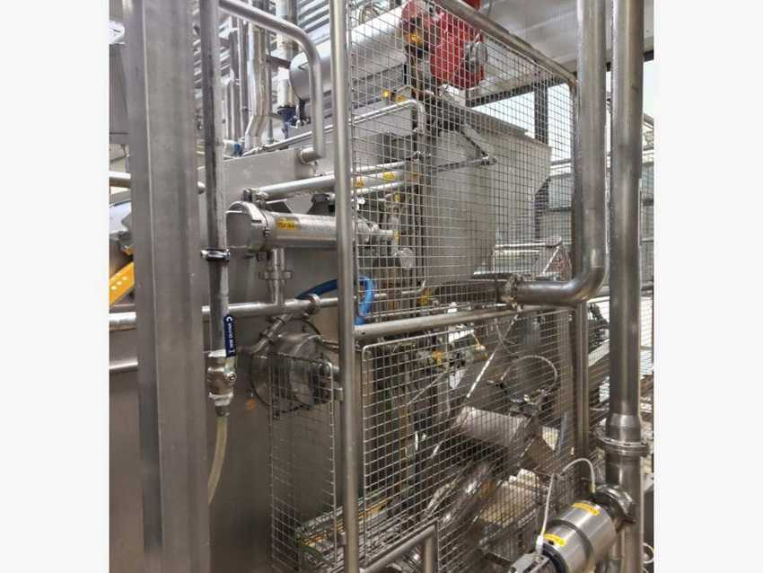
Drum dumping station – roller infeed |  | Drum dumping hopper and transfer pump

10.7 CIP system

Machine data
MACHINE | MAKER | TYPE / MODEL | MFG. DATE | SERIAL NO. | INST. POWER kW | SAP NO. | ASSET NO.
CIP system, fully automatic, 5 series | TMCI Padovan | GR.CIP SX | 2023 | 90605213-0/001 | – | 1000002423 | 223000000015

The fully automatic CIP system cleans and sanitizes the syrup tanks, pipework, distribution lines and line mixers with caustic, acid, hot water and sanitizer. CIP supply and return lines are connected to each circuit through the numbered swing-bend panel, so cleaning solution and product can never be connected at the same time.
CIP tank volumes and the number of tanks are still to be recorded from the tank plates.

Photos
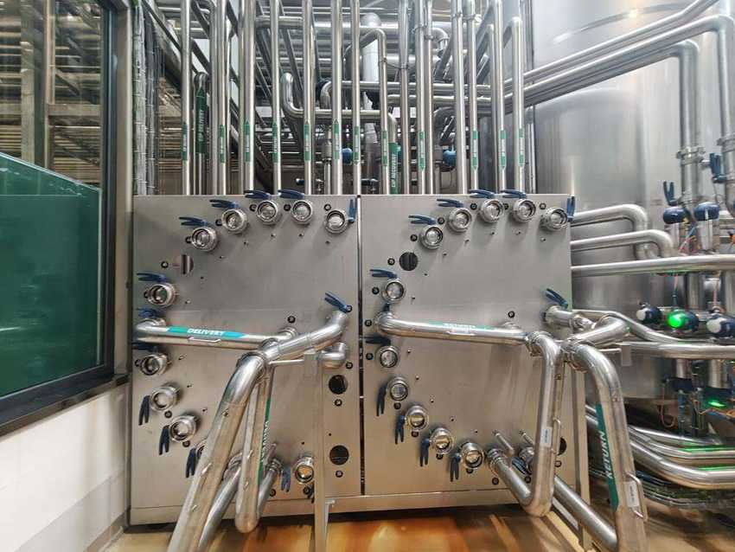 |  | 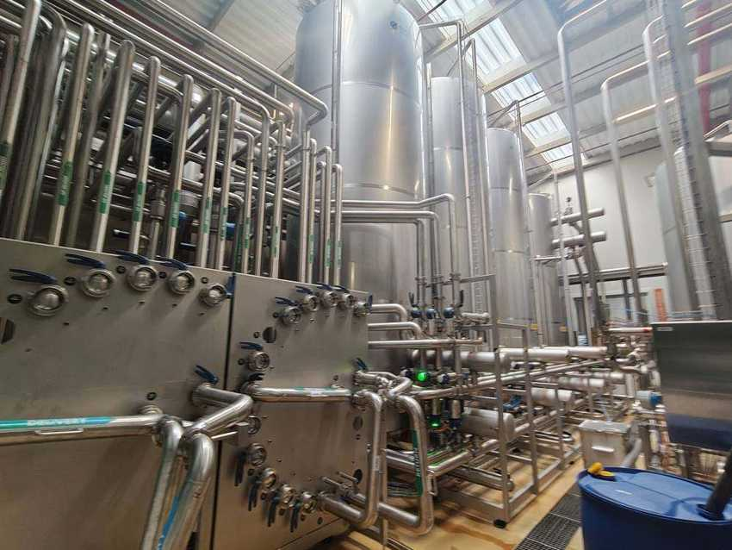
CIP supply / return swing-bend panel |  | CIP panel with tanks and pipework

10.8 Control system

Machine data
MACHINE | MAKER | TYPE / MODEL | MFG. DATE | SERIAL NO. | INST. POWER kW | SAP NO. | ASSET NO.
Main power and control cabinets Q00 | TMCI Padovan / Rittal | – | 2023 | – | – | – | 223000000015
Local operator panel | Siemens | SIMATIC HMI | – | – | – | – | –
SCADA workstation | Fujitsu | Celsius PC, 2 screens | – | – | – | – | –

The syrup room is run from the stainless Q00 power and control cabinets. Local Siemens SIMATIC HMI panels with emergency stops are mounted at the process units, and a SCADA workstation in the control room shows the syrup room overview and the final syrup tanks. The HMI also shows a “Concentrate Station 1” (two concentrate tanks) and a “Pectin Dissolving Station” that are still to be located on site.

Photos
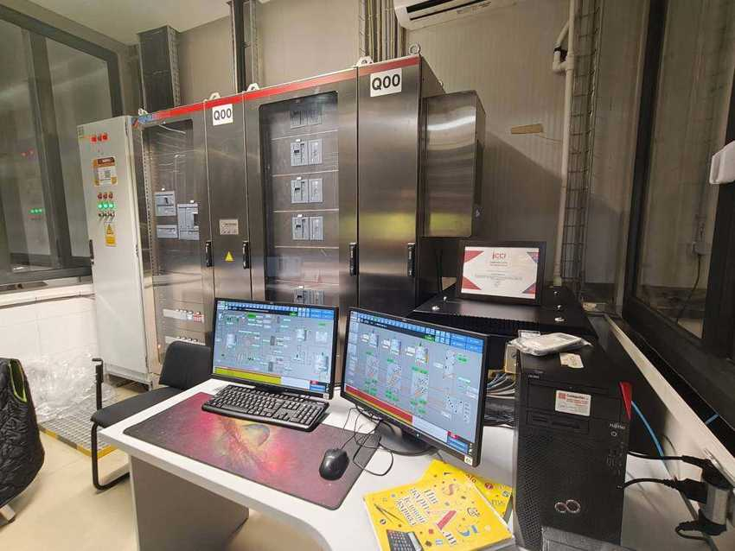 |  | 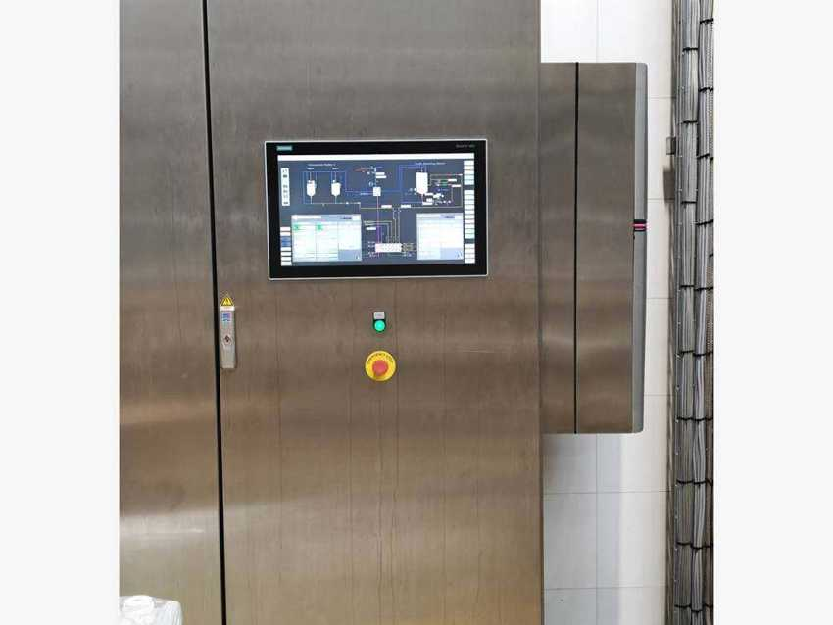
Q00 cabinets and SCADA workstation |  | Local cabinet with Siemens SIMATIC HMI

10.9 Line 4 RGB syrup equipment (Omnia)
The RGB line has its own syrup room equipment supplied by Omnia Technologies S.p.A. (Italy), which feeds the DBF250T mixer of Line 4 (Section 7.7). The QA asset register lists two syrup room tanks for the RGB line (223020000004 and 223020000005, August 2026) and two zero-value addition entries (223000000070 – syrup tanks “24000 l”, 2 pcs; 229800000134 – RGB48 addition). The master data has no model or serial number.
Not photographed during the October 2026 walk – Omnia skids, RGB syrup tanks and their plates to be added.

11 Waste Water Treatment

11.1 System data and equipment register
Supplier | Cuss | Functional location | WWT00033 – SMR / Waste Water Treatment
SAP asset | 223000000047 – Waste water treatment facility | Capitalised | 9 October 2025
Inputs | Washer and CIP effluent, RO reject, filter backwash, floor drains | Output | Treated water to discharge
Capacity | – | Discharge limits | Local permit – to be added

The waste water treatment plant collects the effluent from production, CIP, the bottle and case washers and the water treatment plant. The water is screened, buffered and pH-neutralised before the main treatment stage, then discharged within the permitted limits. Sludge is separated and removed.

Process flow
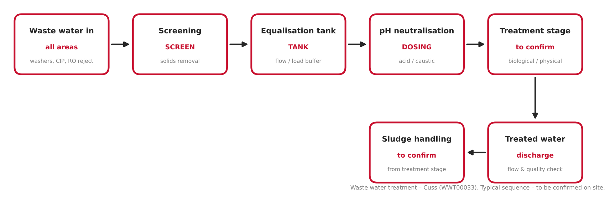
Figure 11.1 – Waste water treatment process flow (typical sequence – to be confirmed on site)

Equipment register
No. | EQUIPMENT / UNIT | MAKER | MODEL | SERIAL NO. | YOM | ASSET NO.
1 | Waste water treatment facility (package) | Cuss | – | – | 2025 | 223000000047
2 | Screen / solids separator | – | – | – | – | –
3 | Equalisation tank and mixers | – | – | – | – | –
4 | pH neutralisation – dosing pumps and tanks | – | – | – | – | –
5 | Main treatment stage (type to confirm) | – | – | – | – | –
6 | Sludge handling | – | – | – | – | –
7 | Discharge flow meter and online monitoring | – | – | – | – | –
8 | Control panel / PLC | – | – | – | – | –

Source: master-data functional location WWT00033 and the QA asset register (asset 223000000047, booked as “Сооружение очистки сточных вод” – waste water treatment facility). Items 2–8 are typical units and must be confirmed during the site walk.

11.2 Collection, screening and equalisation
Effluent from the production hall and the utilities flows to the screen, which removes labels, glass and other solids, and then to the equalisation tank, which evens out flow and load.
Photos and nameplate data (power, capacity): to be collected on site.

11.3 Neutralisation, treatment and discharge
The pH is corrected with acid or caustic dosing (washer and CIP effluent is strongly alkaline). The water then passes through the main treatment stage and is discharged through a flow meter with online monitoring. Sludge from the treatment stage is collected for removal.
Photos and nameplate data (power, capacity): to be collected on site.

12 Quality Control Laboratory

12.1 Laboratory data and asset overview
Area | Quality control laboratory (QA) | Functional location | LAB00039 – SMR / Laboratories Equipment / General
SAP asset class | 223060 – Laboratory equipment | Company code | 1801
Number of assets | 95 (90 capitalised Sept 2024, 5 in March 2026) | Range | 223060000000 – 223060000094
Scope | Water, syrup, product, packaging and hygiene testing | Related | Water treatment (9), syrup room (10), all lines (4–7)

The quality control laboratory checks the treated water, sugar, syrup and finished product (Brix, CO2, pH, dissolved oxygen, colour, turbidity) and the packaging from all four lines (PET bottles, cans, closures and glass bottles). It also runs the microbiological and hygiene programme for the production areas. The instruments are grouped below by use; each group lists the SAP asset numbers from the QA asset register.
Source: QA asset register (company code 1801, asset class 223060). Instrument names are translated and normalised from the register; makers are taken from the asset text where given. Models and serial numbers are to be added from the instrument labels.

12.2 Chemical and physical analysis
No. | INSTRUMENT / EQUIPMENT | MAKER | QTY | USE | YEAR | ASSET NO.
1 | Density meter (Brix) – SAP 1000002728, SN 84477354 | Anton Paar | 1 | Brix / density | 2024 | 223060000013
2 | Carbon dioxide meter | Anton Paar | 1 | CO2 in product | 2024 | 223060000005
3 | Purity tester | Anton Paar | 1 | CO2 purity | 2024 | 223060000009
4 | Refractometer | Rudolph (USA) | 1 | Brix | 2024 | 223060000032
5 | Automatic titrator | – | 1 | alkalinity, acidity | 2024 | 223060000001
6 | Digital burettes | BRAND (Germany) | 3 | titration | 2024 | 223060000015–17
7 | pH meter 7110 | – | 1 | pH | 2024 | 223060000030
8 | Portable pH meter (listed “HP meter”) | – | 1 | pH on site | 2024 | 223060000075
9 | Conductivity meter | WTW | 1 | water conductivity | 2024 | 223060000012
10 | Dissolved oxygen meter | Xylem Analytics | 1 | O2 in water / product | 2024 | 223060000029
11 | Spectrophotometer | Xylem | 1 | water analysis | 2024 | 223060000033
12 | Photometer | Hach | 1 | water analysis | 2024 | 223060000031
13 | Colorimeter | Hach | 1 | colour | 2024 | 223060000011
14 | Chlorine comparator | – | 1 | chlorine in water | 2024 | 223060000008
15 | Turbidity meter | – | 1 | turbidity | 2024 | 223060000037
16 | CO2 removal device | Somex | 1 | sample decarbonation | 2024 | 223060000010
17 | CO2 bottle test calibration (gold standard) | – | 1 | CO2 calibration | 2024 | 223060000086
18 | Sugar sieve shaker (automatic) | – | 1 | sugar granulometry | 2024 | 223060000043
19 | Test sieves 6 / 10 / 20 / 100 mesh | – | 4 | sugar granulometry | 2024 | 223060000044–47
20 | Thermometers | Testo | 2 | temperature | 2024 | 223060000034–35
21 | Digital burettes (additional) | – | 5 | titration | 2026 | 223060000090–94

12.3 Microbiology
No. | INSTRUMENT / EQUIPMENT | MAKER | QTY | USE | YEAR | ASSET NO.
1 | Incubators | Jeio Tech | 4 | culture incubation | 2024 | 223060000055–57, 223060000072
2 | Low-temperature incubator (cooled) | Jeio Tech | 1 | yeast & mould | 2024 | 223060000054
3 | Autoclave NC 40M | – | 1 | sterilisation | 2024 | 223060000049
4 | Laminar flow cabinet | – | 1 | sterile work | 2024 | 223060000089
5 | Microscope | Anka | 1 | microscopy | 2024 | 223060000061
6 | High-flow air samplers (RCS) | – | 2 | air hygiene | 2024 | 223060000048, 223060000050
7 | ATP luminometer | – | 1 | surface hygiene | 2024 | 223060000059
8 | Swab transfer | – | 1 | hygiene swabs | 2024 | 223060000060
9 | Membrane filtration unit | Sartorius | 1 | water / product micro | 2024 | 223060000021
10 | Filtration equipment | – | 1 | micro filtration | 2024 | 223060000053
11 | Vacuum pumps | – | 3 | filtration | 2024 | 223060000039, 223060000064, 223060000081
12 | Burner | Cole-Parmer | 1 | aseptic work | 2024 | 223060000058
13 | Drying / sterilising ovens | Jeio Tech | 2 | glassware | 2024 | 223060000028, 223060000062
14 | Atomisers / sprayers | Poulten & Graf | 3 | disinfection | 2024 | 223060000018–20
15 | Water disinfection device | – | 1 | lab water | 2024 | 223060000041
16 | Dishwashing hygiene system | – | 1 | glassware washing | 2024 | 223060000067

12.4 Packaging and closure testing
No. | INSTRUMENT / EQUIPMENT | MAKER | QTY | USE | YEAR | ASSET NO.
1 | Stress-crack tester, 24 heads | – | 1 | PET stress cracking | 2024 | 223060000079
2 | Vertical load tester | – | 1 | top load | 2024 | 223060000080
3 | Burst tester | – | 1 | PET burst pressure | 2024 | 223060000070
4 | Bottle pressure meter | AT2E | 1 | pressure in pack | 2024 | 223060000023
5 | Perpendicularity sensor | AT2E | 1 | bottle verticality | 2024 | 223060000074
6 | Polariser | AT2E | 1 | PET stress pattern | 2024 | 223060000076
7 | RESAC | AT2E | 1 | bottle / preform check | 2024 | 223060000077
8 | Magnifier with lamp | AT2E | 1 | visual inspection | 2024 | 223060000026
9 | Magnetic wall-thickness tester | – | 1 | PET wall thickness | 2024 | 223060000073
10 | Cap tightness tester | – | 1 | closure leak | 2024 | 223060000078
11 | Cap torque tester | – | 1 | closure torque | 2024 | 223060000036
12 | Double seam analysis system | – | 1 | can seam (Line 3) | 2024 | 223060000082
13 | Enamel rater | – | 1 | can coating (Line 3) | 2024 | 223060000083
14 | Pasteuriser datalogger | – | 1 | PU check (Line 3) | 2024 | 223060000085
15 | Depth gauge | Mitutoyo | 1 | dimensions | 2024 | 223060000014
16 | Depth tester | – | 1 | dimensions | 2024 | 223060000069
17 | Caliper | Suzhou Accud | 1 | dimensions | 2024 | 223060000004
18 | Height measuring device | – | 1 | bottle height | 2024 | 223060000071
19 | Measurement device | – | 1 | dimensions | 2024 | 223060000084

12.5 Weighing and general laboratory equipment
No. | INSTRUMENT / EQUIPMENT | MAKER | QTY | USE | YEAR | ASSET NO.
1 | Laboratory scales | Kern | 1 | weighing | 2024 | 223060000000
2 | Scales | Ohaus (USA) | 2 | weighing | 2024 | 223060000002–03
3 | Precision scales | Ohaus | 1 | weighing | 2024 | 223060000063
4 | Test weights | Kern & Sohn | 1 | scale check | 2024 | 223060000068
5 | Scale accessory (listed “a pearl for scales”) | – | 1 | weighing | 2024 | 223060000087
6 | Magnetic stirrers | Jeio Tech | 2 | mixing | 2024 | 223060000024–25
7 | Water baths | Jeio Tech | 2 | temperature | 2024 | 223060000040, 223060000065
8 | Ultrasonic bath | Ultrawave | 1 | cleaning | 2024 | 223060000038
9 | Dispenser | Prospenser | 1 | dosing | 2024 | 223060000051
10 | Dosing syringe | – | 1 | dosing | 2024 | 223060000052
11 | Adjustable micropipette | – | 1 | dosing | 2024 | 223060000066
12 | Fume cupboard | Laben | 1 | chemical safety | 2024 | 223060000022
13 | Chemical storage cabinets | – | 2 | chemical storage | 2024 | 223060000006–07
14 | Laboratory bench with sink and sockets | – | 1 | workbench | 2024 | 223060000088
15 | Timer (winding clock) | Paul Marienfeld | 1 | timing | 2024 | 223060000042
16 | Hamilton Beach unit (listed “faucet”) | Hamilton Beach | 1 | – | 2024 | 223060000027

Appendix A Open items and data to verify
No. | AREA | ITEM TO VERIFY / COMPLETE
1 | Line 1 | Asset numbers from the SAP asset register; SAP PM equipment numbers added for Lines 1–3 from the SAP equipment list (October 2026). Installed power known only for the stretch wrapper (28.5 kW).
2 | Line 1 | Machines without an electrical nameplate in the book (Palco S, MultiCo S, Linadry, SynCo, cap sorting cabinet, preform tipper, Videojet coders, Diversey unit) are shown with “–” (not available). Modulpal Pro plate values were read from a photo – confirm on site.
3 | Line 1 | Checkmat 752 E (K752U45): no photo (skipped). PET-View 776 D (K776F20) is built into the Contiform – listed in tables only.
4 | Line 2 | Nameplates and photos added. Not photographed: Checkmats K752U47 / K752U48, NH3 refrigeration KU03087, SFM packages. Electrical plates not available for MultiCo, Palco, Modulpal, SynCo, Checkmat 731 FM-X and neck sterilizer (shown as “–”).
5 | Line 3 | All main machines photographed, plus Videojet 1610 DH, conveyor lubrication and UPS (6.11). Conveyor lubrication on site is a Loehrke Loewados BSA I, while SAP lists Diversey – verify. Krones unit K5973NQ (2 A, 2024) found on site, not in the Krones list – to identify. Seifert cooler M9626012557 – host cabinet unknown. SFM packages listed in tables only.
6 | Line 4 | Machine pages 7.2–7.11 added from nameplates and photos. Still to read: depalletiser plate YCXD40R, filler plate (labelled EG14424A on site, YG14424A in master data), case washer XIX30 plate, voltage regulator plate, SMC plate on the CO2 skid. Bottle washer power: middle digit unreadable (1_2 kW). Confirm which KUKA cell is palletiser / depalletiser in the photos. Omnia syrup-room equipment not photographed; FMS photographed with screen off.
7 | Section 1–2 | General information and package values are carried over from the template; confirm for Samarkand.
8 | Master data | Contiroll K893357 listed with asset 223000000101; the SAP register has 223000000101 = Videojet coder 1 and Contiroll = 223000000054. The book uses the register.
9 | Master data | Line-1 Contiflow serial written K890006; Krones number is KB90006. Videojet coders 1 and 2 share the same serial (4918364 / P 230920). Stretch wrapper real serial is T223060238 (Aetna plate); master data only has K82448G.
10 | Master data | Line 2: Contiform 314 Pro, MultiCo S and Palco S carry Line-1 assets (092, 105, 108); Contifeed RS changed from 094 to 112 per register; FlexiFruit filler listed as 132, which the register shows as Contiflow 30/2. Affected assets left empty.
11 | Master data | Line 2: duplicate serials – Checkmat CIC and Checkmat 752-E both K752U47; Checkmat 731 FM-X and Checkmat 776 D both K731EZ8. Contiform 314 Pro serial written k442833.
12 | Master data | Line 3: Checkmat 731 FM-X listed as 223000000116 (a Line-2 asset); register has 223000000075. SynCo S has no serial.
13 | Master data | Line 4: palletizer and depalletizer have no asset number and share serial 202404577. Caser model written “QF 7-8L” – nameplate QF.Z-8L. KUKA serial 8173457 stored as “8173457.0”. Second Novexx XLS 272 unit not listed. Conveyor lubrication (Diversey DryTech 4), CO2 purifier (223000000049) and 3-phase voltage regulator (223000000138) are missing from the master data (SAP register / site only).
14 | Master data | Cost-centre sheet names 7101026018 as LINE-02 / CAN and 7108036018 as LINE-03 / HF PET; functional locations say Line-02 = HF PET and Line-03 = CAN. The book follows the functional locations.
15 | Utilities | Asset no. 223000000018 is used for both Atlas Copco compressor 2 and the air dryer / receiver entries.
16 | Utilities | Diesel generator 2 power is listed as “750” without a unit.
17 | Utilities | CO2 plant power “4831 kW” belongs to the Danstoker boiler nameplate, not to the CO2 plant.
18 | Utilities | Rooftop unit year: register 2025, syrup-room nameplates 2023.
19 | Utilities | Corrected from nameplates: ABC HS1000, Airsec dryer models, Terkan models. Please confirm.
20 | Water treatment | Section 9 completed from the SAP equipment list, nameplates and the October 2026 photo walk (9 machine pages). Open: UV serial per position (OPRP2 / UVL-1); RO and UF plates (capacity); booster set, MCC-HYD and pumps not in SAP; MCC-HYD FAULT lamp lit during the walk; tank labelled “Hypochlorite acid” to be checked by HSE; softener sheet valve numbers BFV15 → BFV16.
21 | Syrup room | Section 10 completed (7 machine pages). Open: syrup filter, PHE, filter-aid tank, sugar receiving and slurry tanks not in SAP; dissolver, simple syrup, CIP and MCC20 plates still to photograph; confirm mix tanks = final syrup tanks; locate Concentrate Station 1 and Pectin Dissolving Station (seen on HMI); Omnia RGB equipment not photographed; check zero-value RGB entries 223000000070 / 229800000134.
22 | Waste water | Section 11 created from location WWT00033 (Cuss) and asset 223000000047. Collect the unit list, nameplates, photos and discharge limits.
23 | QC laboratory | Section 12 created from the QA asset register (95 instruments, class 223060). Add models / serial numbers from the instrument labels and photograph the main instruments. Unclear register texts: “a pearl for scales” (223060000087), “Hamilton Beach faucet” (223060000027), “HP meter” (223060000075).
24 | Master data | SAP PM functional locations use Line-02 = CAN (cost centre 7101026018) and Line-03 = HF PET (7108036018) – the opposite of the line numbering used in this book (Line 2 = HF, Line 3 = CAN). Agree one plant-wide numbering.
25 | Master data | SAP PM: laser coder SN 39831034003 (1000002782, “AD350 AV/D”) sits under Line-02 / Can but carries the HF cost centre; Checkmat written “K731REZ8” (K731EZ8); Line-1 Contiflow serial “K890006” (KB90006); record 1000002331 “BLOCKED” duplicates depalletiser KR74964; cap sorting K110K83 is named “Capper”.
26 | Master data | SAP PM has no equipment yet for Line 4 RGB, waste water treatment, Syrup Juice (SSP) and the QC lab (only the Anton Paar density meter 1000002728). Line 2 HF has a Videojet 3640 (1000002840) and a “Jeting” QR coder (1000002998) not yet seen on site.
27 | Master data | SAP PM utilities: asset 223000000018 is used for an LP compressor, the steam boiler and both HP compressors; the two Parker / Domnick Hunter CO2 units share serial 23PCO210680. (Section 8 itself is not changed.)

