Hi
Hi Gustavo,

Thank for your order!
This email is your order confirmation and receipt. We'll send you another email when your order ships.
Thank you,
-The ExOfficio Team

Order Information

Ship To:  Gustavo Abugarade  8256 NW 30th Ter  Doral, FL 33122-1914  3055921771 |  | Order Date: Tuesday, May 3, 2022  Order Number: EXO98854181530  Payment: MasterCard  Shipment: EC FedX Home Del.

Order Summary | Order Description | QTY | Unit Price
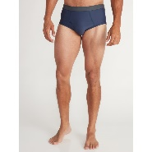 | Men's Give-N-Go® 2.0 Brief  Size & Color: L-Navy  SKU: AFS_613543139696 | 4 | $12
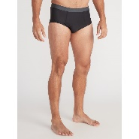 | Men's Give-N-Go® 2.0 Brief  Size & Color: L-Black  SKU: AFS_613543139795 | 4 | $12
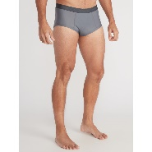 | Men's Give-N-Go® 2.0 Brief  Size & Color: L-Steel Onyx  SKU: AFS_613543139740 | 4 | $12

 | Subtotal | $144.00
 | Shipping | FREE
 | Tax | $10.08
 | Order Total | $154.08

