Hi
Hi Gustavo,

Thank for your order!
This email is your order confirmation and receipt. We'll send you another email when your order ships.
Thank you,
-The ExOfficio Team

Order Information

Ship To:  Gustavo Abugarade  8256NW 30th Terrace Miami Fl 33122  Miami, FL 33122  3055921771 |  | Order Date: Thursday, April 7, 2022  Order Number: EXO98848956203  Payment: MasterCard  Shipment: EC FedX Home Del.  To look up your order, please visit here

Order Summary | Order Description | QTY | Unit Price
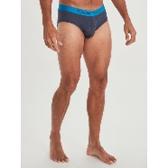 | Men's Give-N-Go® 2.0 Sport Mesh Brief  Size & Color: L-Navy/Skydiver  SKU: AFS_195116021251 | 1 | $25.2
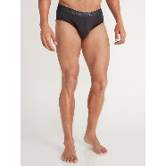 | Men's Give-N-Go® 2.0 Sport Mesh Brief  Size & Color: L-Black/Black  SKU: AFS_613543140845 | 2 | $25.2
 | Men's Give-N-Go® 2.0 Sport Mesh Brief  Size & Color: L-Black/Black  SKU: AFS_613543140845 | 1 | $25.2
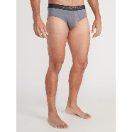 | Men's Give-N-Go® 2.0 Sport Mesh Brief  Size & Color: L-Steel Onyx/Black  SKU: AFS_613543140890 | 2 | $25.2
 | Men's Give-N-Go® 2.0 Sport Mesh Brief  Size & Color: L-Steel Onyx/Black  SKU: AFS_613543140890 | 1 | $25.2
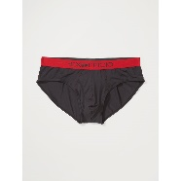 | Men's Give-N-Go® 2.0 Sport Mesh Brief  Size & Color: L-Black/Scarlet Sage  SKU: AFS_613543140791 | 2 | $25.2
 | Men's Give-N-Go® 2.0 Sport Mesh Brief  Size & Color: L-Black/Scarlet Sage  SKU: AFS_613543140791 | 1 | $25.2

 | Subtotal | $252.00
 | Shipping | FREE
 | Tax | $00.00
 | Order Total | $252.00

Join the conversation
 |  | 

MEN | WOMEN

UNDERWEAR | SALE

*Free Shipping on orders of $50 and Free Returns on all orders valid for online orders only. Promotion automatically applied at checkout once the minimum threshold before taxes and discounts has been met. Offer may not be redeemed for cash. No overnight or 2nd day orders included; expedited or ground shipping only. ExOfficio is not responsible for typographical or photographic errors. ExOfficio reserves the right to exclude other products from this offer. For additional information about shipping policies please visit our Shipping & Delivery Page.
Find Your Local ExOfficio Retailer
This email was sent by:
Marmot Mountain, LLC.
5789 State Farm Drive, Suite 100
Rohnert Park CA 94928, USA
© 2022 Marmot Mountain, LLC. All Rights Reserved.
Contact Us | Privacy Policy
Having trouble viewing this email?
View email in web browser

