Orders
Show:Not hidden

ORDER DATE
Oct 14, 2022
ORDER NUMBER
11-09218-60179
SOLD BY
bhfouser ID, click for member’s profile
ORDER TOTAL
US $183.14

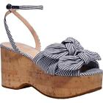

Kate Spade New York Womens Striped Cork Platform Sandals Sandals Open Box BHFO 0619
(295028578717)
US Shoe Size: 7 Medium (B,M)
Color: Blazer Blue Stripe
US Shoe Size (Women's): 7 Medium (B,M)
Delivered on Thu, Oct 20
Tracking number: 1ZE660290393899279
This item has been delivered.
PAID
Shipped on 10/15/22
ITEM PRICE:
US $31.19

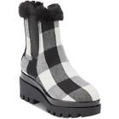

DKNY Womens Bax Cold Weather Ankle Slip-On Booties Open Box BHFO 6396
(295103888357)
US Shoe Size: 7 Medium (B,M)
Delivered on Thu, Oct 20
Tracking number: 1ZE660290391855480
This item has been delivered.
PAID
Shipped on 10/15/22
ITEM PRICE:
US $15.99

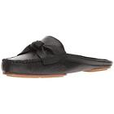

Kate Spade Womens Mallory Knot Casual Square Toe Loafers Flats BHFO 9477
(334515236657)
Delivered on Thu, Oct 20
Tracking number: 1ZE660290393899279
This item has been delivered.
PAID
Shipped on 10/15/22
ITEM PRICE:
US $39.59

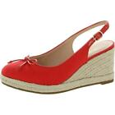

Kate Spade New York Womens Panama Nights Round Toe Wedge Sandals Open Box BHFO 7627
(334576809133)
US Shoe Size: 7 Medium (B,M)
Color: Coral Rose
US Shoe Size (Women's): 7 Medium (B,M)
Delivered on Thu, Oct 20
Tracking number: 1ZE660290391855480
This item has been delivered.
PAID
Shipped on 10/15/22
ITEM PRICE:
US $26.00

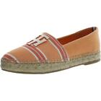

Tommy Hilfiger Womens Kokoi Denim Slip On Sandals Espadrilles Shoes BHFO 2665
(354141658268)
Delivered on Thu, Oct 20
Tracking number: 1ZE660290393899279
This item has been delivered.
PAID
Shipped on 10/15/22
ITEM PRICE:
US $25.59

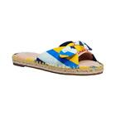

Kate Spade New York Womens Saltie Shore Leather Espadrilles Shoes BHFO 8392
(354179455280)
US Shoe Size: 7 Medium (B,M)
Color: Oceanside Multi
US Shoe Size (Women's): 7 Medium (B,M)
Delivered on Thu, Oct 20
Tracking number: 1ZE660290391855480
This item has been delivered.
PAID
Shipped on 10/15/22
ITEM PRICE:
US $23.19

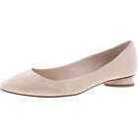

Kate Spade New York Womens Beige Ballet Flats Shoes 7 Medium (B,M) BHFO 9148
(354277971268)
Delivered on Thu, Oct 20
Tracking number: 1ZE660290393899279
This item has been delivered.
PAID
Shipped on 10/15/22
ITEM PRICE:
US $21.59

