



View order details

Need help? Contact us here



Delivered to:
Rodrigo Kauak (721-0159 )
8256 NW 30th Ter
Doral, FL, 33122-1914
United States



Dropped off:
Apr-25 10:55 CLT
Carrier: USPS
Tracking number: 9405508205498755522584

M18X1 TO 5/8-24 TIKKA ADAPTER

  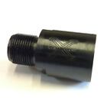
  Total: $52.10
  Order number: 04-08533-62710
  Item ID: 153563686306
  Seller: xcaliberadapters
  Give feedback

