your order has arrived!



View order details

Need help? Contact us here



Delivered to:
Rodrigo Kauak (721-0159 )
8256 NW 30th Ter
Doral, FL, 33122-1914
United States



Dropped off:
Apr-29 10:19 CLT
Carrier: USPS
Tracking number: 9400111202540473377028

New New Fallkniven S1x Survival Knife S1X

  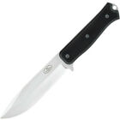
  Total: $224.04
  Order number: 12-08549-62354
  Item ID: 175104785516
  Seller: ultimate_cave
  Give feedback



