your order has arrived!



View order details

Need help? Contact us here



Delivered to:
Rodrigo Kauak (721-0159 )
8256 NW 30th Ter
Doral, FL, 33122-1914
United States



Dropped off:
Apr-29 10:30 CLT
Carrier: USPS
Tracking number: 9500110717562116601009

Steyr Rifle Black Rubber Recoil Pad

  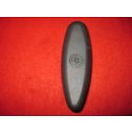
  Total: $19.46
  Order number: 04-08556-27216
  Item ID: 353918301157
  Seller: somersetsuzie32
  Give feedback

