your order has arrived!



View order details

Need help? Contact us here



Delivered to:
Rodrigo Kauak (721-0159 )
8256 NW 30th Ter
Doral, FL, 33122-1914
United States



Dropped off:
May-02 13:02 CLT
Carrier: USPS
Tracking number: 9400111108029801017188

GG&G for Benelli M2 Rear Sling Attachment, GGG-1506

  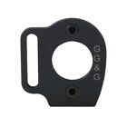
  Total: $26.74
  Order number: 16-08560-16889
  Item ID: 152099778698
  Seller: cactus-tactical
  Save this seller
  Give feedback

