Messtabelle:

**ϑ**

Rϑ

Wasserbad

Kennlinie:

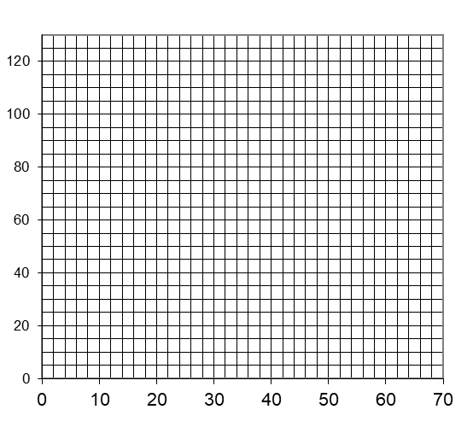

Rϑ

in Ω

ϑ in °C

Erkenntnis:

ϑ: Temperatur in °C

Rϑ: Messwiderstand in Ω

|  |  |
| --- | --- |
| **☺ in °C** | **Rϑ in ** |
|  |  |
|  |  |
|  |  |
|  |  |
|  |  |

Versuch: