Center Console

Preconditions:
Glove box and lower drivers side panels already removed.

Step 1: Remove the screws from the sides of the console.

- There are 2 Phillips screws and 1 bolt at the back.

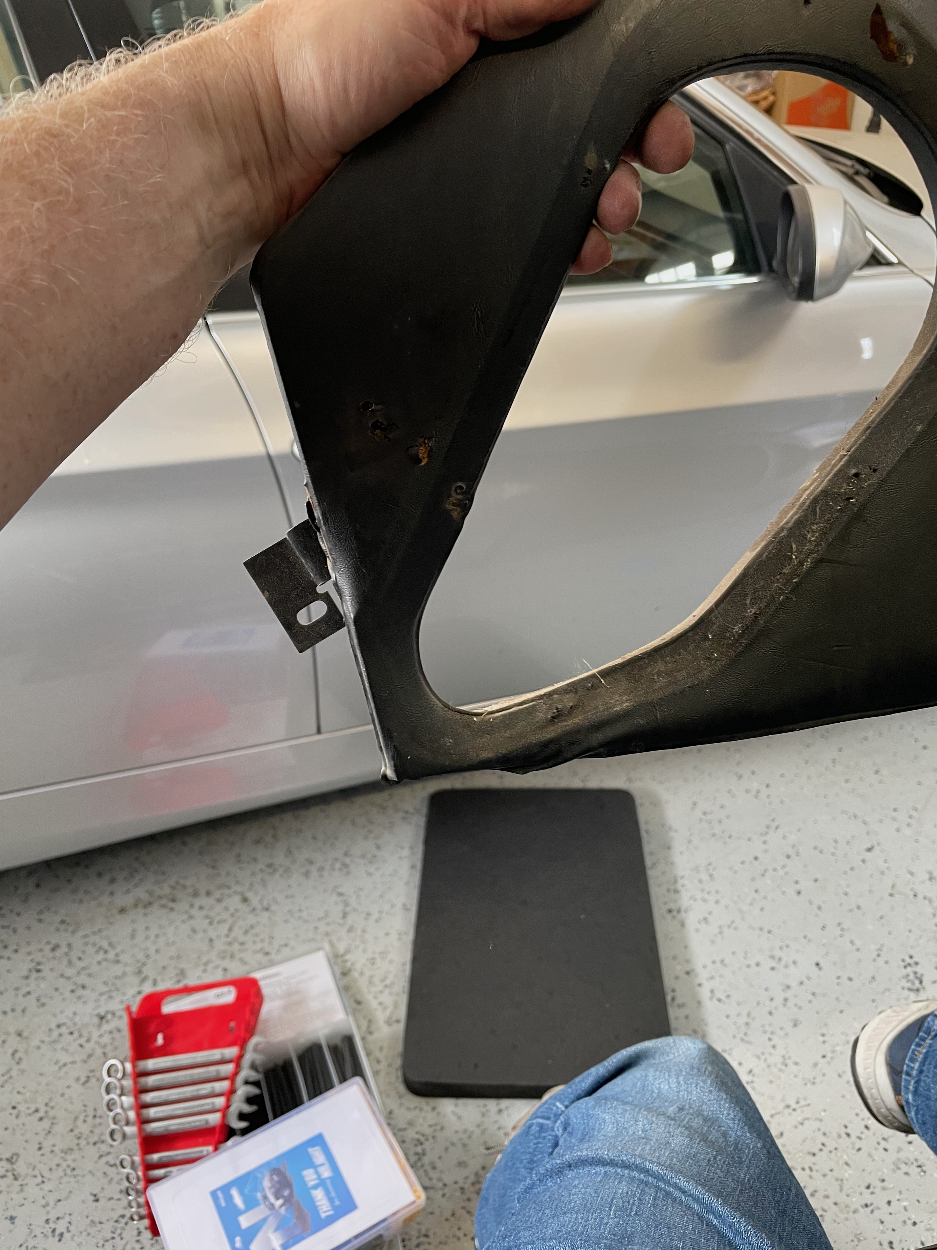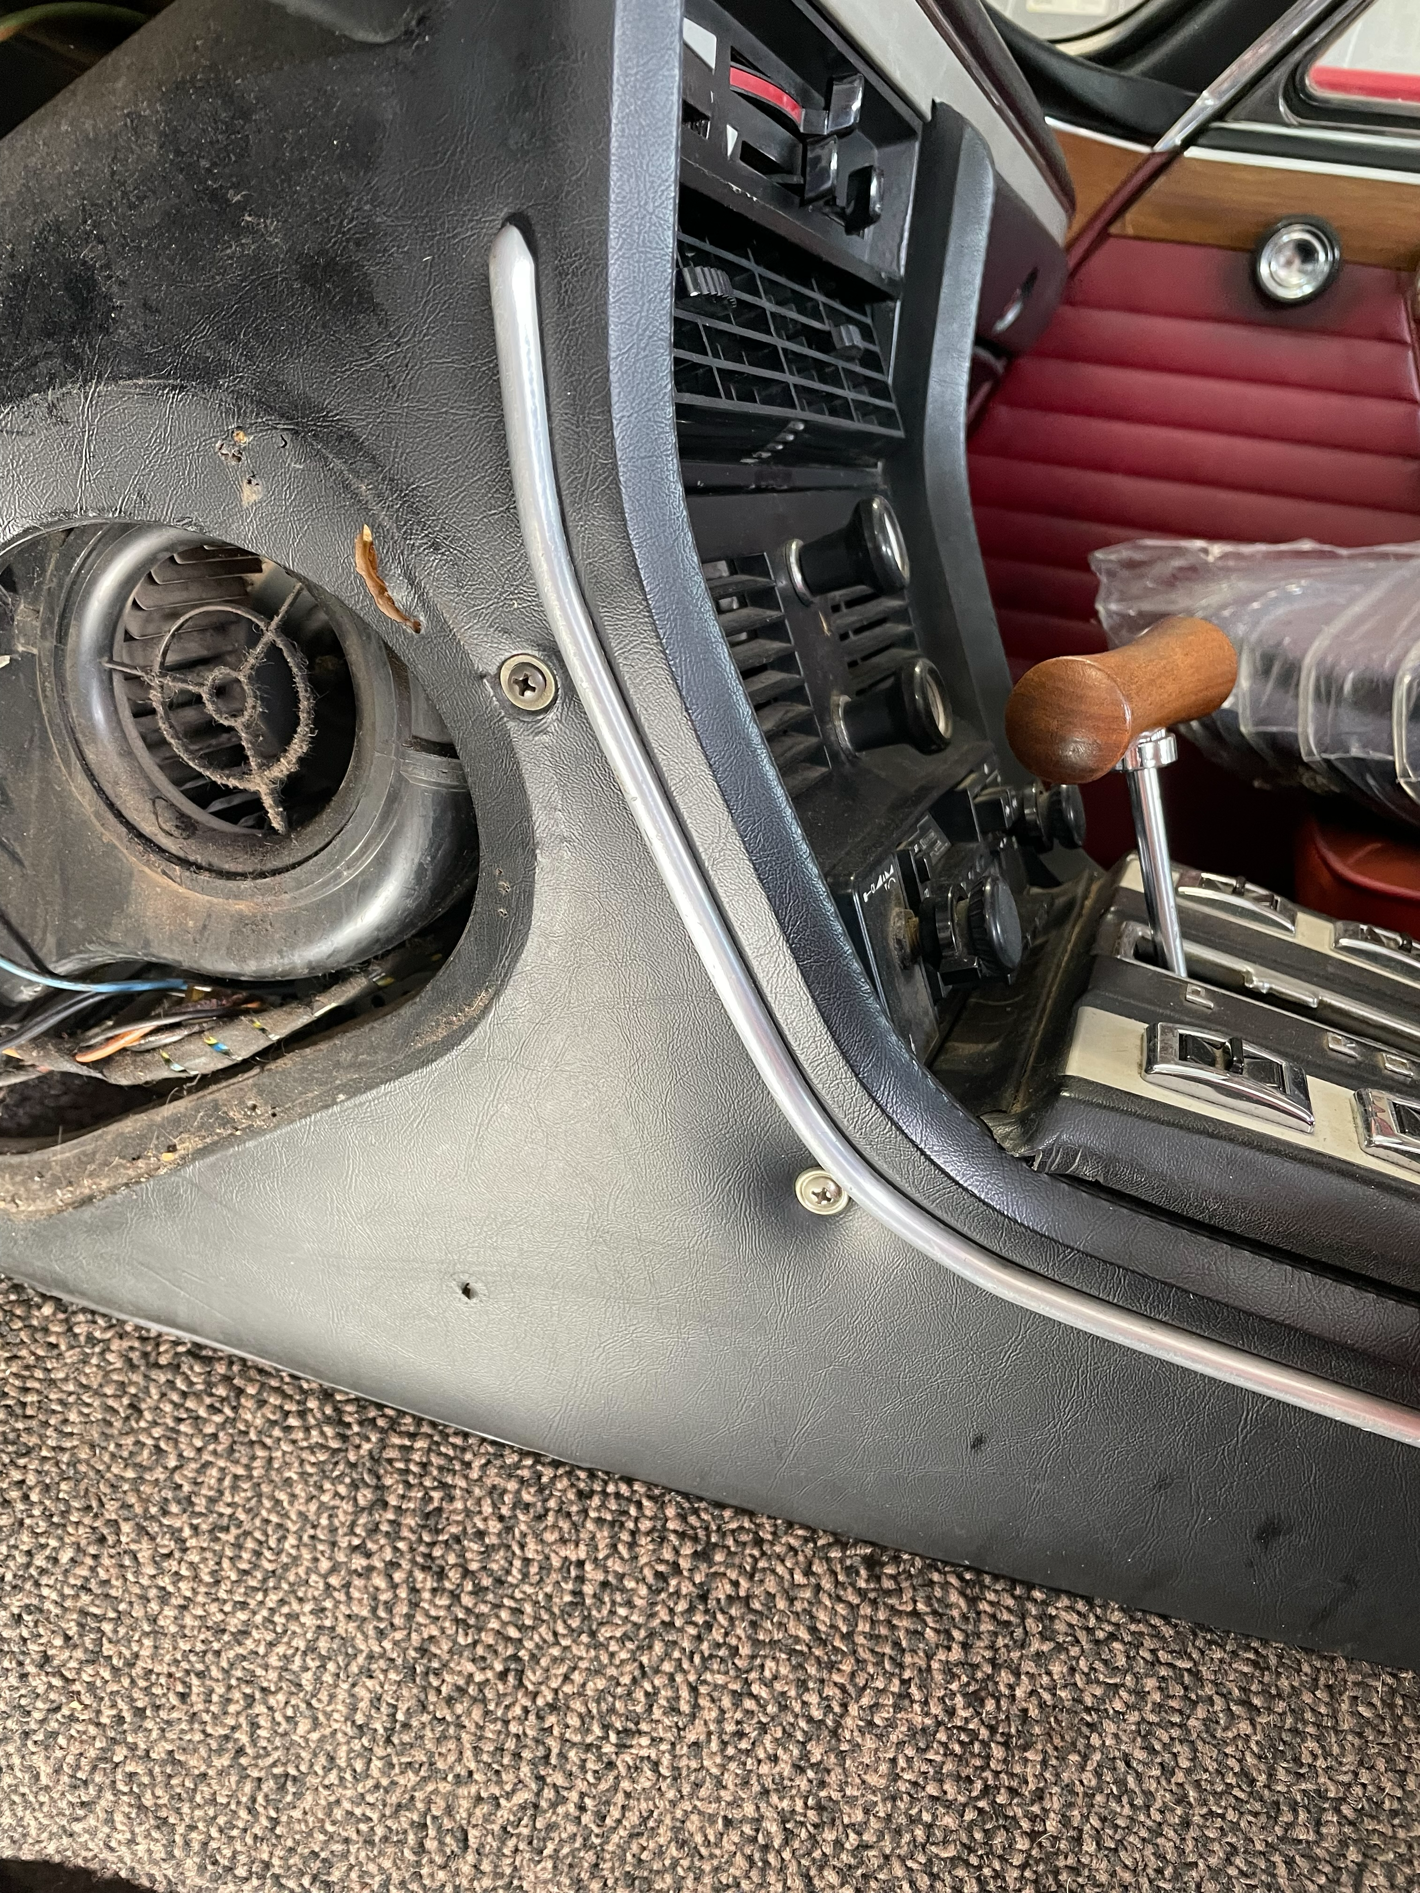

- The bolt in the bracket may spin the nut. It could be difficult to remove. The bracket is held on from the inside with a machine screw that has an embedded nut in the panel. On the glovebox side I had to bend the bracket and remove the inner screw.
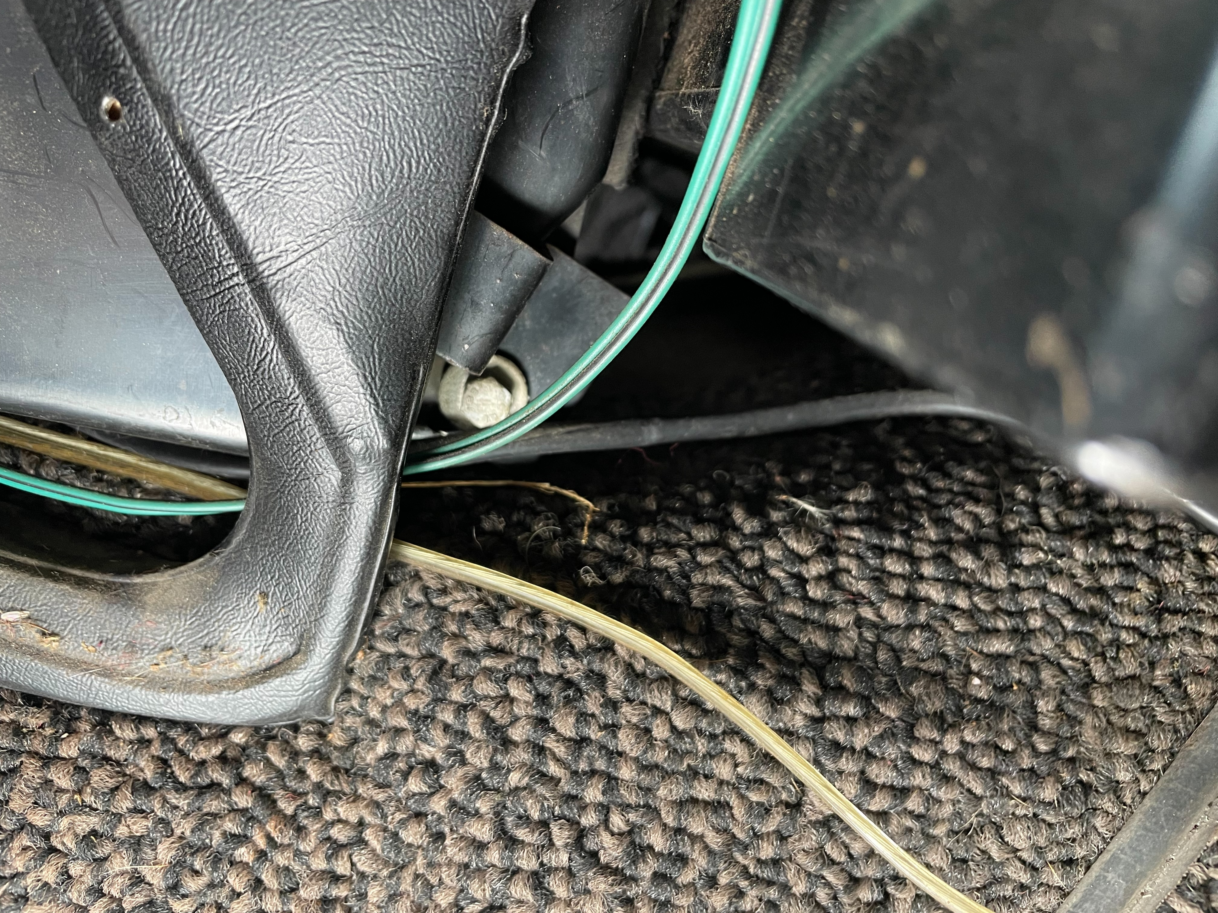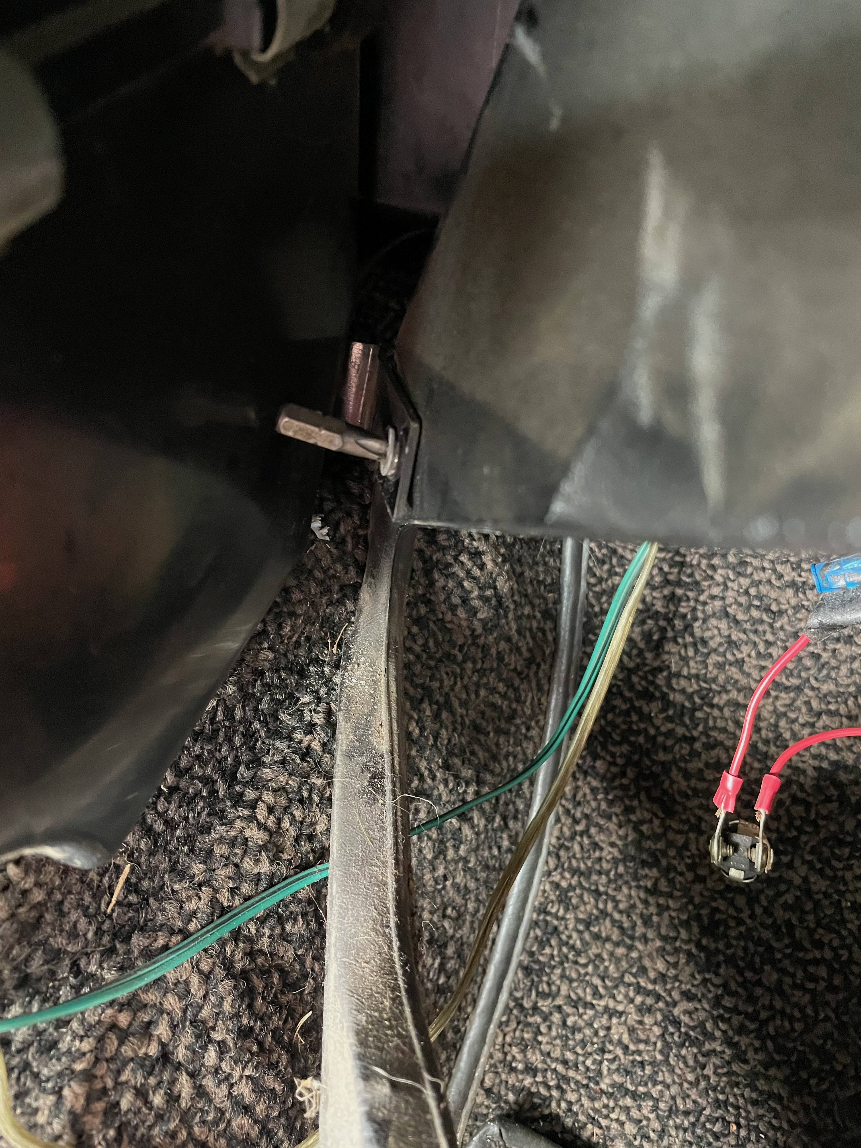

Step 2: Remove the switch/shifter panel.

- Take out the toggle switches by using a spudger door trim removal tool and get under the switch and pop them up.
- Note down the wiring for each switch and remove the switch from the wiring.
- Remove the 2 Phillips screws holding cover to side panels

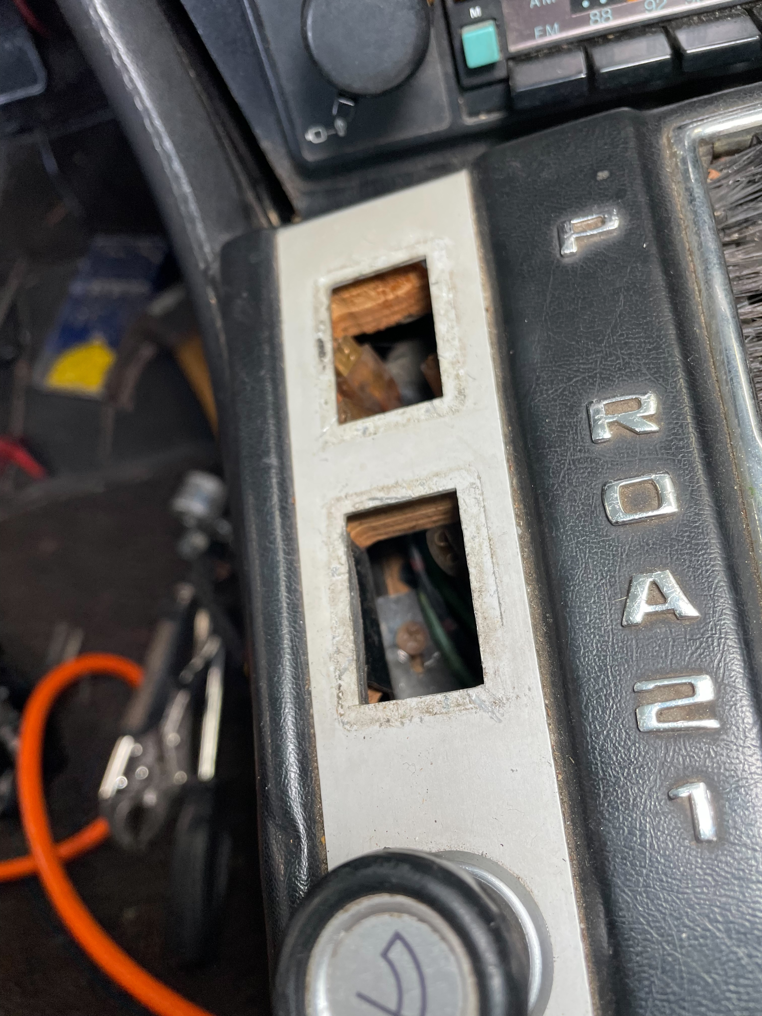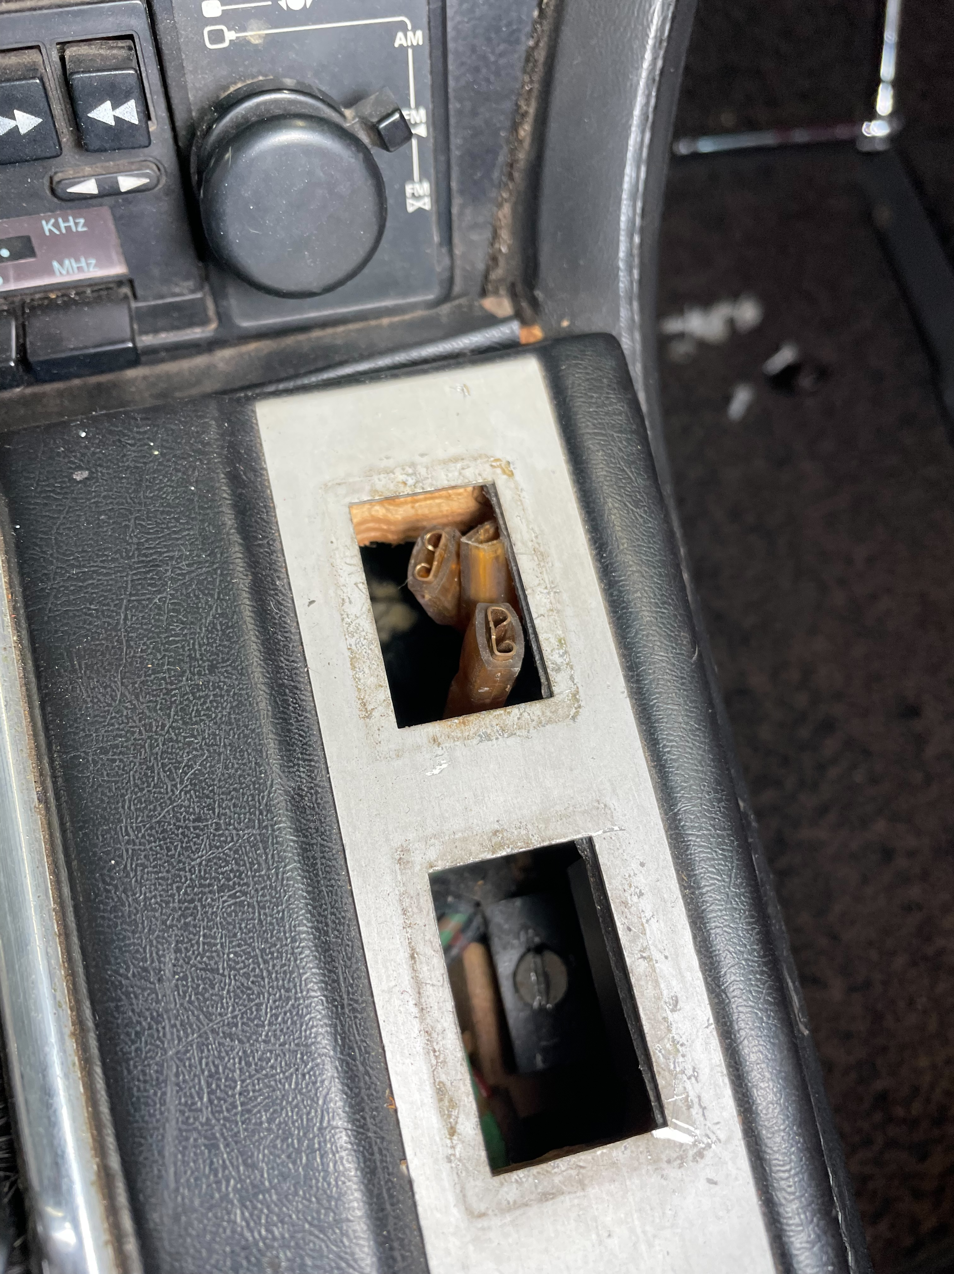

- Remove the shift knob. Mine had a set screw in the side and once loose the knob screwed off the shaft.

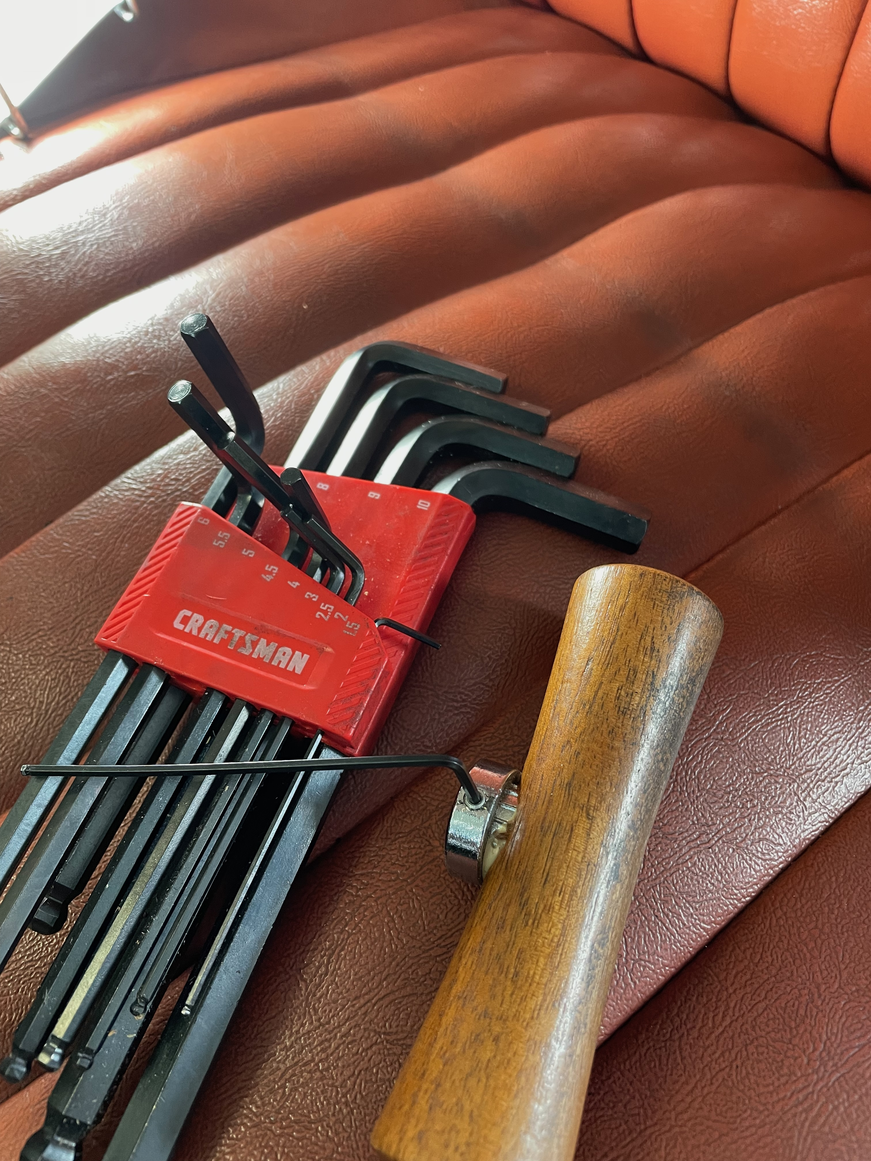

- Lift off the shifter cover and disconnect any remaining wires.
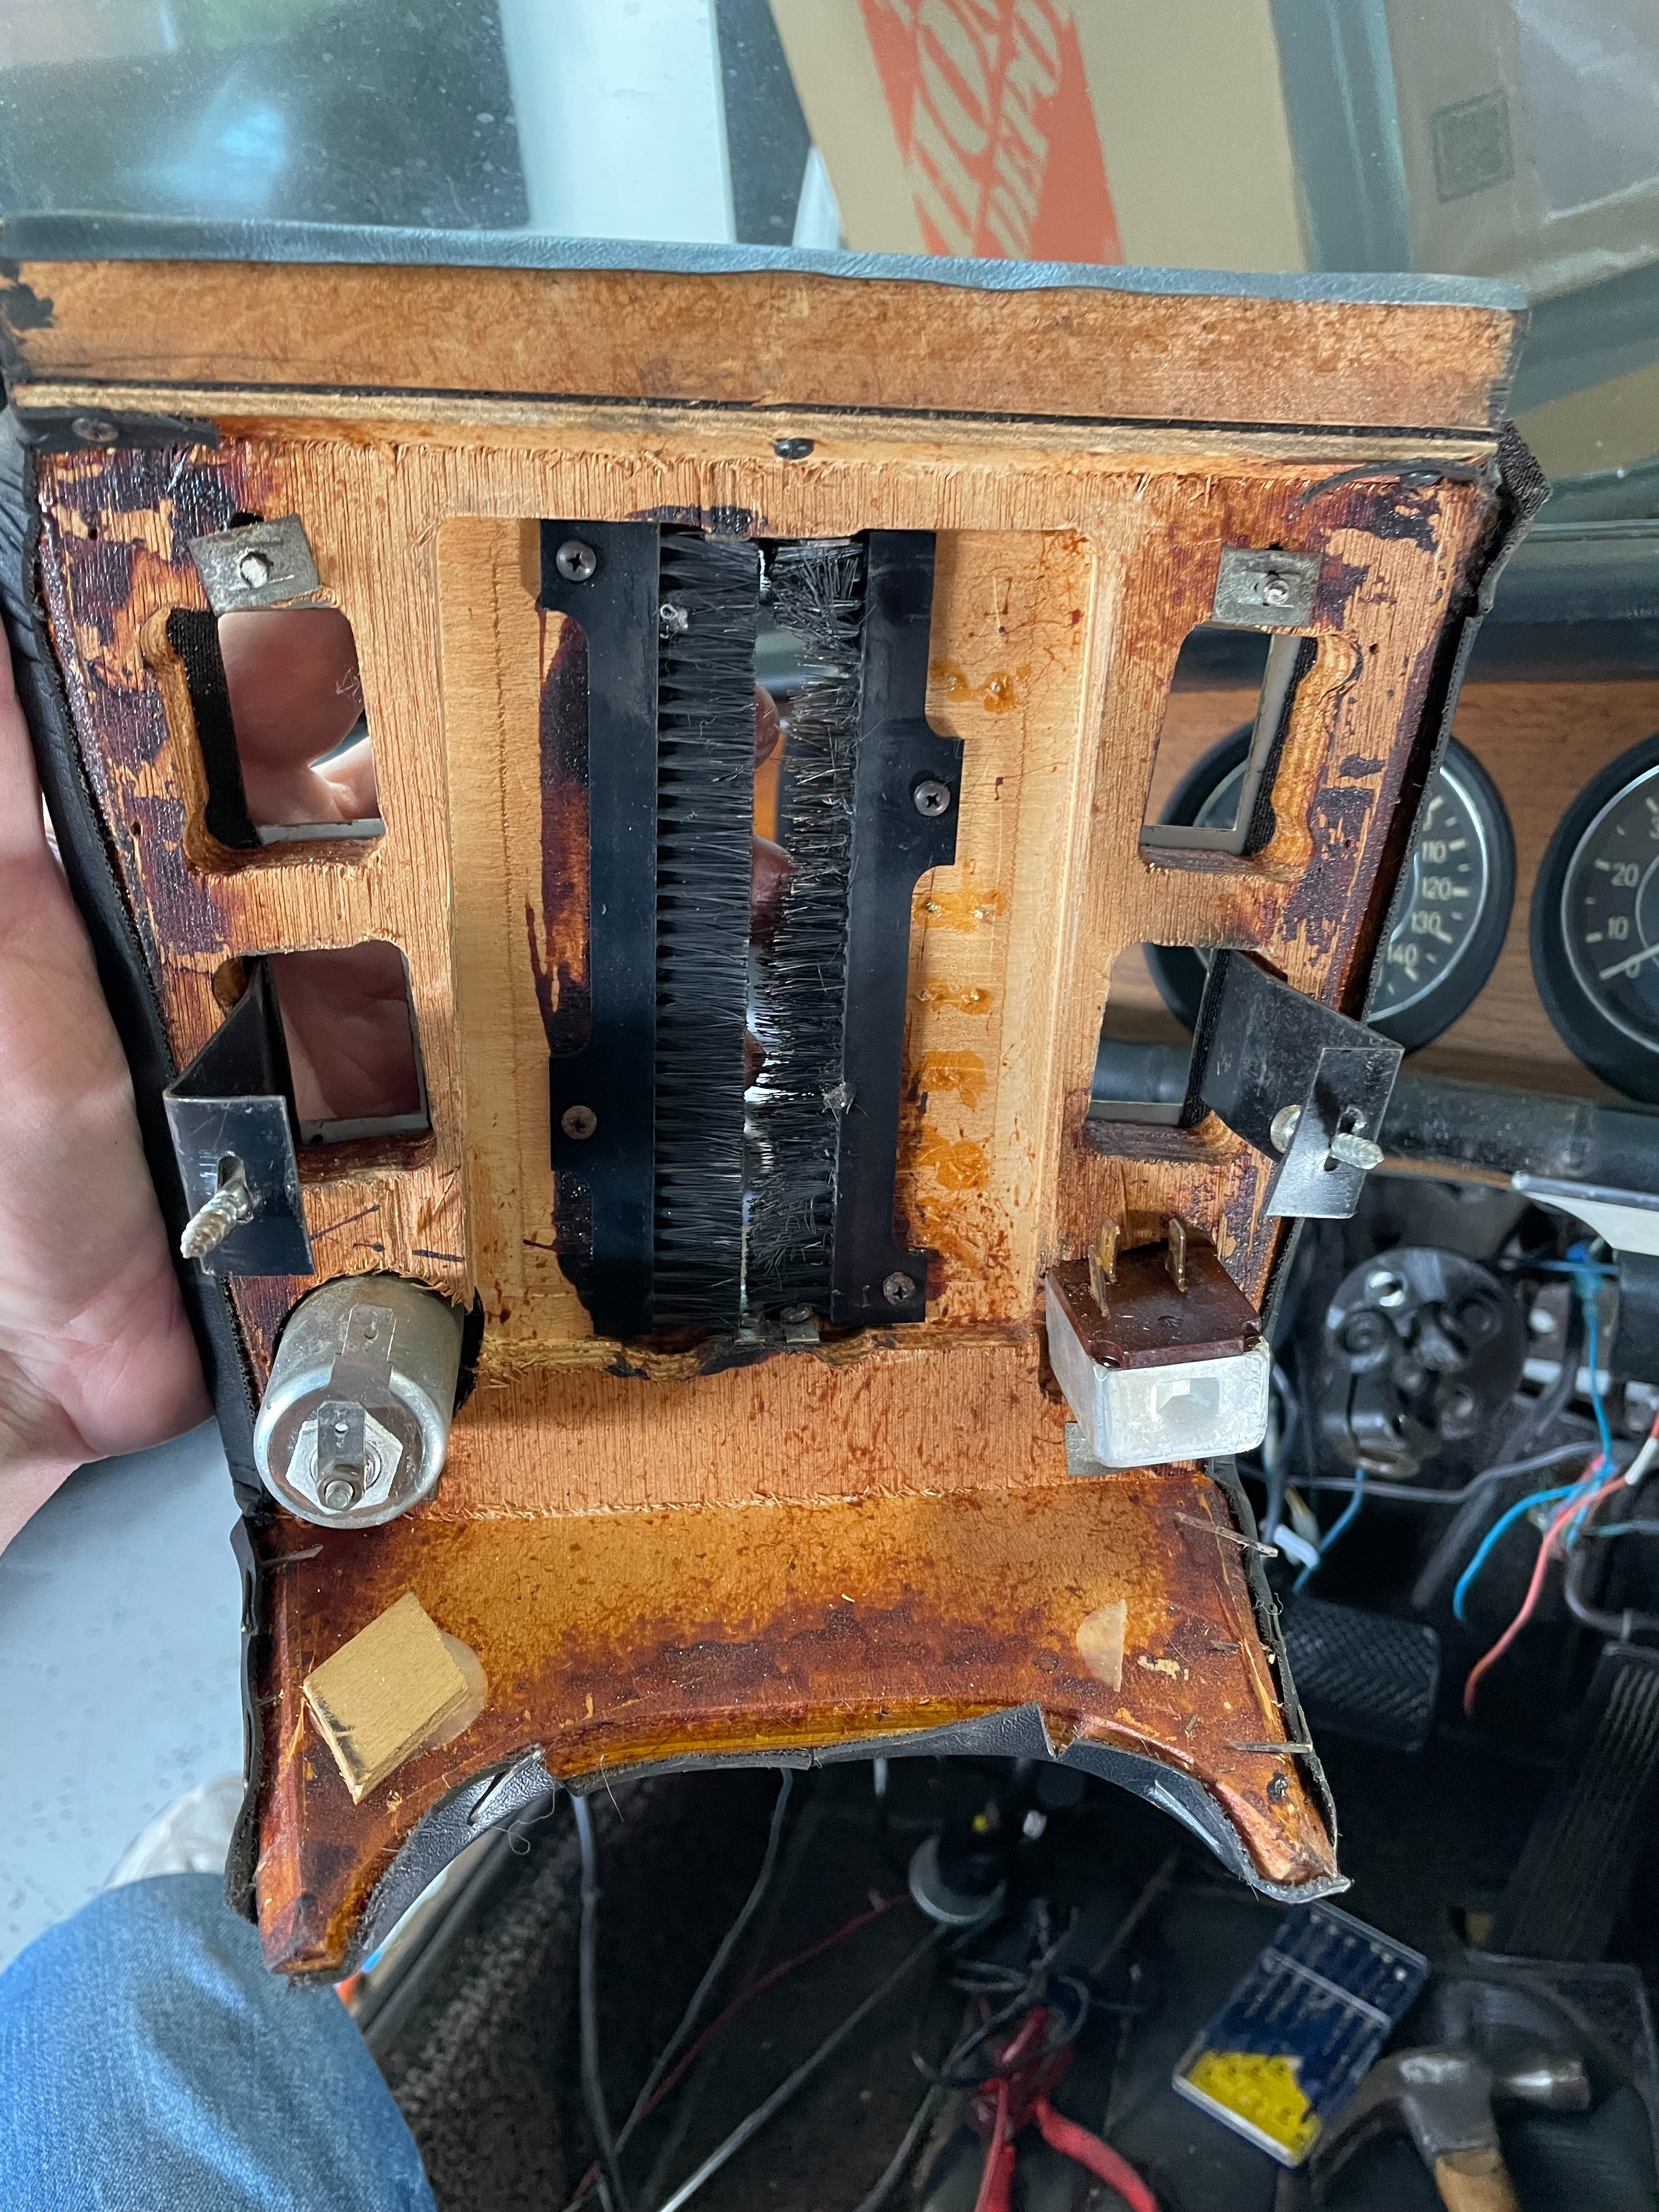

- Remove the 4 screws holding the sides together by the cigarette lighter and windshield knob.

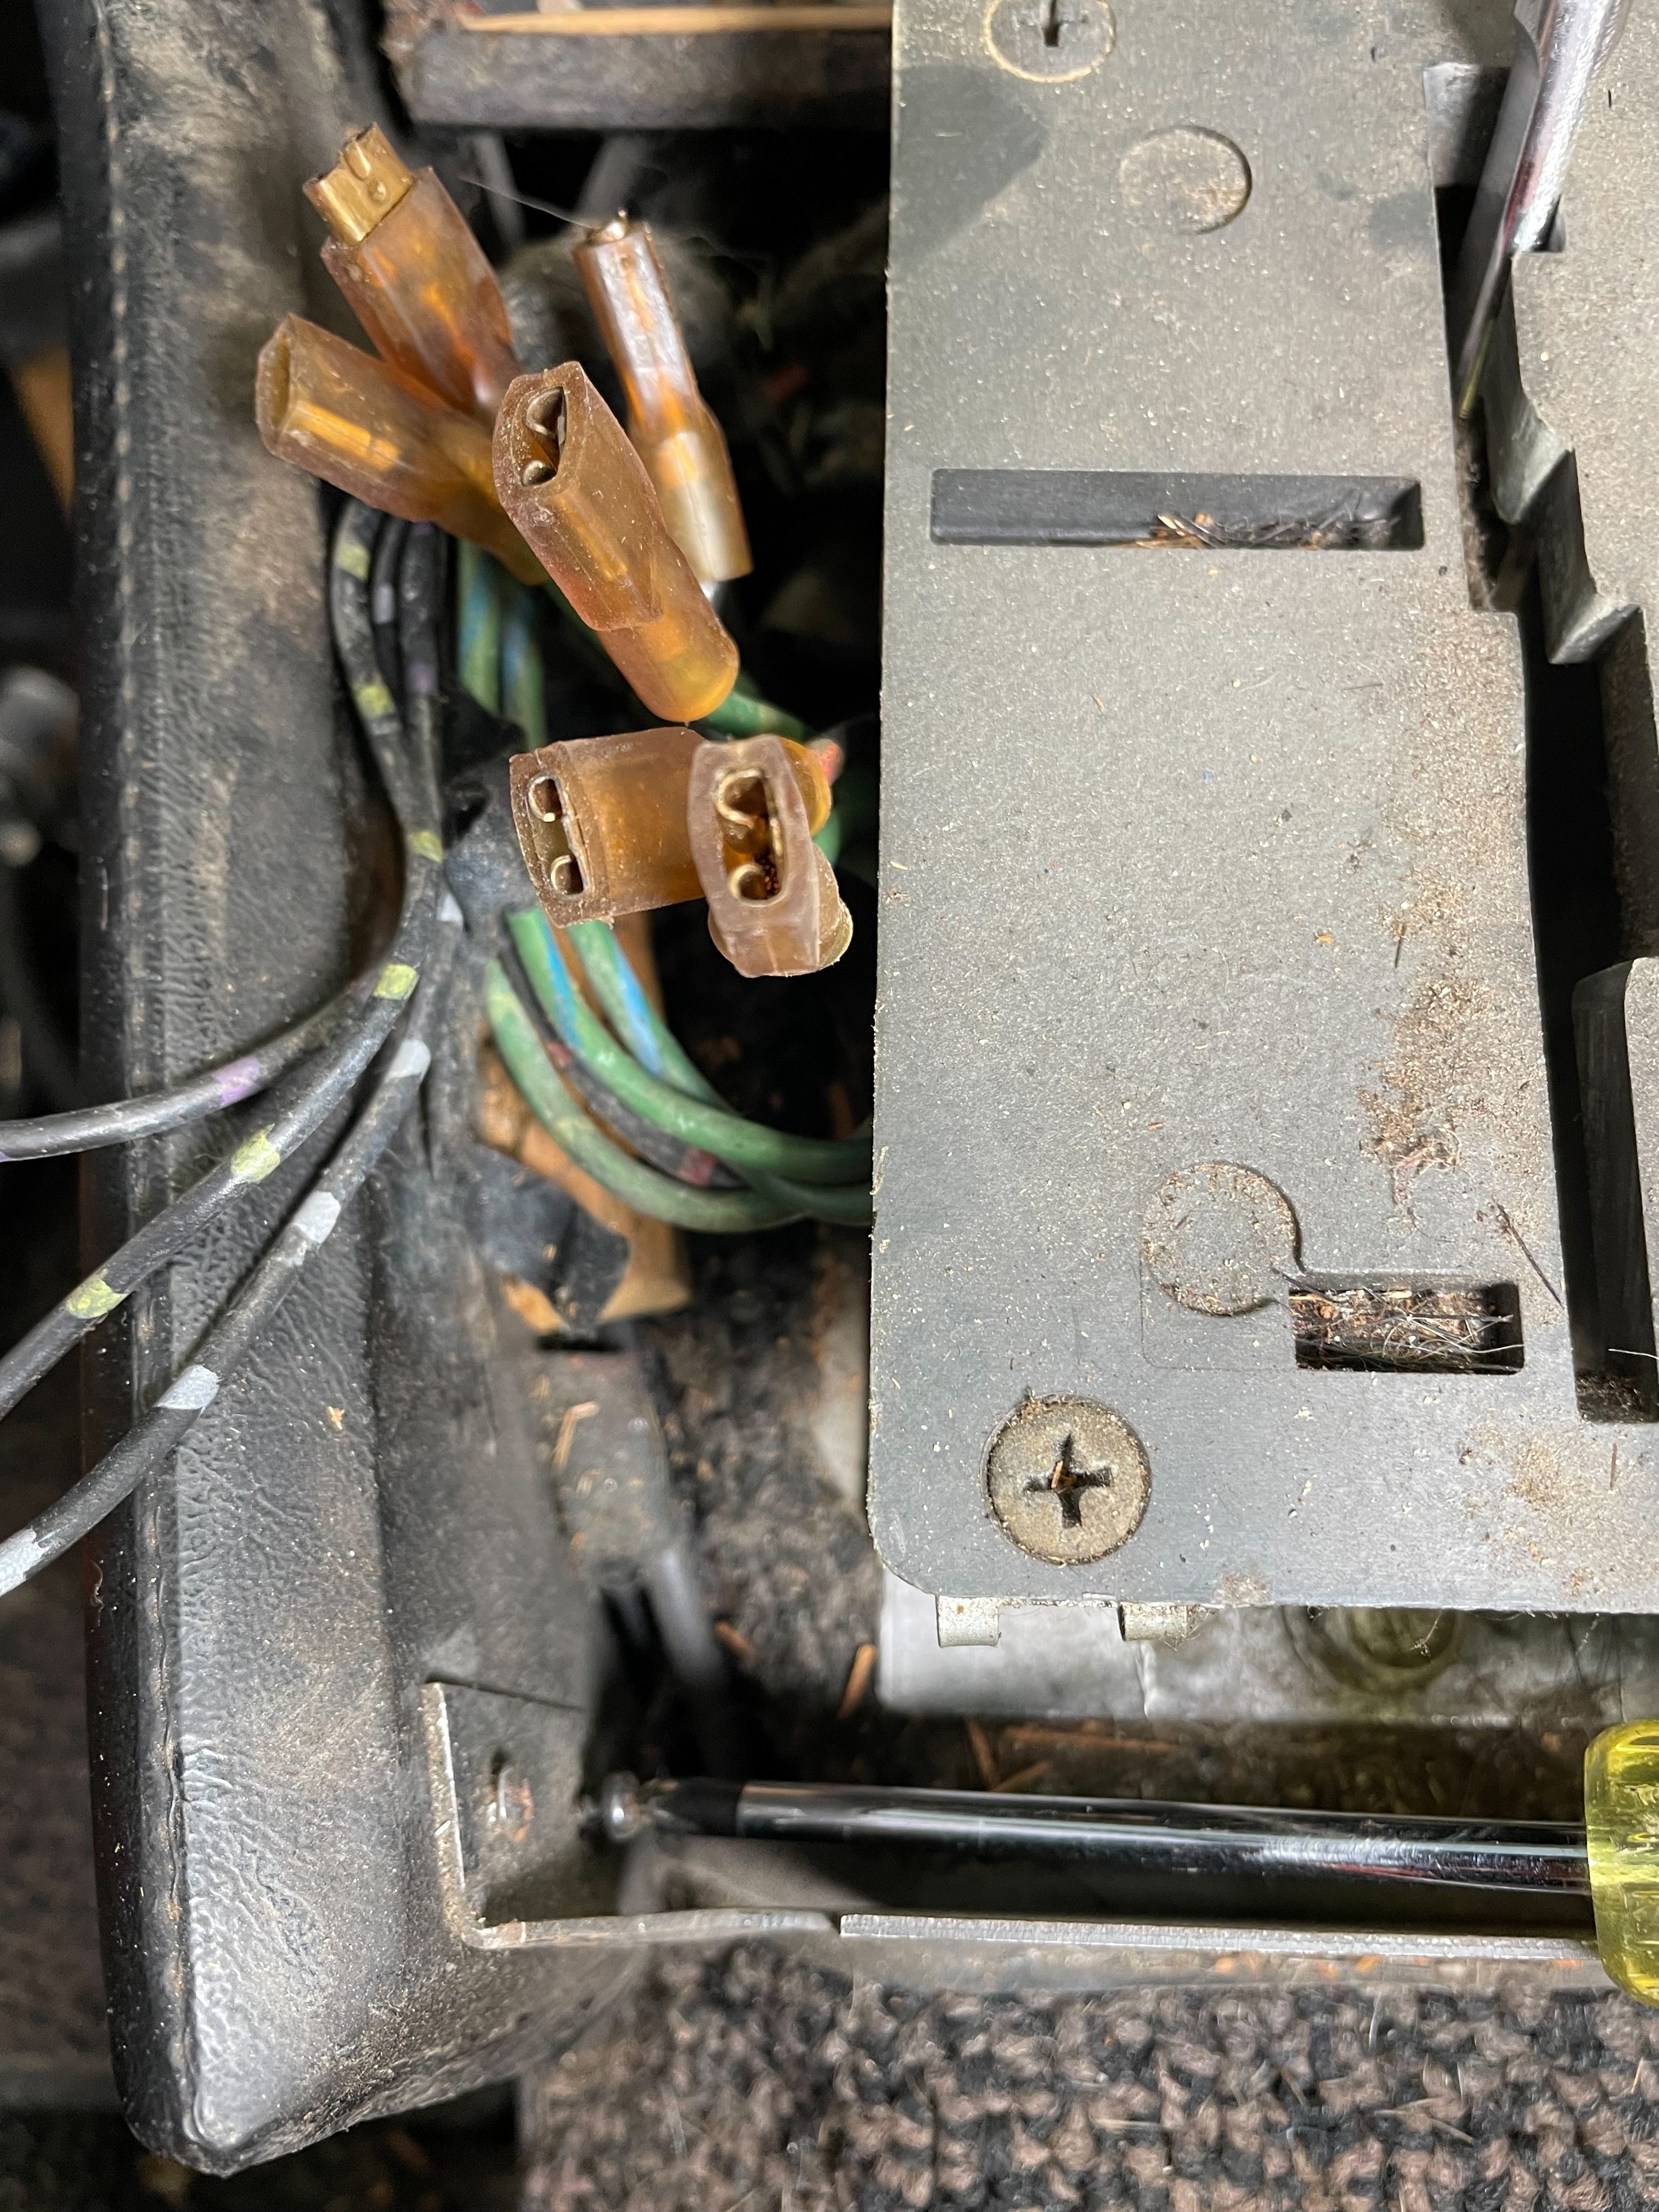

- Finally remove the sides if all the screws are removed.


