Ignition Lock Removal

Preconditions:
The column was already removed from the car. The electrical ignition switch was missing.

Step 1: Remove the security screws.
- There are a total of 5 security screws. The large one holds in the steering wheel locking housing. The other 4 hold the column shaft to the top cover.

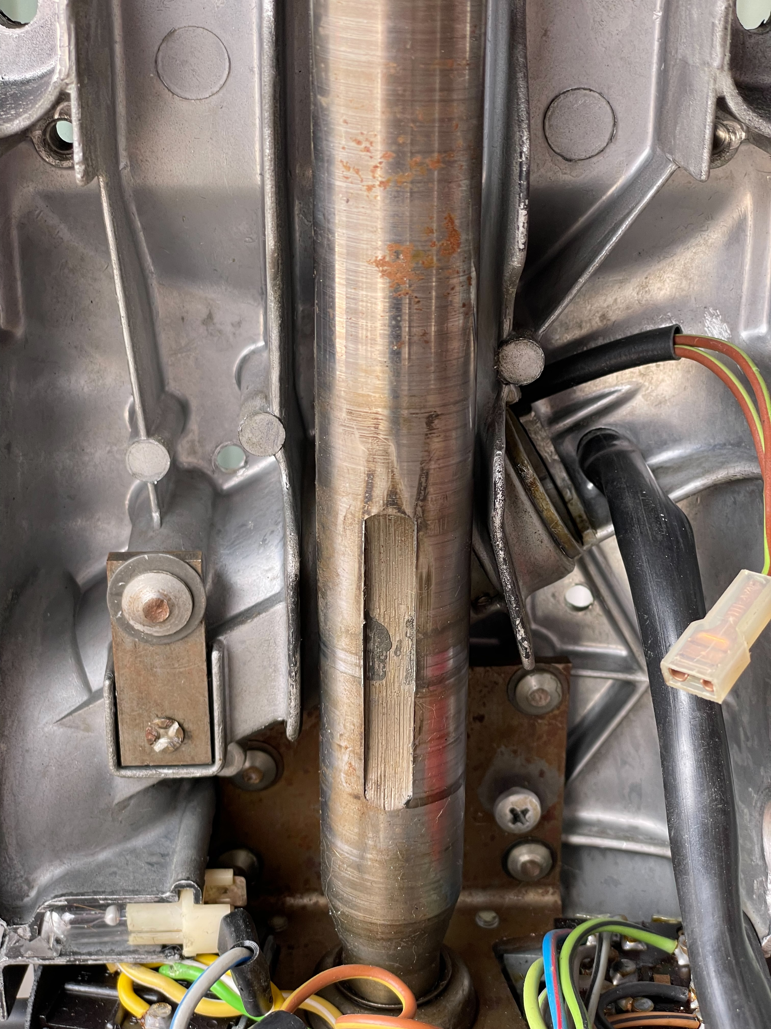
- Use a chisel and gouge the screw close to the edge. Then either continue with the chisel or switch to a nail punch. Keep hitting the head until it breaks free. Only using the nail punch is also possible and causes less damage to the bolt head. The bolts are soft so they are easily dimpled or gouged.
- Remove the small bracket held in by the larger security screw. It pull straight out.

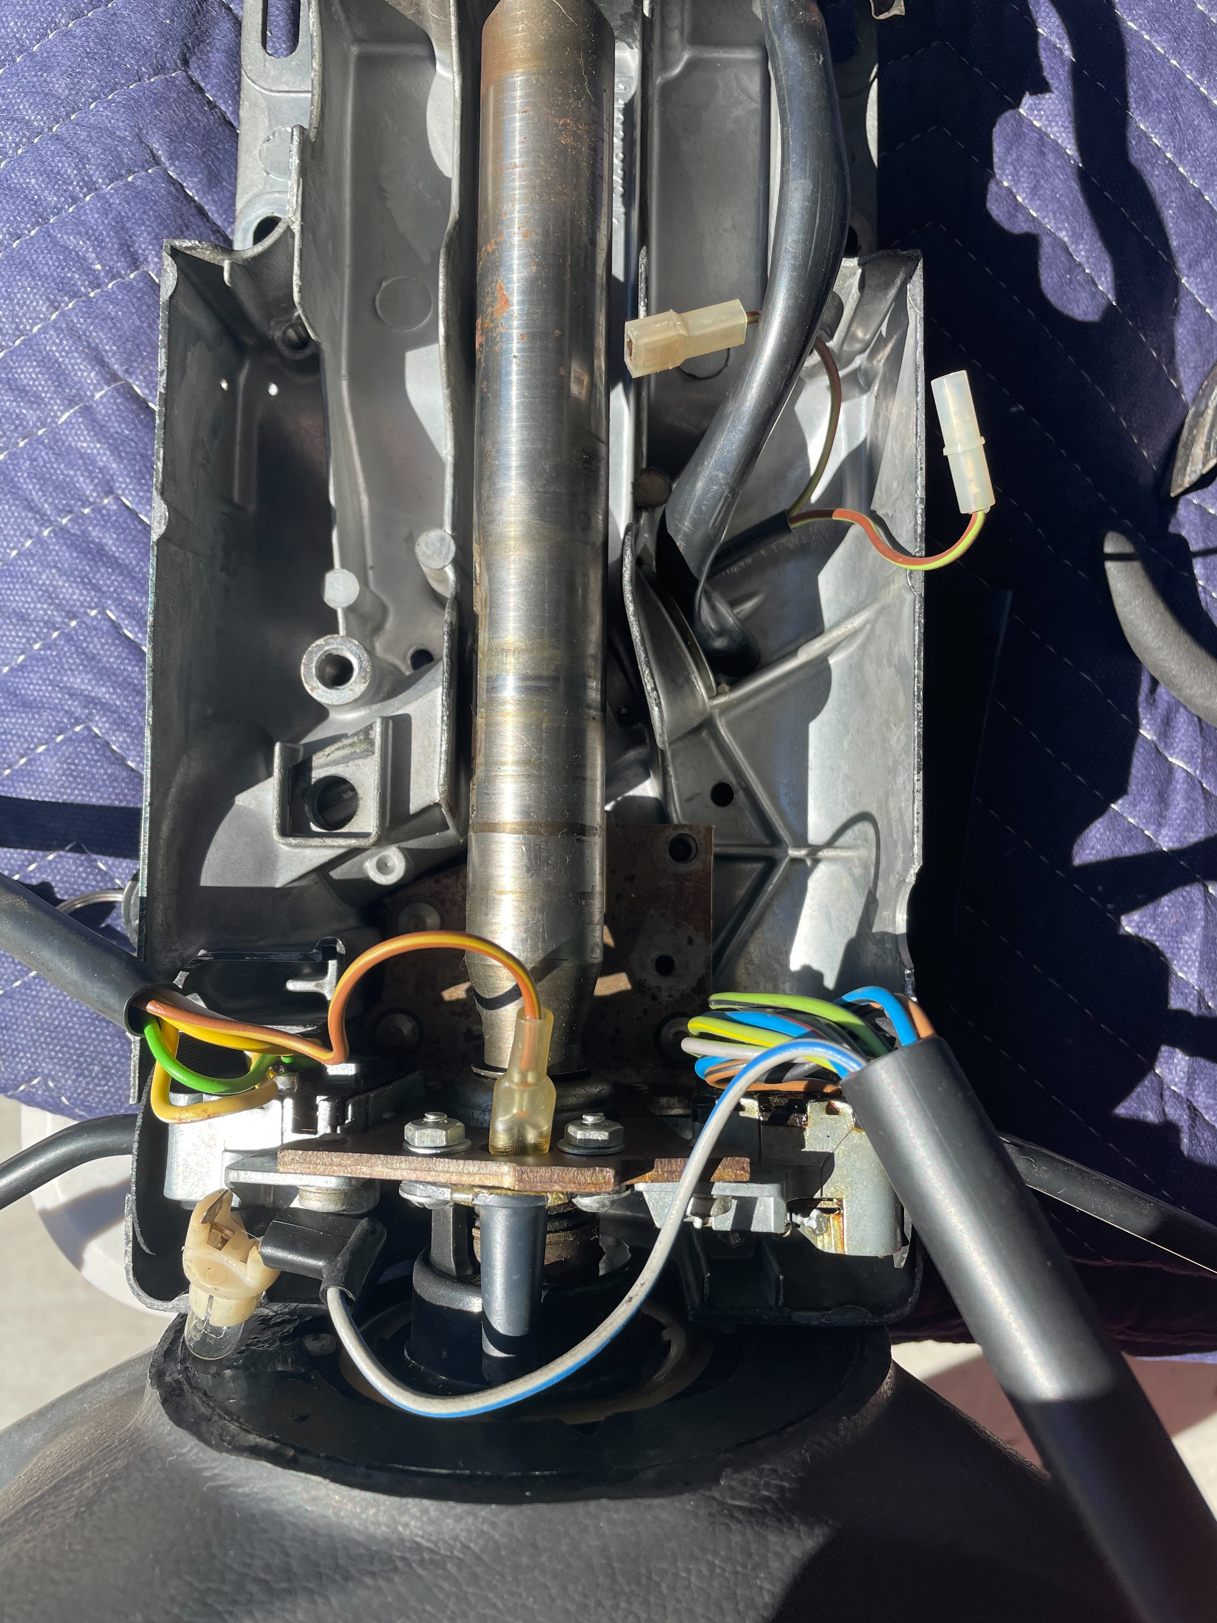
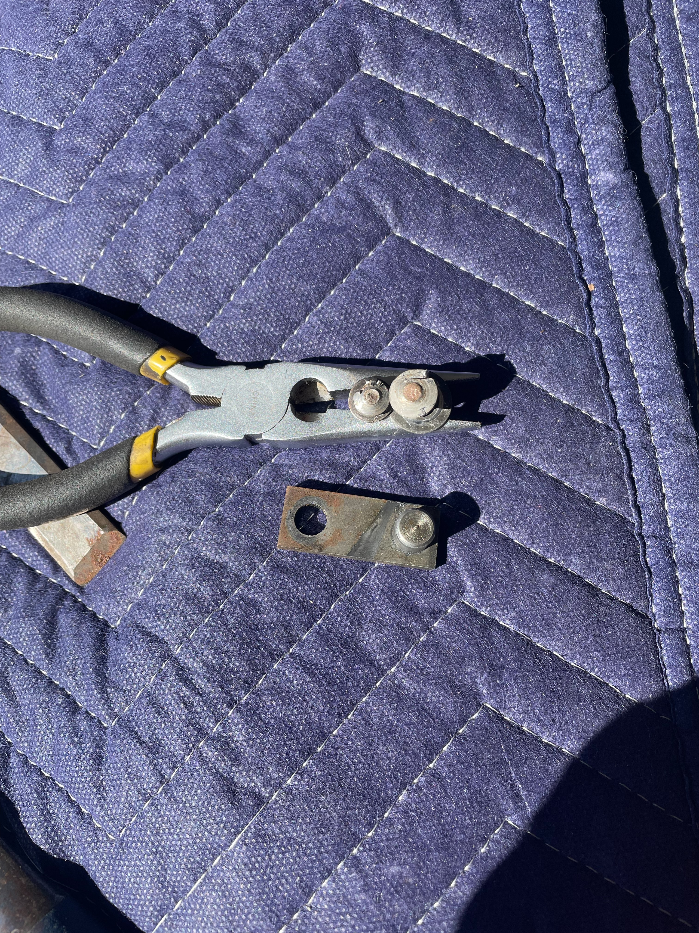
Some of the bolts removed with small bracket.

Step 2: Take out lock housing

- Remove the grub screw. Put in the key and put it to start. This should unlock the column. Then slightly pull the column away from the locking housing and push the housing out of the top column cover.

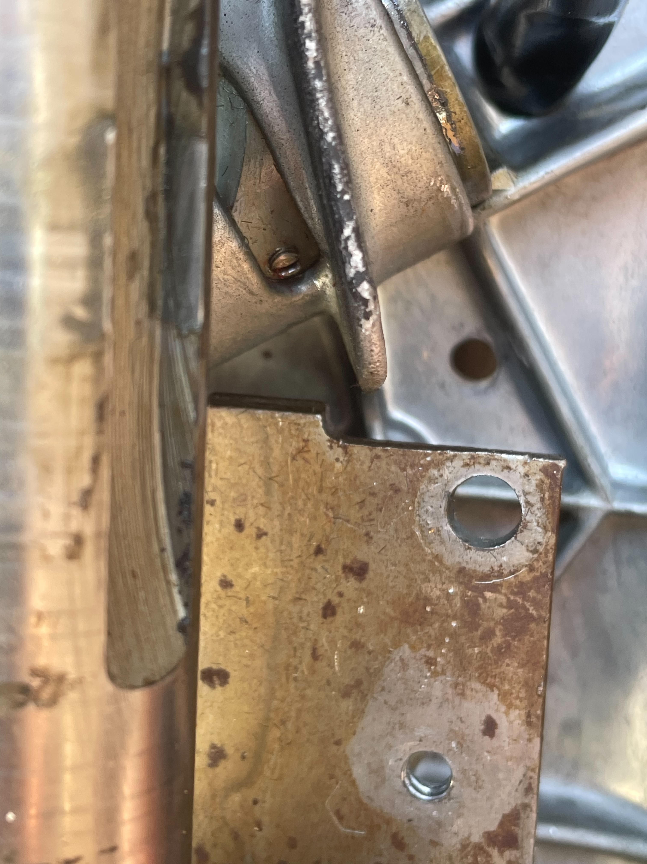
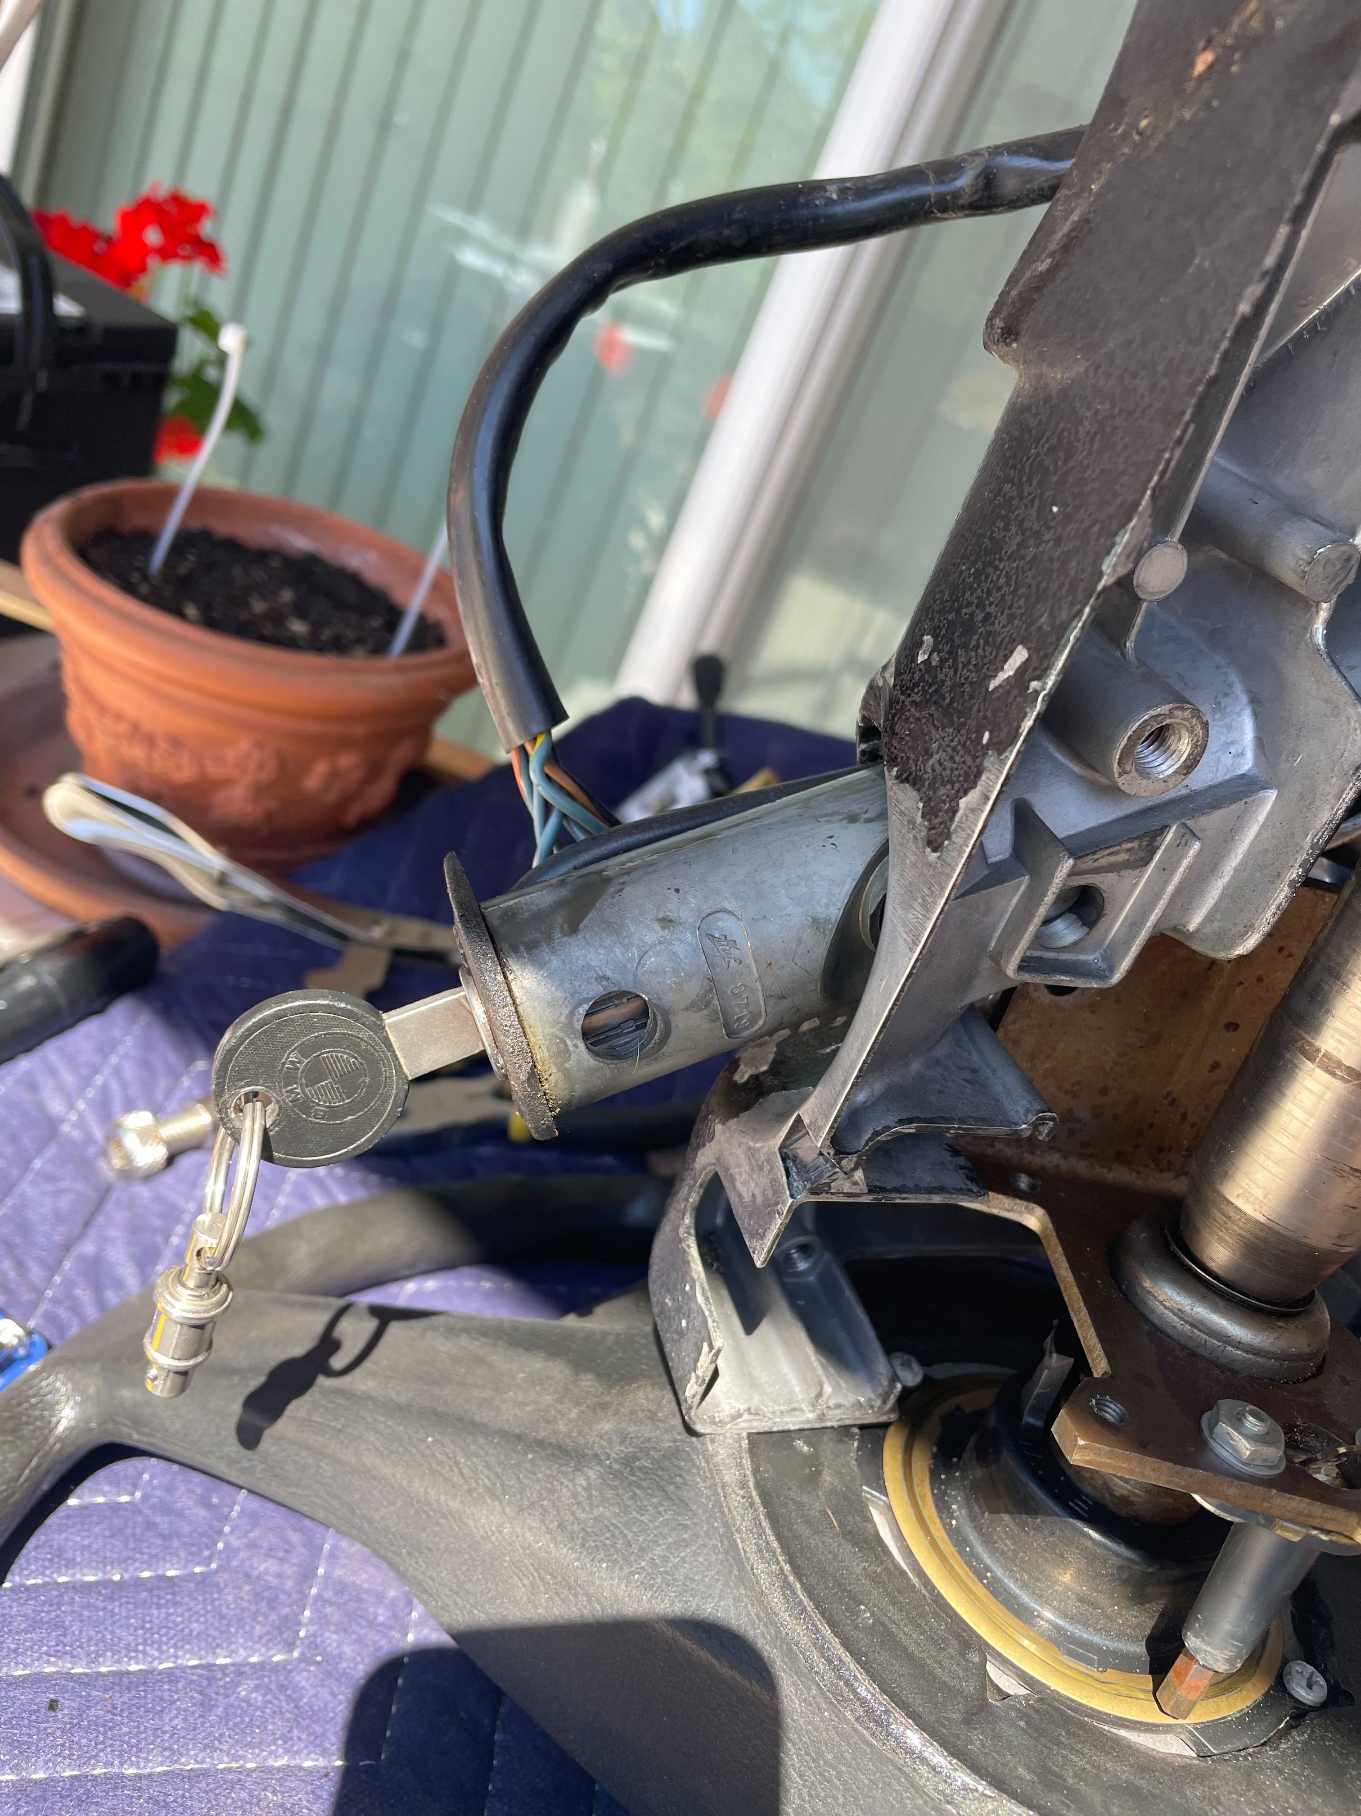
Grub screw and housing coming out.

Step 3: Remove key lock

- To remove the lock take out the key.
- Press the spring through a small hole in the housing and pull on the lock.

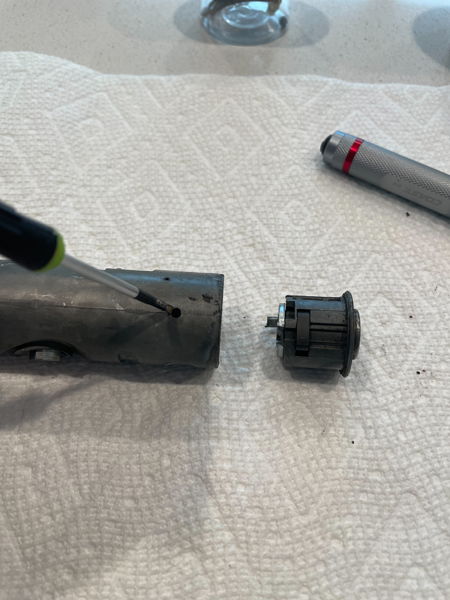
Step 4: Remove shaft, optional.

- Press the small pin out of the housing. I used the nail punch used earlier to get out the security screws.


