IPU Contribution & Loan App — Requirements
Iyobor Progressive Union · Prepared 11/10/2026 · Owner: Festus (Admin)

1. Purpose and scope
The app replaces the Iyobor Progressive Union (IPU) Excel workbook used for 2025–2026. It records monthly member savings, loans and interest, keeps one bank balance, and produces the year-end payout to each member. Officers and members log in to a mobile-friendly web app with their phone number and password.
In scope
- Member register and logins
- Monthly contributions (savings)
- Loan requests with a guarantor, approved by the President and the Treasurer
- Interest at ₦25 per ₦1,000 per month, arrears and overpayment credits
- One union bank account: every inflow and outflow, plus receipt uploads
- Other union income, and investments such as money market funds and treasury bills
- Monthly close and sign-off, and member exits
- Year-end settlement with a dividend set by the union
- Debtor follow-up by SMS, email and call log
- Reports and member statements
Out of scope
- Opay wallet tracking
- Cash held by individuals ("bal in mum")
- Online payment collection: members still pay into the union bank account and upload proof
Financial year: March to February. February is the closing month.

2. User roles and permissions
Six roles cover everyone. One person can hold more than one role; for example, the Admin can also be a member.
Role | Who | Can do | Cannot do
Admin | Festus (system owner) | Everything: users, roles, settings, open and close a year, set the dividend rate, reopen a locked month, correct records | —
President | Union President | Approve or reject loans (first approval), approve loan-limit exceptions, sign off each month, approve year-end close, record members' monthly payments, view all records | Change settings or reopen months
Treasurer | Union Treasurer / Financial Secretary | Record contributions, interest and repayments; confirm receipts against the bank; disburse approved loans; approve loans (second approval); approve loan-limit exceptions; record other income and expenses | Change settings or reopen months
Secretary | Union Secretary | Add and edit members, reset member passwords, record members' monthly payments, send notices, co-sign the monthly sheet | Approve loans or change settings
Auditor | Appointed auditor | Read-only access to every record, report and the change log | Change anything
Member | Every contributor | View own savings, loans, interest and receipts; upload payment receipts; request a loan; name a guarantor; accept or decline being a guarantor | See other members' records

Every money action is stamped with who did it and when. No one can approve their own loan, even if they hold the President or Treasurer role.

3. Business rules
These rules are the calculation engine. They match last year's sheet, except where the sheet had errors (see section 7).

BR-1 Contributions
- Members can contribute any amount in any month. The amount is not fixed per member.
- A contribution counts only after the Treasurer confirms the money reached the union bank account.
- Savings are paid back at year end. A member can ask to exit at any time (BR-8).

BR-2 Loans
- A loan needs one guarantor who is an active member. The guarantor must accept in the app. One person can guarantee at most two loans at a time.
- Loan limit: a member can borrow up to their monthly contribution × 12, counting any loan they already have. Example: ₦10,000 a month gives a limit of ₦120,000.
- Exceptions: a member can get 1.5× the limit or more only as an exception approved by the President or the Treasurer, with the reason recorded. The guarantor is informed of the exception before the loan is paid out.
- Loan window: loans are given from March to December only. No new loans are given in January or February, so loans come back before the year ends.
- The President approves first, then the Treasurer. Either can reject, with a reason.
- The Treasurer records the disbursement date and bank reference. The loan starts that month.
- Members repay principal in any amount at any time. There is no fixed instalment.
- A member with an existing loan can take a top-up. Any unpaid interest stays owed.
- Guarantors: each guarantor gets an email on the loan's repayment progress every quarter (end of May, August, November and February) and a final statement at year end.
- Defaulters: if a borrower defaults, their own contributions are used first. If that is not enough, the guarantor's contributions cover part or all of what is left. A member who still does not settle can be referred for legal action. The app records the referral (date, status, notes) and prints a statement of the debt.

BR-3 Interest
Interest is ₦25 for every ₦1,000 outstanding, each month (2.5% a month). It is simple interest: unpaid interest is never charged interest.
Interest for next month = (Closing loan balance ÷ 1,000) × 25 + Arrears − Credit
- Interest on a loan given in a month is due on or before the 15th of the next month.
- Each month's interest is worked out on the balance left after that month's repayments.
- Interest not paid by the 15th becomes arrears. It is carried forward and added to the next month's interest. There is no late-payment penalty. Arrears still unpaid at year end are deducted from the member's contributions.
- Interest paid above what is due becomes a credit. It reduces later interest. Any credit left at year end is refunded into the member's contributions after all their transactions are cleared.
- February (closing month): no new loans are given in January or February. February's interest on loans still owed is charged at year-end close. The member can pay it, and any balance, until the end of February. Anything still unpaid is deducted from their contributions in the payout (BR-6).
- Amounts are kept to the kobo. Example: a ₦1,250 balance gives ₦31.25 interest.
Worked example (Mrs Enotieomwan, 2025):
Month | Opening balance (₦) | Interest due (₦) | Interest paid (₦) | Arrears / credit (₦) | Principal repaid (₦) | Closing balance (₦) | Due by 15th next month (₦)
March | 0 (new loan 200,000) | — | — | 0 | 0 | 200,000 | 5,000
April | 200,000 | 5,000 | 5,000 | 0 | 20,000 | 180,000 | 4,500
May | 180,000 | 4,500 | 5,000 | 500 credit | 20,000 | 160,000 | 3,500 (4,000 − 500)

BR-4 Bank balance
The union keeps one bank account. Its balance at any point is:
Bank = Opening + Contributions + Interest paid + Loans repaid + Other income + Investments returned − Loans given − Investments placed − Expenses − Payouts
Each figure is counted once. The Treasurer enters the month-end bank statement balance, and the app shows any difference before the month can be closed.

BR-5 Monthly close
- The Treasurer marks a month ready. The President and Secretary sign off in the app.
- A signed-off month is locked. Only the Admin can reopen it, and must give a reason.
- Closing a month carries every member's loan balance, arrears and credit into the next month.

BR-6 Year-end settlement
Members who still owe at year end can pay their loan balance and interest until the end of February. Anything still unpaid is then deducted from their year's contributions, and the rest is paid to them.
After February is closed and February's interest is charged, each member's payout is worked out:
Payout = Year's contributions + Dividend + Interest credit − Loan balance − Interest owed
- Dividend: the union decides the rate each year. The Admin enters it as one flat percentage of each member's contributions for the year. A member qualifies only if they contributed in at least 4 months of the year (a third of 12); others get no dividend. Before saving, the app shows the year's interest earned, other income and expenses next to the total dividend, and warns if the dividend is more than the income.
- Payout zero or more: paid to the member's bank account and recorded as a payout.
- Payout below zero: the member is a debtor. The Admin chooses either "pay up" (with a due date) or "carry over", where the debt becomes the member's opening loan balance next year.
- Debtors get reminders by SMS and email. Officers log every phone call against the member.
- When every member is settled or carried over, the Admin closes the year and opens the next March.

BR-7 Investments
- The union can place money in investments such as money market funds (MMF) and treasury bills.
- Each investment records: type, institution, amount placed, date placed, rate, maturity date, amount returned, date returned and proof.
- Placing money reduces the bank balance; money returned increases it. The profit (amount returned minus amount placed) counts as union income for the dividend decision.
- Investments are approved by the President and the Treasurer before money leaves the bank.

BR-8 Member exit
- A member can ask to exit at any time. The Admin records the exit after the President approves it.
- An exiting member is paid back only what they contributed. They forfeit the year's dividend.
- Any loan balance and interest owed are deducted first. If the member is also a guarantor on an active loan, a new guarantor must be named before the exit is completed.

4. Functional requirements
Requirements are grouped by module. Each has an ID so we can track it through build and testing.

Accounts and login
- FR-1 Users log in with their phone number (Nigerian format, e.g. 0803 …) and a password.
- FR-2 The Admin creates each member's account and gives a one-time password; the Secretary can also do this. Many members are market traders, so there is no self-registration. The user must change it at first login.
- FR-3 "Forgot password" sends a reset code by SMS to the registered phone number.
- FR-4 After 5 failed attempts, the account locks for 15 minutes.
- FR-5 The Admin assigns roles. A user sees only the menus their roles allow.

Members
- FR-6 Member record: member number, title and full name, phone, email, bank name, account number, year joined, occupation, address, emergency contact (name and phone), usual monthly contribution, status (active, suspended, exited).
- FR-7 Members are identified by member number, never by name or row position. Duplicate phone numbers are rejected.
- FR-8 Members can update their own contact details. Changes to bank details need Secretary approval.

Contributions and receipts
- FR-9 A member uploads a receipt (photo or PDF) with amount, payment date and what it is for: contribution, interest, loan repayment, or a split across them.
- FR-10 The Treasurer sees a queue of uploaded receipts, checks each against the bank statement, then confirms, edits the split, or rejects with a reason.
- FR-11 The President, Treasurer or Secretary can create or update any member's monthly record (contribution, loan repayment, interest) directly, for example when a member paid but cannot use the app. Each entry and change records who made it, when, and the old and new values.
- FR-12 Confirmed payments post to the month of the payment date. The member automatically gets an SMS with the amount recorded and their new savings, loan and interest balances.

Loans
- FR-13 A member requests a loan: amount, purpose, and a guarantor chosen from active members. The app blocks new requests in January and February. It shows the member's loan limit and marks any amount above it as an exception (BR-2).
- FR-14 The guarantor gets a notification and accepts or declines in the app.
- FR-15 After the guarantor accepts, the President approves or rejects, then the Treasurer approves or rejects. A rejection needs a reason, and the member is notified.
- FR-16 The Treasurer records disbursement (date, amount, bank reference). The first interest becomes due on the 15th of the next month.
- FR-17 Each loan has a schedule page: opening balance, interest due, paid, arrears or credit, principal repaid and closing balance for each month.
- FR-18 Officers can enter a loan request on behalf of a member.
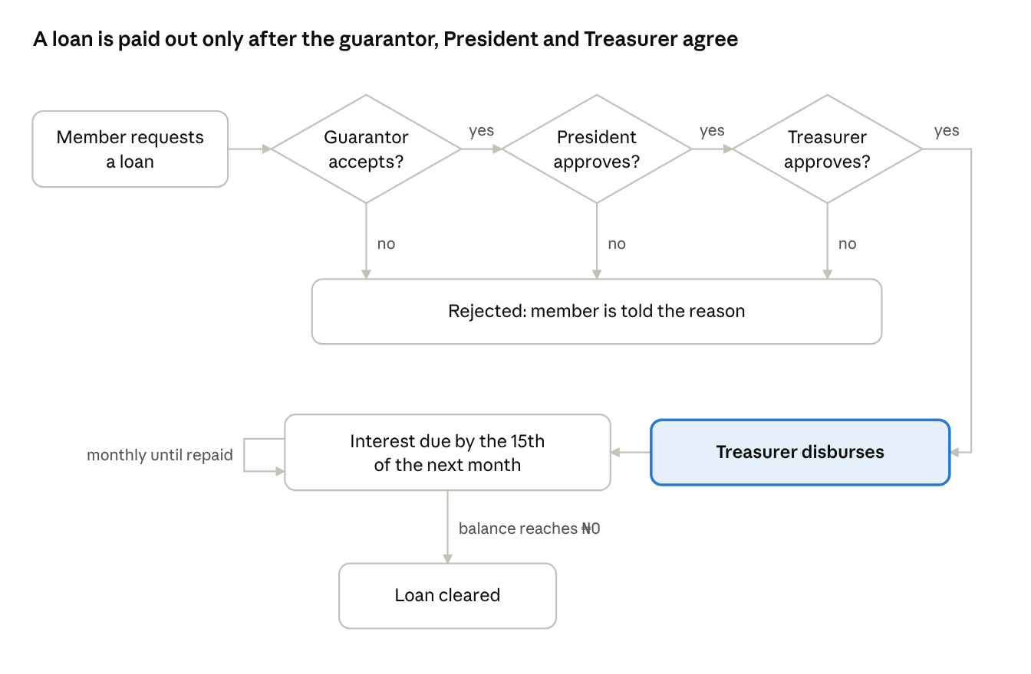
Figure 1. Loan approval flow: a "no" at any of the three approvals ends the request. After disbursement, interest is due every month until the balance reaches ₦0.

Interest and reminders
- FR-19 On the 1st of each month, the app works out every member's interest due by the 15th (BR-3) and notifies them.
- FR-20 On the 10th, members with unpaid interest get a reminder. On the 16th, unpaid interest becomes arrears and the member and guarantor are notified. From 1 December to 15 February, every member with a loan or arrears gets a year-end warning on the 1st and 15th of each month, showing what will be deducted from their contributions if unpaid.
- FR-21 Credits from overpaid interest are shown on the member's dashboard and applied automatically to the next interest due.

Bank and other income
- FR-22 The Treasurer records other income (membership fees, fines, donations) and expenses with a category, date, amount, description and receipt.
- FR-23 The Treasurer enters the month-end bank statement balance. The app shows the difference from the expected balance (BR-4). A month cannot be closed with an unexplained difference.
- FR-36 Officers record each investment (BR-7) and its return. The app reminds the Treasurer 7 days before each maturity date.
- FR-37 A member can request exit in the app, or an officer can enter it. The app shows the exit payout (contributions minus anything owed) for President approval (BR-8).

Month and year close
- FR-24 Monthly close and sign-off as in BR-5. The signed sheet can be printed or saved as a PDF with the officers' names and sign-off times.
- FR-25 Year-end settlement as in BR-6. The Admin sees a preview of every payout before confirming.
- FR-26 The Admin opens a new year. Carried-over debts and the opening bank balance move across automatically.

Debtor follow-up
- FR-27 A debtors list shows each debtor's amount owed, due date, last contact and next action.
- FR-28 Officers send SMS and email reminders from the app, singly or in bulk, using templates the Admin can edit.
- FR-29 Officers log calls: date, who called, outcome and promised payment date.
- FR-34 Guarantor emails go out automatically every quarter and at year end (BR-2).
- FR-35 Officers can mark a debtor as referred for legal action. The app records the date, status and notes, and prints a debt statement.

Notifications
- FR-30 Notifications go in-app, by SMS and by email. Members choose email on or off. An SMS always goes to the member when their payment record is created or changed. The union pays for SMS from members' membership fees.
- FR-31 Notified events: payment confirmed or rejected, loan status changes, guarantor requests, interest due, arrears, month closed, year-end payout.

Settings (Admin)
- FR-32 Admin settings: interest rate (default ₦25 per ₦1,000), interest due day (default 15th), financial year start (default March), union name and logo, bank account details, SMS and email templates, loan limit (default monthly contribution × 12), loan window (default March to December), and year-end warning period (default 1 December to 15 February).
- FR-33 A rate change applies from the next open month. It never changes closed months.

5. Reports and statements
Each report replaces a sheet in the workbook. All reports can be filtered by month and year, printed, and downloaded as PDF or Excel.
Report | Replaces sheet | Who sees it | Contents
Monthly sheet | March … February | Officers, Auditor | One row per member: contribution, loan given, opening balance, interest due, interest paid, arrears/credit, principal repaid, closing balance, next interest. Totals, bank balance and sign-offs.
Member statement | Pay Summary, Trans_Details | Officers, Auditor, the member (own only) | A 12-month history plus year totals and projected or final payout.
Year-end settlement | Aza_Final | Officers, Auditor; each member sees their own line | Per member: year's contributions, dividend, loans taken, repaid, balance, interest owed or credit, payout, Ok/Debtor. Union totals.
Bank book | "Total Money in Bank" rows | Treasurer, President, Admin, Auditor | Every inflow and outflow by date, with running balance and month-end reconciliation.
Loan book | (new) | Officers, Auditor | All active loans: borrower, guarantor, amount, date given, balance, arrears, months outstanding, exceptions.
Debtors and arrears | (new) | Officers | Members with arrears or a negative payout, with the contact log and legal status.
Income summary | (new) | Officers, Auditor | Interest earned, other income and expenses for the year, to support the dividend decision.
Member register | Mem_Records | Officers | The member list with contact and bank details.

Officer dashboard: bank balance, money out on loans, interest due this month and collected so far, arrears total, receipts waiting for confirmation, loans waiting for approval.
Member dashboard: savings so far this year, loan limit, loan balance, interest due and its due date, any credit, projected year-end payout, and an "Upload receipt" button.
Investment register: every MMF and treasury-bill placement with amount, rate, maturity, amount returned and profit. Seen by officers and the Auditor.

6. Non-functional requirements
- Platform: a mobile-first web app that works in any phone browser and can be added to the home screen. Laptops and desktops are also supported. A native Android/iOS app can follow later using the same backend.
- Low data: pages load on a slow 3G connection. Receipt photos are compressed before upload.
- Money accuracy: amounts are stored as whole kobo, never as floating-point numbers. Totals always match the sum of their lines.
- Security: HTTPS only; passwords hashed; sessions time out after 30 minutes idle; role checks run on the server, not just the screen.
- Audit trail: every create, edit, approval, reversal and reopen is logged with user, time, old value and new value. The log cannot be edited. Corrections are made as reversing entries, not by deleting records.
- Backups: an automatic daily backup is kept for 30 days. The Admin can export all data to Excel at any time.
- Privacy: members see only their own data. Phone numbers and bank details are visible only to officers. This follows the Nigeria Data Protection Act 2023.
- Language and format: English, ₦ with thousands separators (₦1,250,000.00), dates as DD/MM/YYYY, Lagos time.
- Scale: at least 200 members and 10 years of history without slowing down.
- Availability: 99% uptime. SMS and email are sent in the background, so a provider outage never blocks recording a payment.

7. Data migration and spreadsheet issues
We go live with clean opening balances from the 2025–2026 year end, then record 2026–2027 in the app from March 2026 onwards. The app's rules remove each issue below.
Migration steps
- Build one clean member list from Mem_Records and the monthly sheets, each member with a member number. The Secretary resolves name spellings, e.g. "Ohiokhuaobo" vs "Ohiokhuarobo".
- Load carried-over debts at 28/02/2026. All loans were netted against savings in Aza_Final, so only debtors carry over: Zeebaby, ₦240,350, unless already paid.
- Load the opening bank balance from the actual bank statement, not the workbook (see issue 1).
- Enter the current year (from March 2026) from the 2026–2027 records. Check that the app's monthly totals match the sheet, after correcting known errors.
Issues found in the 2025–2026 workbook
# | Issue | Effect | App rule that prevents it
1 | December–February bank total adds interest twice | Bank overstated by ₦118,750 (₦8,234,000 shown vs ₦8,115,250 correct) | BR-4: each figure counted once, checked against the bank statement
2 | Dividend (4.2%) paid more than interest earned | ₦376,099.50 paid vs ₦307,500 earned | BR-6: income shown and over-payment warning before the rate is saved
3 | Interest credit wiped when a loan is cleared | Mrs Favour Ohiokhuaobo lost a ₦12,500 credit | BR-3: credit kept until refunded at year end
4 | Arrears dropped on a top-up loan with no interest paid | Interest owed silently cleared | BR-2/BR-3: arrears always carried
5 | Formulas pointing at the wrong month or member | September row 5 read July; statement 5 showed member 4; #REF! errors | Members linked by number; balances carried by the system
6 | Members tracked by row position; names differ between sheets | Wrong person's figures possible | FR-7: unique member number
7 | February interest switched off by formula | Outstanding loans earned nothing in February | BR-3: February interest charged at year-end close

8. Decisions confirmed
The union answered every open question on 11/10/2026. Only the choice of SMS provider remains, and it will be made before go-live.
Topic | Decision | Rule
Loan limit | Monthly contribution × 12; 1.5× or more only as an exception approved by the President or Treasurer, guarantor informed | BR-2
Late interest | No penalty; unpaid interest becomes arrears, added to next month's interest, and deducted from contributions at year end if still unpaid | BR-3
Guarantors | One per loan; at most two loans per guarantor; on default, the borrower's contributions are used first, then the guarantor's | BR-2
Dividend | One flat percentage set by the union each year; only members who contributed in at least 4 months qualify | BR-6
Investments | MMF, treasury bills and similar are recorded with their returns | BR-7
Exit | Any time; member gets back their contributions only and forfeits the dividend | BR-8
Recording payments | President, Treasurer and Secretary can create or update any member's monthly record; every change is tracked | FR-11
SMS | Sent automatically when a member's payment record changes; paid by the union from membership fees; provider chosen before go-live | FR-12, FR-30
Member accounts | Created by the Admin; no self-registration | FR-2
Current year | Loaded from the union's 2026–2027 records | Section 7

9. Approval
______________________________ ______________
President (name and signature) Date
______________________________ ______________
Treasurer (name and signature) Date
______________________________ ______________
Secretary (name and signature) Date
______________________________ ______________
Admin (name and signature) Date

