IPU Contribution & Loan App — System Design
Iyobor Progressive Union · 11/10/2026 · Owner: Festus (Admin) · Status: Approved

1. Summary and technology choices
We build one mobile-first web app that members and officers open in their phone browser, backed by one PostgreSQL database. Every money movement is stored once as a ledger entry, and balances, interest and payouts are worked out from those entries. This design implements the approved Requirements document.
Part | Choice | Why
App (screens and server) | Next.js with TypeScript, installable as a home-screen app (PWA) | One codebase for phone and laptop; no app-store approval needed
Styling | Tailwind CSS with the IPU brand colours and fonts | Matches the brand kit; small pages that load fast on 3G
Database | PostgreSQL (managed, e.g. Supabase or Neon) | Strong accuracy for money; automatic daily backups
Database access | Prisma | Typed queries; safe schema changes
Login | Phone number + password, hashed with Argon2; secure session cookies | Matches the requirement; no email needed to sign in
Receipt and document files | S3-compatible storage (e.g. Supabase Storage or Cloudflare R2) | Cheap; files never stored in the database
PDFs (statements, letters, certificates) | HTML templates from the brand kit, printed to PDF on the server | Documents look exactly like the approved designs
SMS | A Nigerian bulk-SMS provider behind one adapter | The provider can be changed later without touching the rest
Email | Transactional email service, sent from the union's address | Guarantor updates and statements
Scheduled jobs | Netlify scheduled function, run daily, that runs jobs by date rules | Interest on the 1st, reminders, warnings, quarterly emails
Hosting | Netlify (app) + managed PostgreSQL | Little server upkeep; free or low-cost tiers to start

Money rule: every amount is stored as whole kobo (₦1 = 100 kobo) in integer columns. No floating-point numbers are used for money anywhere.
Way of working: the app is built and tested locally (localhost) in VS Code. The code is kept in a private GitHub repository owned by the Admin. Each push to the main branch deploys automatically to Netlify, the live site; work in progress stays on other branches.

2. Architecture
Members and officers use the same web app; only the app talks to the database, file storage, SMS and email.
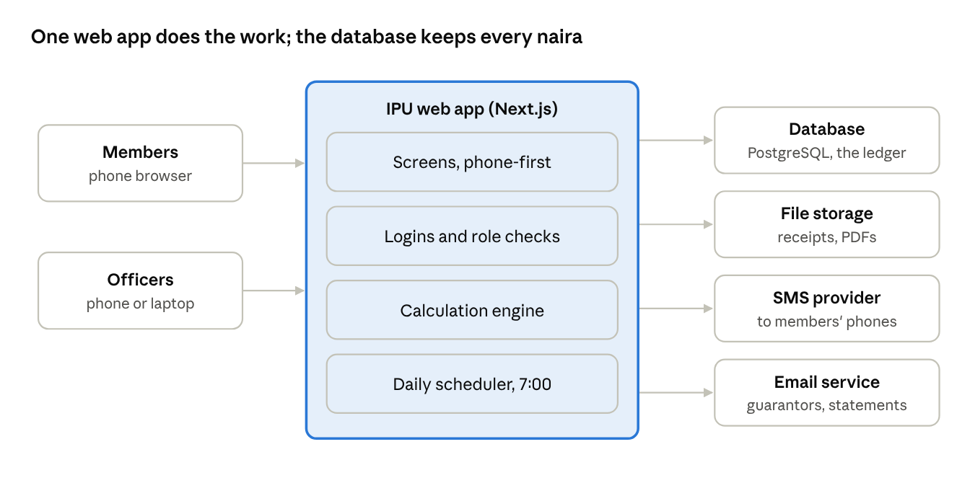
Figure 1. Architecture: one app, four outside services. The calculation engine is the only place interest, limits and payouts are worked out, and the scheduler calls it for the monthly jobs.

3. Data model
The heart of the database is one ledger table: every naira that moves is one row, and rows are never edited or deleted. A correction is a new reversing row. Monthly sheets, statements and the bank balance are all built from the ledger.
Table | Holds | Key fields
users | Login accounts | phone (unique), password hash, must-change-password flag, failed attempts, locked-until
user_roles | Who holds which role | user, role (Admin, President, Treasurer, Secretary, Auditor, Member)
members | Member register | member no. (e.g. IPU-0001), name, phone, email, bank, account no., year joined, trade, address, emergency contact, usual monthly contribution, status
financial_years | One row per March–February year | label (2026–2027), status (open, closing, closed), dividend rate, closed by/at
periods | One row per month | year, month, status (open, ready, signed, locked), bank statement balance, sign-offs
settings | Rules that can change | interest per ₦1,000 (25), due day (15), loan window, warning period, limit multiple; each with an effective-from month
ledger_entries | Every money movement | date, period, member, type, amount (kobo), loan / investment link, receipt link, bank reference, entered by, reverses
receipts | Uploaded proof of payment | member, amount, paid on, file, split, status (pending, confirmed, rejected), checked by
loans | One row per loan | borrower, guarantor, amount, purpose, status, exception flag and reason, disbursed on, bank reference
loan_approvals | Each decision on a loan | loan, step (guarantor, President, Treasurer, exception), decision, reason, by, at
loan_months | Monthly schedule, frozen at each month close | loan, period, opening balance, interest due, interest paid, arrears or credit, principal repaid, closing balance, next interest
investments | MMF, treasury bills, etc. | type, institution, amount placed, placed on, rate, maturity date, amount returned, returned on, proof, approvals
exits | Members leaving mid-year | member, requested on, approved by, contributions refunded, deductions, paid on
settlements | Year-end payout per member | year, member, contributions, months contributed, dividend, credit refund, loan and interest deducted, guarantor recovery, payout, result, debtor plan
contact_logs | Debtor follow-up | member, channel (call, SMS, email), outcome, promised date, by
legal_referrals | Defaulters sent for legal action | member, date, status, notes
notifications | Every SMS and email sent | to, channel, template, message, status, provider reference
audit_log | Every change in the system | user, action, table, record, old value, new value, time (append-only)

Ledger entry types:
Type | Bank effect | Example
CONTRIBUTION | In | Monthly savings
MEMBERSHIP_FEE | In | Joining fee (pays for SMS)
INTEREST_PAID | In | Interest paid by the 15th
LOAN_REPAID | In | Principal returned
OTHER_INCOME | In | Fines, donations
INVESTMENT_RETURNED | In | T-bill matures
LOAN_GIVEN | Out | Disbursement
INVESTMENT_PLACED | Out | Money into an MMF
EXPENSE | Out | SMS bundle, printing
PAYOUT | Out | Year-end or exit payment
INTEREST_CHARGED | None | Interest due for the month (a charge, not cash)
DEDUCTION | None | Loan or interest taken from contributions at year end or on default
REVERSAL | Opposite of the original | Correcting a wrong entry

4. Calculation engine
All calculations live in one tested module, so the same rules drive the screens, the PDFs and the year-end. Each rule will have automated tests built from last year's real figures (for example Mrs Enotieomwan's 2025 loan).

Interest for each loan, each month
Interest charged = (Closing loan balance ÷ 1,000) × 25
Interest owed = All interest charged − All interest paid
A positive interest owed is arrears; a negative one is a credit. This matches the workbook's "New Interest" column without its errors: credits are never wiped and arrears are never dropped on a top-up.

Loan limit check (when a loan is requested)
Limit = Usual monthly contribution × 12
The app compares the requested amount plus any existing balance to the limit. If above it, the loan is flagged as an exception and needs approval from the President or Treasurer, and the guarantor is notified. Requests are refused in January and February, and when the guarantor already backs two active loans.

Month close (run by the Treasurer, signed by the President and Secretary)
- Check every receipt for the month is confirmed or rejected.
- Compare the expected bank balance (sum of ledger entries) with the bank statement balance. Stop if they differ.
- For each active loan: freeze its monthly schedule row and post next month's interest charge, due on the 15th.
- Lock the month. Send each member an SMS summary.

Year-end settlement (after February closes)
- Charge February's interest on any balance still owed.
- For each member, count the months they contributed. A member qualifies for the dividend with 4 or more months.
- Admin enters the dividend rate; the app shows interest earned, investment profit and other income against the total dividend before saving.
- Work out each payout (formula below).
- Payout ₦0 or more is paid by bank transfer and recorded as PAYOUT. Payout below ₦0 makes the member a debtor; Admin chooses pay up or carry over.
- Close the year and open the next March with carried-over debts as opening balances.
Payout = Contributions + Dividend + Credit − Loan balance − Interest owed

Default (borrower cannot pay)
The amount owed is recovered in this order: the borrower's own contributions first, then the guarantor's contributions, up to what is still owed. Each step is a DEDUCTION entry, and the guarantor is notified before it is posted.

Member exit
Exit payout = Contributions − Loan balance − Interest owed
No dividend is paid. A member who is guaranteeing an active loan must be replaced as guarantor first.

5. Scheduled jobs and notifications
One daily job at 7:00 Lagos time checks the date and runs whatever is due. Messages go into a queue, so a slow SMS provider never blocks an officer recording a payment, and failed messages are retried.
When | Job | Who is told | Channel
Every time a payment is recorded or changed | Payment confirmation with new balances | The member | SMS (always)
1st of each month | Interest due by the 15th | Each borrower | SMS, in-app
10th of each month | Reminder of unpaid interest | Borrowers who have not paid | SMS
16th of each month | Unpaid interest becomes arrears | Borrower and guarantor | SMS, email
1st and 15th, Dec to 15 Feb | Year-end warning of what will be deducted | Members with a loan or arrears | SMS, email
End of May, Aug, Nov, Feb | Quarterly loan progress | Each guarantor | Email
7 days before a maturity date | Investment matures soon | Treasurer | In-app, email
When a loan changes step | Guarantor request, approval, rejection, payout | Borrower, guarantor, approvers | SMS, in-app
After year-end close | Final statement and payout | Every member | SMS, email

SMS text is kept to one message (160 characters) where possible. Example: IPU: N10,000 contribution received 05/11/2026. Savings N90,000. Loan bal N150,000. Interest due 15/12: N3,750.
Every SMS sent is recorded with its cost, and the officer dashboard shows the SMS spend against membership fees collected.

6. Screens
There is one app; what a person sees depends on their roles. Members get a short, phone-first menu with large buttons. Officers get the same plus an Office menu. All screens use the brand kit's green, gold and ivory, with Marcellus headings and Public Sans text.
Member screens
Screen | What it shows or does
Login | Phone number and password; forgot password by SMS code
Home | Savings this year, loan balance, interest due and due date, credit, projected payout, "Upload receipt" button
Upload receipt | Photo or PDF, amount, date, what it is for
My statement | Month-by-month history; download as PDF
My loan | Loan schedule, guarantor, request a new loan (with live limit check)
Guarantor requests | Accept or decline being a guarantor; loans I guarantee and their progress
Profile | Contact details, change password, request exit

Officer screens (Office menu)
Screen | Who uses it | What it shows or does
Dashboard | All officers | Bank balance, money out on loans, interest due and collected, arrears, receipts and loans waiting, SMS spend
Monthly sheet | All officers | The workbook's month sheet: one row per member, editable for the open month, totals, sign-off buttons
Record payment | President, Treasurer, Secretary | Find a member, enter contribution / interest / repayment, attach proof
Receipts queue | Treasurer | Confirm, re-split or reject uploaded receipts
Loans | President, Treasurer | Requests by step, approve or reject, exceptions, disburse
Members | Admin, Secretary | Add, edit, suspend, reset password, print certificate and ID card
Bank and investments | Treasurer | Other income, expenses, investments, month-end bank reconciliation
Debtors | All officers | Arrears and debtors, send reminders, log calls, legal referral
Year-end | Admin | Dividend rate, payout preview, close year, open new year
Reports | All officers, Auditor | Monthly sheet, statements, settlement, bank book, loan book, income summary, investment register; PDF and Excel
Settings | Admin | Rates, dates, templates, roles, union details
Change log | Admin, Auditor | Every change, filterable by person, member and date

7. Security, audit and backups
Every permission check runs on the server, and every change to money or member data is written to an append-only change log.
- Passwords: hashed with Argon2; 8 characters minimum; changed at first login; locked for 15 minutes after 5 wrong attempts.
- Sessions: secure, HTTP-only cookies; signed out after 30 minutes idle; officers can see and end their active sessions.
- Roles: each screen and each action checks the user's roles on the server. Members can only ever load their own records.
- No self-approval: an officer cannot approve, disburse or record a payment on their own loan.
- Corrections: ledger rows are never edited or deleted; a correction is a reversing entry with a reason. Locked months need Admin to reopen, with a reason.
- Change log: user, time, action, old value, new value. It cannot be edited, even by Admin.
- Files: receipts and signatures are stored privately and opened through short-lived links, never public URLs.
- Signatures: the President's and Secretary's signature images are used only on certificates and official letters produced by the app, and each produced document gets a unique reference number recorded in the log.
- Backups: daily automatic database backups kept for at least 30 days, plus a monthly Excel export of all data emailed to the Admin.
- Privacy: phone numbers and bank details are shown only to officers, in line with the Nigeria Data Protection Act 2023.

8. Build plan
The app is built in six phases, about 16 weeks in all, and each phase ends with something officers can try.
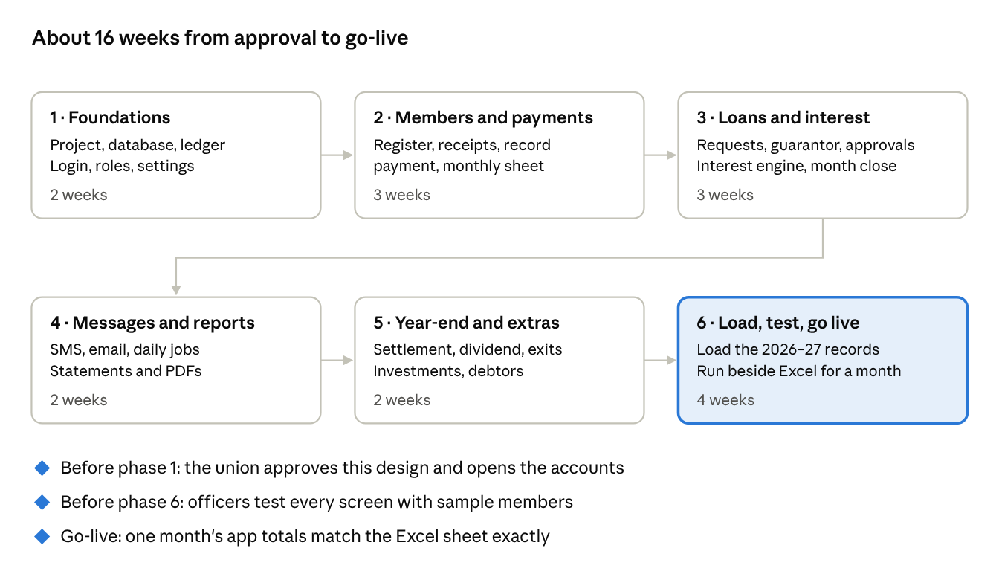
Figure 2. Build plan: six phases and three gates.
The week counts are estimates for one developer; they shift with how quickly the gates are passed. The app runs beside the Excel workbook for one full month before the workbook is retired.

9. Decisions and accounts needed
Four things from the union let the build start; the rest can wait until testing.
- Approve this design and the stack: approved 11/10/2026.
- Web address: choose a domain name, such as ipu.com.ng or iyoborpu.org, and who registers it in the union's name.
- Hosting and database accounts: created with the union's email (iyoborpu@gmail.com) so the union owns them, not the developer.
- The 2026–2027 records: send the current year's workbook so March–October 2026 can be loaded and checked.
- Before testing: choose the SMS provider and buy a starter SMS bundle; register an SMS sender name such as "IPU" (Nigerian networks require sender-name registration, which can take some days).
- Before go-live: the GT Bank account name exactly as registered, and a list of members with phone numbers and usual monthly contributions.

10. Approval
______________________________ ______________
President (name and signature) Date
______________________________ ______________
Treasurer (name and signature) Date
______________________________ ______________
Secretary (name and signature) Date
______________________________ ______________
Admin (name and signature) Date

