JVee Crunch Kitchen

Website Design
15 October 2026 · Version 1 draft for owner review · Prepared by JVeesoft-IT Solutions and Services Ltd

1. Overview
The website is a phone-first ordering site in the Sprout J brand, with 7 customer pages and 4 admin pages. It turns the requirements into screens: every page here traces back to a numbered requirement (C1–C14, A1–A13, R1–R6).
Four principles guide every screen:
- Thumb first. Every action sits within easy reach at the bottom of a phone screen, with tap targets at least 44 px tall.
- Prices up front. The customer never has to ask what something costs; prices show on the menu, in the cart and before payment.
- Three taps to order. Pick a location, add items, check out. Accounts and extras never stand in the way.
- Light on data. Small compressed images and one typeface keep pages fast on 3G.
Phone numbers, fees, bank details and photos in this document and the mockups are made up for now. They are listed in the last section and must be replaced before launch.

2. Sitemap
The site has 11 pages: 7 public pages for customers and 4 admin pages behind sign-in. Checkout is the one point where the two halves meet.
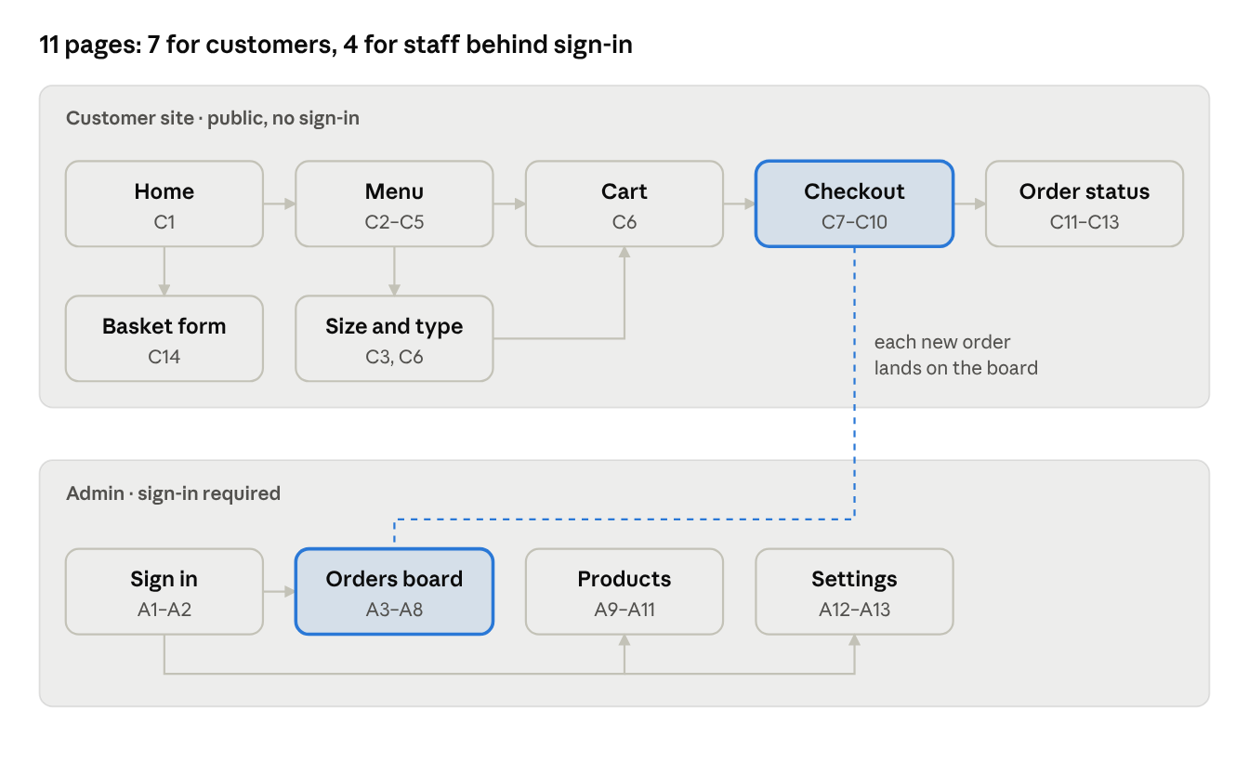
Sitemap: 11 pages, with requirement codes under each
Every order placed at Checkout appears on the Orders board, and each status change on the board shows on the customer's Order status page. The header on every public page links to Home, Menu and Cart.

3. User flows
A customer goes from a shared link to a placed order in 6 steps with no account; the kitchen then moves it through 4 steps that the customer sees live.
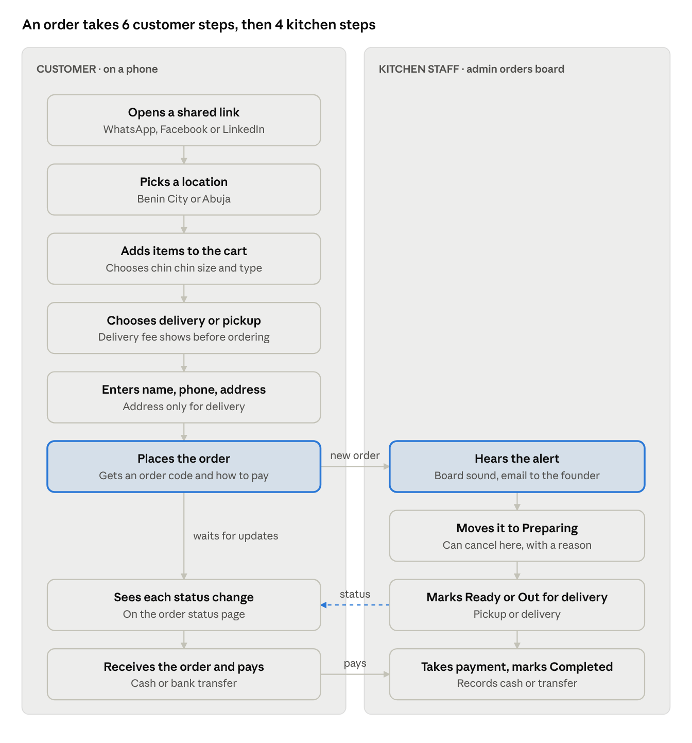
Order journey: customer and kitchen staff
The custom basket enquiry is a separate short path: Home, then Basket form, then a thank-you message; the founder follows up by phone or WhatsApp. Staff sign in once per device and stay signed in for 30 days.

4. Screens
Fourteen screens cover the whole order journey, all four admin pages, the empty and error states, and the desktop home page. Phone screens are drawn at 390 × 844 px, a common Android and iPhone size; the editable versions are on the design canvas.
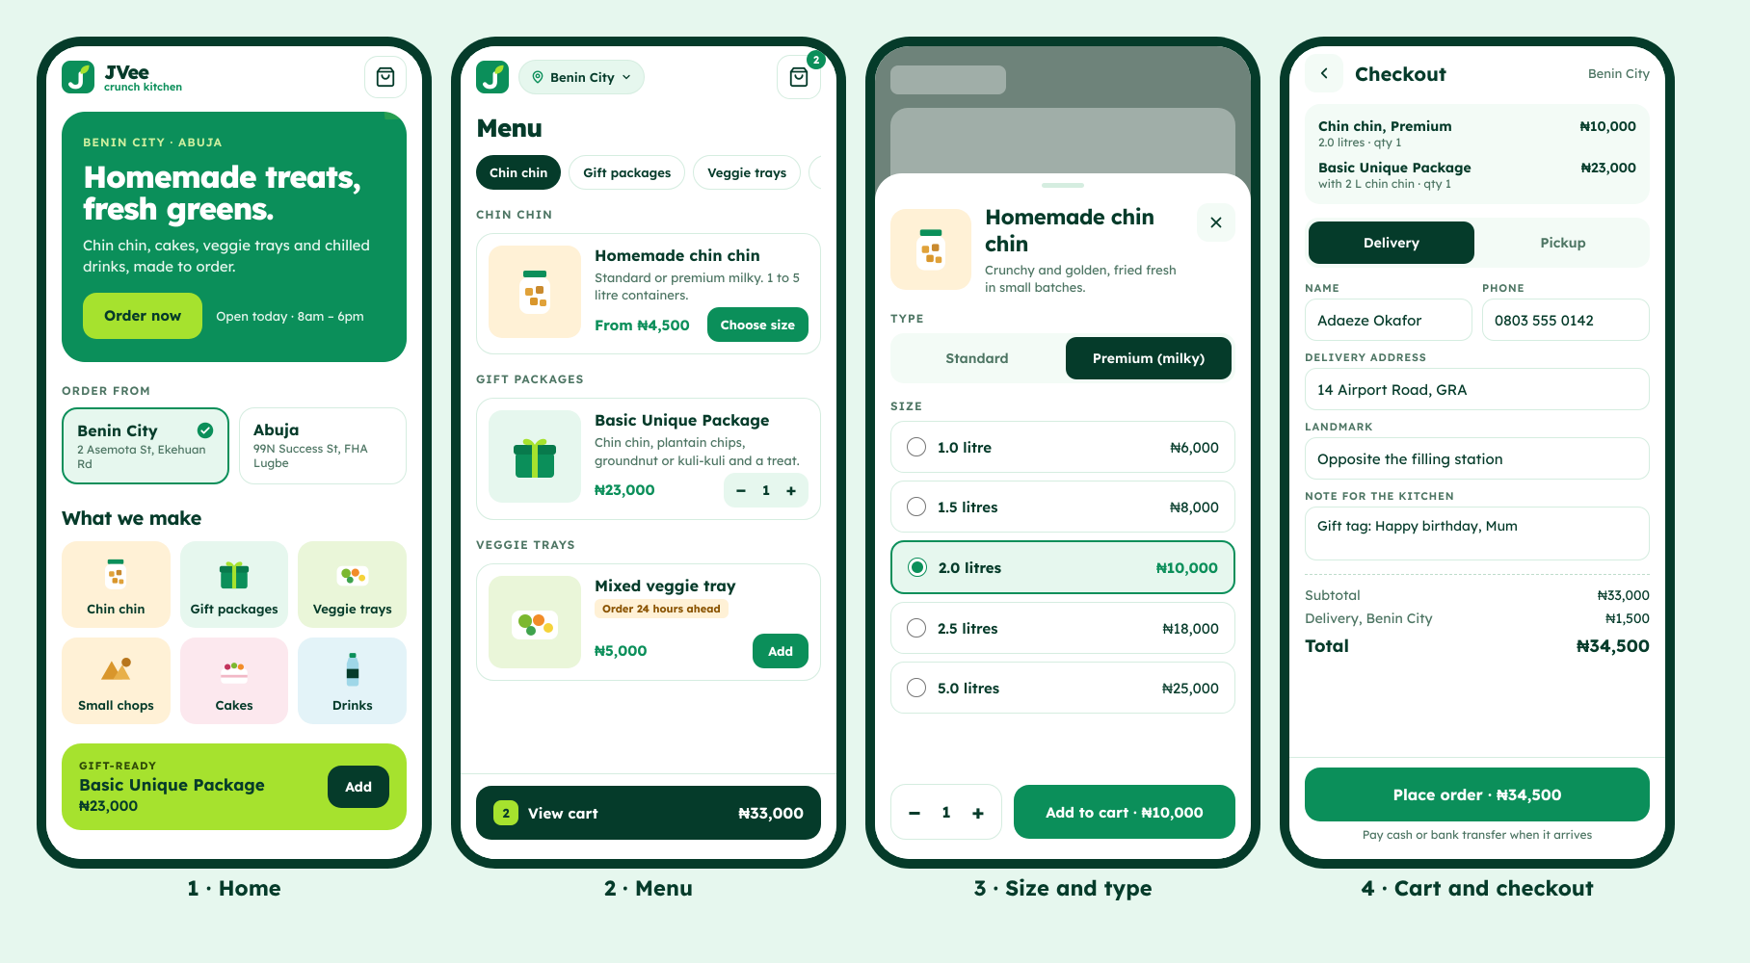
Customer screens: Home, Menu, Size and type, Cart and checkout
Screen | What it does | Key decisions | Requirements
1 · Home | Shows the brand, opening hours, location choice and the six categories | Location is picked here, before the menu, so prices and fees match the city | C1, C5
2 · Menu | Lists products by category with prices | Sticky cart bar with item count and total; chin chin opens a size picker instead of adding straight away | C2–C4, C6
3 · Size and type | Picks Standard or Premium and one of 5 sizes | All 5 prices visible at once; the button shows the exact amount being added | C3, C6
4 · Cart and checkout | Reviews items, picks delivery or pickup, collects details | One page, not several steps; delivery fee and total show before the button | C7–C10, R3–R5

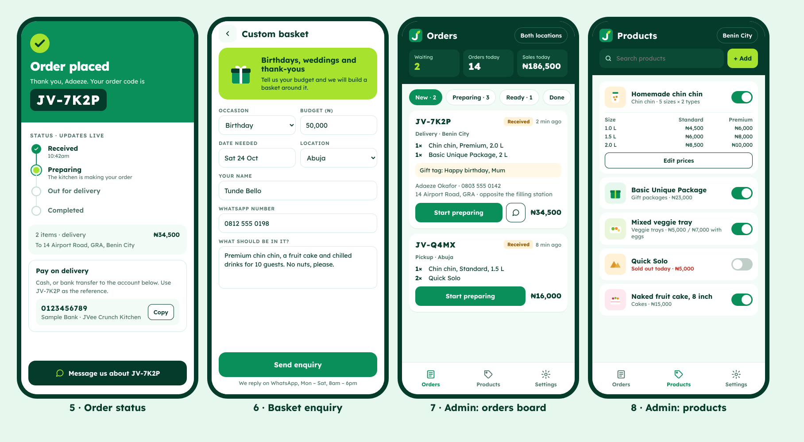
After ordering and admin screens: Order status, Basket enquiry, Orders board, Products
Screen | What it does | Key decisions | Requirements
5 · Order status | Confirms the order, shows the code, live status and how to pay | Bank details with a Copy button; one tap to WhatsApp with the code filled in | C11–C13, R4
6 · Basket enquiry | Collects occasion, budget, date and wishes for a custom basket | Short form; the reply comes on WhatsApp, not by email | C14
7 · Admin: orders board | Shows new orders with everything staff need to act | Today's totals at the top; one big button moves the order to its next status | A3–A8
8 · Admin: products | Edits prices and marks items sold out | A switch per product for sold out; chin chin prices shown as a size-by-type grid | A9–A11

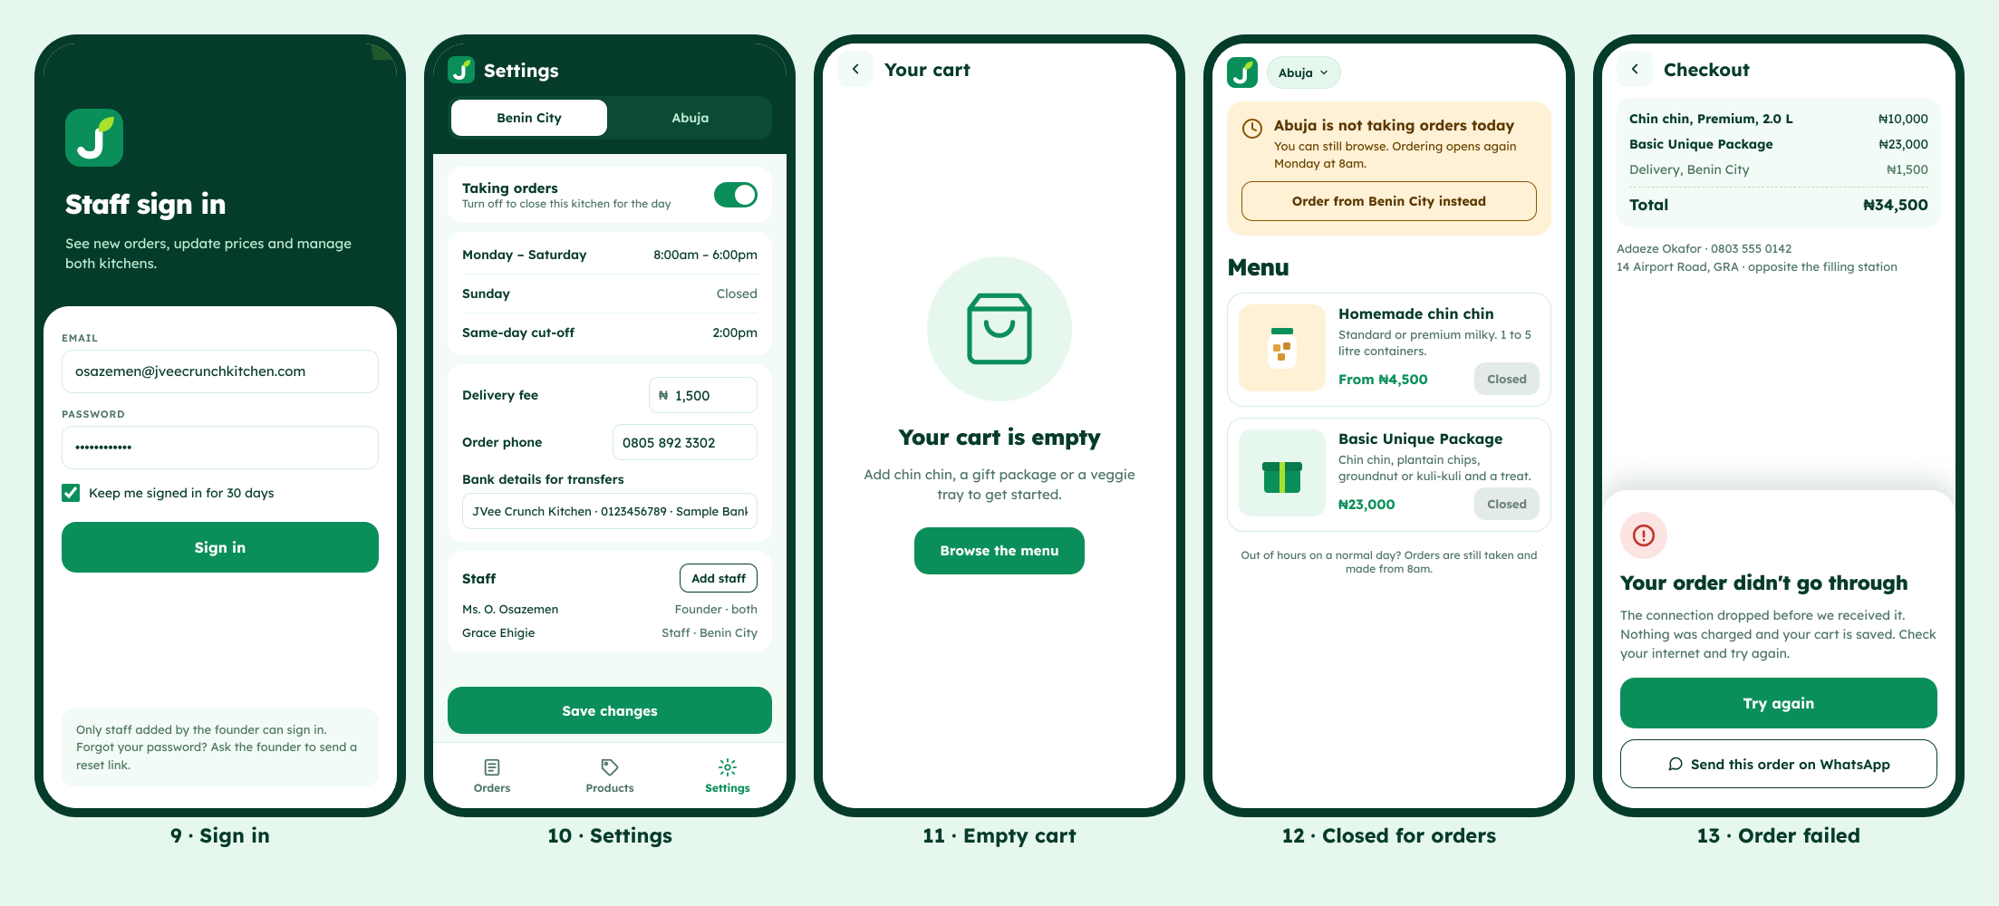
Sign in, Settings, Empty cart, Closed for orders, Order failed
Screen | What it does | Key decisions | Requirements
9 · Admin: sign in | Lets the founder and staff into the admin | No public sign-up; “keep me signed in” for 30 days; the founder resets passwords | A1
10 · Admin: settings | Sets hours, cut-off, delivery fee, contact and bank details, and staff, per location | A location switch at the top; one “Taking orders” switch closes a kitchen for the day | A2, A12, A13
11 · Empty cart | Shows when the cart has nothing in it | One clear way back to the menu | C6
12 · Closed for orders | Shows when the founder has turned a location off | Menu stays visible with Add buttons disabled; offers the other city instead | A12, R1
13 · Order failed | Shows when an order doesn't reach the kitchen | Says plainly what happened and that the cart is kept; WhatsApp as a backup way to order | Reliability

Outside opening hours on a normal day, ordering stays open: a one-line note on the menu and at checkout says the order will be made from 8am on the next opening day (R1).
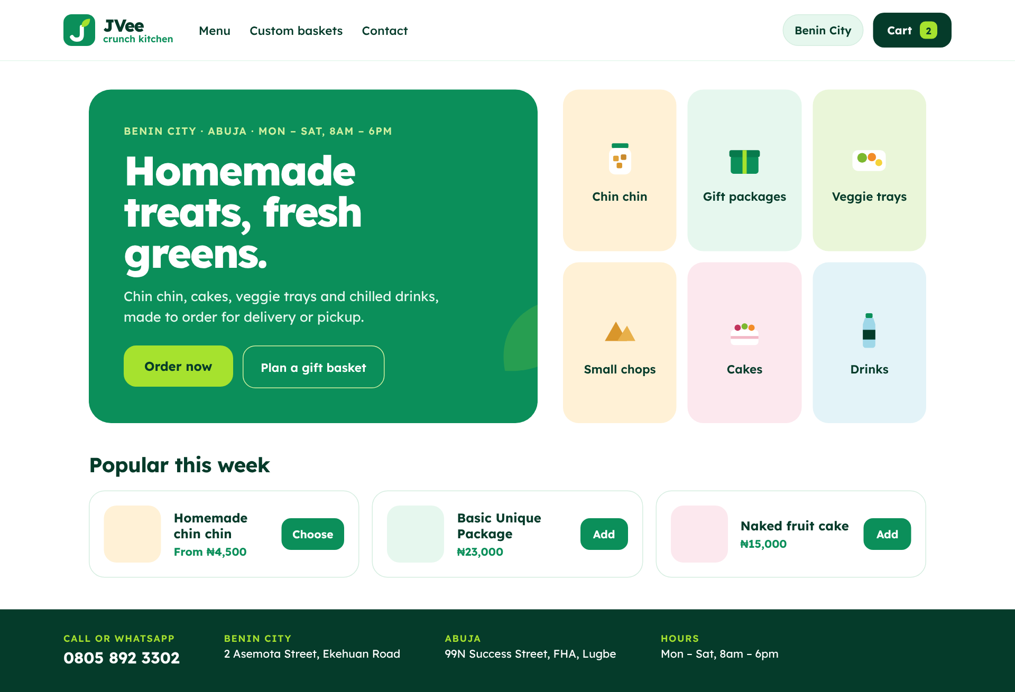
Home page on a desktop screen
14 · Home on desktop. The same content as the phone home page, laid out side by side: the hero and the six categories share the first row, then popular items, then contacts in the footer. Every other page widens the same way: one column on phones, two from 600 px, three from 960 px, capped at 1120 px.

5. Design rules
One typeface, four greens and one set of components keep every page consistent with the business cards and flyer.

Colours
Name | Hex | Used for
Emerald | #0B8F5A | Primary buttons, links, prices, active states
Zest | #A6E22E | Highlights, badges, the leaf in the logo
Deep | #053B2A | Headings, body text, footer background
Mint | #E6F7EE | Page sections, selected options, card backgrounds
White | #FFFFFF | Page background
Alert red | #C2362B | Errors and cancelled orders only
Amber | #B86A00 | Pending and waiting states only

Type (Lexend, falling back to the phone's system font)
Style | Size / weight | Used for
Display | 32 px / 800 | Page heroes
Heading | 22 px / 700 | Section and page titles
Item name | 16 px / 700 | Product names, order codes
Body | 15 px / 400 | Descriptions, form text
Label | 12 px / 600, uppercase, 1 px spacing | Field labels, categories

Components
- Primary button: Emerald fill, white text, 48 px tall, 14 px corners, full width on phones.
- Secondary button: white with a 1.5 px Deep outline.
- Product card: photo, name, one-line description, price, and an Add button. 16 px corners.
- Size picker: pill buttons; the selected pill turns Deep with white text.
- Status pill: colour and word together, never colour alone (Received amber, Preparing amber, Ready green, Completed grey, Cancelled red).
- Bottom bar: a sticky cart bar showing item count and total, appearing once the cart has an item.

Spacing and layout
- Spacing steps of 4, 8, 12, 16, 24, 32 px. Page side margin 16 px on phones.
- One column on phones; menu cards in 2 columns from 600 px and 3 from 960 px.
- Content width capped at 1120 px on desktop.

6. Placeholder content
Every value below is made up so the screens look real. Each one maps to an open question in the requirements and must be replaced before launch.
Item | Placeholder used | Replace with
Delivery fee, Benin City | ₦1,500 | Owner's fee
Delivery fee, Abuja | ₦2,500 | Owner's fee
Same-day cut-off | 2:00pm | Owner's cut-off time
Bank details for transfers | JVee Crunch Kitchen, 0123456789, Sample Bank | Real account
New-order email | orders@jveecrunchkitchen.com | Real address
Web address | jveecrunchkitchen.com | Chosen domain
Instagram and Facebook | @jveecrunchkitchen | Real handles
Chilled drinks | Sports drink 50cl ₦1,000; bottled water 75cl ₦300 | Real list and prices
Samosa pack contents | 6 pieces, filling not named | Real count and filling
Product photos | Drawn colour placeholders | Real photos
Sample customer and orders | Adaeze Okafor, order JV-7K2P and others | Not needed: removed at launch

The phone number 0805 892 3302, both addresses, opening hours and all menu prices are real and come from the owner.

