JVee Crunch Kitchen

Tech Stack and Architecture
15 October 2026 · Version 1 draft for review · Prepared by JVeesoft-IT Solutions and Services Ltd

1. Stack decisions
The site is a React single-page app on Netlify, with Supabase for data, sign-in and live updates, and one Netlify Function that emails the founder. Every tool has a free tier large enough for launch.
Layer | Choice | Why this one
Language | TypeScript | Catches mistakes like a wrong price field before the site goes live
Website framework | React 18 with Vite | Fast to load on phones, quick to run in VS Code, simple to host as static files
Styling | Tailwind CSS | The brand colours and spacing from the design document become reusable settings
Page routing | React Router | Separate web addresses for Menu, Checkout, Order status and the admin pages
Database | Supabase (PostgreSQL) | Stores products, orders and settings; managed, backed up, free to start
Staff sign-in | Supabase Auth | Email and password sign-in with no extra service
Live updates | Supabase Realtime | New orders appear on the board without refreshing
Order emails | Netlify Function + Resend | Sends the founder an email for each new order; keeps the email key off the public site
Code storage | GitHub | Version history and the trigger for publishing
Hosting | Netlify | Publishes automatically from GitHub, free HTTPS, custom domain support

Not used in version 1: online payment (Paystack or Flutterwave), customer accounts and an app-store app. The structure leaves room to add each later without a rebuild.

2. Architecture
The website talks straight to Supabase for all data; the only server code is one small function that emails the founder.
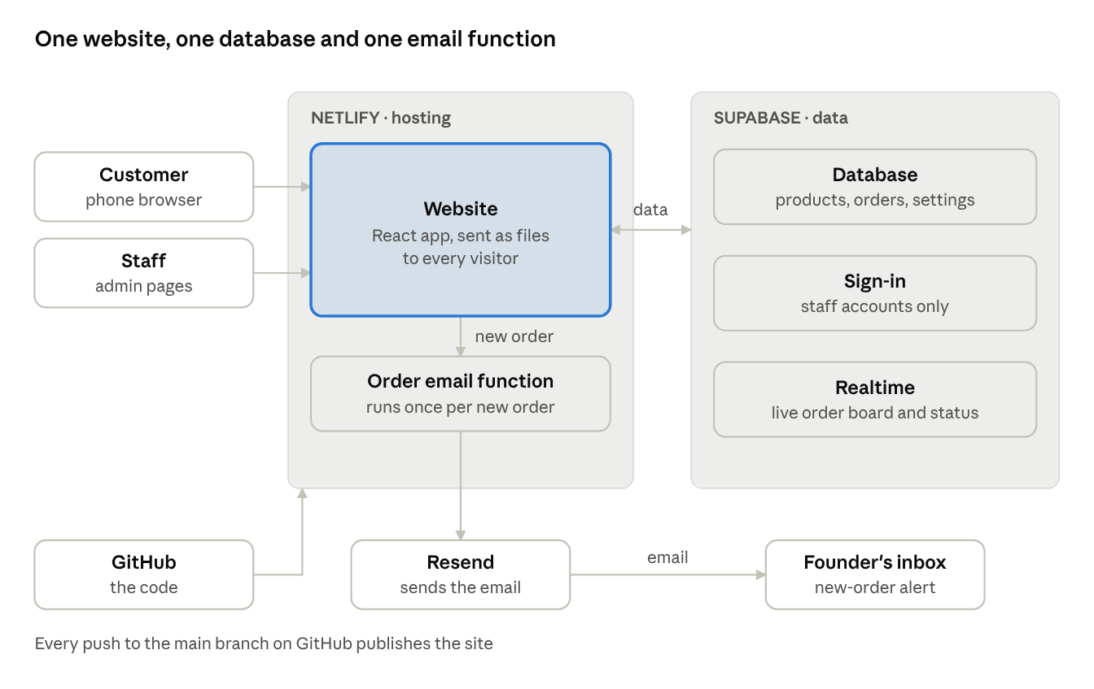
Architecture: Netlify, Supabase, Resend and GitHub
When a customer places an order, the website saves it in the database, then calls the email function. The order board listens through Realtime, so new orders appear within a second or two; the customer's status page checks for changes every 15 seconds. Database access rules, not hidden code, decide who can read or change what (see Security).

3. Data model
Nine tables hold everything. Prices live only in the database, and the order total is always worked out there, never trusted from the customer's phone.
Table | Holds | Key fields
locations | Benin City and Abuja | name, address, phone, taking_orders, delivery_fee, same_day_cutoff, opening_hours, bank_details
categories | Menu sections | name, sort_order
products | Each item on the menu | category, name, description, photo, notice_hours (24 for veggie trays), active, sort_order
product_options | Every priced choice of a product | product, label (for example “2.0 L · Premium”), size, type, price
availability | Sold out per location | product, location, sold_out
orders | One row per order | code (JV-7K2P), tracking_token, location, delivery or pickup, status, customer name, phone, address, landmark, note, needed_for, subtotal, delivery_fee, total, paid, payment_method, cancel_reason, created_at
order_items | Lines in an order | order, product option, name and unit price at the time of ordering, quantity
basket_enquiries | Custom basket requests | occasion, budget, date_needed, location, name, phone, details
staff | Who can use the admin | sign-in account, name, role (founder or staff), location (empty means both)

Three database functions do the work that must not be faked from a browser:
- place_order checks each item is available, looks up its real price, adds the delivery fee, saves the order and returns the code and a private tracking link.
- order_status returns the status of one order to whoever holds its tracking link, and nothing else. The status page asks every 15 seconds.
- next_status lets staff move an order forward, records who did it and when, and refuses invalid jumps such as Received straight to Completed.
Chin chin is stored as one product with 10 options (5 sizes × Standard and Premium). Each option keeps its own price, so the founder can change one without touching the others.

4. Project structure
One repository holds the website, the email function and the database setup, so a single clone in VS Code has everything.
jvee-crunch-kitchen/
├─ src/
│ ├─ pages/ Home, Menu, Checkout, OrderStatus, Basket
│ │ └─ admin/ SignIn, Orders, Products, Settings
│ ├─ components/ Header, ProductCard, SizePicker, CartBar, StatusPill…
│ ├─ lib/ supabase client, cart, money formatting
│ ├─ styles/ Tailwind setup and brand tokens
│ └─ main.tsx app entry and routes
├─ public/ logo, icons, product photos, social preview image
├─ netlify/functions/order-email.ts new-order email through Resend
├─ supabase/
│ ├─ schema.sql tables, access rules, database functions
│ └─ seed.sql launch menu, prices and both locations
├─ docs/ requirements, design, this document
├─ .env.example the settings each copy needs, with no secrets
├─ netlify.toml build command and page routing for Netlify
├─ package.json
└─ README.md how to install, run and publish

The seed.sql file holds the owner's real price list, so a fresh database starts with the full menu. The placeholder values from the design document live in the locations rows and can be changed from the admin Settings page.

5. Workflow
Code is written here and handed over as a zip for version 1, run on your computer in VS Code, pushed to GitHub, and published by Netlify. Later changes come as reviewed branches on GitHub.

First time
- Download the zip and extract it into the folder of your existing GitHub repository.
- In the VS Code terminal run npm install, then copy .env.example to .env and paste in the Supabase project address and public key.
- In Supabase, open the SQL editor and run schema.sql, then seed.sql. The menu and both locations appear.
- Run npm run dev and open the address it prints (usually http://localhost:5173). The site runs on your computer.
- Run git add ., git commit -m "Version 1" and git push.
- In Netlify, choose Add new site, then Import from GitHub, pick the repository, and add the same settings from .env plus the Resend key. Netlify builds and publishes it.

Every change after that
- Small fixes: edit in VS Code, check with npm run dev, commit and push. Netlify republishes within about a minute.
- Bigger changes from me: a branch on GitHub with only the changed lines. You review it, merge it, then run git pull in VS Code. Netlify shows a preview link for each branch before you merge.

Environments
Where | Address | Database
Your computer | http://localhost:5173 | The Supabase project, with test orders
Preview | A Netlify link per branch | Same project
Live | The chosen domain | Same project; test orders deleted before launch

One Supabase project is enough at this size. A separate test database can be added later if the team grows.

6. Accounts and costs
Launch costs nothing in monthly fees; the only certain cost is the domain name. Each free plan has one limit worth planning around, listed in the last column.
Service | Free plan | First paid plan | Limit to watch
Netlify | 300 credits a month; custom domain and HTTPS included | Personal, $9 a month for 1,000 credits | Each publish to the live site uses 15 credits, so about 20 publishes a month; the site pauses if credits run out
Supabase | 500 MB database, 5 GB transfer, 2 active projects | Pro, from $25 a month | Free projects pause after 1 week with no activity
Resend | 3,000 emails a month, 100 a day | Pro, from $20 a month | 100 new-order emails a day
GitHub | Free private repository | Not needed | None at this size
Domain name | Not free | Roughly ₦15,000–₦40,000 a year for .com or .ng (approximate) | Renew yearly

How we stay inside the limits:
- Netlify credits: batch changes and publish once a day at most; branch previews are used for checking.
- Supabase pausing: daily orders keep it active. If it does pause, the site stops loading the menu until someone restores the project from the Supabase dashboard, which takes one click and a few minutes.
- Resend: 100 orders a day is far above the expected volume; past that, the order board still shows every order.
Accounts should be opened in the business's name with an email the owner controls, with you added as a member. That way the owner keeps the site if the team changes.
Prices as of 15 October 2026, from netlify.com/pricing, supabase.com/pricing and resend.com/pricing.

7. Security
The public website can read the menu and place orders, and nothing more; everything else needs a staff sign-in, enforced by the database itself.
Who | Can read | Can change
Anyone on the website | Locations, categories, active products, prices, sold-out flags | Nothing directly; places orders and basket enquiries only through the database functions
A customer with a tracking link | That one order's code, items, total and status | Nothing
Staff | Orders and enquiries for their own location | Order status and payment for their location
Founder | Everything | Everything, including products, prices, settings and staff

- Row-level security is switched on for every table, so these rules hold even if someone calls the database directly with the public key.
- Secrets: the public Supabase key is safe in the website by design. The Resend key and the Supabase service key live only in Netlify's settings and are used only by the email function. Neither is ever committed to GitHub; .env is in .gitignore.
- Staff accounts: no public sign-up. The founder adds staff by email; passwords are at least 10 characters.
- Orders: tracking links use a long random token, not the short order code, so nobody can guess someone else's order.
- Abuse: the order function limits each phone number to 5 orders an hour, and phone numbers must have at least 10 digits.

8. Build plan
The build runs in five milestones. Each ends with something you can run in VS Code and review before the next one starts.
- Foundation. Project setup, brand colours and type, page routes, header and footer, the database tables, and the owner's real menu and prices. You can browse the Home and Menu pages locally with live prices from Supabase.
- Ordering. Size and type picker, cart, checkout, the place_order function, the order status page, and the empty cart, closed and order-failed screens. You can place a full test order.
- Admin. Staff sign-in, the live orders board, products and prices, and settings for each location. Orders move from Received to Completed.
- Alerts and finishing. The new-order email, WhatsApp buttons, the custom basket form, link previews for WhatsApp and Facebook, and speed checks on a slow connection.
- Test and launch. Test orders on real phones in both cities, the owner's real details in place of the placeholders, test data cleared, the domain connected, and the site live on Netlify.
Milestone 1 is first: version 1 as a zip, extracted into your repository folder and run with npm run dev. Before that zip, you need a free Supabase project; its setup steps come with the zip.

