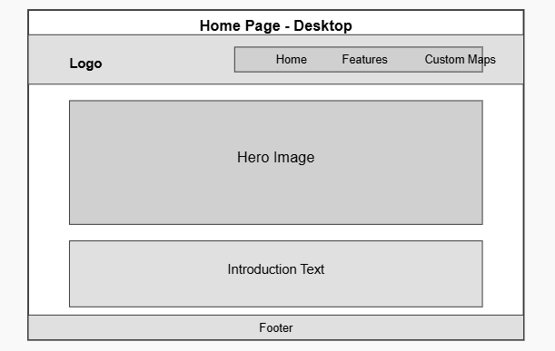

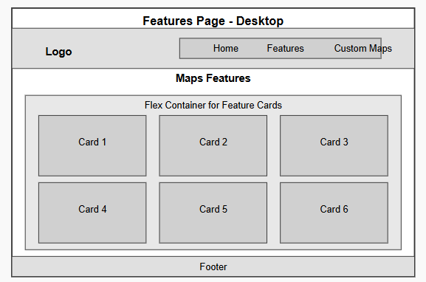

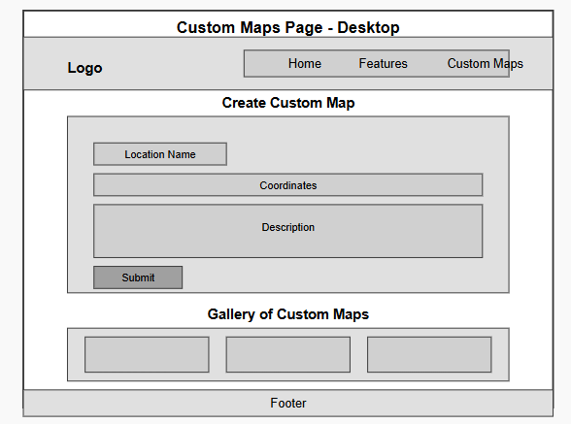

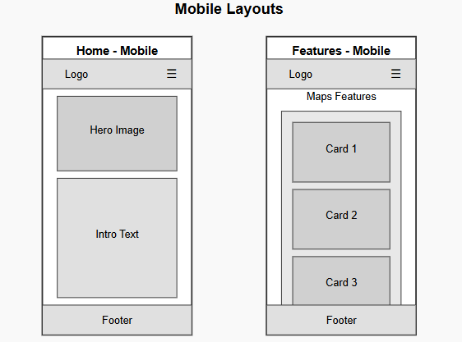

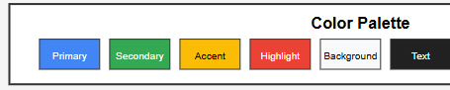

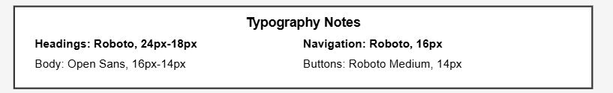

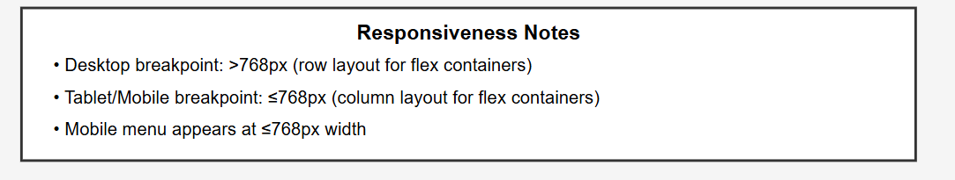

## **The Wire-Frames**

### **Desktop Layouts**

**Home Page (Desktop)**

* Top section: Header with logo on left, navigation menu on right (Home, Features, Custom Maps)
* Middle section: Large hero image showing a stylized map
* Lower section: Introduction text about Google Maps and its features
* Bottom: Footer with contact information

**Features Page (Desktop)**

* Top section: Header with logo on left, navigation menu on right
* Main content: Flex container with 6 interactive feature cards arranged in a 3x2 grid
* Each card: Approximately equal size with image, title, and flip functionality
* Bottom: Footer with contact information

**Custom Maps Page (Desktop)**

* Top section: Header with logo on left, navigation menu on right
* Upper content: Form section with labeled input fields and submit button
* Lower content: Gallery section showing custom map examples in grid format
* Bottom: Footer with contact information

### **Mobile Layouts**

**Home Page (Mobile)**

* Top section: Condensed header with logo on left, hamburger menu icon on right
* Middle: Full-width hero image (smaller than desktop version)
* Lower: Introduction text (stacked vertically)
* Bottom: Condensed footer

**Features Page (Mobile)**

* Top section: Condensed header with logo on left, hamburger menu icon on right
* Main content: Feature cards stacked vertically in a single column
* Bottom: Condensed footer

**Custom Maps Page (Mobile)**

* Top section: Condensed header with logo on left, hamburger menu icon on right
* Upper content: Form elements stacked vertically, full width
* Lower content: Gallery items in single column layout
* Bottom: Condensed footer

### **Design Elements**

**Color Palette**

* Primary: #4285F4 (Google Blue)
* Secondary: #34A853 (Google Green)
* Accent: #FBBC05 (Google Yellow)
* Highlight: #EA4335 (Google Red)
* Background: #F8F9FA (Light Gray)
* Text: #212121 (Dark Gray)

**Typography**

* Headings: Roboto, 24px-18px
* Body: Open Sans, 16px-14px
* Navigation: Roboto, 16px
* Buttons: Roboto Medium, 14px

**Responsiveness Notes**

* Desktop breakpoint: >768px (row layout for flex containers)
* Tablet/Mobile breakpoint: ≤768px (column layout for flex containers)
* Mobile menu appears at ≤768px width
* Images resize proportionally on different screen sizes
* Text size adjusts for readability on smaller screens

**Interactive Elements**

* Navigation menu items highlight on hover
* Feature cards flip on hover/click to reveal additional information
* Form elements show focus states when selected
* Buttons have hover and active states
* Hamburger menu expands/collapses on smaller screens

**Favicon**

* Map pin design using Google Maps red color
* Simple, recognizable icon that works at small sizes