**MOOC 1**

**Fundamentals of Network Communication**

**Task 1.**

**1. Raise two main advantages of packet switching, compared to message switching.**

1) Possibility to breaking long messages into multiple packet

2) Packets can be delivered and reassembled at destination

3) Reducing delay,

The first packet of a multipacket message can be forwarded before the second one has completely arrived.

**2. Given a 20-bit frame and bit-error-rate p in communication. What is the probability that the frame has no error? What is the probability of 1-bit errors?**

Probability when fram has no error:

Probability when fram has 1-bit error

**3. Give two features that the data link layer and transport layer have in common, and further give two features in which they differ.**

Common features:

1) can provide flow control

2) can support multiplexing

3) provide recovery from transmission error

Differ things:

1) Data link layer transport frames, where transport layer cannot

2) Data link layer may concerned with medium acces control when transport layer doesn not

3) Data layer has only 2 layers while the transport layer consists of 4 layers

**4. Which OSI layer is responsible for (a) determining the best path to route packets; (b) providing end-to-end reliable communications; (c) providing node-to-node reliable communications?**

a) Network layer

b) Transport layer: concerned with providing reliable service on an end-to-end basis across the network.

c) Data link layer

**5. How does the network layer in a connection-oriented packet-switching network differ from the network layer in a connectionless packet-switching network?**

Network layer offer either connection-oriented and connectionless services for delivering packets across the network.

For example connection-oriented like TCP and connectionless like UDP differ that TCP need three handshake steps to start transfer SDU. When UDP can immediately transfer SDU, does not connection setup.

|  |  |
| --- | --- |
| **Connection-oriented Service** | **Connection-less Service** |
| Connection-oriented service is related to the telephone system. | Connection-less service is related to the postal (telegraph) system. |
| It is used to create an end to end connection between the senders to the receiver before transmitting the data over the same or different network. | It is used to transfer the data packets between senders to the receiver without creating any connection. |
| It creates a virtual path between the sender and the receiver. | It does not create any virtual connection or path between the sender and the receiver. |
| It requires authentication before transmitting the data packets to the receiver. | It does not require authentication before transferring data packets. |
| Connection-oriented service is preferred by long and steady communication. | Connection-less Service is preferred by bursty communication. |
| Connection-oriented Service is necessary. | Connection-less Service is not compulsory. |
| Connection-oriented Service is feasible. | Connection-less Service is not feasible. |
| In connection-oriented Service, Congestion is not possible. | In connection-less Service, Congestion is possible. |
| Connection-oriented Service gives the guarantee of reliability. | Connection-less Service does not give the guarantee of reliability. |
| In connection-oriented Service, Packets follow the same route. | In connection-less Service, Packets do not follow the same route. (individual indepence route) |
| Connection-oriented Services requires a bandwidth of high range. | Connection-less Service requires a bandwidth of low range. |
| Transmission Control Protocol (TCP) is an example of a connection-oriented service. | User Datagram Protocol (UDP), Internet Protocol (IP), and Internet Control Message Protocol (ICMP) are examples of connectionless service |

Ref: <https://www.javatpoint.com/connection-oriented-vs-connectionless-service>

**Task 2.**

**A bit stream 1101011011 is transmitted using the standard CRC method. The polynomial generator is x2 + x + 1. What is the actual bit string transmitted? Show the major steps to your answer.**

The generator polynomial may be X2 + X + 1 => Encoded as 111 (consists of 3 bits)

So the string of 2 zeros is appended to the bit stream: 110101101100

Calculate the CRC at sender:

1 0 1 0 1 0 0 0 1 0

1 1 1 1 1 0 1 0 1 1 0 1 1 0 0

1 1 1

0 0 1 1

0 0 0

0 1 1 0

1 1 1

0 0 1 1

0 0 0

0 1 1 1

1 1 1

0 0 0 0

0 0 0

0 0 0 1

0 0 0

0 0 1 1

0 0 0

0 1 1 0

1 1 1

0 0 1 0

0 0 0

0 1 0 → CRC = 10

Hence, the actual transmitted message is: 1101010110010

Or “Thus, the code word transmitted to the receiver”

Ref: <https://qr.ae/pGgLhZ>, <https://www.geeksforgeeks.org/ugc-net-ugc-net-cs-2016-aug-iii-question-27/>

Practice: <https://www.gatevidyalay.com/cyclic-redundancy-check-crc-error-detection/>

Suppose the third bit from the left is inverted during transmission. How will receiver detect this error?

From here,

+ The remainder obtained on division is a **non-zero value.**

+ This indicates to the receiver that an error occurred in the data during the transmission.

+ Therefore, receiver **rejects the data** and asks the sender for **retransmission**.

**Task 3.**

**Suppose a IP header consists of four 16-bit words: (11111111 11111111, 11111111 00000000, 11110000 11110000, 11000000 11000000). Please find the Internet checksum for the code.**

0=11111111 11111111=65535

b1=11111111 00000000=65280

b2=11110000 11110000=61680

b3=11000000 11000000=49344

x=b0 + b1 + b2 + b3 modulo 65535 = 241839 modulo 65535 = 45234

b4 = -x modulo 65535 = 20301

So the Internet checksum = 01001111 01001101

0=11111111 11111111=65535

b1=11111111 00000000=65280

b2=11110000 11110000=61680

b3=11000000 11000000=49344

x=b0 + b1 + b2 + b3 modulo 65535 = 241839 modulo 65535 = 45234

b4 = -x modulo 65535 = 20301

So the Internet checksum = 01001111 01001101

b­­­0 = 11111111 11111111 = 65535

b­­­1 = 11111111 00000000 = 65280

b­­2 = 11110000 11110000 = 61680

b­­­3 = 11000000 11000000 = 49344

x = (b­­­0 + b­­­1 + b­­2 + b­­­3) modulo 65535 = 241839 modulo 65535 = 45234

b­­­4 = -x modulo 65535 = 20301

So the Internet checksum = 01001111 01001101

-------------------------------------------------------------------------------------------------------------------------------------------------

10011001

11100010

00100100

10000100

1000100011

------

00100011

00000010

00100101 → 11011010

Now, 1’s complement is taken which is 11011010

Thus, checksum value = 11011010

1001001110010011

1001100001001101

0010101111100000

0000000000000001

0010101111100001

1101010000011110 <- (1’s complement)

Practice: <https://www.gatevidyalay.com/checksum-checksum-example-error-detection/>

**Task 4.**

**Suppose that a group of computers is connected to an Ethernet LAN. If the computers communicate only with each other, does it make sense to use IP protocol in the computers? Should the computers run TCP directly over Ethernet? How is addressing handled?**

**Solution:**

IP convention can be utilized since the IP convention is a lot of necessities for tending to also as directing information on the Internet. Since the computer can't run principles-based TCP without IP, TCP uses IP addresses. There is a need to utilize an individual custom streaming convention. that depends on Ethernet or another link layer as a lower layer.

**Task 5.**

**(1) The figures below show the TCP/UDP communication pattern diagrams. Which diagram works for TCP? Why?**

**(2) Fill the missing steps (blank boxes) in both diagrams for TCP/UDP correspondingly.**

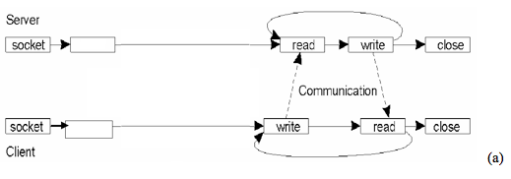

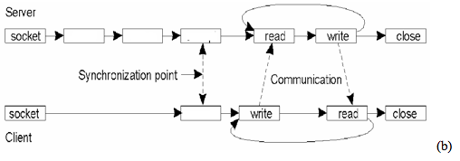

**Solution:**

**(1)**

As Figure (a) is Connection-less communication pattern using sockets => UDP

As Figure (b) is Connection-oriented communication pattern using sockets => TCP

Diagram (b) will work for TCP since it is a network protocol that shows the details of how data is sent as well as received.

(2) Missing steps :

a) bind, connect

b) bind > listen > accept, connect

**MOOC 2**

**Fundamentals of Network Communication**

**Task 1.**

**Suppose that two peer-to-peer processes provide a service that involves the transfer of discrete messages.**

**Suppose that the peer processes are allowed to exchange PDUs that have a maximum size of *M* bytes including *H* bytes of header. Suppose that a PDU is not allowed to carry information from more than one message.**

**a. Develop an approach that allows the peer processes to exchange messages of arbitrary size.**

**b. What essential control information needs to be exchanged between the peer processes?**

**c. Now suppose that the message transfer service provided by the peer processes is shared by several message source-destination pairs. Is additional control information required, and if so, where should it be placed?**

**Solution:**

a) To convert arbitrary sizes, large contents must be split into bytes of each length that will be transmitted in multiple PDUs.

#2: To exchange messages of arbitrary size, large messages must be segmented into parts of M-H bytes each in length to be transmitted in multiple PDUs. Small messages must be placed in a single PDU.

b) Peer-to-peer processes move information allowing messages to be aggregated.

#2: The peer processes need to communicate information that allows for the reassembly of messages at the receiver. For example, the first PDU may contain the message length. The last PDU may contain and end-of-message marker. Sequence numbers may also be useful to detect loss in connection oriented networks and to help in reconstruction of the messages in connectionless networks. Lastly, since variable size PDUs are permitted, the size of the PDU must be transmitted in the PDU header

c) A PDU must be attached to the sequence ID, to process each sequence independently when a message is selected. This stream ID can be dodged if the source and target work for them to process a content transfer at a certain time.

#2: In this case, in addition to all of the header information mentioned in b), each PDU must be labeled with a stream ID, so that the receiver can treat each stream independently when reassembling messages.

**Task 2.**

**Suppose that a Stop-and-Wait ARQ system has a time-out value that is less than the time required to receive an acknowledgment. Sketch the sequence of frame exchanges that transpire between two stations when station A sends five frames to station B and no errors occur during transmission.**

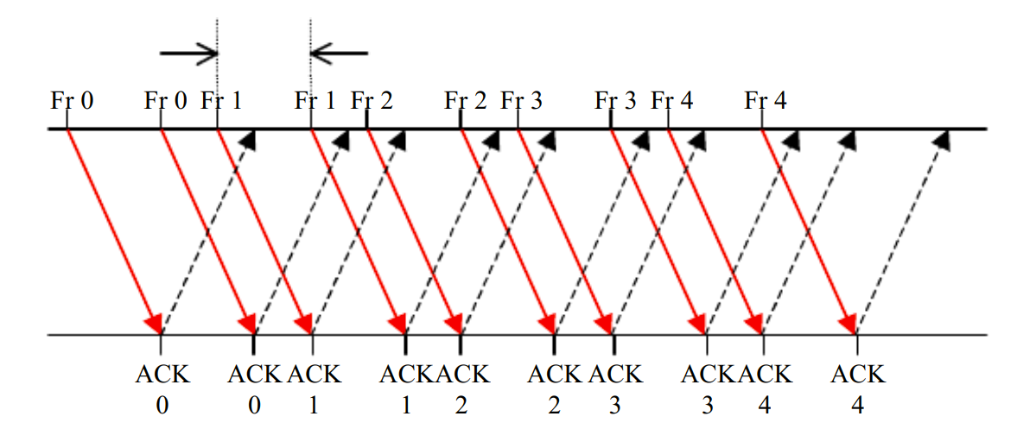

**Task 3.**

**Consider a communication channel with bit rates of 1 Gbps over link that has roundtrip times of 10 msec.**

**a. Find the delay-bandwidth product**

**b. Suppose 32-bit sequence numbers are used to transmit blocks of 1000 bytes over the above channel. How long does it take for the sequence numbers to wrap around, that is, to go from 0 up to 2^32?**

**c. Now suppose the 32-bit sequence numbers are used to count individual transmitted bytes. How long does it take for the sequence numbers to wrap around?**

a) 1GBps*0.1 = 107 bits

b) 2^32/107

c) 2^32/107

**Task 4.**

**A communication channel has a bit rate of 1 Mbps and a propagation delay of 50 msec. The packet processing time at each end of the communication channel is omitted. The frame size is 10,000 bytes. The header of the frame (no trailer) is 500 bytes. The acknowledge frame is 500 bytes.**

**Using a stop-and-wait ARQ:**

**(1) What is the total time to transfer a frame? What` is the effective transmission rate, and what is the transmission efficiency? Suppose the channel is error-free. Show your answer step by step.**

**(2) If the probability of frame arriving with errors is 10%, what is the transmission efficiency?**

**Task 5.**

**Consider building a CDMA/CD network running at 1 Gbps over a 1-km cable. The signal speed in the cable is 200,000 km/sec. What is the minimum frame size?**

(Hint: In order to solve this problem, you need to be aware that the **Ethernet technique always specifies a minimum frame size**. There are two reasons for this:

First, it makes it easier to distinguish between **valid frame and garbage.**

Secondly, if the frame is too short, the transmission will be finished before the collision signal returns (the worst case takes 2tao where "tao" is the propagation delay). That is, the frame has to be longer than 2tao. See details on page 277. Make sure you understand this).

**Solution:**

The frame size should be long enough such that if there is a collision at the receiver's side, the sender can still hear it DURING the transmission.

This way, the sender wouldn't mistakenly thought that the frame has been transmitted successfully.

That is, the transmission time should be equal to or larger than the summation of time it takes for the first bit to propagate to the receiver and if collision occurs, for the jam signal to travel all the way back to the sender.

**Suppose the frame size is F, transmission rate is R and propagation delay is t.**

Then F/R ≥ 2*t → F ≥ R.2t = 1Gbps.2.(1km / 200000km/s)

→ F ≥ 10000 bits = 1250 bytes.

**Practice:**

**For a 10-Mbps LAN with a maximum length of 2500 meters and four repeaters (802.3 specification), the round-trip propagation delay has been determined to be nearly 50 musec in the worst case, including the time to pass through the repeaters.**

**What is the smallest frame size?**

**Explain how 512 bits or 64 bytes minimum Ethernet frame size comes from.**

**(Note that 512 is not the answer to the first part of the problem. Again, refer to page 277 for help.)**

**Solution:**

Similar to above problem, F/R ≥ 2*t → F ≥ R.2t = 10Mbps * 50musec = 500 bits.

Theoretically, the minimum frame size is 500 bits. To add some margin of safety, the value was rounded up to 512 bits (or 64 bytes) for Ethernet standards.

**Task 6.**

**In a LAN, which MAC protocol has a higher efficiency: ALOHA or CSMA-CD? Please consider typical cases of LAN parameters in distance and transmission rate, and discuss your conclusion with reasoning.**

CSMA works well on LANs, where the propagation delay is generally negligible compared to frame transmission.

The maximum efficiency achieved by the Slotted ALOHA is 0.368. The efficiency of CSMA-CD is given by 1/(1 + 6.4a), and is sensitive to a = tpropR/L, the ratio between delay-bandwidth product and frame length. In a LAN environment, the end-to-end distance is around 100m and the transmission rates are typically 10Mbps, 100Mbps and 1Gbps (See Table 6.1). An Ethernet frame has a maximum length of 1500 bytes = 12,000 bits. The table shows the efficiency of CSMA-CD at various transmission rates. Assume L = 12,000 bits and propagation speed of 3 x 108 .

CSMA-CD is dependent on the normalized delay-bandwidth product "a". For small values of "a" CSMA-CD out performs ALOHA. Since ALOHA is not sensitive to "a", for large values of "a" or as "a" approaches 1, ALOHA has better efficiency than CSMA-CD

**A university has 150 LANs with 100 hosts in each LAN.  
(a) Suppose the university has one Class B address. Design an appropriate subnet addressing scheme.  
(b) Design an appropriate CIDR addressing scheme.**

**Solution:**

a)

A Class B address has 14 bits for the network ID and 16 bits for the host ID. To design an appropriate subnet addressing scheme we need to decide how many bits to allocate to the host ID versus the subnet ID. We can choose either 7 bits or 8 bits to identify the hosts. If we allocate 8 bits for to identify the host, as shown below, then there are sufficient subnet-id bits to cover up to 28 = 256 LANs and enough host-id bits to cover up to 256 hosts for each LAN. ***The subnet mask in this case is 255.255.255.0***

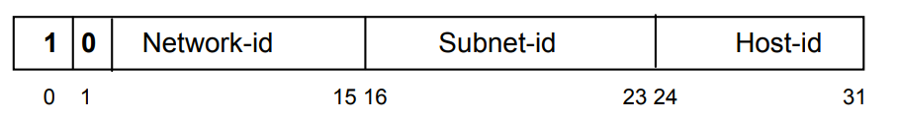

Subnet mask: 255.255.255.0

If we allocate 7 bits for to identify the host, as shown below, then there are sufficient subnet-id bits to cover up to 29 = 512 LANs and enough host-id bits to cover up to 128 hosts for each LAN.

The subnet mask in this case is ***255.255.255.128.***

The choice between 7 or 8 bits to represent the hosts depends on which is likely to grow more, the number of subnets or the number of hosts in a LAN. Alternatively a variable-length prefix scheme using 7-bit host addresses, and grouping these form larger subnets provides greater flexibility in accommodating future changes.

b) CIDR addressing scheme involves devising a prefix length that indicates the length of the network mask. In this case, 8 bits are required to identify each LAN (since 127 < 150 < 255) and 7 bits are required to identify each host in each LAN (since 63 < 100 < 127). Therefore a CIDR address would use a 17-bit prefix, and thus have an address of the form address/17.

**Consider a network link that has distance of 100 meters, and signal traverses at the speed of light in cable 2,5.108 m/s. The link has transmission bandwidth of 100 megabits/second (100.106 bps). The packet size is 400 bits. What is the signal propagation delay? What is the packet transmission delay?**

**Solution:**

**Distance:** d = 100 m

**Speed:** s = 2,5.108 m/s

Signal propagation delay (seconds): tprop = d / s = 100 / (2,5.108) = 4.10-7 seconds

**Packet size:** L = 400 bits  
**Transmission rate:** R = 100.106 bps

Packet transmission delay (seconds): ttrans = L / R = 400 / (100.106) = 4.10-6 seconds

**Suppose two hosts, A and B, are separated by 20,000 kilometers and are connected by a direct link of R = 2 Mbps. Suppose the propagation speed over the link is 2.5 x 10^8 meters/sec.**

**d. What is the width (in meters) of a bit in the link? Is it longer than a football field?**

**e. Derive a general expression for the width of a bit in terms of the propagation speed s, the transmission rate R, and the length of the link m.**

d) Trasmission rate (R) of the direct link between A and B: R = 2Mbps = 2.106 bps

Propagation Speed (S) of the link between A and B: S = 2,5.108 m/s

Length of 1 bit on the transmission line

Length of 1bit = \frac{Speed(S)}{Transmission rate(R)} =\frac{2.5\times 10^{8}}{2\times 10^{6}} =125m/bit

Therefore, it is longer than a football field.

e)  A general expression for the width = (Transmission rate(R) * Speed(s) )/ length of the link (m)

**A channel has a bit rate of 4 kbps and one-way propagation delay of 20 ms. The channel uses stop and wait protocol. The transmission time of the acknowledgement frame is negligible. To get a channel efficiency of at least 50%, the minimum frame size should be**

Bit rate = 4 kbps  
One-way propagation delay = 20 ms  
  
Efficiency = Transmission time of packet/(Transmission time of packet + 2 * Propagation delay)  
0.5 = x/(x + 2 * 20 * 10-3)  
x = 20 * 10-3  
x = 40 * 10-3  
  
Minimum frame size / Bit rate = 40 * 10-3  
Therefore, Minimum frame size = 40 * 10-3 * 4 * 103 = 160 bits

Practical Exam

**1. Done**

**2. Done**

**3. Consider the following network Figure 1. With the indicated link costs, use Dijkstra’s shortest-path algorithm to compute the shortest path from u to all network nodes. Show how the algorithm works by computing a table.**

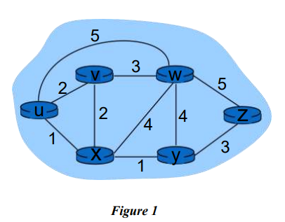

|  |  |  |  |  |  |  |
| --- | --- | --- | --- | --- | --- | --- |
| **iteration** | **N** | **v** | **w** | **x** | **y** | **z** |
| **initial** | u | 2, u | 5, u | 1, u | ∞ | ∞ |
| **1** | ux | 2, u | 5, u | - | 2, x | ∞ |
| **2** | uxv | - | 5, u | - | 2, x | 5, y |
| **4** | uxvy | - | 5, u | - | - | 5, y |
| **5** | uxvyw | - | - | - | - | 5, y |
| **6** | uxvywz | - | - | - | - | - |

**4. A router has the following CIDR entries in its routing table:**

**Address/mask Next hop**

135.46.56.0/22 Interface 0

135.46.60.0/22 Interface 1

192.53.40.0/23 Router 1

default Router 2

**a) What does the router do if a packet with an IP address 135.46.63.10 arrives?**

**b) What does the router do if a packet with an IP address 135.46.57.14 arrives?**

**Solution:**

a) The bit pattern of 135.46.63.10 is 10000111.00101110.00111111.00001010. Take the first 22 bits as net address.

bitmask pattern: 11111111.11111111.11111100.00000000

10000111.00101110.00111111.00001010

11111111.11111111.11111100.00000000

-------------------------------------------------------

10000111.00101110.00111100.00000000 → 135.46.60.0

We get the following network address bit pattern: 10000111.00101110.00111100.00000000.

Thus, network address is 135.46.60.0

Match with network address in the routing table. The 2rd row matches. The router will forward the packet to Interface 1 if a packet with an IP address 135.46.63.10 arrives.

b) The packet will be forwarded to Interface 0 if a packet with an IP address 135.46.57.14 arrives.

*Xét 135.46.63.10 có 135.46 giống Interface 0 và 1.  
135.46.63 lớn hơn Interface 1 thì chọn Interface 1, ngược nếu ví dụ như đề câu b chỉ có 57 (lớn hơn 56 nhưng nhỏ hơn 60) -> chọn Interface 0.  
Nếu đề hỏi khác nữa như cho 10.10.10.10 không giống cái nào ở Interface 0, 1 hay Router 1 thì mặc định chọn* ***Default -> Router 2.***

**5. Suppose two hosts, A and B, are separated by 30,000 kilometers and are connected by a direct link of R = 3 Mbps. Suppose the propagation speed over the link is 2.5 x 108 meters/sec.**

**a. Calculate the bandwidth-delay product, Rdprop**

**b. Consider sending a file of 900,000 bits from Host A to Host B. Suppose the file is sent continuously as one large message. What is the maximum number of bits that will be in the link at any given time?**

**Solution:**

a) The distance between two hosts A and B = 30,000 km → *d = 3.107* (m)

Trasmission rate (R) of the direct link between A and B = 3Mbps → *R = 3.106* (bps)

Propagation Speed (s) of the link between A and B = 2,5.108 m/s → *s = 2,5.108* (m/s)

**The propagation delay:** *tprop = d / s = 3.107 / 2,5.108 = 0,12* (s)

T**he band-width delay product:** *R . tprop = 3.106 . 0,12 = 36.104* bits

b) Maximum number of bits : 0.36 Mb

**The bandwidth-delay product:** is the maximum number of bits that the link can contain in the same time.

**6. Done**

**7. A packet switch receives a packet and determines the outbound link to which the packet should be forwarded. When the packet arrives, one other packet is halfway done being transmitted on this outbound link and four other packets are**

**waiting to be transmitted. Packets are transmitted in order of arrival.**

**Suppose all packets are 2,500 bytes and the link rate is 3 Mbps. What is the queuing delay for the packet?**

**More generally, what is the queuing delay when all packets have length L, the transmission rate is R, x bits of the currently-being transmitted packet have been transmitted, and n packets are already in the queue?**

**Solution:**

a) 1 packet size = 2500 bytes = 20000 bits

R = 3Mbps = 3.106 bps

Already transmitted: 20000/2 = 10000bits

Still remain: 4.20000 + 10000 = 9.104 bits

Queuing delay: t = nremain / R = 9.104 / 3.106 = 0.03s = 30ms

b) Queuing delay = $\frac{L.n + (L-x)}{R}$

**8. Done**

**9. Consider a packet of length 2,000 bytes that propagates over a link of distance 3,500 km with propagation speed of 2,5.108 m/s, and transmission rate 2 Mbps?**

**a. How long does the packet propagation take?**

**b. Does this propagation delay depend on the packet length?**

**c. Does this propagation delay depend on the transmission rate?**

**Solution:**

a) L = 2000 bytes = 16000 bits

d = 3500 km = 35.105 m

s = 2,5.108 m/s

R = 2.106 bps

***tprop = d / s = 0,014s = 14ms***

b) No

c) No

**9+. (a) How long does it take a packet of length 1000 bytes to propagate over a link of distance 2500km, propagation speed 2.5x108 m/s, and transmission rate 2 Mbps?**

**(b) More generally, how long does it take a packet of length L to propagate over a link of distance d, propagation speed s, and transmission rate R bps?**

**(c) Dose this delay depend on packet length?**

**(d) Does this delay depend on transmission rate?**

**Solution:**

a) L = 1000 bytes = 8000 bits

d = 2500 km = 25.105 m

s = 2,5.108 m/s

R = 2Mbps = 2.106 bps

***tprop = d / s = 0,01s = 10ms***

b) ***d / s***

c) No

d) No

**10. Suppose Host A wants to send a large file to Host B. The path from Host A to Host B has three links, of rates R1 = 250 kbps, R2 = 3 Mbps, and R3 = 2 Mbps.**

**a. Assuming no other traffic in the network, what is the throughput for the file transfer?**

**b. Suppose the file is 4 million bytes. Dividing the file size by the throughput, roughly how long will it take to transfer the file to Host B?**

**Solution:**

a) Throughput is limited by the minimum of the capacity of the links.

Throughput = min(R1, R2, R3) = 250 kbps = 2,5.105 bps

b) File size = 4.106 bytes = 32.106 bits

Time to transfer the file to host B: ttrans = 32.106 / 2,5.105 = 128 (s)

**11. Suppose an application layer entity wants to send an L-byte message to its peer process, using an existing TCP connection. The TCP segment consists of the message plus 20 bytes of header. The segment is encapsulated into an IP packet that has an additional 20 bytes of header. The IP packet in turn goes inside an Ethernet frame that has 18 bytes of header and trailer.**

**What percentage of the transmitted bits in the physical layer correspond to message information, if L = 200 bytes, 1000 bytes, 2000 bytes?**

**Solution:**

TCP / IP over Ethenet allows data frames with a payload size up to 1460 bytes.

Therefore, L = 200, 1000 are within this limit

The message overhead includes:   
+ TCP: 20 bytes of header   
+ IP: 20 bytes of header  
+ Ethernet: 18 bytes of header and trailer  
  
Therefore:  
L = 200 bytes, 200 / ( 200 + 20 + 20 + 18) = 77% efficiency  
L = 1000 bytes, 1000 / ( 1000 + 20 + 20 + 18) = 95% efficiency

**Ref:**

*The amount is dependent on the MTU (Maximum Transmission Unit) supported by the network, for normal ethernet the MTU is 1500. This is the maximum amount of data available to IP, TCP, and the application, it excludes the bytes for the ethernet header and trailer.*

*From this 1500 you need to subtract bytes for the IP and TCP headers (normally 20 bytes each) leaving 1460 bytes available to the application. If the RFC1323 Timestamp option is used (fairly common nowadays) it extends the TCP header by 12 bytes leaving 1448 bytes.*

**12. Suppose the size of an uncompressed text file is 1 megabyte**

**a. How long does it take to download the file over a 35 kilobit/second modem?**

**b. How long does it take to take to download the file over a 1 megabit/second modem?**

**c. Suppose data compression is applied to the text file. How much do the transmission times in parts (a) and (b) change?**

**If we assume a maximum compression ratio of 1:6, then we have the following times for the 35 kilobit and 1 megabit lines respectively**

**Solution:**

a) Size text file: L = 1MB = 220B = 220.8 bits = 223 bits

Rate: R1 = 35.103 bps

→ ***t35kb = L / R1 = 223 / 35.103 = 239.675s***

b) Size text file: L = 1MB = 220B = 220.8 bits = 223 bits

Rate: R2 = 1Mbps = 106 bps

→ ***t1Mb = L / R2 = 223 / 106 = 8.389s***

c) ***t’35kb = L / R1’ = 223 / (35.103.6) = 36.792s***

***t’1Mb = L / R2’ = 223 / (106.6) = 1.398s***

**13. Consider the three-way handshake in TCP connection setup.**

**(a) Suppose that an old SYN segment from station A arrives at station B, requesting a TCP connection. Explain how the three-way handshake procedure ensures that the connection is rejected.**

**(b) Now suppose that an old SYN segment from station A arrives at station B, followed a bit later by an old ACK segment from A to a SYN segment from B. Is this connection request also rejected?**

**Solution:**

a) In a three-way handshake procedure, one must ensure the selection of the initial sequence number is always unique. If station B receives an old SYN segment from A, B will acknowledge the request based on the old sequence number. When A receives the acknowledge segment from B, A will find out that B received a wrong sequence number. A will discard the acknowledgement packet and reset the connection.

b) If an old SYN segment from A arrives at B, followed by an old ACK segment from A to a SYN segment from B, the connection will also be rejected. Initially, when B receives an old SYN segment, B will send a SYN segment with its own distinct sequence number set by itself. If B receives the old ACK from A, B will notify A that the connection is invalid since the old ACK sequence number does not match the sequence number previously defined by B. Therefore, the connection is rejected.

**14. Sender A wants to send 100111010011110 to receiver B. This transmission uses CRC algorithm for error detection with generator polynomial bits string is 10110. What is bits string will be transmitted on the medium. Show your all steps to have result.**

**Solution:**

Step 1: Add 0000 to data bits string. It will be 1001110100110110000

Step 2: Divide 1001110100110110000 to 10111 by modulo 2

Cách chia:

Lấy 5 số đầu dùng phép xor với 10111

10011 xor 10111 => 00100

Lấy tiếp 2 số cho đủ 5 số (so với số 1 đầu tiên)

=> 10010 xor 10111 = 00101)

Lấy tiếp 2 số cho đủ 5 số (so với số 1 đầu tiên)

=> 10110 xor 10111 = 00001

Lấy tiếp 4 số cho đủ 5 số (so với số 1 đầu tiên)

=> 10110 xor 10111 = 00001

Lấy tiếp 4 số cho đủ 5 số (so với số 1 đầu tiên)

=> 11100 xor 10111 = 01011

Lấy tiếp 1 số cho đủ 5 số (so với số 1 đầu tiên)

=> 10110 xor 10111 = 0001

Do còn mỗi 1 số 0, không còn đủ để bù đắp nữa, thêm vào chuyển thành kết quả => 00010

Step 3: The transmitted bits string is 1001110100110110010.

**15. Suppose that the TCP entity receives a 1.5 megabyte file from the application layer and that the IP layer is willing to carry blocks of maximum size 1500 bytes. Calculate the amount of overhead incurred from segmenting the file into packet-sized units.**

Solution: 1500 - 20 -20 = 1460 bytes

*TCP / IP over Ethenet allows data frames with a payload size up to 1460 bytes.*

1.5 Megabyte = 1.5*106 bytes

1.5 Megabyte / 1460 bytes = 1.5*106 / 1460 = 1027.4,

Therefore 1028 blocks are needed to transfer the file.

Overhead = ((1028 x 1500 - 1.5M)/1.5M) x 100 = 2.8%

**Ref:**

*1 kilobit = 103 bits*

*1 kibibit = 210 bits*

*1 megabit = 106 bits*

*1 mebibit = 220 bits*

*1 kilobyte = 103 bytes*

*1 kibibyte = 210 bytes*

*1 Mebibyte = 220 bytes*

*1 Gibibyte = 230 bytes*

**Why do LANs tend to use broadcast networks? Why not use networks consisting of multiplexers and switches?**

LANs focus on low cost and simplicity, to accomplish this they use broadcast approach. By adding multiplexers and switches it would increase cost. Another reason is because computer in the LAN have small distances of separation ( < 100 m) reliable communication and high speeds can be achieved while still using the same broadcast medium

In Local Area Network (LAN), which MAC protocol has a higher efficiency: ALOHA or CSMA-CD? What about in a Wide Area Network (WAN)?

CSMA-CD is dependent on the normalized delay-bandwidth product "a". For small values of "a" CSMA-CD out performs ALOHA. Since ALOHA is not sensitive to "a", for large values of "a" or as "a" approaches 1, ALOHA has better efficiency than CSMA-CD

What does Pmax stand for?

Efficiency

What is the Pmax for CSMA-CD?

1/ (1 + 6.44a)

What is the efficiency for ALOHA?

0.368

In Wide Area Network (WAN), which MAC protocol has a higher efficiency: ALOHA or CSMA-CD?

These networks have distances of 1000 km which will increase the normalized delay-bandwidth product "a" so depending on the distances, ALOHA will outperform CSMA-CD

Suppose that a LAN is to carry voice and packet data traffic. Discuss what provisions if any are required to handle the voice traffic in the reservation, polling, token ring, ALOHA and CSMA-CD environments. What changes if any are required for the packet data traffic?

Voice traffic is delay sensitive, so the mac protocols must ensure the delays experienced by voice data packets are sufficiently low.  
Scheduling approaches to medium access control provide predictable delay performance. Random access approaches on the other hand have greater variability in delay.

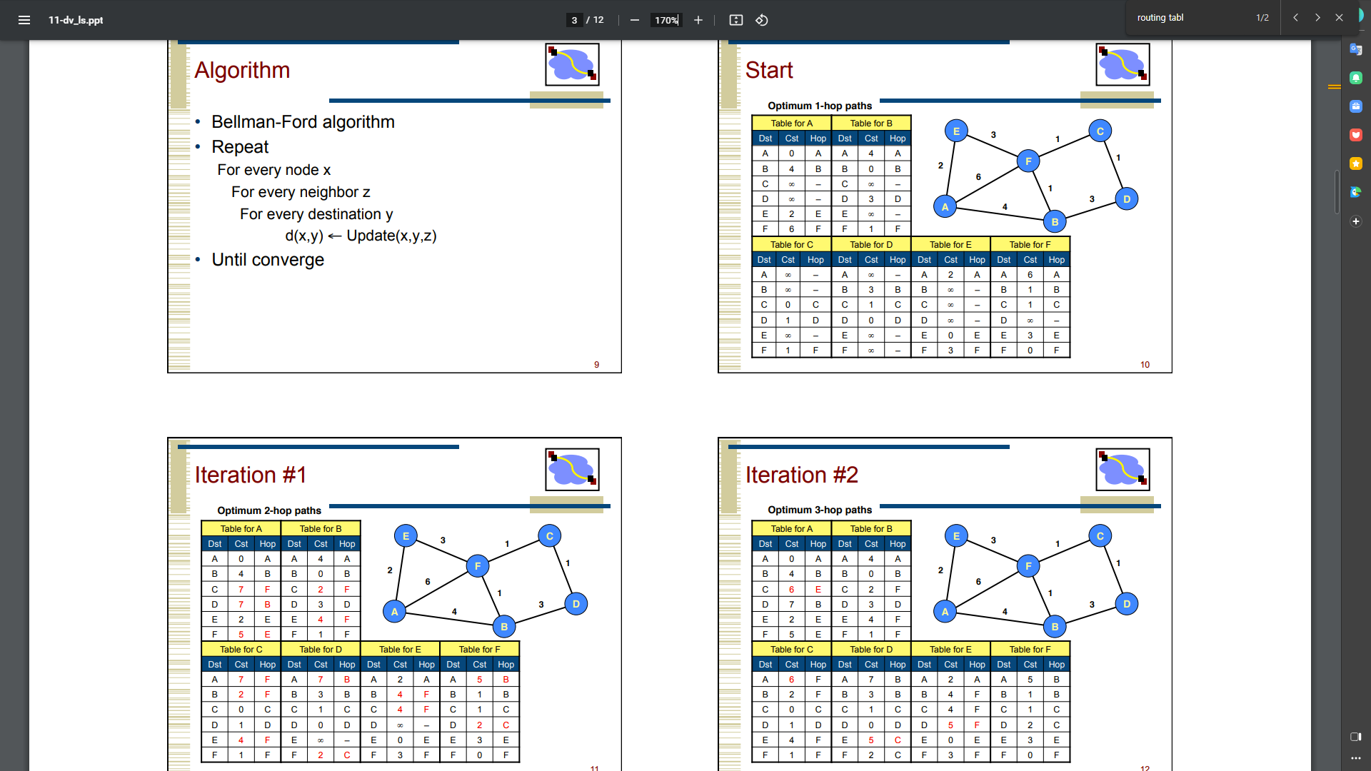

**End to End, Point to Point, and Hop by Hop networks?**

**End to end**indicates a communication happening between two applications (maybe you and your friend using Skype). It doesn't care what's in the middle, it just consider that the two ends are taking with one another. It generally is a Layer 4 (or higher) communication

**Point to point** is a Data link layer link with two devices only on it. That is, two devices with an IP address have a cable going straight from a device into the other. A protocol used there is PPP, and HDLC is a legacy one.

**Hop by Hop** indicates the flow the communication follows. Data pass through multiple devices with an IP address, and each is genetically named “hop”. Hop by Hop indicates analyzing the data flow at Network layer, checking all devices in the path.

------------------------------

A **point-to-point** network is a type of Data Link Layer connection which can have only 2 endpoints, in contrast to multipoint networks like Ethernet, which may have more than 2.

The other two terms are not actual types of network, they are more like principles by which network technologies are designed:

* **End-to-end** networking is the principle that functions such as flow control and errors are all handled between the ultimate endpoints, not at intermediates.
* **Hop-by-hop** networking is the opposite point-of-view, that each intermediate point along the path should handle flow control and retries directly with it’s adjacent nodes.

Hop-by-hop methods have several practical problems, including the need for significant amounts of buffering at each hop, and the need to communicate connection states back to the endpoints anyway; so L4 networks (such as TCP/IP, and hence The Internet) almost always follow the end-to-end principle.

Hop-by-hop is not specifically forbidden, but it has little value except in a network with links of extremely high latency and/or low reliability. A possible case might be an IP network with one or more hops implemented by carrier pigeon (for which an RFC specification does exist).

Higher layer services like e-mail and Usenet can operate in hop-by-hop mode, although this is usually referred to as “store-and-forward”.

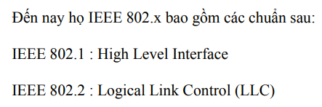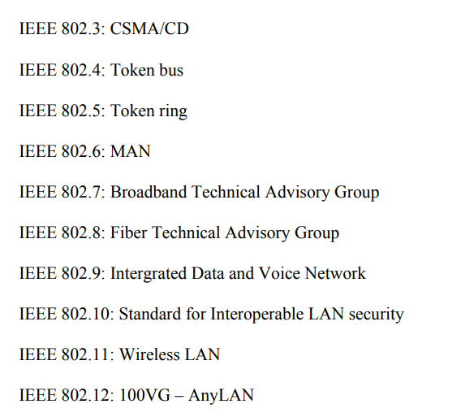

Bandwidth and latency are attributes that characterize the speed of a network.

**Bandwidth**

Bandwidth, typically measured in bits, kilobits, or megabits per second, is the rate at which data flows over the network. This is a measure of throughput (amount per second) rather than speed (distance traveled per second). Just as more water flows through a wide river than a small, narrow creek, a high bandwidth network generally can deliver more information than a low bandwidth network given the same amount of a time. Because this can make the network feel faster, high bandwidth networks and connections often are called "high-speed". Residential cable and DSL Internet connections often are advertised as high-speed connections, even though the actual speed of the information traveling from one end to another is roughly the same for cable, DSL, and normal phone connections.

**Latency**

Latency, usually measured in milliseconds, is the time that elapses between a request for information and its arrival. A high latency can degrade the performance of even the largest capacity network to a tremendous degree. Because it takes time for a signal to pass through wire, some latency will always be present, but slow servers, inefficient data packing, and excessive network hopping can collectively increase transmission delay.

Excess latency gives a network a low-speed feel. If a connection takes three or four seconds to respond, many users will complain the connection is "slow", even though the bandwidth is high, and even though the data comes in such a large chunk that it appears to arrive all at once.

**Speed**

A network's speed is essentially a subjective evaluation of the combination of bandwidth and latency. As mentioned above, the term is often used in place of bandwidth, even by technicians and professionals; many times a network administrator or hardware technician will talk about a 10BaseT, 100BaseT, or gigabit "speed" in reference to products or networks with 10KB/sec, 100KB/sec, or 1,000KB/sec bandwidths.

Most vendors advertise the theoretical bandwidths of their networking products, but due to bottlenecks, hardware problems, and high processing loads, the effective throughput is usually much less. A gigabit (1000BaseT) Ethernet card will be lucky to achieve 800Mb/s in real-world use, and in many situations will achieve far less than that.

