**Group communication**

**A clear, elevated goal:**

separates successful from unsuccessful groups

guides action

Helps set standards – microsoft, fsoft

helps resolve conflict

motivates members

**Communication Process: Basic Elements**

Member: Recognized and accepted as belonging to a group

Message: Ideas, information, opinions, feelings

Context: The physical and psychological environment

Channels: Media used to share messages

Feedbacks: Response or reaction to a message

Noise: Anything that interferes with or inhibits communication

**Basic types of group**

Primary group:

Social group

Service group

Self-help group

Learning group

Governance group

Civic group

Work group

**Advantages of working in group**

Group performance

Member satisfaction

Learning

Cultural understanding

Creativity

Civic engagement

**Disadvantages**

Time, energy, resources

Conflict

People problems

**Balancing Group Dialectics**

The challenge of taking a ***both/and*** rather than an *either/or* approach to resolving dialectic tensions in groups

**Individual Goals ↔ Group Goals:** Personal goals are compatible with group goals.

**Conflict ↔ Cohesion:** Cohesive groups are committed, unified, and willing to engage in conflict.

**Conforming ↔ Nonconforming:** Members value group norms, but are willing to change.

**Task Dimensions ↔ Social Dimensions:** Members want to get the job done and also value their social relationships.

**Homogenous ↔ Heterogeneous:** Members value member similarities and differences.

**Leadership ↔ Followership:** Effective leadership requires loyal and competent followers.

**Structure ↔ Spontaneity:** Members recognize the need for structured procedures and the value of creative thinking.

**Engaged ↔ Disengaged:** Members expend energy and work hard, but also need rest and renewal.

**Open System ↔ Closed System:** Members welcome input and interchange, but also protect the group and its work. External support and recognition are balanced with internal group solidarity and rewards.

**Group development**

**Group Development Stages**

* Forming = create based on common goal
* Storming = difficult in WIG/culture shock
* Norming = solve problem
* Performing = act to reach goal
* Adjourning = mission completed => delete group

1. **Forming stage**

Challenge: Balancing Individual and Group Goals - HIDDEN GOAL

Members are socially cautious and polite.

Members learn about their tasks and test personal relationships.

**Primary tension:** The social unease that accompanies the getting-acquainted process in groups

* **Resolve primary tension:**

+ Be positive, energetic

+ Be patient, open-minded

+ Be prepared, informed

1. **Storming stage**

Challenge: Balancing Conflict and Cohesion

Members compete for status and roles.

Members openly disagree on issues.

Groups experience Secondary Tension.

**Secondary tension:** The frustration and personality conflicts experienced by group members as they compete for acceptance and achievement

1. **Norming stage (Give in + give up)**

Challenge: Balancing Conformity and Nonconformity

Groups resolve primary and secondary tensions.

Groups develop norms or ground rules.

1. **Performing stage (Give job to suitable person)**

Challenge: Balancing Task and Maintenance Dimensions

Group focuses on productivity and member satisfaction.

Groups adapt and change if necessary.

1. **Adjourning stage**

Challenge: Balancing Engagement and Disengagement

Upon completing the group task:

+ The group may disband.

+ Members may leave the group for personal or professional reasons.

+ Some members may take on a new group task.

----------

Antecedent: Tiền lệ

Anticipatory: Dự đoán được

Encounter: Bắt gặp

Assimilation: Đồng hóa

Exit: Lối ra

----------

**Set your goals**

**Clarity**. Is the goal clear, specific, and observable if achieved?

**Challenge**. Is the goal challenging, inspiring, and thought-provoking?

**Commitment**. Do members see the goal as meaningful, realistic, and attainable?

**Compatibility**. Can both group and individual goals be achieved?

**Cooperation**. Does the goal require member cooperation?

**Cost**. Does the group have adequate resources (time, money, materials) to achieve the goal?

----------

**Hidden agendas:** Members’ private goals conflict with the group’s goals

----------

**Types of NORMS:**

+ Explicit norm

+ Implicit norm

----------

+ Interaction norm

+ Procedural norm

+ Status norm

+ Achievement norm

----------

**Types of NONCONFORMITY**

Constructive nonconformity -> to build

Destructive nonconformity -> to kill

Respond: Accept; Confront; Exclude

----------

**Characteristics of effective groups**

A clear, elevated goal

Results-driven structure

Competent team members

Unified commitment

Collaborative climate

Standards of excellence

External support and recognition

Principled leadership

**C3. Group membership**

Schutz’s Theory of Interpersonal Needs

Fundamental Interpersonal Relationship Orientation (FIRO)

**Inclusion Needs**

**Control Needs**

**Affection Needs**

**Group Role**

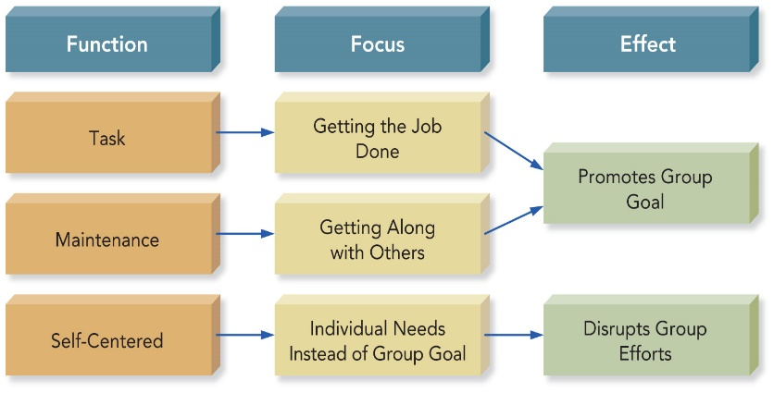

**Group Task Roles**

1. Initiator
2. Information Seeker
3. Coordinator - Chairperson
4. Information Giver
5. Opinion Seeker
6. Opinion Giver
7. Clarifier-Summarizer
8. Implementer-Completer
9. Evaluator-Critic
10. Energizer
11. Procedural Technician
12. Recorder-Secretary

**Group Maintenance Roles**

1. Encourager – Supporter
2. Harmonizer
3. Compromiser
4. Tension Releaser
5. Gatekeeper
6. Observer-Interpreter
7. Teamworker-Follower

**Self-Centered Roles**

1. Aggressor
2. Blocker
3. Dominator
4. Recognition Seeker
5. Clown
6. Deserter
7. Confessor
8. Special Interest Pleader

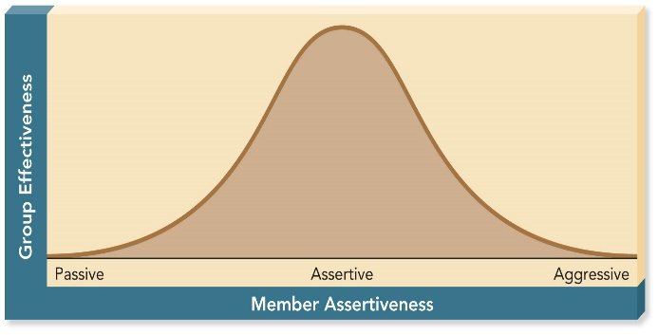**Assertiveness**

Speaking up and acting in your own best interests without denying the rights and interests of others

**C4. Group leadership**

**Leadership**

The ability to make strategic decisions and use communication effectively to mobilize group members toward achieving a common goal

+ A leader is a person.

+ Leadership is a behavior.

**Types of Position Power**

Legitimate Power – Relies on a job title or duty

Reward Power – Controls and gives out valued resources

Coercive Power – Controls and deals out sanctions and punishments

Informational Power – Controls and transmits information and resources

**Types of Personal Power**

Expert Power – do you have the knowledge that others need (expertise and credentials/dignity) ? **IQ**

Referent Power – do others respect you and want to be like you? **AQ** – ability to get over difficulties

Persuasive Power – do you have perfect communication skills? **EQ** – 5 senses

Charismatic Power – do you attract others by your character? **Creative Intelligent Quotient**

*Relies on leader’s personal character, competence, & vitality*

**Becoming a Leader**

Designated Leaders

Selected by group members or an outside authority.

Being designated leader is no guarantee of leadership ability unless the leader’s skills match the group’s needs.

Emergent Leaders

Gradually achieve leadership by helping the group achieve its goals

Emerging from within a group has the advantage of relying on expert or referent power.

**Styles Theory**

Democratic leaders are usually the best.

Autocratic leaders may be more effective in a crisis or chaotic situation.

Laissez-faire leaders may succeed in mature and highly productive groups.

**Hersey-Blanchard’s Model**

As a group’s readiness increases, leaders should rely more on relationship behavior than task behavior.

1. The Telling Stage: Low Readiness
2. The Selling Stage: Moderate Readiness
3. The Participating Stage: Moderate to High Readiness
4. Delegating Stage: High Readiness

**5-M Model of Leadership Effectiveness**

Interdependent Leadership Functions:

* 1. **M**odel leadership behavior
  2. **M**otivate members
  3. **M**anage group process
  4. **M**ake decisions
  5. **M**entor members

**Transformational Leadership Characteristics**

1. Charismatic
2. Visionary
3. Supportive
4. Empowering
5. Innovative
6. Modeling

**Nonverbal Immediacy**

* Leaning forward
* Physical closeness to others
* Eye contact
* Openness of arms and body
* Touching
* Direct body orientation
* Relaxed posture
* Positive facial and vocal expressions
* Laughing and smiling

**8 Group think Symptoms**

1. **Invulnerability:** Overly confident; takes big risks – risk of time – quality – score
2. **Rationalization:** Makes excuses, ignores warnings
3. **Morality:** Ignores ethical and moral issues
4. **Stereotyping Outsiders:** Considers others too weak or stupid to cause trouble
5. **Self-Censorship:** Unwilling to disagree; doubts their own concerns
6. **Pressure on Dissenters:** Pressures members to agree
7. **Illusion of Unanimity:** Believes everyone agrees
8. **Mindguarding:** Shields members from adverse information or opposition

**Conduct meeting**

**Parliamentary Procedure**

A set of formal rules used to determine the will of the majority through fair and orderly discussion and debate

Purpose:  
To protect the rights of minority members while ensuring majority rule

**Basic Principles:**

* Majority Will
* Minority Rights
* Balanced Discussion
* Orderly Progress
* Equal Opportunity

**Standard Parts of a Letter**

* Heading
* Inside address
* Salutation
* Body
* Complimentary close
* Signature block
* Reference initials

**Supplementary Parts of a Letter**

* Attention line
* Subject line
* Company name in signature block
* Enclosure or attachment notation
* Copy notation
* Postscript

**Memo Format**

* To
* From
* Date
* Subject

**The Indirect Plan**

* Opening buffer
* Logical explanation
* Negative information
* Constructive follow-up
* Friendly close