ERD HOMEWORK - BLOG

Họ tên: Nguyễn Đăng Lộc – SE160199 Lớp: SE1616

**Đề:** ERD và DDL (SQL Server) để lưu trữ các thông tin của Blog

**ERD**

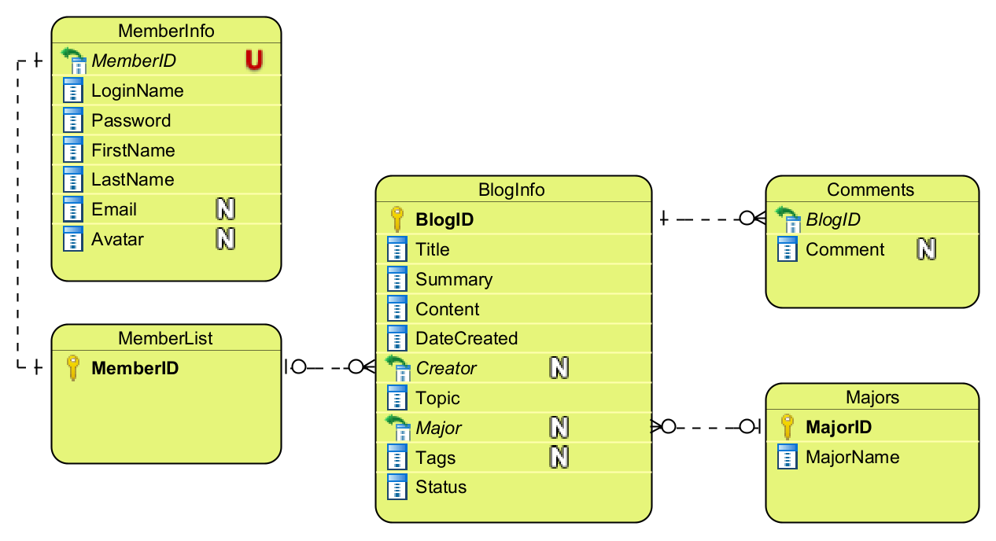

**DDL**

CREATE TABLE BlogInfo (

BlogID char(5) NOT NULL,

Title varchar(50) NOT NULL,

Summary varchar(100) NOT NULL,

Content varchar(255) NOT NULL,

DateCreated char(10) NOT NULL,

Creator char(8) NULL,

Topic varchar(30) NOT NULL,

Major char(2) NULL,

Tags varchar(30) NULL,

Status varchar(20) NOT NULL,

PRIMARY KEY (BlogID)

);

CREATE TABLE Comments (

ID int IDENTITY NOT NULL,

BlogID char(5) NOT NULL,

Comment varchar(255) NULL,

PRIMARY KEY (ID)

);

CREATE TABLE Majors (

MajorID char(2) NOT NULL,

MajorName varchar(30) NOT NULL,

PRIMARY KEY (MajorID)

);

CREATE TABLE MemberInfo (

ID int IDENTITY NOT NULL,

MemberID char(8) NOT NULL UNIQUE,

LoginName varchar(50) NOT NULL,

Password varchar(30) NOT NULL,

FirstName varchar(10) NOT NULL,

LastName varchar(30) NOT NULL,

Email varchar(50) NULL,

Avatar varchar(255) NULL,

PRIMARY KEY (ID)

);

CREATE TABLE MemberList (

MemberID char(8) NOT NULL,

PRIMARY KEY (MemberID)

);

ALTER TABLE MemberInfo ADD CONSTRAINT FKMemberInfo448176

FOREIGN KEY (MemberID) REFERENCES MemberList (MemberID)

ON UPDATE Cascade

ON DELETE Cascade;

ALTER TABLE BlogInfo ADD CONSTRAINT FKBlogInfo737834

FOREIGN KEY (Creator) REFERENCES MemberList (MemberID)

ON UPDATE Cascade

ON DELETE Set null;

ALTER TABLE BlogInfo ADD CONSTRAINT FKBlogInfo163457

FOREIGN KEY (Major) REFERENCES Majors (MajorID)

ON UPDATE Cascade

ON DELETE Set null;

ALTER TABLE Comments ADD CONSTRAINT FKComments638534

FOREIGN KEY (BlogID) REFERENCES BlogInfo (BlogID)

ON UPDATE Cascade

ON DELETE Set null;

ALTER TABLE MemberInfo DROP CONSTRAINT FKMemberInfo448176;

ALTER TABLE BlogInfo DROP CONSTRAINT FKBlogInfo737834;

ALTER TABLE BlogInfo DROP CONSTRAINT FKBlogInfo163457;

ALTER TABLE Comments DROP CONSTRAINT FKComments638534;

DROP TABLE BlogInfo;

DROP TABLE Comments;

DROP TABLE Majors;

DROP TABLE MemberInfo;

DROP TABLE MemberList;