ERD 1-N RELATIONSHIP HOMEWORK

Họ tên: Nguyễn Đăng Lộc – SE160199 Lớp: SE1616

**Exercise 1.**

**ERD**

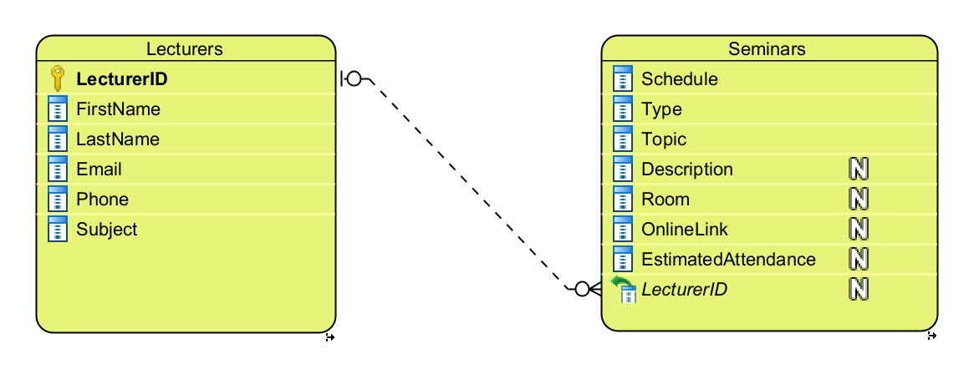

**DDL**

CREATE TABLE Lecturers (

LecturerID char(4) NOT NULL,

FirstName varchar(10) NOT NULL,

LastName varchar(30) NOT NULL,

Email varchar(30) NOT NULL,

Phone char(10) NOT NULL,

Subject varchar(10) NOT NULL,

PRIMARY KEY (LecturerID)

);

CREATE TABLE Seminars (

ID int IDENTITY NOT NULL,

Schedule varchar(20) NOT NULL,

Type varchar(10) NOT NULL,

Topic varchar(50) NOT NULL,

Description varchar(255) NULL,

Room char(4) NULL,

OnlineLink varchar(255) NULL,

EstimatedAttendance int NULL,

LecturerID char(4) NULL,

PRIMARY KEY (ID)

);

ALTER TABLE Seminars ADD CONSTRAINT FKSeminars246452

FOREIGN KEY (LecturerID) REFERENCES Lecturers (LecturerID)

ON UPDATE Cascade

ON DELETE Set null;

ALTER TABLE Seminars DROP CONSTRAINT FKSeminars246452;

DROP TABLE Lecturers;

DROP TABLE Seminars;

**Exercise 02.**

**UML**

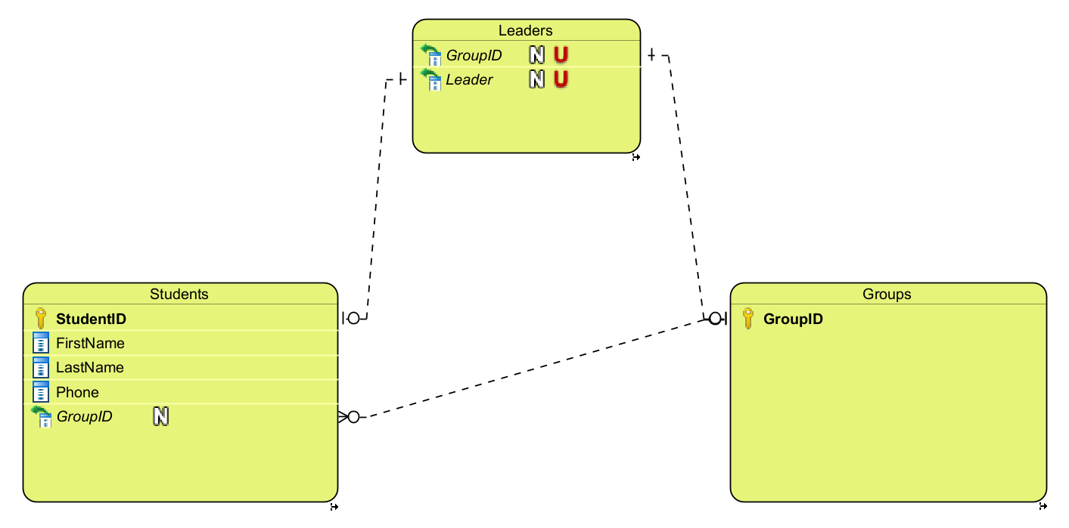

**DDL**

CREATE TABLE Groups (

GroupID char(3) NOT NULL,

PRIMARY KEY (GroupID)

);

CREATE TABLE Leaders (

ID int IDENTITY NOT NULL,

GroupID char(3) NULL UNIQUE,

Leader char(8) NULL UNIQUE,

PRIMARY KEY (ID)

);

CREATE TABLE Students (

StudentID char(8) NOT NULL,

FirstName nvarchar(10) NOT NULL,

LastName nvarchar(30) NOT NULL,

Phone char(10) NOT NULL,

GroupID char(3) NULL,

PRIMARY KEY (StudentID)

);

ALTER TABLE Students ADD CONSTRAINT FKStudents735599

FOREIGN KEY (GroupID) REFERENCES Groups (GroupID)

ON UPDATE Cascade

ON DELETE Set null;

ALTER TABLE Leaders ADD CONSTRAINT FKLeaders389919

FOREIGN KEY (GroupID) REFERENCES Groups (GroupID)

ON UPDATE Cascade

ON DELETE Set null;

ALTER TABLE Leaders ADD CONSTRAINT FKLeaders295155

FOREIGN KEY (StudentID) REFERENCES Students (StudentID)

ON UPDATE Cascade

ON DELETE Set null;

ALTER TABLE Students DROP CONSTRAINT FKStudents735599;

ALTER TABLE Leaders DROP CONSTRAINT FKLeaders389919;

ALTER TABLE Leaders DROP CONSTRAINT FKLeaders295155;

DROP TABLE Groups;

DROP TABLE Leaders;

DROP TABLE Students;

____________________________________________________________________________________________________________________________________________________________________________________________________________________________________

TABLE Leaders để lưu thông tin tổ trưởng, thông tin ai là tổ trưởng của mỗi học sinh sẽ được truy vấn qua lệnh:

SELECT s.*, l.Leader AS [Lead by]

FROM Students s JOIN Groups g ON s.GroupID = g.GroupID

JOIN Leaders l ON l.GroupID = g.GroupID

WHERE l.GroupID = s.GroupID