

**FEvent**

**Software Requirement Specification**

– TP HCM, July 2021 –

**Table of Contents**

I. Overview 4

1. Introduction 4

2. Purpose 4

3. System Functions 5

II. Functional Requirements 8

1. Guest – Get Notification on Mobile 8

a) Get Notification when guest is invited to an event 8

b) Get Notification when guest has a question from users 8

2. Guest – Event Management 8

a) View all events 8

b) View event details 9

c) Register to participate in an event 10

3. Guest – Calendar Management 11

d) View all events that the guest joined 11

e) Choose time to view the events 12

f) View all events in one date 13

g) View event details 14

h) View QR Code to check-in an event 15

i) Set Reminder 16

j) Cancel the participation 17

4. Guest – Events Statistics 18

k) View All Events statistics 18

l) View Event Statistics Details 19

5. Guest – Question Statistics 20

6. Guest – View Questions 21

m) View all questions in summary 21

n) View question detail 22

7. User – Get Notification on Mobile 23

o) Get notification when there’s a new event 23

p) Get notification when guests has answer the question of user 24

8. User – Main menu/Navigation Sider 24

9. User – Event Management 25

q) View all events 25

r) View event details 26

s) View the map to the location of the event 27

t) Register to participate in an event 28

10. User – Calendar Management 29

u) View all events that the user joined 29

v) Choose time to view the events 30

w) View all events in one date 31

x) View event details 32

y) View QR Code to check-in an event 33

z) Create question for guests 34

aa) Set Reminder 35

bb) Cancel the participation 36

11. User – Questions List 37

cc) View all created question 37

dd) View question details 38

ee) Delete question 39

12. User – View Registered Events 40

ff) View all registered events in summary 40

gg) Feedback an event 41

13. User – Statistics 42

hh) View All Events statistics 42

ii) View Event Statistics Details 43

14. User – Profile Page 44

jj) View user’s profile 44

kk) Edit user’s profile 45

15. Manager - Event Viewing 46

a.View events in the form of a list as an Event Manager 46

b. View events in the form of a calendar as a Event Manager 47

16. Manager – Event Statistics Viewing 47

17. Manager – Question Polls Managing 48

18. Manager – Feedback Managing 49

19. Admin – Create, View, Update and Delete Guests 50

20. Admin – Create, View, Update and Delete User 51

21. Admin – Create, View, Update and Delete Events 52

22. Admin – Create, View, Update and Delete Managers 53

23. Admin – Upload Guest List 54

24. Supporter - List Event View 55

25. Supporter - View Information 57

26. Supporter - Question Polls Manage 59

# I. Overview

## 1. Introduction

The FEvent Management System is a web-based software application that replaces the current manual event manage. The system is expected to evolve over several releases, ultimately connecting to the Internet managing services for several event organizers with all the benefit and convenience that provided by the digitalization.

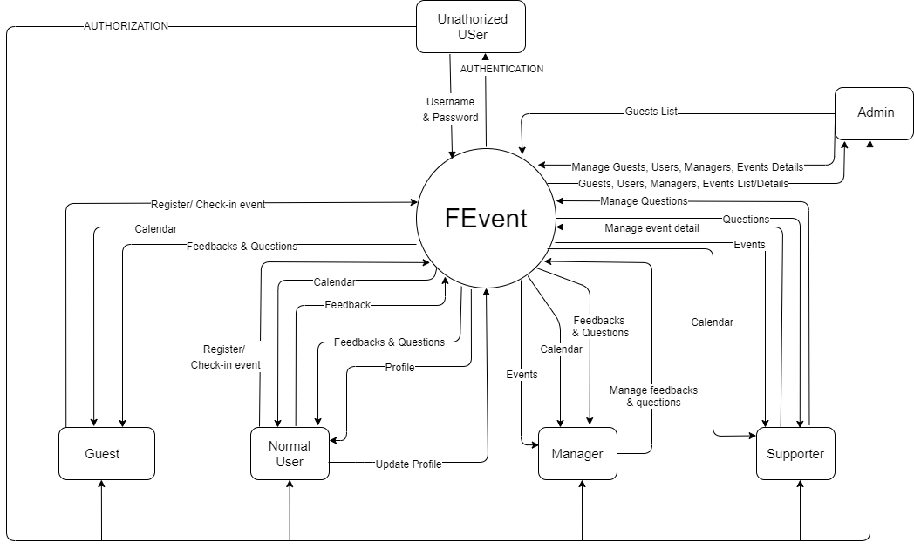

FIGURE The Context Diagram for Fevent

## 2. Purpose

This document is structured for internal use by the team of developers who implement the system only. All information included within this SRS all bears relevance to, unless stated otherwise, the context, the scope of the 1.0 version of the product.

## 3. System Functions

#### a. Screen Flow

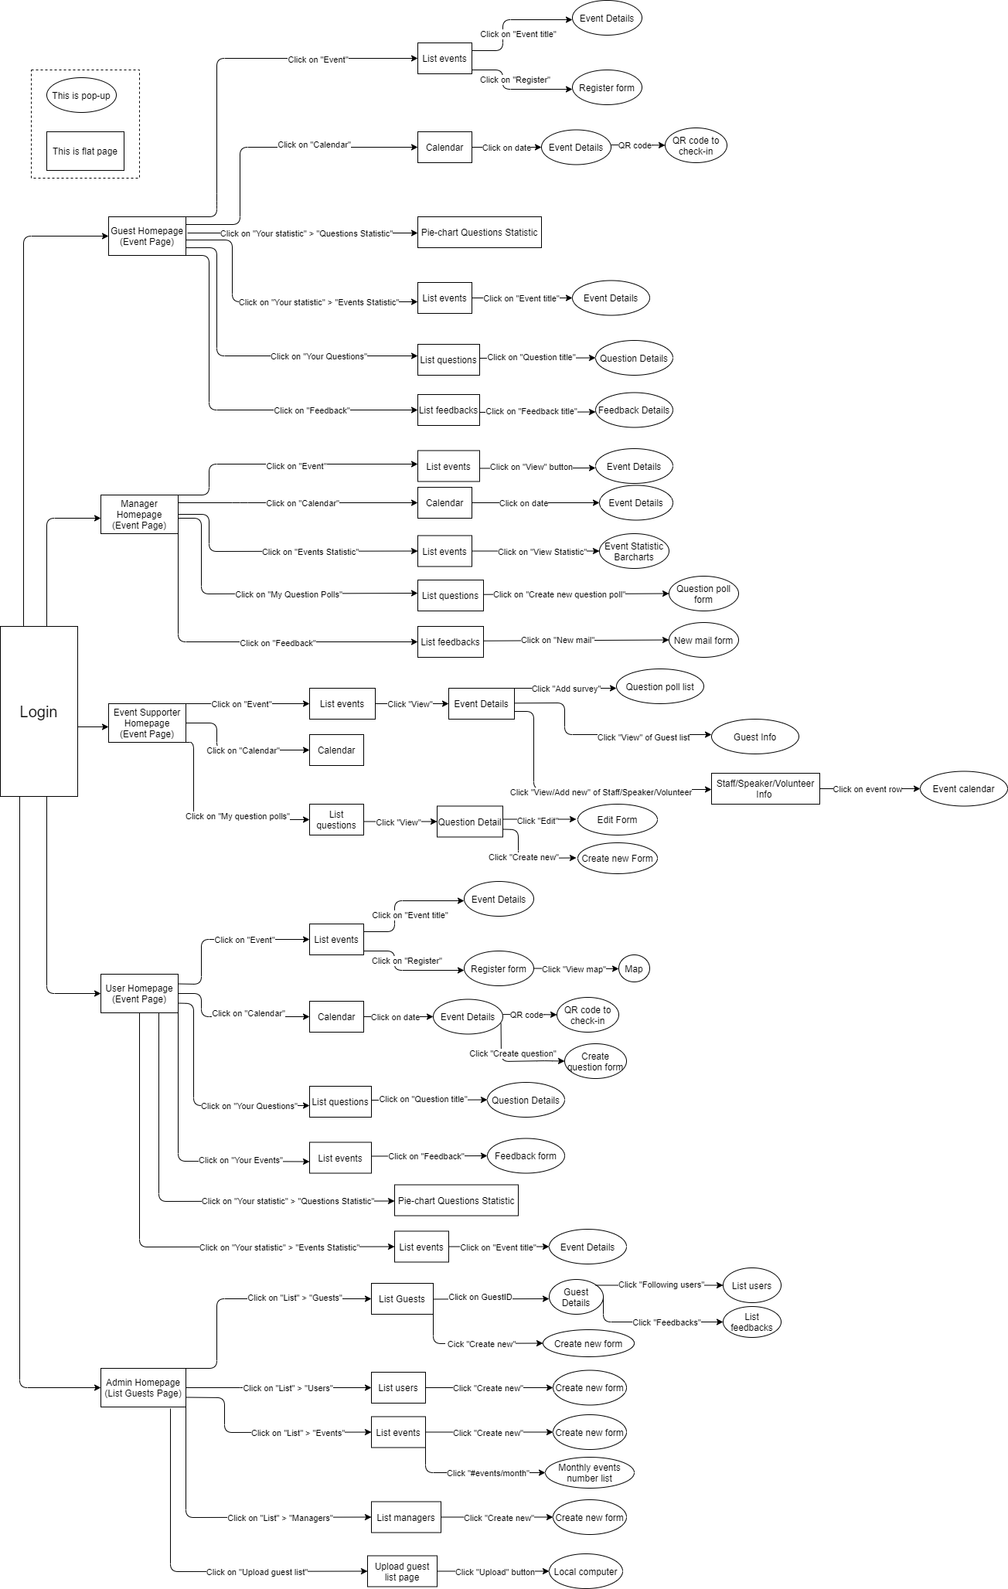

***b. Screen Details***

|  |  |  |  |
| --- | --- | --- | --- |
| **#** | **Feature** | **Screen** | **Description** |
| 1 | Guest - Event | List events | View events information and register/ cancel a specific event. |
| 2 | Guest - Calendar | Calendar | View calendar and event information which are placed in specific calendar date. |
| 3 | Guest - Questions Statistic | Questions Statistic | View the questions statistic which is displayed as a pie-chart. |
| 4 | Guest - Events Statistic | List events statistic | View list of events statistic and specific event statistic information. |
| 5 | Guest - Questions | List questions | View the list of questions of events and specific question information. |
| 6 | Guest - Feedbacks | List feedbacks | View the list of feedbacks of events and specific feedback information. |
| 7 | Manager - Event | List events | View events and specific event information. |
| 8 | Manager - Calendar | Calendar | View calendar and event information which are placed in specific calendar date. |
| 9 | Manager – Events Statistic | List events | View the events statistic which is displayed as barcharts. |
| 10 | Manager – My Question Poll | List questions | View list of questions / create new question. |
| 11 | Manager - Feedbacks | List feedbacks | View list of feedbacks / create new mail. |
| 12 | Supporter - Event | List events | View list of events, add survey, view specific guest information and view/add new a staff/speaker/volunteer to a specific event. |
| 13 | Supporter - Calendar | Calendar | View calendar and event information which are placed in specific calendar date. |
| 14 | Supporter – My Question Poll | List questions | View list of questions and create or edit a question. |
| 15 | User - Event | List events | View events information, register/ cancel a specific event and view a specific place of an event on a map view. |
| 16 | User - Calendar | Calendar | View calendar and event information which are placed in specific calendar date and create new question. |
| 17 | User – List Questions | List questions | View the list of questions of events and specific question information. |
| 18 | User – Your Events | List events | View the list of user’s events and create feedbacks. |
| 19 | User - Questions Statistic | Questions Statistic | View the questions statistic which is displayed as a pie-chart. |
| 20 | User - Events Statistic | List events statistic | View list of events statistic and specific event statistic information. |
| 21 | Admin – List Guest | List guests | View list of guests’ accounts, specific guest related information and create/update/delete a guest account. |
| 22 | Admin – List Users | List users | View list of users’ accounts, specific user information and create/update/delete an user account. |
| 23 | Admin – List Events | List events | View list of events, specific event information, create/update/delete an event and create monthly events report. |
| 24 | Admin – List Managers | List managers | View list of managers’ accounts, specific manager information and create/update/delete a manager account. |
| 25 | Admin – Upload Guests List | Upload guests list | Upload guests list to the webpage. |

# II. Functional Requirements

## Guest – Get Notification on Mobile

### Get Notification when guest is invited to an event

* Function trigger: Event Manager adds the guest to the guests list of an event.
* Function description:
  + Role: Guest.
  + Purpose: Notify the guest to check their calendar and events to response to the invitation.
  + On the Notification: Title: **“You are invited to an event”**, Description: **“<<Name of the event>>“**.
* Function details:

The Guest is added to the Guest List of an event.

The system is informed with the change, and it triggers this function.

Guest’s smart phone get notified and then he/she should hit on the notification pop-up and is navigated to the details screen of the event.

### Get Notification when guest has a question from users

* Function trigger: User submits a question to the guest.
* Function description:
  + Role: Guest.
  + Purpose: Notify the guest to check their questions list to prepare the event well.
  + On the Notification: Title: **“You have a new question”**, Description: **“<<Title of the event>>“**.
* Function details:

A question is submitted to the guest.

The system is informed with the change, and it triggers this function.

Guest’s smart phone get notified and then he/she should hit on the notification pop-up and is navigated to the details screen of the question.

## Guest – Event Management

### View all events

* Function trigger: Guest clicks **“Events”** on the menu.
* Function description:
  + Role: Guest.
  + Purpose: Allow the guest to view information about the events that are about to take place.
* Screen layout:

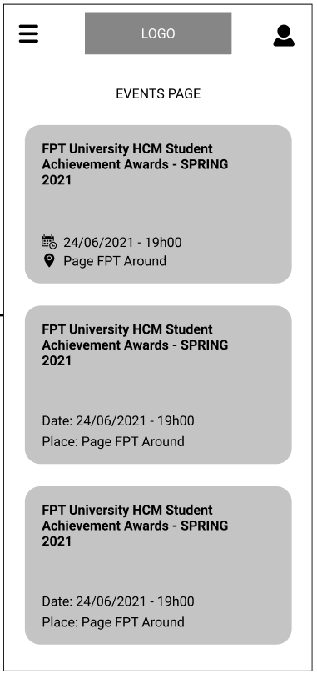

* Function details:
  + Data: The events are displayed with its summary of Title, Date, Time, and Place. All the information is read from database.
  + Validation: No.
  + Business logic:
    - The guest clicks on **“Events”** item on the Main Menu.
    - Normal case: The screen **“Events Page”** is displayed with all information about the events that are about to take place.
    - Abnormal cases:
      * If the user is not authenticated, the **“Login”** screen will display.
      * If there is no event, a message of **“There is no event right now, please check back later!”** will display on the screen.

### View event details

* Function trigger: Guest clicks on one of the events on **“Events”** screen.
* Function description:
  + Role: Guest.
  + Purpose: Allow the guest to view details of an event.
* Screen layout:

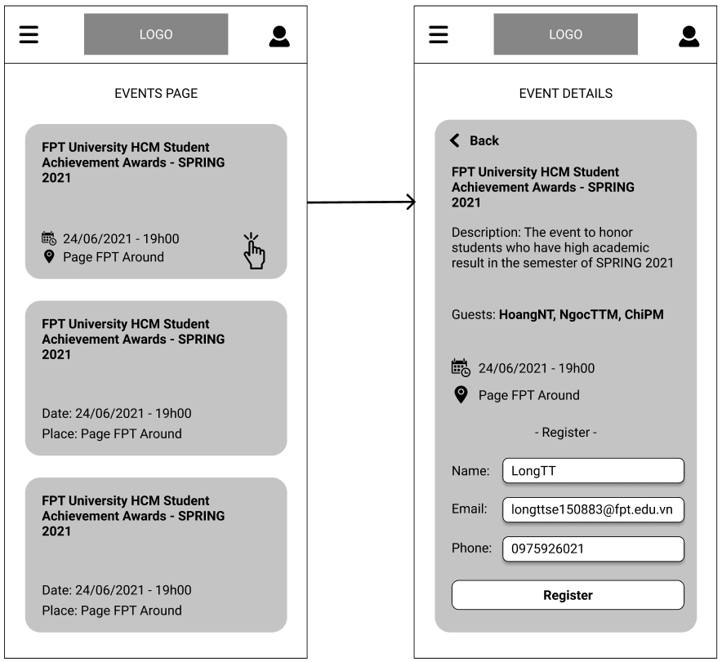

* Function details:
  + Data: The information is displayed in detail including Title, Description, Guests List, Date, Time, Place, and a form for guest to register to join the event.
  + Validation: No.
  + Business logic:
    - The guest clicks on one of the events on **“Events”** screen.
    - Normal case: The screen **“Events Details”** is displayed with all information about the event.
    - Abnormal cases:
      * If the user is not authenticated, the **“Login”** screen will display.
      * If the event had taken place, a message of **“The event had been taken place!”** will display.
      * If the event was deleted, a message of **“The event does not exist!”** will display.

### Register to participate in an event

* Function trigger: Guest clicks **“Register”** button at the **“Event Details”** page.
* Function description:
  + Role: Guest.
  + Purpose: Allow the guest to register to participate in an event.
* Screen layout:



* Function details:
  + Data: The information of Name, Email and Phone of the guest must be filled in.
  + Validation:
    - **“Name”** must be the guest’s full name, just alphabetical characters.
    - **“Email”** must be in email format.
    - **“Phone”** must be the phone number to contact with the guest, just numeric.
  + Business logic:
    - Guest click on the event he/she wants to participate in to navigate to the **“Event Details”** page, then fill out all the information and hit **“Register”** button.
    - Normal case: A pop-up displays and says that the guest has registered to participate in the event successfully. A mobile notification is displayed.
    - Abnormal cases:
      * If one of the required information is filled incorrectly, an error message will display to remind the guest to correct it.
      * If the guest had already registered before, an error message will display to inform them.

## Guest – Calendar Management

### View all events that the guest joined

* Function trigger: Guest clicks on **“Calendar”** item on the Main Menu.
* Function description:
  + Role: Guest.
  + Purpose: Give the guest an ability to view all events that he/she joined.
* Screen layout:

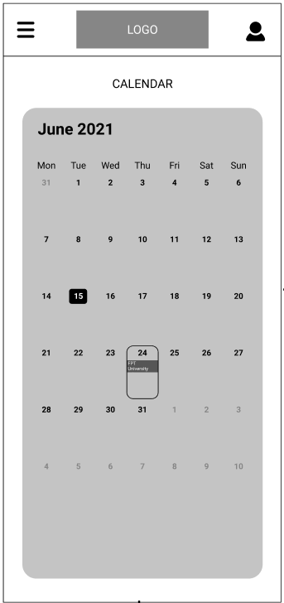

* Function details:
  + Data: Events information.
  + Validation: No.
  + Business logic:
    - Guest clicks on **“Calendar”** item on the Main Menu and a calendar-like screen is displayed with the title of event on the day on when the event will take place.
    - Normal case: A calendar-like screen is displayed with the title of event on the day on when the event will take place.

### Choose time to view the events

* Function trigger: Guest clicks on the date title of the screen.
* Function description:
  + Role: Guest.
  + Purpose: Allow the guest to choose time to filter the events.
* Screen layout:

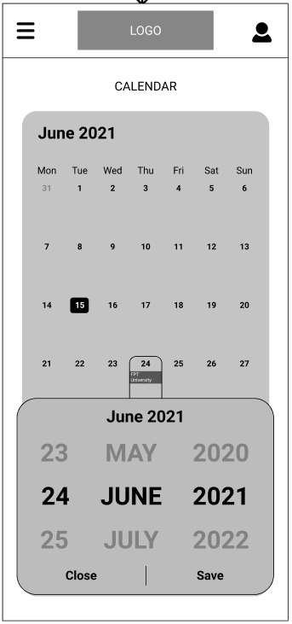

* Function details:
  + Data: Date information.
  + Validation: No.
  + Business logic:
    - Guest clicks on the date title of the screen, for example: **June 2021**. A pop-up shows up for the guest to choose the date. Then click **“Save”**.
    - Normal case: The data of events is refreshed, and the **“Calendar”** screen will refresh to display new filtered events.

### View all events in one date

* Function trigger: Guest clicks on any date on the **“Calendar”** screen.
* Function description:
  + Role: Guest.
  + Purpose: Guest can see list of events which take place on a particular date.
* Screen layout:

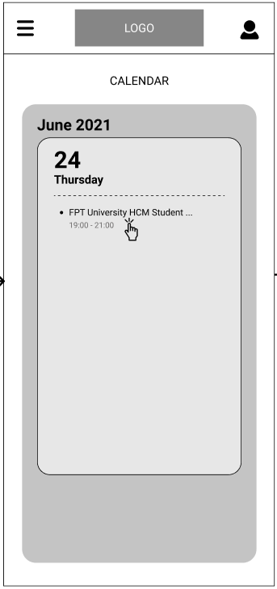

* Function details:
  + Data: Information about all events of the date.
  + Validation: No.
  + Business logic:
    - Guest clicks on any date on the **“Calendar”** screen and a pop-up with information of the events in that date including Title and Time of the event will display.
    - Normal Case: All the events on that date will be displayed.

### View event details

* Function trigger: Guest clicks on the event on the **“Calendar”** screen.
* Function description:
  + Role: Guest.
  + Purpose: Guest can view the detail information about an event that he/she joined.
* Screen layout:

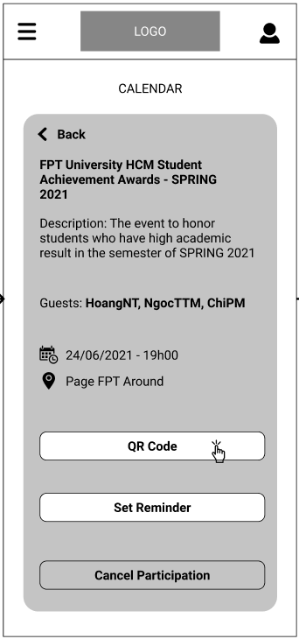

* Function details:
  + Data: Information about the specific event.
  + Validation: No.
  + Business logic:
    - Guest clicks on the event on the **“Calendar”** screen and a new screen will display with all information of that event.
    - Normal Case: Event Details will display.

### View QR Code to check-in an event

* Function trigger: Guest clicks **“QR Code”** button on the Event Details screen.
* Function description:
  + Role: Guest.
  + Purpose: The QR Code to check-in at the event.
* Screen layout:

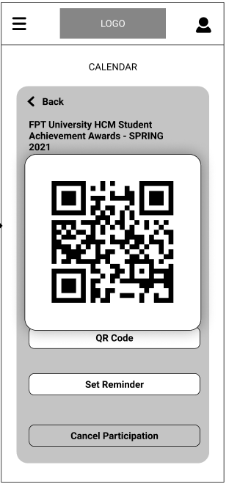

* Function details:
  + Data: Automatic-generated QR code.
  + Validation: No.
  + Business logic:
    - Guest clicks **“QR Code”** button on the Event Details screen and the QR code will be displayed on a pop-up window.
    - Normal Case: QR Code is displayed.

### Set Reminder

* Function trigger: Guest clicks **“Set Reminder”** button on the Event Details screen.
* Function description:
  + Role: Guest.
  + Purpose: Add Reminder into the Calendar app on guest’s mobile.
* Screen layout:



* Function details:
  + Data: Title and date, time of the event.
  + Validation: No.
  + Business logic:
    - Guest clicks **“Set Reminder”** button on the Event Details screen and the event is added to the Calendar app on the guest’s smart phone with its corresponding information.
    - Normal Case: The Reminder is set.
    - Abnormal Case: The app is not granted for the reminder setting permission and an error message will display to inform the guest.

### Cancel the participation

* Function trigger: Guest clicks **“Cancel Participation”** button on the Event Details screen.
* Function description:
  + Role: Guest.
  + Purpose: Allow the guest to cancel their participation in an event.
* Screen layout:



* Function details:
  + Data: No.
  + Validation: No.
  + Business logic:
    - Guest clicks **“Cancel Participation”** button on the Event Details screen. A confirm pop-up will display to ask again. The guest clicks **“Yes, I am sure!”** and the participation is deleted.
    - Normal Case: The participation is deleted successfully.
    - Abnormal Case: An error message will display if the guest is the only guest on the event.

## Guest – Events Statistics

### View All Events statistics

* Function trigger: Guest clicks on the **“Events Statistics”** item on the Main Menu.
* Function description:
  + Role: Guest.
  + Purpose: Allow the guest to view statistics about all the events that he/she has checked-in and not checked-in.
* Screen layout:

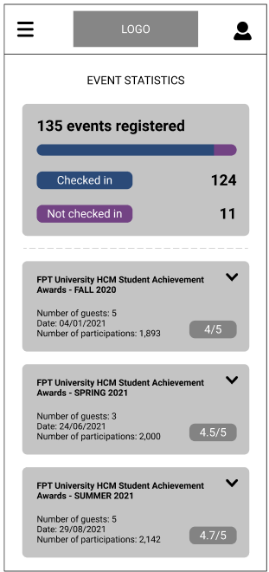

* Function details:
  + Data: Number of checked- and not checked-in events of the guest, and some statistics information of all that events.
  + Validation: No.
  + Business logic:
    - Guest clicks on the **“Events Statistics”** item on the Main Menu. The **“Events Statistics”** screen will display with the information of number of checked- and not checked-in events of the guest. Information including title of events, number of guests, date, and number of participants of those events and the rating is also displayed.
    - Normal Case: All the information is displayed successfully.
    - Abnormal Case: A message will display if the guest had not been to any event.

### View Event Statistics Details

* Function trigger: Guest clicks on any of the Event on the **“Event Statistics”** screen.
* Function description:
  + Role: Guest.
  + Purpose: Allow the guest to view details statistics about a specific event.
* Screen layout:

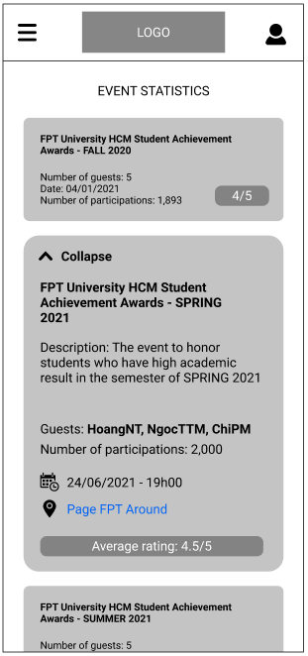

* Function details:
  + Data: Number of checked- and not checked-in events of the guest, and some statistics information of all that events and detail information of the event.
  + Validation: No.
  + Business logic:
    - Guest clicks on any of the Event on the **“Event Statistics”** screen. The details will drop down.
    - Normal Case: All the information is displayed successfully.

## Guest – Question Statistics

* Function trigger: Guest clicks on the **“Question Statistics”** item on the Main Menu.
* Function description:
  + Role: Guest.
  + Purpose: Allow the guest to view the trend of their questions.
* Screen layout:

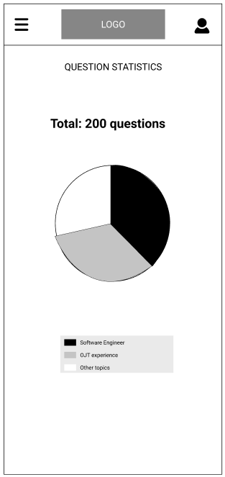

* Function details:
  + Data: Total of questions the guest has been asked and percentage of each subject of the questions.
  + Validation: No.
  + Business logic:
    - Guest clicks on the **“Question Statistics”** item on the Main Menu. All the trends will display.
    - Normal Case: All the information is displayed successfully.
    - Abnormal Case: An error message will display to inform the guest if they had no questions at all.

## Guest – View Questions

### View all questions in summary

* Function trigger: Guest clicks on the **“Your Questions”** item on the Main Menu.
* Function description:
  + Role: Guest.
  + Purpose: Allow the guest to view the summary of all questions that belong to them.
* Screen layout:

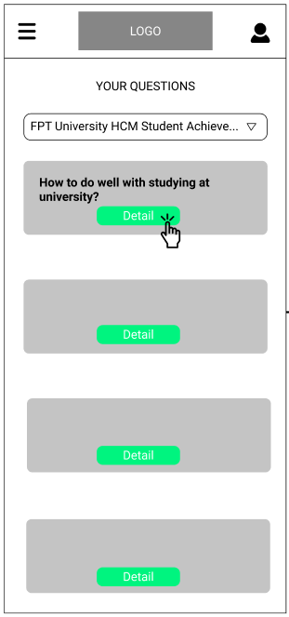

* Function details:
  + Data: All the questions that belong to the guest.
  + Validation: No.
  + Business logic:
    - Guest clicks on the **“Your Questions”** item on the Main Menu. The questions are displayed including only the questions’ title.
    - Normal Case: All the questions are displayed.
    - Abnormal Case: An error message will display to inform the guest if they had no questions at all.

### View question detail

* Function trigger: Guest clicks **“Details”** button on a specific question on **“Your Questions”** screen.
* Function description:
  + Role: Guest.
  + Purpose: Allow the guest to view the detail of a question.
* Screen layout:

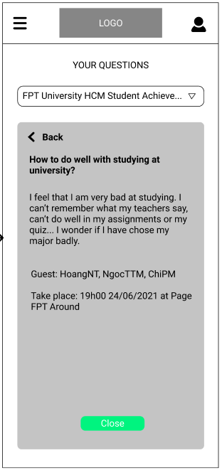

* Function details:
  + Data: All the information about the question including Title, Description and Event detail that the question belongs to.
  + Validation: No.
  + Business logic:
    - Guest clicks **“Details”** button on a specific question on **“Your Questions”** screen. All information about the question is displayed.
    - Normal Case: All the information is displayed.

## User – Get Notification on Mobile

### Get notification when there’s a new event

* Function trigger: Event Manager adds a new event to the event list.
* Function description:
  + Role: User.
  + Purpose: Notify the user that there is a new event that they might interested in.
  + On the Notification: Title: **“There is a new event near your location!”**, Description: **“<<Name of the event>>. Click to find out more!“**.
* Function details:

When a new event is added into the event list by the Event Managers, the system is informed with the addition, and it triggers this function. Then a notification will be sent to the user and then he/she should hit on the notification pop-up and is navigated to the details screen of the event.

### Get notification when guests has answer the question of user

* Function trigger: Guest answer a question of the user.
* Function description:
  + Role: User.
  + Purpose: Notify the user that their question has been answered
  + On the Notification: Title: **“Your question to <<guestname>> has been answered”**, Description: **“<<(Short) title of the question>> - <<(Short) title of the event>>“**.
* Function details:

A question of user has been answered by the guest.

The system is informed with the change, and it triggers this function.

User’s smart phone get notified and then he/she should hit on the notification pop-up and is navigated to the details screen of the question.

## User – Main menu/Navigation Sider

* Function trigger: User click on the **Hamburger icon** on the left of the logo on the **Header**.
* Function description:
  + Role: User.
  + Purpose: Allow the user to navigate through the app and change the language of the application
* Screen layout:

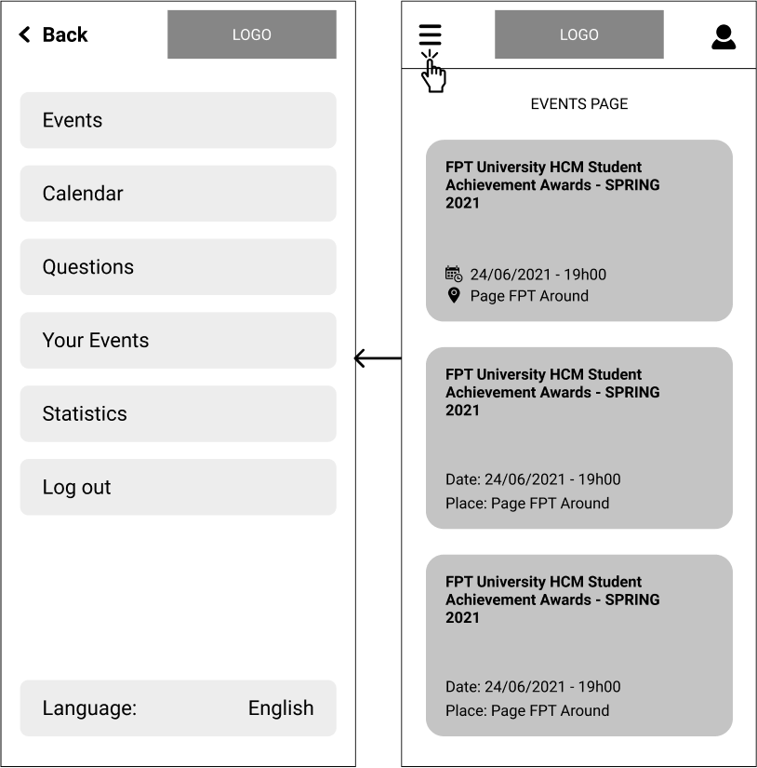

* Function details:

User click on the Hamburger icon on the left of the logo on the Header to open the main menu, each of item on the main menu will redirect user to the corresponding screen.

The **“Log out”** will sign out user of their current session.

The “**Language”** will allow user to change their application default language back and forth between English and Vietnamese.

## User – Event Management

### View all events

* Function trigger: Users click **“Events”** on the menu or user first login into/open the app with new session.
* Function description:
  + Role: User.
  + Purpose: Allow the user to view list of events that are upcoming
* Screen layout:

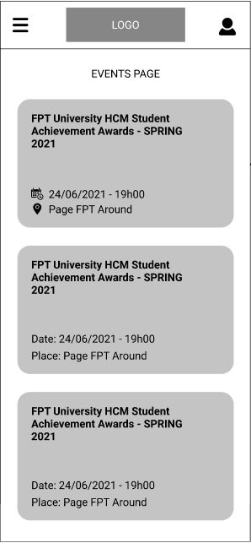

* Function details:
  + Data: The events are displayed with its summary of Title, Date, Time, and Place. All the information is read from database.
  + Validation: No.
  + Business logic:
    - The user clicks on **“Events”** item on the Main Menu or user first login into/open the app with new session.
    - Normal case: The screen **“Events Page”** is displayed with all information about events that are upcoming.
    - Abnormal cases:
      * If the user is not authenticated, the **“Login”** screen will display.
      * If there is no event, a message of **“There isn’t any event right now, please check back later!”** will display on the screen.

### View event details

* Function trigger: User clicks on one of the events on **“Events”** screen.
* Function description:
  + Role: User.
  + Purpose: Allow the user to view details of an event.
* Screen layout:

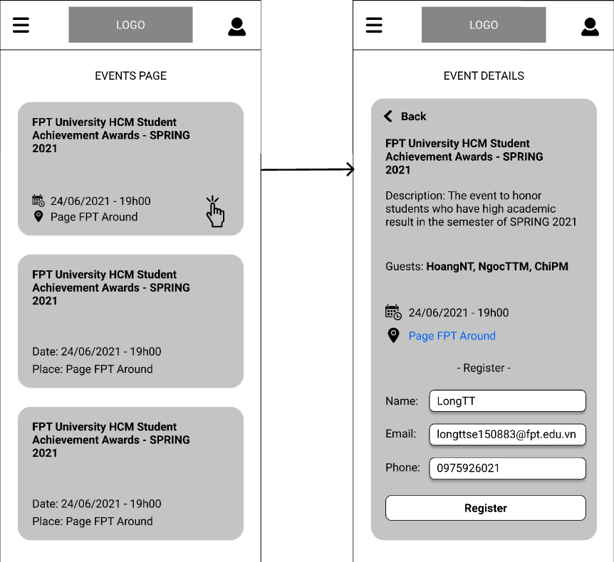

* Function details:
  + Data: The information is displayed in detail including Title, Description, Guests List, Date, Time, Place, and a form for user to register to join the event.
  + Validation: No.
  + Business logic:
    - The user clicks on one of the events on **“Events”** screen.
    - Normal case: The screen **“Events Details”** is displayed with all information about the event.
    - Abnormal cases:
      * If the user is not authenticated, the **“Login”** screen will display.
      * If the event had taken place, a message of **“The event had taken place!”** will display.
      * If the event was deleted, a message of **“The event does not exist!”** will display.

### View the map to the location of the event

* Function trigger: User clicks the Place details of the event.
* Function description:
  + Role: User.
  + Purpose: Open a map for user to view the way to the event.
* Screen layout:

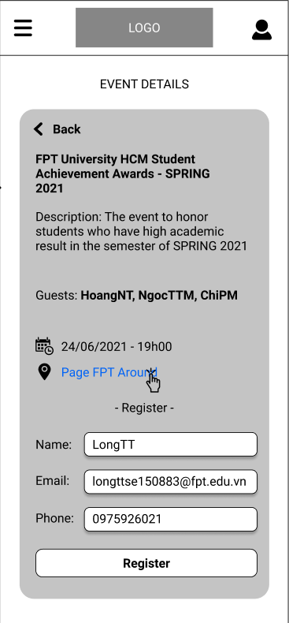

* Function details:
  + Data: The Place details is clickable and has a link to redirect user to Google Map with the address of the event’s location
  + Validation: No.
  + Business logic:
    - User clicks the Place details of the event.
    - Normal case: User will be redirected to Google Map with the address of the event’s location
    - Abnormal cases:
      * Google Map cannot find the address of the event’s location.

### Register to participate in an event

* Function trigger: User clicks **“Register”** button at the **“Event Details”** page.
* Function description:
  + Role: User.
  + Purpose: Allow the user to register to participate in an event.
* Screen layout:

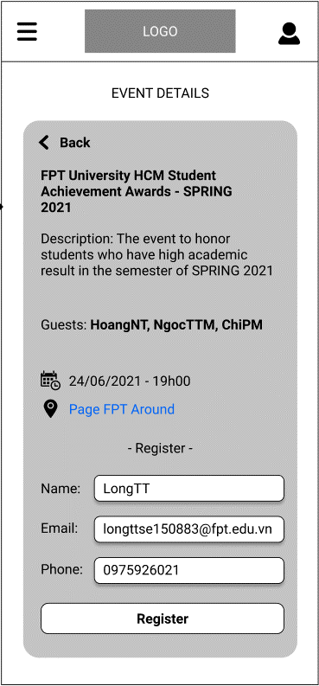

* Function details:
  + Data: The information of Name, Email and Phone of the user must be filled in.
  + Validation:
    - **“Name”** must be the user’s full name, just alphabetical characters.
    - **“Email”** must be in email format.
    - **“Phone”** must be the phone number to contact with the user, just numeric.
  + Business logic:
    - User click on the event he/she wants to participate in to navigate to the **“Event Details”** page, then fill out all the information and hit **“Register”** button.
    - Normal case: A pop-up displays and says that the user has registered to participate in the event successfully. A mobile notification is displayed.
    - Abnormal cases:
      * If one of the required information is filled incorrectly, an error message will display to remind the user to correct it.
      * If the user had already registered before, an error message will display to inform them.

## User – Calendar Management

### View all events that the user joined

* Function trigger: User clicks on **“Calendar”** item on the Main Menu.
* Function description:
  + Role: User.
  + Purpose: Give the User an ability to view all events that he/she joined in calendar view.
* Screen layout:



* Function details:
  + Data: Events information.
  + Validation: No.
  + Business logic:
    - User clicks on **“Calendar”** item on the Main Menu and a calendar-like screen is displayed with the title of event on the day on when the event will take place.
    - Normal case: A calendar-like screen is displayed with the title of event on the day on when the event will take place.

### Choose time to view the events

* Function trigger: User clicks on the date title of the screen.
* Function description:
  + Role: User.
  + Purpose: Allow the user to choose time to filter the events.
* Screen layout:



* Function details:
  + Data: Date information.
  + Validation: No.
  + Business logic:
    - User clicks on the date title of the screen, for example: **June 2021**. A pop-up shows up for the user to choose the date. Then click **“Save”**.
    - Normal case: The data of events is refreshed, and the **“Calendar”** screen will refresh to display new filtered events.

### View all events in one date

* Function trigger: User clicks on any date on the **“Calendar”** screen.
* Function description:
  + Role: User.
  + Purpose: User can see list of events which take place on a particular date.
* Screen layout:



* Function details:
  + Data: Information about all events of the date.
  + Validation: No.
  + Business logic:
    - User clicks on any date on the **“Calendar”** screen and a pop-up with information of the events in that date including Title and Time of the event will display.
    - Normal Case: All the events on that date will be displayed.

### View event details

* Function trigger: User clicks on the event on the **“Calendar”** screen.
* Function description:
  + Role: User.
  + Purpose: User can view the detail information about an event that he/she joined.
* Screen layout:

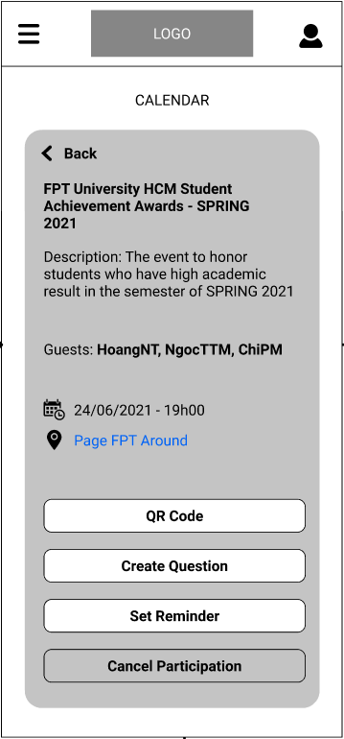

* Function details:
  + Data: Information about the specific event.
  + Validation: No.
  + Business logic:
    - User clicks on the event on the **“Calendar”** screen and a new screen will display with all information of that event.
    - Normal Case: Event Details will display.

### View QR Code to check-in an event

* Function trigger: User clicks **“QR Code”** button on the Event Details screen.
* Function description:
  + Role: User.
  + Purpose: The QR Code to check-in at the event.
* Screen layout:

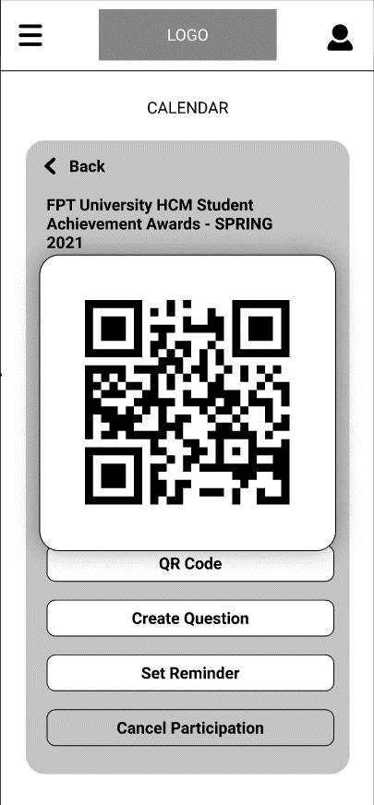

* Function details:
  + Data: Automatic-generated QR code.
  + Validation: No.
  + Business logic:
    - User clicks **“QR Code”** button on the Event Details screen and the QR code will be displayed on a pop-up window.
    - Normal Case: QR Code is displayed.

### Create question for guests

* Function trigger: User clicks **“Create question”** button on the Event Details screen.
* Function description:
  + Role: User.
  + Purpose: Create question for the guests of the event.
* Screen layout:

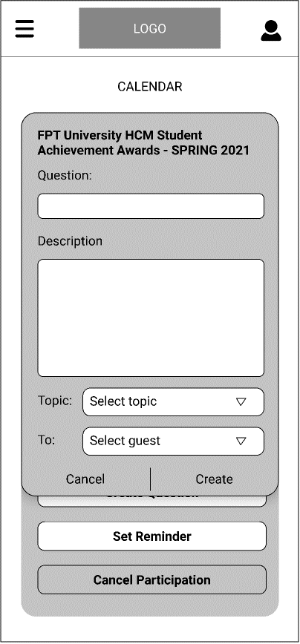

* Function details:
  + Data: The question, description must be filled in, topic and the guest to send to must be selected.
  + Validation: No.
  + Business logic:
    - User view the **“Event Details”** of the event he/she has already registered to in **“Calendar”** screen, then click on “Create question” to popup a form for user to create a question to a specific guest of that event.
    - Normal case: A form will pop-up for the user to fill in his/her question. After hitting **“Create**”, A notification is displayed that the question has been created for the guest **<<Guestname>>**.
    - Abnormal Case: The guest which user create question for decided to not go to the event and is deleted from the guest list of the event.

### Set Reminder

* Function trigger: User clicks **“Set Reminder”** button on the Event Details screen.
* Function description:
  + Role: User.
  + Purpose: Add Reminder into the Calendar app on User’s mobile.
* Screen layout:

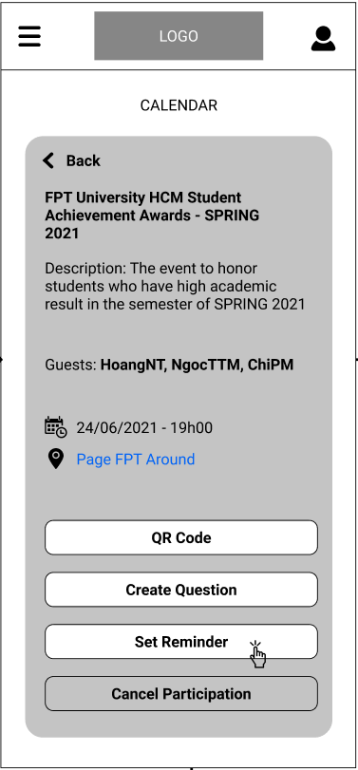

* Function details:
  + Data: Title and date, time of the event.
  + Validation: No.
  + Business logic:
    - User clicks **“Set Reminder”** button on the Event Details screen and the event is added to the Calendar app on the user’s smart phone with its corresponding information.
    - Normal Case: The Reminder is set.
    - Abnormal Case: The app is not granted for the reminder setting permission and an error message will display to inform the user and will ask for permission again.

### Cancel the participation

* Function trigger: User clicks **“Cancel Participation”** button on the Event Details screen.
* Function description:
  + Role: User.
  + Purpose: Allow the user to cancel their participation in an event.
* Screen layout:

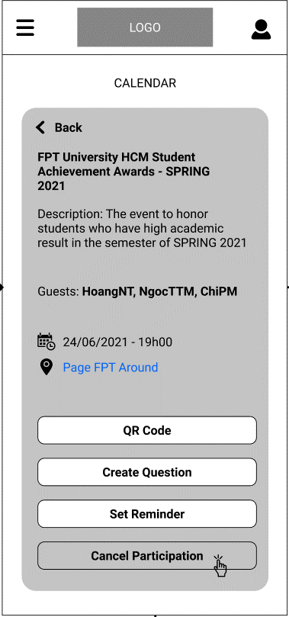

* Function details:
  + Data: No.
  + Validation: No.
  + Business logic:
    - User clicks **“Cancel Participation”** button on the Event Details screen. A confirm pop-up will display to ask again. The user clicks **“Yes, I am sure!”** and the participation is deleted.
    - Normal Case: The participation is deleted successfully.
    - Abnormal Case: An error message will display if the cancellation is failed.

## User – Questions List

### View all created question

* Function trigger: User clicks on the **“Question”** item on the Main Menu.
* Function description:
  + Role: User.
  + Purpose: Allow the User to view list of their created question and its status in a specific event.
* Screen layout:

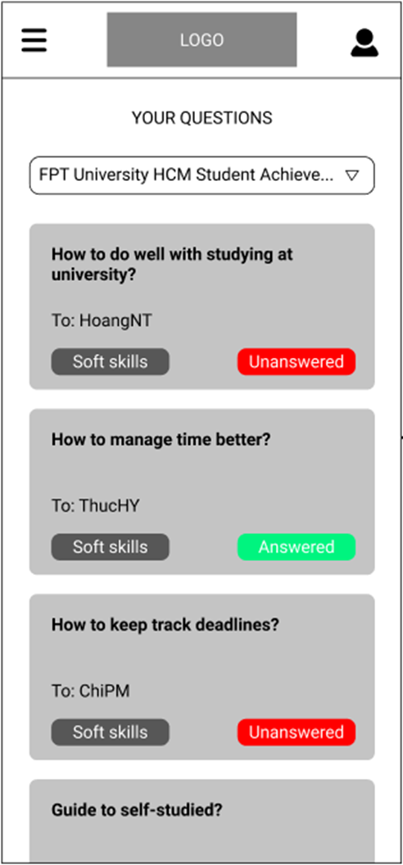

* Function details:
  + Data: The questions are displayed with its summary of Title, target guest, topic, and status. All the information is read from database.
  + Validation: No.
  + Business logic:
    - The user clicks on **“Questions”** item on the Main Menu
    - Normal case: The screen **“Questions”** is displayed with all information about the questions that user has created
    - Abnormal cases:
      * If the user is not authenticated, the **“Login”** screen will display.
      * If there isn’t any question, a message of **“You haven’t create any question for guests!”** will display on the screen.

### View question details

* Function trigger: User clicks on the question on the **“Questions”** screen.
* Function description:
  + Role: User.
  + Purpose: User can view the detail information about an question that he/she created for the guest.
* Screen layout:

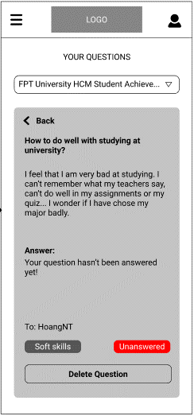

* Function details:
  + Data: Information about the question.
  + Validation: No.
  + Business logic:
    - User clicks on a question on the **“Questions”** screen and a new screen will display with all information of that questions.
    - Normal Case: Question Details will display.

### Delete question

* Function trigger: User clicks on the **“Delete question”** on the **“Question Details”** screen.
* Function description:
  + Role: User.
  + Purpose: User can delete the question that they’ve created.
* Screen layout:

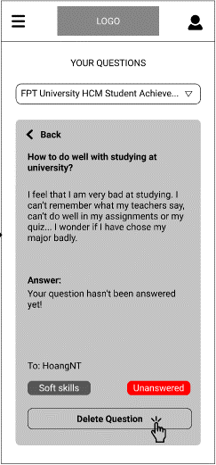

* Function details:
  + Data: No
  + Validation: No.
  + Business logic:
    - User clicks **“Delete Question”** button on the Event Details screen. A confirm pop-up will display to ask again. The user clicks **“Yes, I am sure!”** and the question is deleted.
    - Normal Case: The question is deleted successfully.
    - Abnormal Case: An error message will display if the deletion is failed

## User – View Registered Events

### View all registered events in summary

* Function trigger: User clicks on the **“Your Events”** item on the Main Menu.
* Function description:
  + Role: User.
  + Purpose: Allow the user to view the summary and status of participation of all events he/she has registered.
* Screen layout:

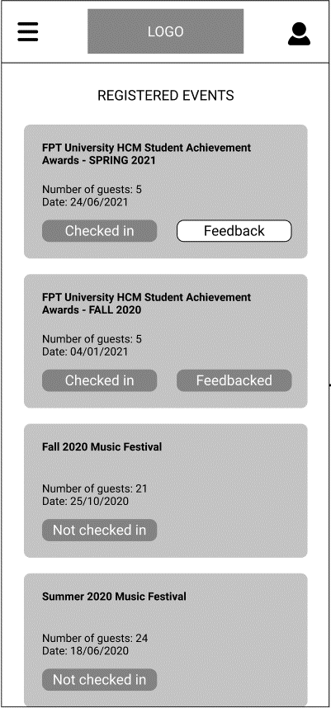

* Function details:
  + Data: All the events that user has registered in descending ordered by date, if they’ve checked in an event, a **“Feedback”** button is displayed for user to give feedback about that event.
  + Validation: No.
  + Business logic:
    - User clicks on the **“Your Events”** item on the Main Menu. All of his/her registered events are displayed in summary and in descending ordered by date
    - Normal Case: All the registered event are displayed.
    - Abnormal Case:
      * An error message will display to inform the user if they hadn’t registered in any event at all.
      * If user has checked in and feedbacked an event, the feedback button will be changed into a status displayed “Feedbacked”

### Feedback an event

* Function trigger: User clicks **“Feedback”** button on a checked-in event on **“Your Events”** screen.
* Function description:
  + Role: User.
  + Purpose: Allow the user to give feedback on an event they have checked-in.
* Screen layout:

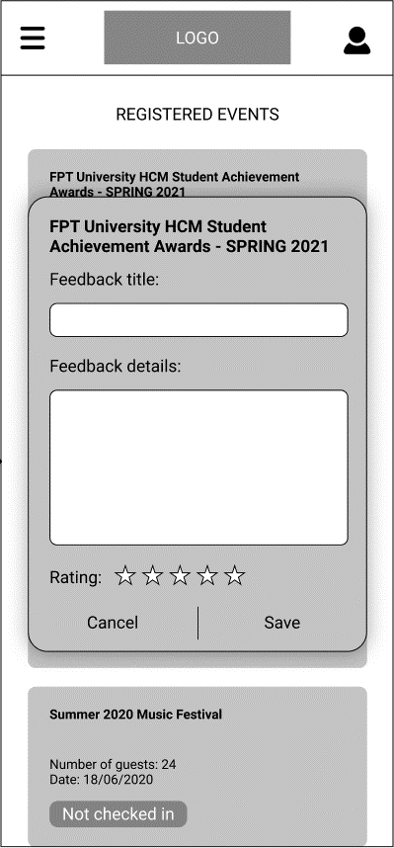

* Function details:
  + Data: The information about the feedback title, details must be filled in. The rating must be given
  + Validation: No.
  + Business logic:
    - User clicks **“Feedback”** button on an event they’ve checked in on **“Your Events”** screen. A popup form to give feedback on the event is displayed.
    - Normal case: A pop-up displays and says that the user has given feedback on the event successfully. A mobile notification is displayed.
    - Abnormal cases:
      * If the user had already given a feedback, an error message will display to inform them.

## User – Statistics

### View All Events statistics

* Function trigger: User clicks on the **“Events Statistics”** item on the Main Menu.
* Function description:
  + Role: User.
  + Purpose: Allow the user to view statistics about all the events that he/she has checked-in and not checked-in.
* Screen layout:

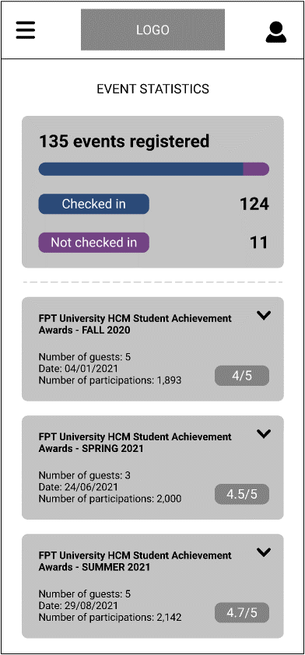

* Function details:
  + Data: Number of checked- and not checked-in events of the user, and some statistics information of all that events.
  + Validation: No.
  + Business logic:
    - User clicks on the **“Events Statistics”** item on the Main Menu. The **“Events Statistics”** screen will display with the information of number of checked- and not checked-in events of the user. Information including title of events, number of guests, date, and number of participants of those events and the rating is also displayed.
    - Normal Case: All the information is displayed successfully.
    - Abnormal Case: A message will display if the user had not been to any event.

### View Event Statistics Details

* Function trigger: User clicks on any of the Event on the **“Event Statistics”** screen.
* Function description:
  + Role: User.
  + Purpose: Allow the user to view details statistics about a specific event.
* Screen layout:

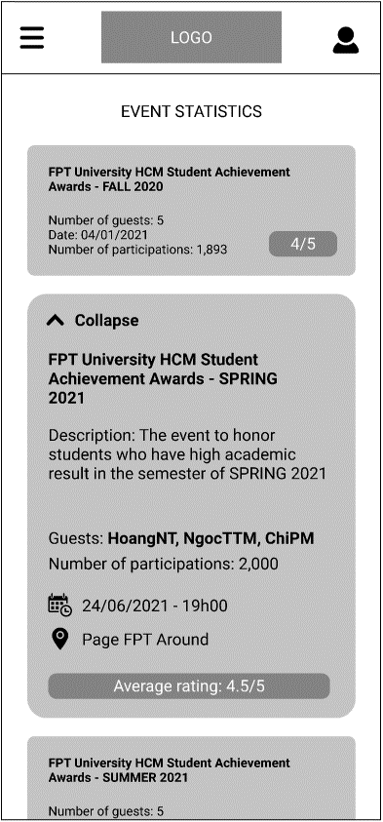

* Function details:
  + Data: Number of checked- and not checked-in events of the user, and some statistics information of all that events and detail information of the event.
  + Validation: No.
  + Business logic:
    - Users clicks on any of the Event on the **“Event Statistics”** screen. The details will drop down.
    - Normal Case: All the information is displayed successfully.

## User – Profile Page

### View user’s profile

* Function trigger: User clicks on the **Profile Icon** on the right of the logo on the **Header**
* Function description:
  + Role: User.
  + Purpose: Allow the user to view their information, they can also view their statistics about the questions they’ve created.
* Screen layout:

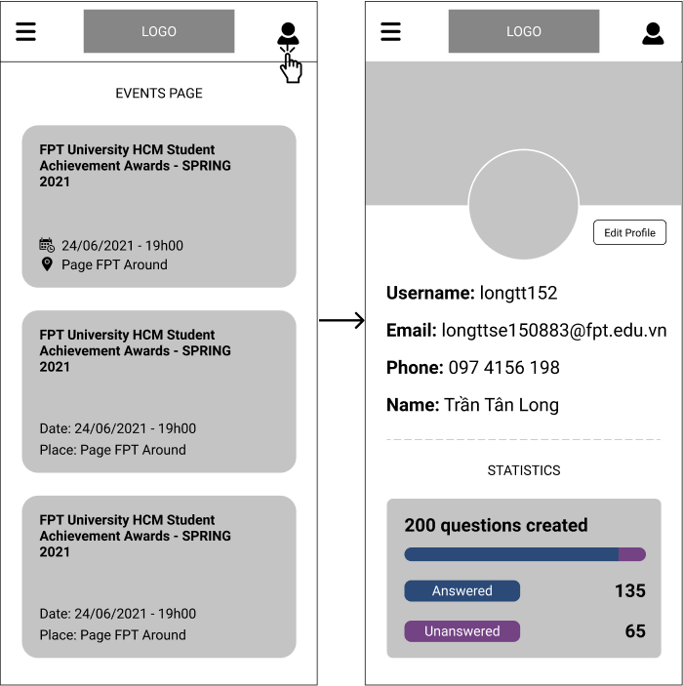

* Function details:
  + Data: basic information about the user and the total of questions the user has created and the number of questions have been answered or not.
  + Business logic:
    - User clicks on the **Profile Icon** on the right of the logo on the **Header**. All of their basic information and questions statistics will be displayed.
    - Normal Case: All the information is displayed successfully.

### Edit user’s profile

* Function trigger: User clicks on the **“Edit Profile”** button on the **“Profile”** screen
* Function description:
  + Role: User.
  + Purpose: Allow the user to view and edit their information, they can also view their statistics about the questions they’ve created.
* Function details:
  + Data: The new information of Email and Phone of the user must be filled in.
  + Validation:
    - **“Email”** must be in email format.
    - **“Phone”** must be the phone number to contact with the guest, just numeric.
  + Business logic:
    - User clicks on the **“Edit Profile”** button on the **“Profile”** screen, then change their Email or Phone (or both) and hit **“Save”** button.
    - Normal case: A pop-up displays and says that the user has changed their information successfully. A mobile notification is displayed.
    - Abnormal cases: If one of the required information is filled incorrectly, an error message will display to remind the guest to correct it.

## Manager - Event Viewing

### a.View events in the form of a list as an Event Manager

* *Function trigger: when the user is authorized as an Event Manager and navigated to default section (in this case is the Event section) of the main page for Event Manager. Then he/she chooses one event that needs viewing and click on the View button.*
* *Function description:* 
  + *Actors:Event Manager*
  + *Purpose: allows the Event Manager to view events that he/she is administering*
* *Screen layout:*

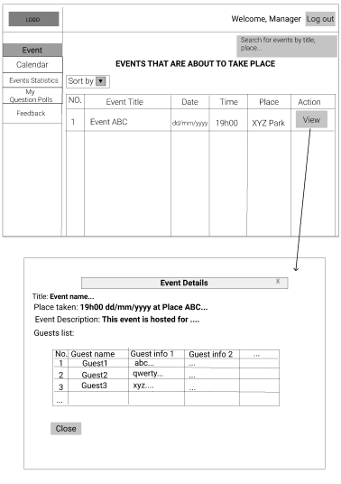

* *Function Details:* 
  + *Data: read and write data from the app’s database*
  + *Validations:*
    - *The account must exist in the system and the role is Event Manager*
    - *Event search field must contain only title or place of an event*
  + *Functionalities:*
    - *Search for events by title, place*
    - *Sort events*
    - *View events details*

### b. View events in the form of a calendar as a Event Manager

* *Function trigger: when the user is authorized as an Event Manager and navigated the Calendar section of the main page for Event Manager.*
* *Function description:* 
  + *Actors:Event Manager*
  + *Purpose: allows the Event Manager to view events that he/she is administering*
* *Screen layout:*

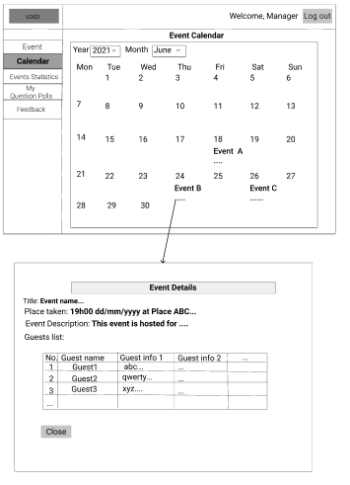

* *Function Details:* 
  + *Data: read and write data from the app’s database*
  + *Validations: The account must exist in the system and the role is Event Manager*
  + *Functionalities:*
    - *Show events of one specific month in a specific year*
    - *View events details*

## Manager – Event Statistics Viewing

* *Function trigger: when the user is authorized as an Event Manager and navigated to the Event Statistics section of the main page for Event Manager.* 
  + *Actors:Event Manager*
  + *Purpose: allows the Event Manager to view the statistics of events he/she is administering that have taken place*
* *Screen layout:*

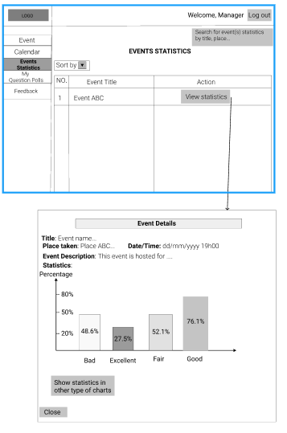

* *Function Details:* 
  + *Data: read and write data from the app’s database*
  + *Validations:* 
    - *The account must exist in the system and the role is Event Manager*
    - *Event search field must contain only the title or place of an event*
  + *Functionalities:*
    - *Search for events statisitcs by title, place*
    - *Sort events*
    - *View events statistics details*

## Manager – Question Polls Managing

* *Function trigger: when the user is authorized as an Event Manager and navigated to the My Question Polls section of the main page for Event Manager.* 
  + *Actors:Event Manager*
  + *Purpose: allows the Event Manager to view and control question polls of events he/she is administering*
* *Screen layout:*

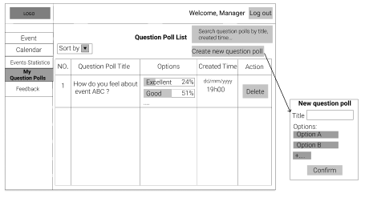

* *Function Details:* 
  + *Data: read and write data from the app’s database*
  + *Validations:* 
    - *The account must exist in the system and the role is Event Manager*
    - *Question Poll search field must contain only the title or place of an event*
    - *Title of new question poll must not exceed 90 characters*
    - *New question poll must have 2 or more options*
  + *Functionalities:*
    - *Search for question poll by title, created time*
    - *Sort question polls*
    - *Create a new question poll*
    - *Delete a question poll*

## Manager – Feedback Managing

* *Function trigger: when the user is authorized as an Event Manager and navigated to the Feedback section of the main page for Event Manager.* 
  + *Actors:Event Manager,recipients*
  + *Purpose: allows the Event Manager to view and manipulate his/her feedbacks/emails*
* *Screen layout:*

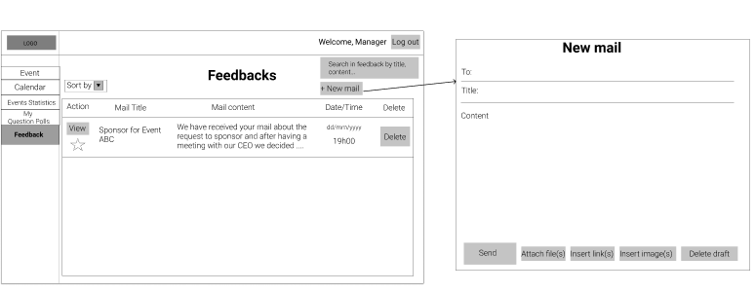

* *Function Details:* 
  + *Data: read and write data from the app’s database*
  + *Validations:* 
    - *The account must exist in the system and the role is Event Manager*
    - *Feedback/email search field must contain only the title or content of a feedback/email*
    - *The “To” field of a new mail must contain only email addresses of recipients*
    - *Title of a new feedback/mail must not exceed 90 characters*
    - *New question poll must have 2 or more options*
    - *The content field of a new feedback/mail must not be empty*
    - *A new mail can only contain no more than 10MB of attachment files*
  + *Functionalities:*
    - *Search for feedback/email by title, content*
    - *Sort feedback/mail*
    - *Create a new feedback/mail*
    - *View a feedback/mail content*
    - *Mark a feedback/mail as important*
    - *Delete a feedback/mail*

## Admin – Create, View, Update and Delete Guests

* Function trigger: logged in successfully as Admin account and navigation to List > Guests.
* Function description: an Admin can view a list of detailed Guest accounts or more details about a specific Guest accout from the list. Admin can also create new Guest account, update or delete existed Guest and view list of inactive Guest accounts.
* Screen Layout: (as below)

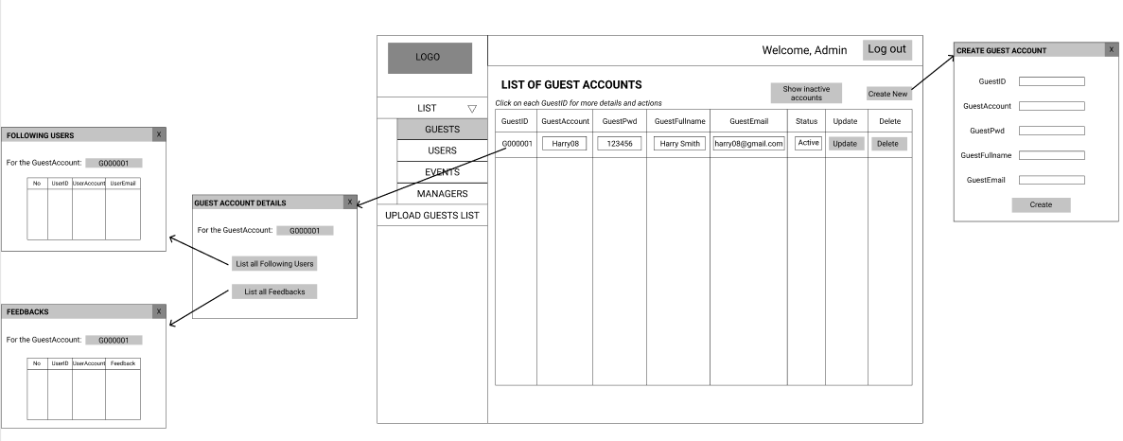

* Function Details:
  + The screen consists of a list of Guest accounts with columns as GuestID, GuestAccount, GuestPwd, GuestFullName, GuestEmail, Status, Update and Delete.
  + Admin can click on each GuestID column for a pop-up Guest account details such as “Following users” list and “Feedbacks” list.
  + “Create New” button is used for creating a new Guest account.
  + “Update” button is used for updating the columns which are displayed as textboxes.
  + “Delete” button is used for deleting a Guest account.
  + “Show inactive accounts” button which show a list of inactive accounts which have not worked for 6 months or more and the status would be expected as “Inactive”.

## Admin – Create, View, Update and Delete User

* Function trigger: logged in successfully as Admin account and navigation to List > Users.
* Function description: an Admin can view a list of detailed User accounts, create new Guest account and update or delete existed User account.
* Screen Layout: (as below)

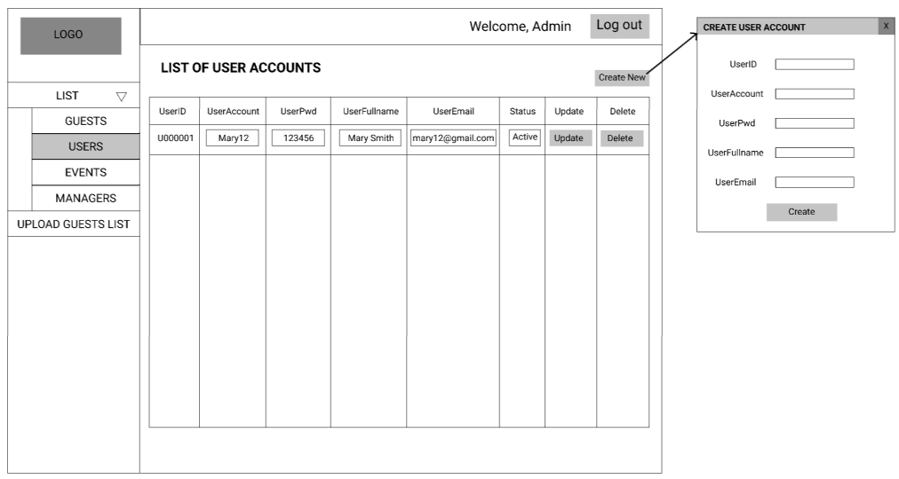

* Function Details:
  + The screen consists of a list of User accounts with columns as UserID, UserAccount, UserPwd, UserFullName, UserEmail, Status, Update and Delete.
  + “Create New” button is used for creating a new User account.
  + “Update” button is used for updating the columns which are displayed as textboxes.
  + “Delete” button is used for deleting an User account.

## Admin – Create, View, Update and Delete Events

* Function trigger: logged in successfully as Admin account and navigation to List > Events.
* Function description: an Admin can view a list of detailed Events, create new Event, update or delete existed Event and statistic number of events per month.
* Screen Layout: (as below)

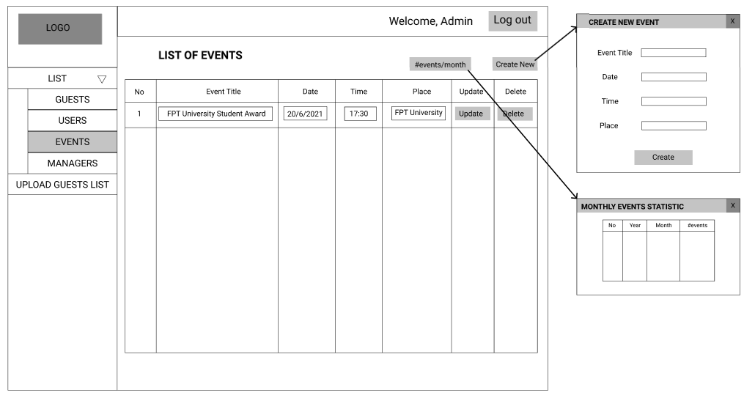

* Function Details:
  + The screen consists of a list of Event information with columns as No, Event Title, Date, Time, Place, Update and Delete.
  + “Create New” button is used for creating a new Event.
  + “Update” button is used for updating the columns which are displayed as textboxes.
  + “Delete” button is used for deleting an Event.
  + “#events/month” button will show a list of Monthly Events Statistic with columns as No, Year, Month, #events.

## Admin – Create, View, Update and Delete Managers

* Function trigger: logged in successfully as Admin account and navigation to List > Managers.
* Function description: an Admin can view a list of detailed Manager accounts, create new Manager account and update or delete existed Manager account.
* Screen Layout: (as below)

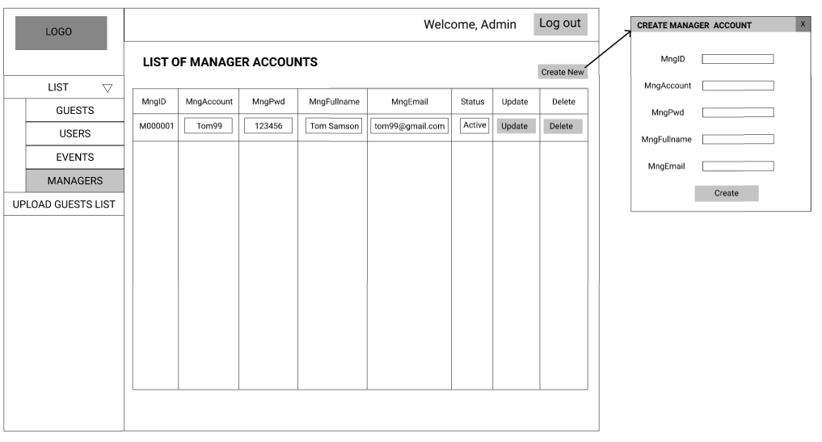

* Function Details:
  + The screen consists of a list of Manager accounts with columns as MngID, MngAccount, MngPwd, MngFullName, MngEmail, Status, Update and Delete.
  + “Create New” button is used for creating a new Manager account.
  + “Update” button is used for updating the columns which are displayed as textboxes.
  + “Delete” button is used for deleting a Manager account.

## Admin – Upload Guest List

* Function trigger: logged in successfully as Admin account and navigation to Upload Guest List.
* Function description: an Admin can upload a guest list to the webpage so that Users can see and choose which guests they are interested in for their upcoming events.
* Screen Layout: (as below)

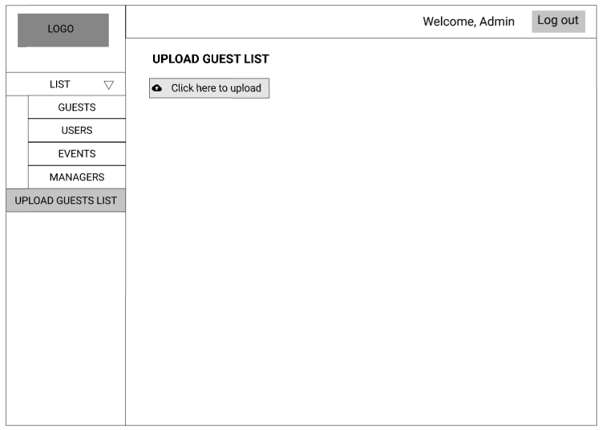

* Function Details:
  + The screen consists of a button which link to the local computer for picking guest list to upload to the webpage.

## Supporter – List Event View

* 1. **View events in the form of a list as an Event Supporter:**
     + Function trigger: when the user is authorized as an Event Supporter and navigated to default section (in this case is the Event section) of the main page for Event Supporter. Then he/she chooses one event that needs viewing and click on the View button.
     + Function description:
       - Actors: Event Supporter
       - Purpose: allows the Event Supporter to view events that he/she is supporting
     + Screen layout:

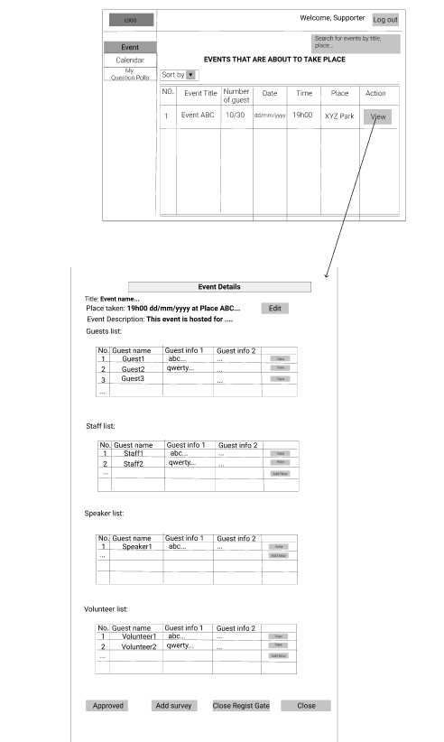

* + - Function Details:
  + Data: read and write data from the app’s database
  + Validations:
    - The account must exist in the system and the role is Event Supporter
    - Event search field must contain only title or place of an event
* Functionalities:
  + - Search for events by title, place
    - Sort events
    - View events details
  1. **View events in the form of a calendar as a Event Supporter:**
* Function trigger: when the user is authorized as an Event Supporter and navigated the Calendar section of the main page for Event Supporter.
* Function description:
  + Actors:Event Supporter
  + Purpose: allows the Event Supporter to view events that he/she is supporting
* Screen layout:

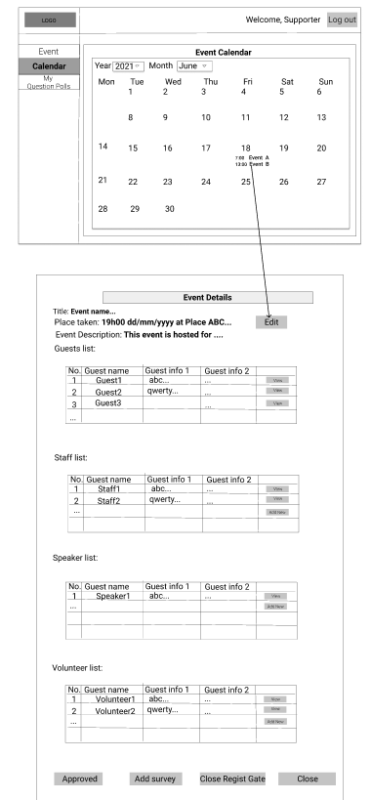

## Supporter – View Information

* 1. **View Guest Info**
* Function trigger: when the user click on View button in Guest List. All information will be shown.
* Function description:
  + Actors: Event Supporter
  + Purpose: allows the Event Manager to view guest in events that he/she is supporting
* Screen layout:

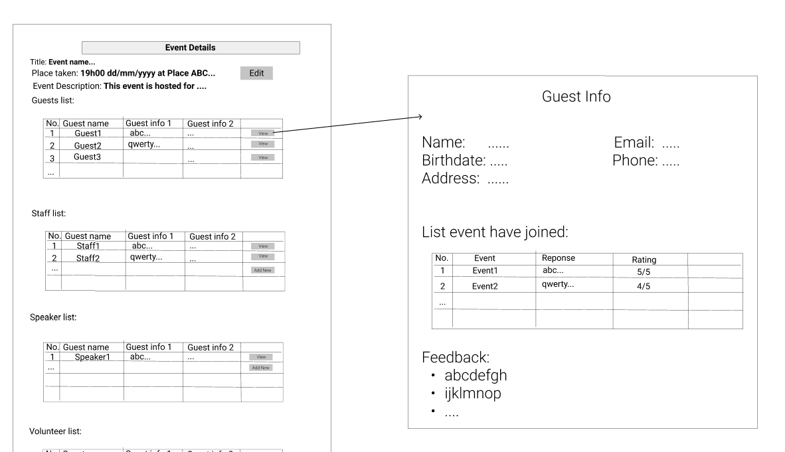

* Function Details:
  + Data: read and write data from the app’s database
  + Validations:
    - The account must exist in the system and the role is Event Supporter
  + Functionalities:
    - Search for guest by id
    - Sort events
    - View events which guest joins
  1. **CRUD Staff/Speaker/Volunteer:**
* Function trigger: when the user click on View button in Staff/Speaker/Volunteer List. All information will be shown, and can working in this page.
* Function description:
  + Actors: Event Supporter
  + Purpose: allows the Event Manager to view, edit, create Staff/Speaker/Volunteer in events that he/she is supporting
* Screen layout:

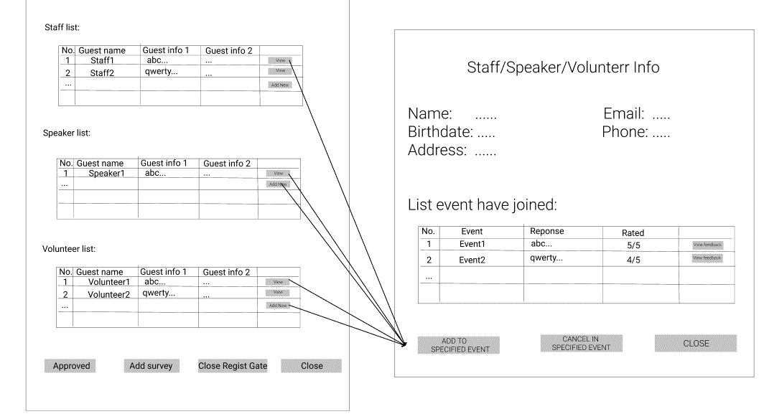

* Function Details:
  + Data: read and write data from the app’s database
  + Validations:
    - The account must exist in the system and the role is Event Supporter
  + Functionalities:
    - Search for Staff/Speaker/Volunteer by id
    - Sort events
    - View events which Staff/Speaker/Volunteer joins
    - Add/Remove Staff/Speaker/Volunteer to/from specific event

## Supporter – Question Poll Manage

* 1. **Manage Question Poll**
* Function trigger: when the user is authorized as an Event Supporter and navigated to My Question Polls button.
* Function description:
  + Actors: Event Supporter
  + Purpose: allows the Event Supporter to view and manage question polls in the Event that he/she is supporting
* Screen layout:

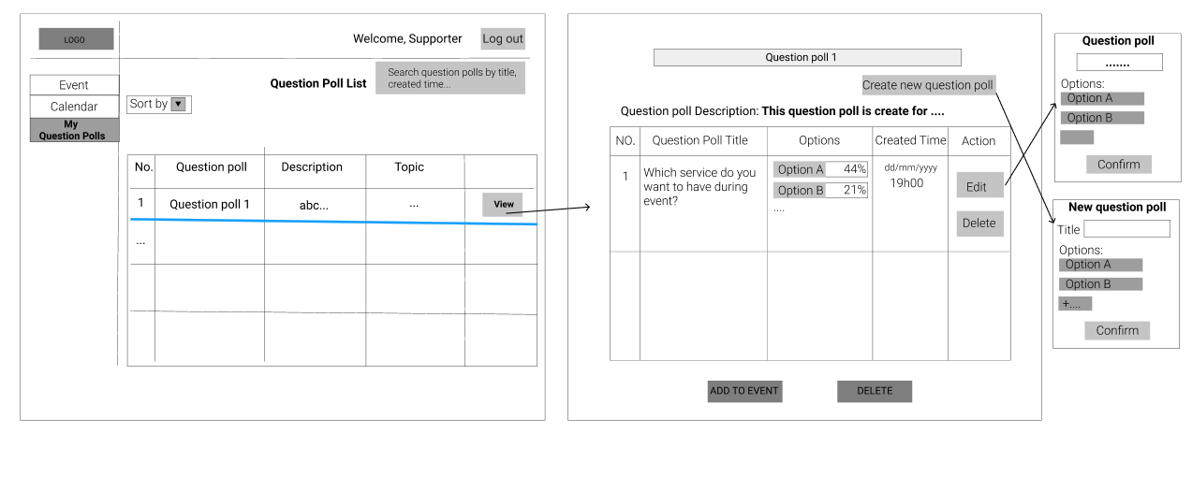

* Function Details:
  + Data: read and write data from the app’s database
  + Validations:
    - The account must exist in the system and the role is Event Supporter
    - Question Poll search field must contain only the title or place of an event
    - Title of new question poll must not exceed 200 characters
    - New question poll must have 3 or more options
  + Functionalities:
    - View list Question Poll has created
    - Search for question poll by id, title, created time
    - Create a new question poll, question
    - Update specific question poll, question
    - Delete a question poll, question
  1. **Add Question poll to Event**
* Function trigger: when the user is authorized as an Event Supporter and navigated to Event Details Page.
* Function description:
  + Actors: Event Supporter
  + Purpose: allows the Event Supporter to view and add question polls to the Event that he/she is viewing
* Screen layout:

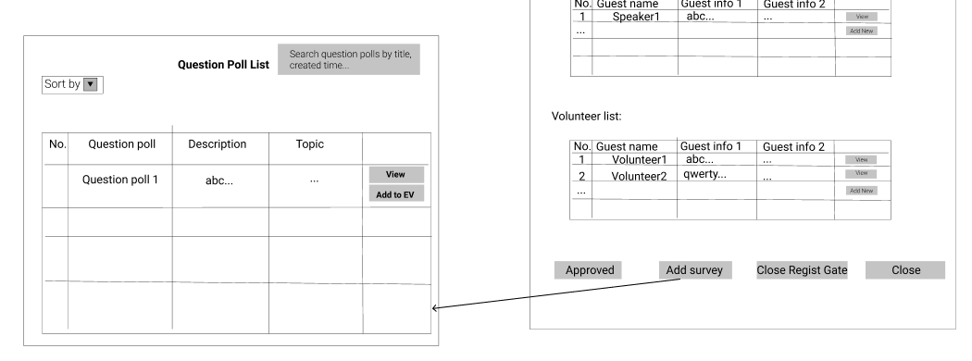

* Function Details:
  + Data: read and write data from the app’s database
  + Validations:
    - The account must exist in the system and the role is Event Supporter
  + Functionalities:
    - View list Question Poll has created
    - Search for question poll by id, title, created time to view list question in specific question poll
    - Add Question poll to Event