**Task 1: 60 minutes**

Write an argumentative essay of 350-400 words on the following question: Should first-year academic writing courses be compulsory for all students – not just for international students or those whose first language is not English? In your essay, consider both sides of the argument, and state your own position clearly

3 dạng đề : Coi cấu trúc của bài văn cho đầy đủ

+ Argumentative

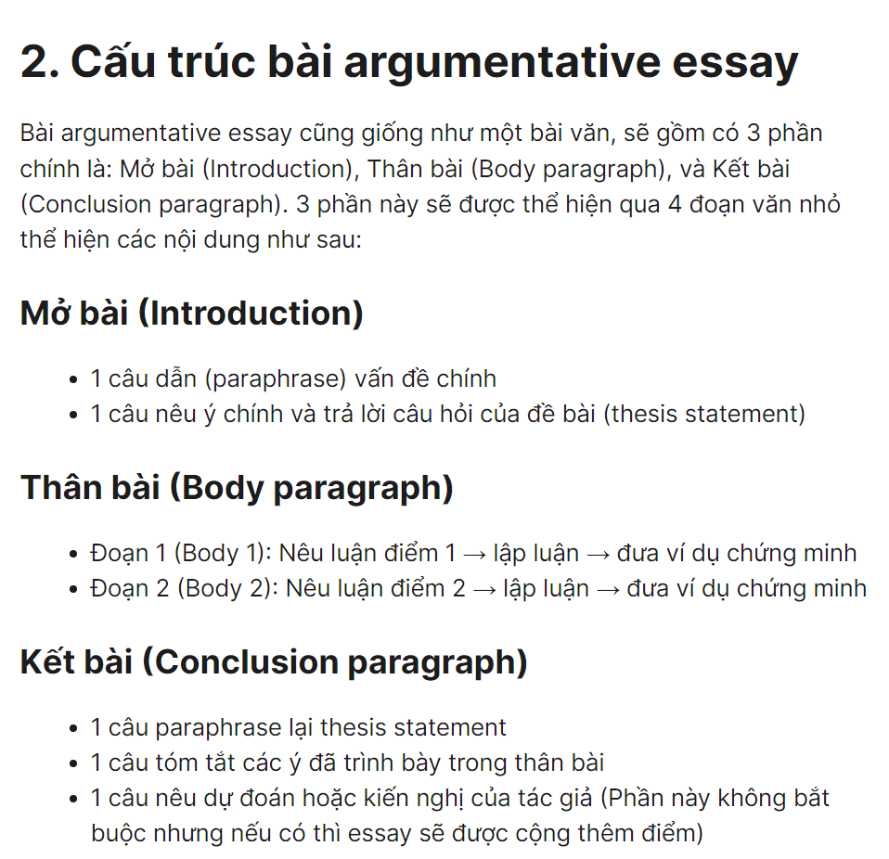

<https://ieltstolinh.vn/ielts-writing-huong-dan-cach-viet-argumentative-essay>

+ Compare and contrast

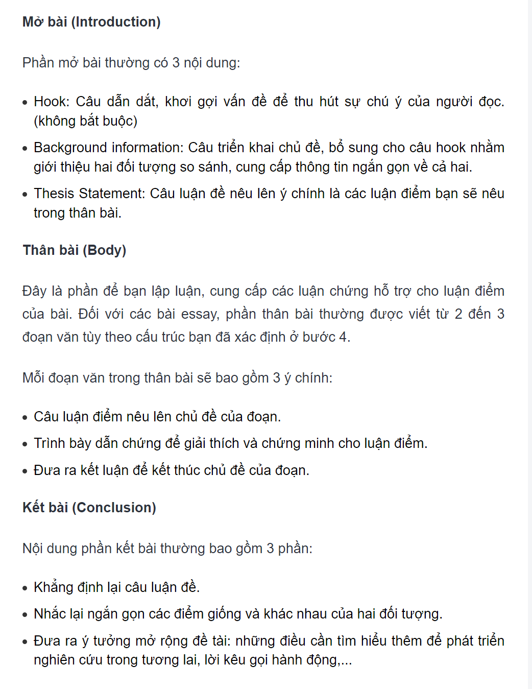

<https://trithuccongdong.net/tai-lieu-essay/cach-viet-compare-and-contrast-essay.html>

+ Problem and solution

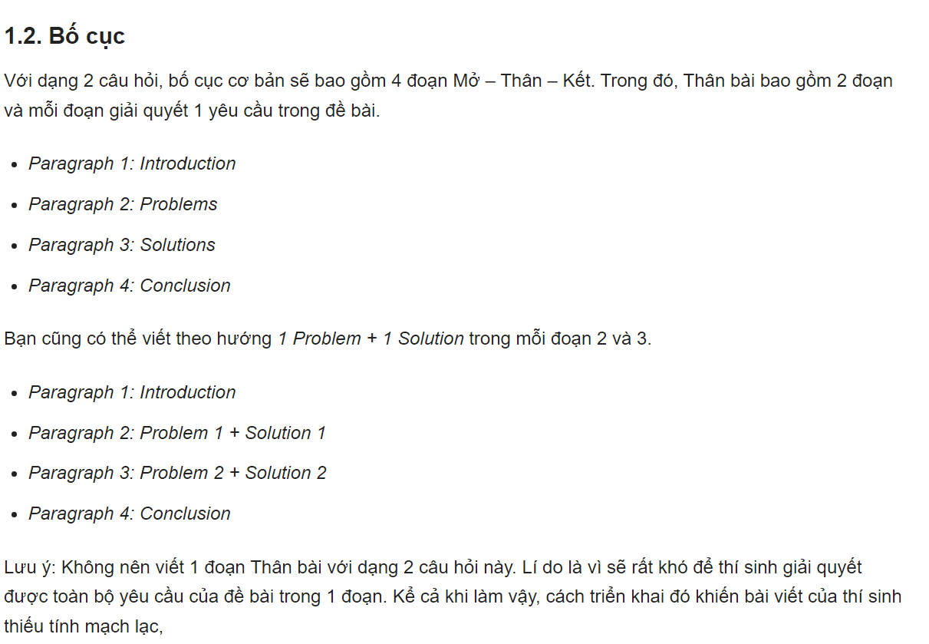

<https://onthiielts.com.vn/luyen-thi-ielts/luyen-thi-ielts-writing/problems-and-solutions-task-2-html.html>

**Task2: 25 minutes**

Read the modal argumentative essay. Then answer the question below

**Compulsory First-year Academic Writing Courses**

**[1]** Students succeed in higher education for many reasons, ranging from having good organizational skills to understanding knowledge in different subject areas**. [2]** One skill that is central to success is academic writing**. [3]** In many courses, most assessment of students is through writing, for example. In essay assignments or examinations. **[4]** There is a long tradition, particularly in North American universities, of students taking academic writing courses, or compulsory courses, during their first year of study. **[5]** Some institutions require all students to take such courses; in others, the requirement is only for international students or for students who speak English as an additional language (EAL). **[6]** The question of whether all students should take such courses, rather than only international or EAL students, will be discussed in this essay, focusing on two key themes: equality of learning opportunity and cost. **[7]** It will be argued that first-year writing classes provide essential skills for students built that a “one-size-fits-all” approach is unworkable.

**[8]** All higher education institutions should provide equal learning opportunities for all their students, regardless of linguistic back or visa status. **[9]** In this sense, it could be argued that requiring only international or EAL students to take certain courses discriminates against them, suggesting that some students are not equal and lack legitimacy compared to others (Flowerdew, 2000). **[10]** However, it should be recognized that the playing field is not equal**. [11]** The demands of university writing are great, and many domestic students whose first language is English are at a significant advantage. **[12]** Granted, academic language is a new language for all first year students (Bourdieu & Passeron, 1994), and many do need to take an extra class that teaches them academic writing. **[13]** This raises the question, therefore. Whether it would not be wiser to focus limited resources exclusively on those who most need support: international and EAL students. **[14]** Considering the concept of equal learning opportunity, I would argue that all students should have the same opportunity of experience in higher education, either all students should be required to take first year writing courses, or no students should have to do so.

**[15]** Another important factor to consider is cost. **[16]** In other words, who should pay for providing courses to all first-year students? **[17]** Those who support making first-year academic writing courses obligatory for all students might argue that the cost can be included in students regular tuition fees, thus avoiding extra fees. **[18]** Other arguments would be to raise tuition fees to cover the costs, extend the number of credits required for graduation (so that an extra course can be added), or reduce some of the credits for courses across the disciplines so that they can be allocated to an academic writing course. **[19]** Nonetheless, those who oppose an obligatory-for-all approach would counter that all options would involve passing costs on to students, many of whom already struggle to meet the financial burden of higher education. **[20]** Moreover, if we bear in mind that many institutions charge international students triple or even quadruple tuition compared to domestic students (Marshal & Walsh Marr, 2018), the idea of increasing financial burden becomes even more unacceptable. **[21]** With regard to the cost of compulsory courses, I would first argue that policies in higher education should never be driven solely by financial considerations. **[22]** Admittedly, cost is an unavoidable factor in any decision: however, issues such as fairness, equality, and learning are far more important

**[23]** The question of whether first-year academic writing courses should be compulsory for all students, not just international students or EAL students, has been discussed above, focusing on two perspectives: equality of learning opportunity and cost. **[24]** A theme that has run through the discussions is fairness. **[25]** Is it fair to treat students differently based on their language backgrounds or visa status? **[26]** Is it fair, in the name of equality, to require students to take courses that they may not require? **[27]** And is it fair to add more cost to already expensive tuition fees? **[28]** The answer to each of these questions is no. **[29]** Consequently, educators need to rethink how academic writing is taught, and to whom, in higher education. **[30]** a compulsory first year academic writing program for all students is not the answer**. [31]** Instead courses that focus specifically on academic should be made available to all but should not be compulsory**. [32]** Those who choose to take optional academic writing courses should accept that they need to meet the additional costs that come with providing such courses**. [33]** At the same, institutions should develop more writing across-the-curriculum initiatives (McCarthy, 1987) so that all students can improve their knowledge and ability to write in the different subject areas they may choose to specialize in**. [34]** This would provide a solution that is as fair as possible, fairness and equality being tow goals that all higher education institutions should constantly pursue.

References

Bourdieu P.. & Passeron.J.C.(1994) Introduction: Language and the relationship to language in the teaching situation In P.Bourdieu. J.C.Passeron. & M. de Saint Martin (Eds. ) Academic discourse (pp 1-34). Cambridge: Polity Press

Flowerdew. J. (2000). Discourse community. Legitimate peripheral participation. And the nonnative-English-speaking scholar. TESOL Qiarterly. 34(1). <https://doi.org/10.2307/3588099>

Marshall. S. & Walsh Marr. J. (2018) Teaching multilingual learners in Canadian writing-intensive classrooms: Pedagogy , binaries and conflicting identities Journal of Second Language Writing 40. 32-43.

<https://doi.org/10.1016/j.jshw2018.01.002>

McCarthy. L. P. (1987). A stranger in strange lands: A college student writing across the curriculum. Research in the Teaching of English 233.265

1. Which of the following statements are **correct**? Tick 3 correct answers.
2. The essay follows a thematic structure (?)
3. The essay follows a for-then-against structure

GIỚI THIỆU (nêu chủ đề cùng với tình hình hiện tại của nó mà không đưa ra quan điểm của người viết)

THÂN HÌNH:

Đoạn 1: (Lập luận ủng hộ- cùng với lý do, ví dụ, sự kiện, v.v.)

Đoạn 2: (Lập luận phản đối- cùng với lý do, ví dụ, sự kiện, v.v.)

.

.

KẾT LUẬN (trực tiếp/gián tiếp nêu quan điểm của người viết và đưa ra quan điểm cân bằng về chủ đề)

1. The introduction shifts from general to specific
2. The conclusion shifts from general to specific
3. The conclusion shifts from specific to general
4. Paragraph 3: **Match the sentence, or pair of sentences**. To the corresponding function

Sentences 19-20: __________

1. The writer’s opinion on the theme of the paragraph
2. Topic sentence
3. Arguments supporters would present
4. Arguments opponents would present
5. Paragraph 2: **Match the sentence to the corresponding function**

Sentence 12: ________

1. Concession sentence

(câu nhượng bộ)

Một mệnh đề nhượng bộ là một mệnh đề bắt đầu bằng “although” hay “even though” và có nội dung trái ngược với thành phần chính của câu

1. Topic sentence
2. The writer’s opinion on the theme of the paragraph
3. Argument against having separate courses for different groups of students
4. Paragraph 4: Match the **sentence or group of sentences** to the corresponding function

Sentence 23:__________

1. Closing position
2. Synthesize (highlight a key theme that has run through the discussion)
3. General final statement
4. Summarize
5. Paragraph 4: Match the sentence or group of sentences to the corresponding function

(?)

1. Paragraph 3: **Match the sentence or pair of sentences**. To the corresponding function

Sentences 21-22: ________

1. The writer’s opinion on the theme of the paragraph
2. Arguments supporters would present
3. Arguments opponents would present
4. Topic sentence
5. Paragraph 3**: Match the sentence or pair of sentences**. To the corresponding function

Sentences 17-18: _________

1. Arguments opponents would present
2. Arguments supporters would present
3. Topic sentence
4. The writer’s opinion on the theme of the paragraph
5. Paragraph 4**: Match the sentence or group of sentences** to the corresponding function

Sentences 29-32: _______

1. General final statement
2. Synthesize (highlight a key theme that has run through the discussion)
3. Closing position
4. Summarize
5. Paragraph 4: **Match the sentence or group of sentences** to the corresponding function

Sentences 24-27: ________

1. Synthesize (highlight a key theme that has run through the discussion)
2. Summarize
3. Closing position (?)
4. General final statement
5. Paragraph 3**: Match the sentence or pair of sentences**. To the corresponding function

Sentence 15: ________

1. Arguments supporters would present
2. Topic sentence
3. Arguments opponents would present
4. The writer’s opinion on the theme of the paragraph
5. Paragraph 2: **Match the sentence to the corresponding function**

Sentence 8: ________

1. The writer’s opinion on the theme of the paragraph
2. Concession sentence
3. Topic sentence
4. Argument against having separate courses for different group of students
5. Paragraph 2: **Match the sentence to the corresponding function**

Sentence 9: _______

1. The writer’s opinion on the theme of the paragraph
2. Concession sentence
3. Topic sentence
4. Argument against having separate courses for different groups of students
5. Paragraph 2: **Match the sentence to the corresponding function**

Sentence 14: ________

1. Topic sentence
2. The writer’s opinion on the theme of the paragraph
3. Concession sentence
4. Argument against having separate courses for different groups of students

NOTE :

Closing position: là gì ?

Làm sao để phân biệt được

Summarize và general

Thematic structure : là gì ?

Writing: Write an argumentative essay of 350-400 words on the following question: Should first-year academic writing courses be compulsory for all students – not just for international students or those whose first language is not English? In your essay, consider both sides of the argument, and state your own position clearly

1. Argumentative :

Lợi ích : Tăng khả năng tư duy, khả năng lập luận, khả năng viết…

* Introduction
* Balanced :

To a certain extent, I agree that the first-year academic writing courses be compulsory for all students – not just international students or those whose first language is not Language. However, I also believe that first-year academic writing courses be compulsory for all students will affect the ability to acquire and improve knowledge in the learning process

* Agree:

People have different views about what the main purpose of school should be ability and quality of training for all students are guaranteed. Personally, I agree that first-year academic writing courses will help students ability to acquire and imporve knowledge in the learning process

* Disagree:

Many people argue that the main purpose of first-year academic writing courses is to prepare students for their studies and future jobs. However, I believe that the ability to acquire first-year academic writing courses will affect not good the ability to acquire and improve knowledge in the learning process and it will be missing other important skills

* Body
* Balanced:

On the one hand, first-year academic writing courses will help students thinking abilities. One example of an activity is when students write a report or argue a text, the ability to write will help them avoid basic mistakes and the argument in the report will be more rigorous. I remember that in my freshman year of college when I didn't have enough writing knowledge when I did a report for my teacher, I made a lot of spelling mistakes, and wrong sentence structure, and when the teacher looked at it, the teacher could not understand what I wanted to convey and was deducted points. Academic writing courses will help students increase their ability to find authentic information. In my opinion, first-year academic writing courses will help students a lot in the learning process and prepare them for future knowledge.

On the other hand, learning first-year academic writing will adversely affect the ability to acquire and improve knowledge in the learning process, and will also lack other important skills. For example, students taking writing courses will spend a lot of time honing their writing skills and improving their reasoning skills. In my case, after focusing only on learning writing, I won't be able to learn other important skills: reading comprehension, speaking, and listening. Other uncultivated skills will affect my ability to acquire knowledge in my own learning process, which will affect my future results. I believe that studying academic writing will affect students' academic performance if the study time is not allocated appropriately.

* Agree:

On the other hand, when students learn writing skills from the first year, their writing skills will be cultivated over the years, from which students will have a foundation in writing skills. For example, after studying at universities in the 3rd year, students will take the internship exam, where the writing ability will help students in CV writing. After being recruited into the company, the ability to rewrite was effectively used in preparing reports to communicate with colleagues by email. The better the student's writing skills, the more responsibilities are assigned. From there, students will have many opportunities for career advancement. I believe that taking academic writing courses will be of great help to future students and their career advancement.

* Disagree:
* Conclusion
* **Balanced:**

In conclusion, forcing all first-year students to take academic writing courses is useful for students in the learning process and for the future. But students need to management a reasonable time to balance subjects and other skills, otherwise it will affect their learning results later.

* **Agree:**

In conclusion, forcing all first-year students to take academic writing courses is helpful for students in their studies and for the future. That will help students perfect all the skills that they lack, and in the future will have more opportunities in the process of studying and working.

* **Disagree:**

In conclusion, forcing all first-year students to take academic writing courses is will make all students feel dissatisfied and unnecessary. It will waste students' time to learn other soft skills. If that happens over time, it will reduce the ability to acquire specialized academic knowledge.

**Task2: 25 minutes**

Read the modal argumentative essay. Then answer the question below

**Pixels and Print: Effects of the Digital Age on Children’s Literature**

[1] The impact of the Internet technology on children today is unavoidable: children are increasingly immersed in the digital world through a variety of media. One of my cousins, a happy eighteen-year-old living with Down syndrome, carries her Leap Frog Pad everywhere she goes. When she first received the Leap Pad, she had been reading well below her grade level and hated how difficult it was for her to get through a book. The Leap Pad provided my cousin with an opportunity to see interactions with print as fun, exciting, and relevant: just as she loved watching her DVDs and playing computer games, she grew to enjoy her interactive storybooks. My cousin is only one of millions of children affected by the growth of the digital age in children’s literature. The development of the digital environment, including interactive books, praphics, websites, games, movies, and television, has dramatically expanded the realm of children’s literature and has influenced the way that children interact with reading and language.

[2] Studies of the technology movement in children’s literature began at the birth of the Internet and continue as technology becomes more and more applicable to different formats in children’s literature. At the turn of the twenty-first century. Theory Into Practice magazine published a series of articles entitled Expanding the Worlds of Children’s Literature. In one article, children’s literature critic and technology analyst Eliza Dresang wrote about a way of thinking she titled Radical Change, a “theoretical construct [that] identifies and explains books with characteristics reflecting the types of interactivity, connectivity, and access that permeate our emerging digital society” (Dresang). While children are still interpreting information through language, they are approaching these new texts with an expectation of connections and meaning that is much different from linear, traditional texts. Dresang explores such text as David Macaulay’s Black and White and The Stinky Cheese Man by Jon Sciezka, book that exemplify the interconnectivity of perspectives, olots, and meaning. Black and White is a four-paneled picture book that uses pictures and text to tell four stories with unlimited connections. The Stinky Cheese Man is a collection of scrutinizing challgenges to classic fairy tales that requires the reader to have an understanding of the orginal tales, of story structure, and of comedy. According to Dresang, the way in which children interact with text and meaning has also shifted with the literature they read: “They are interactively and freely organizing information and making their own connections, not from left to right, not from beginnig to end, not in the traditional straight line, but in any order they choose”(Dresang). Children have begun to own their reading, looking actively for meaning in places and frameworks that did not exist before the digital age.

[3] The format of the classic children’s picture book has also been challenged as a result of technology. The children’s sections of modern bookstores are filled with more than bright colors and graphics: stores sell interactive book, books with characters from TV shows, protable audio books, books that come with stuffed animals, and books that talk back to the reader. In 1999, historian Gloria Skuzynski described the birth of a new kind of book, the protable electronic book that has “screens rather than pages” (Skuzynski, 1999, 179). She writes, “They are easier to read than a laptop screen… and they advance one page at a time with a button push rather than by scrolling”. Certainly a technological leap at the time, these portable books paved the way for other “book” formats to emerge. Eight year later, children are clamoring for their Leapsters and Leap Pads, their books with interactive CD-roms attached, and books downloadable to their PSP or Nintendo DS. One educator compiled a list of technology tools that includes websites like BooksJust4Me and StoryPlace: The Children’s Digital Library, which make it easy for children and parents to enjoy a children’s story without physically turning the pages (Edyburn). The BookBox website, which guarantees “Education and Fun”, allows parents to download e-Books in a variety of languages at reasonable prices (Edyburn). Even Scholastic Inc, and other publishing companies have sections of their websites dedicated to interactive games with students’ favorite storybook characters (Edyburn).

[4] One format in particular has librarians and bookstores rushing to fill the shelves: the graphic novel Bickers asserting that publishing companies are taking what the students want to heart, writes, “Graphix [a division of Scholastic Inc] is arguably the first imprint dedicated exclusively to graphic novels for kids, but it is certainly no longer the only one”, Publisher realize that putting words and pictures in a format that draws the reader through a story as if he was watching TV or a movie is effective way to encourage students to read: graphic novels are now being used to retell classic literature like Beowulf or Oliver Twist as well as popular series like Babysitter’s Club and the Hardy Boy (Bickers). The Magic School Bus series by Joanna Cole, a favorite among both teachers and students, fills pages of scientific learning with speech bubbles, post-its, and compelling illustrations. While not technically a comiec-style graphic novel, there is very little white space in a Magic School Bus book, and that’s the way kids like it (Bickers). In addition, the Bone comic book series by Jeff Smith, published into graphic novels for kids, is one of the most popular items in bookstores, libraries, and book fairs across the country (Bickers).

[5] There is no denying that digital interpretations of children’s literature are being encouraged in a variety of places and media, but the effects of this digital hurricane are under the gun in research around the world. One research project proposed that preschoolers would benefit from digital read-alouds as opposed to the traditional print read-aloud. Not surprisingly, the project produced favorable results. Researcher L.Collen summarizes her interpretation of one of the project’s results: “That children in the traditional storytimes asked no picture-based questions and children in both digital storytime dis ask picture-base questions suggests that.. the digital storytimes may have resulted in an enhanced understanding of the story, based on an enhanced visual experince” (Collen). In imagining a class of preschoolers in front of a large screen, one does not need to ponder long on how enthralled the students would be with the enlarged graphics. After all, many preschool-aged childre have already been exposed to television and other media. The question remains whether the students were asking questions because they noticed more, or whether the traditional read-aloud format did not adequately encourage these kinds of questions.

[6] Continued research and reflection will be necessary if teachers, parents, abd society at large wish to determine whether the immersion in digital media that in occurring in schools and homes acroos the country-and the world-is benefiting our youth. Undoubtedly, the world is becoming more inter-connected with the evolution of the Internet and an exponential increase in communication. Children are clamoring for texts that are graphically appealing and have an element of technology, whether it is a website they can visit, a game they can buy, or an attched CD-rom. Books themselves are changing both in format and in content to meet the increasing demand for interconnectivity, and children are changing as they interact with text in multi-directional, multi-media ways.

Works Cites

1. **In paragraph [4], the author talks about graphic novels _______**
2. To introduce a new book format
3. To argue
4. To provide supporting details
5. To show how popular they are
6. **What is the argument of this essay?**
7. Digital age has negatively influence the way kids interact with reading and language
8. Digital age has changed children
9. Digital age has affected the way kids interact with reading and language
10. Digital age hasn’t affected the way kids interact with reading and language
11. **In paragraph [4], is the refernce Bickers correctly cited according to the MLA style?**

Bickers, asserting that publishing companies are talking what the students want to heart, writes, “Graphix [a division of Scholastic Inc] us arguably the first imprint dedicated exclusively to graphic novels for kids, but it is certainly no longer the only one”

1. No. Both first name and last name of the author must be provided in the attribution, and a citation at the end of the sentence must be provided
2. Yes. It is correctly cited
3. **In paragraph [3], how to correct the citation at the end of the sentence following the MLA style?**

In 1999, historian Gloria Skuzynski described the birth of a new kind of book, the portable electronic book that has “screens rather than pages” (Skuzynskim 1999, 179)

1. Remove the page number and the year
2. Remove the author’s name but keep the year and page number
3. Add the author’s first name
4. **In paragraph [5], is the author referenced in the following sentence correctly cited according to the MLA style ?**

Researcher L.Collen summarizes her interpretation of one of the project’s results: ….

1. No. The author’s first name’s intial should be removed
2. No. The author’s first name must be written in full
3. **What can be said about the Works Cites list?**
4. All of the sources are correctly formatted following the MLA sytle
5. None of the sources are correctly formatted following the MLA style
6. Some of the references are correctly cited following the MLA style
7. **In paragraph [2], the writer references the children’s literature critic and technology analyst Eliza Dresang _______**
8. To provide evidence to support the thesis statement
9. To give credit to the source
10. To report research findings
11. To present the researcher’s research on digital age
12. **In paragraph [3], the topic sentence is _____________**
13. The first sentence of this paragraph
14. The last sentence of this paragrah
15. **In paragraph [5], it can be inferred that _________**
16. Research in digital media has been conclusive
17. More research in digital media is necessay
18. **In paragraph [6], the writer ______**
19. Summarises the main points and reiterates the argument
20. Summarises the main points
21. Summarises the main points, reiterates the argument, and adds a final thought