

ADDITION OF METEOROLOGICAL INFORMATION TO
GNSS DATA PROCESSING SOFTWARE
(Master of Science Degree Thesis in Geoinformatics Engineering)

BY
FELIX ENYIMAH TOFFAH

Student Id:  Advisor:  Co-Advisor:  Academic Year: | 936545  Professor Giovanna Venuti  Andrea Gatti  2020/2021

DEDICATION
I dedicate this work to my parents Mr Kobina Ebo Toffah and Miss, Aba Abokomah.

“Have I not commanded you? Be strong and courageous. Do not be afraid; do not be discouraged, for the Lord your God will be with you wherever you go.”
(Joshua 1:9, NIV)

ACKNOWLEDGEMENT
I would first of all like to thank God for sustaining me throughout this journey of pursuing a Laurea Magsitrale in Italy. I am also very grateful to my supervisor, Professor Giovanna Venuti for the opportunity given me to do the work and her patience with me. I am also thankful to my Co-Supervisor for his guidance in doing the work. I am also thankful to my admirer and someone whose life I would like to emulate, Professor Ludovico Biagi. I also thank my family and friends for always being there for me. I am forever grateful to you all.

ABSTRACT

Key-words: goGPS, weather information, GNSS, atmophsere.

SOMMARIO

Parole chiave: goGPS, weather information, GNSS, atmophsere.

TABLE OF CONTENTS
DEDICATION i
ACKNOWLEDGEMENT iii
ABSTRACT v
SOMMARIO vii
TABLE OF CONTENTS ix
LIST OF FIGURES xiii
LIST OF TABLES xiv
CHAPTER 1 1
INTRODUCTION 1
1.1 Background information and statement of problem 1
1.2 Objective 5
1.3 Expected Output 6
1.4 Technologies to be Used 7
1.5 Thesis Structure 7
CHAPTER 2 9
ATMOSPHERE 9
2.1 Composition and structure of the atmosphere 9
2.2 Atmospheric Humidity 12
2.2.1 Hydrologic cycle 12
2.2.2 Humidity of the air 13
2.2.3 Variation of humidity on the surface of the Earth 14
2.2.4 Measuring airs humidity 15
2.3 Atmospheric pressure 15
2.4 Atmospheric temperature 16
2.4.1 Measurement of atmospheric temperature 17
2.5 Clouds, categories, formation and processes 18
2.5.1 Categories of Clouds 19
28
CHAPTER 3 29
INTERACTION OF ATMOSPHERE WITH GNSS SIGNALS 29
3.1 Delay on GNSS Signals 29
3.1.1 Ionospheric Delay 30
3.1.2 Tropospheric Delay 31
3.2 Modelling tropospheric delay 32
3.3 Atmospheric delay mapping functions 37
CHAPTER 4 39
goGPS, SOFTWARE DEVELOPMENT 39
4.1 goGPS 39
4.2 Graphical Objects in MATLAB 40
4.2.1 Graphical Objects 40
4.2.2 Accessing Properties of MATLAB Graphical Objects 44
4.2.3 Dealing With Images in MATLAB 45

LIST OF FIGURES
Figure 1 Radiosondes (source: Japan Meteorological Agency) 1
Figure 2 Current graphical outputs of goGPS 4
Figure 3 goGPS plot of estimated ZWD 5
Figure 4 Expected output of the visualisation tool 6
Figure 5 Expected menu item and its sub-items 6
Figure 6 Variation of temperature with height of atmosphere 11
Figure 7 Hydrologic cycle 13
Figure 8 Cirrus 21
Figure 9 Cirrocumulus 22
Figure 10 Cirrostratus 22
Figure 11 Altocumulus 23
Figure 12 Altocumulus 24
Figure 13 Nimbostratus 24
Figure 14 Stratocumulus 25
Figure 15 Stratus 25
Figure 16 Cumulus 26
Figure 17 Cumulonimbus 27
Figure 18 GNSS Systems that Operating on a Global Scale 30
Figure 19 Variation of Ionospheric Effect (Global Map) 31
Figure 20 goGPS logo Figure 21 MATLAB logo 39
Figure 22 goGPS Interface 40
Figure 23 Hierarchy of graphical objects in MATLAB 42
Figure 24 Descendants of a figure object 43

LIST OF TABLES
Table 1 Classification of Clouds 19
Table 2 Categories of Clouds 20
Table 3 Graphical Object Functions 43

INTRODUCTION

Background information and statement of problem
The amount of water vapour in the atmosphere varies considerably over an area and across the globe. The water vapour and the interaction of the various elements of the atmosphere with electromagnetic radiations, such as solar radiation, play a major role in the changing state of the atmosphere and its dependent parameters such as pressure, temperature and humidity.
Several instruments are available for measuring atmospheric parameters. These instruments operate on land (such as thermometer, wind vane and barometer at Meteorological stations), on sea (such as acoustic depth sounder and marine sounding probes) and in the air (such as artificial satellites, Meteorological aircrafts, aerosondes and radiosondes). Data collected by instruments that operate in the air medium are very helpful as most parameters that influence the changing state of the atmosphere are found there. Among these, radiosondes (Figure 1) are commonly used to measure various atmospheric parameters including water vapour, pressure, and temperature. However, the cost of acquiring a radiosonde and establishing a radiosonde ground monitoring station makes it difficult to increase the spatial extent of a radiosonde network (Flores et al., 2013).
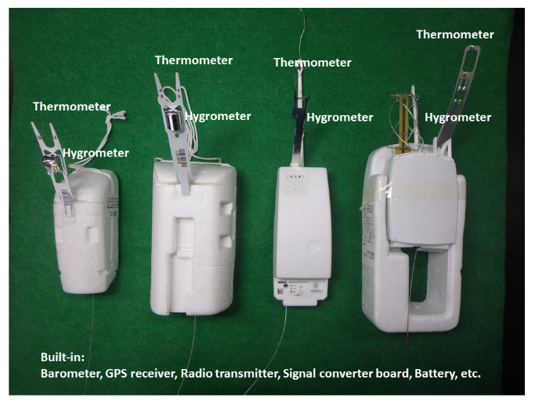
Figure 1 Radiosondes (source: Japan Meteorological Agency)

Although they do not physically operate in the air, Global Navigation Satellite System (GNSS) measure space vehicle emitted signals that travel through and interact with the components of the atmosphere. The GNSS system is composed of space vehicles that operate in the skies, a control segment that monitors the space vehicles and user receivers that observe the signals emitted by the space vehicles for various purposes and applications.
The use of GNSS for positioning and other scientific purposes has been widely explored and has undergone technological advancements. Accurate positioning has been possible through appropriate modelling of the atmospheric interaction of the satellite signals which is subdivided into ionospheric and tropospheric components.
The ionospheric delays are caused by the interaction of free electrons in the ionosphere (about 100 and 1000 km altitude) with the satellite signal. These delays can be removed by a proper combination of the observations on the L1 (1575.42 MHz) and L2 (1227.60 MHz) frequencies made by double frequency receivers. For single frequency receivers, standard models (such as Klobuchar ionospheric model) exist for evaluating and removing this effect from the signal observations.
The tropospheric delay is partly caused by the presence of water vapour in the troposphere (0 to 40 km above the Earth Surface). This delay affects all the signals received by the GNSS station from all the satellites simultaneously in view at the time of observation. In standard processing of GNSS observations, the delays on the signal path from all the satellites in view are mapped in a common delay in the zenith direction above the receiver. This delay known as the Zenith Tropospheric (or Total) Delay (ZTD) can be modelled using for instance the Saastamoinen model. The ZTD is the sum of the delay caused by the water vapour (Zenith Wet Delay, ZWD) and the delay caused by the dry gases of the troposphere in hydrostatic equilibrium (Zenith Hydrostatic Delay, ZHD). If temperature and pressure values are known at the time of observation, it is possible to exploit them to compute the ZHD components of the delay and to derive the wet components. The later can be used to monitor the presence of water vapour in the atmosphere. Both ZTDs and ZWDs can then be assimilated into numerical weather prediction models to enhance the prediction of heavy rains. The varying state of the atmospheric water vapour and its impact on the space vehicle signals make GNSS an innovative approach for measuring atmospheric water vapour contents.
In most cases, monitoring of atmospheric water vapour content using GNSS approach are made using a network of stations that are far apart. Due to the temporal and spatial variability of the water vapour content of the atmosphere, a more localised observation of GNSS derived ZTD will give more accurate results in monitoring localised events such as convective storms. Just like radiosondes, a densified network of geodetic GNSS receivers for monitoring purposes has high costs of setup. Moreover, the risk of damages and losses can be discouraging. A monitoring system based on low-cost GNSS receivers represents a possible solution. As a justification for using these receivers, Biagi et al. (2016), achieved sub-cm accuracy levels when they used low-cost GNSS receivers for monitoring displacements and deformations. Also, Fermi et. al (2018) found that data from single frequency GNSS receivers (of which class belongs low-cost receivers) could provide more accurate results in estimating ZWD parameter for Meteorological purposes. In this light, many observation stations using GNSS satellite signals as an aid for meteorological purposes also use low-cost receivers.
One software that can be used for post-processing GNSS observations is goGPS (see Chapter 4 for detailed description of the performance of goGPS). By making a plot of the processing results, goGPS produces, among others, plots of estimated amount of precipitable water vapour in the atmosphere (see Chapter 3 for further discussions) at an observation station (Figure 2).
However, while making estimates of the amount of precipitable water vapour and monitoring the position coordinates and ZTD data of a GNSS station, it might be useful to know the state of the atmosphere such as the variability of temperature and pressure to better understand the impact of the atmosphere on the time variation of the ZTD and position coordinates. This is very essential as the observation station is exposed to the atmosphere and the observed signals traverse the atmosphere from the space vehicle to the receivers. Some events such as earthquake, tsunami and flood can significantly affect the estimated GNSS observations. Also, these events are useful for interpreting the GNSS estimates.
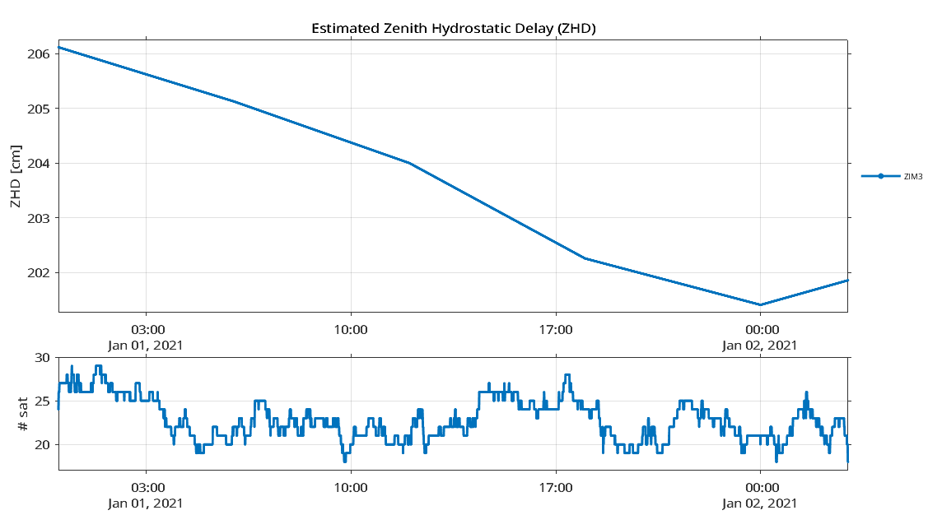
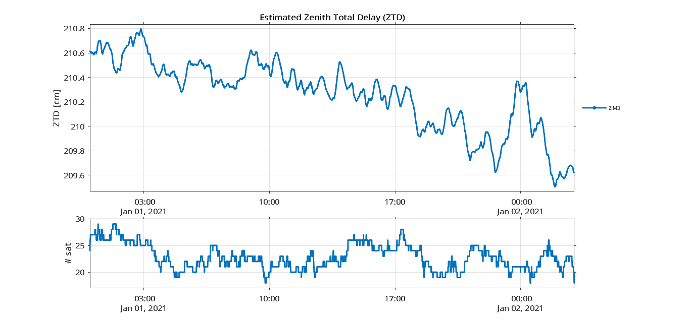

Figure 2 Current graphical outputs of goGPS

Knowing these meteorological events and conditions will help better understand the analyse the plots of the processing result.
In most cases, while analysis the trend of weather parameters such as temperature, pressure and water vapour contents of a station, independent plots are produced for each variable under consideration and the relation between the variables made by comparing the trends in the different plots. On the other hand, it will also be useful to produce a single plot that contains all those variables. This will be time saving and make it easier for comaprisons to be made between the different variables.
The current interface of plots produced by goGPS is as in Figure 3. It includes the standard menu items (File, Edit, View, etc.) found in a figure object in Matlab, additional Export menu item for exporting the plots for other purposes and the Aspect menu item for changing the background colour of the figure object. It also contains axes objects that show time series of the number of satellites and other parameters such as ZWD, ZHD and ZTD according to which variable is being plotted.
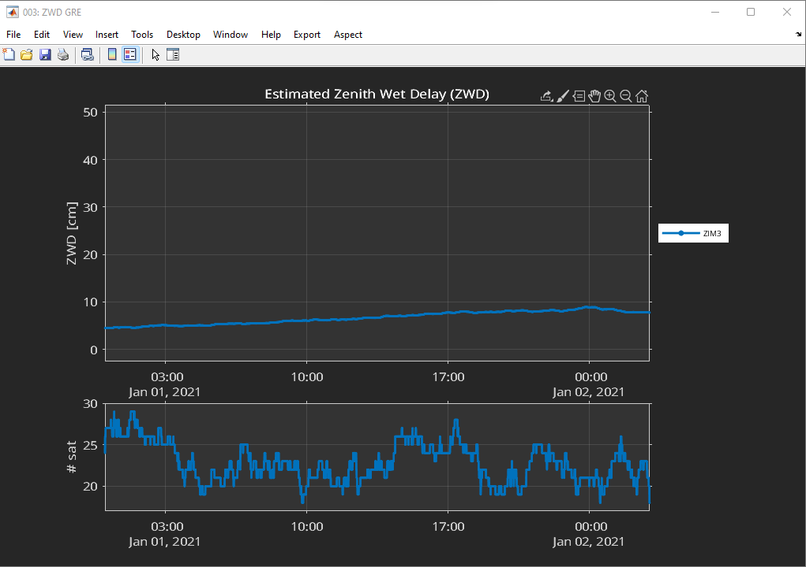
Figure 3 goGPS plot of estimated ZWD

Objective
The objective of this work is to develop a visualisation tool that displays weather parameters such as humidity, temperature and pressure as a component of the goGPS software. The displayed information will help better interpret the plots produced by goGPS. The tool will extract weather data from a source and display them on goGPS plots. As an illustration of its usage, time series of GNSS position estimates will be analysed and interpreted using the added information. As an additional feature, a component will be developed for the export of the extracted weather data in a format that could be used for other purposes.

Expected Output
To achieve the set objective, the visualistion tool (Figure 4) has to be displayed on a plot produced by goGPS software. From the figure, the line plots are the existing plots produced by goGPS software. The extracted data are displayed as rows containing the identifier and values for the parameter. The icons symbolise the weather condition (such as rain, snow, clear weather, etc.) for data for less than 30 hours. For data of more than 30 hours, patches are instead shown coloured with different face colours and interpreted using the legend on the lower left. However, the axes labels and titles are the same as the ones shown in the goGPS plot. Also, the tool has to be accessed using a menu item with submenu items as shown in Figure 5.
Figure 4 Expected output of the visualisation tool

Figure 5 Expected menu item and its sub-items

Technologies to be Used
- goGPS and MATLAB for the implementation of the tool
- Figma for getting the weather icons and Adobe Photoshop for their redesign
- Microsoft Office (Word, Excel, PowerPoint) for preparation of the reports
- GitHub for the deployment of the developed tool

Thesis Structure
The organisation of the thesis is carried out as follows.
The first chapter discussed the variability of atmospheric water vapour and the possibility to estimate its amount using GNSS techniques. It also introduces goGPS as a software that can be used to process observed GNSS data and produce plots for analysis. Also, the objectives and expected results for this work are presented.
The second chapter gives an overview of atmospheric dynamics and phenomena. These are very useful to better understand some atmospheric dynamics and state that are purposed to be displayed on the goGPS plots.
The third chapter talks about how the atmosphere interacts with GNSS signals and the two delays effected on the GNSS signals. Also, the derivation of ZWD, ZTD and precipitable water vapour from observed GNSS satellite signals are presented.
The fourth chapter gives a short introduction to goGPS software and Matlab tools that are used for this work.
The fifth chapter gives the procedures that were used for the achievement of the objectives while the sixth chapter gives the results of the work and additional information useful for interpreting information added to the plots.
Finally, the seventh chapter concludes the work and gives recommendations that are useful for future development of this work.

ATMOSPHERE
In this chapter, an overview of the atmosphere is given for knowledge purposes. This will be useful
- to understand characterises of the layers of the atmosphere since the satellite signals traverse these layers. This also gives a fair idea of the components of these layers and how they affect the traversing satellite signals, and
- classes of clouds that produced the various meteorological events needed to be shown on the plots.

Composition and structure of the atmosphere
The atmosphere is the layer of gases that surrounds the Earth, retained by the Earth’s gravity. Up to about 80 km, the atmosphere consists chiefly of nitrogen and oxygen in almost constant proportions forming a layer known as the homosphere. There are also varying amounts of water vapour and carbon dioxide in the layer, which have a significant impact on weather and climate. In proportions, the atmosphere is composed of about 78 percent nitrogen, 21 percent oxygen, 0.9 percent argon, and 0.1 percent other gases which include water vapour, hydrogen, carbon dioxide, ozone, neon, etc.
The atmosphere is classified by composition of gases into the heterosphere and the homosphere, separated by the turbopause. In accordance with the change of temperature above the surface of the Earth, the atmosphere is divided into the exosphere, thermosphere, mesosphere, stratosphere and the troposphere.
The heterosphere has a non-uniform composition of gases, with the heavier molecules lying beneath the lighter ones. It extends from about 80-100 km to the outermost part of the atmosphere. It contains the thermosphere and the exosphere. Beneath the heterosphere is the turbopause, which caps the homosphere beneath. The homosphere is characterised by a uniform mixture of gases.
The exosphere is the outermost layer of the atmosphere that fades into space. Beneath it is the thermosphere, separated by the thermopause.
The thermosphere lies between the thermopause on the upper part and the mesopause on the lower part. It extends from about 85 to between 500 and 1000 km above the surface of the Earth. The solar radiation from the Sun heats up the air molecules in this layer and causes the dissociation of the molecules. This results in the freeing of electrons, creating many charged ions. Thus, the thermosphere contains most of the ionosphere. The layer is also characterised by low density of air molecules which are thoroughly mixed due to the turbulence in the layer.
Beneath the thermosphere is the mesosphere, bounded on the upper layer by the mesopause and on the lower part by the stratopause. The layer extends from about 50 to 80 km above the Earth’s surface. In the mesosphere, the temperature decreases with increasing height as there is less absorption of solar radiation in the region and increasing cooling by CO₂ radiative emissions. The coldest regions of the Earth’s atmosphere are found on the upper section of the mesosphere.
From the surface of the Earth, the stratosphere is the second lower layer, lying above the troposphere and separated from it by the tropopause. The stratopause separates the stratosphere from the mesosphere above. The layer extends from about 12 km to 50 km above the surface of the Earth. The stratosphere is the layer of the Earth’s atmosphere that has a high concentration of ozone gas. These gases absorb much of the solar ultraviolet radiation coming from the Sun, causing an increase in the temperature of the layer with height. This temperature trend creates an atmosphere of stability such that the layers of air are stable, free from the weather phenomena that characterise the troposphere.
Finally, the troposphere is the last layer and the one lying on top of the Earth’s surface. It extends to about 12 km above the surface of the Earth, bounded on the upper part by the tropopause. Radiations from the Sun that reach the surface of the Earth heats up the air molecules in the lower parts of the troposphere, causing a decrease in the temperature of the layer with increasing height. The water bodies on the Earth’s surface (rivers, lakes, seas, etc.) humidify the troposphere through evaporation and thus, much of the water vapour in the atmosphere is located in the troposphere, causing significant changes in the weather conditions in the layer. In the GNSS, the troposphere is very vital as the water vapour in this layer causes a significant delay on the travelling satellite signals.
Figure 6 gives a clear picture of the variation of temperature with height for the various layers of the atmosphere (source: Linacre and Geerts, 1997).
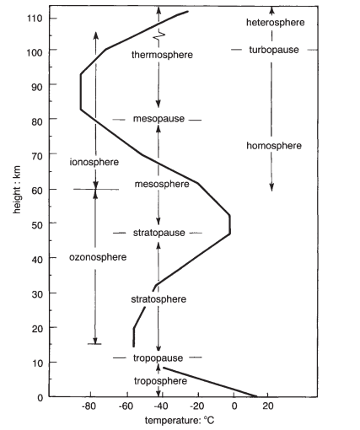
Figure 6 Variation of temperature with height of atmosphere

The atmosphere is essential for life on Earth as it makes available water, CO₂, oxygen and other essential gases for living organisms. It also protects life on the Earth surface by absorbing harmful ultraviolet solar radiations. Conversely, the atmosphere serves as the medium in which most Meteorological phenomena take place. These Meteorological phenomena are usually interrelated and categorised into (Linacre and Geert, 1997)
- those concerning the air’s composition and structure such as air mass,
- those involving the Sun’s energy such as thunderstorm and lightning,
- processes related to the transformations of water from liquid to vapour, cloud, rain and snow, and
- winds such as dust storms.

Atmospheric Humidity

Hydrologic cycle
Water vapour contributes greatly to the changing dynamics of the atmosphere. It is a fundamental variable of study in the hydrologic cycle and in Meteorology. The hydrologic cycle describes the continuous circulation of water between the Earth and the atmosphere.
Solar radiations cause evaporation of water from the surface of the Earth to the atmosphere. This water vapour then condenses into clouds, fog etc. and falls as precipitates or rain to the Earth (land or ocean). The water that falls on the surface of the Earth is transported to the oceans through surface runoff. Some of the rain percolates into the soil and is discharged into the ocean and other water bodies as groundwater. Figure 7 shows the phenomenon of the hydrologic cycle. In this cycle, the atmosphere holds less amount of water vapour, which also has a smaller molecular density compared to the oxygen (32 g/mol) and nitrogen (28 g/mol). Thus, the water vapour exerts less vapour pressure in the air. The atmosphere also holds very little of the world’s water.
Figure 7 Hydrologic cycle

Humidity of the air
The amount of water vapour present in the atmosphere is defined as the humidity. Four indices are usually used for determining humidity are absolute humidity, specific humidity, mixing ratio and relative humidity.
Absolute humidity refers to the mass of water vapour per unit volume of moist air without taking into consideration temperature. The higher the amount of water vapour present, the higher the absolute humidity. It is expressed as grams of water vapour per cubic meter of air. Specific humidity refers to the mass of water vapour per unit mass of dry air and is measured as grams of water vapour per kilogram of dry air. It represents the actual amount of water vapour present in a unit mass of air. Mixing ratio is similar to the specific humidity, the only difference being that it considers mass of moist air instead of dry air. Relative humidity is defined as the ratio of the partial vapour pressure of air to the saturated vapour pressure of the air at a specified temperature. In its simplest terms, it specifies how much of the water holding capacity of the air has been occupied by the water vapour at the specified temperature. At low temperature, the water molecules tend to condense and the water holding capacity of the air decreases. Contrarily, warming the air will cause the water molecules to evaporate and the water holding capacity of the air to increase. Relative humidity is expressed as a percentage and is the variable most commonly used in literature for expressing humidity of the air. It is also the variable being used to describe the humidity of the atmosphere in this work.
As always said, humidity is dependent on temperature. For the same amount of water vapour, the humidity of cold air will be higher than that of warm air. A related parameter for describing the temperature dependence is the dew point. It is the point on a temperature scale to which an air parcel must be cooled to cause saturation. Below the dew point, the air deposits on surfaces as dew or cloud droplets.

Variation of humidity on the surface of the Earth
The amount of water vapour in the atmosphere at any point in time varies from place to place depending on factors such as elevation of an area with respect to the sea level, closeness to a water body, season of year, changes in weather phenomena during the day, latitude of the point of consideration etc.
Across the surface of the Earth, air masses originating from the continental landmasses are usually dry and have low humidity values as compared to those from the oceans, especially during the winter season in which the reduced temperature reduces the saturation vapour pressure of the air. Also, regions of higher latitudes have lower vapour pressure and lower humidity.
In addition, humidity decreases with increasing elevation and height of the atmosphere above the Earth surface. This is because moisture is added to the air mass nearer to the surface, which by convection is lifted upwards. At higher elevation, the temperature of the air reduces, the capacity of the air to hold moisture reduces, decreasing the humidity.
In addition, water vapour content of the atmosphere varies considerably during the day taking into perspective an air layer closer to the land surface. Lower temperatures at night cause condensation of water on cold surfaces and some also absorbed by colder soils. During clear or Sunny days, water vapour evaporates from warm surfaces and increases the moisture content of the air. Sea breeze during the day also adds moisture to the atmosphere. Thus, humidity is higher during the day and lower at night hours. Similarly, the moisture content of land areas closer to water bodies are higher than those of inland.
Generally, wind moves air masses from one place to another. In windy hours, surrounding air is mixed with water vapour evaporating from surfaces, thus reducing the amount of water vapour in the atmosphere.

Measuring airs humidity
Humidity can be measured using several devices such as a psychrometer, electrical sensor and leaf wet sensor. Psychrometers are most commonly used in Meteorological stations. The device consists of wet and dry bulb thermometers. The wet bulb is covered with a moist wick. When air is passed over the wick, it evaporates the moisture, causing the bulb to register a lower temperature than the dry bulb.

Atmospheric pressure
The gravitational force of the Earth pulls the gaseous molecules in the air towards the centre of the Earth. As a result, the gaseous molecules exert an amount of pressure. By measuring the pressure of the atmosphere, it is possible to know how much air there is above the measuring station. A reduction in atmospheric pressure value indicates a loss of air above the column. Atmospheric pressure is usually measured using a barometer made up of a column of mercury in a glass tube.

Atmospheric temperature
The temperature of the atmosphere is one variable whose variation is significantly felt by living beings. It also has predominant impact on the changing scenes of the atmosphere and weather phenomena though pressure, water vapour and wind also have impacts. Solar radiation from the Sun is divided into visible, infra-red, ultraviolet and shorter wavelength radiations. Passing through the atmospheric layers, some of the radiations are absorbed by the molecules contained in the atmosphere. For instance, ozone molecules in the stratosphere absorb the ultraviolet radiations. A minimal amount reaches and warms the Earth surface. Insolation defines the amount of solar radiation that reaches the surface of the Earth. Air masses in the lower troposphere closer to the Earth surface get warmed-up by the radiations reflected from the surfaces, rise to higher heights in the atmosphere, and undergo several transformations resulting in the changing conditions of weather. Approximately all weather phenomena occur in the troposphere due to the heating of the air mass near the surface of the Earth.
Temperature varies at different heights relative to the Earth’s surface as discussed in Section 2.1 and the corresponding profile shown in Figure 6. In the troposphere, where most atmospheric phenomena occur, temperature decreases with increasing height above the Earth surface. This is due to the warming of the air mass near the Earth. Same also applies to higher elevations and mountains. Average temperatures tend to decrease by about 4.2 K per kilometre extra elevation (Linacre and Geerts, 1997).
Water has an especially high heat capacity at 4.18 Jg⁻¹°C⁻¹ while for land, it is usually less than 1 Jg⁻¹°C⁻¹ (Anon., 2022). This means that it takes more heat to warm a gram of water than land. As a result, the ocean responds very slowly to temperature changes than the land. Hence, the land has a higher temperature than the ocean. Thus, air masses over the land surface will be much warmer than air masses over the oceans.
Latitude of a station on the Earth’s surface is also another factor that causes variation in temperature. Around the equator (low latitudes), the solar insolation is higher than the thermal radiation resulting in considerable net heat gain. The polar regions (higher latitude), are characterised by a higher rate of thermal radiation than insolation, hence, more heat losses. These impacts may be nullified by the wind and ocean currents that carry air masses from the areas of higher temperatures to the areas of lower temperature.
The variation of temperature during the 24-hour period of a day is known as diurnal temperature variation. The maximum temperatures usually occur after noon as the air still keeps hold of some of the solar radiations absorbed at noon. The lowest temperatures occur at night, usually after dawn. This occurs as the Earth surface undergoes radiative cooling processes, especially when the night is clear and heat can escape through the atmosphere. The air above however gets warmer than the surface resulting in an inversion of temperature.
In the same way, there are seasonal contrasts in temperature. During summer, the air above land has a higher temperature than the oceans. In winter, the air above oceans gets higher temperature than landmasses.

Measurement of atmospheric temperature
Temperature is usually measured using a thermometer. At a meteorological station, the standard height for the thermometer above the ground has to be between 1.25 and 2 m according to the World Meteorological Organisation and protected with the Stevenson screen. There is no single thermometer measuring the global temperature, however, individual measurements taken every day at several thousand stations over the land areas of the world are combined with thousands more measurements of sea surface temperature taken from ships moving over the oceans to produce an estimate of global average temperature every month (Trenberth et al., 2007). Such is the data source of DarkSKY (see Section 5.3) upon which this work is being carried out.

Clouds, categories, formation and processes
The data source being used for this work, DarSKY classifies the state of the atmosphere in five major groupings: clear, cloudy, rain, sleet and snow. These are formed from clouds as a result of the changing conditions of the atmosphere due to the heating of the Earth surface by the Sun. The ultraviolet radiation of the Sun reaches the Earth’s surface unevenly creating variations in air pressure. Low air pressure causes rising air that is lighter than the surrounding air masses. Rising air makes the water vapour in the air condense and form clouds, leading to rain, thunderstorms and hurricanes. On the other hand, high air pressure causes heavy and sinking air that makes the environment unstable. High air pressure is usually related to clear skies and Sunshine. The condition of the sky at any point in time is determined by the predominance of a state (such as mostly cloudy, overcast, and cloudy) over other conditions of the sky.
Clouds are made up of tiny droplets of water and ice crystals suspended in the atmosphere. Clouds play an essential role in the hydrologic cycle of the planet Earth. They reflect some of the incident solar radiation into space and also absorb infrared radiations reflected from the Earth surface. On the other hand, clouds have a significant impact on the changing weather conditions.
Cloud droplets have a diameter of about 10 – 15 microns (1 micron = 1/1000 mm), each cubic metre of air will contain about 100 million droplets (Anon., 2022) and can remain in liquid form in temperatures of -30°C.
Clouds are generally formed when molecules of water vapour in the air condense into water droplets or ice crystals. It is essential that the air be saturated to a point that it is unable to hold any more water vapour. Also, there has to be availability of cloud condensation nuclei such as dust, clay and soot, to provide a surface on which the water molecules will condense. There are two basic ways in which saturation can be reached (Anon., 2021)
- By increasing the water vapour content of the air to a point such that the air is unable to hold any more water. This can be realised when the Sun heats up the ground, which in turn heats the air in contact with it, causing the air to rise to higher atmospheres.
- By cooling the air to its dew point so that the air is unable to hold any more water vapour, making it favourable for condensation to occur. This cooling is realised
- When a mass of warm air moves over a mass of cold air creating a frontal boundary.
- When the air mixes with colder air
- Through Interaction of the air with mountains or undulated topography of an area
- by nocturnal radiation loss

Categories of Clouds
There are various clouds identified by their shape and other attributes, however only ten are recognised according to the World Meteorological Organisation standards. These 10 basic classes of clouds, also referred to as genera, describe the height where they are formed and their appearances. These classes are listed in Table 1.

Table 1 Classification of Clouds
Cloud Level | Altitude  (Km) | Class According to Shape
High | 6-10 | Cirrus, Cirrocumulus, Cirrostratus
Medium | 3-6 | Altocumulus, Altostratus, Nimbostratus
Low | Less than 3 | Stratocumulus, Stratus, Cumulus
towering vertical | 0.6-6 | Cumulonimbus

These genera are further divided into secondary classes of 14 species, which are further divided into 9 varieties of tertiary classes. The species describe the internal structure of the cloud while the varieties describe the transparency and arrangement of the clouds. These categories are as shown in table 2.

Table 2 Categories of Clouds
Classification | Categories
Species | calvus, capillatus, castellanus, congestus, fibratus, floccus, fractus, humilis, lenticularis, mediocris, nebulosus, spissatus, stratiformis, uncinus
variety | cumulogenitus, duplicatus, intortus, lacunosus, opacus, perlucidus, radiatus, translucidus, undulates, vertebratus,

In the following sections, the primary classification of clouds based on height of formation and its appearance will be discussed.

Cirrus
This is the main type of high cloud occurring in the upper troposphere. They appear as tufts and whitish and sometimes greyish in colour (Figure 8). It is made up chiefly of ice crystals that form because of the low temperatures at the top of the troposphere. On falling, these ice crystals evaporate on warmer layers and usually do not fall to the ground. They also give precipitation when they join together and form thicker components. They can be an indication of rain.
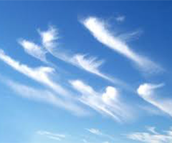
Figure 8 Cirrus

Cirrocumulus
Cirrocumulus (Figure 9) is a layer of cloud made up of small elements in the form of ripples that form as a result of the transformation of cirrus and cirrostratus. They are whitish but sometimes appear greyish. They are smaller than the width of the littlest finger when one holds up the hand at arm’s length. It consists, chiefly, of water vapour. Cirrocumulus clouds indicate an unstable atmosphere and lead to heavy showers.
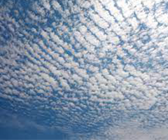
Figure 9 Cirrocumulus

Cirrostratus
Cirrostratus clouds (Figure 10) are high layer clouds with no variation in tone from part to the other. They are formed at the forefront of the frontal weather system and also through the trails left by an air plane as it flies through the atmosphere. Cirrostratus clouds, which arise after cirrus and spread from one location over the sky, can occasionally indicate the arrival of a warm front, and so may be signals of precipitation in the next 12 to 24 hours.
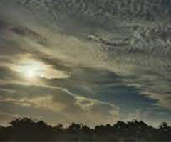
Figure 10 Cirrostratus

Altocumulus
This is a mid-level layer cloud that looks like it is made of regular cotton-wool balls. Altocumulus clouds (Figure 11) are comparatively larger in size than the cirrocumulus clouds and they give an indication of storm or development of thunderstorms later in the day.
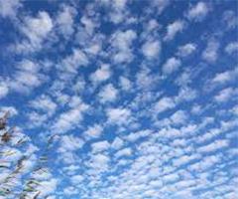
Figure 11 Altocumulus

Altostratus
Altostratus (Figure12) appears as a greyish or bluish layer of fibrous or striated cloud that often blurs the Sun or makes it appear as if one is looking through a frosted glass. They can be formed when a layer of cirrostratus descends from the higher atmospheres. Altostratus clouds do not usually produce rain but may thicken with progressive lowering of the base to form nimbostratus which give an indication of rain.
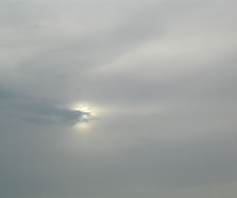
Figure 12 Altocumulus

Nimbostratus
Nimbostratus (Figure 13) is a layer of low-level greyish cloud that precipitates rain reaching the ground. They form from the thickening of altostratus and are also thick enough to obscure the Sun from view.
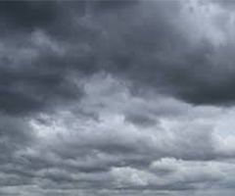
Figure 13 Nimbostratus

Stratocumulus
Stratocumulus (Figure 14) are low-level patches of clouds that vary in colour between white and grey. They might have gaps between them or joined together. They are formed from the spreading out of cumulus clouds. Stratocumulus clouds do not often produce precipitation and when they do, they give out light rain or snow.
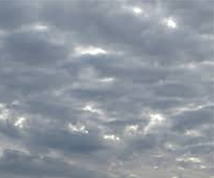
Figure 14 Stratocumulus

Stratus
These are low-level clouds with greyish or whitish colour (Figure 15). The clouds form under stable atmospheric conditions when gentle breezes raise moist air over a cold surface. They can sometimes be very close to the ground in the form of fog or mist. Stratus cloud produces little to no rain and if it is thick enough, it can drizzle.
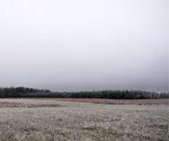
Figure 15 Stratus

Cumulus
Cumulus clouds (Figure 16) are detached, cauliflower –shaped clouds that usually appear in fair weather conditions during the day. They usually form a few hours after daybreak and scatter before the Sun goes down. Cumulus clouds produce no rain or snow and lazily drift across the sky on a Sunny day.
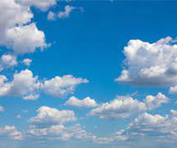
Figure 16 Cumulus

Cumulonimbus
Cumulonimbus clouds (Figure 17) are dense and heavy clouds that extend into the atmosphere in plumes. The upper part of it is fibrous and spreads out in the shape of anvil. The base however is very dark with small clouds hanging with it or attached to it. They are formed through convection from small cumulus clouds. Cumulonimbus clouds are often associated with heavy downpours, hailstorms, lighting, thunder and even tornadoes.
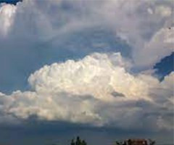
Figure 17 Cumulonimbus

INTERACTION OF ATMOSPHERE WITH GNSS SIGNALS
The plots produced by goGPS software are based on the results of processing GNSS data. A summary of the techniques used by the goGPS software for processing data is given in Section 4.1. It will be thus essential to give a background to the plots in this section.
GNSS, abbreviation for Global Navigation Satellite Systems, allows for the determination of the position of a point or station on the surface of the Earth by observing the electromagnetic signals emitted by space orbiting satellites. The signals are transmitted in the microwave band of the electromagnetic spectrum to the receivers. GNSS finds applications in positioning, location-based services, transportation and scientific research activities.
GNSS involves a number of satellite constellations that communicate with devices on the surface of the Earth for positioning purposes. Among these constellations are the NAVSTAR Global Positioning System (GPS) operated by the US government, the Russian GLONASS, the European Galileo and the China’s Beidou that operate on a global scale (Figure 18) and the Japanese QZSS and the Indian IRNSS that offer services only in the Asia-Pacific region. Other systems such as the European Geostationary Navigation Overlay Service (EGNOS) offer similar services but on a local scale using geostationary satellites, improving upon the performance of GNSS. Though these constellations work independently, with the introduction of multi-constellation GNSS by the International GNSS Service, in the future, users will be able to use these constellations as one single system of GNSS to benefit from the enhancements contributed by the individual systems.

Delay on GNSS Signals
GNSS point positioning involves measurement of the signals emitted by GNSS satellites for the determination of the position of a receiver on the surface of the
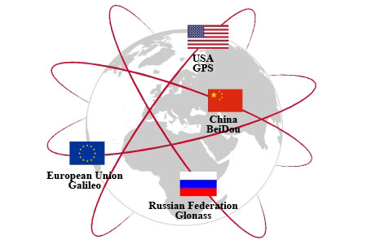
Figure 18 GNSS Systems that Operating on a Global Scale

Earth. The emitted signals contain information about the clock, ephemerides and integrity of the satellite. For the purpose of understanding GNSS point positioning services, the fundamentals of GPS (Biagi, 2009) book is recommended. In this section, attention will be paid to the interaction of the satellite signals with the atmosphere on its travel from space to the earth surface as this is the main factor used for GNSS meteorology and this work seeks to relate atmospheric paramters with GNSS data processed and plotted using goGPS software.
In the absence of the atmosphere, the satellite signals would travel to the Earth surface at the constant speed of light of 299792458 m/s. However, the presence of charged electrons in the ionosphere and water vapour in the troposphere affects the signals by reducing their propagation speed and by bending their path. This results in propagation delays which are respectively known as ionospheric and tropospheric delays.

Ionospheric Delay
The ionospheric delay is caused by the presence of free and charged electrons in the ionosphere (about 100 to 1000 km above the surface of the Earth). For a double frequency receiver, a proper combination of observations on both L1 and L2 frequencies of the signals can be used to get rid of the delay. For a single frequency receiver, there exist models, such as the Klobuchar model, exist for removing the ionospheric effect. These models exploit the correction parameters contained in the signal emitted by the satellite. Figure 19 shows a sample variation of ionospheric delay across the globe, for midday-GMT and 90° elevation of receiver position with respect to the satellite vehicle, with regions of higher ionospheric error shaded red and regions of lower ionospheric effects shaded blue. Figure 19 was produced using the standard ionospheric error correction model for a single frequency receiver specified by the IGS ionosphere working group. For details on the algorithms used to correct the delay due to ionospheric effects, for both single and dual frequency receivers, it is recommended to read IS-GPS-200L sections (20.3.3.5.2.5 for the single frequency receiver and 20.3.3.3.3.3 and 30.3.3.3.1.1.2 for the dual frequency receivers).
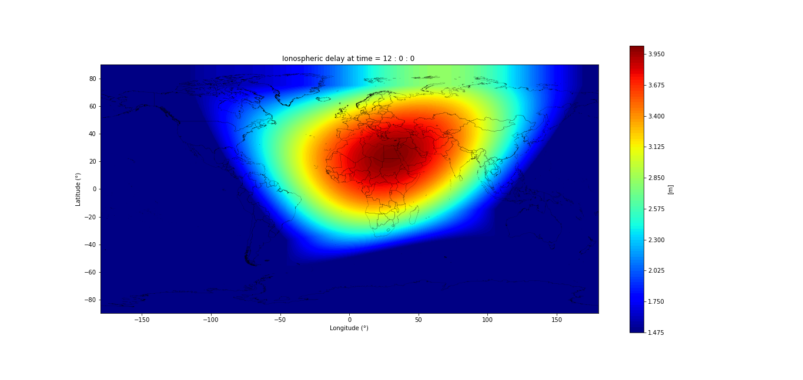
Figure 19 Variation of Ionospheric Effect (Global Map)

Tropospheric Delay
This delay is caused by the presence of water vapour and other constituents in the atmosphere. The total tropospheric delay on the satellite signal is the sum of a wet delay caused by the dipole components of water vapour and a hydrostatic delay caused by dry air constituents and non-dipole components of water vapour. Water vapour is a key element in the hydrologic cycle and its variation in the atmosphere plays a significant role in climate change and change of weather patterns. Also, water vapour is unique in the atmospheric components because it is the only constituent which possesses a dipole moment contribution to its refractivity (Bevis et al., 1992). The water vapour content of the atmosphere can be expressed as the height of an equivalent column of liquid water, known as the precipitable water vapour (PWV). By using a combination of ancillary measurement of surface pressure and temperature and the tropospheric delay exerted on the GNSS satellite signals, it is possible to derive the amount of perceptible water vapour in the atmosphere from the tropospheric delay.
Conventional techniques for measuring atmospheric water vapour such as radiosondes are of less advantage with respect to GNSS due to low frequency of observation periods. Radiosondes for instance make observations once or twice a day (Smith et al., 2008). Ground-based GNSS stations are capable of providing continuous estimates of vertically integrated water vapour content over a global distribution of land-based locations, limited only by the oceans. On the other hand, though space-borne GNSS receivers can provide observations that are discontinuous with respect to time and geographical location, it can also provide a good coverage of the oceans as well as land.

Modelling tropospheric delay
The interaction of the satellite signals with the atmosphere is determined by the refractive index of the atmosphere, (Warren, 2019). Most space-based geodetic systems operate in one of two distinct frequency bands, either the microwave band (e.g. GPS) or in the optical band (e.g. Satellite laser ranging) in which the refractive index is dispersive in the ionosphere and non-dispersive in the other constituents of the atmosphere (Herring, 1992). GNSS signals are also able to efficiently excite the dipole component of the water vapour refractivity and therefore there is a large contribution to the refractive index from water vapour in the atmosphere. This causes a satellite signal passing through the atmosphere to encounter variations on its path, causing the signal to become curved and travelling a longer distance with time than it would travel in a vacuum. The delay on the signal (Equation 1) is thus given by the difference in paths between travel in the atmosphere and travel in the vacuum, (Herring, 1992).
1
where is the atmospheric delay correction,
is the refractive index along the path followed by the ray as a function of position s,
the first integral is by definition the electromagnetic distance covered by the signal in the atmosphere, and
the second integral is the length of the path covered by the signal in vacuum.
Let , defined in Equation 2, be the geometric length of the path followed by the signal.
2
By introducing this geometric length into Equation 1, we get the atmospheric delay to be, (Mendes, 1999):
By regrouping, the delay becomes
3
The first term on the right of Equation 3 is known as the excess path delay (due to the signal travelling along a curved path compared to an equivalent vacuum path, thus covering a longer (excess) distance) and the second term is known as the geometric delay due to the traverse along the geometric path. Considering a signal that travels in the zenith direction above a receiver, the curvature path becomes negligible and the atmospheric delay thus becomes:
4
The tropospheric delay in the zenith direction (90° elevation with respect to the space vehicle) above the receiver station is known as the Zenith Tropospheric or Total Delay (ZTD). The ZTD is nearly proportional to the amount of precipitable water vapour above a GNSS receiver station (Bevis et al., 1992). The precipitable water vapour gives the height of an equivalent column of atmospheric water vapour overlying a given point on the Earth’s surface, making GNSS estimate of ZTD a tool for the remote sensing of the atmospheric water vapour. The delay for the other signals which travel in the slant directions different from the zenith direction and excluding potential multipath sources of signals is known as the slant total delay (STD).
Without considering variations in the composition of dry air and with the assumption of laboratory conditions of CO₂ free air, the refractive index, n, is related to the surface pressure, temperature and humidity as in Equation 5, (Thayer, 1974). The first two terms in the expressions on the right are the results of induced molecular polarisation of air and water vapour molecules respectively and the third term represents the effects of permanent dipole moment of water vapour molecule.
5
where is the refractivity of the atmosphere, and are the partial pressures of dry air and water vapour respectively in mbar, is the absolute temperature in Kelvin, and and are the inverse compressibility factors (corrections for non-ideal gas behaviour) for dry air and water vapour respectively. Using the expressions for inverse compressibility given by Owens (1967), Thayer reorganises the inverse compressibilities as
6
7
Where and are the partial pressure of dry air and water vapour respectively in mbar, is the absolute temperature in Kelvin, and is the temperature of the air in degrees Celsius. There have been several determinations of the refractivity constants (K₁, K₂ and K₃) in Equation 5 in literature. However, the one empirically determined by Thayer is suggested for use by Davis et al. (1985). The values of the constants and standard deviations are given below.
The first term on the right of Equation 5 does not depend on the water content of the atmosphere and is known as the hydrostatic component (N_{d}) of the atmospheric refractivity. The second and third terms are water dependent and known as the wet component (N_{w}) of the refractivity. The refractivity of the atmosphere is then expressed as
8
By substituting Equation 8 into Equation 4 and simplifying, the zenith delay becomes
9
Consequently, by rewriting Equation 9 in terms of the hydrostatic and wet part of the atmospheric refractivity, the zenith delay becomes
10
Where the first term on the right is the zenith hydrostatic delay (ZHD) and the second term is the zenith wet delay (ZWD). Thus,
11
Given measured values of meteorological parameters of pressure, humidity and temperature, the zenith hydrostatic delay can be modelled using for instance the Saastamoinen model (Teke et al. (2011), Bevis et al. (1992), Rocken et al. (1993), Saastamoinen (1973)). Although some effort has been made to develop models that can be used to predict the zenith wet delay from surface measurements, their predictive value is very poor compared to modelling of the zenith hydrostatic delay. This is because the zenith wet delay relies on the amount of water vapour in the atmosphere which is variable and difficult to be measured. Two approaches however can be used in high accuracy GPS analysis to estimate the zenith wet delay; a least squares estimation of one parameter per station per specified time interval and a stochastic estimation process using a Kalman filter (Rocken et al., 1993). In both methods, the estimation is based on the assumption that the atmosphere above a GPS antenna is azimuthally isotropic and slant wet delay is azimuthally related to the zenith wet delay by a mapping function. The second method involving the use of the Kalman filter process was initially used in goGPS software. However, recent developments see the use of the least squares approach for estimating the zenith wet delay. A fast technique for deriving the ZWD is by estimating the ZTD from the observation data and the ZHD using the Saastamoinen model and finding the difference between the two as follows
12
Also, it is possible to derive an approximate value of the integrated water vapour from the zenith wet delay using the expression
13
Where is the zenith wet delay and the is a constant (see Bevis et al. (1992) for the definition of ). The precipitable water vapour of the atmosphere is then derived from the product of the density of water and the integrated water vapour.

Atmospheric delay mapping functions
In most cases, GNSS observation signals from a satellite rarely come from the zenith direction above a receiver, with the space vehicle mostly being positioned at an angle different from the zenith one. The tropospheric delay then becomes a slant delay instead of zenith delay. The slant delay can be expressed as the product of the corresponding delay in the zenith direction and a mapping function which models the dependence of the tropospheric delay on the elevation angle of the satellite with respect to the user. The tropospheric delay can also be written as
14
Where is the tropospheric delay of the atmosphere,
and are the zenith hydrostatic and wet delays
and are the hydrostatic and wet mapping functions respectively, and
is the elevation angle of the satellite with respect to the receiver station.
Most of the existing mapping functions used in modelling the elevation angle dependence or the neutral atmosphere describes the atmosphere by the surface pressure, temperature, relative humidity, temperature lapse rate in the troposphere and the height of the tropopause (Niell, 1996). However, these mapping functions differ in the number of meteorological parameters that are incorporated. For instance, Chao’s mapping function makes no reference to meteorological conditions whereas the one derived by Davis et al. (1985) incorporate surface pressure, temperature, relative humidity, height of the tropopause and the temperature lapse rate of the troposphere.
It is advisable to set a threshold for the elevation angle that will be used with the mapping function to avoid the probable introduction of systematic errors. These errors are mostly larger for lower elevation angles. A useful method to detect the presence of systematic errors from the mapping function is the use of elevation cut-off test described by Davis et al., (1985). In the test, observations of all elevation angles are used for a baseline. The baselines are then re-estimated using a minimum or threshold for the elevation angle. If the mean of the difference between corresponding baseline lengths does not tend to zero, then, there are errors coming from the mapping function.

goGPS, SOFTWARE DEVELOPMENT

goGPS
goGPS (logo in Figure 20) is a software developed by the Geomatics Research and Development (GReD) s.r.l., a spin-off of Politecnico di Milano, using the Matlab programming language. It provides a graphical user interface for the processing of GNSS data.

Figure 20 goGPS logo Figure 21 MATLAB logo

Its development started in 2007 as a set of routines for processing GPS data based on the Kalman Filtering algorithm. Due to the limiting performance factor of the algorithm, especially when used in the MATLAB environment, recent developments have used two batch least squares undifferenced engines for processing. The first engine uses a combination of the observables (such as iono-free observations) for computing solutions for only Precise Point positioning (PPP). The second engine does not perform any combination of the observables and uses all the frequencies and tracks observed for computing PPP solutions, adjusting baselines of networks with multiple receivers.
In the initial developments, there was support for only GPS single frequency low cost receivers, but the current version provides support for all other GNSS observations (including single and double frequency), except kinematic observations.
The first release of the software, was in 2009 under the GPLv3 licence. The current version of the Open Source software is still under development, with new features and functionalities being added to improve the performance and appearance of the software. Also, the current version (1.0) is being managed and maintained by GReD s.r.l., providing support for the open source community.
An executable version of the software is yet to be released. However, performing any functionality with the software can be done by running it on the MATLAB platform.

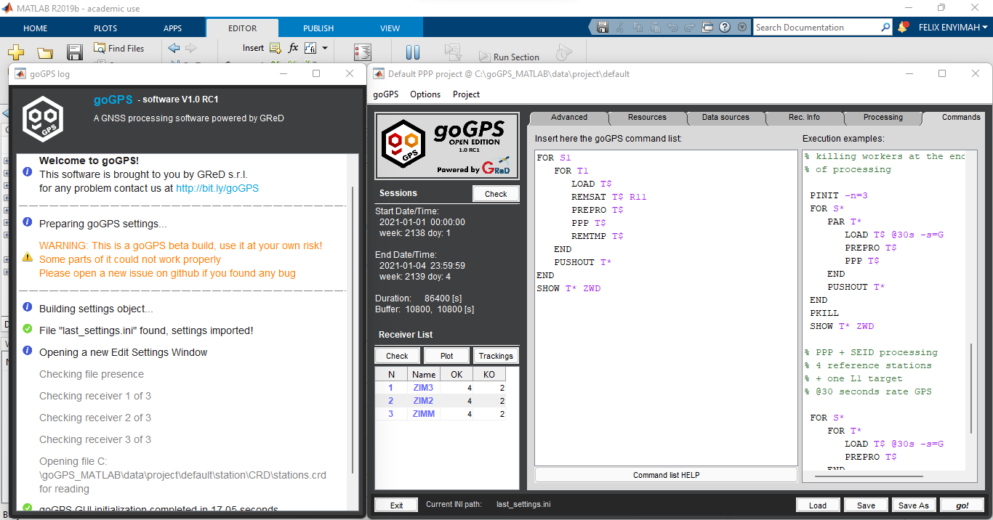
Figure 22 goGPS Interface

Graphical Objects in MATLAB

Graphical Objects
In MATLAB, the outputs of a plot are directed to a window, known as a figure, separate from the command window. Default line styles and colours are then used to differentiate plots of data from other components of the figure such as menu bar and toolbar. However, it is possible to change the appearance of the plotted graph and add or remove annotations such as texts, lines, surfaces and patches. This flexibility serves behind this work. Thus, this section discusses the graphical objects being used, their properties and accessibility. This is made possible by the available graphical objects and functions provided by MATLAB. Thus, these graphical objects are being exploited for this work to provide added information for the plots produced by goGPS.
These graphical objects are organised in a hierarchical structure (Figure 23), each instance of the object being associated with a handle for its identification. There is a parent-child relationship existing between the objects, with those in the lower rank of the hierarchy being the descendants of those at the top of the hierarchy and it is essential for the existence of a parent object before a child object can be created. For instance, line objects are core graphical objects. To create a line, there is a need for an axes object to exist (because a line object is a descendant of an axes object), which also needs a figure. To create a child object, if the parent does not exist, MATLAB automatically creates the parent in order for the child to be created. Also, if parent(s) exist(s), MATLAB sets the most recent one as the parent object for the child. However, one can also specify the parent for a child object at creation time. The root object sits at the top of the hierarchy and is created at MATLAB startup by default. Thus, one does not need to create the root object. All other objects that are descendants of the root object however need to be instantiated before being used. For further description of these, it is recommended to read the documentation on ‘Using MATLAB Graphics’. However, brief descriptions of the relevant ones for this work are reported.
Figure 23 Hierarchy of graphical objects in MATLAB

Graphical objects are displayed in a figure window containing menus, toolbars, user-interface objects, axes and its children, etc. (Figure 24).
Axes objects define the coordinate system for displaying graphs.
Core graphics objects include basic drawing primitives like line, text, patch, surface, images and light objects, which are not visible but affect the way some objects are coloured. These objects can be defined using the functions given in Table 3.

Figure 24 Descendants of a figure object

Table 3 Graphical Object Functions
Function | Purpose
surface | 3-D grid of quadrilaterals created by plotting the value of each element in a matrix as a height above the x-y plane.
patch | Filled polygons with separate edge properties. A single patch can contain multiple faces, each coloured independently with solid or interpolated colours.
text | Character strings positioned in the axes.

Accessing Properties of MATLAB Graphical Objects
The properties of a graphical object control its appearance and behaviour after it has been instantiated. These properties include general information of the object such as the object’s type, its parents and children (if available), whether it is visible and other relevant information peculiar to the particular object. The ‘get’ function of MATLAB can be used to query the value(s) of a property of a graphical object. The basic syntax for setting the property of an object is given by:
returnedValue = get(objectHandle, ‘PropertyName’)
where objectHandle refers to the identifier for the object being queried and PropertyName refers to the property of the object whose value is needed.
In addition, the ‘set’ function available in MATLAB can also be used to change the value of the property of an object. The basic syntax for using the set method is:
set(objectHandle, ‘PropertyName’, ‘NewPropertyValue’)
The objectHandle and PropertyName arguments of the ‘set’ function are as defined for the ‘get’ function. The ‘NewPropertyValue’ however is the value being set for the property of the object. In an instance where the handle of an object has not been specified at creation time, it is possible to use the ‘findobj’ method to query the particular object in the hierarchy having a particular property set to a particular value using the syntax:
findobj(‘PropertyName’, ‘PropertyValue’)
Alternatively, the ‘findall’ method can be used to find an object in case its ‘HandleVisibility’ property is set to off.
Also, an object and all its descendants can be removed from a graph using the ‘delete’ method available in MATLAB.

Dealing With Images in MATLAB
Images are represented as an array of data structure in MATLAB, thus working with images is comparable to working with any other data in MATLAB. Most images are stored as a two-dimensional array in which each element of the matrix corresponds to a single pixel in the image. On the other hand, RGB images require a three-dimensional array where in the third dimension, the first, second and third planes represent the red, green and blue pixel intensities. The image is interpreted according to the numerical class in which the data is stored: double-precision floating-point (double), 16-bit unsigned integer (uint16) and 8-bit unsigned integer (uint8). Images stored in double-precision (64-bit) floating-point numbers require a very large memory and are not always ideal for storing images. Thus, it is of recommendation to store images as 8-bit or 16-bit unsigned integers that require one-eight or one-fourth, respectively, as much memory as double precision numbers.
There are three basic data types used in MATLAB in accordance with interpretation of the data matrix of the image: indexed, intensity and RGB image. An indexed image consists of a data matrix and a colormap. The colormap is automatically loaded with the image when the ‘imread’ function is used. An intensity image is a data matrix whose values represent a range of intensities of the pixel values. An RGB image on the other hand is represented as an m-by-n-by-3 data array that defines the red, green and blue colour components of each pixel. Thus, the colour of each pixel is stored as a combination of the intensities of the red, green and blue components of colour planes at each pixel’s location. The ‘imread’ function is used to read an image for processing an image, the ‘imwrite’ function is used to write an image and the ‘imfinfo’ function is used to obtain information about the image.
MATLAB supports the following graphics file formats:
- BMP (Microsoft Windows Bitmap)
- HDF (Hierarchical Data Format)
- JPEG (Joint Photographic Experts Group)
- PCX (Paintbrush)
- PNG (Portable Network Graphics)
- TIFF (Tagged Image File Format)
- XWD (X Window Dump)
The essential properties of an image in MATLAB are the CData, XData and YData. The CData property determines whether the image will be interpreted as an RGB image or as a colormap image. If the CData array is two-dimensional, the image is interpreted either as an indexed image or an intensity image and in each case, the colormap colours are used. If the CData has a dimension of m-by-n-by-3, the image is displayed as an RGB image.

