***Geoinformatics Project, 2021***

|  |  |  |
| --- | --- | --- |
| **GNSS (GPS) DATA PROCESSING**    **GROUP MEMBERS** | | |
| **Name** | **Student ID** | **E-mail** |
| Alessandro Gatti | 10522639 | alessandro6.gatti@mail.polimi.it |
| Felix Enyimah Toffah | 10647752 | felixenyimah.toffah@mail.polimi.it |

**Project Supervisor**

**- Professor Ludovico Biagi (ludovico.biagi@polimi.it)**

**Course Professor**

**- Professor Gianluca Palermo**

Delivery date: September 15, 2021

# Abstract

The Clock, Ephemeris, Integrity (CEI) data set of a GNSS Satellite contain the essential parameters to use the satellite’s broadcast signals for positioning purposes. By reading the navigation message file of a GPS, a user can determine the position and velocity of a satellite and correct for the propagation delay of the signal due to ionospheric effects.

The GNSS Data Processing Software (GDPS) has been developed, using Python, for determining the position and velocity of a satellite by reading its navigation message. By using the ionospheric error correction parameters in the file, GDPS determine the variation of the ionospheric effect on different positions of the Earth. A Graphical User Interface has been developed to enable a user to access GDPS.

**Table of Contents**

Abstract i

List of Figures iii

1.0 Introduction 1

1.1 Objectives 1

1.2 Prerequisites 1

1.2.1 Libraries 1

1.2.2 Data types and formats 2

1.3 Revision History 3

2.0 GDPS Interface 4

2.1 Menu items 4

2.1.1 Input 4

2.1.2 Help 6

2.2 Main windows 9

2.2.1 Satellite orbit 9

2.2.2 Ionosphere 11

3.0 Graphical Outputs and Interpretation 14

3.1 Satellite orbit 14

3.1.1 Global map 14

3.1.2 Local Map 14

3.2 Ionosphere 15

3.2.1 Global map 15

3.2.2 Local Map 16

4.0 Testing 17

5.0 Conclusion 18

5.1 Recommendations 18

6.0 References 19

# List of Figures

Figure 1 Input Menu Item 4

Figure 2 File Opening Dialog 5

Figure 3 File type Error 5

Figure 4 Ionospheric Correction Parameter Unavailablity Notice 6

Figure 5 Help Menu Item 6

Figure 6 Help Content 7

Figure 7 About Page 8

Figure 8 Satellite Orbit Panel 9

Figure 9 Satellite Orbit (Global Map Page) 10

Figure 10 Satellite Orbit (Local Map Page) 10

Figure 11 Ionosphere Model Panel 11

Figure 12 Ionosphere Model (Global Map) Page 12

Figure 13 Ionosphere Model (Local Map) Page 12

Figure 14 File Unavailability Error Notice 13

Figure 15 Global map: ground track 14

Figure 16 Local: azimuth & elevation plot 15

Figure 17 Ionospheric Effect (Global Map) 16

Figure 18 Ionospheric Effect (Local Map) 16

Figure 19 Setting the parameters for running the script 17

Figure 20 Comparing results 17

# 1.0 Introduction

GNSS Point positioning involves measurement of the signals emitted by a satellite for the determination of the position of a receiver on the surface of the Earth. The emitted signal contains information about the clock, ephemerides and integrity of the satellite. The signal propagation through the atmosphere is delayed by the presence of free electrons in the ionosphere (about 100 and 1000 km altitude) and the water vapour content of the troposphere. These delays affect the precision in the estimated position of a receiver. By reading the navigation message file, a user can determine the position and velocity of a satellite and correct for the propagation delay of the signal due to ionospheric effects.

## 1.1 Prerequisites

### 1.1.1 Libraries

Python is the programming language used to develop the application. To run the program, the user is required to install the following packages:

* Matplotlib ( 3.2.0 )
* Cartopy ( 0.18.0 )
* Astroplan ( 0.8 )
* wx ( 4.1.1 )
* Geopandas ( 0.9.0 )
* Numpy ( 1.18.1 )

#### Running the application

To run the application, on the Command Line Interface, navigate to the geoInfoProj folder and run using the command below

python Main.py

This will open the GUI OF GDPS.

### 1.1.2 Data types and formats

GDPS uses GPS RINEX legacy navigation (LNAV) message files (with extensions .yyn or rnx) up to version 3.05. The file has to contain the navigation message of one or more satellite. Versions later than this would not be recognized by the system.

When accessing the respective modules, the elevation, azimuth, longitude and elevation parameters have to be of decimal degree formats. The heights value for producing the local map of the satellite orbit module must be in meters. The time parameter for the ionosphere model is in the format HH:MM:SS

#### Acceptable Range of User Inputs

The minimum and maximum values of azimuth, elevation, latitude, longitude and time expected from the user are defined in Table 1. However, it is assumed that the height value of the receiver station will be of a numerical type and a true value.

**Table 1 Acceptable Range of User Input**

|  |  |  |
| --- | --- | --- |
| **Parameter** | **Minimum** | **Maximum** |
| Azimuth (Deg Decimal) | -180 | 180 |
| Elevation (Deg Decimal) | 0 | 90 |
| Latitude (Deg Decimal) | -90 | 90 |
| Longitude (Deg Decimal) | -180 | 180 |
| Time (HH:MM:SS) | 00:00:00 | 23:59:59 |

## 1.2 Revision History

During the development, some changes were made from the initial draft. It was decided to keep the core functionalities intact and replace the tropospheric and relativistic effect computations in favor to dedicating more importance to the graphical interface and presentation of the results.

# 2.0 GDPS Interface

GDPS is a program for determining the position and velocity of a satellite by reading its navigation message.

GDPS has two main modules:

* Satellite orbit: this module tracks the position and velocity of a satellite vehicle over time. It allows to visualize the ground tracks of any chosen satellite vehicle over the surface of the earth, and to show the variation of azimuth and elevation that it would have with respect to an arbitrary position inserted by the user.
* Ionospheric error correction: This module shows the time varying effects of ionospheric delay on a GPS satellite emitted signal. It allows visualizing the ionospheric delay with respect to time across varying positions of the earth, elevation and azimuth of a GPS receiver with respect to satellite.

The algorithms implemented for the modules are as defined in the IS-GPS-200L (Sections 20.3.3.4.3 and 20.3.3.5.2.5 for ephemeris determination and Ionospheric Model respectively).

## 2.1 Menu items

The menu items of GDPS GUI are

### 2.1.1 Input

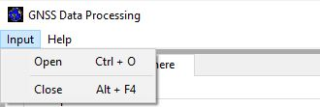

Figure 1 Input Menu Item

Open

This provides access to the file directory (Figure 2) for opening an LNAV RINEX file. When the file is not of the GPS navigation type, an error message is printed to the user, as shown in Figure 3, defining the error and by closing the dialog, the user can select the required file type.

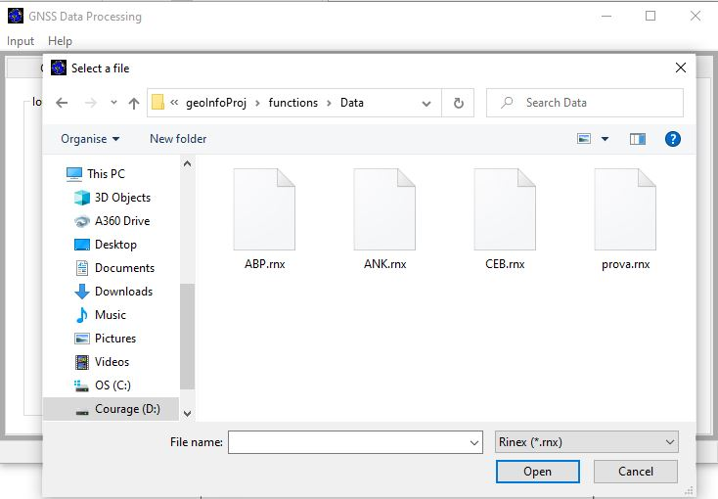

Figure 2 File Opening Dialog

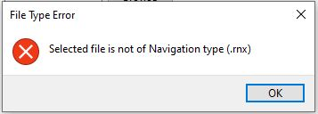

Figure 3 File type Error

On opening a file, when there are no ionospheric error correction parameters in the file (Figure 4), the user is informed of such.

Figure 4 Ionospheric Correction Parameter Unavailability Notice

Close

This exits the currently running window of the GUI.

### 2.1.2 Help

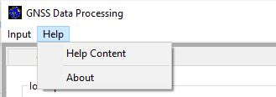

Figure 5 Help Menu Item

Help Content

This gives a brief documentation (Figure 6) on how to use the software and the modules being used.

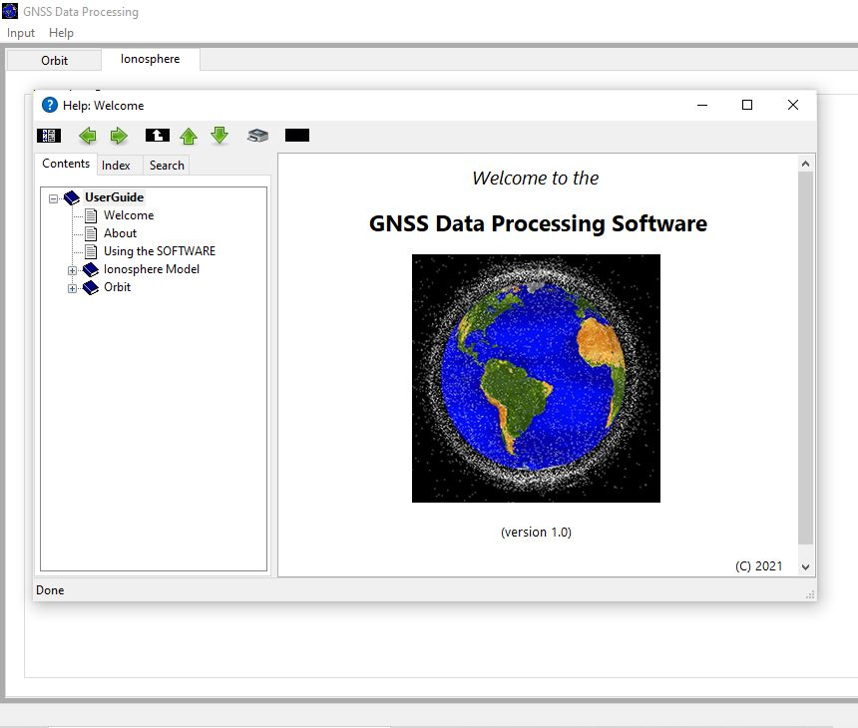

Figure 6 Help Content

About

This gives a brief description (Figure 7) of GDPS.

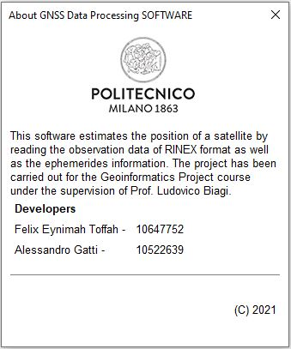

Figure 7 About Page

To allow easier navigation, the menu items could be accessed using the ALT key and followed by the highlighted key on the item. Also, the key combinations defined in Table 2 can be used to access the respective items.

**Table 2 Key Combinations**

|  |  |
| --- | --- |
| **Key short-cuts** | **Definition** |
| Ctrl + O | Open |
| Alt + F4 | Close |
| F1 | Help contents |

## 2.2 Main windows

### 2.2.1 Satellite Orbit

This is the initial panel (Figure 8) for the orbit visualization. From here, the user can choose between 2 preferable modes, Global or Local Map.

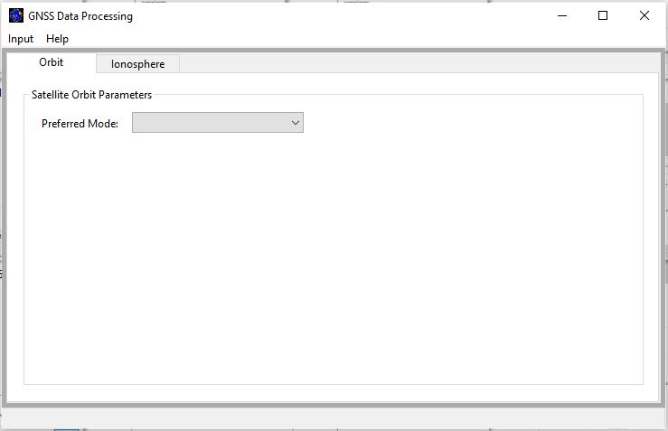

Figure 8 Satellite Orbit Panel

#### Global map

By selecting Global Map (Figure 9), the user can insert the PRN number of the satellite he wants to visualize and click on the ‘proceed’ button. This will produce the map of the orbit.

Figure 9 Satellite Orbit (Global Map Page)

#### Local Map

By switching to Local Map (Figure 10), the number of parameters to insert changes. In addition to the SV PRN number, boxes to enter the position of the reference point in geodetic coordinates are added on the screen. From here, it is possible to produce the trend of the azimuth and elevation in time with respect to the inserted parameters.

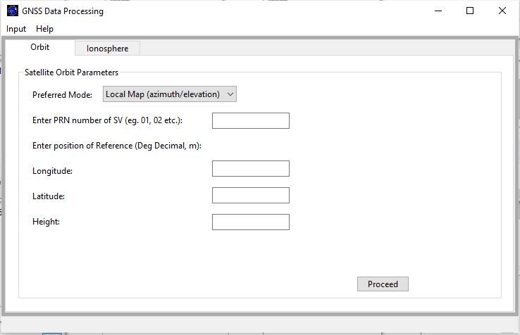

Figure 10 Satellite Orbit (Local Map Page)

### 2.2.2 Ionosphere

On this panel (Figure 11), the user selects a preferred model (Global Map or Local Map).

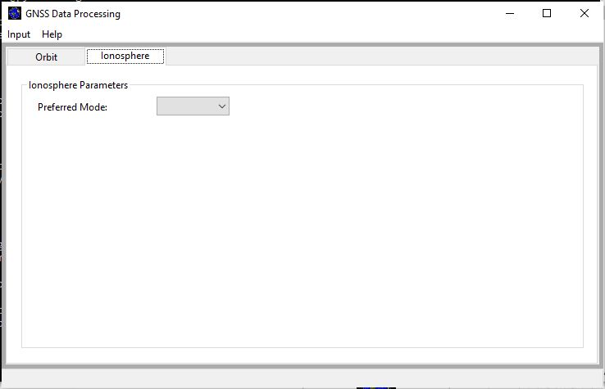

Figure 11 Ionosphere Model Panel

#### Global Map

By selecting the Global Map, the panel is updated, exposing the buttons for inserting the required parameters (time, elevation and azimuth), Figure 12. The default time values are zeros and the user can change the values. Also, only numerical values can be entered in each button. By clicking on the ‘Proceed’ button, an Ionospheric Error map is produced showing the variations in the ionospheric effects on the globe.

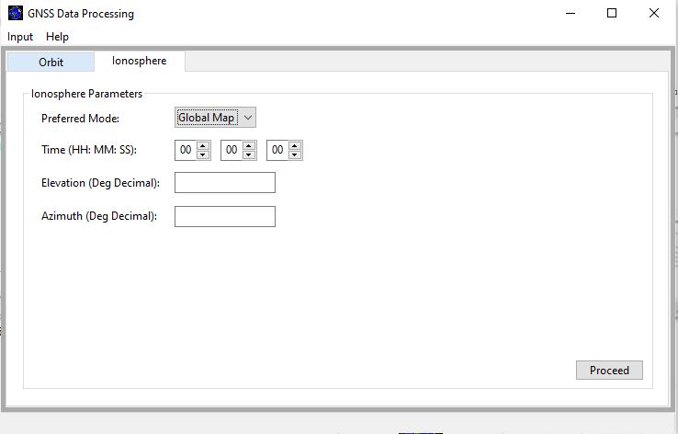

Figure 12 Ionosphere Model (Global Map) Page

#### Local Map

By selecting the Local Map, the panel is also updated (Figure 13), exposing the buttons for inserting the parameters (time, longitude and latitude) required for the model. Also, the default time values are zeros and the user can change the values. By clicking on the ‘Proceed’ button, an Ionospheric Error map is produced showing the variations in the ionospheric effects on the globe.

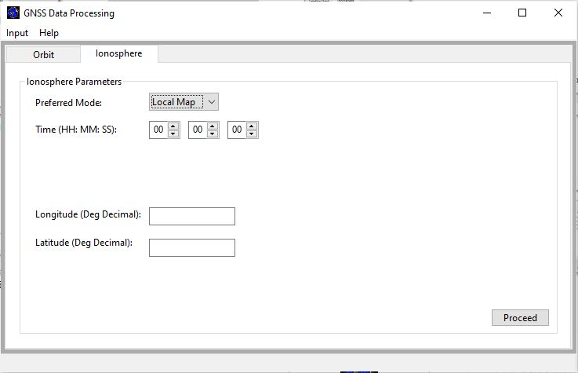

Figure 13 Ionosphere Model (Local Map) Page

In both instances of Global or Local Map analysis, when a GPS Navigation message file has not been selected, the user is informed of the unavailability of the RINEX file (Figure 14) and given a guide to select the file.

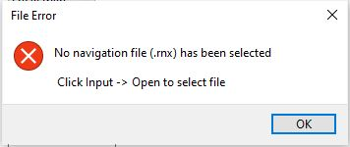

Figure 14 File Unavailability Error Notice

# 3.0 Graphical Outputs and Interpretation

## 3.1 Satellite orbit

The software computes position and velocity of satellites every 5 minutes, in a range of 2 hours, after every epoch (entry) in the data. With the available dataset a map is produced visualizing the shape of the orbit of the chosen vehicle.

### 3.1.1 Global map

This functionality shows the ground track (Figure 15) with respect to the Earth’s surface. As shown in Figure 15, “gaps” in the orbit are caused by insufficient data in the navigation message, i. e. when there is no new entry that specifies the positions after the 2 hours validity of the previous entry.

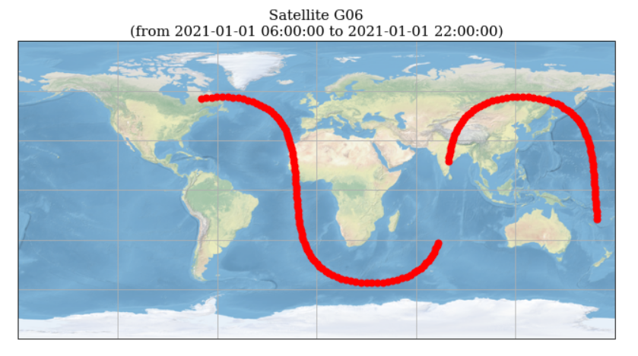

Figure 15 Global map: ground track

### 3.1.2 Local Map

This functionality displays the difference in time of the azimuth and elevation of a satellite (Figure 16), calculated with respect to an arbitrary position set by the user.

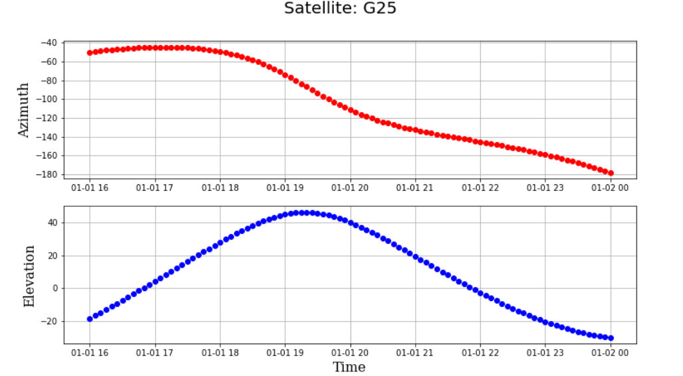

Figure 16 Local: azimuth & elevation plot

## 3.2 Ionosphere

### 3.2.1 Global Map

Figure 17 shows a sample output map for a global map of ionospheric effects with regions of higher ionospheric error at the time shaded red and regions of lower ionospheric effects shaded blue.

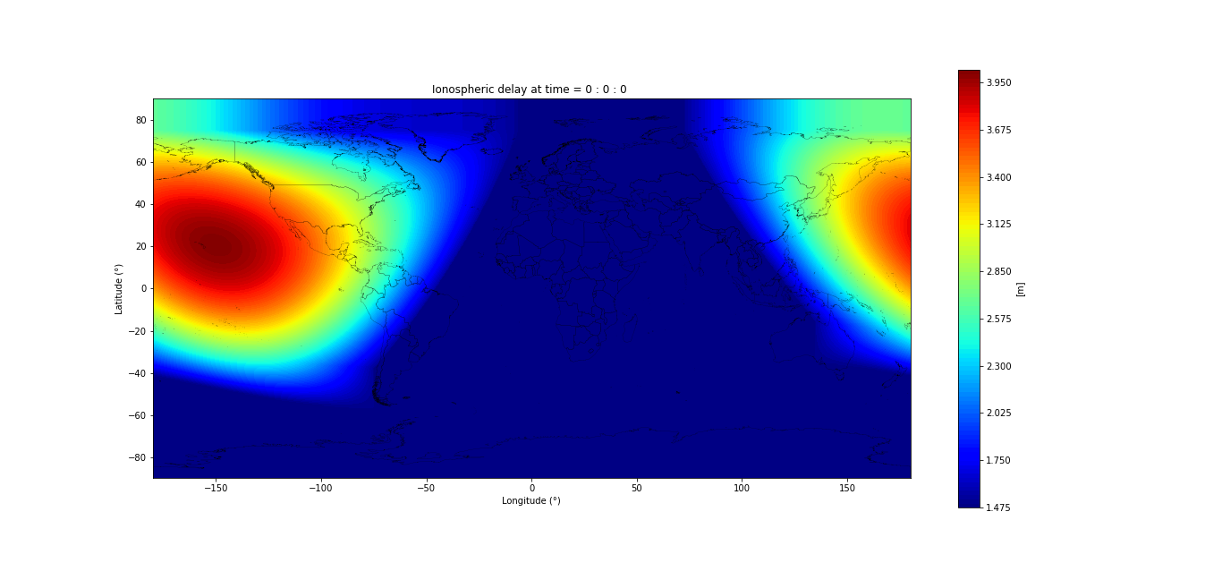

Figure 17 Ionospheric Effect (Global Map)

### 3.2.2 Local Map

Figure 18 shows a sample output local map of ionospheric effect for varying elevation and azimuth. From the graph, it’s clear that the ionospheric error is higher for lower elevation of the station with respect to the satellite vehicle.

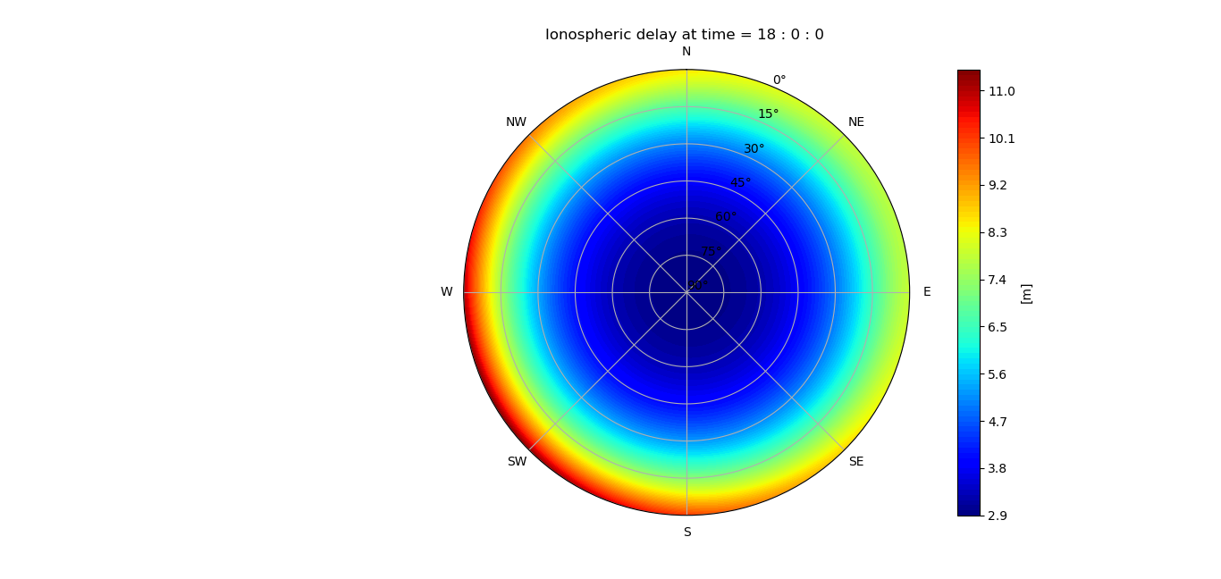

Figure 18 Ionospheric Effect (Local Map)

# 4.0 Testing

A script “differences.py” was developed for comparing the output of the software with the precise ephemerides (i.e. an historical archive where precise positions of satellites are stored). The script takes in input (Figure 19) the produced file of positions and the precise ephemerides file (.sp3) and elaborates a text file of the differences.

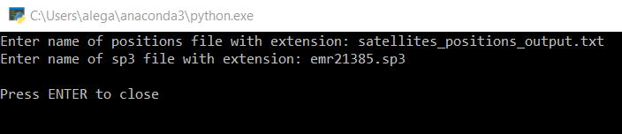

*Figure 19 Setting the parameters for running the script*

After testing with thousands of results, the difference has always been in the range of some meters (Figure 20).

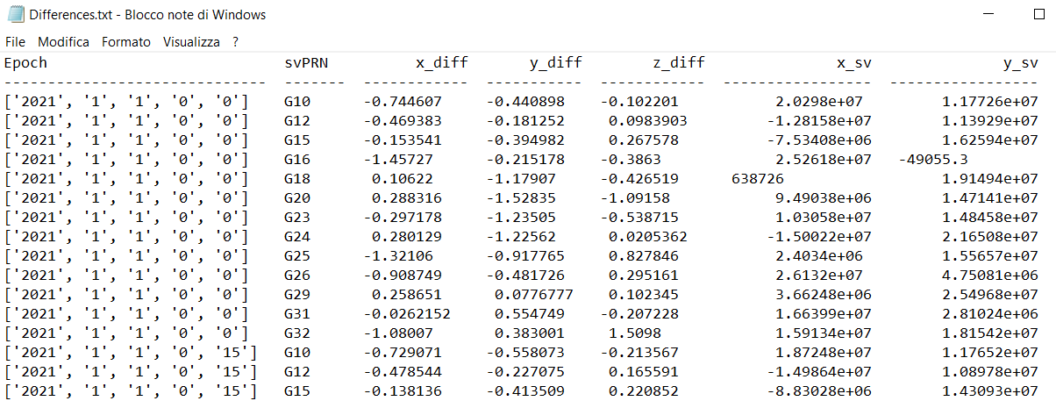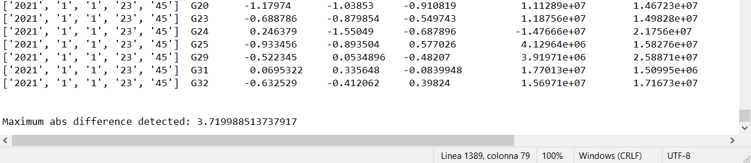

Figure 20 Comparing results

# 5.0 Conclusion

Python libraries for the estimation of the position of a satellite by reading the observation data of RINEX format as well as the ephemerides information has been implemented. The modules defined in the GPS Interface Specification reports were used. A simple GUI has also been developed to enable a user easy access the implemented libraries and visualization of the results in maps.

# 5.1 Recommendations

1. For future development, the software can be upgraded to work also with newer versions of navigation message files.
2. Also, given the modular approach to the solution, other modules can be added for further processing of satellite data, for example for the computation of the tropospheric delay on the signals or for the correction of the relativistic effect.

# 6.0 References

* Interface Specification IS-GPS-200L, August 2020 <https://www.gps.gov/technical/icwg/IS-GPS-200L.pdf>
* Interface Specification IS-GPS-705G, August 2020 <https://www.gps.gov/technical/icwg/IS-GPS-705G.pdf>
* Interface Specification IS-GPS-800G, August 2020 <https://www.gps.gov/technical/icwg/IS-GPS-800G.pdf>
* Rinex300, November 2007 <https://files.igs.org/pub/data/format/rinex300.pdf>
* Rinex305, December 2020 <https://files.igs.org/pub/data/format/rinex305.pdf>