***Geoinformatics Project, 2021***

|  |  |  |
| --- | --- | --- |
| **GNSS (GPS) DATA VISUALIZER**    **GROUP MEMBERS** | | |
| **Name** | **Student ID** | **E-mail** |
| Alessandro Gatti | 10522639 | alessandro6.gatti@mail.polimi.it |
| Felix Enyimah Toffah | 10647752 | felixenyimah.toffah@mail.polimi.it |

**Project Supervisor**

**- Professor Ludovico Biagi (ludovico.biagi@polimi.it)**

**Course Instructor**

**- Professor Gianluca Palermo**

Delivery date: September 15, 2021

**Abstract**

GPS Point positioning involves measurement of the signals emitted by a satellite for the determination of the position of a receiver on the surface of the Earth.

Today it’s a widely diffused technology that is mainly used in the field of transportations.

But determining positions is a complex problem, to achieve this some fundamentals preliminaries steps are needed: the computation of the position of the satellite in a global reference frame and the calculation of the interference that the signals are subjected to, when travelling through the layers of the atmosphere.

This software aims to show the result of these preliminaries step.

Table of contents:

Abstract

Table of content

List of figures

Introduction

Satellite orbit

Ionospheric error correction

Objective reached

Tools

Prerequisites

Libraries

Data types

File formats

Running the application

Installing the executable GUI

GNSS Data Processing interface

Menu items

Input

Open

Close

Help

Help Content

About

Main windows

Satellite orbit

Global map

Local Map

Ionosphere

Global map

Local Map

Graphical outputs and interpretation

Satellite orbit

Global map

Local Map

Ionosphere

Global map

Local Map

Testing

Scalability

References

**Introduction**

GPS Data Visualizer is a program for interpreting data from the GPS constellation navigation messages. It consists of 2 main modules:

Satellite orbit: this module tracks the position and velocity of a satellite vehicle over time. It allows to visualize the groundtracks of any chosen sv over the surface of the earth, and to show the variation of azimuth and elevation that it would have with respect to an arbitrary position inserted by the user.

Ionospheric error correction: one of the main source of errors that can affect GPS signals is the delay caused by the presence of free electrons in the ionosphere (about 100 and 1000 km altitude). This module allows to show the ionospheric delay in 2 ways: global and local.

(Additional models have also been developed for estimating the ionospheric effect at a user station, with respect to the elevation and azimuth of a Satellite Vehicle.)

The program is composed of libraries implemented with python and it incorporates a Graphical User Interface to enable a user an intuitive access the models.

Detailed description on how to use the software follows in the next pages.

**Objectives reached**

During the development some changes were made from the initial draft while maintaining the same core functionalities: in particular it was decided to replace the tropospheric and relativistic effect computation in favor to dedicating more space to the graphical aspect.

However given the modular approach to the solution, modules for these functionalities can easily be integrated in the future.

**Tools**

The program was developed in python using Spyder IDE.

Libraries: numpy, matplotlib, cartopy, astroplan, wx, tabulate(diff), datetime.

Rinex file: it’s the standard format for exchanging data of navigation systems. In this program it’s used as input, and from it info about ephemerides and clock offset of the satellite can be extracted. Using the contained ephemeris parameters it is possible to compute the orbit of a satellite, considered valid for a range of 2 hours, for every epoch(entry) in the data.

Interface

**Results**

Our libraries: main, read_rinex, sat_orbit, ionosphericcorrection, cart2geod, geod2cart, rotation.

Numerical results outputs…

Orbit

Graphs example

Azimuth and elevation

Ionospheric correction

Testing

#from differences.py

**DEFINED LIBRARIES**

The main libraires are being used in the Main.py file are

* IonosphericCorrectionSF.py
* sat_orbit.py
* read_rinex.py which contains the methods
  + readIonosphericParamters( )
  + read_nav( )
  + getSatellitePRN ( )
* Cart2geod.py
* RotationParam.py
* Rotation.py

Other olibraries defined but not used include

* ClockCorrection.py
* Deg2rad.py
* Ecef2eci.py
* Geod2cart.py
* GeometricRange.py
* GPStime.py
* IonosphericCorrectionDF.py
* L1_L2Corection.py
* PseudoRangeIonoCorrection.py
* Rad2deg.py
* RelativisticEffects.py
* SaastamoinenModel.py

**How to install the software**

**Menu Items**

* The File menu contains the items Open and Close.

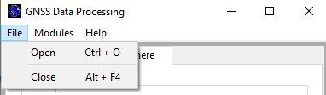



The Open menu item is needed to open a GPS Navigation message file (.rnx) before the main functionalities can be accessed (Figure ………..).

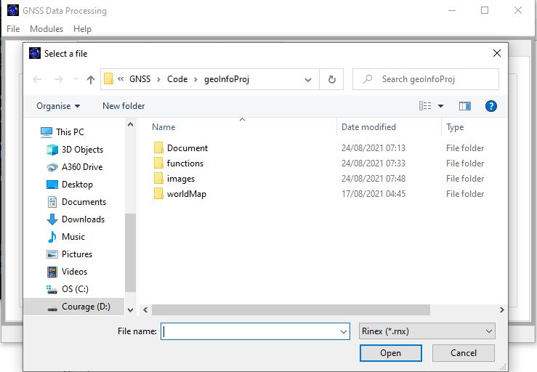

When the file is not of the type ‘.rnx’, an error message is printed to the user as shown in Figure ……….. defining the error and by closing the dialog, the user can select the required file type.

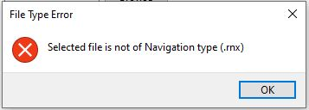

The Close menu item exits the main window of the GUI.

* Modules

The Modules menu shows the main functionalities (Satellite Orbit and Ionospheric Model) for the software.

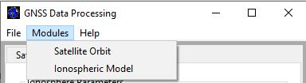

The Satellite Orbit item gives navigation to the Orbit panel.

The Ionospheric Model navigates to the Ionosphere panel where the paramters needed for performing the Ionosphere computation are needed. On this panel (Figure ………………..), the user selects the preferred model (Station analysis or Globe analysis).

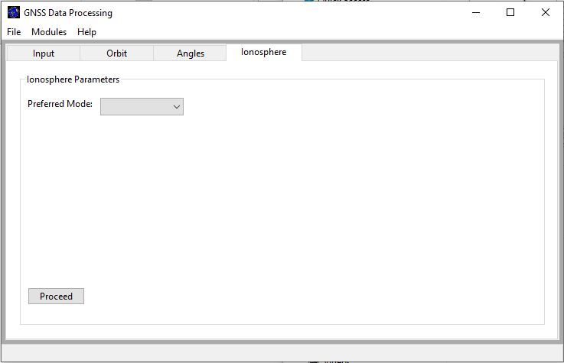

By selecting the Globe aanalysis, the panel is updated, exposing the buttons for inserting the paramters (time, elevation and azimuth), Figure …………………. The default values in the buttons are zeros and the user can change the values. Also, only numerical values can be entered in each button. By clicking on the ‘Proceed’ button, an Ionospheric Error map is produced showing the variations in the ionospheric effects on the globe.

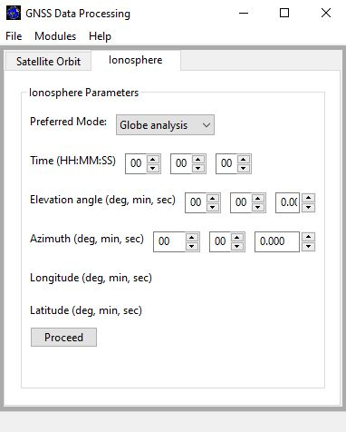

By selecting the station analysis, the panel is also updated (Figure ………..), exposing the buttons for inserting the parameters (time, longitude and latitude) required for the model. Also, the default values in the buttons are zeros and the user can change the values. By clicking on the ‘Proceed’ button, an Ionospheric Error map is produced showing the variations in the ionospheric effects on the globe.

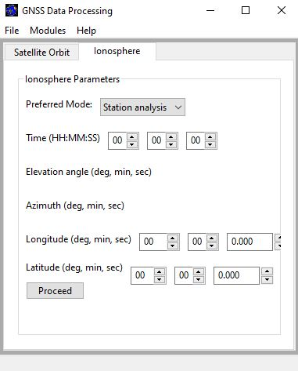

In both instances of Global and station analysis, when a GPS Navigation message file has not been selected, the user is informed of the unavailability of the Rinex file (Figure ……………..) and given a guide to select the file.

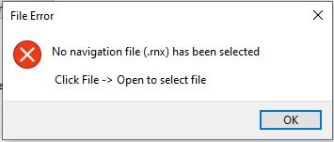

Also, when a file is selected and there are no ionospheric error correction parameters in the file (Figure ……………..), the user is also informed of such and can select another file.

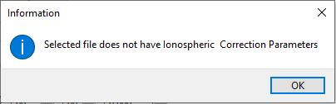

* Help

The Help menu (Figure …..) shows the Help Content and About items.

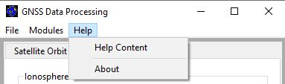

The Help Content gives a brief description on how to use the software as well as an introduction to the models used in the software.

The About menu item shows the About page (Figure ….) which gives a brief description to the about the project.

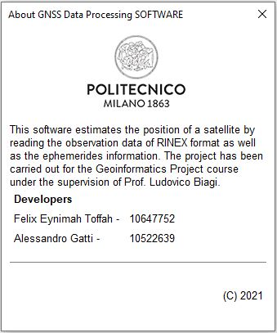

For easy access, shortcuts have been created for access shown in the table below

|  |  |
| --- | --- |
| **KEY SHORT CUTS** | **DEFINITION** |
| Ctrl + O | Open |
| Alt + F4 | Close |
| Ctrl + K | Orbit panel |
| Ctrl + I | Ionosphere panel |
| F1 | Help contents |

**Data Processing**

Figure …………….. shows a sample output map for a global and station ionospheric error analysis respectivley. With regions of higher ionospheric error at the time shaded red and regions of lower ionospheric effects shaded blue.

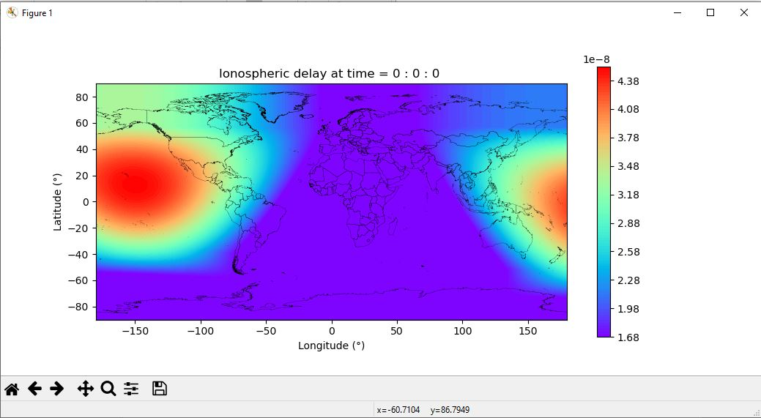

Figure ………………………. Shows a sample output map of the varation of ionospheric error for varying elevation and azimuth. From the graph, it is more clear that the ionospheric error is higher for lower elevation of the station with respect to the satellite vehichle.

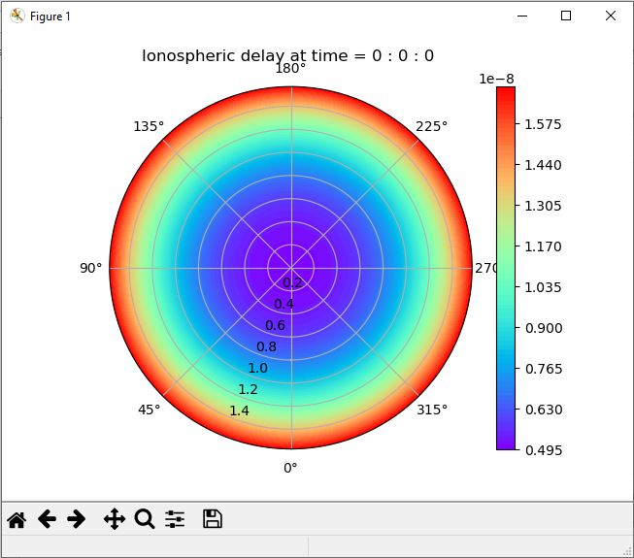

**/// Update the readme on libraries to install to use the program**

References

The implemented algorithms are as defined in the IS-GPS-200L (Sections 20.3.3.4.3 and 20.3.3.5.2.5 respectively).