***Software Engineering for Geoinformatics***

|  |  |  |
| --- | --- | --- |
| ***Spatial Visualization Analysis (SpaVia)***  ***Web Application***  **Group members:** | | |
| **Name** | **Student ID** | **E-mail** |
| Felix Enyimah Toffah | 10647752 | felixenyimah.toffah@mail.polimi.it |
| Sahar Gholami Bourani | 10718755 | sahar.gholami@mail.polimi.it |
| Phesto Osano | 10714566 | phesto.osano@mail.polimi.it |
| Arli Ardiandy Nurseramika | 10693181 | arliardiandy.nurseramika@mail.polimi.it |

**Lecturer**

**Professor Di Nitto Elisabetta**

**Summer 2020**

Chapter 1: Requirement Analysis and Specification Document

Section 1 - Project scope and goals

The usage of the road is an indisputable mode of transportation for vehicle users, individuals, bicycle users, etc. As a result of the increase in human activities in the urban areas, the safety of pedestrians in the usage and crossing of streets becomes an issue of concern to road designers, managers and local Government authorities. The Pedestrian Level of Service (PLOS) is an index that incorporates the size of the road for vehicular and human traffic flow, terrestrial features such as the buffer of the road, spaces for different modes of travel, traffic volume and speed and the availability of street lights. It is aimed at enhancing safety of pedestrians on the road and to ease traffic flow at all times of the day. Oftentimes, concerns of pedestrians are left out after the design of the road. However, regular interaction of road managers and local government authorities with pedestrians would provide valuable information that can facilitate planning, enhance maintenance and make the streets more useful for the people at all times. Thus, the participation of the road users in decision making would be very vital.

SpaVia is an intended web application aimed at offering a participative geographic information system environment for the people in an area to offer their views as an input for decision making by the relevant authorities. It is intended to be managed by the local authorities and road managers. It provides a spatial interface for an individual to visualize the level of service of a segment of a street using the PLOS index computed for that street section. A segment is an integrated section of a street with respect to the parameters measured.

The application involves road designers and managers taking the necessary measurement data involving geographic coordinates, a series of quantitative and qualitative attributes, and digital media information using the Epicollect5 platform to compute the PLOS index. The data are then retrieved, processed and displayed on the Spavia application for visualization.

Goal:

Using pre-existing data the web app provides the user with the opportunity to explore the collected data, visualize the value of the roads features on the map and the dynamic analysis. The user is also able to visualize the PLOS value of a specific area and the illustration of static analysis for this area.

Section 2- Domain analysis

Intended audience

The intended users for the proposed web application include, but not limited to;

* Citizens, city managers.
* Researchers, both universities and Local Government authorities
* Professionals e.g. civil engineers, urban planners, transportation engineers,
* Interested Programmers for upscaling the web app

Pre-existing platforms

The developing web app is retrieving data from two platforms. Which are now called pre-existing references. First is data retrieved from Epicollect5 platform. It is a geo-localized mobile data-gathering platform. The data is collected (including GPS and media) in order to evaluate the quality of sidewalks in eight area of Milano. The quantities collected are explained below. Then is PostgreSQL which stores the same data in addition to calculated PLOS for the area Stazione Milano Lancetti (latter data is collected and calculated by the group members before). Lastly base map which enables the user to navigate through the study area easily. In order to do that the web app employs basemap from OSM platform.

Variables of collected data and PLOS data are including:

## Vm is the count of vehicles traveling along the segment in an hour. This is specified separately for each direction of travel along the segment.

1. Nth is the number of thorough lanes in the subject direction of travel. This count is specified separately for each direction of travel.
2. SR is the motorized vehicle running speed expressed in km/h to be converted to mph.
3. Wv is the sum of the width of the outside lane, bike lane and shoulder expressed in metres and converted to feet.
4. W1 is the sum of the width of the bike lane and the shoulder also expressed in metres and converted to feet. The bike lane width is assigned a value of zero (0) if it is not provided.
5. ppk is the proportion of parallel on-street parking occupied in the analyzed period. If parking is not allowed, a zero value is assigned. If parking is allowed along the full length of the segment, but only one half is occupied during the analyzed period, a value of 0.50 and if it is allowed and fully occupied, a value of 1 is assigned.
6. Wbuf is the width of a buffer (containing greenery, bollards, trees) between roadway and sidewalk, expressed in meters and converted to feet. fb is the buffer continuity coefficient assigned a value of 5.37 is the buffer is continuous, and 1 if the buffer is discontinuous.
7. WaA is the sidewalk width, measured in meters and converted to feet.
8. fsw is the coefficient of the sidewalk width that is assigned a value of 3 if sidewalk width is greater than 10 feet. If the sidewalk width is less than 10 feet, then

fsw = (6 – 0.3*actual width of sidewalk).

These parameters, after collection, are used in the formula below to compute the index for the PLOS.

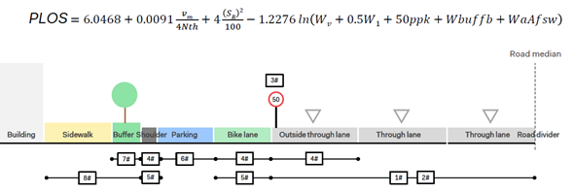

Figure 1- : PLOS variables

## 

## 

## 

## 

Section 3 - Relevant phenomena

Regarding the procedure to analyze the street quality the phenomena is defined.

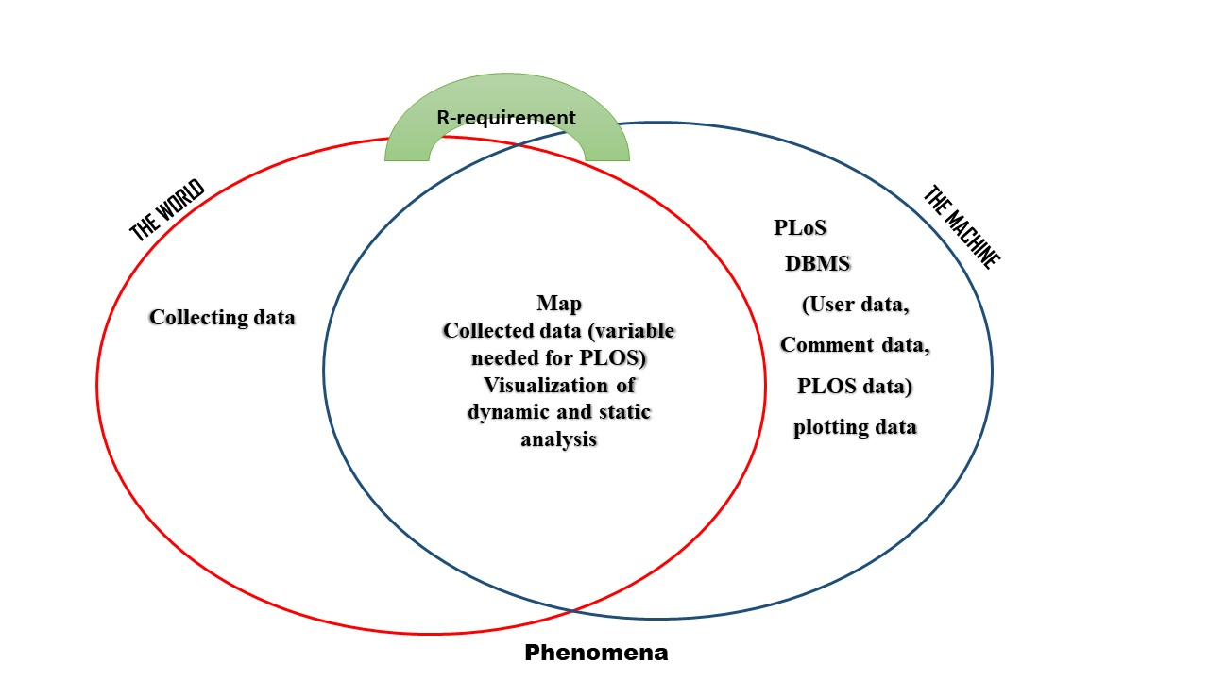

Figure 1- : Relative phenomena of the web application

As it is clear in the figure all parameters measured in the world have specific values in the machine so they are shared phenomena between the world and the machine. But the PLOS calculation and analyzing maps and graphs along with queries are just available in the machine. The requirements, which function as a bridge between these two will be explained for every specific Use Cases.

Table 1- 1: Relative phenomena of the web application regarding place and control

|  |  |  |  |
| --- | --- | --- | --- |
| Phenomena | Where they are located?  (W,S,M) | Controlled by  (W,S,M) | Short explanation |
| User starting to use the web app. | S | W | The system does not manage the process of using the browser by user. So, this happens outside the system control. |
| User registration | S | W |  |
| System connecting to the DBMS to store user data | M |  | The user is not able to observe machine phenomena |
| DBMS sending user data to the System | M |  |  |
| System sending confirmation to the user | S | M | The user does not have any control on this phenamena |
| User requesting log in | S | W |  |
| System sending the home page to the user | S | M |  |
| User sending request to visualize static analysis | S | W |  |
| User sending request to visualize Dynamic data | S | W |  |
| System connecting to the DBMS to retrieve user data (local or external) | M |  |  |
| System sending the data requested | S | W |  |
| System updating the data requested | S | W |  |
| User logging out | S | W |  |
| System sending registration page | S | M |  |

Section 4 - Use cases

Regarding to the aim of the web app and the phenamena, following user cases are defined:

* **UC1: User signs up**
* **UC2: User logs in**
* **UC3: User request to visualize static analysis**
* **UC4: User request to visualize dynamic analysis**
* **UC5: User send comment**
* **UC6: User log out**

Participating actors:

* **User**
* **spaVia (the web application)**
* **external servers**

UC1: User Signs up

### Flow of events:

* User sending the HTTP URL request through an internet browser
* SpaVia responds by sending registration page to the user
* User requests for sign up by posting the user and password
* SpaVia sign up registration/login page

### Entry Condition

True (the user has requested an HTTP URL)

### Exit condition:

* User case terminates when the user requests for login

### Exception:

* User stops using the app

### Requirements:

* SpaVia must guarantee the connection with its DBMS to store and retrieve the user data
* SpaVia must store the input data with single unique id.

UC2: User Logs in

### Flow of events:

* User requests to login by sending username and password (user data)
* SpaVia connects to DBMS and retrieve the user data
* SpaVia sends the home page to the user.

### Entry Condition

True (the user has requested an HTTP URL)

### Exit condition:

* SpaVia sends the home page

### Exception:

* User enters invalid data

### Requirements:

* SpaVia must guarantee the connection with its DBMS to store and retrieve the user data
* SpaVia must store the input data and retrieved data with single unique id.

UC3: User requests to visualize static analysis

### Flow of events:

* user requests the static analysis visualization
* Spavia connects to DBMS and retrieve the data
* Spavia responds by sending the graphs to the user

### Entry Condition

* True

### Exit condition:

* user log out using the app

### Requirements:

* SpaVia must guarantee the connection with its DBMS to store and retrieve the PLOS data

UC4: User request to visualize dynamic analysis

### Flow of events:

* user requests the visualize the dynamic map and analysis
* Spavia connects dynamically to DBMS and retrieve the data
* Spavia responds by sending the map and graphs to the user

### Entry Condition

* True

### Exit condition:

* user log out

### Requirements:

* SpaVia must guarantee the connection with its DBMS to store and retrieve the collected data
* SpaVia must connect to the browser of the user and let them visualize and query dynamically.

UC5: User send comment

### Follow of events

* User posts a comment
* SpaVia stores the comment in DBMS
* Spavia sends confirmation of comment to the user

### Entry Condition

* User writes in the comment box and press the send button.

### Exit condition:

* User log out

### Exception:

* User writes nothing and presses the send button.
* User writes longer than allowed character.

### Requirements:

* SpaVia must guarantee the connection with its DBMS to store and retrieve the PLOS data
* SpaVia must define the regulation for posted comments including lengh, type of the letters.
* SpaVia must guarantee the connection between the user data and comment data.

UC6: User Log out

### Follow of events

* User request to log out
* SpaVia responds by sending the registration page

### Entry Condition

* User sending the request.

### Exception:

* User has not been logged in

### Requirements:

* SpaVia must guarantee the connection with its DBMS to store and retrieve the user data
* SpaVia must store the input data and retrieved data with single unique id.

Section 5: Requirements and Domain assumption

Requirements:

* SpaVia must create the databases for each user case (possible to integrate some in a same database but the table should be define).
* SpaVia must store the input data also retrieved data with single unique id.
* SpaVia must guarantee the connection with its DBMS to store and retrieve the user data
* SpaVia must guarantee the connection with its DBMS to store and retrieve the PLOS data
* SpaVia must guarantee the connection with its DBMS to store and retrieve the collected data
* SpaVia must guarantee the connection between the user data and comment data.
* SpaVia must define the regulation for posted comments including length, type of the letters.
* SpaVia must connect to the browser of the user and let them visualize and query dynamically.

Domain assumption

* The data are precisely collected in all the areas.
* In case a parameter value is not available it is assumed to be zero.
* The coordinate system of the points containing the values has 10 meter accuracy with respect to the segments’ location.