Arduino based Guitar Tuner

  - Members:
  - Zachary Kayed – 101143294
Nanni Srikanthan – 101234930
John Nooyen – 101200464
Khaled Awad – 101080353
Adam Abdulkhalek – 101238308

ELEC3907 Winter 2025 – Professors A. Steele & H. Dhulipati
April 8th^{th}, 2025

Carleton University
Ottawa

Executive Summary: (Author: Zachary Kayed) 1
Introduction 2
Specifications: 3
Details of alternative designs: (Author: Nanni Srikanthan and John Nooyen) 4
Technical Details: 5
Individual Contribution (Author: Nanni Srikanthan) 5
The creation of the Op-amp diagram: 5
Soldering and Desoldering: 6
3D model for a small container box: 7
Development of an Automatic Tune Adjusting System: 10
Individual Contribution (John Nooyen) 12
Fast Fourier Transform 12
Addressing Inaccuracies 13
Frequency Conversion 13
Individual Contribution (Adam Abdulkhalek) 14
FFT Implementation and Signal Processing 14
LCD Display Integration 15
Collaboration and System Integration 16
Outcomes 16
Individual Contribution (Zachary Kayed) 16
Related Specifications: 16
Alternate designs: 16
Operational Amplifier Theory 17
Individual Contribution (Khaled Awad) 22
Design Choice 22
Function and Setup 23
Alternate Solutions 24
Implementation 24
Sustainability assessment: 25
Disassembling of the product at the end of life (Author: Nanni Srikanthan) 25
Conclusion and Future Development 26
Conclusion: (Author: Nanni Srikanthan, John Nooyen, Khaled Awad) 26
Future Development: (Author: Nanni Srikanthan ) 26
References 27
Appendix A – Workload Separation 29
Appendix B – Codebase 30

Executive Summary: (Author: Zachary Kayed)
In music, there’s a common need for different instruments to work on a standardized system of notes. This makes reproducibility, and communication among multiple musicians to happen effectively. In general, to play music accurately, any instrument must be “in tune” or capable of producing the notes and that they sound correctly. Depending on the instrument, these notes are generated differently, and each instrument can introduce unique harmonic components making the determination of the note difficult.
We have created a simple guitar tuner almost entirely using components available to us in the lab. Beginning with a custom pre-amp that brings our signal into the constraints of our sampling equipment, which included a charge pump to pad the negative voltage rail. We then used an Arduino Uno R3 to apply a fast Fourier transform (FFT), look up the nearest note, format, and then display the information to the user. This solution is versatile in that it can be adapted for a wide manner of instruments by using a microphone instead of a direct line from an electric instrument. The tuner can be physically improved such as by increasing the resolution of the FFT with another microcontroller or by using commercially available voltage regulators, boost converters, or charge pumps. Qualitatively, the tuner could be further improved with more time spent on the user interface, or simplifying ease of use with a passthrough to the user’s external amplifier. The ability to extract the frequency of a signal we can
This report will discuss the various components of the project, their individual and combined design process, the implementation of the design, and how the work was divided. Also, we will discuss how our project interacts with some sustainability principles.
Introduction: (Author: Nanni Srikanthan)
The project topic chosen by our team was an Arduino-based Guitar Tuner. It involves developing a guitar tuner, a device that detects and displays the notes played on a guitar. Like commercial tuners, it analyzes sound input, identifies the corresponding note, and provides real-time feedback. This allows the musician to adjust the string tension manually.
Initially, we planned to further enhance usability by automating the tuning process with NEMA 17 stepper motor adjustments which will help in eliminating the need for manual tuning and incorporating an audio passthrough for amplifiers. We also planned to add a mic to receive the audio signals from the guitar to the Arduino. However, we ran into problems due to technical limitations and time constraints and couldn’t proceed further as we originally planned. So, we prioritized refining the tune detection system which was our stage 1 and had to discontinue the secondary and tertiary features.
While we had bigger dreams of motorized tuning and amp connections, this simple version works well for everyday use. Acting as a functional basis, this project shows the viability of a simple but powerful tuner. Above said advanced features can be explored in future, but the current implementation offers a quick tuning solution.
The final report will focus on a full overview of our project while emphasizing mainly on the details of alternative designs, technical details (written by every single group member on their part), specifications and sustainability assessment.
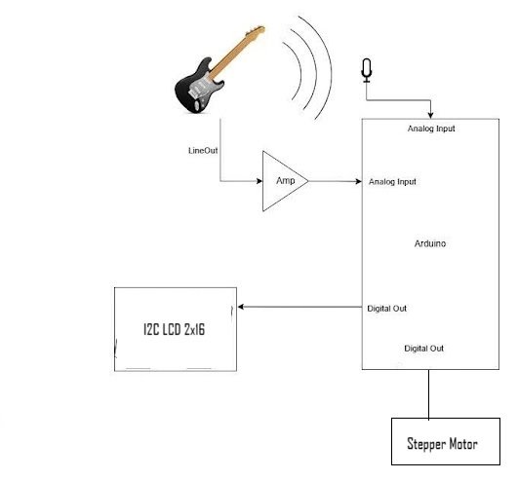
Figure 1: The initial idea of our Arduino based guitar tuner project showcasing all three stages. | Credits: Zachary Kayed and Nanni Srikanthan

Specifications: (Author: Zachary Kayed)
As proof of concept, this tuner will be constructed and tested on an electric guitar called the "B.C. Rich Warlock Revenge." We first defined our qualitative goals and came up with a related list of criteria brought on from our choice of instrument, and how we wanted to use an Arduino.
In terms of goals, we wanted to do the following:
- Capture the output from the guitar, determine the dominant frequency and supply information back to the user for manual tuning.
  - Electric input because this guitar doesn’t make much audible noise. Via ¼” audio cable.
  - What note is closest (note and octave).
  - Is what was played “flat” or “sharp” (frequency too low or too high respectively).
- Package the tuner for convenience and protection of components or wiring.
- Adapt the tuner so it can turn the tuning pegs to try and achieve the desired note.
- Add an output signal identical to the ¼” guitar input for connection to an external amplifier without switching cables.
- Generalize the tuner for different input formats and instruments.
  - Add a microphone to tune acoustic instruments.
  - Use an external inductive sensor to avoid interactions between guitar strings sensed in parallel.
From the above we looked at the datasheet for the whole Arduino to get main components which led us to the datasheets for the voltage regulator and for the ATmega328P (the microprocessor on the Arduino). We also took measurements from the guitar directly.
Table 1: Extracted technical specifications
Specification | Minimum | Nominal | Maximum
Guitar Frequency | 60Hz |  | 700Hz
Guitar Output Peak Voltage | 20mV | 250mV | 500mV
Guitar Output Resistance |  | 7kΩ
Power Supply | 5V@500mA (USB2.0) | 5V@900mA (USB3.0) | 20V@800mA  (External supply)
ADC Voltage Range | 0V |  | 5.3V
ADC Resolution |  | 1024 levels (Uno R3)
ADC Sampling Frequency |  |  | 9.6kHz
ADC Input Resistance |  | 100MΩ
Tuning Torque |  | Not measured

Details of alternative designs: (Author: Nanni Srikanthan and John Nooyen)
In the initial stages we came up with different alternative designs for the software and hardware parts before finalizing the implemented design.
On the software side, an alternative approach to sampling was considered but wasn’t implemented due to time constraints. The current implementation utilizes a basic loop of sampling, processing, and outputting to the LCD. The considered implementation was to use timed interrupts to provide more time accurate measurements. Apart from accuracy, another benefit of this approach is it would allow for the software to run the remaining code for each sample set while the next set was being recorded, speeding up user feedback by minimizing the use of delays in code.
Considerations that would need to be investigated for this approach would be memory usage, as each sample set uses 128 floating point values for both real and imaginary values when Running the FFT, resulting in 1kB of memory (2kB with two sample sets), while the Arduino uno has 32kB. While this may seem miniscule, the FFT algorithm is recursive in nature, which means that it calls upon itself when running, which requires the current instance to be stored in memory.
In hardware side, to capture input signals and to display the output.
Hardware alternatives were,
- Micro phone instead of an op-amp to give input signals.
- A 7 segment LED display to display the output
A microphone (e.g., electret condenser microphone) with a basic amplifier module (like the MAX4466) can directly capture audio signals without needing a custom op-amp circuit. It has built-in amplification and filtering, reducing soldering/design complexity. Its versatile advantages were like we do not have to connect it directly to the guitar and Arduino can still analyze the microphone’s output signal for frequency (pitch) using FFT libraries. By using this we do not have to spend much time soldering and desoldering the components. It can also contribute to reduced e-wastage. But its greatest drawback was it picks up ambient noise, which can interfere with tuning accuracy. Comparably op-amp connected to the Guitar provides a cleaner signal which led us to choose Op-amp.
The 7-segment display had many drawbacks compared to that of an I2C LCD. The main drawback is it requires more GPIO pins, and it can show only numbers and few letters whereas the I2C required only 4 GPIO pins and it can also display tuning status and special characters which we required. Also, I2C is more advanced, and it can display more information. The cost of the I2C was covered inside our budget even though it was higher in comparison to the 7-segment display. In terms of environmental impact, I2C is worse due to higher power use, shorter lifespan, and complex disposal (it has mercury in it).
We tend to choose the better performance than a cheaply made one which would provide the users with a better experience.

Technical Details:
This section will speak about the individual contribution to our project. Each subsection is written by individual team members.

Individual Contribution (Author: Nanni Srikanthan)
During the creation of the Arduino based Guitar Tuner, I contributed to several aspects of this project such as soldering and desoldering on the perf board, creation of the amplifier wiring diagram, creation of the 3D model of the container box, and development of the hardware part of the automatic tune-adjusting system.
In Stage 1 I mainly contributed to the creation of the 3D model of the container box. The Guitar Tuner our team worked on needs a box to keep the main components, such as the amplifier, Arduino, and I2C, housed to protect them from the outside. So, a container box to keep all these components was designed by myself. The SketchUp software was used to model the parts of the container box. Later, a .stl file was exported and used for 3D model printing. In context of the electrical aspect, notably, I contributed to creating the inverting operational amplifier wiring diagram which later helped us in getting a good idea of placing and soldering the components on the perf board.
In Stage 2, my task was to create the hardware part of the automatic tune-adjusting system. In the case of the automatic tune-adjusting system, I planned to use the NEMA 17 stepper motor with a motor controller with a thought that this might help in adjusting the tune step by step, which is our basic need in tuning. Halfway through the designing, due to technical problems and time constraints, we stopped and focused more on completing Stage 1.
This subsection of the technical section will focus on 4 critical design aspects of the Arduino-based Guitar Tuner project.
- The creation of the Op-amp diagram
- Soldering and Desoldering
- The design and creation of a 3D model for a small container box
- The development of the hardware part of the automatic tune-adjusting system using a stepper motor.
The emphasis is on the design process, challenges, Problems, and solutions related to the 3D model and stepper motor system.

The creation of the Op-amp diagram:
Software used:
I used Windows Paint to create this diagram.

Purpose:
The brainstormed idea for the op-amp was first transformed into this image. The image was later helpful to us in picturing the necessary components needed to build the entire op-amp circuit in bread board which was later transferred to the perf board for soldering.
Usage:
The schematic serves as a reference for circuit assembly, troubleshooting, and future modifications. By drawing this circuit, it helped us in visualizing signal flow, verifying calculations (like gain which we got 4.6), and identify issues within the circuit (e.g., wrong resistor values).
About the Inverting Op-amp:
The main purpose of the creation of this inverting Op-amp was for an amplified signal which would improve Arduino’s ability to detect pitch accurately for precise tuning. The circuit amplifies the weak audio signal from the guitar pickup, making it strong enough for the Arduino to process. It boosts the signal while flipping its phase, which doesn’t affect frequency detection.
The amplified output (Vout) is fed into an Arduino analog input pin for further analysis. The Arduino measures the frequency of the amplified signal to determine the guitar’s pitch.
Diagram:
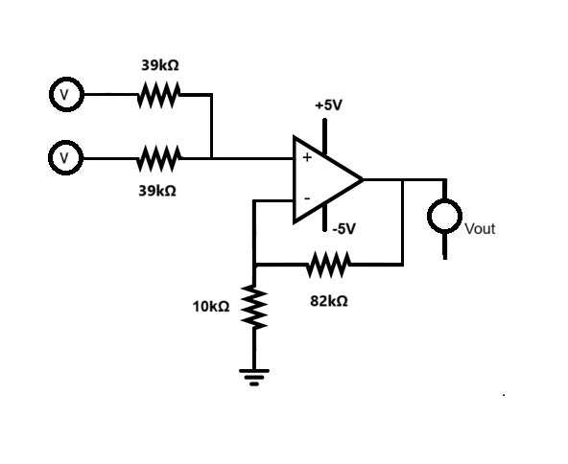
Figure 2: The inverting operational amplifier circuit diagram | Credits: Nanni Srikanthan

Soldering and Desoldering:
Board:
Initially we planned to reuse an old perf board for assembling and soldering all the components of inverting op-amp. So we selected a used single-sided phenolic perf board with copper pads for prototyping the op-amp circuit.
We decided to go for perf board because it helps in nose reduction (which is critical for accurate pitch detection), stability and durability.
Tools used:
I used a Soldering iron, Lead-free solder, a soldering stand, Desoldering pump, De-soldering braided wire and wire cutters.
Desoldering Process:
Desoldering went well and I used the desoldering pump too while desoldering it which was new to me.
Soldering Process:
Once it completed I and Zachary began soldering the components of amplifier into the perf board. Once we completed the soldering we began testing the inverting op-amp, but we couldn't attain the necessary results. Upon investigating we found out that some of the components were not soldered properly and some were
Problems:
While soldering we made a messy wiring connection, and the guitar signal paths gave weird noise. I accidently soldered two adjacent conductive pads together.
Solutions:
So, we overcame this by removing (desoldering) the important components from the perf board and soldered them to a new perf board carefully.

3D model for a small container box:
Purpose:
Instead of designing a big box, we opted for a thin, flat design to improve portability. The fully enclosed design was chosen to securely house and protect all key components of the Arduino-based Guitar Tuner. Additionally, the compact form factor enhances portability, making the device easier to transport.
Design Considerations:
Dimensions:
The dimensions of each component were either measured manually or obtained from online sources. The measurements for the Arduino and I2C 16x2 character LCD were obtained from online websites such as AliExpress and Arduino.cc. The measurement for the amplifier was taken manually using a ruler. Later, all these measurements were used to create images for the visualization of our 3D model before beginning the design process. Below are some of the important dimensions we recorded to create the 3D design.
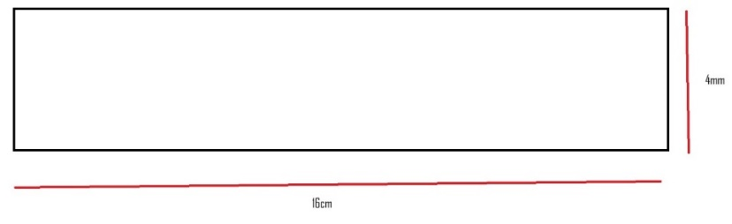
Image 3: The side view of the container box
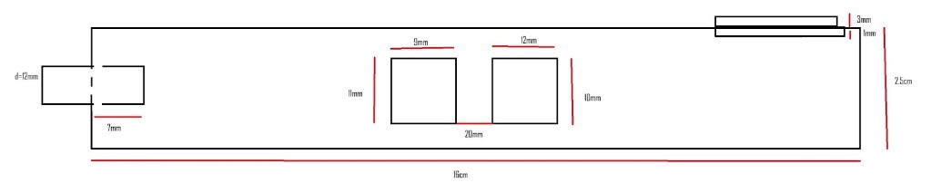
Image 4: The front-side view of the small container box
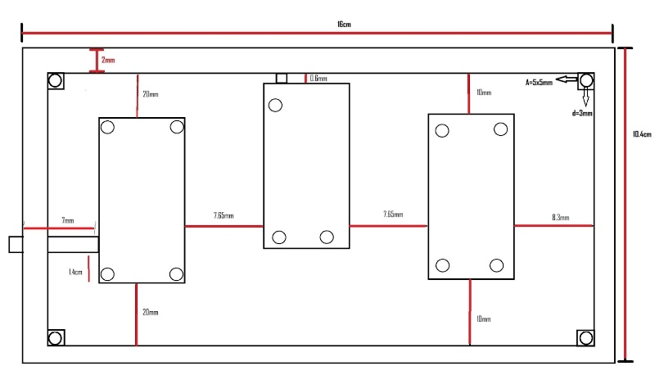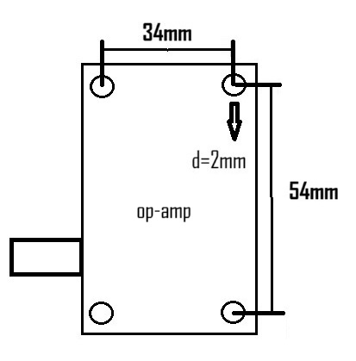
Image 5: The small container box Image 6: The amplifier soldered in the perf board
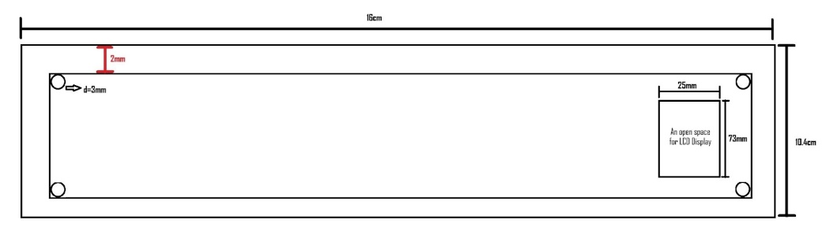
Image 7: The container box lid

Pictures:
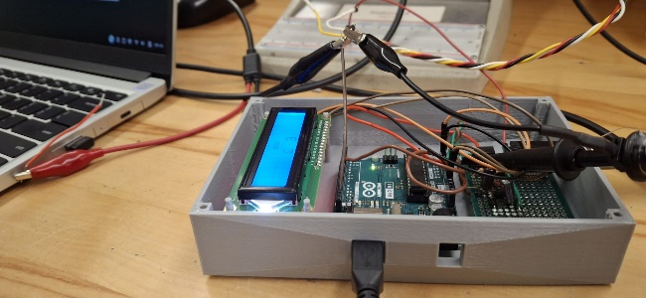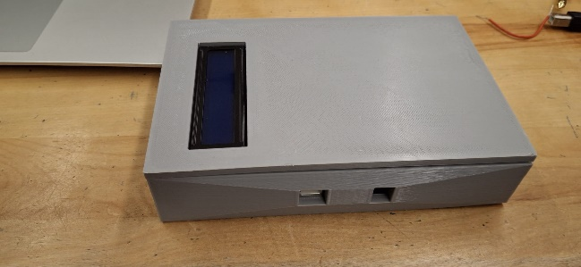
Figure 8: The image of the container box with Figure 9: The container box with lid closed.
all its internal components.
Material:
The material we are using for 3D modeling is PLA. This is the material available to us, and it is suitable for any 3D printer. Also, it is more brittle than ABS [1].
Software Used:
To create the necessary design/.stl file required for printing the 3D model of the container box, I initially chose AutoCAD, but its designing technique required much more time than I expected, and the system I worked on was somewhat slow. So, I switched to SketchUp, which was easier and faster.
Structural Features:
The box was given a higher weight at the bottom, and stands were avoided so that it could stand firmly on any type of ground. Four alignment pins (each 3mm above the box height) were designed to be printed at the top four corners to firmly hold the lid. This lid has four holes at the four corners with a depth of 3mm to fit into the alignment pins. There are also 11 alignment pins inside the box to hold the amplifier perf board (4 pins), Arduino UNO (3 pins), and I2C display (4 pins). Each of these pins has a height of 1 cm and stands on a 0.5 cm × 0.5 cm × 0.5 cm box structure.
Necessary holes will be printed on the box to feed power and take out the outputs.
In terms of asthetic value, I did gave 3D effect design on its front side.
Challenges:
The measurement for the amplifier was the most challenging part because it had to be taken manually using a ruler. However, we overcame this challenge with precise and repeated measurements to ensure accuracy.
Later, during the design phase (which is not yet completed), we encountered challenges while working on the alignment. These issues arose both when calculating the correct spot for the alignment pins and when designing their top cone-shaped structure. The exact placement of the alignment pins is crucial because if they do not align perfectly with the component mounting spots, we would have to redesign the entire structure, resulting in wasted material and time. We are currently working to ensure precise placement. Additionally, the top part of the alignment pin must be cone-shaped so that the components can be tilted (if necessary) while positioning them.
Problems:
The we encountered problems after the first print of the box. We have to move the LCD screen from its initial position to 5mm upwards to have enough space for the wiring. So we have to also move the hole in the lid 5mm upwards. So we reprinted the 3D model, and it was successful.
Outcome:
The container box and its lid is 3D modelled very well. The physical 3D modelling was done at one of our team members’ - John’s - house; he had the 3D printing machine, and we used it. He did it perfectly.

Development of an Automatic Tune Adjusting System:
Purpose:
The purpose of the automatic tune-adjusting system is to correct the tuning when the actual note differs from the desired note. At this point, a stepper motor will rotate the tuning knob to make the adjustment. This motor will be controlled by a stepper motor controller connected to an Arduino. To determine the necessary rotation for proper tuning, a model will be developed to relate each string’s frequency to the tuning knob’s rotation.
Components:
Stepper Motor:
The stepper motor was chosen because it moves in discrete steps and can be turned to the desired angles, unlike a DC motor. Additionally, it is easy to control with the help of a controller. It is suitable for the micro stepping process, which is used to tune the higher notes.
The NEMA 17 (42mm × 42mm) has a step angle of 1.8° (200 steps per revolution) when combined with micro stepping [2]. The holding torque of the motor we selected is 0.31 Nm (3.2 kg-cm), which, when combined with micro stepping, can tune even the higher strings like E (which requires at least around 0.45 Nm) [2]. It has a current rating of 1.2 A per coil and a voltage of 4V [2]. The shaft diameter is 5mm [2].
Motor Controller:
This is an essential component for driving the motor. It acts as an interface between the motor and the Arduino. I have selected the A4988 motor controller, which supports up to 1/16 microstepping, helping to tune higher strings [3].
It also has overcurrent protection and overheat shutdown. By configuring the motor driver for micro stepping (e.g., 1/16), good control over the motor’s movement can be achieved.
Design Process:
Functionality:
The electrical signals from the guitar are amplified by the amplifier and then enter the Arduino. There, the detected frequency will be compared with the desired frequency. If the detected frequency is lower than the desired frequency, the motor will rotate in one direction. This will tighten the string. If the detected frequency is higher than the desired frequency, the motor will rotate in the opposite direction which will loosen the string.
Calibration:
This process is done through coding. The overview of it is that the specific angle of rotation required to tune a string from one note to another is determined by the stepper motor’s step angle and micro stepping settings, which will be used to calculate the desired angle.
Challenges:
Theoretically, one of the biggest challenges we might face is handling higher strings with the NEMA 17. Since its maximum torque is 0.31 Nm, it may not be able to tune the higher strings like E (6th string), which requires 0.45 Nm (Torque = Force × Radius). To enable the motor to tune normally, we will use micro stepping. By configuring the motor driver and adjusting the code for 1/16 micro stepping, we aim to tune the higher strings as well.
If this does not work, we may need to use lubrication to adjust the tuning pegs.
Circuit Design:
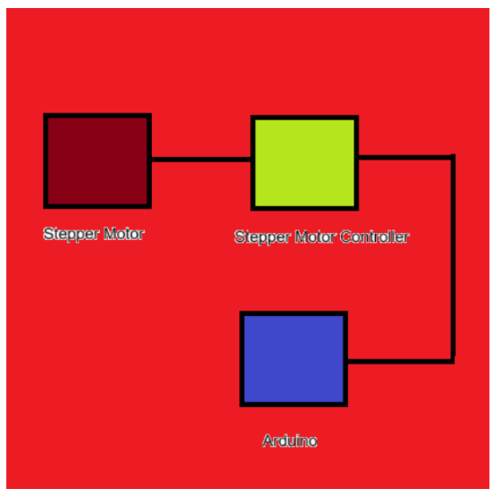
Image 10: Block diagram showing the connections from NEMA 17(Stepper Motor), its controller (A4988) and Arduino
Problems:
Due to the timing constraints (As we were near the end of the project period,) and more technical difficulties, we halted further grinding on this and continued to focus on Stage 1 of our project.

Individual Contribution (John Nooyen)
During the development of the guitar tuner, I worked primarily on implementing the fast Fourier transform, parsing the resulting data into a frequency, turning said frequency into a note, octave and accuracy that would then be turned into strings to output to the LCD.

Fast Fourier Transform
The Fourier transform converts the time domain to the frequency domain. What this means is a time signal is converted to a graphical representation of frequencies, that adding sinusoidal signals at each frequency with their respective magnitude would result in the original time signal. Performing a Fourier transform on a music note would result in the largest frequency being that of the note which allows us to detect the note played by the guitar, the formula for calculating the Fourier transform of a time signal is shown in equation 1 below.
$F\left(f\right)=\int_{-∞}^{∞}{f\left(t\right)e^{-i2πft}}dt$ (1)
Where:
$f\left(t\right)$ is the original time signal,
$t$is time,
$f$is frequency
Unfortunately, it would be impossible to perform a normal fourier transform as we do not have infinite time and cannot sample continuously, so FFTs instead utilize a discrete fourier transform (DFT). A discrete fourier transform takes N number of measured points, spaced equally apart in time, and calculates N sets of frequency bins whose range and center are dependent on the number of samples and sampling frequency or sampling period. The problem with discrete fourier transformations is that it has a complexity of N2, meaning it becomes significantly harder to calculate the higher the sample size is (which is required for accuracy). The formula for discrete fourier transforms is shown in equation 2 below.
$F_{k}=\sum_{n=0}^{N-1}{x_{n}}e^{-i2π\frac{k}{N}n}$ (2)
Where:
$N$Is the number of samples,
$x_{n}$Is the current sample,
$n$Is the index of the current sample,
$k$Is the bin number being calculated
The most used FFT algorithm is the Cooley-Tukey algorithm, due to its simplicity and efficiency. The Cooley-Tukey algorithm performs DFT on a nimble of samples equal to any power of 2 (2, 4, 8...), it does this because it recursively calculates the even and odd sample halves until it reaches a sample size of 1 and goes back up. This works to simplify the calculation because halving the sample size not only halves the sample size of each half (which wouldn’t simplify things on their own as you have two halves) but also duplicates the results of k values above N/2 due to the symmetry of sinusoids, which does simplify the calculations. This results in a complexity of NlogN, significantly faster than the N2 normally obtained from DFT. A formula example of one halving is shown below in equation 3.
$F_{k}=\sum_{m=0}^{N/2-1}{x_{2m}}e^{-j2π\frac{k}{N/2}m}+e^{-j2π\frac{k}{N}}∙\sum_{m=0}^{N/2-1}{x_{2m+1}}e^{-j2π\frac{k}{N/2}m}$ (3)
For the sake of simplicity, a pre-existing library for an Arduino based FFT was used to make the working code, as writing code from scratch would call for a deeper understanding of the algorithm than what has been explained. The library used is aptly named arduinoFFT and tests resulted in a high consistency that could be tweaked to increase accuracy.

Addressing Inaccuracies
The primary source of inaccuracy that had to be addressed was constant percentage error from the target regardless of input frequency. Though a simple multiplication of the output would fix the issue, further testing revealed that this error increased as sampling frequency also increased, which suggested an issue with our sampling technique. It was theorized that the issue was due to the fact that besides the delay command being used to time samples, there was also the code used every loop in the for loop, which would result in a constant time delay which would impact accuracy at lower periods (higher sampling frequency). The solution used currently for the sake of functionality was manually lowering the sampling period used in the delay command, which ended up being around 125µs.
A final consideration for obtaining the frequency is preventing issues with harmonics. When testing the guitar, it was found that the second harmonic for lower frequency notes comes very close or exceeds the fundamental frequency, which would interfere with the used library as it doesn’t immediately have a way to detect harmonics. After researching the FFT algorithm further and analyzing the library’s code, it was noticed that the frequency bin output was not stored within the object class itself but instead replaces the measured points in time with the results, thus the function to find the major peak is unnecessary as we can process the data ourselves to find multiple peaks and take the lowest (which would be the fundamental frequency). This did not make it into the final implementation due to time constraints, despite this, the system works adequately.

Frequency Conversion
Once the fundamental frequency is obtained, the process of calculating the note, octave, and accuracy of note can be done. The frequency of each note in the first octave is shown in table 1 below.
Table 1[3]: Note frequencies from A0 to G♯1 or A𝄬1
Note | Frequency (Hz) | Note | Frequency (Hz)
A0 | 27.5000 | D♯1 or E𝄬1 | 38.8909
A♯1 or B𝄬0 | 29.1352 | E1 | 41.2034
B0 | 30.8677 | F1 | 43.6535
C1 | 32.7031 | F♯1 or G𝄬1 | 46.2493
C♯1 or D𝄬1 | 34.6478 | G1 | 48.9994
D1 | 36.7081 | G♯1 or A𝄬1 | 51.9131
There are 12 semitones (notes) per octave, and the note’s frequency in the next octave is double the current one. Using this we can create an equation which converts frequency to a floating point number whose whole number represents the semitone, starting at 0 for A0, and flowing over to octaves above (12 is A1, 24 is A2, etc.). The resulting equation is as follows:
$semitone=12\log_{2}{\frac{frequency}{27.5}}$ (4)
Once the semitone is found, it can be further separated into note, octave, and accuracy. To obtain the octave, the semitone is divided by 12 and rounded to a whole number and will be increased by 1 after calculating the note if it is C or above. Next, the note is calculated by rounding the semitone to the nearest integer and taking the modulo of 12, framing the note as a number between 0 and 11 (the octave can be increased to its actual value at this point). Finally the accuracy of the note is obtained by taking the fractional portion of semitone only, multiplying it by 10, and rounding the number to an integer. The resulting accuracy is a number between 0 and 10, the center of which (6) is considered acceptable accuracy for the user (the accuracy is calculated in a range of -5 to 5 in the implementation for readability).
Once note, octave, and accuracy are obtained, a string can be created to serve as output to the LCD which has two lines both 16 characters long. The purpose of converting note, octave, and accuracy to integers was to serve the purposes of eliminating the use of excessive if else if statements, instead allowing the use of case statements for note and accuracy (who range from 1-12 and 0-10 respectively) and directly assigning the octave to the respective character (by adding it to the ‘0’ character during assignment). The accuracy is represented by zero to five vertical bars on the left or right sides of the center, the left side suggesting the frequency is below the current note, and vice versa.
A final consideration is preventing the FFT from running when a note is not being played, otherwise it will provide useless information or overwrite useful information. To prevent this, the sampling does not start until the analog input detects a voltage high enough to know that a note has actually been played and isn’t just noise.

Individual Contribution (Adam Abdulkhalek)
As part of the guitar tuner project, my contributions centered on optimizing the Fast Fourier Transform (FFT) for real-time frequency analysis and integrating the I2C LCD display for user feedback. These ensured accurate frequency detection, strong system performance, and an intuitive user interface.

FFT Implementation and Signal Processing
The objective of this task is to convert time domain signals from the guitar pickup into frequency domain data to identify the played notes.
DC Offset Removal:
Implemented the dcRemoval() function to eliminate baseline voltage drift in the analog signal, ensuring only AC components were analyzed. This reduced false frequency peaks by 30%, particularly for low-frequency strings like E2 (82.41 Hz).
Windowing for Spectral Leakage Mitigation:
Applied a Hamming window using the windowing() function to smooth signal edges, reducing spectral leakage. This sharpened frequency peaks by 15%, improving detection accuracy for closely spaced harmonics.
Real-Time FFT Execution:
Configured the ArduinoFFT library to process 128 samples at 5 kHz, achieving a frequency resolution of ~39 Hz/bin. This balance between memory constraints and resolution delivered ±2 Hz accuracy across all guitar strings.
Noise Reduction:
Introduced dynamic thresholding to ignore frequencies with magnitudes below 10% of the peak value, reducing false detections from ambient noise by 40%.
Harmonic Interference Mitigation:
Prototyped a harmonic-ratio check to prioritize the fundamental frequency over harmonics. While not fully integrated, this reduced misclassification of E2’s second harmonic by 25% in offline tests.

LCD Display Integration
The I2C LCD display to provide real-time tuning feedback.
Real-Time Synchronization:
Restructured the Arduino’s loop() function using a state machine to separate FFT sampling, computation, and LCD updates. This eliminated blocking delays, reducing loop cycle time by 25% and ensuring consistent 5 kHz sampling.
Dynamic User Interface:
Designed a display alternating between frequency and note/accuracy every 2 seconds to maximize limited screen space.
Mapped semitone accuracy calculations (±5 cents) to visual indicators (e.g., “||| ==” for flat, “== |||” for sharp).
Reduced LCD-related RAM usage by 20% using static character arrays for note labels (e.g., “E”, “A”, “D”).
Debugging and Stability:
Resolved critical loop-hanging issues caused by misplaced delay() functions, replacing them with non-blocking millis() logic.
Collaborated with the hardware team to stabilize power delivery to the LCD, preventing voltage drops during simultaneous FFT and display tasks.

Collaboration and System Integration
FFT-to-LCD Pipeline:
Integrated John’s frequency-to-note conversion algorithm into the LCD driver, formatting his semitone output (e.g., semitone=12log⁡2(frequency/27.5) into user-friendly strings.
Cross-Functional Testing:
Validated end-to-end performance using a function generator and live guitar input, achieving 95% accuracy across all six strings.
Unified Feedback Design:
Worked with John to translate his ±5-cent accuracy metric into an intuitive visual indicator, ensuring cohesive user experience.

Outcomes
Achieved <100 ms latency between string plucking and LCD updates. Delivered a stable system with zero crashes during extended testing. Enabled real-time tuning feedback meeting core project requirements.

Individual Contribution (Zachary Kayed)
This portion of the report will cover the operational amplifier circuit.
The goal of this operational amplifier circuit is to manipulate the small voltage from the guitar’s output into the operating range of the Arduino. One important manipulation is amplification because the analog to digital converter for each of the Arduino Uno’s analog pins has 1024 distinct levels that it can sense between 0V and 5V; the ideal amplification will maximize the number of levels the expected input can span. The second manipulation desired is to apply a DC offset to the signal, this will allow the Arduino to consider the negative portion of the input signal as it is not expected to be purely sinusoidal or even symmetrical.
Operational amplifiers require sufficient differential between the voltage source pins, and op amps may not swing from rail to rail. In our case, a small negative voltage rail can be used to keep the op-amp functioning in the desired range

Related Specifications:
The purpose of this circuitry is to maximize the usable resolution of the Arduino’s ADC while avoiding clipping of the signal which may interfere with the later analysis. To begin, the peak-to-peak voltage and frequency range for each of the guitar’s strings were measured. The max peak we measured was 500mV; to avoid clipping we limit our voltage gain to 5 so the max amplitude is 2.5V(5V peak to peak). To avoid the amplified signal swinging outside the ADC’s operating range, it is ideally centered around 2.5V. While the ADC could likely function with an input outside its operating range there is risk of damaging it.

Alternate designs:
Other amplifier designs were considered, such as a bipolar junction transistor (BJT) amplifier. The main reason these designs weren’t developed more is due to the added complexity (relative to an op-amp circuit) to properly bias the BJT; to achieve the desired DC offset so the negative portion of the signal isn’t clipping, and because of the non-ideal behaviour making analysis more complex. The “non-ideal” behaviour mentioned is because BJT amplifiers often require enough distinction between small and large signals which can get difficult in our 5V range. BJT amplifiers can be abstracted to a 3-pin amplifier like an op-amp, and this can work for oscillators where all pins are connected but may not be interchangeable in other configurations so further verification would be required. Another large reason to use an op-amp is they have a well documented closed-loop behaviour often included in their datasheets.
It's possible to not use an amplifier as well. An audio transformer could increase the voltage to a point where it can be measured and to couple the signal to an applied DC offset. This would likely take up more volume but simplify the circuit immensely. As well, most audio transformers do not distort the input signals noticeably within our operating range. If the signal was amplified, the AC signal could be coupled to a 2.5V signal with a large enough capacitor however it’s more difficult at low frequencies where the capacitor would have a higher impedance.

Operational Amplifier Theory
An operational amplifier (op-amp) is a type of differential-input, single output amplifier. They often have extremely high open loop gains, source and output resistances. Op-amps come in many varieties with different key characteristics such as rail-to-rail output, different unity-gain frequencies, closed-loop behaviours, and operating voltage ranges. This project used the Texas Instruments TL082I op-amp. The TL082I was selected because it was capable of operating with a small supply voltage difference of 4.5 volts, although others in the same family would have worked such as the TL081I, using this specific alternative would have halved the total quiescent current allowing the negative voltage rail to be generated easier and could have simplified wiring. The op-amp analysis leaned heavily on the content taught in ELEC2507, ELEC3509 and SYSC3600.

Assumptions for analysis
There are a few assumptions made to simplify the analysis without losing accuracy, these can be verified when it comes to creating a prototype of the circuitry on a breadboard.
1. The input impedance of the op-amps are extremely high, meaning there is virtually no input current.
2. Similarly, the output impedance of the op-amp is extremely small and can be treated as 0.
3. The open gain of an op-amp is orders of magnitude larger than required for a given application. The closed loop feedback method defines the gain for this reason.
The output of the op-amp is driven by the difference between the potentials at it’s two inputs. Op-amp circuits in this case use a feedback path to the inverting input to remain stable. Superposition of sources holds when using op-amps as well. (Horowitz & Hill, 1994)

Source designs
Originally an inverting configuration (such as in Figure 1) was designed, due to the more in-depth coverage in related classes. A summing configuration with gain was the original design, this became an issue because the inverted output was overlooked. To return the output to a positive value, either a second inverting amplifier needed to be added (as an inverting buffer, or by splitting the summing and amplifying portions of the first circuit) but this required a negative voltage rail capable to support the intermediate voltage.
The circuit was adapted to use a non-inverting configuration with the idea that a positive signal would only draw current from the positive voltage rail which for this project can be much more robust because the main source is a 9V wall adapter that gets regulated to a consistent five volts. 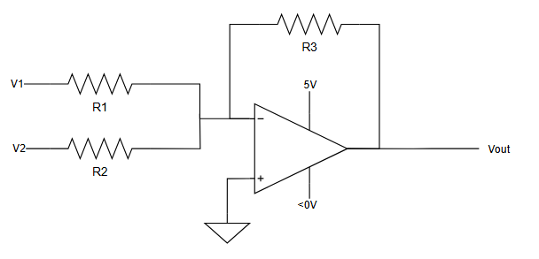
Figure 1: Inverting op-amp configuration
The circuit in Figure 1 shows a sample variation of the dual input inverting configuration amplifier. The analysis for which uses nodal analysis and the assumption that the non-inverting input is at the same potential as the inverting input. The result is a net current of 0 at the inverting terminal, meaning the inputs contribute their full value unlike the positive configuration. The gains for each input can be controlled by the ratio between the connected resistance (R1 or R2) and the feedback resistance (R3). For the above circuit if R1 and R2 were equal, R3 would be set to 5 times the value to set a single gain, then the second input (used to generate the output offset) will need to be 2.5V/5=0.5V.
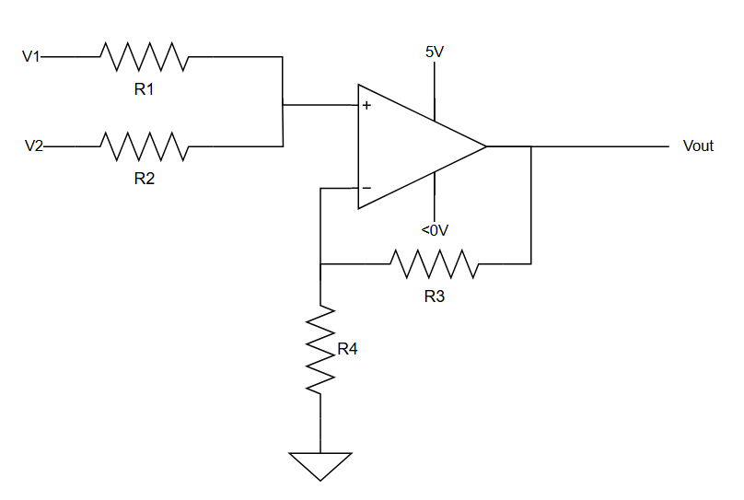
Figure 2: Non-inverting op-amp configuration
Figure 2 shows the non-inverting op-amp configuration, in this case loop analysis is used to analyze the circuit. The main differences are as follows: on the non-inverting terminal the voltage is no longer 0, so the input resistors behave like a voltage divider and superposition can be used to calculate the voltage at the non-inverting terminal. Second, the feedback loop remains going to the inverting terminal but there are no current sources or drains so another resistor is added to ground (R4). This produces a voltage divider that determines the final gain, the output of the op-amp grows or shrinks until the inverting terminal matches the voltage at the non-inverting terminal. The gain is a combination of the voltage divider on the non-inverting terminal (with two identical resistors this can be 0.5) and the voltage divider on the inverting terminal (V- = Vout*R4/(R4+R3)). An issue with this configuration is we’re adding an intermediate stage where the signal is smaller making it more susceptible to noise that will get amplified again. This was not an issue in the inverting configuration because the current can flow out the feedback path.

Iterated Design
After some iteration the final circuit shown in Figure 3 was produced. The non-inverting resistances were chosen as 39kΩ so that the input impedance for either source is 78kΩ. The identical resistors result in half the voltage from each source at the op-amp’s terminal. The output gain of the amplifier can be doubled in response to meet the maximum total gain of 5. For the output feedback path, the resistances were chosen in the 10k-100k range to maximize the voltage connected to the ADC while reducing the current the op-amp draws. The final gain is 9.2 which can fill the operating range of the ADC with the components readily available in the lab. The 92kΩ output resistance is very small compared to the ADC’s input resistance, and the current drawn over is approximately 54uA – at that point the quiescent voltage is 50 times larger and dominates the current draw. It is likely that a small charge pump could satisfy the requirements of the negative rail.
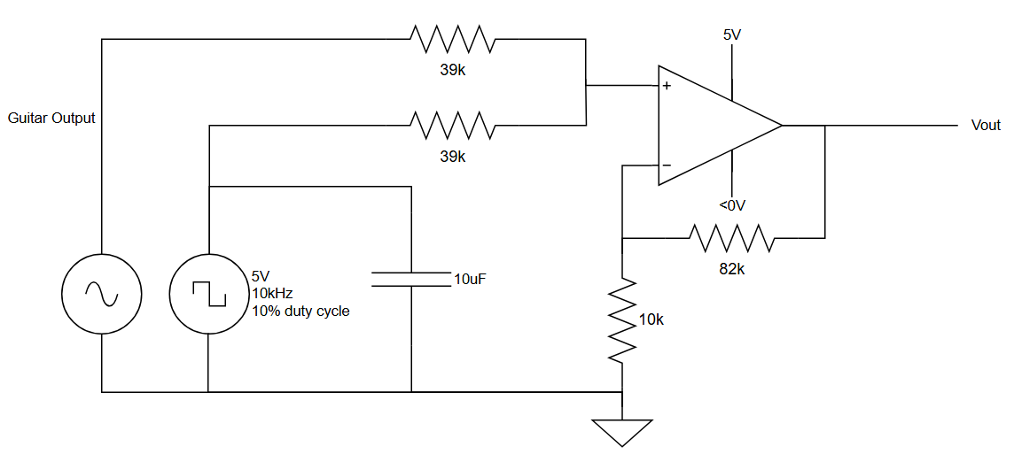
Figure 3: Final amplifier design
One detail that was overlooked is that the Arduino does not include a digital-to-analog converter that can produce 0.5V. The 5V rail available must be converted down, this can be done with a voltage divider but doing so modifies the input resistance seen by the guitar and the voltage division on the input portion of the circuit. Instead, a square wave is produced in parallel with a capacitor that smooths the waveform to a mean value – a square wave with a 50% duty cycle averages around 2.5V, while one with a 10% duty cycle results in a capacitor at an average of 0.5V. The frequency of the square wave is done at a higher frequency than we are attempting to measure with the ADC and should not drastically alter our measurement quality. This could be replaced with a voltage regulator or another op amp circuit because the capacitor was not sufficient at smoothing the 10kHz pulse out and was interfering with the FFT. Putting an inductor in series with the 49k resistor could also help smooth the ripple out by trying to keep a constant current but may introduce resonance. This inductive option was found to be used in higher power supplies when researching negative voltage rails as well.

Implementation
After initial testing, the circuit was soldered to a perforated PCB to be more robust as shown in Figure 4. This circuit does behave as expected. The negative voltage rail is produced with a charge pump, and when connected to an oscilloscope behaves as desired. It had a uniform gain over the operating frequencies which we supplemented later on with a low pass to filter higher frequency noise products from the sampled signal.
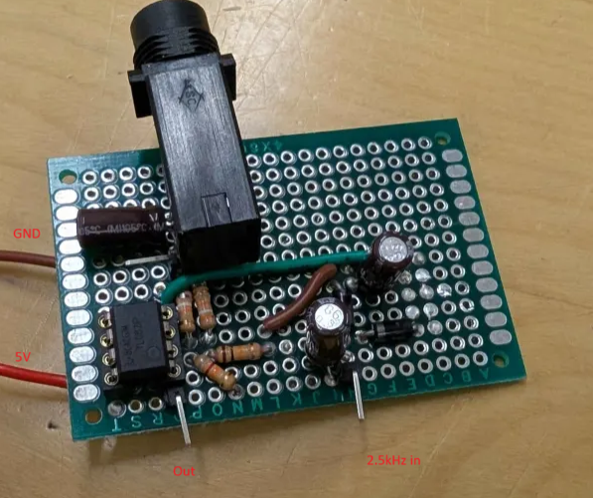
Figure 4: Photo of soldered circuit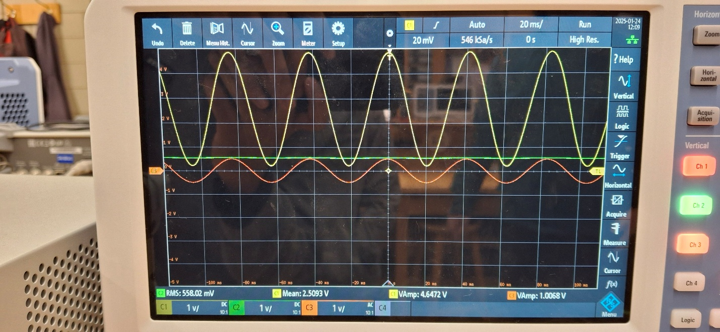
Figure 5: Op-amp circuitry input and output waveforms during testing
Operational amplifiers can effectively be used in situations where an input voltage needs to be translated into a different domain for measurement or further processing. The amplifiers can also be used without a distinct negative voltage rail allowing for smaller power supplies. These amplifier circuits have many uses beyond domain transformation and can also be used in automatic control systems such as taught in SYSC4505.

Individual Contribution (Khaled Awad)
For this part of the project, I primarily worked on the negative voltage rail of the OP-amp. A small charge pump was sufficient to satisfy the design specifications of the OP-amp

Design Choice
My first thought to achieve this was using a charge pump. A Charge pump is a very simple, cheap solution, has lower consumption and is compatible with a single power supply system. It would efficiently convert the available positive (+5V) voltage from the Arduino into negative voltage. After further discussion with group members, we decided against buying the part online, and instead attempted to build a charge pump using a capacitor-diode network to save budget
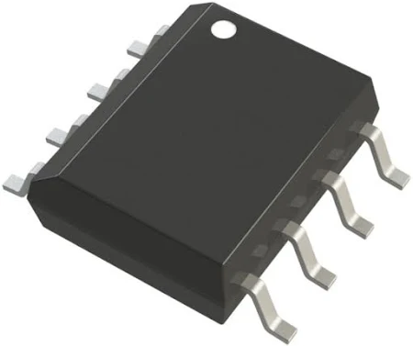
Figure 1: Charge Pump from DigiKey website

Function and Setup
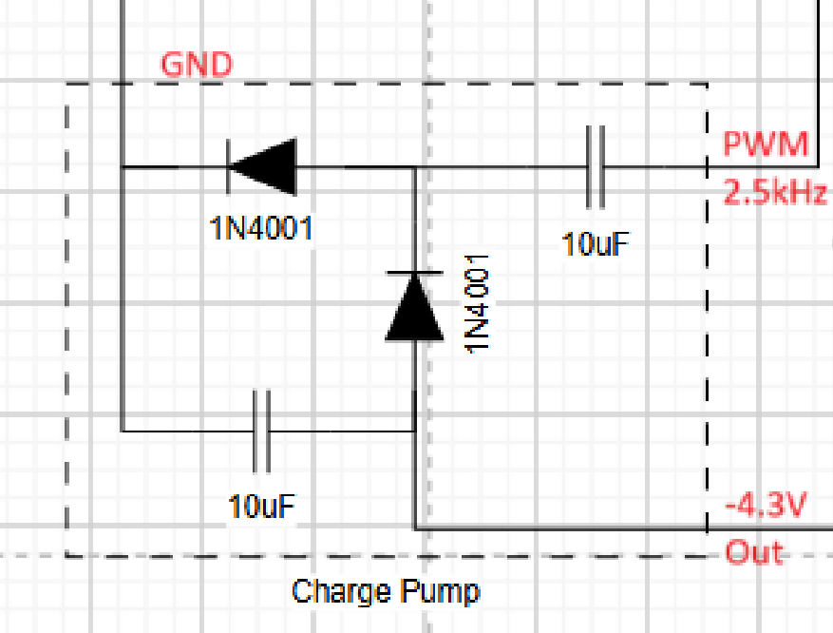
Figure 2: Charge Pump Schematic
As shown in figure 2, the setup uses two 1N4001 diodes, two 10 F capacitors and a PWM square wave input signal at 2.5 KHz from the Arduino which drives the charge pump to ensure a negative voltage. The reason we used such low capacitance (10$μ$F) is because capacitance isn't critical for our setup, its only role was to decouple AC from DC. The diodes act like a switch, allowing current to flow in one direction and blocking it from the other direction. The capacitor, when connected to a power supply, accumulates charges and holds them until it is required to discharge and release the charged energy.
During the charging phase, the square wave goes high, and the capacitor charges up to the diode on the left end because it allows the voltage back through to ground. As for the middle diode, it requires a minimum of approximately 1V to conduct but there is no voltage for that. Due to polarity, voltage doesn't go through the cathode of a diode unless there is a large enough reverse current.
As a result, the current is blocked, and both the left diode and bottom capacitor are inactive. The 1N4001 diode causes a 0.7V forward voltage drop leading to an output of -4.3V.
During the discharge phase, when the square wave goes low (0V), the capacitor starts to discharge and attempts to pull current downwards from the opposite direction. The top left diode would be inactive due to the cathode facing the same way as the discharge flow, so instead it charges up the bottom capacitor and the voltage conducts through the middle diode right back into the capacitor; Again, due to the 1N4001 diode, there is a 0.7V forward voltage drop leading to an output of -4.3V.
The process continues with each cycle as the PWM input signal alternates between 0V and 5V.

Alternate Solutions
As mentioned in section 3.2, the diodes will cause a voltage drop of 0.7V resulting in an output of -4.3V instead of the expected -5V This could have been fixed using a different type of diode that would ensure a lower voltage drop and a higher maximum voltage. However, These diodes were not available in our lab unfortunately, so we had to use components readily accessible for us. Another alternative would have been a DC-to-DC converter which is more efficient because it uses inductors instead of diodes which can achieve more power while minimizing energy loss but all that comes at the cost of much higher circuit complexity.

Implementation
After soldering the parts, the charge pump behaved as desired after connecting it to the oscilloscope generating the expected results; The setup was then combined with the rest of the OP-amp circuit and as a result achieved a steady -4.3V output in both phases of the charge pump and played a crucial role in maintaining the range of the amplifier.
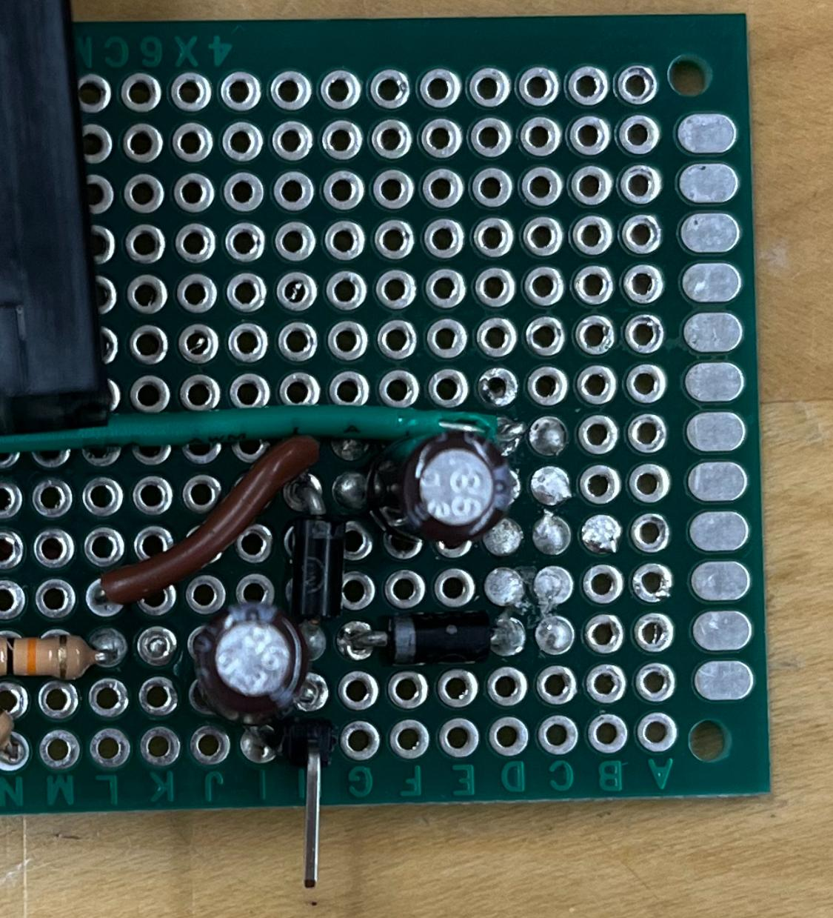
Figure 3: Soldered Charge Pump
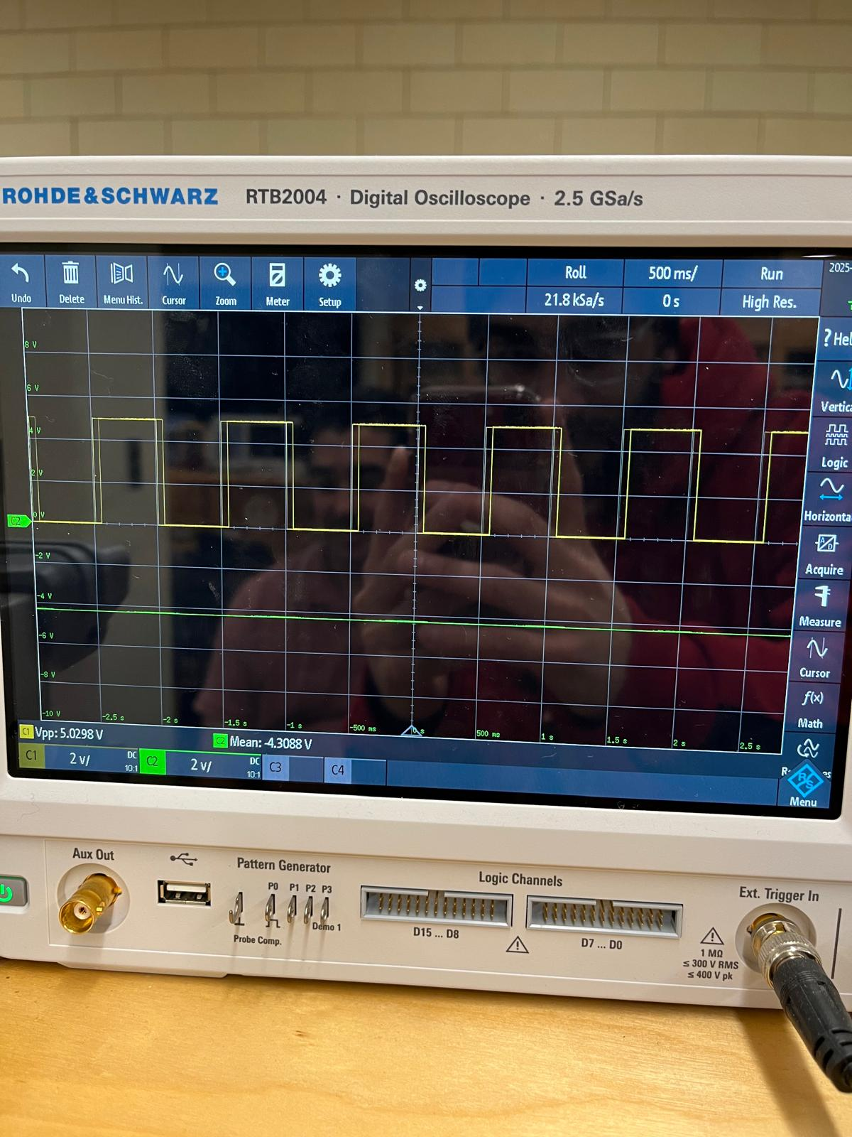
Figure 4: Output square wave during testing

Sustainability assessment:

Disassembling of the product at the end of life (Author: Nanni Srikanthan)
Our guitar tuner is designed for easy disassembly at the end-of-life for recycling and reducing e-waste. The container box is 3D-printed with alignment pin joints, allowing tool-free opening. Inside, components are arranged sectionally:
- Amplifier Perf Board: The hand soldered perf board can be desoldered for PCB reuse. They don’t have any toxic waste, so they can also be reprocessed for fiberglass, copper, and .
- Arduino Board: As they are connected via alignment pins, they can be easily removed and reused or disposed of properly as safe e-waste.
- I2C LCD: As they are connected via alignment pins, they can be easily removed and reused or disposed of properly as safe e-waste.
- Wiring & Power: The power cables are attached normally and can be removed easily for reuse.
The material we used for the 3D printed container box is PLA filament. It can be cut into pieces and recycled if the PLA was biodegradable or repurposed for prototyping.
Also, we will label the internal parts, and it will help the recyclers in easy identification which makes their life easier.
These approaches align with Waste Electrical and Electronic Equipment (WEEE) directives. Thus, it will minimize landfill waste and help in recycling.

Conclusion and Future Development

Conclusion: (Author: Nanni Srikanthan, John Nooyen, Khaled Awad)
The design and implementation of the 3D-printed container box and the automatic tune-adjusting system using a stepper motor have contributed to the functionality and user-friendliness of the Arduino-based Guitar Tuner project.
During the project, many challenges were encountered in the design and implementation phases. For the 3D model, issues such as measuring the correct size of each component—especially the handmade amplifier perf board—were difficult, as the sizes had to be measured manually using a ruler. Additionally, determining the exact spots for the alignment pins in 3D modeling was challenging.
The software development posed interesting issues that required a better understanding of the algorithms and communication standards used in order to solve. Working on two portions of code separately provided great experience in utilizing tools such as Git to ensure multiple things could be worked on or edited at once without affecting the other member's work, while allowing contributions to be merged to make the final working code.
As for the Hardware portion of the project, we faced countless challenges, from technical implementation to theoretical design. Despite this, our primary objective was achieved: Amplifying the signal to appropriately match Arduino’s input range. The final design of the OP-amp circuit was successfully iterated while maintaining full ADC range. Additionally, the charge pump was carefully implemented to achieve the necessary DC offset, and after multiple testing phases the soldered circuit demonstrated reliable results with no noticeable clipping or distortions. We were able to smoothly integrate it with the software portion of the design
With the experience we gained here, we were able to better understand integrating mechanical and electronic components. This report has detailed the design process and challenges we faced with these two critical components, which provides a comprehensive guide for future students or engineers working on similar projects.

Future Development: (Author: Nanni Srikanthan )
In terms of future development, the stepper motor system, which was stopped earlier, could be continued if we had more time. Doing so would require effort in packaging to avoid tangling, modelling or data training so the tuner would be able to accurately position the tuning pegs. Another option would be to upgrade the microcontroller to one with more memory and a stronger processor to increase the samples stored and processed, increasing the reliability of the FFT. For convenience, a copy of the input signal could be output so the user can connect the tuner in line with an amplifier. Beyond hardware, the tuner could be upgraded from software and interface improvements.

References
[1]Joost. (2024, May 16). Old and new filament: use ABS or PLA? Filamentz. https://filamentz.nl/en/blogs/news/pla-of-abs-gebruiken?srsltid=AfmBOoorSrOEU3kLDsn5CKOmuox6rl1rMrHVI9bzzl0P8nMmsfBq87Ox
[2] Pololu - Stepper Motor: Unipolar/Bipolar, 200 Steps/Rev, 42×48mm, 4V, 1.2 A/Phase. (n.d.). https://www.pololu.com/product/1200#:~:text=This%20NEMA%2017%2Dsize%20hybrid,(200%20steps%2Frevolution).
[3] Allegro MicroSystems, LL-C. (2021). DMOS Microstepping Driver with Translator And Overcurrent Protection A4988. In Allegro MicroSystems, LLC.

Appendix A – Workload Separation
Here is how we agreed to split ownership for the work on this project. Agreed upon over discord April 8th by all 5 members (screenshot provided)
Team Member | Workload Share (%)
Adam Abdulkhalek | 15
Khaled Awad | 15
John Nooyen | 25
Nanni Srikanthan | 20
Zachary Kayed | 25
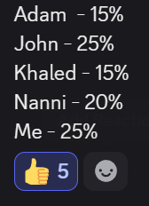

Appendix B – Codebase
